Hands-on Lecture Workbook 08

|  |  |  |
| --- | --- | --- |
| **PSCI 1102 Sec #:** |  | **Date:** |
| **Name:** | | |

1. Activity 01: IR Sensor and remote control

A receiver photodiode such as the infrared (IR) sensor will convert IR light energy emitted into electrical current. IR is used in wireless communication technologies where receivers and transmitters allow for information processing. Frequency of 38kHz is used as a modulation signal for transmitting data different from the frequency of our environment to an IR receiver. Data information collected can be read and used by a receiver for having short range communications made seen in Television (TV) remote controls. Specifically, an encoder inside the device of an IR remote receiver will convert a binary signal into a modulated electrical signal to an LED for a light signal. A binary signal is converted from the light signal to be used by the microcontroller (Arduino electronic circuit board). A remote control will generate a code for each key pressed. This information is modulated and a receiver will receive and translate a binary signal to the microcontroller.

* 1. Open TinderCad Circuit
  2. Create a circuit as shown in figure 01.
  3. Component list:
     1. Arduino Uno R3
     2. Breadboard
     3. 1 x IR sensor
     4. 1 x IR remote
     5. 4 x LED
     6. 1 x resistor 220 Ω



Figure 01

* 1. Upload Arduino sketch (code) named “IR_sensor_code_v01” from D2L.
  2. Run your simulation.

1. Activity 01: Questions
   1. Is the IR sensor emitting a signal? How do you know? Explain.

|  |
| --- |
|  |

* 1. What is the function of the LED here?

|  |
| --- |
|  |

* 1. In what ways does infrared light differ from visible light?

|  |
| --- |
|  |

* 1. Why is the characteristics of infrared useful?

|  |
| --- |
|  |

1. Activity 02: Sparkfun MMA7361 accelerometer

A Cadmium Sulfoselenide in electronics is a photoresistor or photocell sensor that senses light from 400 to 700 nm. They are photoconductive and are made of the inorganic compound Cadmium Sulfide (CdS). This device changes its resistance only when depending on the light intensities that shine through. Photoresistors vary based on the measurement of light gained in units of lux (lx). The resistance of a photoresistor will decrease when light intensity increases.A photoresistor will be connected along with the DC motor to regulate power supply for mechanical motion.

1. Component list:
   1. 1 x DC motor
   2. 1 x 9v Battery
   3. 1 x Photoresistor (CdS)
2. Create a circuit as shown in figure 02.



Figure 02

1. Activity 02: Questions
   1. Choose the following answers for what will occur if the photoresistor connection is opposite from the above setup (Note: The circuit connection uses a single jumper wire per terminal end):

i) Same

ii) Different

Include an explanation for your answer about this setup.

|  |
| --- |
|  |

* 1. What do the conditions of both an increase and a decrease in resistance for the photoresistor mean?

|  |
| --- |
|  |

* 1. How fast and slow is the speed (rpm) of the electronic circuit? How is this operation being made?

|  |
| --- |
| Max =  Min = |

* 1. Now, choose the following answers for what will occur if the motor and photoresistor are connected in reverse instead to the powersupply.

i) Same.

Ii) Different.

Include an explanation for your answer about this setup.

|  |
| --- |
|  |

* 1. Connect a multimeter to CdS. Plot a potential (x-axis) vs. rpm (y-axis) and tell me what type of relationship they do have.

|  |
| --- |
|  |

1. Activity 03: Pulse Width Modulation
   1. Create an electronic circuit as shown in figure 03.
   2. Component list:
      1. Arduino UNO R3
      2. 1 x 9v battery
      3. DC motor
      4. TIP20
      5. Diode
      6. 1 x resistor 2.2 kΩ
      7. 1 x 1000 us oscilloscope

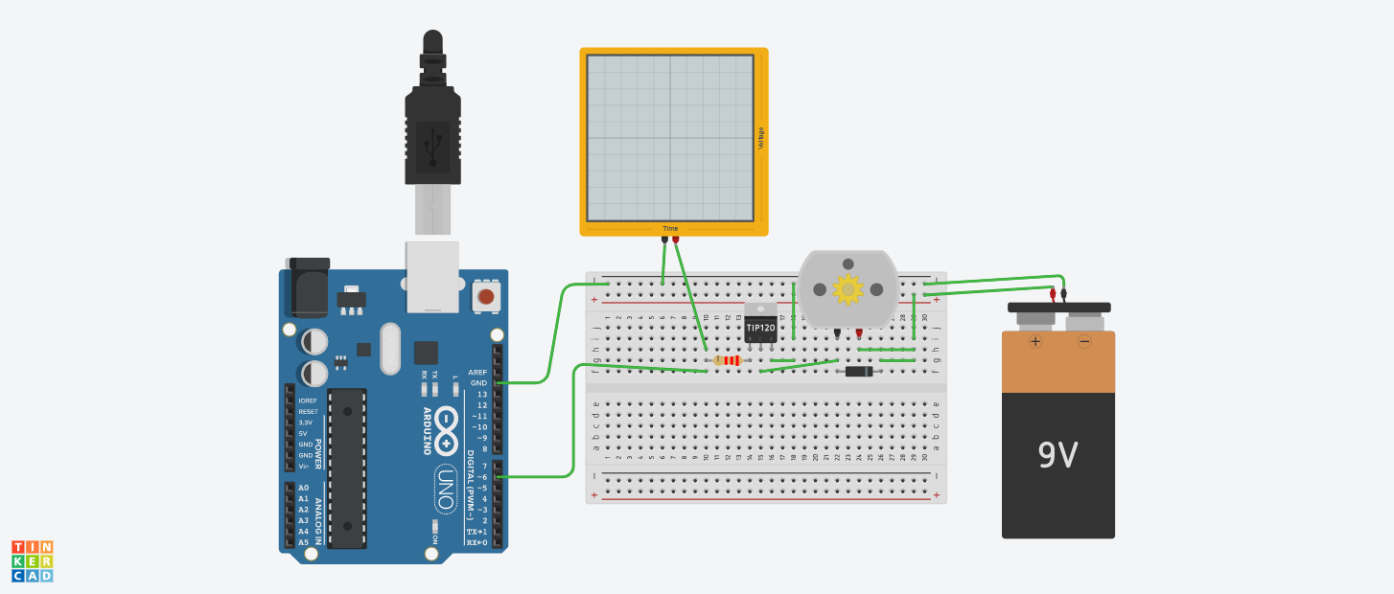

Figure 3

* 1. Upload Arduino sketch (code) named “pwm_code_v01” from D2L.
  2. Run your simulation.

1. Activity 03: Questions
   1. How a pwm from an Arduino related to rpm on a DC motor?

|  |
| --- |
|  |

* 1. How many different speed modes you can find?

|  |
| --- |
|  |

1. Activity 04: H-bridge
   1. Create the follow circuit on TinkerCad Circuit.

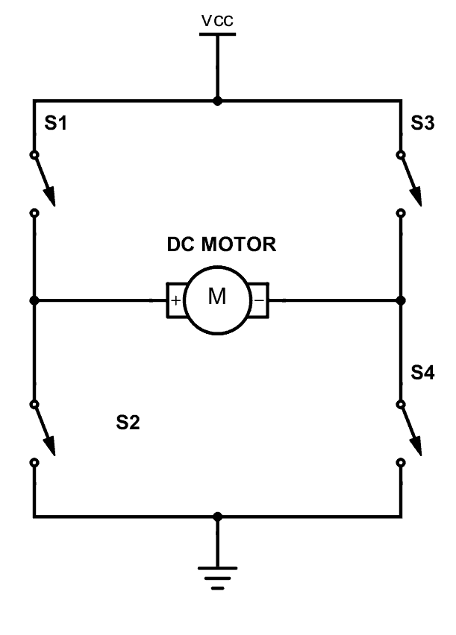Figure 04

* 1. To create the above circuit, you will need following parts.
     1. 4 x slide switch
     2. 1 x 9v battery
     3. 1 x DC motor
  2. Now, it is time to upload a circuit shown in Figure 05.

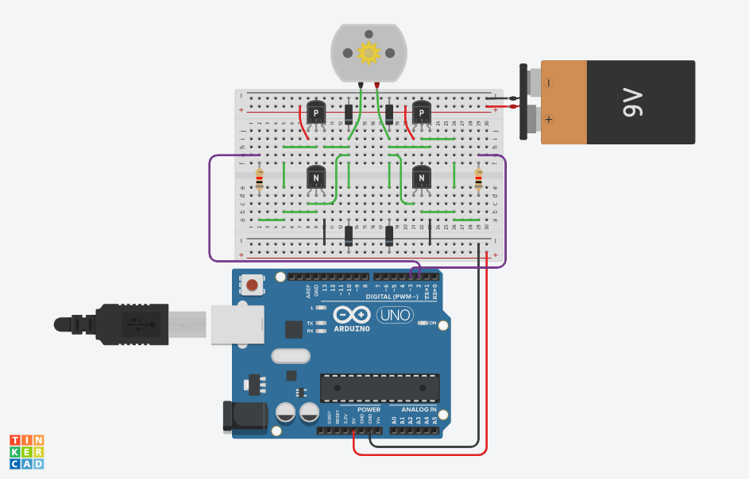

Figure 05

* 1. Go to the main menu window of TinkerCAD Circuits.
  2. Under a search window, type “PSCI_wb_H Bridge”.
  3. Click on the first option saying “PSCI_wb_H Bridge”.
  4. Click on “Tinkder This”.
  5. You do not need to change anything with this circuit.
  6. Upload Arduino sketch (code) named “H_bridge_code_v01” from D2L.
  7. Run simulation.
  8. Open “Code”.
  9. Click on “Serial Monitor” on the bottom of “Code”.
  10. You must type “1”, “2”, or “3” and click on “send” option.

1. Activity 04: questions
   1. How to change a direction of the DC motor (Figure 04 activity)?

|  |
| --- |
|  |

* 1. Tell me about what the functions of “1”, “2”, or “3” mode.

|  |
| --- |
|  |

* 1. What has been changed between figure 04 and figure 05? What does it mean by this?

|  |
| --- |
|  |