**G1101: Introduction to Human Geography** Name:______________________

**Ch 10 Food & Agriculture**

Agriculture Activity:

It’s time to look at the spatiality of crops grown in the United States.

Go to this website: <https://nassgeodata.gmu.edu/CropScape/>

Hover over the Toolbar buttons at the top. There are the familiar ones (Zoom in, Zoom out, etc.) and the less familiar ones (Define Area of Interest or Change Analysis)

The crops produced in a particular area are obviously variable across space, but they are also variable o across time. Farmers react to changes in the market by planting more or less of a crop or changing the crop completely. Weather events such as floods can also disrupt the planting or harvesting of a particular crop.

Just look at the colors on the screen. Each different color is a separate crop. I know the map is really busy, but it cannot really be helped, since there are so many different categories. Click the Legend tab in the upper left to see all the categories included.

Without changing any setting on the Left of the screen, click the Define Area of Interest tool .

Click and drag to make a square like this over the Mississippi River touching several states.

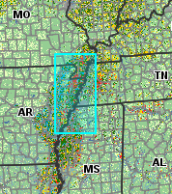

Now click the Bar Graph in the Toolbar. It will look something like this.

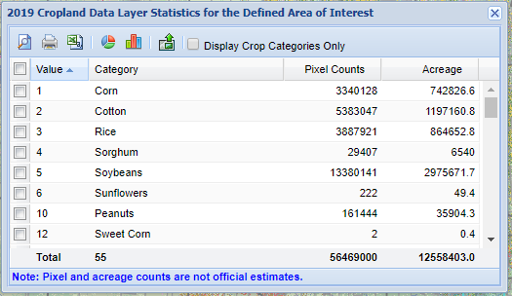 Are you surprised by anything growing there?

Now click the Bar Graph in this window. Look at all that data, nicely graphed for you!

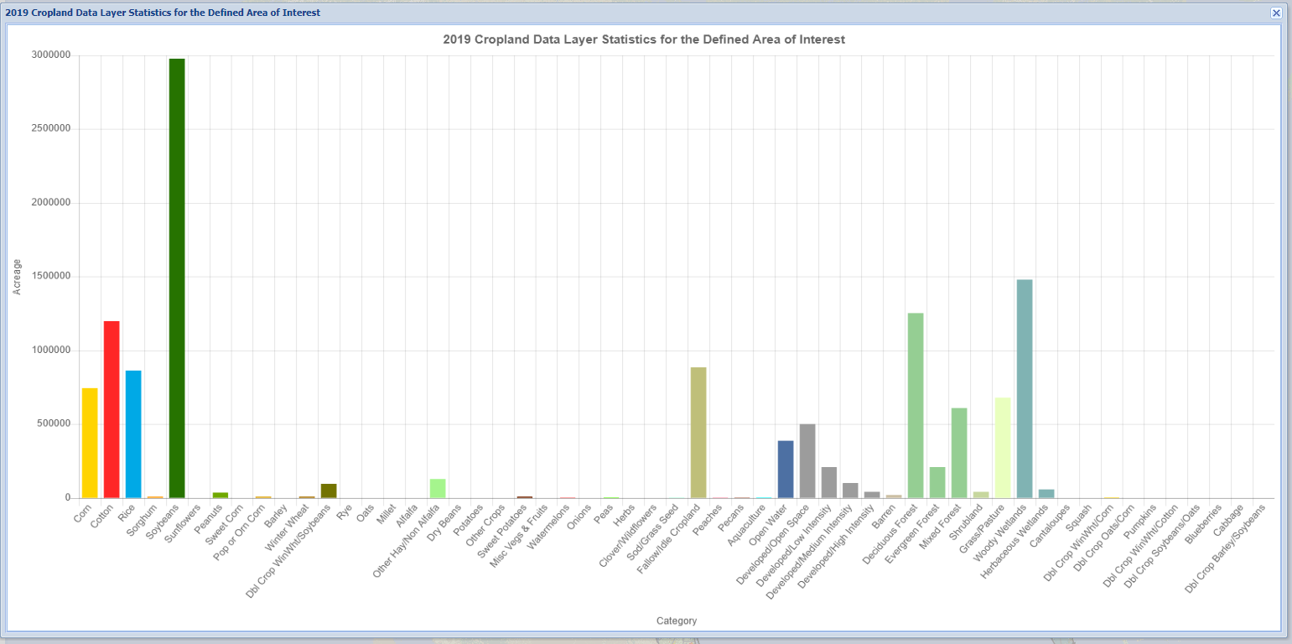

What is the most common crop in this region?

Now you can close this window and the previous data window. Click on Clear Area of Interest to remove your settings .

Do this for two more different regions that are not southern Louisiana. You will see that the mix of crops available changes. Why are crops so regional? Are the reasons due to climate and soil type or distance to market? What about cultural preferences for particular foods?

Finally, select southern Louisiana as your area of interest. Click the Bar Graph (AOI Statistics) to look at the data. Close that.

Click the PDF tool in the Toolbar. Accept the defaults. Click submit.

What is the most common crop in southern Louisiana?

Download and turn in the pdf map plus this document with the questions answered.

**Please remember that Feedback is not graded, nor will your opinion be held against you!**

Feedback:

1. On a scale of 1 to 5, 1 being the least useful, I would rate this assignment a __________
2. What is the most useful aspect of this assignment?
3. What is the least useful aspect of this assignment?
4. How would you improve this assignment?
5. Please comment on the Assignment.