**G1101: Introduction to Human Geography** Name:______________________

**Ch 11 Industry & Manufacturing, by Professor Todd Lindley**

**IMPORTANT: Do not put your name on this exercise!**

**G1101: Introduction to Human Geography** Student ID#:______________________________

**CAT app #2: US Manufacturing Sec. #/Class Time:________________________**

**INTRODUCTION/BACKGROUND**

US Manufacturing in the 21st Century

Manufacturing was the main driver of economic growth in the United States for much of the 20th century. The U.S. was the world's leading producer of cars, steel, construction equipment, and thousands of other items for several decades beginning in the 1930's. The country ranked number one in total industrial output every year until 2010, when China became the world's leading manufacturer. Politicians, economic advisers, and media reports have commented on the rise of China and the decline of manufacturing in the U.S. Some American manufacturers relocated operations to Mexico, China, India, and to other corners of the world to save money, which may signal the demise of American manufacturing in the 21st century and beyond. Geographers are interested in understanding the relationship between globalization, economic restructuring, and political decision-making and the effects of such phenomena on unemployment, social development, and general well-being. As such, historical data and graphs are helpful to better understand current, past, and future trends in American manufacturing. Some have argued that American manufacturing has been weakened because of competition from other countries and that output will continue to decline without governmental protection from competitors. Examine the graph below showing the number of employees working in manufacturing in the U.S. from 1940-2015 to answer the following questions. (**Source:** [U.S. Bureau of Labor Statistics](https://www.bls.gov/) - <https://www.bls.gov/> )

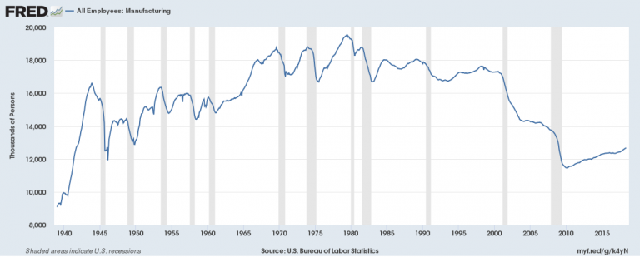

1. How strongly do the data support the idea that the American manufacturing output declined from 1985 to 2015? Please comment.

2. If American manufacturing output did not decline from 1985-2015, what are two (2) other possible interpretations of the data presented in this graph?

3. What other specific piece of information might be helpful to determine whether manufacturing output increased in the U.S. from 1985-2015?

Sole Author: Dr. Todd Lindley, Georgia Gwinnett College (Spring 2019)