GEOG 1101: Dr. Georgeta Connor Name: ________________________

Chapter 10: Agriculture and Food Section #/Class time: _____________

Exercise # 1: **Labeling GM Food**

This exercise contains 3 questions. 5 points total. Answer all questions as best you can.

Using **Figure 10.26,** which shows the global distribution of GM labeling, respond to the questions below the figure.

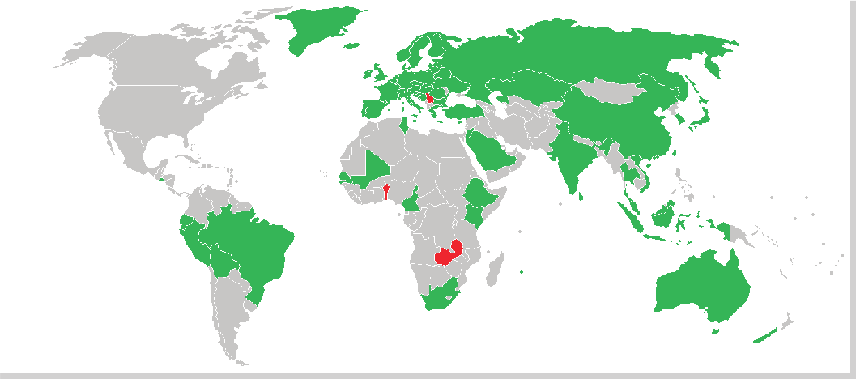

**Figure 10.26 | GM Labeling Around the Globe**

**Green**: Mandatory labeling; **Gray**: No labeling

**Red**: Ban on import and cultivation of genetically engineered food

1. Why the United States and other countries do not require labeling genetically modified food? (1 point)

------------------------------------------------------------------------------------------------------------------------------------------------------------------------------------------------------------------------------------------------------------------------------------------------------------------------------------------------------------------------------------------------------------------------------------------------------------------------------------

1. In what continent are more countries in which GM labeling in not required? (0.25 points)

------------------------------------------------------------------------------------------------------------------------------------------------------------------------------------------------------------------------------------------

1. Using the table below, write five countries from each continent in which labeling of GM food is not required. (3.75 points)

|  |  |  |
| --- | --- | --- |
| **NO REQUIRED LABELING**  **OF GENETICALLY MODIFIED FOOD** | | |
| **A F R I C A** | **A S I A** | **LATIN AMERICA** |
|  |  |  |
|  |  |  |
|  |  |  |
|  |  |  |
|  |  |  |

**Sources:** Except for the map above, **y**ou may need to refer to your textbook, Power Point, your notes, and, for some detailed maps, either a Word Atlas or an electronic source using this address: <http://www.eduplace.com>

**Instructions:** Your answers must be typed and submitted to D2L - Assignments.