Hands-on Lecture Workbook 05

|  |  |  |
| --- | --- | --- |
| **PSCI 1102 Sec #:** |  | **Date:** |
| **Name:** | | |

1. Activity 01: LCD display
   1. Open TinderCad Circuit
   2. Create a circuit as shown in figure 01.
   3. Component list:
      1. Arduino Uno R3
      2. Breadboard
      3. 1 kΩ and 1Ω
      4. LCD 16 x 2

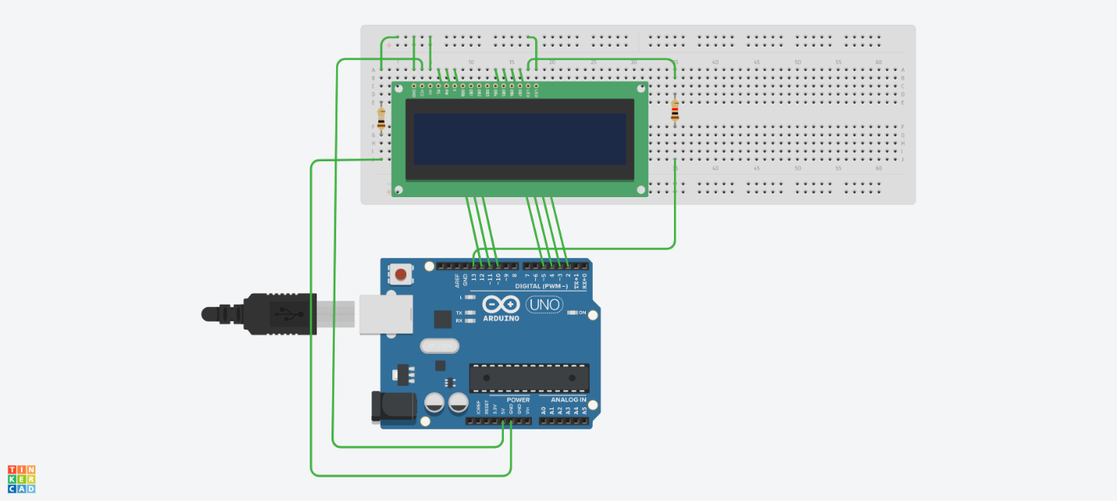

Figure 01

* 1. Upload Arduino sketch (code) named “LCD_code_v01” from D2L.
  2. Run your simulation.

1. Activity 01: Questions
   1. What is the LCD displaying?

|  |
| --- |
|  |

* 1. Change a code to display your name? How did you achieve this task?

|  |
| --- |
|  |

* 1. Change from “Smiley” to “Heart”. What did you do to change from “Smiley” to “Heart”?

|  |
| --- |
|  |

1. Activity 02: TMP36 Temperature sensor

TMP36 is a centigrade temperature sensor that features a plastic hemi-cylinder (TO-92 package mainly used for transistors) with three separate pins (Figure 5.1). The pins of the TMP36 are able to bend easily to fit into a breadboard and will allow a circuit connection to be made.



Pin 1 of the TMP36 is the voltage common collector (Vcc) used to connect to the power supply that is between 2.7 to 5.5V direct current (DC). Pin 3 is used to connect to ground on an electronic circuit board. Pin 2 is the output and has an analog voltage reading that will range between 0 to 1.75V. It is important to note that a 9V battery will not be compatible for having a connection be made.

Inside this temperature sensor, there are tiny microchips that help display the temperature. The TMP36 reads temperatures from -40 to 150 degrees celsius (°C). The value of the temperature is essentially read when the output pin is connected to the analog input port of the electronic circuit board. The code will run and the temperature in °C, in Fahrenheit (°F), and the measured analog voltage will be displayed under the serial monitor. The analog input port will work as an Analog to Digital Converter (ADC) in order to have the voltage (input signal) converted into a digital or binary number (output signal). ADC has a value between 0 (no voltage) to 1023 (5V). This 10-bit analog reading can be converted into a temperature reading. The ADC reading can be found by following formula when obtaining the measured analog voltage reading:

If for example 5V of power is used in the electronic circuit board, the voltage of ADC equal to the reading from the ADC multiplied by 5 divided by 1024:

Voltage (V)= reading from ADC · (5/1024)

If 3.3V of power is used, the voltage of ADC is equal to the reading from the ADC multiplied by 3.3 divided by 1024:

Voltage (V)= reading from ADC · (3.3/1024)

Temperature can be found by measuring the output voltage that was supplied when millivolts is converted to °C:

Centigrade temperature = [Measured analog voltage (V) – 0.5] / 100

1. This activity will display the function of the TMP36 temperature sensor.
2. Component list:
   1. Arduino UNO R3
   2. Breadboard Mini
   3. Temperature sensor (TMP36)
3. Create the electronic circuit shown in Figure 02.

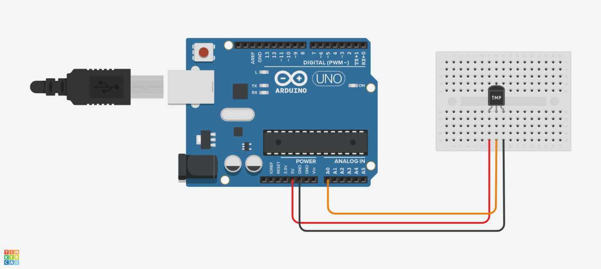

Figure 02

1. Upload Arduino sketch (code) named “LCD_code_v01” from D2L.
2. Run your simulation.
3. You can find “Serial Monitor” from the lower Corner of “Text” box.
4. Activity 02: Questions
   1. How does the TMP36 work?

|  |
| --- |
|  |

* 1. When ADC reading is 307, what is the temperature based on your calculation (show all your calculation work)? What is display reading from your computer? Is there any difference between them?

|  |
| --- |
|  |

* 1. Set the temperature to 78 oC. What is the ADC reading? What is a voltage reading?

|  |
| --- |
|  |

1. Activity 03: Key pad
   1. Create an electronic circuit as shown in figure 03.
   2. Component list:
      1. Arduino UNO R3
      2. 4 x 4 keypad
      3. Red LED and green LED
      4. Mini servo

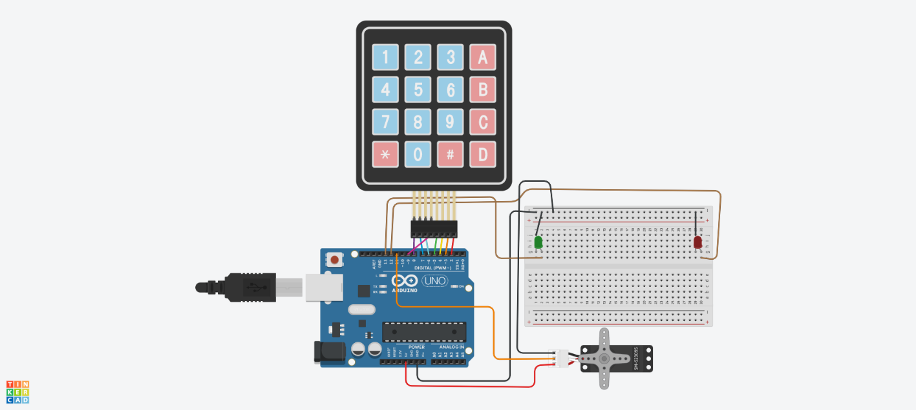

* 1. Upload Arduino sketch (code) named “Keypad_code_v01” from D2L.
  2. Run your simulation.
  3. You must “*” or “#” to reset.

1. Activity 03: Questions
   1. What is a “Password”? Hint: you can find the password from the code.

|  |
| --- |
|  |

* 1. When you push a correct password, tell me what happens?

|  |
| --- |
|  |

* 1. When you change ServoMotor.write values, what will happen?

|  |
| --- |
|  |