G1101: Introduction to Human Geography Name:______________________
Ch 3 Migration
IMPORTANT: Do not put your name on this exercise!
G1101: Introduction to Human Geography Student ID#:______________________________
CAT app #1: US Mexico Border Security 2018 Sec. #/Class Time:________________________

INTRODUCTION/BACKGROUND

In a January 2018 Harvard-Harris poll, 61 percent of Americans reported that they believed border security was inadequate. Moreover, many voters in the 2016 Presidential election believed that the US government had been too lenient in securing the border between the U.S. and Mexico between the years 2006-2016. In 2016 the number of foreign undocumented (illegal) residents was approximately 11.3 million. Some political scientists believe that U.S. government did, in fact, slow down the number of illegal immigrants present in the U.S. between 2006-2016. The data presented below account for all apprehensions at or near any portion of the U.S. / Mexico border. Examine the graph (Source: Department of Homeland Security) below to answer the following questions.

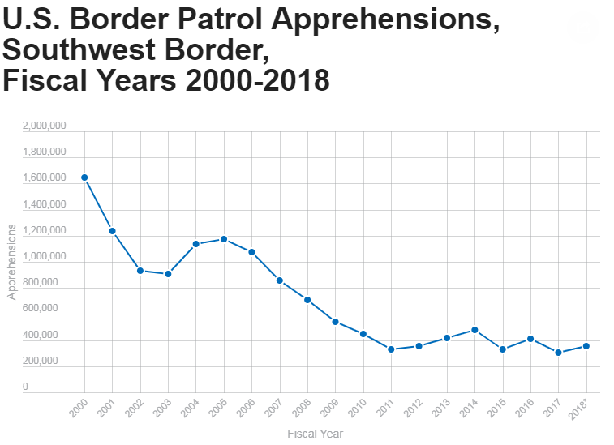

- How strongly do the data support the idea that the U.S. government succeeded in reducing illegal immigrants present in the U.S. from 2006-2016? Please explain.

- If the number of illegal/undocumented people residing in the U.S. wasn't reduced from 2006-2016, what are 2 other possible interpretations of the data presented in this graph? Explain each interpretation.

- Explain one other specific piece of information would be helpful to determine whether numbers of illegal/undocumented immigrants decreased in the U.S. from 2006-2016?

Sole Author: Dr. Todd Lindley, Georgia Gwinnett College (Spring 2019)

