G1101: Introduction to Human Geography Name:______________________
Ch 3 Migration

Sec. #/Class Time:________________________
Instructions: Completely answer each of the questions below. You may need to refer to your textbook, your notes, and/or other sources of information (including the Internet) in order to complete this exercise. Pay careful attention to your instructor’s guidelines to be given during class. You may work with a partner to discuss each of these questions, but your final answers must be your own. The exercise includes lines to guide the length of your responses, but you may delete/add lines as you type your answers. All exercise answers need to be typed in complete sentences typed in orange bold font! This exercise is due in 2 forms 1)via D2L in Assignments AND 2) in paper form(typed) by the beginning of class time on _____________________________________________.

I. Migration Overview:
Currently, there are an estimated 244 million migrants worldwide (International Organization for Migration 2017). Only the four most populous countries in the world contain total populations larger than this. What are these countries? (1 pt)
- ___________________________
- ___________________________
- ___________________________
- ___________________________
What country in the world has a population closest to the total number of migrants in the world? (Google is your friend!) ____________________________
Global Migrants comprise what percent of the world’s total population (show math)? (1/4 pts)
______________________________________________________
The number of foreign born (immigrants) in the U.S. is approximately 44.5 million (2017). What is the percentage of the U.S. population is foreign born (show math)? (1/4 pts)
______________________________________________________

Part II. Migration Effects
As defined by your textbook, migration is “a form of relocation diffusion involving a permanent move to a new location.” Formerly, migration was studied only in terms of permanent moves, but in recent years, scholars and policy makers have begun to acknowledge that many moves involve shorter time frames and distances. In the table below complete your own migration (all moves) history from birth to the present moment (add more rows as needed). If you have never moved, then you may interview a parent or other close relative (1 pt)

Age | From(where) | To(where) | Main Reason | Effect on you/your life

Next, interview a classmate and compare/contrast your migration (domestic and/or international) histories. Enter your partner’s name(s) below and briefly describe differences and/or similarities? (1/2 pts)

Answer one of the following, depending upon your situation:
A) If you or your parents are/were foreign-born, describe in greater depth the impact of your migration experience upon your current life. How does/did this experience affect the way you see the world? How/why? Have you returned to your (or your parents’) birth country? Why or why not? How does you/your family’s migration experience affect your educational experience? Finally, what is something that you wish you knew about your family’s migration history or experience but don’t?
B) If you or your parents did not migrate (internationally), then investigate your family’s migration experience. You may need to interview relatives to answer this question. What country/region of the world did they come from originally? When? Why? What do you know about the circumstances of that migration? How does this knowledge affect your identity today? Describe how you think your family’s migration experience might have been different from those who migrate today. Finally, what is something that you wish you knew about your family’s migration history or experience but don’t? (1.5 pt)

III. Push and Pull Factors
Immigration has been a highly contested political issue in the United States throughout much of its history. At its most basic level, migration can be examined in terms of ‘push’ and ‘pull’ factors. Utilizing the chart below, carefully consider the forces that brought you or your family to your current residence. Be sure to include at least one example for each type of pull and push. (Hint: If you don’t know the answers, or if your family only moved before you were born, then you may have to consult a member of your family with some insight) (1/2 pt)

Current residence | Economic Pull | Cultural Pull | Environmental Pull

Next, enter the push factors for leaving your hometown/state or country.
Hometown/Previous Residence | Economic Push | Cultural Push | Environmental Push
Which of these forces was stronger than the others in driving the decision to move? Why do you think that might be? (1/2 pts)

Table 1: University Student Migration Preferences
University | Most Preferred | Least Preferred
U. of Alabama | Alabama, California, Florida, North Carolina, Texas | Michigan, Montana, North Dakota, Rhode Island, South Dakota
U. of California | California, Massachusetts, New York, Oregon, Washington | Alabama, Arkansas, Louisiana, Mississippi, South Carolina
U. of Minnesota | California, Maine, Michigan, Minnesota, Wisconsin | Alabama, Arkansas, Louisiana, Mississippi, South Carolina
Miami of Ohio | California, Colorado, Florida, Hawaii, Ohio | Alaska, Idaho, Iowa, Kansas, Utah
Penn State | Connecticut, Massachusetts, New York, Pennsylvania, Vermont | Alabama, Georgia, Mississippi, South Carolina, Tennessee

Table 1 indicates migration preferences of students at other universities. What geographic patterns do you see in other schools choices? Are these patterns consistent with Ravenstein’s migration theory? (1 pt)

Part V. Migration and Demography
Countries that pass through various stages of the demographic transition experience population “deficits” and “surpluses” of particular ages groups at different moments in the transition. Japan, for example, is beginning to experience a surplus of older men and women and a deficit of young workers. Meanwhile, many in the US, Europe, and Australia (among others) complain that immigrant families place undue strain upon government social services. Debate the merits of this argument in demographic terms, and use the pyramids below to assess the role that immigration plays in the demographic structure of the United States. (2 pts)

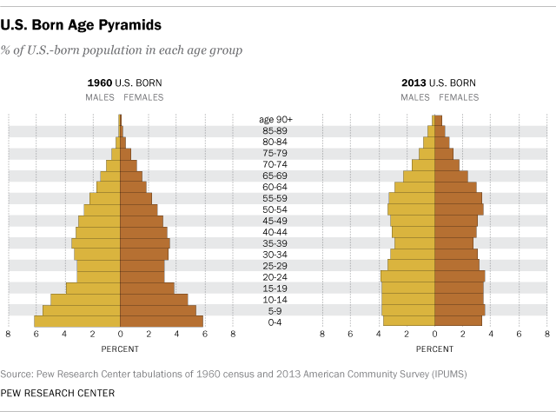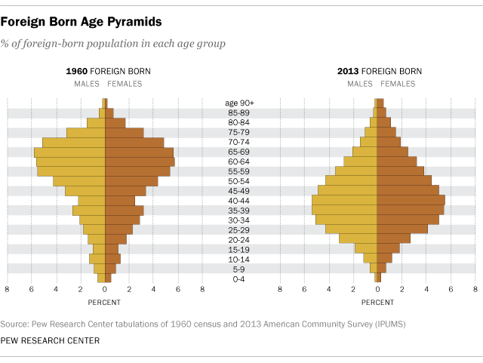

Part VI. Mapping
In this section, include a map of all of the places you have lived. You may choose to do this task however you deem best. You may copy an image from the internet and then use a graphics program to mark places. You may also use Google Maps. (1 pt)

