NEED A NEW APPROACH TO TEACHING?

ENGAGE YOUR STUDENTS with REACTING to the PAST!

AND PLAY “BOMB THE CHURCH”

MARCH 29 or APRIL 5, 2019, 1:00 p.m.—4:00 p.m.
Governor’s Mansion Ed Room

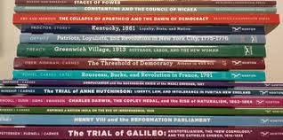

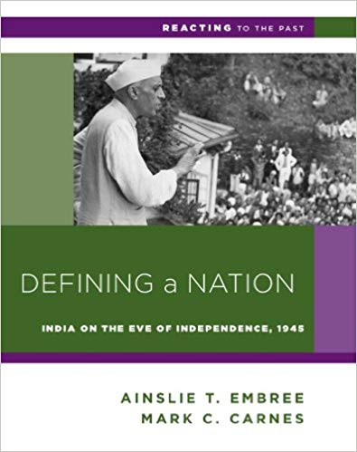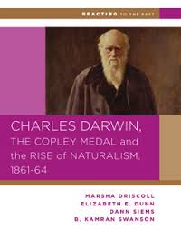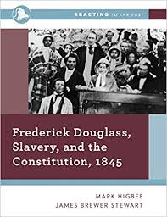

Join colleagues from across the disciplines for a hands-on workshop designed to introduce the basic components of “Reacting to the Past.” Learn why students are raving about this immersive, role-playing pedagogy that improves critical thinking, research, and communication skills.

Register for the workshop one of two dates: March 29 or April 5

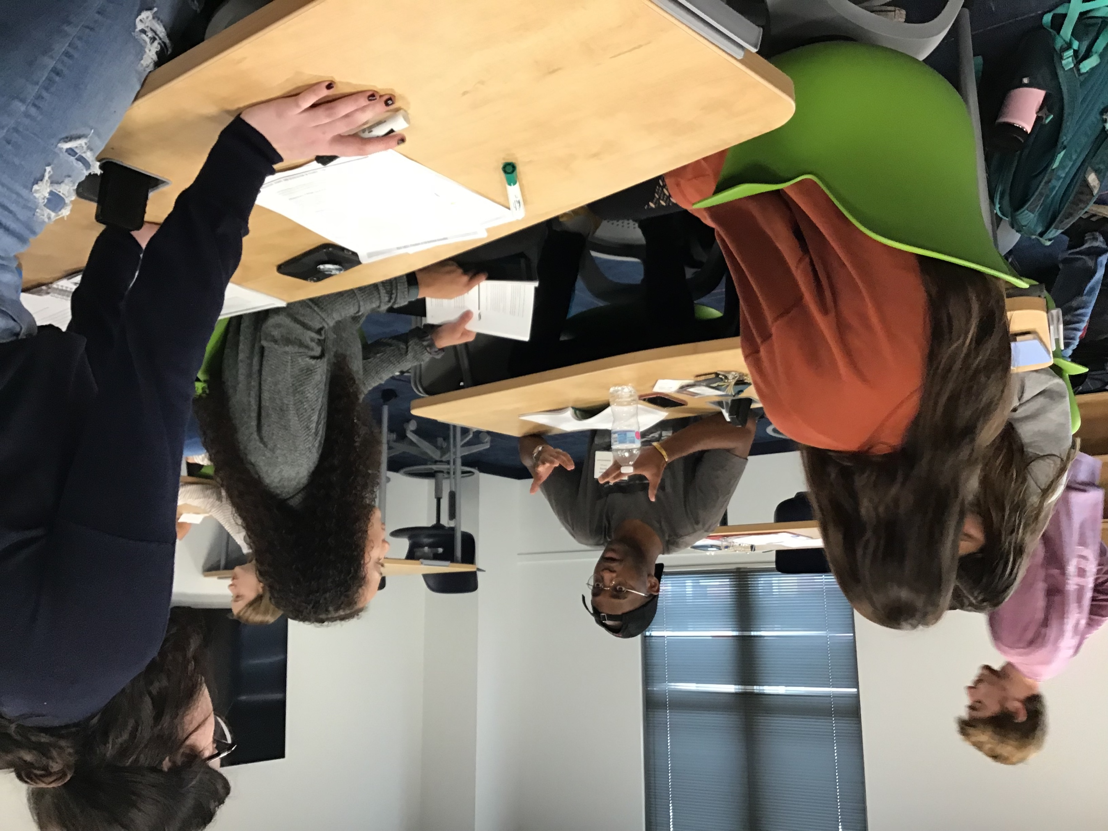
Tentative Agenda:

1 – 2:00 p.m.: Check-in/lunch
1:30 – 2 p.m.: Introduction
2 – 2:30 p.m.: Let’s play! “Bomb the Church” role-play mini-game
2:30 – 3 p.m.: Debrief; Student testimonies; Q & A
3 – 4:00 p.m.: Using our campus resources: mini-games, grants, OER, Course design assistance, RTTP team help (The Game Master is “in”!)

REGISTRATION IS FREE, and includes lunch. Register here
For more information, contact Dr. Peggy Elliott at 478.445.5118, email peggy.elliott@gcsu.edu or Jaclyn Queen at 478.445.1276, email jaclyn.queen@gcsu.edu.

