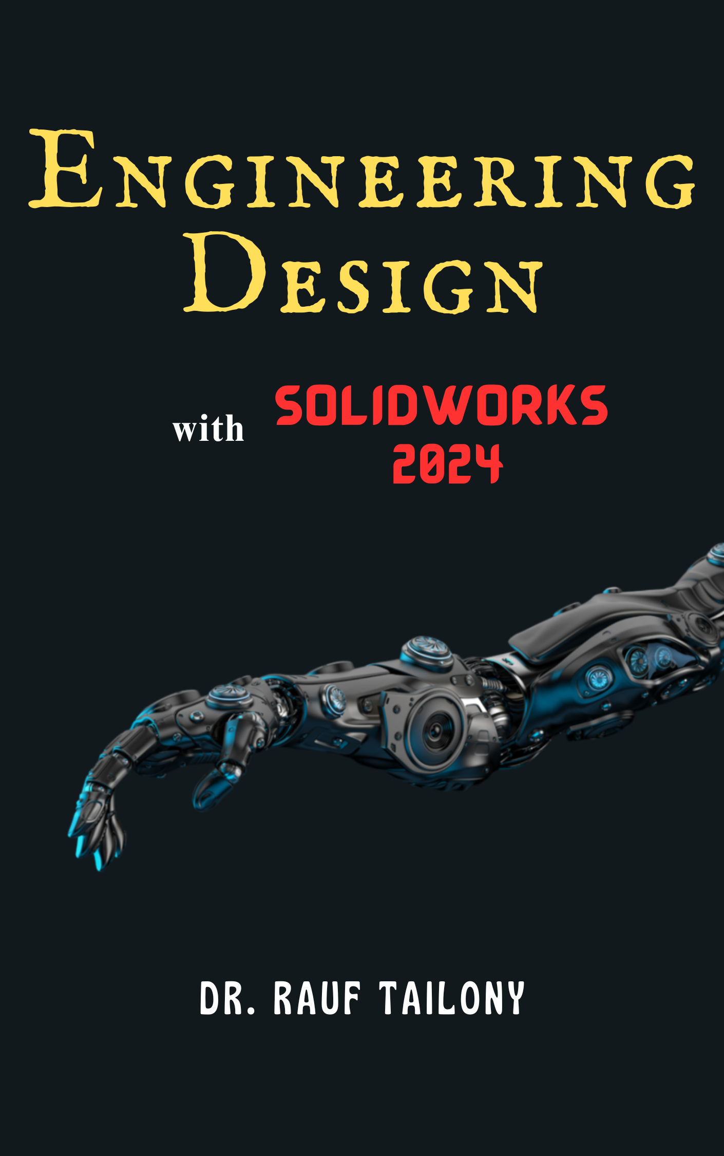

Engineering Design

With **SOLIDWORKS**® **2024**

**Dr. Rauf Tailony**

**Copyright © 2024 Dr. Rauf Tailony**  
**Engineering Design with SolidWorks 2024**

This book is made available as an **Open Access** resource under the terms of the **Creative Commons Attribution-NonCommercial-Share Alike 4.0 International License** (CC BY-NC-SA 4.0).

**You are free to:**

* **Share** — copy and redistribute the material in any medium or format.
* **Adapt** — remix, transform, and build upon the material.

**Under the following terms:**

* **Attribution** — You must give appropriate credit, provide a link to the license, and indicate if changes were made. You may do so in any reasonable manner, but not in any way that suggests the licensor endorses you or your use.
* **NonCommercial** — You may not use the material for commercial purposes.
* **Share Alike** — If you remix, transform, or build upon the material, you must distribute your contributions under the same license as the original.

**No additional restrictions** — You may not apply legal terms or technological measures that legally restrict others from doing anything the license permits.

To view the full license, visit: https://creativecommons.org/licenses/by-nc-sa/4.0/

**Open Access Statement:**  
This book has been published as an Open Access resource to promote the sharing of knowledge and educational equity. It is free to use, share, and adapt within the terms of the license. By providing this work for free, we aim to support learners, educators, and professionals worldwide.

**Published by:**  
Amazon KDP

**First Edition**  
12, 2024

For inquiries, permissions, or additional information, please contact: rauf.tailony@gmail.com

Contents

**CHAPTER 1 5**

**INTRODUCTION TO ENGINEERING DESIGN 5**

1.1 Importance of Engineering Design 6

1.2 Overview of SOLIDWORKS 2024 10

1.3 The Engineering Design Process 12

1.4 The Importance of CAD in Modern Engineering 16

1.5 Installing SOLIDWORKS 19

**CHAPTER 2 28**

**TWO-DIMENSIONAL SKETCHING 28**

2.1 Introduction to Sketching in SolidWorks 29

2.2 Creating Basic Geometric Shapes 33

2.3 Sketch Constraints and Relations 41

2.4 Dimensioning the Sketch 47

2.5 Editing and Modifying Sketches 52

**CHAPTER 3 68**

**PARTS AND FEATURES 68**

3.1 Introduction to Parts and Features 69

3.2 Creating a Basic Part 70

3.3 Understanding Features 74

Example: Creating a Hole in a Block 81

3.4 Using Reference Geometry 86

3.5 Design Intent and Feature Order 86

**CHAPTER 4 94**

**ASSEMBLIES 94**

4.1 Introduction to Assemblies 95

4.2 Creating Assemblies in SolidWorks 95

4.3 Mates in Assemblies 99

4.4 Analyzing Assemblies 104

4.5 Managing Assemblies 106

4.6 Practical Example: Creating a Simple Assembly 107

**CHAPTER 5 116**

**PROJECTION VIEWS 116**

5.1 Introduction to Projection Views 117

5.2 Types of Projection Views 118

5.3 Creating Projection Views in SolidWorks 121

5.4 Practical Applications of Projection Views 128

5.5 Practical Example: Documenting a Mechanical Part 131

# CHAPTER 1

# INTRODUCTION TO ENGINEERING DESIGN

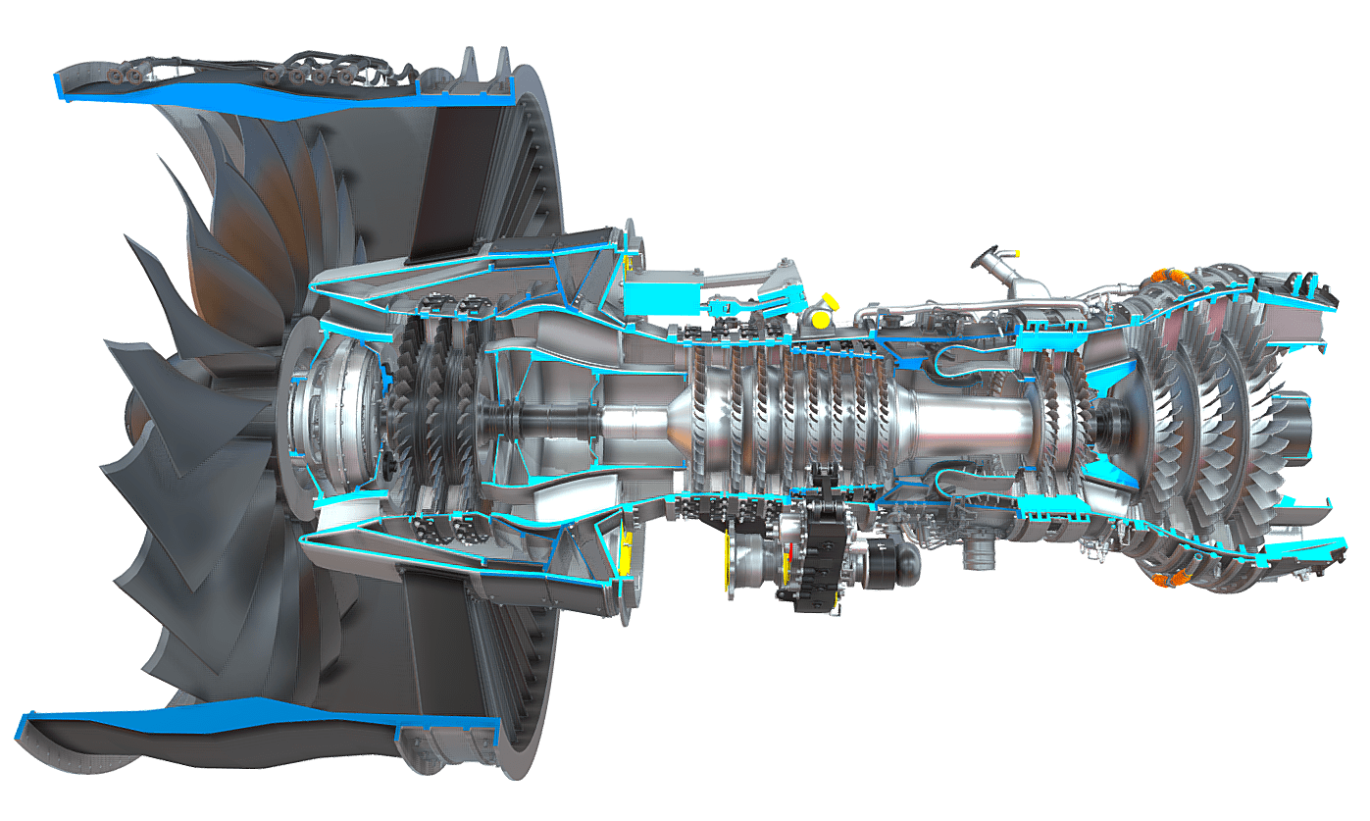

## Importance of Engineering Design

**Definition and Scope of Engineering Design**

Engineering design is a creative process of developing new products, systems, or solutions to meet specific needs. It involves problem-solving, creativity, and innovation to produce functional and aesthetically pleasing designs. The scope of engineering design ranges from small components to complex systems and encompasses various disciplines, including mechanical, electrical, civil, and software engineering.

**Role of Engineering Design in Product Development**

Engineering design is a cornerstone of product development, serving as the bridge between abstract ideas and tangible products. This process involves several critical stages, each contributing to the creation of functional, reliable, and manufacturable products that meet user needs and industry standards.

**Conceptualization**

Figure 1: Dyson Vacuum Cleaner.

The conceptualization stage is where ideas are born. Engineers and designers brainstorm and sketch out potential solutions to a given problem or need. This phase is highly creative and often involves considering multiple design alternatives before settling on the most promising concept.

Example: Dyson Vacuum Cleaners

James Dyson's invention of the first bagless vacuum cleaner began with conceptualization. Frustrated with his vacuum's declining performance, Dyson envisioned a vacuum using cyclonic separation to maintain suction. Numerous sketches and conceptual models were created before the first prototype was built.

**Detailed Design**

Once a concept is chosen, the detailed design phase begins. This involves creating precise 3D models and detailed drawings that define every aspect of the product. This stage ensures that all components fit together correctly and function as intended.

Example: Boeing 787 Dreamliner

In the development of the Boeing 787 Dreamliner, the detailed design phase was crucial. Engineers created comprehensive 3D models of the aircraft, integrating systems such as the electrical wiring, fuel lines, and avionics. Detailed drawings specified the materials and dimensions for every component, ensuring seamless integration and performance.

Figure 2: Boing 787 Dreamliner.

**Prototyping**

Prototyping is the process of creating a physical model of the product to evaluate its design, functionality, and manufacturability. Prototypes can range from simple mock-ups to fully functional models, allowing designers to test and refine their ideas.

|  |
| --- |
| Example: SAMSUNG Galaxy Z Fold |
| Samsung’s development of the Galaxy Z Fold involved creating multiple prototypes to perfect the foldable screen technology. Engineers tested various hinge designs, screen materials, and folding mechanisms. Each prototype iteration helped Samsung address challenges such as screen durability and fold endurance, ultimately leading to a robust and user-friendly final product. |

Figure 3: SAMSUNG Galaxy Z Fold Phone.

**Testing**

Testing is a critical phase where prototypes are rigorously evaluated to identify any design flaws or performance issues. This stage involves various types of testing, including stress testing, usability testing, and safety testing, to ensure the product meets all necessary standards and performs reliably under expected conditions.

|  |
| --- |
| Example: SpaceX Falcon 9 Rocket |
| SpaceX’s Falcon 9 rocket underwent extensive testing during its development. Prototypes were tested for structural integrity, propulsion efficiency, and reliability under extreme conditions. These tests were crucial in identifying potential failure points and refining the design to achieve the high reliability needed for space missions. |

Figure 4: SpaceX Falcon Rockets.

**Final Production**

Once the design has been thoroughly tested and refined, it moves into final production. This stage involves scaling up the manufacturing process to produce the product in large quantities while maintaining quality and consistency.

**Examples of Successful Engineering Designs**

GE Haliade-X Wind Turbine: The world's most powerful offshore wind turbine, the Haliade-X represents a significant advancement in renewable energy technology. Its design includes a 12 MW capacity and a 220-meter rotor, enabling it to produce more energy at lower costs.

The Vertical Farming Systems by AeroFarms: AeroFarms has developed advanced vertical farming systems that use aeroponics to grow crops without soil. These systems can produce large quantities of food using less water and space, addressing food security issues in urban areas.

HoloLens by Microsoft: The HoloLens is a mixed reality headset that overlays digital information onto the real world. Its applications range from gaming to industrial design, providing an immersive way to interact with digital content and enhancing productivity and creativity.



Figure 5: HoloLens Mixed Reality Headset.

## Overview of SOLIDWORKS 2024

**Introduction to SOLIDWORKS as a CAD Software**

SOLIDWORKS is a premier computer-aided design (CAD) software extensively utilized in engineering and design industries for creating detailed 3D models, performing complex simulations, and generating comprehensive documentation for manufacturing and assembly. Known for its intuitive user interface and powerful capabilities, SOLIDWORKS facilitates the entire design process, from conceptualization to production, making it an indispensable tool for both novice and experienced designers.

**Key Features and Capabilities of SOLIDWORKS 2024**

At the heart of SOLIDWORKS is its robust 3D modeling functionality, which allows designers to create precise and complex models with ease. Parametric modeling is one of the core features, where dimensions and relationships define the model, enabling automatic updates throughout the design whenever changes are made. This ensures consistency and accuracy across all stages of the design process. Surface modeling tools in SOLIDWORKS 2024 have been significantly enhanced, allowing for the creation of complex shapes and freeform designs that are essential in industries such as automotive and consumer products. For those working with sheet metal, the software provides specialized tools that simplify the design of flat patterns and bent sheet metal parts, integrating manufacturing considerations early in the design process. Additionally, the weldments feature offers tools to design welded structures, adding structural members, weld beads, and generating cut lists.

Figure 6: A product designed within SOLIDWORKS Environment.

SOLIDWORKS is not just about creating static models; it also includes powerful simulation capabilities. Finite Element Analysis (FEA) allows users to perform structural, thermal, and vibration analyses, helping to evaluate the performance of designs under real-world conditions. The Computational Fluid Dynamics (CFD) module facilitates the analysis of fluid flow and heat transfer, optimizing the performance of designs involving liquids or gases. Moreover, the motion analysis feature simulates the kinematics and dynamics of assemblies, providing insights into how parts interact and move, which is crucial for designing mechanical systems.

Documentation is another critical aspect of the design process that SOLIDWORKS addresses comprehensively. The software allows users to generate detailed 2D drawings from 3D models, including various views, sections, and annotations necessary for manufacturing and assembly. Automatically creating and updating Bills of Materials (BOM) is streamlined within SOLIDWORKS, listing all components and materials required for a project. Ensuring compliance with industry and company standards is made easier using standardized templates and drawing formats.

Collaboration is key in modern engineering projects, and SOLIDWORKS offers robust tools for team-based design efforts. The SOLIDWORKS Product Data Management (PDM) system helps manage design data and control revisions, ensuring that all team members are working with the most current information. Integration with the 3DEXPERIENCE platform further enhances collaboration by offering cloud-based tools for project management and data sharing, making it easier to work with stakeholders across different locations.

Data management in SOLIDWORKS includes features like design history and rollback, which track changes and maintain a complete history of the design process. This capability allows designers to revert to previous versions if necessary, providing a safety net during the iterative design process. Configuration management is also a strong suit, enabling the management of multiple configurations of a part or assembly within a single document, which is particularly useful for designing product variants.

**Benefits of Using SOLIDWORKS in Engineering Design**

The benefits of using SOLIDWORKS in engineering design are manifold. Efficiency is significantly enhanced through streamlined workflows that integrate various design and simulation tools into a single platform, reducing the need to switch between different software. Automation features such as design tables and macros save time and reduce errors by automating repetitive tasks. Precision in modeling ensures that every detail of the design is accurate, crucial for manufacturing and assembly. Advanced simulation tools provide accurate predictions of real-world performance, allowing designers to make informed decisions early in the design process, thus minimizing costly revisions later.

Collaboration is greatly improved with real-time tools and PDM that facilitate teamwork among members regardless of their location. Easy sharing of design data with stakeholders, suppliers, and customers ensures better communication and feedback, which is essential for iterative improvement. The access to cutting-edge tools fosters innovation, enabling engineers to push the boundaries of what is possible. The large and active user community provides a wealth of support, resources, and inspiration, contributing to a culture of continuous improvement and innovation.

## The Engineering Design Process

**Steps in the Engineering Design Process**

The engineering design process is a systematic, iterative methodology used by engineers to create functional products and processes. It involves several key stages: problem definition, research and analysis, conceptual design, detailed design, prototyping and testing, and final design and production. This structured approach ensures that designs are thoroughly evaluated and optimized before they reach the market. Here’s a more detailed exploration of each stage, with examples to illustrate how SOLIDWORKS can be integrated into each step.

**Problem Definition**

The first step in the engineering design process is to clearly define the problem or need that the design will address. This involves understanding the requirements, constraints, and goals of the project. It is crucial to gather input from stakeholders to ensure that all aspects of the problem are considered.

|  |
| --- |
| Example: Automotive Component Design |
| For instance, in designing a new automotive component, the problem definition stage would involve identifying the specific performance requirements, such as weight reduction, durability, and compatibility with existing systems. Engineers would gather data on material properties, manufacturing processes, and cost constraints to ensure a comprehensive understanding of the project goals. |

**Research and Analysis**

Once the problem is defined, the next step is to conduct research and analysis. This involves gathering information on existing solutions, technologies, and materials that could be applied to the new design. Engineers analyze this information to identify potential approaches and innovations.

|  |
| --- |
| Example: Medical Device Development |
| In the development of a new medical device, engineers would research current technologies and materials used in similar devices. They would analyze data on biocompatibility, safety standards, and patient needs to determine the most suitable materials and design approaches. Using SOLIDWORKS, engineers can create preliminary models and perform initial simulations to evaluate different concepts. |

**Conceptual Design**

The conceptual design phase is where ideas begin to take shape. Engineers generate multiple design concepts and evaluate their feasibility. This stage is highly creative and involves brainstorming and sketching out potential solutions.

|  |
| --- |
| Example: Consumer Electronics Design |
| For a new consumer electronics product, such as a wearable fitness tracker, engineers would generate various design concepts focusing on form factor, ergonomics, and functionality. Using SOLIDWORKS, they can create 3D sketches and models to visualize these concepts and assess their viability. Advanced sketching tools and rapid prototyping capabilities in SOLIDWORKS allow engineers to explore different designs quickly and efficiently. |

**Detailed Design**

After selecting the most promising concept, the detailed design phase begins. This involves creating precise 3D models and detailed drawings that define every aspect of the product. Engineers specify dimensions, tolerances, materials, and manufacturing processes.

|  |
| --- |
| Example: Aerospace Component Design |
| In designing an aerospace component, detailed design would involve creating comprehensive 3D models that include all necessary features and details. Engineers use SOLIDWORKS to develop these models, ensuring accuracy and precision. They can also use SOLIDWORKS to generate detailed 2D drawings for manufacturing, including specifications for materials, dimensions, and assembly instructions. |

**Prototyping and Testing**

Prototyping and testing are critical steps where physical models are created to evaluate the design's functionality, performance, and manufacturability. Prototypes can range from simple mock-ups to fully functional models.

|  |
| --- |
| Example: Renewable Energy Systems |
| For a new wind turbine blade design, engineers would create prototypes to test aerodynamic performance and structural integrity. Using SOLIDWORKS, they can simulate these tests virtually before building physical prototypes. Finite Element Analysis (FEA) and Computational Fluid Dynamics (CFD) tools in SOLIDWORKS allow engineers to predict how the design will perform under real-world conditions, enabling them to refine the design before moving to physical testing. |

**Final Design and Production**

Once the design has been thoroughly tested and refined, it moves into the final design and production phase. This involves preparing the design for mass production, ensuring that all components and assemblies can be manufactured efficiently and cost-effectively.

|  |
| --- |
| Example: Consumer Product Manufacturing |
| In the final production of a new kitchen appliance, engineers use SOLIDWORKS to finalize the design, incorporating any changes identified during testing. They generate detailed manufacturing documentation, including assembly instructions, Bill of Materials (BOM), and quality control procedures. Integration with Product Data Management (PDM) systems in SOLIDWORKS ensures that all design data is managed and updated accurately, facilitating smooth production processes. |

**How SOLIDWORKS Integrates into Engineering Design Process**

SOLIDWORKS plays a crucial role in each stage of the engineering design process. During problem definition, SOLIDWORKS tools help document requirements and constraints, providing a clear foundation for the project. In the research and analysis phase, SOLIDWORKS enables preliminary modeling and simulation, helping engineers evaluate different concepts early on.

In the conceptual design stage, SOLIDWORKS' advanced sketching and modeling tools allow for rapid exploration of ideas. Detailed design is where SOLIDWORKS truly excels, providing precise 3D modeling and documentation capabilities that ensure accuracy and manufacturability. Prototyping and testing are facilitated by SOLIDWORKS’ robust simulation tools, which help predict performance and identify potential issues before physical prototypes are built. Finally, in the production phase, SOLIDWORKS generates comprehensive documentation and integrates with PDM systems to ensure efficient and error-free manufacturing.

**Case Study: Using SOLIDWORKS in a Real-World Project**

To illustrate the integration of SOLIDWORKS in the engineering design process, consider the development of a new electric scooter. The problem definition phase involved identifying the need for a lightweight, durable, and energy-efficient scooter suitable for urban commuting. Research and analysis focused on existing scooter designs, materials, and battery technologies.

During the conceptual design phase, engineers used SOLIDWORKS to create multiple design concepts, evaluating their feasibility in terms of weight, durability, and aesthetics. The most promising concept was selected for detailed design, where engineers developed precise 3D models and generated detailed drawings for each component.

Prototyping involved creating physical models to test the scooter’s performance, including battery life, structural integrity, and ride comfort. SOLIDWORKS simulations helped refine the design by predicting how different materials and design choices would affect performance. After successful prototyping and testing, the final design was prepared for production. Detailed manufacturing documentation and integration with PDM ensured a smooth transition to mass production.

Figure 7: YAMAHA E01 Electric Scooter.

## The Importance of CAD in Modern Engineering

Computer-Aided Design (CAD) has become a fundamental tool in modern engineering, transforming how products are conceptualized, designed, and brought to market. The integration of CAD systems into engineering workflows has provided numerous advantages, significantly enhancing efficiency, reducing costs, and fostering innovation. This section explores the critical role of CAD in modern engineering, highlighting its impact on various aspects of the design and manufacturing process.

**Design Efficiency**

One of the most significant benefits of CAD is its ability to streamline the design process. Traditional drafting methods were time-consuming and prone to errors, requiring manual revisions and extensive physical prototyping. CAD software, such as SOLIDWORKS, enables engineers to create detailed and accurate digital models quickly. These models can be easily modified and refined, allowing for rapid iteration and optimization. The parametric design capabilities of CAD systems ensure that any changes made to the model are automatically updated across all associated drawings and assemblies, maintaining consistency and accuracy throughout the design process.

**Cost Reduction**

CAD significantly reduces costs associated with product development. Virtual prototyping allows engineers to test and validate designs digitally, minimizing the need for physical prototypes. This not only saves material costs but also reduces the time required to identify and correct design flaws. Advanced simulation tools integrated into CAD software can predict how a product will perform under various conditions, allowing engineers to address potential issues before they arise. By identifying and resolving problems early in the design phase, companies can avoid costly revisions and rework during manufacturing.

|  |
| --- |
| Example: Automotive Industry |
| In the automotive industry, CAD software is used to design and simulate vehicle components, from individual parts to entire systems. Engineers can run crash simulations and aerodynamic tests on digital models, reducing the need for expensive physical crash tests and wind tunnel experiments. This leads to faster development cycles and significant cost savings. |

**Innovation Facilitation**

CAD tools play a crucial role in fostering innovation by providing engineers with the flexibility to explore complex geometries and new materials. The ability to visualize and manipulate 3D models in a virtual environment allows for more creative and innovative design solutions. Advanced features like generative design and topology optimization, available in modern CAD software, enable engineers to create lightweight and efficient structures that would be challenging to design using traditional methods.

|  |
| --- |
| Example: Aerospace Industry |
| In aerospace engineering, CAD software has been instrumental in developing advanced materials and lightweight structures. Engineers use CAD to design and optimize components for strength and weight, enabling the creation of more fuel-efficient aircraft. For example, the Boeing 787 Dreamliner’s extensive use of composite materials and advanced aerodynamics was made possible through sophisticated CAD modeling and simulation. |

**Collaboration and Communication**

CAD software enhances collaboration and communication among team members and stakeholders. With the ability to share digital models and design data easily, engineers can work together more effectively, regardless of their physical location. Cloud-based CAD platforms, like the 3DEXPERIENCE platform integrated with SOLIDWORKS, facilitate real-time collaboration, allowing multiple users to access and modify the same design simultaneously. This collaborative approach reduces misunderstandings and ensures that everyone involved in the project is on the same page.

|  |
| --- |
| Example: Construction Industry |
| In the construction industry, Building Information Modeling (BIM) tools integrated with CAD software enable architects, engineers, and contractors to collaborate on complex building projects. By sharing a single digital model, all parties can coordinate their efforts, identify potential conflicts, and ensure that the final construction meets the design specifications. |

**Accuracy and Precision**

The precision offered by CAD software is unmatched by traditional drafting methods. CAD systems allow engineers to create highly detailed and accurate models, ensuring that every component fits perfectly within the assembly. This level of precision is crucial in industries where tight tolerances are required, such as aerospace, automotive, and medical device manufacturing. CAD tools also provide advanced analysis and validation capabilities, helping engineers ensure that their designs meet all necessary specifications and standards.

|  |
| --- |
| Example: Medical Device Industry |
| In the medical device industry, CAD software is used to design implants, prosthetics, and surgical instruments with extreme precision. Engineers can create models that match the exact anatomical features of patients, ensuring that the final products provide the best possible fit and function. This precision is critical for the safety and effectiveness of medical devices. |

**Sustainability and Environmental Impact**

CAD software also contributes to sustainability and reducing the environmental impact of product development. By enabling virtual testing and optimization, CAD reduces the need for physical prototypes, which can be resource-intensive to produce. Advanced simulation tools help engineers design products that use less materials and are more energy efficient. Additionally, CAD can facilitate the design of products that are easier to disassemble and recycle, supporting the principles of a circular economy.

|  |
| --- |
| Example: Consumer Electronics |
| In the consumer electronics industry, companies use CAD to design products that are not only high-performing but also environmentally friendly. For instance, engineers can optimize the design of electronic devices to reduce energy consumption and make it easier to recycle at the end of their life cycle. |

## Installing SOLIDWORKS

1. **Installation and Setup**

Getting started with SOLIDWORKS 2024 involves a few straightforward steps to install and set up the software. Here’s a step-by-step guide to help you through the process:

1. **System Requirements Check**

Before installing SOLIDWORKS 2024, ensure your computer meets the minimum system requirements. This includes checking the operating system, processor, RAM, graphics card, and hard drive space.

Visit the SOLIDWORKS official website for detailed system requirements.

1. **Download Installation Files**

* Go to the SOLIDWORKS Customer Portal or your reseller’s website.
* Log in with your credentials or create an account if you don’t have one.
* Navigate to the Downloads section and select SOLIDWORKS 2024.
* Download the installation manager, which will guide you through the rest of the process.

1. **Run the Installation Manager**

Open the downloaded installation manager.

Choose the type of installation: Individual, Administrative Image, or Server Products.

For most users, the Individual option is appropriate.

1. **Enter Serial Numbers**

You will be prompted to enter your SOLIDWORKS serial numbers. These are provided by your reseller or found in your purchase confirmation email.

Enter the serial numbers for SOLIDWORKS and any additional products like Simulation, Composer, or Electrical if you have them.

1. **Select Products to Install**

The installation manager will display a list of products associated with your serial numbers.

Select the products you wish to install and click Next.

Choose Installation Location

Select the destination folder for the SOLIDWORKS installation. The default location is usually appropriate, but you can change it if needed.

Ensure there is enough disk space available.

1. **Download and Install**

The installation manager will download the necessary files and install SOLIDWORKS.

This process can take some time, depending on your internet speed and computer performance.

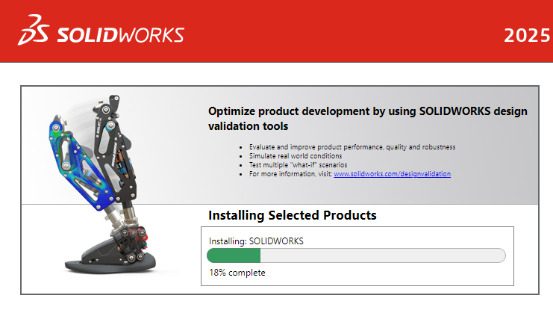

Figure 8: SOLIDWORKS Installation Screen.

1. **Activation**

After installation, launch SOLIDWORKS.

You will be prompted to activate the software. Follow the on-screen instructions to complete the activation process.

You can choose online or offline activation, depending on your internet access.

## Chapter 1 Practice Questions

**Definition and Scope of Engineering Design**

1. What is engineering design?

A) A scientific method for testing hypotheses.

B) A creative process of developing new products, systems, or solutions to meet specific needs.

C) A process of maintaining and repairing existing products.

D) A method for financial planning in engineering projects.

1. Which disciplines are encompassed by engineering design?

A) Mechanical, electrical, and civil engineering only.

B) Software engineering only.

C) Mechanical, electrical, civil, and software engineering.

D) Chemical and agricultural engineering only.

**Role of Engineering Design in Product Development**

1. How does engineering design serve as a bridge in product development?

A) By providing financial support for projects.

B) By converting abstract ideas into tangible products.

C) By managing marketing strategies.

D) By ensuring products are recycled correctly.

1. Which of the following is NOT a critical stage of the engineering design process?

A) Conceptualization

B) Marketing analysis

C) Detailed design

D) Testing

**Conceptualization**

1. What happens during the conceptualization stage?

A) Detailed manufacturing plans are created.

B) Engineers and designers brainstorm and sketch potential solutions.

C) The product is marketed to consumers.

D) Financial feasibility is assessed.

1. Which product is an example of a strong conceptualization phase?

A) Dyson Vacuum Cleaners

B) Boeing 747

C) Ford Model T

D) iPhone 12

**Detailed Design**

1. What activities are involved in the detailed design phase?

A) Conducting market research

B) Creating precise 3D models and detailed drawings

C) Launching the product to the market

D) Managing customer feedback

1. How did detailed design contribute to the Boeing 787 Dreamliner development?

A) By creating comprehensive 3D models integrating various systems.

B) By testing the marketing strategies for the aircraft.

C) By producing the final assembly line.

D) By developing the brand identity for Boeing.

**Prototyping**

1. Why is prototyping essential in the engineering design process?

A) It allows for the final product to be marketed.

B) It helps in evaluating the design, functionality, and manufacturability.

C) It is necessary for regulatory approval.

D) It ensures the product is environmentally friendly.

**Testing**

1. What types of testing are typically involved in the engineering design process?

A) Market testing and financial testing

B) Stress testing, usability testing, and safety testing

C) Employee satisfaction testing

D) Legal compliance testing

**Final Production**

1. What is a key consideration during the final production stage?

A) Evaluating initial sketches and ideas

B) Ensuring quality and consistency in manufacturing

C) Conducting market surveys

D) Drafting the initial design specifications

**Examples of Successful Engineering Designs**

1. Which engineering design principle contributed to the success of the GE Haliade-X Wind Turbine?

A) Use of renewable energy technology

B) Advanced marketing strategies

C) Financial planning

D) Customer satisfaction surveys

**Integration with SOLIDWORKS**

1. How can SOLIDWORKS be utilized in the conceptualization phase of engineering design?

A) For creating initial sketches and 3D models

B) For conducting market research

C) For managing production schedules

D) For drafting financial reports

1. How does SOLIDWORKS help in the detailed design and documentation process?

A) By creating advertisements for the product

B) By providing precise 3D modeling and documentation capabilities

C) By handling customer service inquiries

D) By managing company finances

**Importance of Engineering Design**

1. Why is engineering design considered a cornerstone of product development?

A) It ensures effective marketing strategies.

B) It helps in converting abstract ideas into tangible products.

C) It manages the financial aspects of product development.

D) It handles customer feedback and support.

1. What role does creativity play in the engineering design process?

A) It is not significant and rarely used.

B) It is essential for problem-solving and innovation.

C) It is primarily used in the marketing phase.

D) It is only relevant during the final production stage.

## Chapter 1 Answer Sheet

1. B
2. C
3. B
4. B
5. B
6. A
7. B
8. A
9. B
10. B
11. B
12. A
13. A
14. B
15. B
16. B

# CHAPTER 2

# TWO-DIMENSIONAL SKETCHING



## Introduction to Sketching in SolidWorks

Sketching in SolidWorks is the cornerstone of the entire 3D modeling process. Whether you’re designing a simple bracket or a complex assembly, every part begins with a well-constructed 2D sketch. Think of a 2D sketch as the blueprint or the skeleton of your final design—it’s where you establish the shapes, dimensions, and relationships that form the foundation of your 3D model.

**Why is Sketching Important?**

SolidWorks is a parametric modeling tool, meaning it relies on sketches and constraints to define geometry. The key to successful 3D modeling is creating precise, accurate, and flexible sketches. Here’s why sketching is so critical:

**Foundation for 3D Shapes:** A 2D sketch defines the profiles that are extruded, revolved, or lofted to create 3D geometry.

**Control and Precision:** Well-defined sketches ensure that changes in one part of the design propagate predictably through the model.

**Efficiency:** A properly constrained sketch reduces errors and simplifies modifications later in the design process.

For beginners, mastering the sketch environment is like learning the grammar of a new language. It provides the building blocks for creating functional and aesthetically pleasing designs.

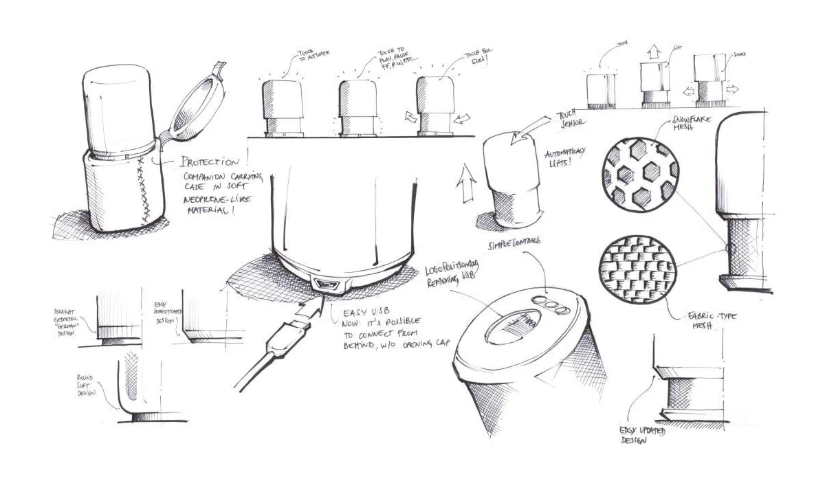

Figure 9: Product Sketch Illustration.

**What Is the Sketch Environment?**

The sketch environment in SolidWorks is a workspace designed specifically for creating and editing 2D sketches. It is activated when you begin a new sketch on a selected plane or planar face. Let’s break this environment down into its key components:

**Planes**

Planes are flat, infinite surfaces where sketches are created. Think of them as sheets of paper floating in 3D space. SolidWorks comes with three default planes:

Front Plane: Represents a front-facing view.

Top Plane: Acts as a bird’s-eye view.

Right Plane: Represents a side view.

You can select any of these planes as the foundation for your sketch. Additionally, custom planes can be created if your design requires sketches at specific angles or positions.

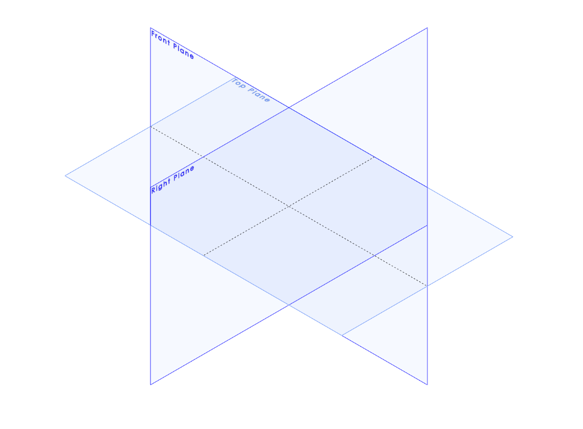

Figure 10: Default Planes in SolidWorks.

**Sketch Toolbar**

The Sketch toolbar provides access to all the tools you need to create geometry, such as lines, circles, rectangles, arcs, and splines. It also includes tools for applying dimensions, constraints, and relations to your sketch entities.

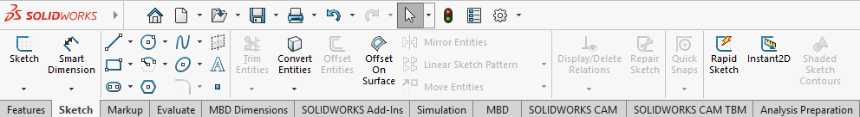

Figure 11: The Sketch Toolbar.

**Graphics Area**

This is the main workspace where your sketch appears. When you enter the sketch environment, the selected plane is highlighted, and you can begin drawing directly on it. A grid may appear, depending on your settings, to assist with alignment.

**Feature Manager Tree**

The Feature Manager tree, located on the left-hand side of the screen, lists all the planes, sketches, and features in your model. It helps you organize and navigate your design process.

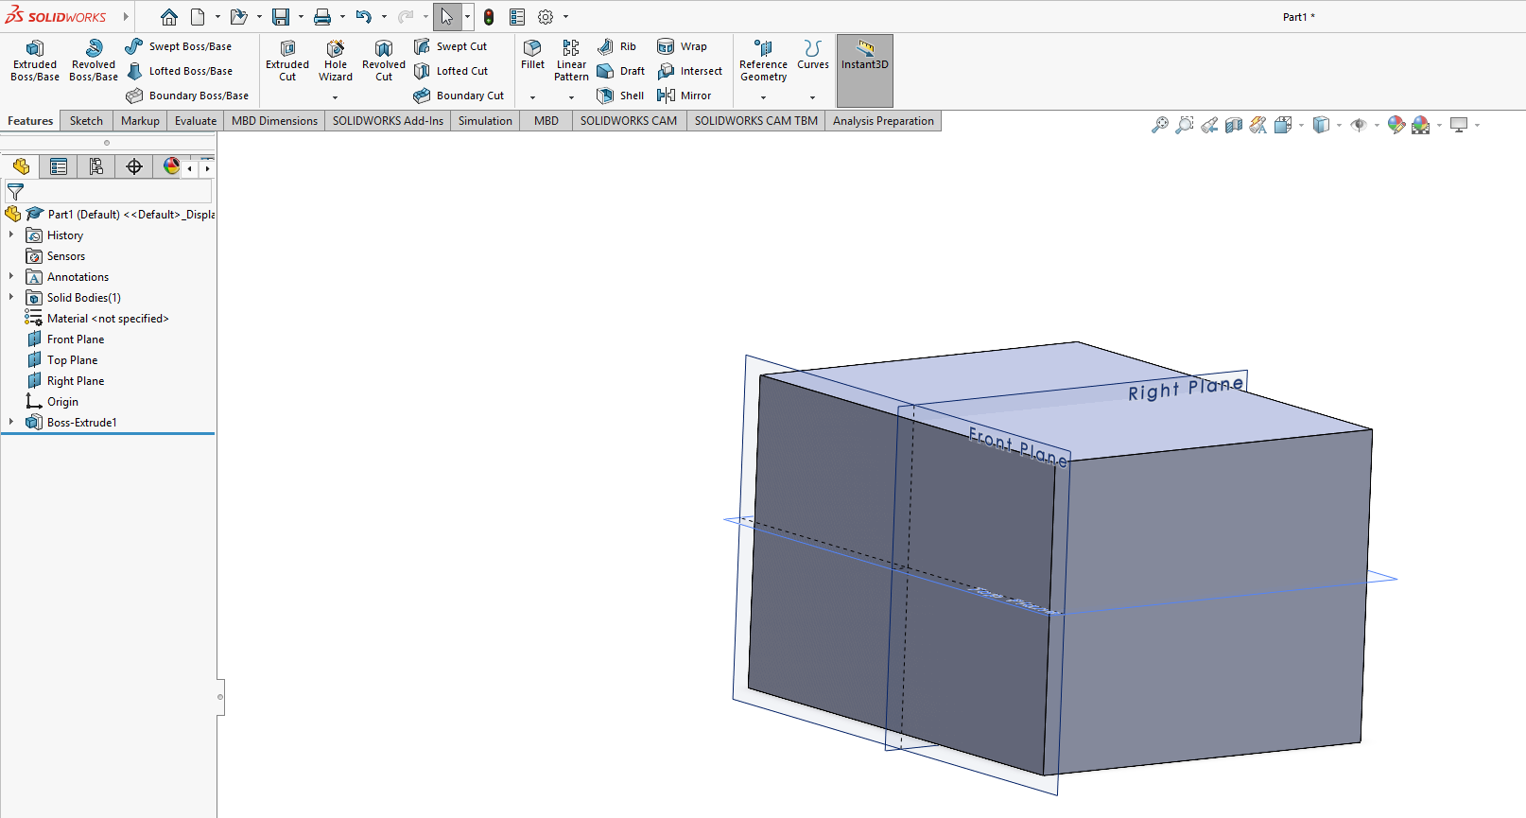

Figure 12: Graphics Area and Features Tree.

**Property Manager**

When you select a sketch tool, the Property Manager appears, allowing you to customize the tool’s settings, such as line type, dimensions, or relations.

**Heads-Up Toolbar**

This floating toolbar provides quick access to commonly used commands like zoom, rotate, and view orientation. It ensures that you don’t have to navigate away from your workspace to perform basic operations.

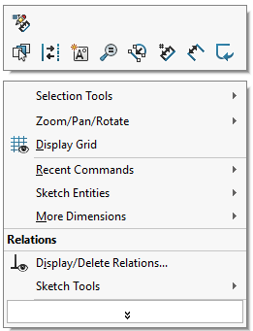

Figure 13: Heads-Up Toolbar.

## Creating Basic Geometric Shapes

In SolidWorks, creating basic geometric shapes is a foundational skill that enables users to build more complex models. The software provides a variety of tools for drawing fundamental shapes such as lines, circles, rectangles, arcs, and splines. These shapes serve as the building blocks of your sketches, which can later be used to create 3D features.

Let’s explore these tools in detail and understand how to use them effectively.

* + 1. **Drawing a Line**

The Line Tool is one of the most versatile tools in SolidWorks and is often used to create edges, boundaries, and construction geometry. Most SolidWorks designs start with using the line tool in their basic sketch before turning into a sophisticated three-dimensional design.

Drawing usually happens within the sketch environment only. Entering the sketching environment can be achieved by following the steps detailed here:

1. Open SolidWorks.
2. From File choose New.

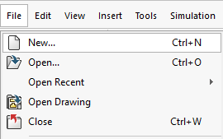

1. Select Part

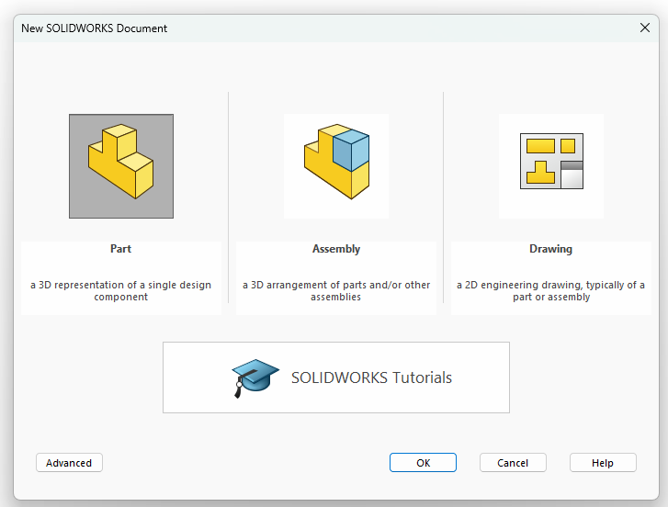

1. View the sketching plane needed.

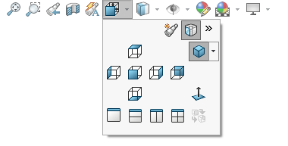

Now you are ready to start sketching.

**Steps to Draw a Line:**

1. Activate the Tool:

Click the Line Tool Sketch toolbar, or press L on your keyboard.

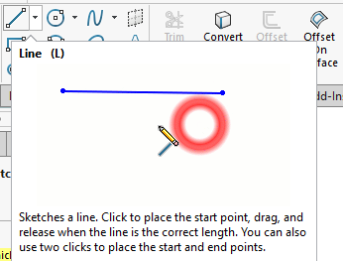

1. Select the plane you want to draw the line on

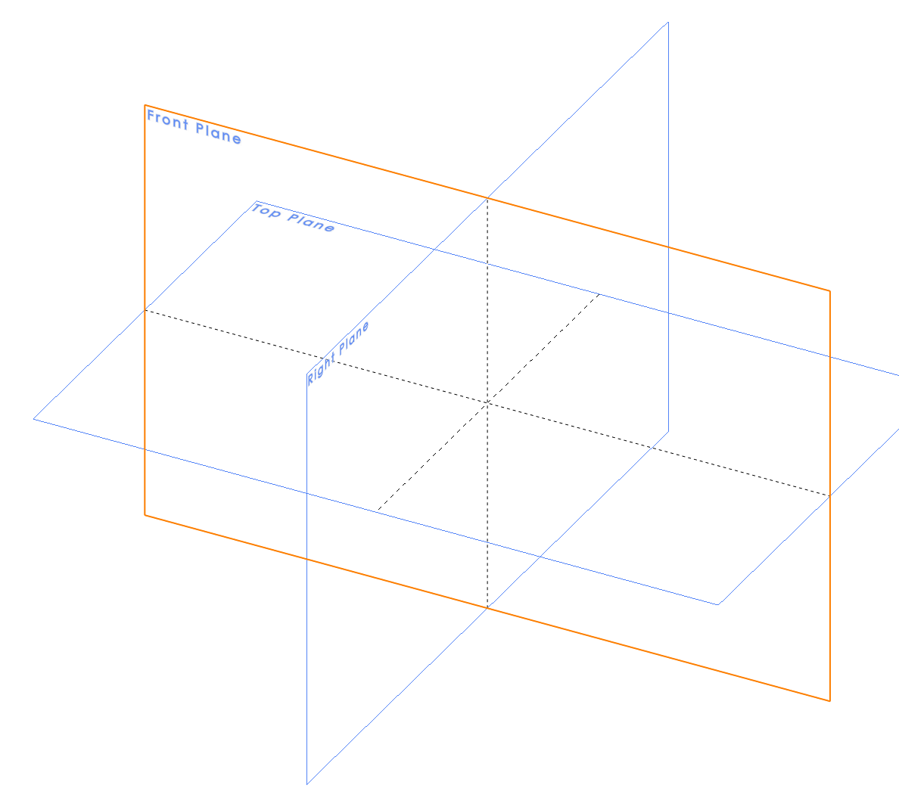

1. Start the Line:

Click anywhere on the active sketch plane to set the starting point.

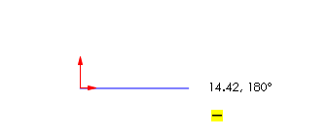

1. Define the Line:

Move the mouse to adjust the line's length and direction. Click again to set the endpoint.

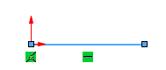

After defining the end point of the line, you will notice a parameters dialogue to the left of the screen for the line length and angle. Input the exact length you need for the line and the line angle with the horizon. For a straight horizontal line, the angle is 0o.

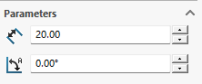

1. Exit the Tool:

Press Esc to exit the Line Tool, or press L again to start a new line.

|  |
| --- |
| Tips for Drawing Lines |
| Constrain the Direction: Hold down the Shift key while drawing to lock the line's direction horizontally, vertically, or at 45° increments.  Snap to Geometry: Pay attention to the yellow inference lines or dots that appear while sketching. These indicate alignment with existing geometry, such as other lines, points, or the origin.  Chain Mode: After finishing a line, you can immediately start another connected line without exiting the tool. Simply click to set the next start and endpoint. |

* + 1. **Drawing a Rectangle**

Rectangles are commonly used to define the boundaries of parts, profiles, or slots. SolidWorks provides multiple rectangle types to suit different design needs.

**Types of Rectangles and Their Use Cases:**

1. **Corner Rectangle (Default):**

Ideal for creating rectangles where you define two opposite corners.

Commonly used for basic rectangular profiles.

1. **Center Rectangle:**

Useful for symmetric designs where you want to define the center of the rectangle first.

1. **3-Point Rectangle:**

Allows you to create rectangles at an angle by defining three points: one corner, the adjacent corner, and the direction.

1. **Parallelogram (Optional):**

Designed for sketches where you need slanted, parallelogram-like geometry.

**Drawing a Corner Rectangle**

1. Click the Rectangle Tool from the Sketch toolbar.
2. From the drop-down menu, select Corner Rectangle (if not already selected by default).

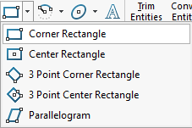

1. Click to set the first corner point, then drag to define the opposite corner. Click again to complete the rectangle.

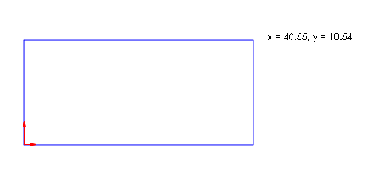

|  |
| --- |
| Tips for Drawing Rectangles |
| Automatic Constraints: SolidWorks automatically adds horizontal and vertical constraints to the rectangle’s sides for stability.  Dimensions: After creating the rectangle, use the Smart Dimension Tool to add dimensions and define the rectangle’s size.  Dynamic Feedback: As you draw, notice the dimensions appear dynamically next to your cursor, showing the rectangle's width and height. |

* + 1. **Drawing a Circle**

Circles are essential for creating holes, round profiles, and other circular features in designs.

**Steps to Draw a Circle**

1. Select the Circle Tool from the Sketch toolbar, or press C on your keyboard.

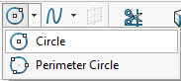

1. Click anywhere on the sketch plane to define the circle’s center point.

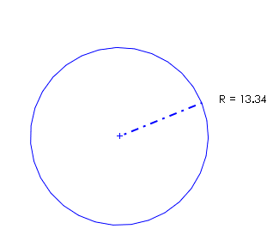

1. Drag the mouse outward to set the size of the circle and click again to finalize it.

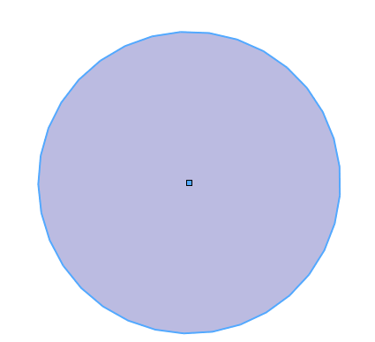

1. On the left dialogue of the screen input the value of radius for the sketched circle then press Enter.

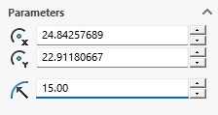

|  |
| --- |
| Tips for Drawing Circles |
| Concentric Circles: To create a circle concentric with an existing one, hover near the center of the first circle. A yellow concentric symbol will appear.  Dimensions: Use the Smart Dimension Tool to define the circle’s diameter or radius. Right-click the circle to toggle between diameter and radius dimensions.  Snapping to Geometry: Circles can snap to the origin, edges, or midpoints of other geometry for precise alignment. |

* + 1. **Creating Arcs**

Arcs are partial circles often used for rounded edges, slots, or profiles. SolidWorks provides multiple types of arcs for flexibility.

**Types of Arcs**

**3-Point Arc:**

Click to set the start point, then the endpoint, and drag to define the curvature.

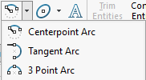

**CenterPoint Arc:**

Define the center point first, then click to set the start and endpoint.

**Tangent Arc:**

Automatically snaps the arc tangentially to existing geometry.

**Steps to Draw a 3-Point Arc**

1. Click the Arc Tool from the Sketch toolbar and select 3-Point Arc.

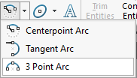

1. Click the first point to set the starting location.

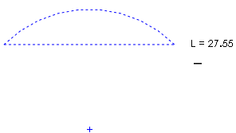

1. Click the second point to define the arc's endpoint.



1. Drag to adjust the curvature.

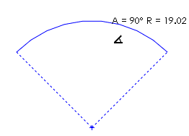

1. Input the parameters needed for the arc such as radius and angle in the dialog to the left of the screen then hit the green tick to finalize.

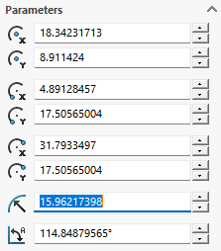

|  |
| --- |
| Tips for Drawing Arcs |
| Use Tangency: SolidWorks automatically adds a tangency constraint if the arc connects to an existing line or circle.  Dynamic Adjustments: After drawing, adjust the arc’s curvature by dragging its midpoint or end points. |

## Sketch Constraints and Relations

When creating sketches in SolidWorks, understanding and applying constraints and relations is essential to ensure your design behaves as intended during modifications. These tools control how sketch entities interact with one another and help maintain the design intent, even when dimensions or shapes are changed.

**What Are Constraints?**

Constraints, also referred to as geometric relations, define the behavior and relationship between sketch entities. These are applied automatically by SolidWorks in some cases as you sketch, but they can also be manually added to enhance precision and ensure proper control over your geometry.

**Examples of Constraints**

Horizontal or Vertical Lines: A line can be constrained to remain perfectly horizontal or vertical.

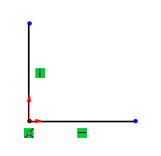

Concentric Circles: Two circles can share the same center point.

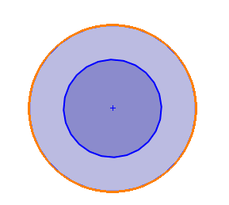

Tangency: A line or arc can be constrained to touch a circle or another arc at a single point, maintaining smoothness at the intersection.

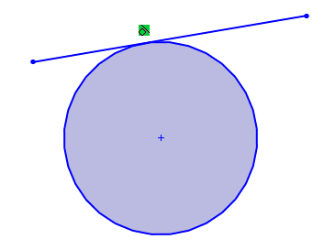

Constraints are especially useful for ensuring that sketches remain parametric, meaning they adjust predictably when dimensions or other parts of the sketch are changed.

**How to Apply Constraints**

SolidWorks offers a simple and intuitive way to apply constraints manually to sketch entities. Follow these steps to apply constraints:

1. Select Entities:

Click on one or more sketch entities, such as lines, arcs, or points. The entities can be selected by clicking directly on them or by dragging a selection box around them.

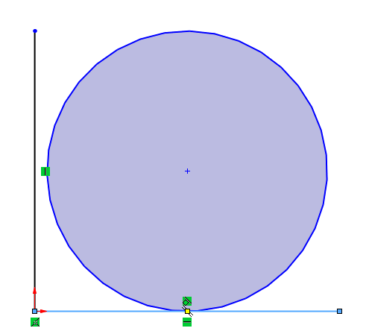

1. Open the Add Relations Menu:

When entities are selected, the Add Relations section appears in the left-hand Property Manager.

This menu provides a list of applicable relations based on the selected entities.

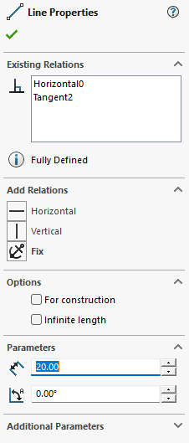

1. Choose the Desired Relation.
2. Check the Status:

After applying constraints, SolidWorks displays a green icon near the related geometry, indicating the applied relation.

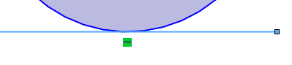

**Types of Common Constraints and Their Uses**

1. **Coincident**

Ensures two points overlap or that a point lies on a line, arc, or circle.

2. **Collinear**

Ensures two or more lines lie on the same infinite line.

3. **Parallel**

Ensures two lines never intersect, regardless of length.

4. **Perpendicular**

Ensures two lines intersect at a 90° angle.

5. **Tangent**

Ensures a line or arc touches a curve or circle at exactly one point, creating a smooth transition.

6. **Equal**

Forces two entities, such as lines, arcs, or circles, to have the same length or radius.

7. **Concentric**

Ensures two circles or arcs share the same center point.

8. **Horizontal or Vertical**

Forces lines to align perfectly along the horizontal or vertical axis.

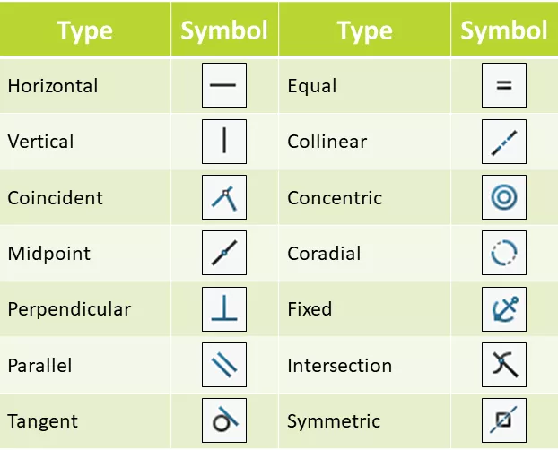

Figure 14: Common SolidWorks Constraints.

**Automatic Constraints in SolidWorks**

While sketching, SolidWorks automatically applies some constraints to improve efficiency. For example:

When drawing a line, moving the cursor horizontally or vertically causes SolidWorks to automatically apply a Horizontal or Vertical constraint (indicated by a yellow icon near the line).

Hovering over an endpoint of an existing line before starting a new one creates a Coincident constraint automatically.

|  |
| --- |
| Tips to Work with Automatic Constraints |
| * Pay attention to the yellow inference lines or symbols that appear as you sketch. These suggest constraints that will be applied automatically. * If an automatic constraint isn't desired, press Ctrl while sketching to temporarily disable it. |

**Managing and Editing Constraints**

All constraints in SolidWorks are visible in the Feature Manager Design Tree and directly on the sketch geometry.

To manage or edit these:

* **View Constraints:**

Hover over a sketch entity to see its existing constraints, represented by small icons.

* **Delete Constraints:**

Right-click a constraint icon and select Delete to remove it.

* **Modify Constraints:**

Select a different relation from the Add Relations menu to change the behavior of the geometry.

**Fully Defined Sketches**

A well-constrained sketch is a fully defined sketch, meaning every entity has specific dimensions or relations that control its size, position, and orientation. Fully defined sketches are marked in black in SolidWorks, while underdefined sketches appear in blue.

**Why Fully Define Sketches?**

* Prevents unintended changes when editing.
* Ensures the model updates predictably when dimensions are modified.
* Avoids errors during 3D feature creation.

## Dimensioning the Sketch

Dimensioning is a critical step in sketching within SolidWorks as it specifies the exact size, position, and angles of your sketch entities. Proper dimensioning transforms a sketch from under-defined to fully defined, ensuring it behaves predictably and aligns with your design intent.

**Why Dimensioning Is Important**

Dimensions provide precise control over your sketch geometry. Without dimensions, your sketch is ambiguous and may not behave as expected during further modeling steps, such as extrusion or revolved features. By dimensioning, you can:

* Specify exact **sizes** of lines, circles, arcs, or other entities.
* Control the **position** of sketch entities relative to each other or the origin.
* Define **angles** between lines or between curves and reference geometry.
* Ensure your design adheres to engineering requirements.

**Types of Dimensions in SolidWorks**

1. **Linear Dimensions:**

* Measure the distance between two points, such as the endpoints of a line.
* Useful for defining the length of edges or the spacing between entities.

1. **Radial and Diameter Dimensions:**

* Measure the radius or diameter of circular entities like circles and arcs.
* Essential for defining holes, fillets, or rounded features.

1. **Angular Dimensions:**

* Measure the angle between two lines or the included angle of an arc.
* Useful for sketches involving inclined lines or rotational features.

1. **Ordinate Dimensions:**

* Define the position of entities in relation to a reference point.
* Often used in complex sketches to maintain positional control.

**How to Add Dimensions**

SolidWorks makes dimensioning intuitive with the Smart Dimension Tool, which allows you to add various dimensions based on the entities you select. Here’s how to use it:

1. **Activate the Tool:**

Select the Smart Dimension tool from the Sketch toolbar, or press the keyboard shortcut D.



1. **Select an Entity:**

* Single Entity:

Click on a line to set its length, a circle to set its diameter, or an arc to define its radius.

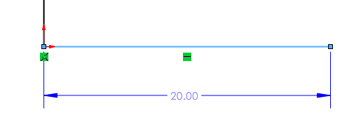

* Two Entities:

Click on two points, lines, or circles to define a distance, angle, or positional relationship between them.

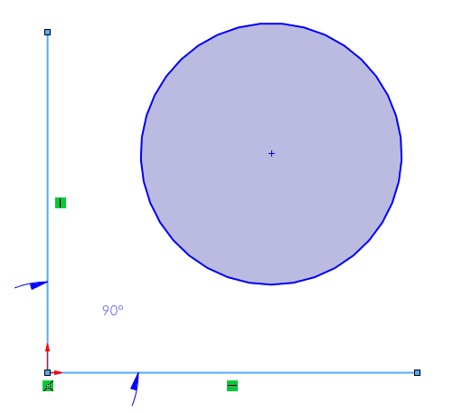

1. **Position the Dimension:**

Move the mouse to drag the dimension to the desired location. SolidWorks automatically provides a preview of the dimension.

Click again to place the dimension. The numeric value is now editable.

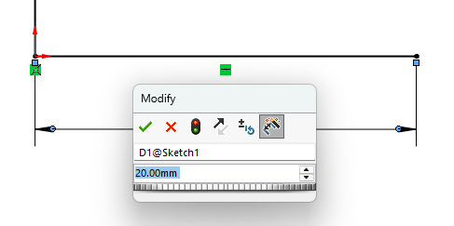

1. **Adjust Dimension Values:**

After placing the dimension, double-click the value to edit it. Enter the desired number and press Enter to finalize.

**Dimensioning Techniques**

**Dimensioning a Line:**

1. Select the Smart Dimension tool.
2. Click on the line to define its length.
3. Drag the dimension line outward and click to place the dimension.

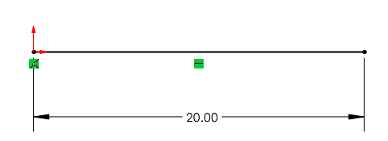

**Dimensioning a Circle:**

1. Select the Smart Dimension tool.
2. Click on the circle to set its diameter or radius (default is diameter).
3. Position the dimension text by dragging outward and clicking.

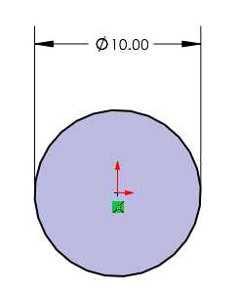

**Dimensioning Between Two Entities:**

1. Select two entities (e.g., two lines or points).
2. If the entities are parallel, SolidWorks will measure the perpendicular distance.
3. For non-parallel lines, an angle dimension will be provided by default.

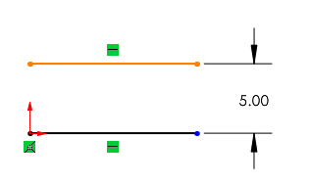

**Dimensioning to the Origin:**

Click a sketch entity (e.g., a line or circle) and then click the Origin to dimension its position relative to the sketch's starting point.

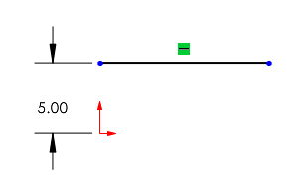

**Defining vs. Over-Defining Sketches**

In SolidWorks, the status of your sketch is visually indicated by the color of its geometry:

1. **Black Geometry: Fully Defined**

All dimensions and constraints are applied. The sketch's size and position are completely fixed.

Example: A rectangle where all four sides have dimensions, and its position relative to the origin is defined.

1. **Blue Geometry: Under-Defined**

Some entities still lack dimensions or constraints, allowing them to move or resize freely.

Example: A circle without a specified diameter or location.

1. **Red Geometry: Over-Defined**

Conflicting dimensions or constraints are applied, resulting in an over-constrained sketch.

Example: A line constrained to two conflicting lengths.

**Avoiding Over-Defined Sketches**

Double-check existing dimensions and constraints before adding new ones. If an error occurs, remove unnecessary or redundant constraints using the Delete key or right-clicking on the dimension/constraint and selecting Delete.

|  |
| --- |
| Tips for Effective Dimensioning |
| Use the Origin as a Reference:  Start by positioning key sketch entities relative to the origin. This ensures that your sketch is anchored in 3D space.  Dimension Symmetrically:  When working on symmetrical designs, dimension only one side and use symmetry constraints to mirror the other.  Avoid Over-Defining:  Use only the minimum number of dimensions needed to fully define the sketch. |

## Editing and Modifying Sketches

Sketches in SolidWorks are highly versatile, allowing you to make adjustments dynamically even after they have been created. Editing and modifying sketches efficiently is essential for creating complex designs while maintaining design intent and adaptability. SolidWorks offers a suite of tools specifically designed for trimming, extending, mirroring, and offsetting sketch entities. This section will provide detailed guidance on how to utilize these tools effectively.

**Trimming and Extending Sketch Entities**

Sketches often contain excess or incomplete geometry, especially when working with intersecting lines, arcs, or curves. The Trim and Extend tools help refine such sketches by removing unnecessary sections or completing entities to meet intersections.

**Trimming Entities**

The **Trim Entities** tool allows you to remove parts of sketch entities that extend beyond or intersect with other entities.

1. Select the Trim Entities tool from the Sketch toolbar.

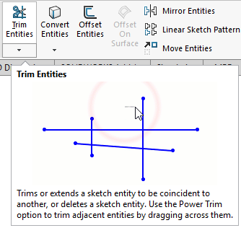

1. Select the Trim Method:

* Power Trim: Click and drag your mouse cursor across the portion of the entity you wish to remove. This method provides a dynamic and intuitive way to trim geometry.
* Trim to Closest: Click on the section of an entity to trim it back to the nearest intersecting entity.

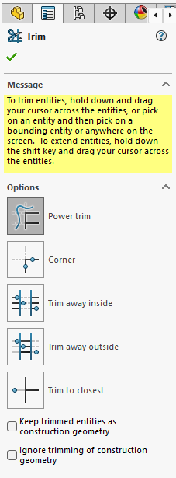

1. Trim the Entities:

Hover over the part of the sketch you want to trim, and SolidWorks will highlight it. Click to remove it.

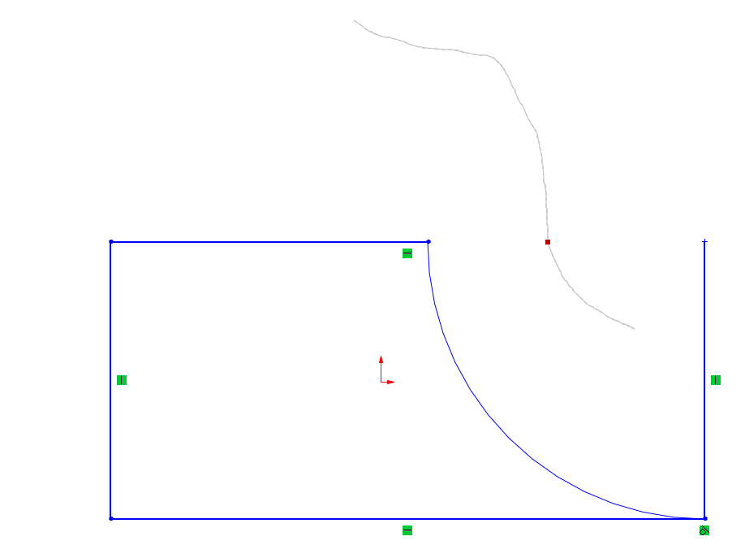

1. Exit Trimming:

Press Esc to exit the tool.

|  |
| --- |
| Tips for Trimming |
| Use Ctrl+Z to undo accidental trims.  Watch for the yellow preview that indicates the section to be trimmed. |

**Extending Entities**

The Extend Entities tool is used to extend sketch entities (e.g., lines or arcs) to meet another sketch entity.

1. Select the Extend Entities tool from the Sketch toolbar.

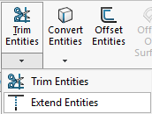

1. Select the Entity to Extend:

Hover over the endpoint of the entity you wish to extend. SolidWorks highlights the preview extension path.

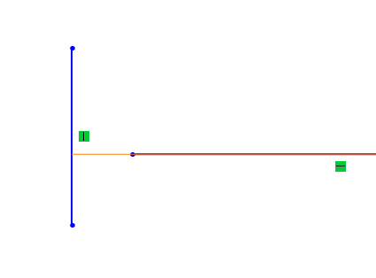

1. Extend:

Click to extend the entity until it meets the next sketch entity.

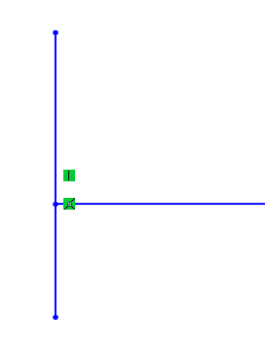

**Offsetting and Mirroring Sketch Entities**

Offsetting and mirroring are powerful tools for creating repetitive or symmetrical geometry, reducing the need for redundant sketching.

**Offsetting Entities**

The Offset Entities tool allows you to create parallel copies of existing sketch geometry. These offsets can be created at a specified distance and can either follow the original direction or be reversed.

1. Activate the Tool:

Select the Offset Entities tool from the Sketch toolbar.

1. Select the Entities:

Click on the line, curve, or set of sketch entities you wish to offset.

1. Specify the Offset Distance:

Enter the desired offset distance in the Property Manager.

1. Choose the Direction:

Use the directional arrows to control whether the offset is inward or outward.

1. Create the Offset:

Click OK to finalize the offset.

|  |
| --- |
| Tips |
| * Use the Bi-Directional Offset option to create offsets on both sides of the selected entity. * Maintain relationships between the original and offset geometry for better control during design modifications. |

**Mirroring Entities**

The Mirror tool duplicates selected sketch entities across a designated centerline, creating symmetrical geometry.

1. Select the Mirror Entities tool from the Sketch toolbar.

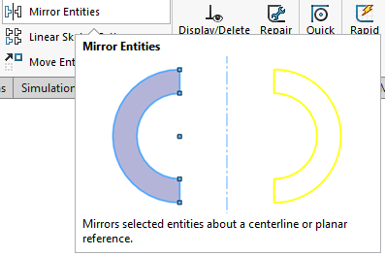

1. Select the Geometry to Mirror:

Click on the lines, arcs, or other sketch entities you wish to mirror. For selecting more than one entity hold the ctrl key while selecting.

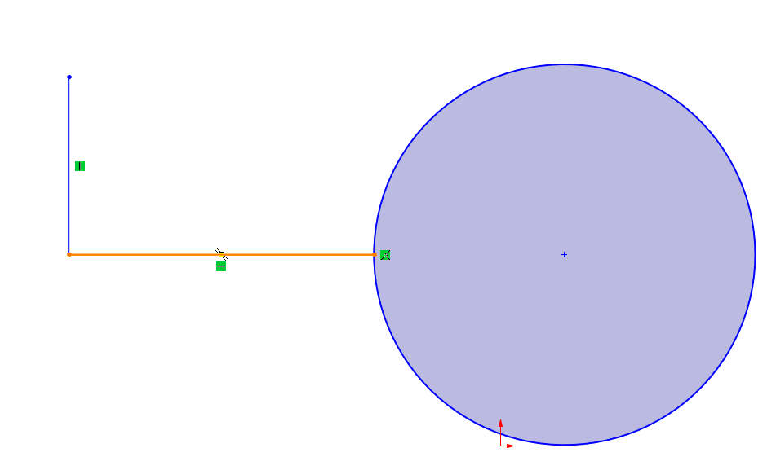

1. Define the Mirror Line:

Click on the sketch entity that serves as the centerline (e.g., a vertical or horizontal line). If there is no mirror line created by drawing a line at the mirroring axis of your choice. Delete the line after finishing the mirroring process.

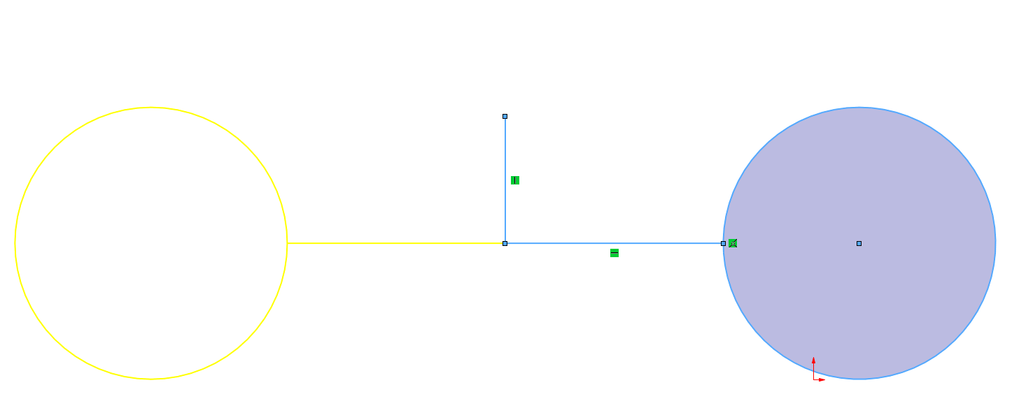

1. Preview and Finalize:

SolidWorks displays a preview of the mirrored geometry. Click OK to complete the mirroring operation. Notice that the selected entities and mirroring axis are shown to the left dialogue and can be adjusted before confirming the mirroring.

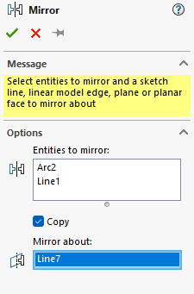

|  |
| --- |
| Tips |
| * Ensure that the mirror line is properly constrained and positioned to maintain symmetry. * Use construction lines (dashed lines) as mirror lines for better organization. |

|  |
| --- |
| Example: Sketching a Mechanical Component |
| Create the base sketch for a mounting bracket following the dimensions provided. |

**Solution**

1. Start with a Corner Rectangle to define the main body. Define the length and the width to be 50 mm each using smart dimensions tool.

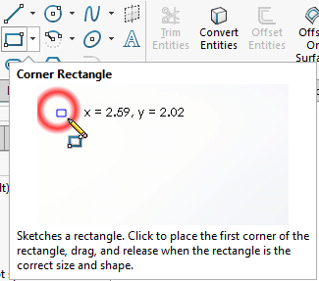

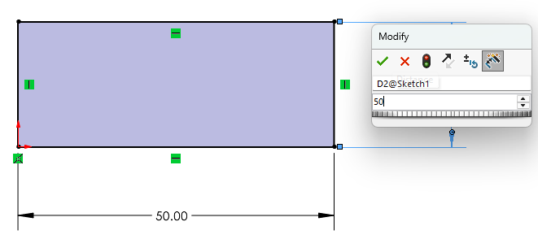

1. Add the central circles by drawing 25 mm line on the horizontal axis and 25 mm on the vertical axis. Start drawing the circle and type in the diameter of 30 mm then press Enter.

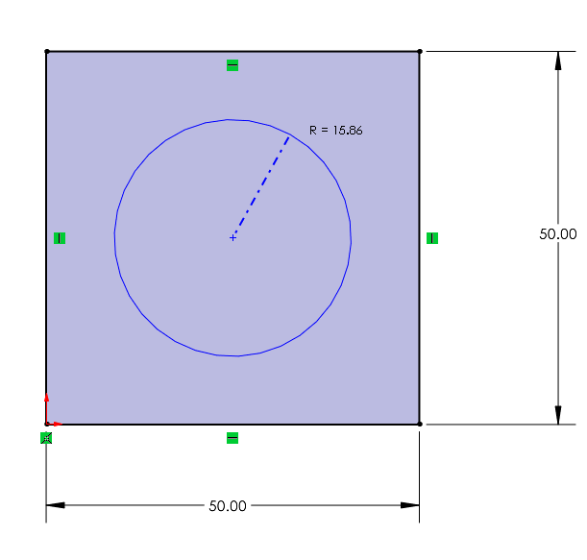

1. Draw a circle at each corner 5mm inward from the vertical edge of the bracket and 5 mm away from the horizontal edge. Repeat this process for the remaining three holes. Or use the mirroring feature to mirror two holes into four holes.

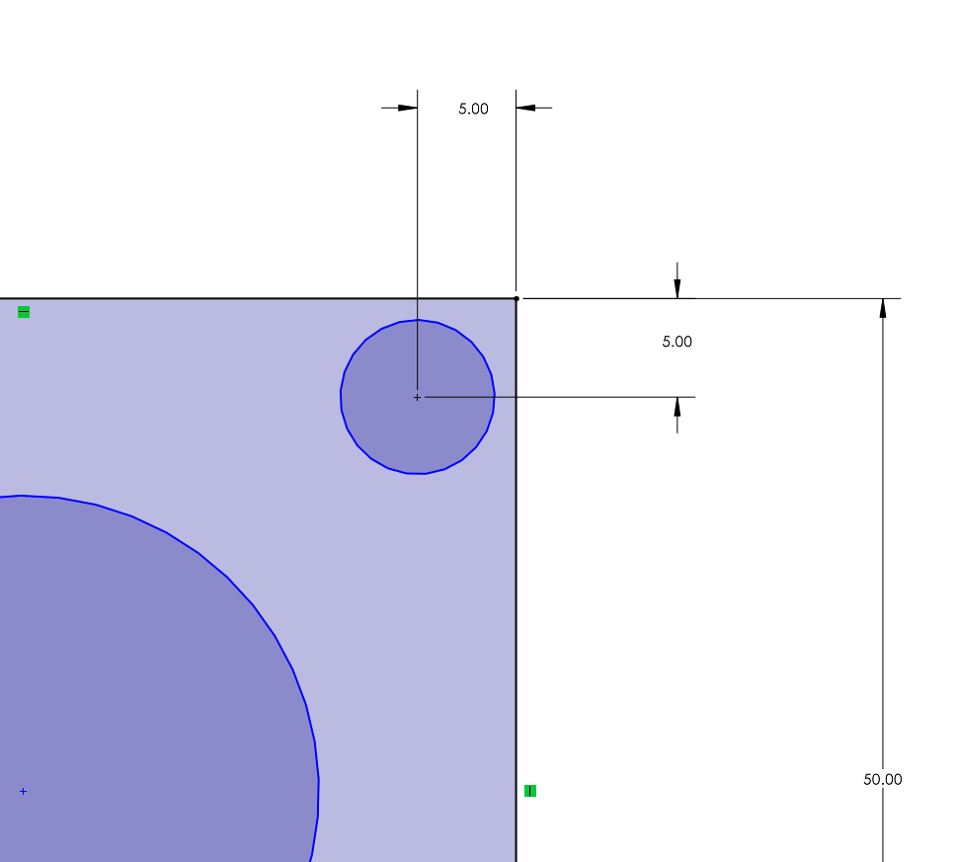

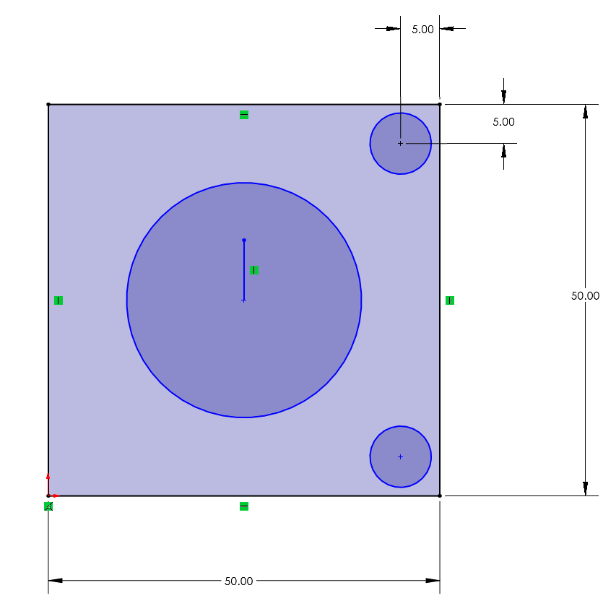

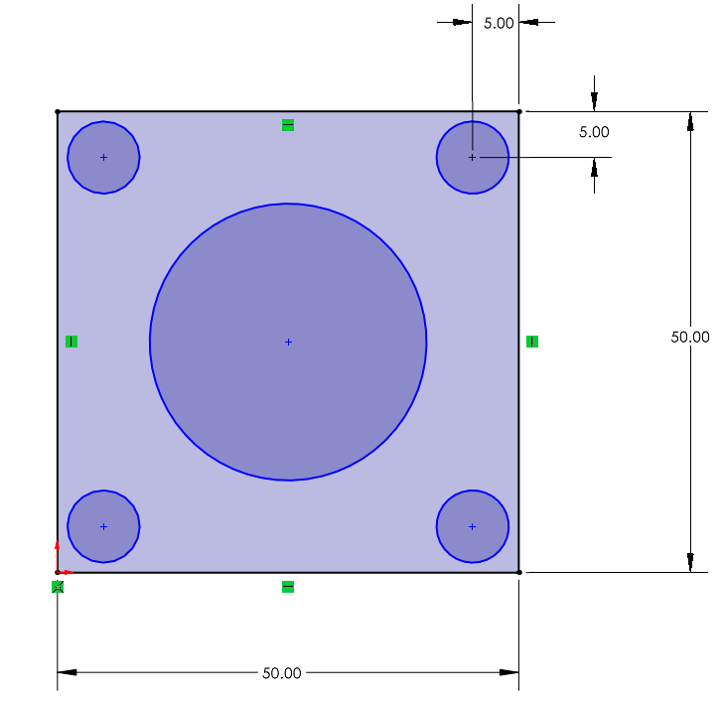

1. Use the Smart Dimension tool to write dimensions into the sketch.

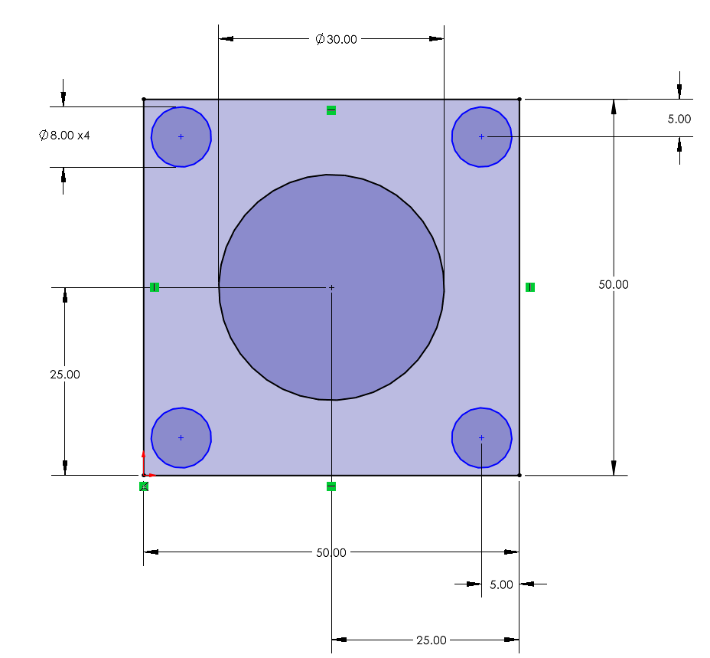

1. Use the Trim Tool to cut unnecessary parts if needed.

## Chapter 2 Practice Questions

**Section 1:** **Multiple Choice Questions**

1. Which of the following is NOT a default plane in SolidWorks?

A. Front Plane

B. Top Plane

C. Right Plane

D. Bottom Plane

1. What happens when a sketch entity is over-defined in SolidWorks?

A. It turns blue.

B. It turns black.

C. It turns red.

D. It disappears from the sketch.

1. Which tool allows you to create parallel copies of an existing sketch entity?

A. Mirror Entities

B. Offset Entities

C. Extend Entities

D. Trim Entities

1. What is the main purpose of the "Smart Dimension" tool?

A. To create sketch entities.

B. To trim unwanted parts of a sketch.

C. To define the size and position of sketch entities.

D. To apply constraints between entities.

1. Which relation ensures that two circles share the same center point?

A. Tangent

B. Concentric

C. Coincident

D. Equal

1. What does the color blue indicate in a SolidWorks sketch?

A. The geometry is over-defined.

B. The geometry is fully defined.

C. The geometry is under-defined.

D. The geometry is unsaved.

1. Which of the following tools can be used to create a rectangle in SolidWorks?

A. Corner Rectangle

B. Center Rectangle

C. 3-Point Rectangle

D. All of the above

1. What does the "Trim Entities" tool do?

A. Creates a mirrored copy of the selected geometry.

B. Deletes unwanted parts of lines or curves.

C. Moves sketch entities to a new location.

D. Makes a sketch entity tangent to another.

1. Which tool would you use to create a horizontal line across the center of your sketch?

A. Line Tool

B. Centerline Tool

C. Mirror Entities

D. Spline Tool

1. What type of rectangle requires you to set its center point first?

A. Corner Rectangle

B. Center Rectangle

C. 3-Point Rectangle

D. Tangent Rectangle

**Section 2: Design Practice Questions**

Design Task 1: Simple Frame

Design a rectangular frame with the following requirements:

Outer dimensions : 200 mm x 150 mm.

Inner dimensions : 180 mm x 130 mm.

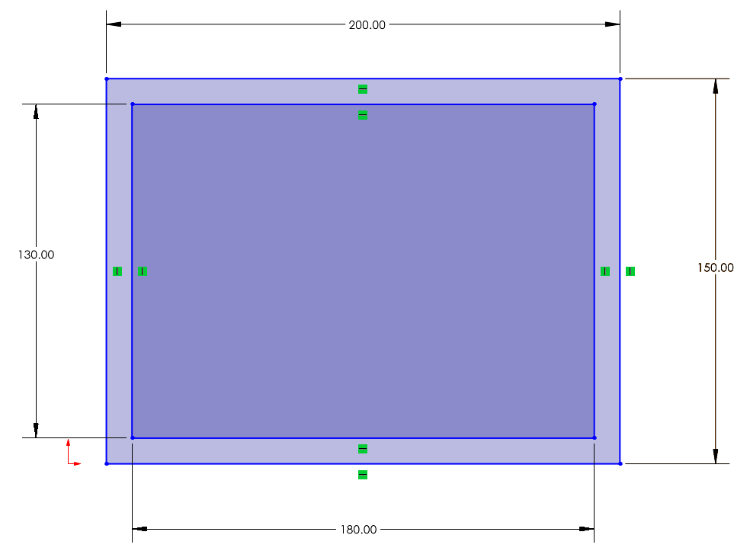

Design Task 2: Circular Plate with Holes

Create a circular plate with the following specifications:

Outer circle diameter: 150 mm.

Add four smaller circles (diameter 10 mm each) evenly spaced around the outer circle. Use the "Smart Dimension" tool to position the smaller circles at equal distances from the plate’s center. Fully define the sketch with dimensions and relations.

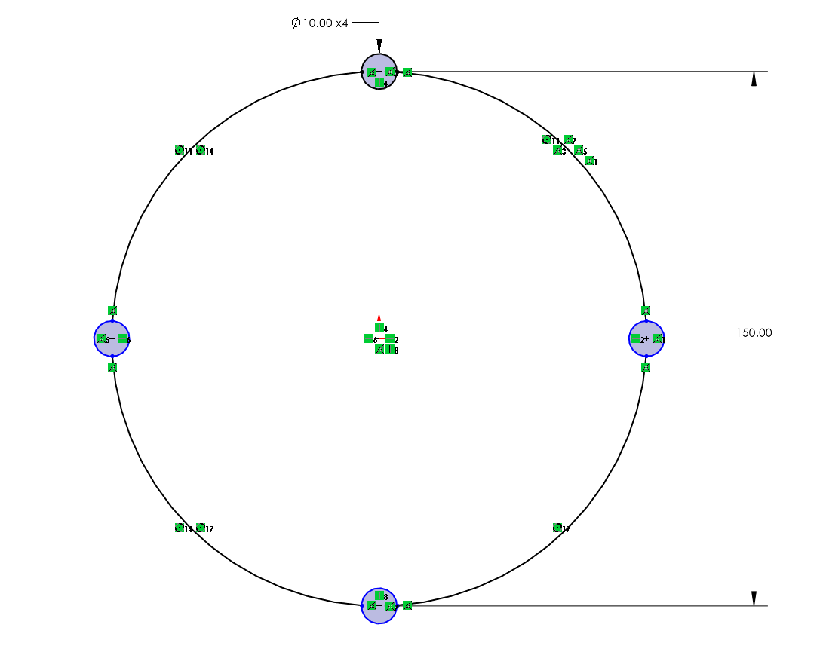

Design Task 3: Mechanical Bracket Sketch

Sketch the base profile for a mounting bracket: Start with a rectangle measuring 100 mm x 60 mm. Add two circular holes (diameter 15 mm) at the top corners of the rectangle. Ensure the circles are concentric with the top corners. Trim excess geometry to leave a smooth profile. Fully define the sketch.

Design Task 4: Mirrored Sketch

Create a symmetrical design for a keychain: Start with a base rectangle of size 80 mm x 40 mm. Draw a circle with a diameter of 10 mm near one corner of the rectangle. Use a centerline to divide the rectangle into two equal halves. Mirror the circle to the opposite side of the rectangle. Fully define the sketch and include all necessary dimensions.

## Chapter 2 Answer Sheet

1. D
2. C
3. B
4. C
5. B
6. C
7. D
8. B
9. B
10. B

# CHAPTER 3

# PARTS AND FEATURES

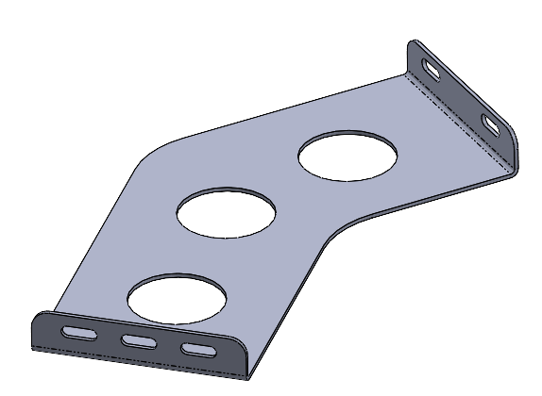

## Introduction to Parts and Features

SolidWorks is centered around the concept of parts, which are individual components that can be combined to create complex assemblies. A part is essentially a single 3D object, designed by combining various features. Features are the tools used to shape parts by either adding or removing material. For instance, extrusions are used to extend 2D sketches into 3D objects, cuts remove material to create spaces or holes, and revolutions rotate 2D sketches around an axis to form cylindrical or spherical shapes.

Every feature begins with a 2D sketch, making sketches the foundation of all parts. The shapes drawn in a sketch, such as rectangles, circles, or splines, act as profiles that SolidWorks uses to generate 3D geometry. Fully defining these sketches with dimensions and constraints ensures the resulting features behave predictably and meet design requirements. For example, a rectangular sketch can be extruded into a block, a circular sketch can create a hole through an extruded cut, and a semicircular sketch can be revolved to form a sphere.

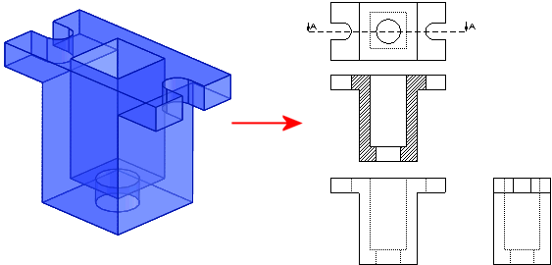

Figure 15: 2D to 3D geometry illustration.

Parts in SolidWorks are built by combining two main types of features: base features and secondary features. The base feature such as an extrusion, which forms the core of the part. Secondary features modify or add details to the base feature, such as fillets to round edges or cuts to remove material. This layered approach to part creation allows for precise control and easy modification.

One of the key advantages of feature-based modeling is its parametric nature. Features are driven by parameters, such as dimensions and constraints, which can be adjusted at any time. These changes automatically update the part and any dependent features, ensuring the design remains consistent. The feature-based approach also captures design intent, allowing relationships like concentricity or symmetry to remain intact even when the geometry is edited. Additionally, the Feature Manager Design Tree organizes all features in a part, making it easy to modify or reorder them.

The workflow for creating a part in SolidWorks begins with selecting a sketching plane and creating a 2D profile. This profile is then transformed into a 3D feature using tools like Extrude or Revolve. Secondary features can then be added to refine the part, such as chamfers, fillets, or additional cuts. This process allows for iterative development, where the part evolves through the addition and refinement of features.

For example, creating a simple block with a cylindrical hole demonstrates the relationship between sketches and features. First, a rectangle is drawn on the Front Plane and dimensioned to define its size. This sketch is then extruded to form a solid block. Next, a circle is sketched on the top face of the block, dimensioned to specify its diameter, and then cut using the Extruded Cut tool to create the hole. This process illustrates how sketches and features work together to build precise parts.

Parts are not standalone; they are often combined with other parts to create assemblies. Mastering the creation of robust and accurate parts is essential for building larger systems, which will be explored in later chapters. Understanding parts and features lays the foundation for 3D modeling in SolidWorks and equips you with the skills to create components with precision and flexibility for any design project.

## Creating a Basic Part

Creating a basic part in SolidWorks is the first step toward mastering 3D modeling. Parts are built by transforming 2D sketches into 3D shapes using features such as extrusions, revolutions, and cuts. In this section, we’ll guide you through the process of creating your first basic part, introducing key tools and workflows.

**Steps to Create a Basic Part**

**Step 1: Start a New Part File**

1. Open SolidWorks and click on File > New > Part. This creates a blank canvas where you can design your part.

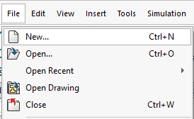

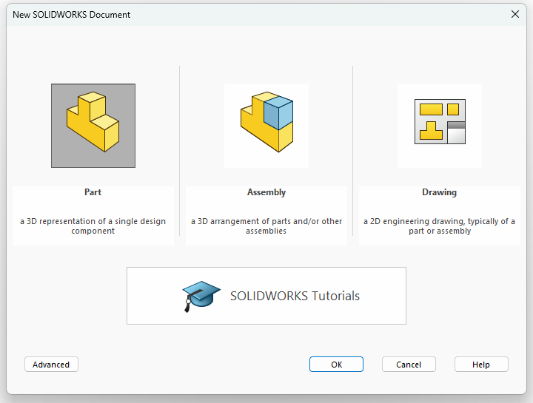

1. Once inside the new part environment, the first task is to select Sketch and then select a plane for sketching.
2. Click on one of these planes in the Feature Manager Design Tree to activate it as your sketching surface.

**Step 2: Create a Sketch**

1. After selecting the plane, SolidWorks enters the sketching environment.
2. Use the sketching tools from the Sketch Toolbar to draw a 2D shape.
3. Add dimensions to fully define the sketch. Use the Smart Dimension Tool to specify the size and position of the sketch entities.
4. Apply constraints (like horizontal, vertical, or concentric relations) to ensure the sketch behaves predictably when modified.

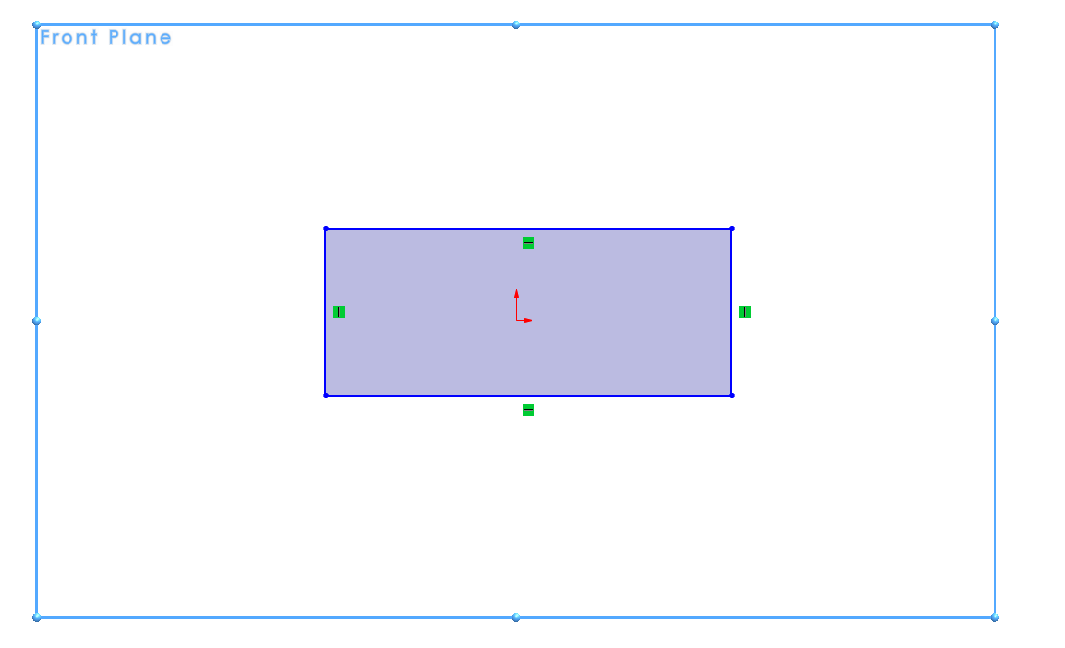

**Step 3: Add a Feature**

Once the 2D sketch is complete, it’s time to transform it into a 3D object by adding a feature. The Extrude Boss/Base tool is one of the most commonly used tools for this purpose.

1. Click on Features > Extruded Boss/Base from the Command Manager.

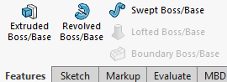

1. In the Property Manager, define the extrusion settings:

* Depth: Specify how far the sketch will extend in the third dimension (e.g., 50 mm).
* Direction: Choose whether the extrusion extends forward, backward, or symmetrically in both directions.
* Draft Angle (optional): Add a taper to the extrusion if needed.

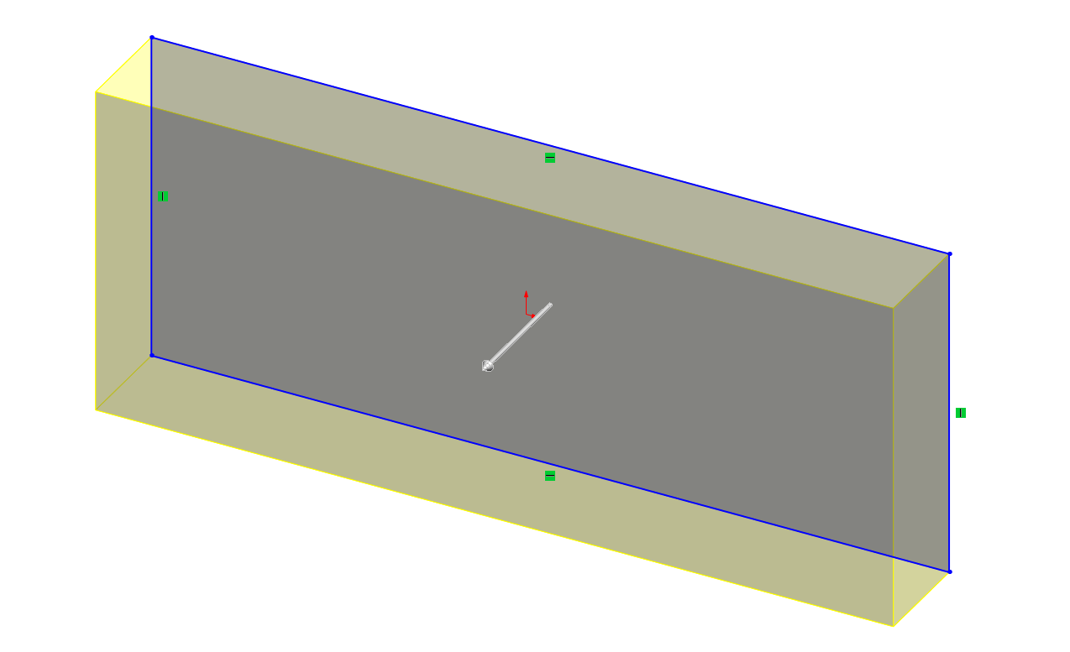

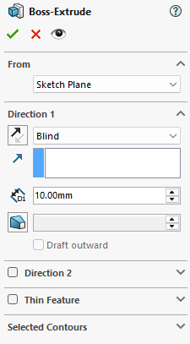

1. Preview the 3D shape in the graphics window. Adjust parameters as necessary.
2. Click OK to finalize the feature.

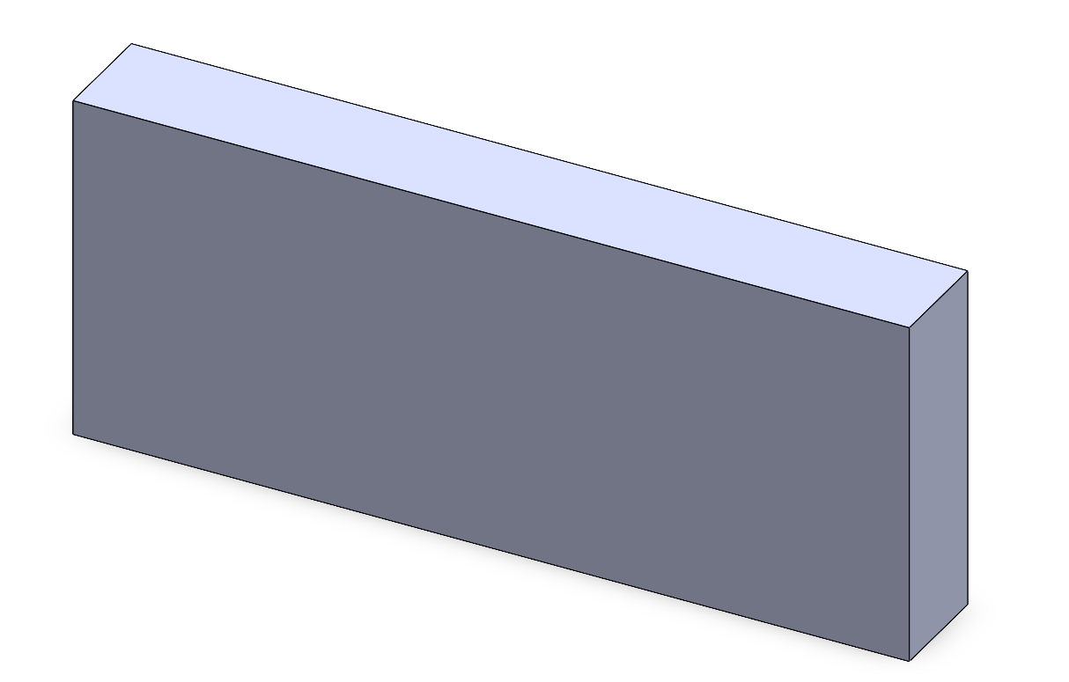

**Step 4: Modify the Part**

Once the first feature is created, additional features can be added to refine the part. Use tools like Extruded Cut to remove material (e.g., create holes or slots). Add fillets or chamfers to smooth or taper edges. To modify the part further, right-click on the feature in the Feature Manager Design Tree and select Edit Feature or Edit Sketch.

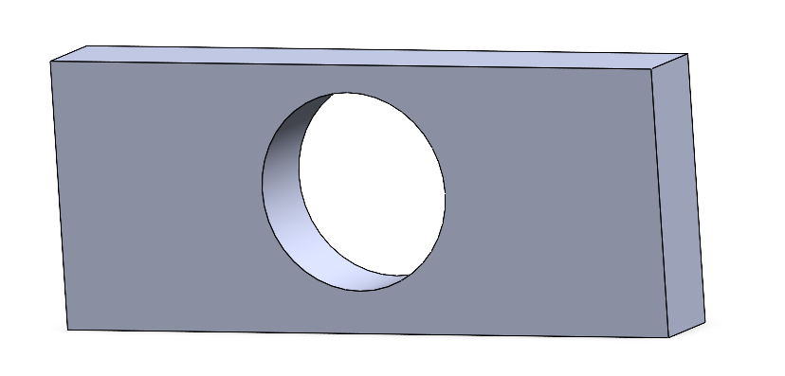

## Understanding Features

Features are the building blocks of SolidWorks parts. They define how the material is added, removed, or modified. Below are some of the most commonly used features:

**3.3.1 Boss/Base Features**

These features add material to your part.

**Extrude Boss/Base**

The Extrude Boss/Base tool is one of the most fundamental and versatile features in SolidWorks. It is used to transform a 2D sketch into a 3D solid shape by extruding the sketch along a straight path perpendicular to the sketch plane. This feature forms the foundation of most 3D models in SolidWorks and is frequently used to create the primary geometry of a part.

The Extrude Boss/Base adds material to a sketch to create a 3D solid. It is ideal for building blocks, plates, cylinders, and other basic shapes. To use the tool, you must first have a fully or partially defined 2D sketch, such as a rectangle, circle, polygon, or other closed-loop geometry. The result of the extrusion depends on the sketch's shape and the parameters you define, such as the extrusion depth and direction.

**Steps to Use the Extrude Boss/Base Tool**

1. Start by selecting a plane (e.g., Front, Top, or Right Plane) or a flat face of an existing part.
2. Use sketch tools (like Rectangle, Circle, or Polygon) to draw a closed-loop 2D shape.
3. Once the sketch is complete, click on Features > Extrude Boss/Base from the Command Manager, or select it from the right-click menu.
4. A dynamic preview of the extrusion will appear in the graphics area. This helps you visualize the final shape before applying the feature.



|  |
| --- |
| Tips |
| * Closed Sketch Requirement: Ensure your sketch is a closed profile; open profiles cannot be extruded into a solid object. * Using Multiple Profiles: You can extrude multiple, non-overlapping closed profiles from a single sketch at the same time. * Adding Drafts: Use the draft angle to prepare parts for manufacturing, such as injection molding. * Reusing Sketches: Sketches can be reused for multiple extrusions by selecting them again from the Feature Manager Design Tree. |

**Revolve Boss/Base**

The Revolve Boss/Base tool in SolidWorks is used to create 3D features by rotating a 2D sketch around a central axis. It is particularly useful for designing symmetrical, rounded, or rotational components such as shafts, pulleys, bowls, and spheres. This tool takes a 2D profile and "sweeps" it in a circular motion, producing a solid shape.

The **Revolve Boss/Base** tool is designed to create features with radial symmetry by revolving a sketch about a chosen axis. The output is a 3D solid created by rotating the sketch around the specified axis. The angle of revolution determines how much of the shape is created.

**Steps to Use the Revolve Boss/Base Tool**

1. Select a plane (e.g., Front, Top, or Right Plane) or a flat face of an existing part.
2. Use sketch tools (like Line, Arc, or Spline) to create the 2D profile you want to revolve.

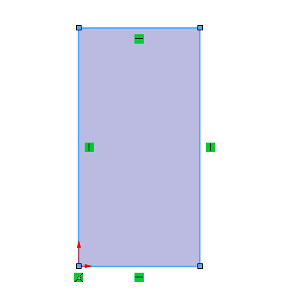

1. Add a centerline (construction geometry) to serve as the axis of revolution.

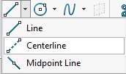

1. Once the sketch is complete, click on Features > Revolve Boss/Base from the Command Manager, or access it via the right-click menu.



1. A dynamic preview of the revolved shape will appear in the graphics area, allowing you to visualize the final result before applying the feature.

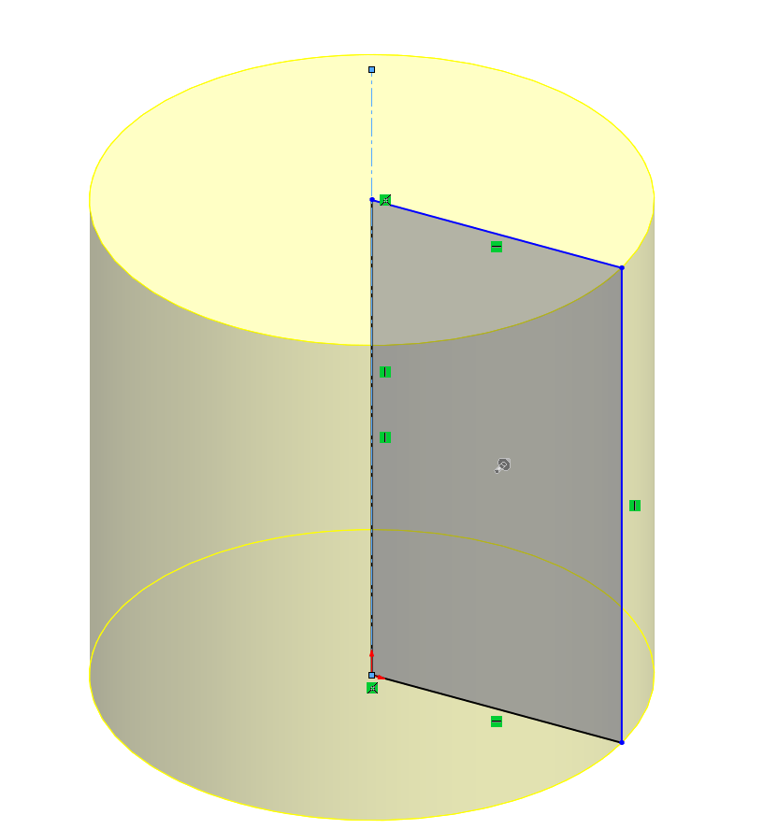

1. Click OK or press Enter to complete the revolution, transforming your 2D sketch into a 3D revolved feature.

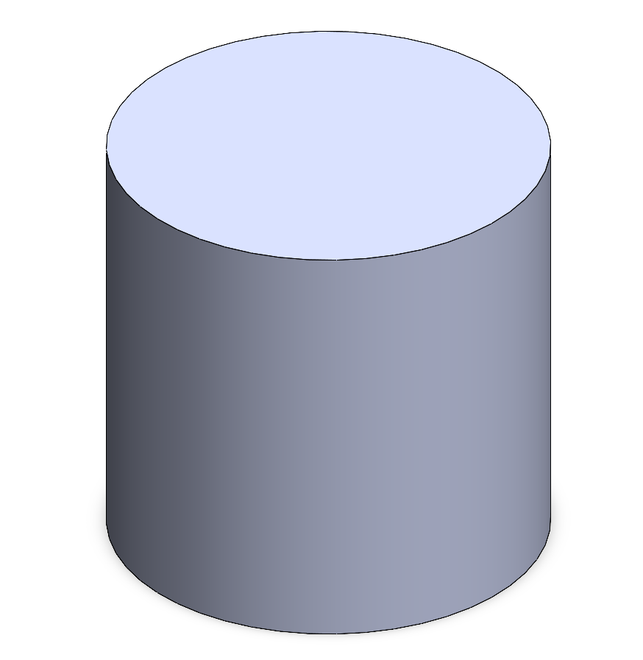

**3.3.2 Cut Features**

Cut features in SolidWorks are powerful tools that remove material from a 3D part, enabling the creation of complex geometries and hollowed sections. These features are essential for designing functional parts, such as those requiring holes, grooves, or cavities.

**Overview of Cut Features**

Cut features are similar to Boss/Base features but instead of adding material, they subtract it. They are applied to existing 3D models and rely on 2D sketches to define the shape and location of the material to be removed.

**Common types of cut features include:**

* **Extruded Cut**: Removes material along a straight path.
* **Revolve Cut:** Removes material by revolving a sketch around an axis.

Both methods rely on precise sketching and proper alignment with the part geometry to achieve accurate results.

**Extruded Cut**

The Extruded Cut tool removes material by extending a sketch along a linear path. It is one of the most frequently used tools for cutting holes, slots, and other shapes.

**Steps to Use the Extruded Cut Tool:**

1. Select a face or plane on the part to begin sketching.

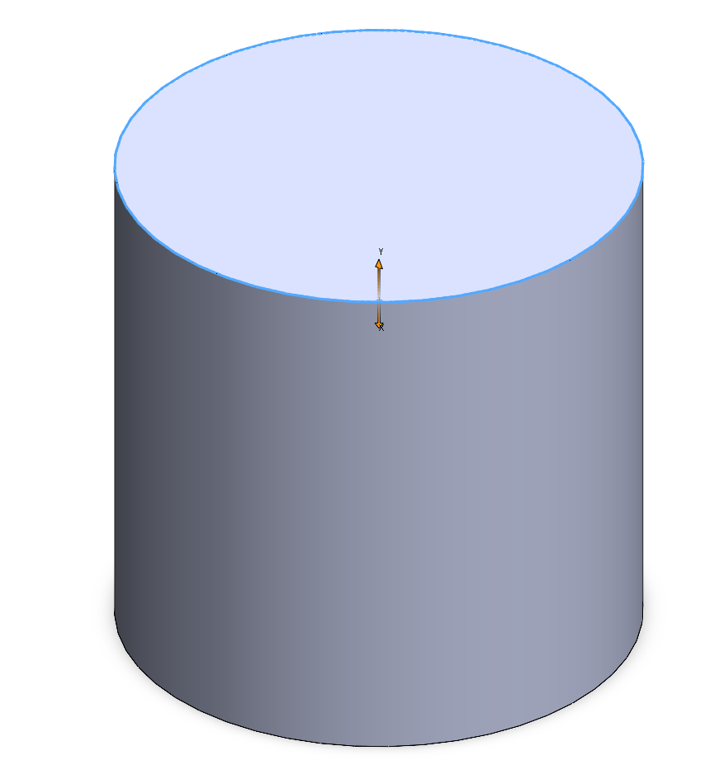

1. Draw the 2D profile of the shape you want to cut (e.g., a circle for a hole, a rectangle for a slot).

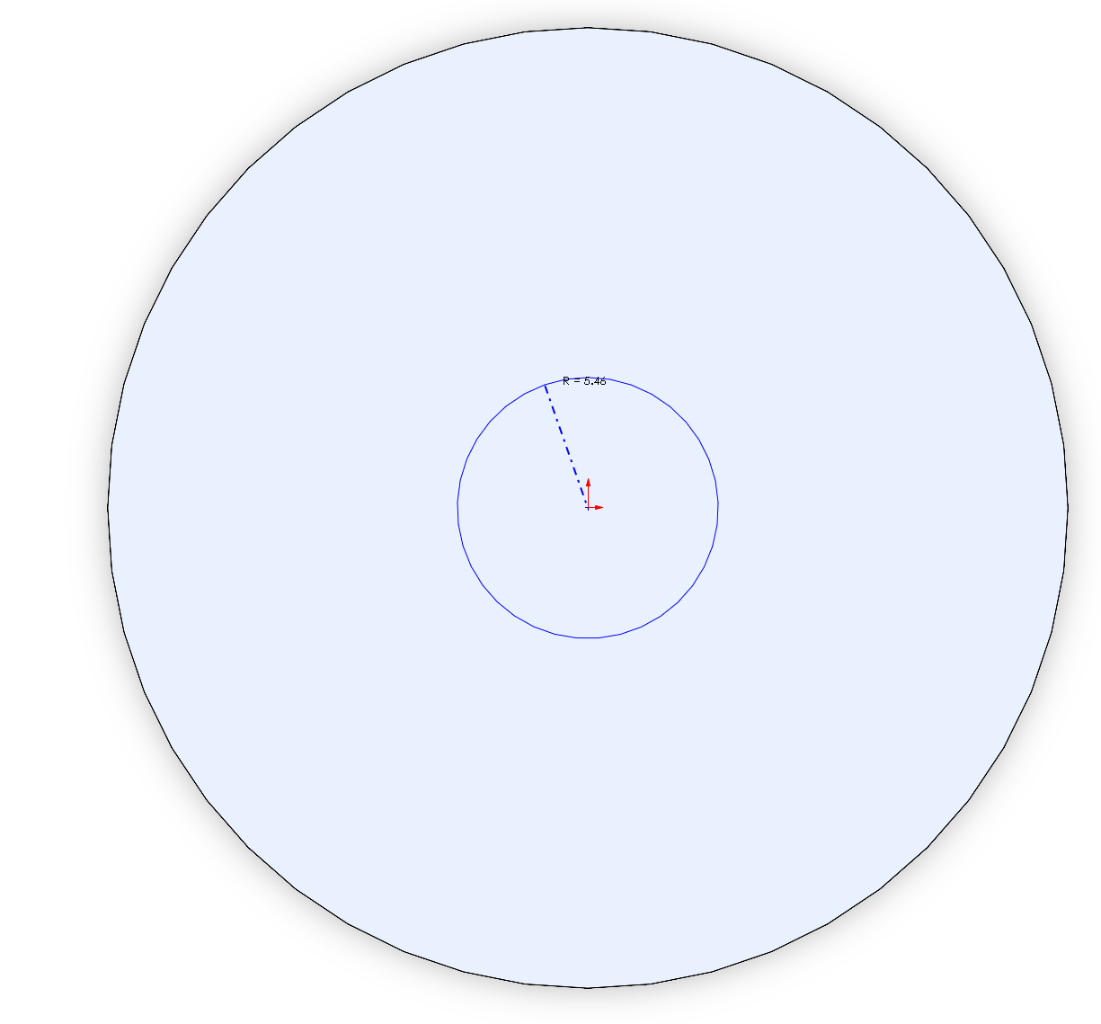

1. Click Features > Extruded Cut from the Command Manager.

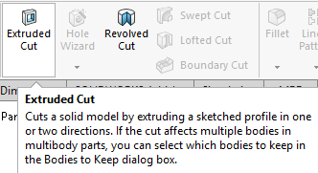

1. Direction: Choose the direction of the cut (e.g., "Blind," "Through All," or "Up to Next").

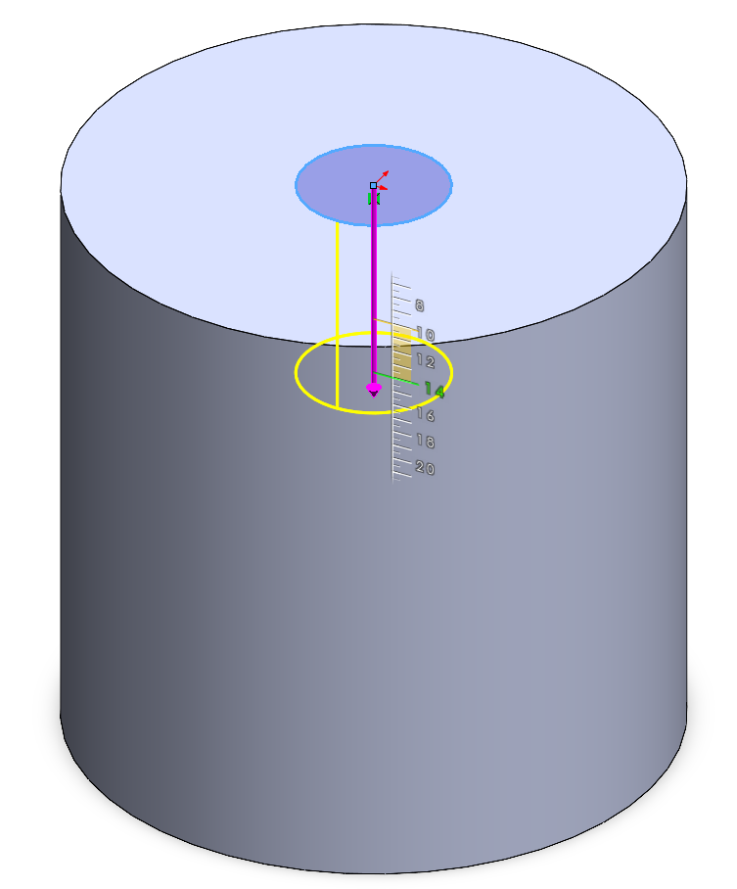

1. Depth: Specify the distance the cut should extend.

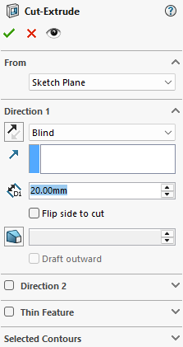

1. A preview of the cut will appear in the graphics area.

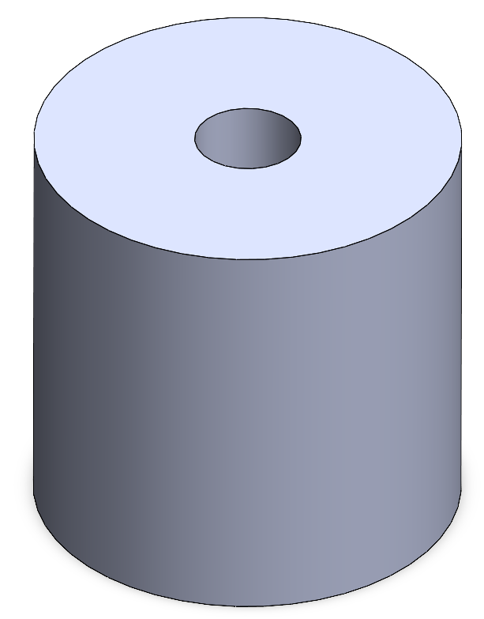

1. Click OK to apply the cut.

|  |
| --- |
| Example: Creating a Hole in a Block |
| Create a 20mm diameter hole at the center point of a 40mm x 30mm block that is 22mm thick. |

**Solution**

**Create the 40mm x 30mm Block**

Step A: Select a Plane

In the Feature Manager Design Tree (on the left side), select the Top Plane (or another preferred plane, such as Front Plane).

Step B: Create a Rectangle Sketch

1. Click on Sketch from the Command Manager and select Rectangle > Center Rectangle from the drop-down menu.
2. Click on the origin (the center of the plane) to start the rectangle.
3. Drag the rectangle outward and click again to complete it.

Step C: Add Dimensions

1. Activate the Smart Dimension tool from the Sketch toolbar.
2. Click on one side of the rectangle and set its length to 40mm.
3. Click on the adjacent side and set its width to 30mm.

Step D: Extrude the Rectangle

1. Click Features > Extruded Boss/Base in the Command Manager.
2. Set the extrusion depth to a value of your choice (e.g., 10mm) in the Property Manager.
3. Click OK to create the 3D block.

**Create the 20mm Diameter Hole**

Step A: Select the Top Face of the Block

1. Rotate the part using the middle mouse button (scroll wheel) to view the top face.
2. Click on the top face of the block to highlight it.
3. Click Sketch from the Command Manager to start a new sketch on this face.

Step B: Draw a Circle

1. Select the Circle tool from the Sketch toolbar.
2. Hover over the center of the top face, and a yellow dot will appear indicating the midpoint. This is the center of the rectangle.
3. Click once to place the center of the circle, then drag outward and click again to define the circle's size.

Step C: Add a Dimension

1. Activate the Smart Dimension tool.
2. Click on the circle and set its diameter to 20mm.

Step D: Fully Define the Sketch

Ensure the circle is fully defined (black in color). This should occur automatically because its center is at the midpoint of the rectangle.

Step E: Create the Hole

1. Click Features > Extruded Cut in the Command Manager.
2. In the Property Manager, select Through All as the depth option to ensure the hole passes through the block.
3. Click OK to apply the cut.

**3.3.3 Fillets and Chamfers**

In SolidWorks, Fillets and Chamfers are essential tools used to modify edges of 3D parts. They enhance the design's functionality, aesthetics, or manufacturability by rounding or beveling edges.

**Fillets: Rounding Edges**

A fillet is used to create a smooth, rounded transition between two adjacent surfaces or edges. Fillets are especially useful in improving part strength, reducing stress concentrations, and enhancing the overall appearance of a part.

**Steps to Create a Fillet**

1. In the Command Manager, go to Features > Fillet (or select the Fillet tool from the shortcut toolbar).

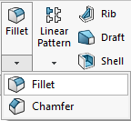

1. Click on the edge or edges of the part that you want to round. Selected edges will highlight in blue.

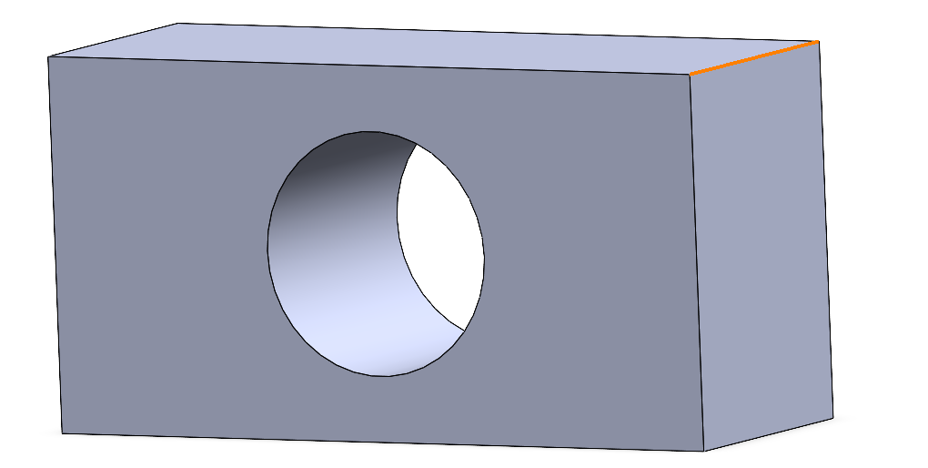

1. In the Property Manager, define the Fillet Radius (e.g., 5mm). This determines the size of the rounded edge.

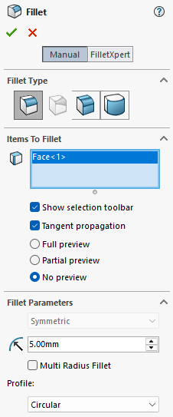

1. SolidWorks displays a yellow preview of the fillet to help you visualize the change.

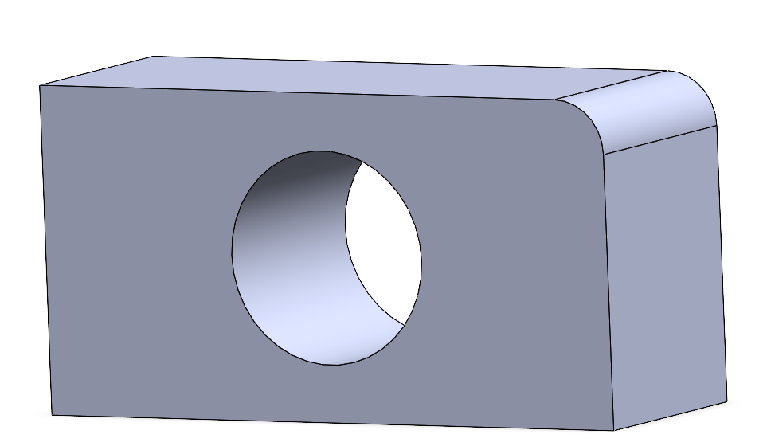

1. Click OK to confirm and apply the fillet. The rounded edge is now part of the geometry.

**Chamfers: Beveling Edges**

A chamfer creates a flat, angled surface along the edge of a part. Chamfers are often used to facilitate part assembly, eliminate sharp edges, or prepare parts for machining.

**Steps to Create a Chamfer**

1. In the Command Manager, go to Features > Chamfer (or select the Chamfer tool from the shortcut toolbar).

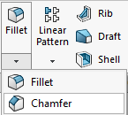

1. Click on the edge or edges where the chamfer will be applied. Selected edges will highlight in blue.

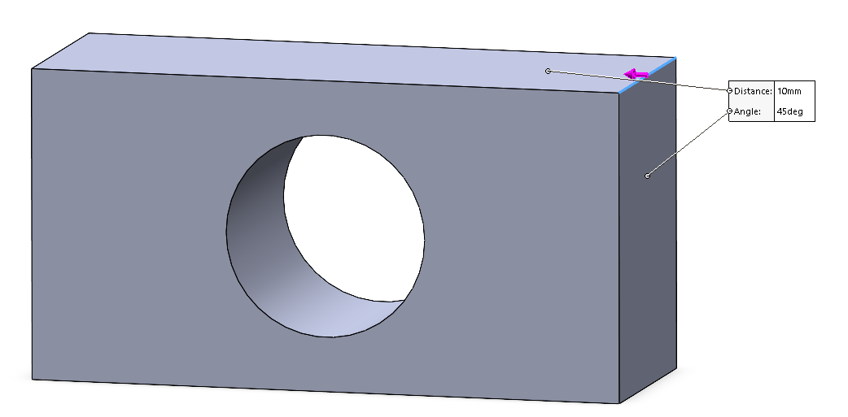

1. SolidWorks displays a yellow preview of the chamfer. Adjust parameters as needed.
2. Click OK to confirm and apply the chamfer.

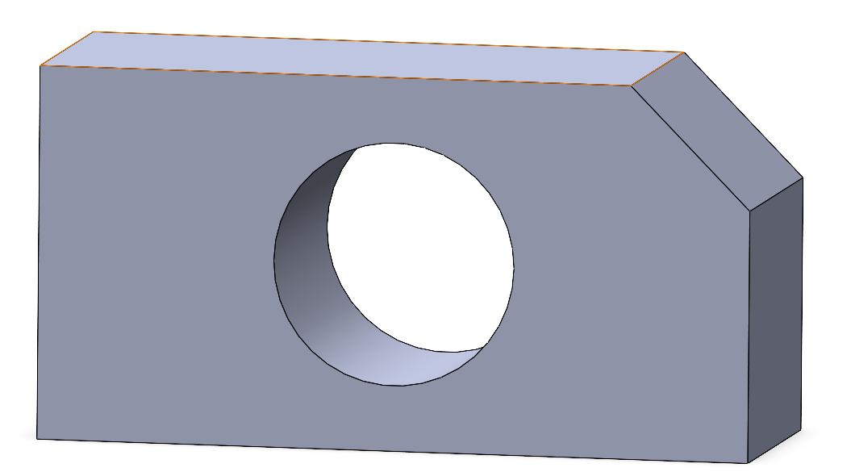

## Using Reference Geometry

Reference geometry helps you create complex parts by providing additional construction elements.

**Planes**

Create additional planes at specific angles or distances from existing planes.

Example: A plane at 45° is used to create an angled cut.

**Axes**

Define axes for use in revolve or circular pattern features.

**Points**

Add reference points to help locate specific positions in the part.

Insert Screenshot: Show a part with additional planes and an axis used for a revolve.

## Design Intent and Feature Order

Design intent is a fundamental principle in SolidWorks that ensures your part adapts seamlessly to changes while maintaining its functionality. The sequence in which you create features plays a crucial role in preserving design intent and avoiding potential issues.

One key concept is parent-child relationships, where later features (children) rely on earlier features (parents). For example, if a child feature depends on a specific edge or face created by a parent feature, deleting or modifying the parent can lead to errors or broken references in the child features. This relationship emphasizes the importance of carefully planning the order of feature creation.

To achieve robust designs, adhere to these best practices

* Fully define your sketches before converting them into features. Undefined sketches can lead to unpredictable behavior when dimensions or constraints are modified.
* Begin with base features, such as extrusions or revolves, to establish the fundamental shape of the part. Once the primary structure is complete, add refinement features like cuts, fillets, and chamfers to enhance detail and functionality.

|  |
| --- |
| Example: Designing a Bracket as a Part |
| Create a 20mm diameter hole at the center point of a 40mm x 30mm block with 22mm thickness. Make the upper corners rounded with a 5mm fillet each. The lower corners need to be chamfered 10 mm with a 45o angle. |

**Solution**

**Create the 40mm x 30mm Block**

Step A: Select a Plane

In the Feature Manager Design Tree (on the left side), select the Top Plane (or another preferred plane, such as Front Plane).

Step B: Create a Rectangle Sketch

1. Click on Sketch from the Command Manager and select Rectangle > Center Rectangle from the drop-down menu.
2. Click on the origin (the center of the plane) to start the rectangle.
3. Drag the rectangle outward and click again to complete it.

Step C: Add Dimensions

1. Activate the Smart Dimension tool from the Sketch toolbar.
2. Click on one side of the rectangle and set its length to 40mm.
3. Click on the adjacent side and set its width to 30mm.

Step D: Extrude the Rectangle

1. Click Features > Extruded Boss/Base in the Command Manager.
2. Set the extrusion depth to a value of your choice (e.g., 10mm) in the Property Manager.
3. Click OK to create the 3D block.

**Create the 20mm Diameter Hole**

Step A: Select the Top Face of the Block

1. Rotate the part using the middle mouse button (scroll wheel) to view the top face.
2. Click on the top face of the block to highlight it.
3. Click Sketch from the Command Manager to start a new sketch on this face.

Step B: Draw a Circle

1. Select the Circle tool from the Sketch toolbar.
2. Hover over the center of the top face, and a yellow dot will appear indicating the midpoint. This is the center of the rectangle.
3. Click once to place the center of the circle, then drag outward and click again to define the circle's size.

Step C: Add a Dimension

1. Activate the Smart Dimension tool.
2. Click on the circle and set its diameter to 20mm.

Step D: Fully Define the Sketch

Ensure the circle is fully defined (black in color). This should occur automatically because its center is at the midpoint of the rectangle.

Step E: Create the Hole

1. Click Features > Extruded Cut in the Command Manager.
2. In the Property Manager, select Through All as the depth option to ensure the hole passes through the block.
3. Click OK to apply the cut.

**Apply Fillets to the Upper Corners**

Step A: Activate the Fillet Tool

1. Go to Features > Fillet.
2. Set the fillet radius to 5mm.

Step B: Select the Edges

Click the two upper corners of the block. The edges will round off.

Step C: Confirm the Fillet

Click OK to apply the fillets.

Step D: Apply Chamfers to the Lower Corners

Go to Features > Chamfer.

Step E: Set the chamfer parameters to:

Distance: 10mm

Angle: 45°

Step F: Select the Edges:

Click the two lower corners of the block. The edges will bevel according to the specified dimensions.

Confirm the Chamfer:

Click OK to apply the chamfers.

## Chapter 3 Practice Questions

**Section 1:** **Multiple Choice Questions**

1. What is the primary purpose of features in SolidWorks?

A. To add or remove material from a part

B. To create 2D sketches

C. To simulate mechanical assemblies

D. To design layouts for technical drawings

1. Which feature is used to create a 3D shape by revolving a sketch around an axis?

A. Extruded Boss/Base

B. Revolved Boss/Base

C. Fillet

D. Chamfer

1. What happens when you delete a parent feature in a part?

A. The child features become suppressed automatically

B. The child features remain intact

C. The child features break and may need to be repaired

D. The entire part is deleted

1. How do you create a beveled edge in SolidWorks?

A. Using the Fillet tool

B. Using the Chamfer tool

C. Using the Offset Entities tool

D. Using the Mirror Entities tool

1. What does a fillet do to the edges of a part?

A. It rounds them

B. It sharpens them

C. It adds material to them

D. It removes material along the edges

1. Which option is NOT required when performing an extruded cut?

A. Selecting a sketch

B. Choosing a direction or depth

C. Specifying a rotation angle

D. Setting the cut type (e.g., blind or through all)

1. What are the key components of design intent in SolidWorks?

A. Avoiding constraints and dimensions

B. Ensuring adaptability to future changes

C. Adding arbitrary relations to a sketch

D. Creating parts without considering assemblies

**Section 2: Design Practice Questions**

1. Basic Block Design

Design a 50mm x 40mm block with a thickness of 25mm. Add a 15mm diameter hole centered on the top face. Round the top edges with a 5mm fillet.

1. Revolve a Part

Create a semi-circle sketch with a diameter of 40mm on the Front Plane. Use the Revolve Boss/Base tool to create a full cylindrical part. Add a circular groove near the middle of the cylinder using a Revolve Cut feature.

1. Chamfer and Fillet Exercise

Design a rectangular block (60mm x 40mm x 30mm). Apply a 10mm chamfer to one corner on the top face. Add 7mm fillets to all remaining edges.

1. Complex Part Creation

Start with a 100mm x 50mm rectangle and extrude it to 20mm thickness. Add two circular holes, each with a 10mm diameter, 20mm apart and centered on the rectangle. Use the Chamfer tool to bevel all vertical edges with a 3mm distance at a 45° angle.

1. Revolve and Combine Features

Create a 2D sketch of a trapezoid (base: 40mm, top: 20mm, height: 30mm). Revolve this trapezoid around its vertical axis to create a conical shape. Add a 15mm diameter cylindrical cut through the center of the cone.

## Chapter 3 Answer Sheet

|  |  |
| --- | --- |
| 1 | A |

|  |  |
| --- | --- |
| 2 | B |

|  |  |
| --- | --- |
| 3 | C |

|  |  |
| --- | --- |
| 4 | B |

|  |  |
| --- | --- |
| 5 | A |

|  |  |
| --- | --- |
| 6 | C |

|  |  |
| --- | --- |
| 7 | B |

# CHAPTER 4

# ASSEMBLIES

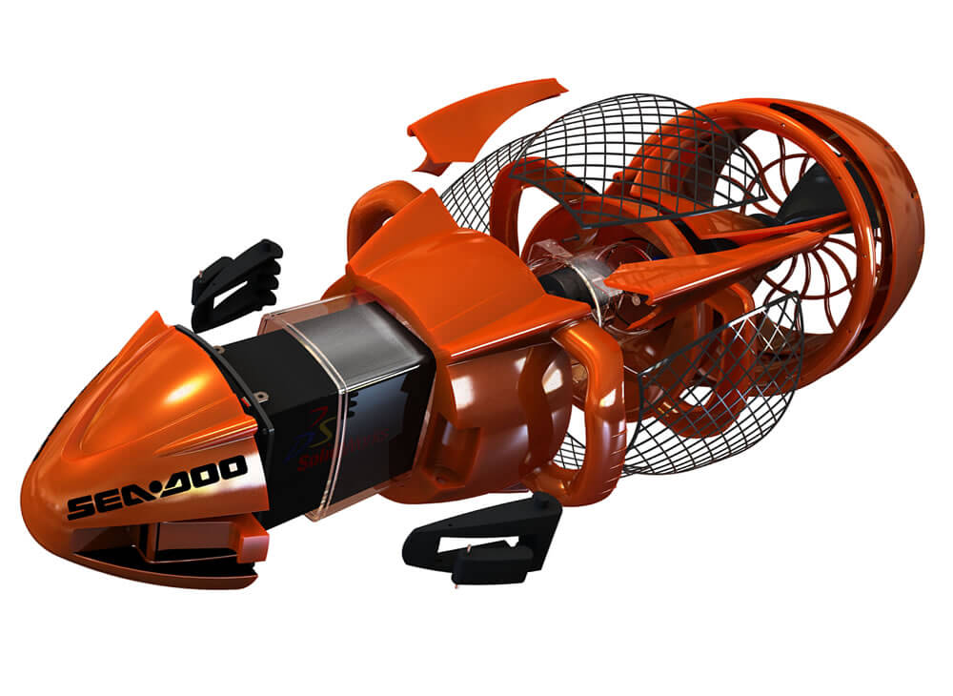

## Introduction to Assemblies

Assemblies are a fundamental aspect of SolidWorks, allowing users to combine individual components into a larger, functional system. They enable designers to visualize how parts fit and interact with one another, ensuring proper functionality before manufacturing. Whether creating simple mechanisms or intricate machines, assemblies provide a platform for integrating, validating, and refining designs.

An assembly in SolidWorks is essentially a collection of parts or sub-assemblies arranged together. This process allows engineers to assess the fit and functionality of the design, check for potential issues such as interference, and simulate real-world motion. Assemblies are created using either the bottom-up approach, where pre-designed parts are added to the assembly, or the top-down approach, where parts are designed within the assembly context. These methods can be used independently or combined, depending on the complexity of the project.

## Creating Assemblies in SolidWorks

Assemblies in SolidWorks provide a platform to combine individual components and simulate how they interact. This allows designers to ensure the fit, alignment, and functionality of parts before proceeding with manufacturing. Creating an assembly involves importing parts, arranging them in the desired positions, and applying constraints, called mates, to control their spatial relationships.

The first component inserted into an assembly file is fixed in space by default. This part acts as the foundation, or reference, for all subsequent components. You can change its status to float if repositioning is needed. After the first part is fixed, additional components can be added to create the complete assembly.

Each component in an assembly is essentially "free-floating" until constrained. By applying mates, you define relationships like alignment, rotation, or fixed distances between parts. This ensures that parts are positioned correctly relative to one another, mimicking real-world conditions. Advanced mates like gear mates or path mates allow for simulating mechanical motion, such as gears turning or components sliding along a defined path.

In addition to adding and constraining components, assemblies offer tools for analysis, including interference and collision detection. These tools help identify design flaws and prevent costly manufacturing errors. Once the assembly is complete, features like exploded views, assembly configurations, and detailed drawings can further enhance communication and documentation of the design.

**Creating a New Assembly in SolidWorks**

Follow these steps to create a new assembly in SolidWorks:

1. **Start a New Assembly File**
   * Open SolidWorks and click on **File > New**.
   * Select **Assembly** from the options and click **OK**.

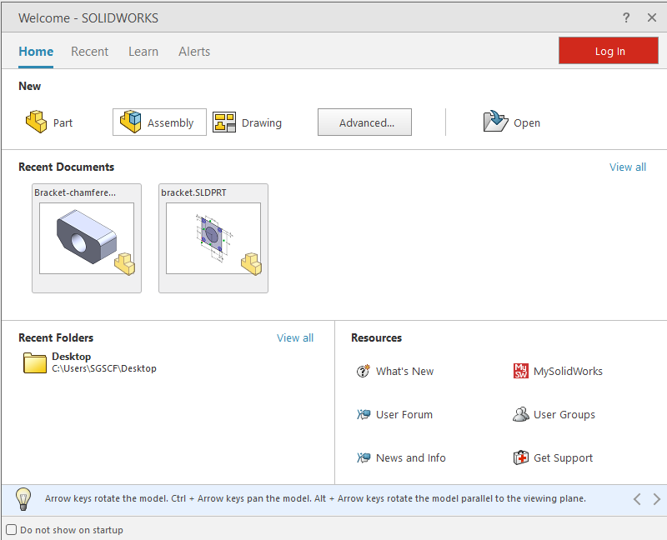

1. **Insert the First Component**
   * After starting the assembly file, the "Insert Component" dialog appears.
   * Browse for the first part you want to add (e.g., a base or reference component) and click **Open**.
   * Place the part in the workspace. This first part is fixed by default.

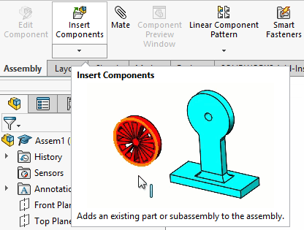

1. **Add Additional Components**
   * Click on **Insert Components** from the toolbar or the Assembly tab.
   * Select the next part to add and position it near the first component in the workspace.

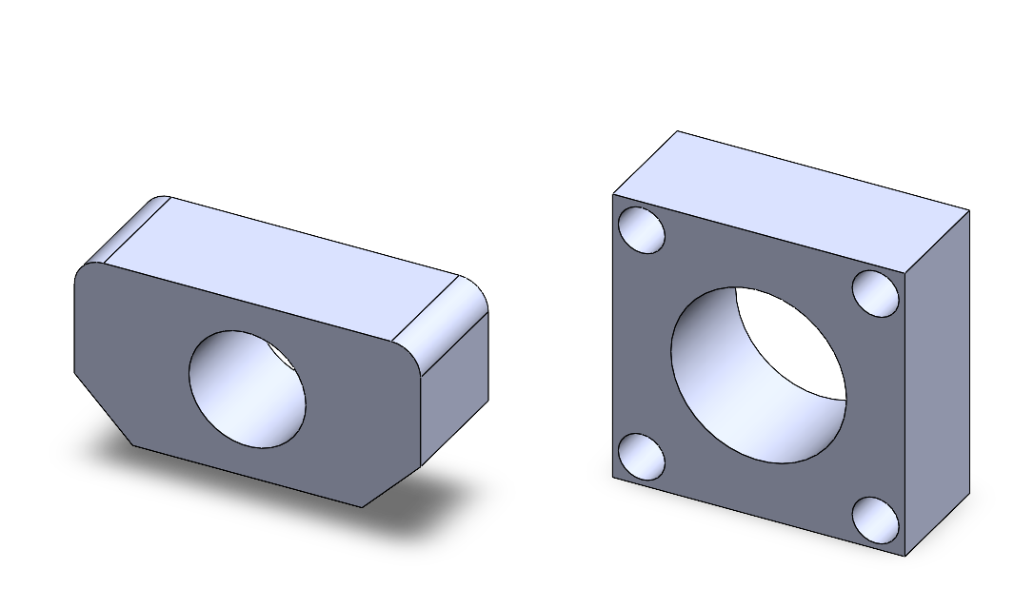

1. **Apply Mates to Define Relationships**
   * Click on the **Mate** tool from the Assembly toolbar or Features tab.
   * Select faces, edges, or points of two parts to define how they interact.
   * Specify the type of mate (e.g., Coincident, Concentric, Tangent) in the Property Manager.
   * Click **OK** to apply the mate.

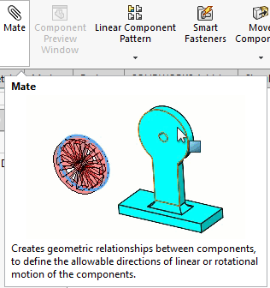

1. **Repeat for All Components**
   * Continue adding components and applying mates until all parts are assembled.
   * Adjust or float parts as needed to finalize their positioning.

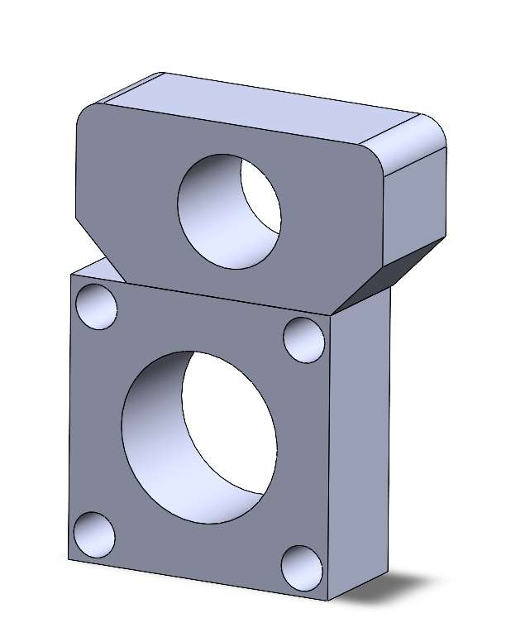

1. **Analyze the Assembly**
   * Use **Interference Detection** to ensure no parts overlap.
   * Enable **Collision Detection** during movement to verify proper mechanical interactions.

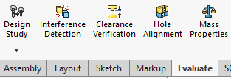

1. **Save the Assembly**
   * Once satisfied with the arrangement and functionality, click **File > Save As** and choose a location to save your assembly file with a descriptive name.

## Mates in Assemblies

Mates in SolidWorks are essential tools that define how parts in an assembly relate to each other. They act as constraints, restricting or guiding the movement of components to ensure proper alignment, positioning, and behavior. Mates help simulate real-world interactions between components, allowing you to validate design functionality before production. Understanding the types of mates and their applications is critical to creating effective and functional assemblies.

#### **Types of Mates**

SolidWorks provides several categories of mates, each tailored to different design needs. These categories include Standard Mates, Advanced Mates, and Mechanical Mates.

1. **Standard Mates**

These are the most commonly used mates that establish basic relationships between parts.

* **Coincident Mate**: Aligns two faces, edges, or points so they touch or overlap in the same plane.

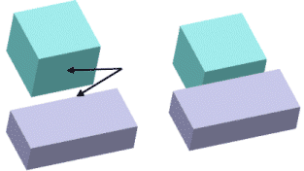

Example: Aligning a bolt's flat face with a washer's flat face.

* **Parallel Mate**: Ensures two faces or edges remain parallel to each other, regardless of their distance.  
  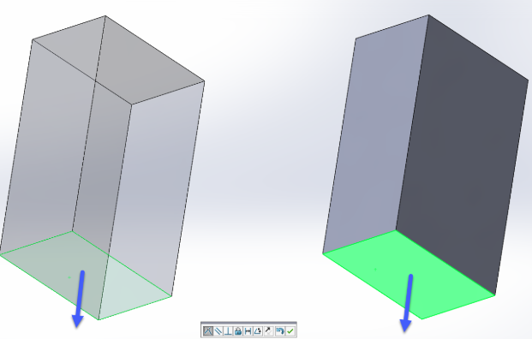

Example: Keeping two brackets aligned side by side.

* **Perpendicular Mate**: Constrains two faces or edges to be at a 90° angle relative to each other.

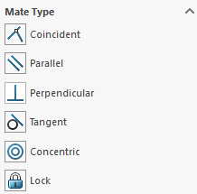  
Example: Ensuring a vertical post stays perpendicular to a horizontal base.

* **Tangent Mate**: Ensures a curved surface (e.g., a cylinder or sphere) touches another surface at a single point.

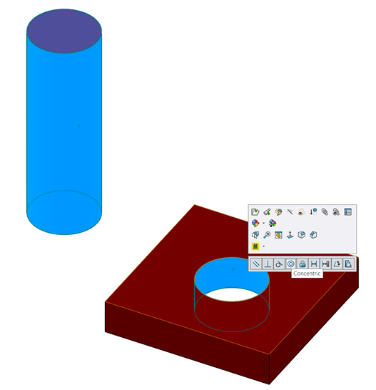  
Example: Positioning a roller against a guide track.

* **Distance Mate**: Sets a fixed distance between two entities (e.g., faces, edges, or points).  
  Example: Ensuring a gap between two plates.
* **Angle Mate**: Defines an angular relationship between two components.  
  Example: Positioning a ramp at a 30° incline relative to the ground.

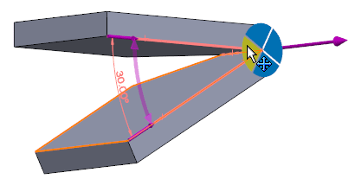

1. **Advanced Mates**

Advanced mates are used for more specific or complex constraints.

* **Width Mate**: Centers a component between two parallel faces or planes.  
  Example: Placing a piston rod equidistant between the walls of a cylinder.
* **Path Mate**: Constrains a component to follow a predefined path, such as a sketch or an edge.  
  Example: Guiding a slider along a curved track.
* **Symmetric Mate**: Keeps a part symmetrically positioned between two reference entities.  
  Example: Centering a shaft between two supports.

1. **Mechanical Mates**

Mechanical mates simulate real-world mechanical interactions, making them invaluable for motion analysis.

* **Gear Mate**: Simulates rotational motion between two gears with a specified gear ratio.  
  Example: Ensuring one gear rotates twice as fast as another.
* **Cam Mate**: Constrains a follower to remain in contact with a cam profile as it rotates.  
  Example: Defining the motion of a camshaft and its follower.
* **Hinge Mate**: Simulates a hinge, allowing rotation around a single axis.  
  Example: Defining the motion of a door.
* **Rack and Pinion Mate**: Simulates the interaction between a rack and a pinion gear to convert rotary motion to linear motion.  
  Example: A rack sliding forward as the pinion rotates.

#### **Steps to Add Mates**

Adding mates in SolidWorks is a straightforward process. Follow these steps to ensure accurate and effective mating of components in an assembly:

1. **Activate the Mate Tool**
   * Open your assembly and navigate to the **Assembly Toolbar**.
   * Click on the **Mate** tool to open the Mate Property Manager.

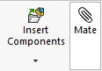

1. **Select Components to Mate**
   * Click on the faces, edges, vertices, or points you want to mate.
   * The selected entities appear in the Mate Selections box within the Property Manager.

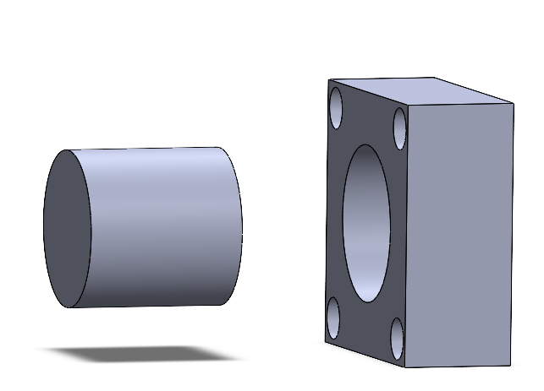

1. **Choose the Mate Type**
   * From the Mate Type section, choose the desired type of mate (e.g., Coincident, Parallel, Tangent).
   * Preview lines and icons will indicate the result of the mate.

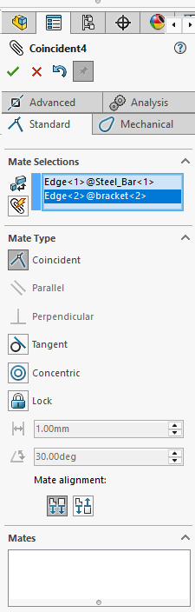

1. **Adjust Mate Parameters**
   * For mates like Distance or Angle, specify the required values in the input fields.
   * Adjust mate alignment if necessary (e.g., flip alignment for coincident or parallel mates).
2. **Confirm the Mate**
   * Click **OK** or the green checkmark to apply the mate.
   * The mated components will now be constrained according to the selected relationship.

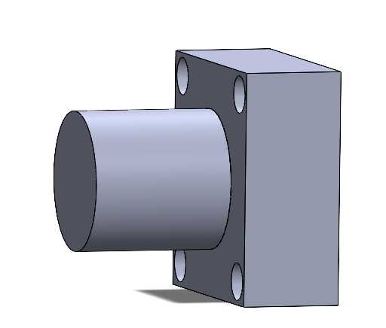

## Analyzing Assemblies

Analyzing assemblies in SolidWorks is a crucial step in validating your design. By using the built-in analysis tools, you can identify potential issues, optimize performance, and ensure the assembly meets functional requirements. This section explores the tools available for evaluating assemblies in detail.

**1. Interference Detection**

Interference Detection is a tool that identifies overlapping geometry between components in an assembly. This is particularly useful in complex assemblies where tight tolerances are required or where multiple parts are assembled in close proximity. Overlapping parts can cause manufacturing errors or functionality issues, so detecting them early is vital.

* **Purpose**: Identify and resolve unwanted overlaps between parts.
* **Accessing the Tool**: Navigate to **Evaluate** then **Interference Detection** on the toolbar.
* **Procedure**:
  + Select the components or subassemblies you want to evaluate.
  + The tool highlights areas where interference occurs, providing visual feedback.
  + You can choose to ignore certain interferences, such as those in fasteners or intended press fits.

**2. Collision Detection**

Collision Detection allows you to simulate the movement of parts in the assembly and check if any components collide during motion. This tool is essential for assemblies with moving parts, such as mechanisms, machines, or robotic systems.

* **Purpose**: Identify and resolve collisions during part motion.
* **How to Enable**:
  + Open the **Move Component** tool in the Assembly tab.

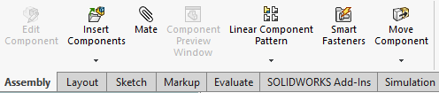

* + Check the **Collision Detection** option and specify the parts to monitor.

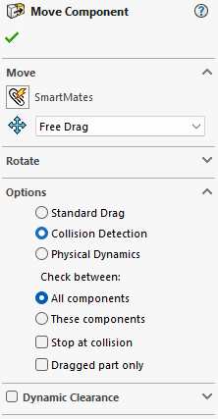

* **Features**:
  + Real-time feedback as components move, showing where and when collisions occur.
  + You can simulate motion manually by dragging parts or using predefined mates to drive motion.

**3. Mass Properties**

The Mass Properties tool calculates the physical properties of the entire assembly or individual components, such as weight, center of gravity, and moments of inertia. This information is essential for structural, dynamic, and material-related analysis.

* **Purpose**: Evaluate the physical characteristics of the assembly to ensure proper design.
* **Accessing the Tool**: Go to **Evaluate** > **Mass Properties**.
* **Procedure**:
  + The tool uses the materials assigned to each part to calculate properties.
  + The center of gravity is displayed graphically in the assembly view, helping you visualize weight distribution.
* **Features**:
  + The ability to export mass property data for further analysis.
  + Modify material properties to see how changes affect the assembly’s mass or balance.

**4. Motion Analysis**

Motion Analysis is used to simulate the movement and interaction of parts within an assembly. It helps you understand how the assembly will behave under real-world conditions, including forces, constraints, and external influences.

* **Purpose**: Test the functionality and motion of mechanical assemblies.
* **Accessing the Tool**: Open the **Motion Study** tab at the bottom of the screen.
* **Procedure**:
  + Add components like motors, springs, dampers, or gravity to the assembly.
  + Define mates and constraints to guide the motion.
  + Run the simulation to visualize and analyze the movement.
* **Features**:
  + Generate animations to present the motion to stakeholders.
  + Use plots to measure variables like velocity, displacement, or force.

## Managing Assemblies

Managing assemblies in SolidWorks is essential as designs grow in size and complexity. Assemblies often include dozens, hundreds, or even thousands of components, which can make navigating, modifying, and optimizing them challenging. SolidWorks provides a variety of tools and strategies to ensure efficient organization, quick modifications, and enhanced performance. This section covers the core methods for managing assemblies effectively.

**Assembly Tree (Feature Manager)**

The Assembly Tree, displayed in the Feature Manager Design Tree, is the central hub for organizing and interacting with the components and mates within an assembly. It lists all parts, subassemblies, and relationships in a hierarchical structure, allowing you to easily locate, group, or modify items.

* **Hierarchy and Grouping**: The tree represents the structure of the assembly, showing how components and subassemblies are nested. Parts and subassemblies are displayed in order, with mates listed below them. You can use folders to group related components, such as fasteners or similar subassemblies, for better organization.
* **Editing Components**:
  + Right-click on a component to edit its properties, suppress it, or hide/show it within the assembly.
  + Drag and drop parts to reorganize them in the tree or move them to different subassemblies.
* **Tips for Efficiency**:
  + Rename components in the tree to reflect their function (e.g., “Left Bracket” instead of “Part1”).
  + Use the search bar to quickly locate components in large assemblies.

|  |
| --- |
| Tips for Efficiency |
| * Rename components in the tree to reflect their function (e.g., “Left Bracket” instead of “Part1”). * Use the search bar to quickly locate components in large assemblies. |

## Practical Example: Creating a Simple Assembly

Understanding how to create a simple assembly is a critical step in mastering SolidWorks. Assemblies are at the heart of mechanical design, allowing you to bring together individual parts and define their relationships to simulate real-world functionality. In this section, we will walk through the process of creating a simple assembly consisting of a rectangular base, a cylindrical rod, and a mounting plate. This example introduces basic assembly tools and concepts, including inserting components, adding mates, and refining the assembly for proper alignment and movement.

**Objective**

Create an assembly where a cylindrical rod with 10 mm radius and 100 mm long is inserted vertically into a rectangular 25 mm thickness base that is 100 mm x 60 mm with a central hole that is 20 mm in diameter, and a mounting plate is attached on top of the rod. This assembly will demonstrate the use of component insertion, standard mates, and adjustments for design intent.

**Steps to Create the Assembly**

**Step 1: Preparing the Parts**

Before creating an assembly, you need individual part files for the base, cylindrical rod, and mounting plate. Each part should be saved separately in SolidWorks. Ensure the dimensions are compatible:

* The base has a rectangular footprint of 100 mm x 60 mm with a 20 mm diameter hole at its center.

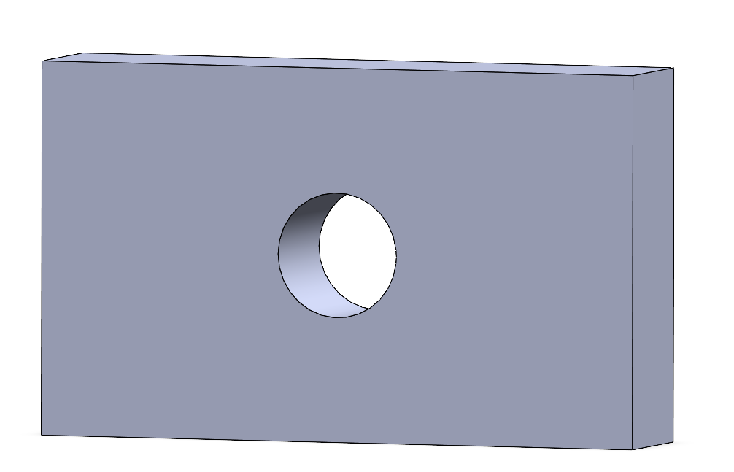

* The cylindrical rod is 20 mm in diameter and 100 mm in height.

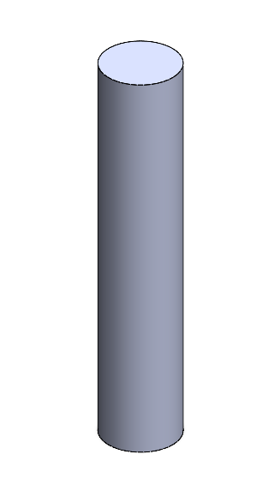

* The mounting plate is 40 mm x 40 mm with a central hole of 20 mm in diameter.

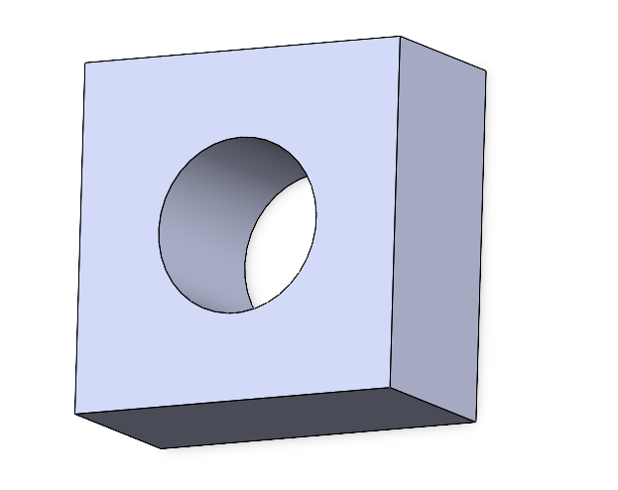

**Step 2: Starting a New Assembly**

1. Open SolidWorks and click **File > New > Assembly**.
2. In the **Begin Assembly** dialog box, click **Insert Components**.
3. Browse for the base part file and insert it into the assembly. The first part is fixed automatically, serving as the foundation.

**Step 3: Inserting Additional Components**

1. Click **Insert Components** again from the Assembly toolbar.
2. Select the cylindrical rod file and place it near the base in the graphics area.
3. Repeat the process to add the mounting plate.

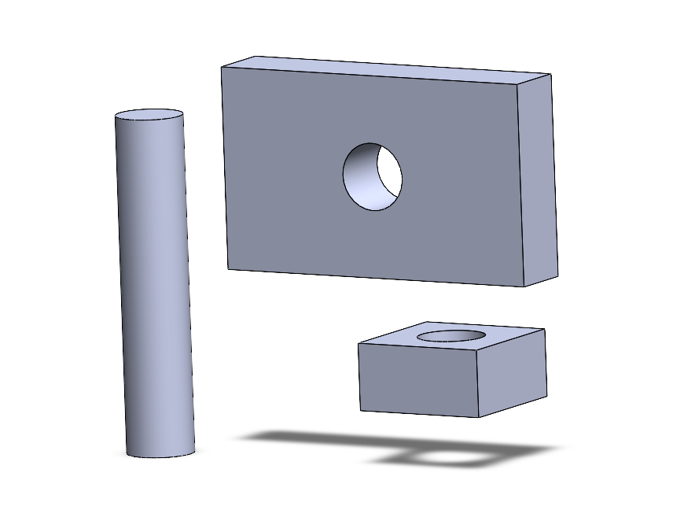

**Step 4: Applying Mates**

Mates define how components relate to each other within the assembly. For this example, you will align the cylindrical rod with the hole in the base and position the mounting plate on top of the rod.

1. **Mate the Rod to the Base**:
   * Click the **Mate** tool in the Assembly toolbar.
   * Select the cylindrical face of the rod and the cylindrical face of the hole in the base.

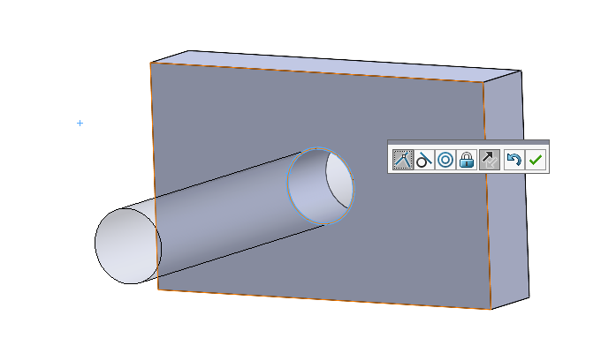

* + Choose **Concentric Mate** from the Property Manager. This ensures the rod is aligned with the hole.
  + Select the bottom face of the rod and the top face of the base. Apply a **Coincident Mate** to make them flush.

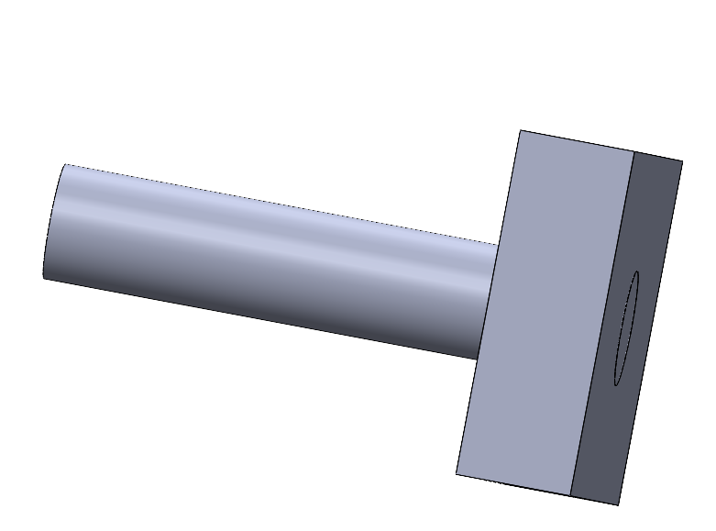

1. **Mate the Mounting Plate to the Rod**:
   * Select the cylindrical face of the hole in the mounting plate and the outer cylindrical face of the rod. Apply a **Concentric Mate**.
   * Mate the bottom face of the mounting plate to the top face of the rod using a **Coincident Mate**.

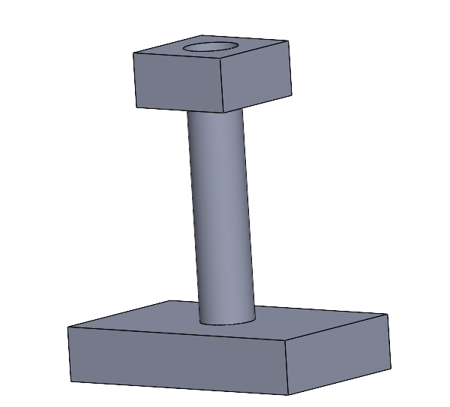

**Step 5: Adjusting and Verifying the Assembly**  
After adding mates, verify the assembly for proper alignment and functionality:

* **Check Alignment**: Rotate the view and inspect if all parts are properly aligned.
* **Test Movement**: If any mates allow movement (e.g., rotational freedom), test the assembly by dragging the parts to ensure they move as intended.

**Step 6: Saving the Assembly**  
Once the assembly is complete, save it:

1. Click **File > Save As**.
2. Name the assembly and choose a location.
3. SolidWorks will automatically save references to the individual part files.

## Chapter 4 Practice Questions

**Section 1:** **Multiple Choice Questions**

1. What is the primary function of the Mate tool in SolidWorks assemblies?

A. To create new parts in the assembly

B. To define spatial and functional relationships between parts

C. To adjust the dimensions of individual parts

D. To apply materials to components

2. Which mate ensures two faces are flush with each other?

A. Parallel Mate

B. Coincident Mate

C. Perpendicular Mate

D. Tangent Mate

3. What is the purpose of Interference Detection in assemblies?

A. To create mates between parts

B. To identify overlapping geometry between components

C. To measure the total weight of the assembly

D. To adjust the transparency of parts

4. How do you access Large Assembly Mode in SolidWorks?

A. Assembly Toolbar > Large Assembly

B. Insert > Components > Large Assembly

C. Options > System Options > Assemblies

D. Evaluate > Performance Tools > Large Assembly

5. What type of mate allows a cylindrical component to follow a curved path?

A. Width Mate

B. Path Mate

C. Cam Mate

D. Gear Mate

6. Which of the following best describes an Exploded View?

A. A detailed representation of an individual part

B. A simplified version of an assembly for performance optimization

C. A view that shows the disassembled state of an assembly

D. A simulation of motion between components

**Section 2: Design Practice Questions**

1. Design an Assembly with Mates:

Create an assembly consisting of a rectangular base (100mm x 50mm), a cylindrical rod (diameter 20mm, height 80mm), and a spherical cap (diameter 40mm) positioned on top of the rod. Use mates to ensure proper alignment and attachment of all components. Save the assembly file.

2. Interference Check in an Assembly:

Design an assembly with two rectangular blocks (100mm x 50mm x 20mm) and a cylindrical rod (diameter 20mm, height 50mm). Place the rod through a hole in one block and check for interference with the second block. Use the Interference Detection tool to verify and correct any issues.

3. Exploded View Creation:

Create an assembly of a mechanical hinge with two rectangular plates (60mm x 30mm) connected by a pin (diameter 10mm, length 40mm). Use the Exploded View tool to show how the hinge components are assembled.

4. Gear Assembly with Mechanical Mate:

Design an assembly with two gears (diameters 40mm and 60mm) and use a Gear Mate to simulate their rotational interaction. Test the motion of the gears to ensure they function correctly.

## Chapter 4 Answer Sheet

|  |  |
| --- | --- |
| 1 | B |

|  |  |
| --- | --- |
| 2 | B |

|  |  |
| --- | --- |
| 3 | B |

|  |  |
| --- | --- |
| 4 | C |

|  |  |
| --- | --- |
| 5 | B |

|  |  |
| --- | --- |
| 6 | C |

|  |  |
| --- | --- |
|  |  |

# CHAPTER 5

# PROJECTION VIEWS

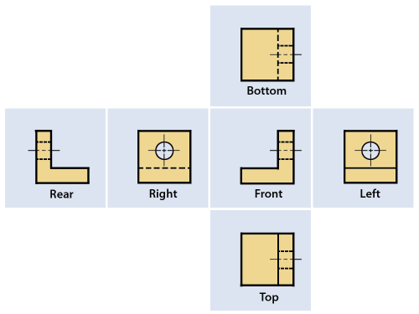

## Introduction to Projection Views

Projection views are a cornerstone of engineering design and technical drawings, serving as a bridge between three-dimensional (3D) models and two-dimensional (2D) representations. These views allow engineers, manufacturers, and other stakeholders to visualize and interpret a 3D object accurately on a flat surface. By breaking down complex geometries into clear, flat representations, projection views ensure that every detail of a design is captured and communicated effectively.

In practice, projection views enable manufacturers to understand the dimensions, features, and spatial relationships of a part or assembly without ambiguity. This is critical for tasks like machining, assembly, quality control, and inspection. Without precise projection views, misinterpretations could lead to errors in production or failures in functionality.

SolidWorks offers a suite of tools to create and manage projection views seamlessly. These tools are designed to ensure that engineers can generate drawings that conform to industry standards, such as ISO or ANSI. SolidWorks automates much of the process, enabling users to quickly create multiple views from a single 3D model, maintain alignment between views, and update drawings dynamically when the model changes.

**The Role of Projection Views in Design Documentation**

Projection views play a pivotal role in documenting both parts and assemblies. They allow designs to move from the virtual environment of CAD software into the real world, where they can be manufactured and assembled. By providing detailed and accurate representations, projection views help ensure:

1. **Manufacturability:** Precise views highlight all critical dimensions and tolerances, ensuring parts can be machined or molded to exact specifications.
2. **Inspectability**: Projection views make it possible for quality control teams to measure and verify dimensions against the design intent.
3. **Communication**: Engineers, machinists, and assemblers can easily interpret the design, regardless of their familiarity with the 3D model.

In this chapter, we will explore the various types of projection views, their specific applications, and the step-by-step process of creating them using SolidWorks. This foundation is essential for mastering technical drawings and producing professional-grade documentation for engineering designs.

## Types of Projection Views

Projection views are essential tools for representing 3D objects on 2D planes, allowing for clear and precise communication of design intent. Each type of projection view serves a specific purpose, helping to convey different aspects of an object’s geometry and features. In SolidWorks, users can create these views with ease, ensuring their technical drawings meet industry standards. Below are detailed descriptions of the main types of projection views, their applications, and examples.

* + 1. **Orthographic Projection**

Orthographic projection is the most widely used method for engineering drawings. It involves projecting an object’s features onto a 2D plane to create multiple aligned views, typically including the front, top, and side views. These views are drawn without perspective distortion, ensuring accurate dimensions and spatial relationships.

Orthographic projections are ideal for documenting an object’s precise geometry because each view isolates one side of the part. For example, the front view displays the height and width, while the top view reveals the width and depth.

**Purpose:**

* To communicate accurate dimensions, shapes, and spatial relationships between features.
* To provide machinists and manufacturers with unambiguous details about the part's geometry.

**Example:**

Imagine a cube. The orthographic projection would display its front view (a square), top view (another square), and side view (also a square), all aligned with one another. Each view represents the cube’s specific dimensions and relationships without distortion.

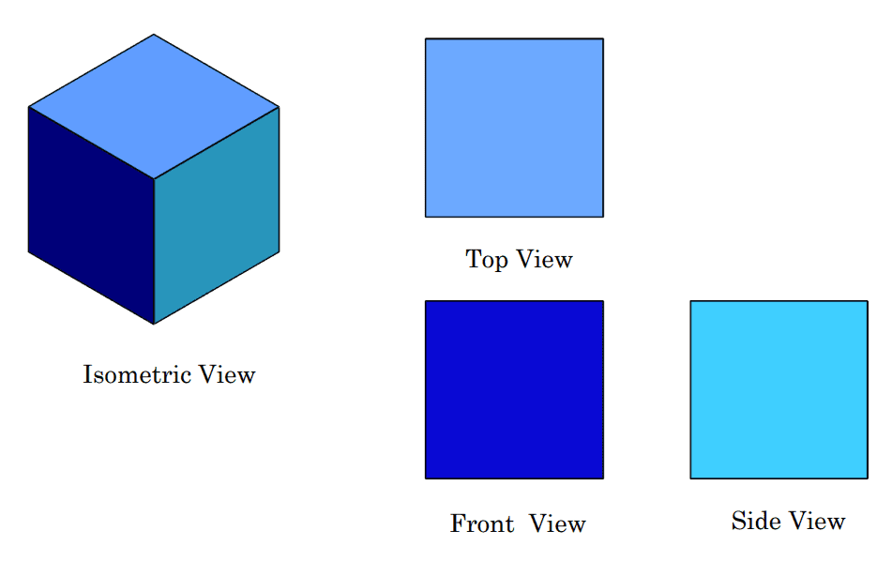

* + 1. **Isometric Views**

An isometric view offers a pseudo-3D representation of a part by positioning it at an angle where the three principal axes (X, Y, and Z) are equally inclined, typically 120° apart. Unlike orthographic views, isometric views add a sense of depth, making them highly effective for visualizing the overall shape and design of an object.

**Purpose:**

* To provide a comprehensive 3D perspective of the object.
* To help non-technical viewers, such as clients or stakeholders, better understand the design.
  + 1. **Section Views**

Section views are invaluable for revealing interior features of an object that are hidden in standard orthographic or isometric views. By cutting through the object along a predefined plane, section views expose internal details, such as cavities, holes, or structural reinforcements, that are otherwise invisible.

**Purpose:**

* To provide clarity about hidden or internal features of a part or assembly.
* To ensure that internal structures are accurately communicated in technical drawings.

**Example:**

Consider a gear with internal spokes and a hollow center. A section view can slice through the middle of the gear, displaying the spoke pattern and the cavity’s dimensions, making it easier to understand the internal design.

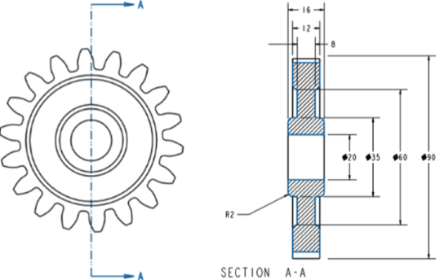

* + 1. **Auxiliary Views**

Auxiliary views are used to accurately depict inclined or slanted surfaces that are not clearly visible in standard orthographic projections. By projecting the view perpendicular to the inclined surface, auxiliary views capture the true dimensions and shape of the feature.

**Purpose:**

* To clarify the geometry of non-standard angles or slanted surfaces.
* To provide accurate dimensions for features that are distorted in other views.

**Example:**

Imagine a ramp structure with an inclined surface. While the standard orthographic views may not show the ramp’s true shape or angle, an auxiliary view can be created to focus on the inclined plane, providing its precise dimensions and geometry.

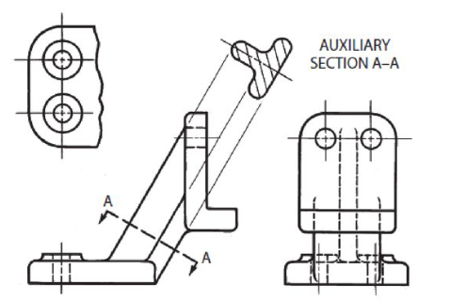

* + 1. **Detail Views**

Detail views magnify a specific area of a drawing to provide additional clarity for small or intricate features. These views are typically used when certain aspects of a part are too small to be properly understood at the scale of the primary views.

**Purpose:**

* To focus on critical features, such as small holes, threads, or fillets, without overcrowding the drawing.
* To enhance understanding of intricate areas that require additional attention.

**Example:**

Suppose a part has a small fillet radius in one corner. A detail view can enlarge this corner, showing the fillet’s exact dimensions and shape, ensuring manufacturers understand how to produce the feature accurately.

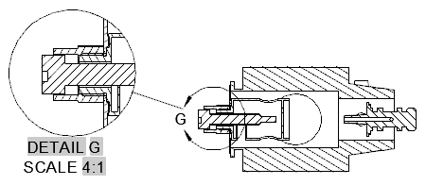

## Creating Projection Views in SolidWorks

SolidWorks streamlines the process of creating projection views from a 3D model, enabling users to document their designs efficiently and accurately. Projection views are essential for communicating design intent, as they represent the geometry, dimensions, and spatial relationships of a model in a format suitable for manufacturing and inspection. This section provides an in-depth explanation of how to create projection views in SolidWorks and their significance in engineering drawings.

**Overview of the Process**

To create projection views in SolidWorks, the workflow begins with a completed 3D model, which is then inserted into a drawing file. From there, you can create various types of views, such as orthographic, isometric, section, auxiliary, and detail views, each serving a specific purpose. SolidWorks automates much of this process while offering customization options to meet specific documentation requirements.

**Steps to Create Projection Views in SolidWorks**

**1. Create a Drawing File**

* Launch SolidWorks and open your completed 3D model.
* Go to the top menu and click **File > New > Drawing**.

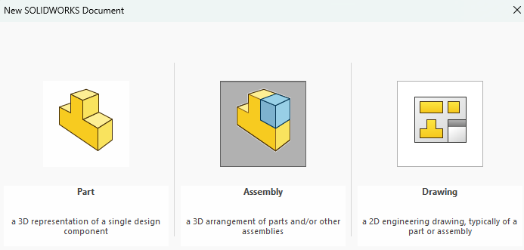

* Select a drawing template that matches your required sheet size, format, and orientation. Templates can be customized to align with company standards, such as A4 landscape or A3 portrait.

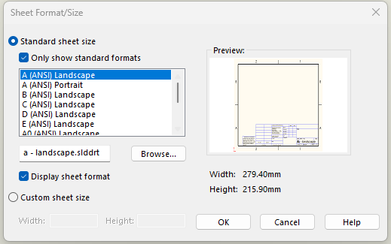

**2. Insert the 3D Model**

* Use the **Insert > Model View** command from the menu or drag and drop the 3D model into the drawing sheet.

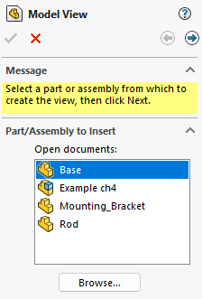

* The model appears as a primary view, typically the front view, which acts as the parent for creating other projection views.

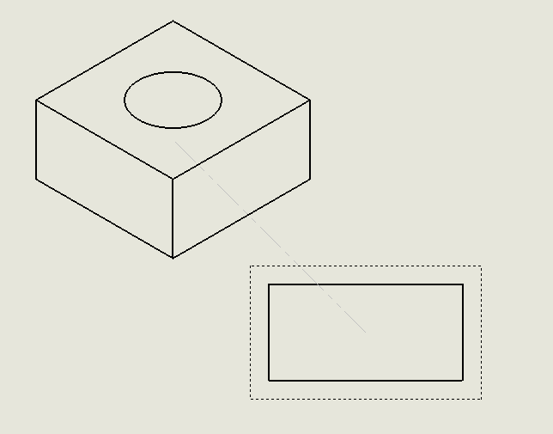

**3. Create Orthographic Views**

* Open the **View Palette** from the Task Pane or Drawing toolbar.

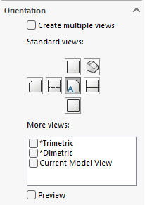

* Select standard views, such as Front, Top, and Right (or Left), to represent the object from multiple angles.
* Drag and place these views onto the drawing sheet. SolidWorks ensures proper alignment of these views, maintaining consistency and clarity.

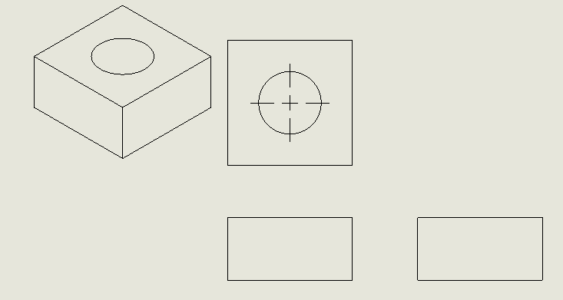

* Adjust the spacing between views for readability.

**4. Generate an Isometric View**

* From the **View Palette**, select the **Isometric View** option.

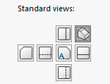

* Drag the isometric view onto the drawing sheet to provide a pseudo-3D perspective of the object.
* Position the view for optimal visibility, usually near the upper-right corner of the sheet.

**5. Add Section Views**

* Use the **Section View** tool, available in the Drawing toolbar or under the **Insert > Drawing View** menu.

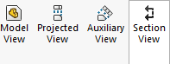

* Define a cutting plane by selecting an edge or face in an existing view and drawing a line to indicate the cut.

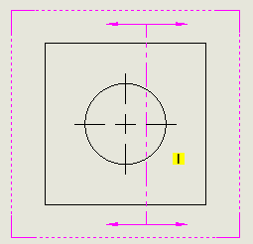

* Place the section view on the drawing sheet, showing internal features such as holes, cavities, or assemblies.

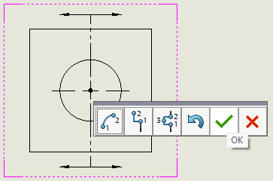

* Annotate the section view with hatch patterns to differentiate between cut surfaces and remaining material.

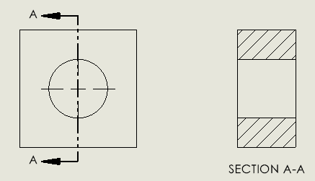

**6. Generate Auxiliary Views**

* Select the **Auxiliary View** tool from the Drawing toolbar.

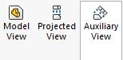

* Identify an inclined surface in one of the standard views to serve as the basis for the auxiliary view.
* Place the resulting auxiliary view on the sheet, perpendicular to the inclined surface, to capture its true dimensions and shape.

**7. Create Detail Views**

* Use the **Detail View** tool to focus on small or intricate features of the design.

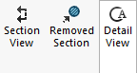

* Draw a circular or rectangular boundary around the area of interest in an existing view.

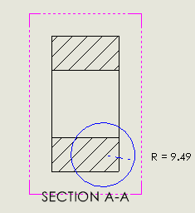

* Drag and place the detail view onto the sheet, magnified for better understanding.

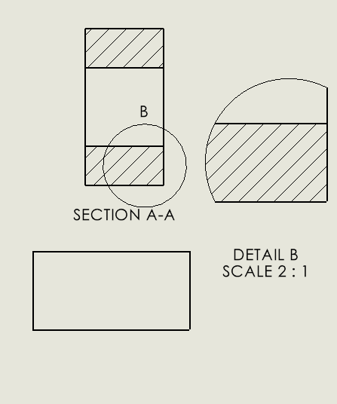

* Label the detail view with a letter or number, referencing it back to the original view for clarity.

## Practical Applications of Projection Views

Projection views are integral to engineering and manufacturing processes, serving as the cornerstone for communicating design intent effectively. By accurately representing 3D objects on 2D planes, projection views provide critical information that bridges the gap between conceptual designs and real-world implementation. This section elaborates on how projection views are utilized in various practical applications, highlighting their importance in manufacturing, quality control, assembly, and technical documentation.

**1. Manufacturing**

Projection views play a vital role in manufacturing by providing machinists and fabricators with the precise information needed to create parts. They include dimensions, tolerances, and geometric details that ensure components are machined or fabricated to exact specifications.

* **Dimensions and Tolerances:** Orthographic views, combined with annotations, convey critical measurements such as lengths, diameters, and angles. Tolerances are specified to define acceptable deviations, ensuring parts function as intended.
* **Material Indications:** Section views often include hatch patterns to differentiate between materials, enabling machinists to select the correct stock material.
* **Ease of Interpretation:** Isometric and auxiliary views can offer additional clarity, reducing the risk of misinterpretation and errors during the manufacturing process.

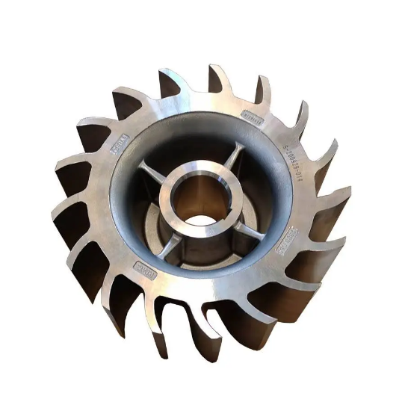

Figure 16: Engineering Part.

**2. Quality Control**

Projection views are essential for verifying that manufactured components meet design specifications. Quality control (QC) teams rely on these views to measure and inspect parts, ensuring they conform to the original design intent.

* **Inspection Standards:** QC personnel use the dimensions and tolerances from orthographic views to verify critical features using tools like calipers, micrometers, or coordinate measuring machines (CMM).
* **Internal Features:** Section views reveal hidden internal geometries, such as cavities or threads, allowing inspectors to assess these elements without damaging the part.
* **Reference for Comparison:** Projection views serve as a baseline for comparing the manufactured part with the design, highlighting any deviations or defects.

**3. Assembly Instructions**

Projection views provide clear and detailed instructions for assembling products, especially when dealing with intricate or multi-component assemblies. They ensure that components are assembled correctly, reducing errors and improving efficiency.

* **Exploded Views:** Used in assembly drawings to show how parts fit together, offering a clear roadmap for workers during the assembly process.
* **Alignment Guidance:** Auxiliary views help illustrate proper alignment for components with inclined or non-standard surfaces.
* **Assembly Order:** Detailed annotations and callouts in projection views guide the sequence of assembly, ensuring that critical steps are not overlooked.

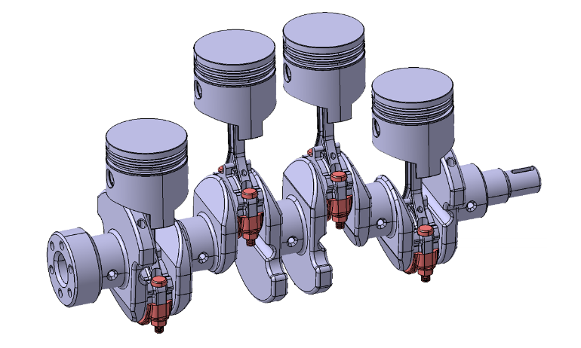

Figure 17: Engine Assembly Design.

**4. Technical Documentation**

Projection views are the backbone of technical documentation, serving as a standardized means of communication between designers, engineers, manufacturers, and clients. They ensure that all stakeholders have a common understanding of the design.

* **Consistency:** Standardized projection views (e.g., orthographic and isometric) ensure that documentation adheres to industry norms such as ASME Y14.5 or ISO 128.
* **Collaboration**: Engineers and designers can exchange detailed technical drawings with clients or manufacturers, facilitating seamless collaboration.
* **Design Revision Tracking:** Projection views document design changes over time, creating a record of revisions that can be referenced during production or maintenance.

**Key Benefits of Projection Views in Practical Applications**

1. **Clarity**: Projection views eliminate ambiguity, ensuring that everyone involved in the project understands the design intent.
2. **Accuracy**: By conveying precise dimensions and tolerances, projection views minimize errors during manufacturing and assembly.
3. **Efficiency**: Clear documentation reduces the time spent on interpretation, inspection, and troubleshooting.
4. **Standardization**: Following industry standards ensures compatibility across different teams, tools, and workflows.

## Practical Example: Documenting a Mechanical Part

Projection views are integral to engineering and manufacturing processes, serving as the cornerstone for communicating design intent effectively. By accurately representing 3D objects on 2D planes, projection views provide critical information that bridges the gap between conceptual designs and real-world implementation. This section elaborates on how projection views are utilized in various practical applications, highlighting their importance in manufacturing, quality control, assembly, and technical documentation.

**Objective**

The goal is to create a detailed drawing of a bracket with the following features:

* **Base Dimensions**: 100mm x 50mm.
* **Holes**: Two circular holes with a diameter of 10mm, each located 20mm from the respective edges.
* **Fillet**: A 5mm fillet applied to all four corners of the bracket.

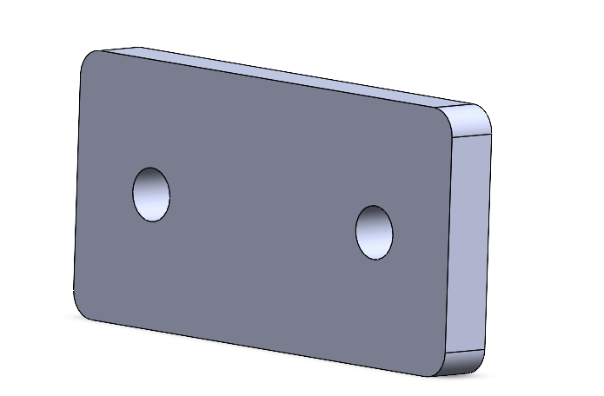

The drawing will include multiple views, annotations, and proper formatting to ensure clarity and usability.

**Steps to Create the Drawing**

1. **Open the 3D Model of the Bracket**

* Begin by designing the 3D model of the bracket in SolidWorks. Ensure the part is fully defined with all required features, including the fillet and holes. Save the model before proceeding.

1. **Create a New Drawing File**

* Open SolidWorks and click **File > New > Drawing**.
* Select an appropriate drawing template based on the desired sheet size (e.g., A4 or ANSI A).
* Set the orientation (landscape or portrait) to best fit the views and dimensions of the bracket.

1. **Insert the Model into the Drawing**

* Use the Insert Model View tool from the Drawing toolbar or drag the bracket model into the drawing sheet.
* Choose the Front View as the base view and place it in the center of the sheet.

1. **Add Orthographic Views**

* From the View Palette, select the Top View and position it above the front view.
* Add the Side View and align it to the right of the front view. Ensure proper alignment between these orthographic views to maintain clarity and consistency.

1. **Generate an Isometric View**

* Select the Isometric View option in the View Palette.
* Place the isometric view in the upper-right corner of the drawing sheet to provide a 3D representation of the bracket. This view helps visualize the overall shape and features of the part.

1. **Create a Section View**

* Use the Section View tool to reveal internal details of the bracket.
* Define a cutting plane (e.g., through the center of the bracket) and place the resulting section view below the front view. This will display the thickness and hole locations clearly.

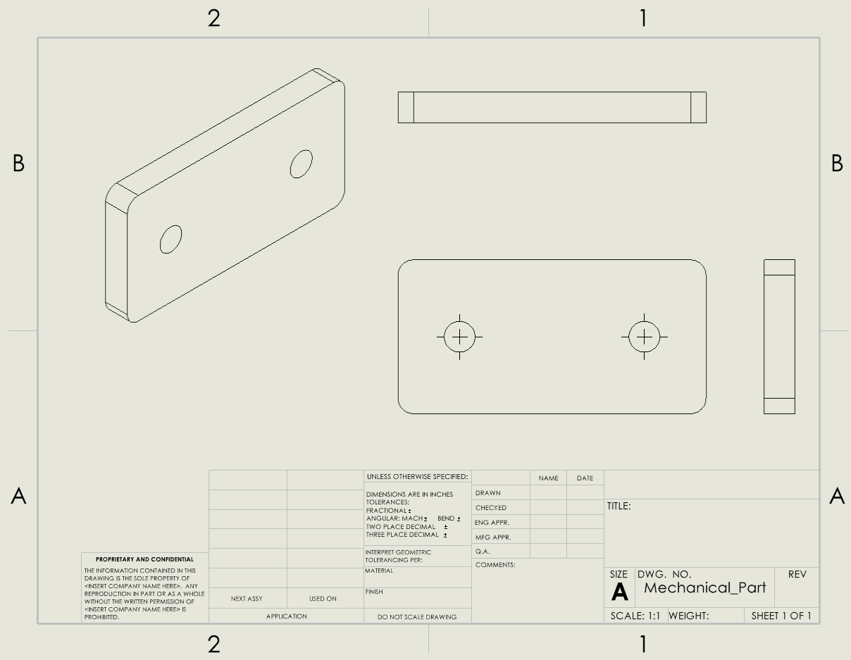

1. **Annotate the Drawing**

* Use the Smart Dimension tool to add the following annotations:
  + - **Base Dimensions**: Add dimensions for the 100mm x 50mm rectangle.
    - **Hole Locations**: Dimension the two holes, specifying their diameters (10mm) and distances (20mm from the edges).
    - **Fillet Radius**: Annotate the 5mm fillets on all corners.
* Add center marks and centerlines for the holes to enhance clarity.
* Include any necessary tolerances or notes, such as material specifications or surface finish requirements.

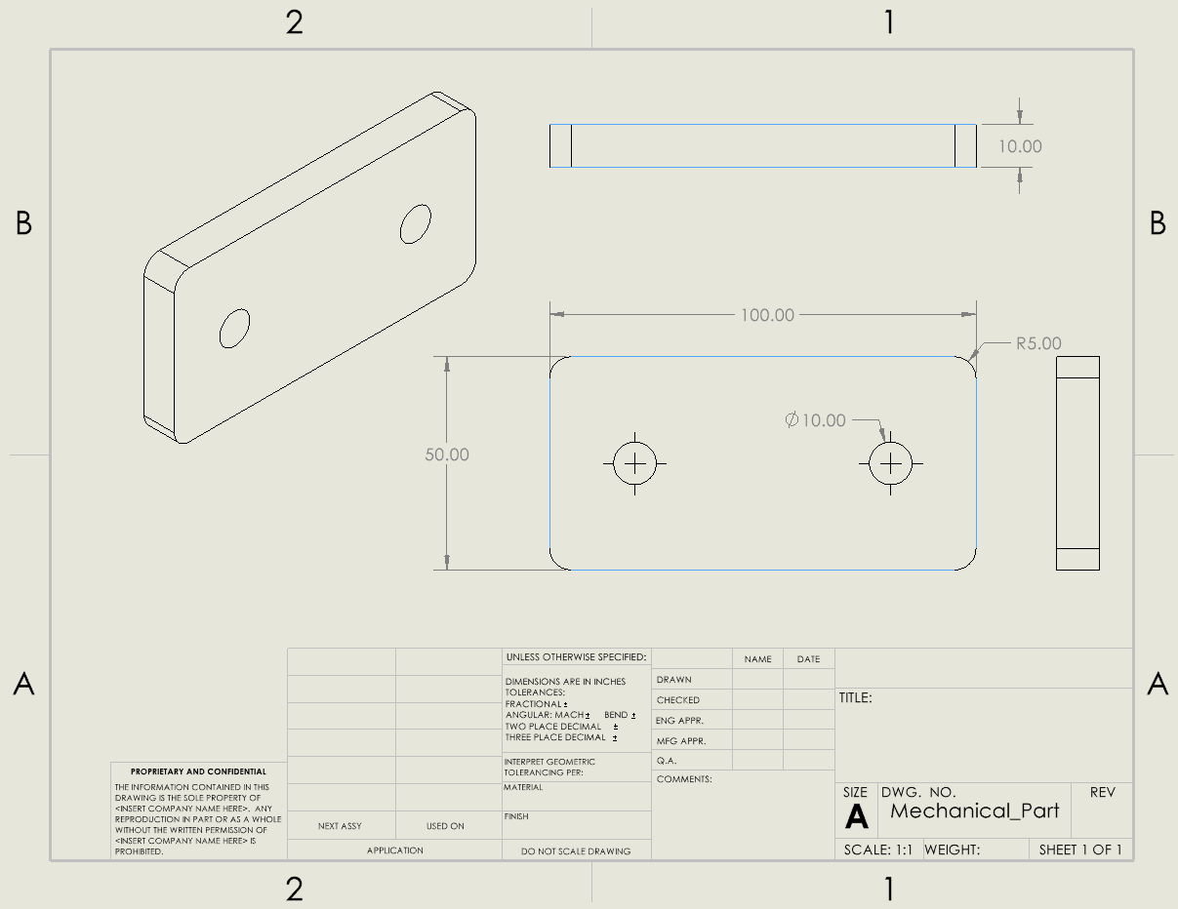

1. **Format the Drawing**

* Add a title block that includes the part name, drawing number, scale, date, and drafter's initials.
* Ensure the views and annotations are properly spaced to avoid clutter.

1. **Save and Export the Drawing**

* Save the completed drawing file in SolidWorks format (*.slddrw) for future edits.
* Export the drawing as a PDF by clicking File > Save As > PDF. This format is widely used for sharing and printing.

The final drawing will include:

* **Front, Top, and Side Views** (orthographic projection) to communicate precise dimensions and spatial relationships.
* **Isometric View** for an intuitive 3D representation.
* **Section View** to reveal hidden internal features, such as the hole depth.
* Annotations that provide all critical information for manufacturing and quality control.

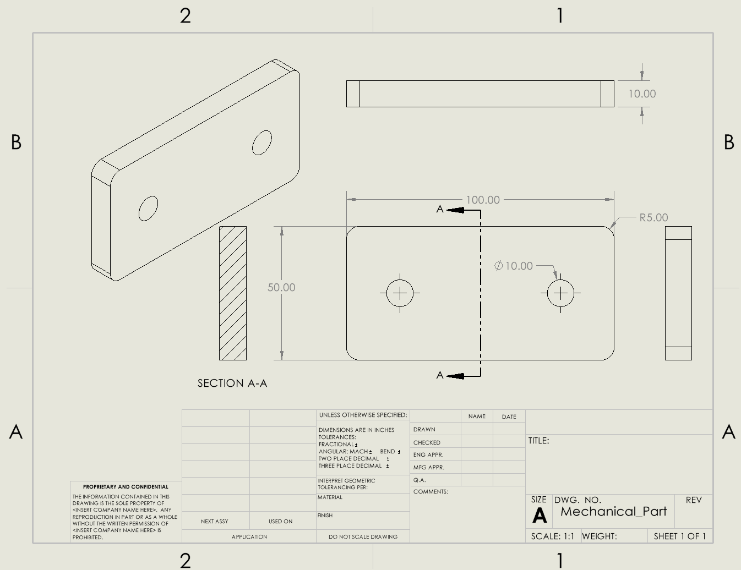

## Chapter 5 Practice Questions

**Section 1:** **Multiple Choice Questions**

1. What is the primary purpose of projection views in engineering drawings?  
   A. To add color to 3D models  
   B. To represent 3D objects on a 2D plane  
   C. To make designs look artistic  
   D. To remove unnecessary dimensions
2. Which type of projection view shows an object’s front, top, and side without perspective distortion?  
   A. Isometric View  
   B. Section View  
   C. Orthographic Projection  
   D. Auxiliary View
3. In an isometric view, how are the axes typically inclined?  
   A. 90° apart  
   B. 120° apart  
   C. 180° apart  
   D. 60° apart
4. What is the main purpose of section views?  
   A. To show a 3D perspective of the object  
   B. To display the object's hidden interior details  
   C. To enlarge small features for clarity  
   D. To represent inclined surfaces accurately
5. Which tool in SolidWorks is used to create a detail view?  
   A. Section View  
   B. Detail View  
   C. Auxiliary View  
   D. Isometric View
6. What type of projection view is commonly used to represent slanted surfaces?  
   A. Orthographic Projection  
   B. Auxiliary View  
   C. Section View  
   D. Detail View
7. When generating an orthographic projection in SolidWorks, which views are typically included?  
   A. Top, Isometric, and Section  
   B. Front, Top, and Side  
   C. Section, Detail, and Auxiliary  
   D. Front, Side, and Detail
8. Why are detail views important in engineering drawings?  
   A. To highlight large features  
   B. To provide a 3D perspective  
   C. To magnify small or intricate areas  
   D. To show inclined surfaces

**Section 2: Design Practice Questions**

1. **Create an Orthographic Projection**

Design a drawing of a mechanical component (e.g., a bracket, gear, or block) in SolidWorks. Include front, top, and side views in your drawing file. Ensure proper alignment between the views.

1. **Generate a Section View**

Design a hollow cylinder in SolidWorks. Create a section view that reveals the interior features, such as thickness and holes. Annotate all critical dimensions in the section view.

1. **Add Detail and Auxiliary Views**

Design a slanted block with small holes on an inclined surface. Create an auxiliary view to show the slanted surface accurately. Then, add a detail view to magnify one of the holes for clarity.

1. **Document an Isometric View**

Create an isometric view of a part with multiple features (e.g., fillets, holes, and cuts). Place it on the drawing sheet alongside orthographic views. Ensure annotations are clear and properly scaled.

## Chapter 5 Answer Sheet

|  |  |
| --- | --- |
| 1 | B |

|  |  |
| --- | --- |
| 2 | C |

|  |  |
| --- | --- |
| 3 | B |

|  |  |
| --- | --- |
| 4 | B |

|  |  |
| --- | --- |
| 5 | B |

|  |  |
| --- | --- |
| 6 | B |
| 7 | B |
| 8 | C |

|  |  |
| --- | --- |
|  |  |