Major Graded Assignment: Exploring and Explaining Implicit Bias

Purpose: The purpose of this assignment is to provide an opportunity for students to engage ideas about diversity and inclusion in ways that require higher-order thinking skills. In so doing, students will:

Increase awareness of any implicit biases in regard to race/ethnicity, gender, sexuality, and/or religion.

Deepen the level of student engagement regarding issues of diversity.

Recognize and respect the complexity of sociocultural diversity and individual differences.

Recognize, compare, and apply the core domains of psychology.

Recognize the value of psychology in professional and personal domains.

Skills: The purpose of this assignment is to help you practice the following skills that are essential to your success in this course / in school / in this field / in professional life beyond school:
Understand basic concepts and terms associated with social psychology, in particular, and the broader field of psychology, in general.

Identify basic concepts and terms associated with social psychology, in particular, and the broader field of psychology, in general, in a similar but unfamiliar context.

Apply basic concepts and terms associated with social psychology, in particular, and the broader field of psychology, in general, in a similar but unfamiliar context.

Analyze their own behavior and thoughts regarding implicit bias and issues of diversity using basic concepts and terms associated with social psychology, in particular, and the broader field of psychology, in general.

Seek a variety of sources that provide evidence to support an argument about the past.

Develop a methodological practice of gathering, sifting, analyzing, ordering, synthesizing, and interpreting evidence

Explore the complexity of the human experience, across time and space.

Knowledge: This assignment will also help you to become familiar with important content knowledge in this discipline through the following objectives:
Thoroughly and accurately define the theory you have chosen

Provide real-world examples that support and exemplify the theory you have chosen

Identify key events that define change over time in a particular place or region, and identify how change occurs over time

Tasks:
Major Graded Assignment for Chapter 12 Social Behavior

1)This must be completed at the beginning of the semester.
Due by Jan. 16th, 11:59 pm. Choose one of the following IATs: Race, Sexuality, Gender, or Religion at: https://implicit.harvard.edu/implicit/takeatest.html. Please take at least one of the tests. Once you have submitted your own IAT results to the CH12 Implicit Association Test (IAT) Pre-MGA Dropbox, please give your opinion on the IAT - Was the IAT accurate? Why or Why not?
1a) Take the Big Five Test,
1b) Submit your results to the Big Five Dropbox Pre-MGA dropbox. To do this, copy the link from your web browser on the results page. For example, here are the results from my Big Five Test: https://bigfive-test.com/result/5e1a5a93dff3440062488857 and provide screenshot of the first chart on your results page.
1b) Complete the brief Pre-MGA report.
These tasks must be completed at the beginning of the semester. Due by Jan. 16th, 11:59 pm.

2)When we cover Chapter 12 in our course:
After reading the chapter, taking the quiz, and familiarizing yourself with the content in the module, choose one of the following videos to watch for this Major Graded Assignment:
Race--White Like Me: Race, Racism, and White Privilege in America

Gender and Sexuality--Codes of Gender: Identity and Performance in Popular Culture

Gender--Miss Representation

Religion--Constructing the Terrorist Threat: Islamophobia, the Media, and the War on Terror

These films are accessible through the GHC Library, in the Kanopy Streaming Database. You may need to sign in with your GHC credentials if you are accessing Kanopy Streaming Database and are not on campus when you attempt to access it.

Pick 5 concepts from the list below. For each concept/term you choose, 1) define the concept/term thoroughly and accurately using the textbook and 2) find and describe examples of the concept/term in the video you chose to watch. Citations should be in APA format. Descriptions should be at least 6-7 complete sentences per concept.

Out group Homogeneity

Ingroup/Outgroup bias

Normative Social Influence

Informational Social Influence

Dispositional Attribution

Situational Attribution

Fundamental Attribution Error

Instrumental Aggression

Conformity

Cognitive Dissonance

Self-serving bias

3)Next
After watching the video, defining at least 5 concepts/terms from the list above, describing examples of the concepts from chapter 12 that you found in the video, revisit your statements from the beginning of the semester regarding the accuracy of your results for the IAT Pre-MGA you took.

Often people who take an IAT get a result they do not agree with. For example, a person may explicitly state that they have gay relatives and/or friends but get a result on the IAT that says they have a strong automatic association for straight people over gay people. These opposing notions can cause psychological discomfort. That discomfort is called cognitive dissonance. If you experienced any cognitive dissonance in the process of completing this assignment (e.g taking the IAT, receiving your results from the IAT or watching the video, writing/thinking about the assignment), describe the opposing behaviors, thoughts, or attitudes that caused the dissonance.

On pages 422-423 in the text, it discusses the ways we attempt to reduce dissonance. Which technique(s) (you can use more than one) did you use to attempt to reduce your dissonance? Explain why you chose this technique(s) and if it was successful.

Resources for understanding Cognitive Dissonance
Understanding Cognitive Dissonance and Why it Happens to Most People

Cognitive Dissonance
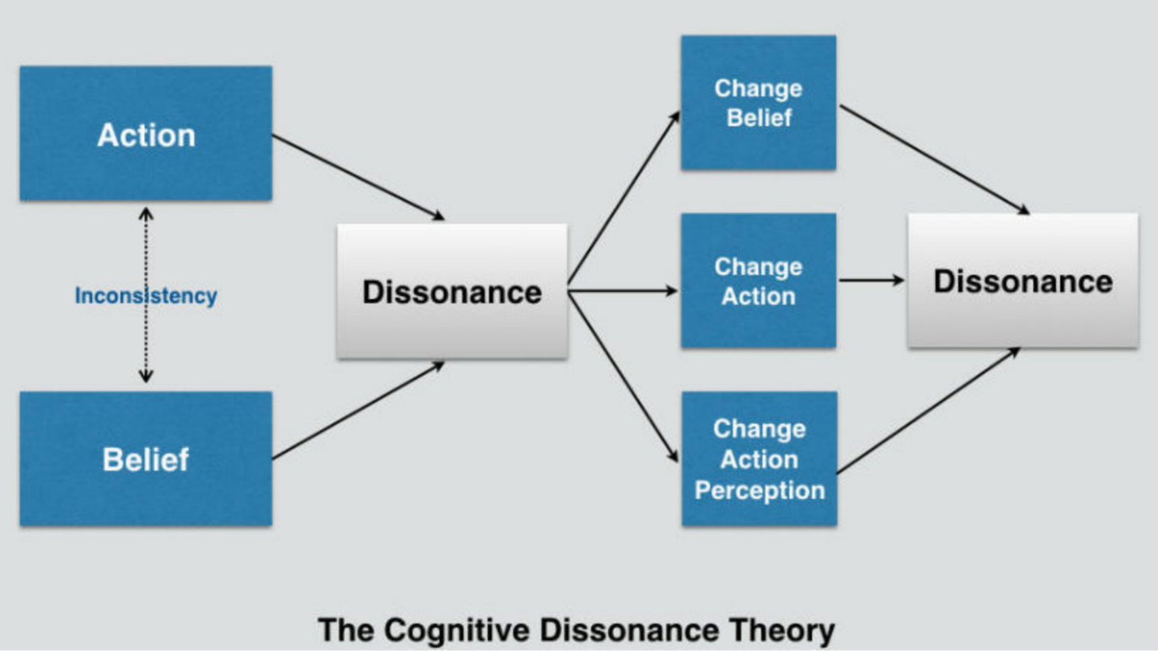
If you did not experience any cognitive dissonance, that’s fine. Do not respond to the prompt #3. Simply move to prompt #4 below.

4)Use one of the following perspectives (a or b) to explain/explore your automatic association(s):

a) Biology of Behavior-
Remember the quote below? No? It’s from the TedTalk on connectomes you watched for the discussion prompt for Chapter 3.

“As you grow during childhood and age during adulthood, your personal identity changes slowly. Likewise, every connectome changes over time. What kinds of changes happen? Well, neurons, like trees, can grow new branches, and they can lose old ones. Synapses can be created, and they can be eliminated. And synapses can grow larger, and they can grow smaller. Second question: what causes these changes? Well, it's true. To some extent, they are programmed by your genes. But that's not the whole story, because there are signals, electrical signals, that travel along the branches of neurons and chemical signals that jump across from branch to branch. These signals are called neural activity. And there's a lot of evidence that neural activity is encoding our thoughts, feelings and perceptions, our mental experiences. And there's a lot of evidence that neural activity can cause your connections to change. And if you put those two facts together, it means that your experiences can change your connectome.”(https://www.ted.com/talks/sebastian_seung_i_am_my_connectome?utm_campaign=tedspread&utm_medium=referral&utm_source=tedcomshare)

Guiding questions and Thoughts: Is it possible that bias is part of your neural network? Use the concepts of connectomes, neuronal transmission, epigenetics and/or nature vs. nurture to explain the results of your IAT.

b) Learning-
Guiding questions and Thoughts: Bias is something we learn and, fortunately, unlearn. Often times we learn it without knowing that we learn it. Use classical conditioning (UC, UR, CS, CR), operant conditioning (shaping, positive/negative reinforcement, punishment, reinforcers), or observational learning (vicarious learning, vicarious punishment, prosocial effects, anti-social effects) explain the results of your IAT. Be sure to use each of the components listed in the parenthesis in your answer.

5)Lastly, take the same IAT you took at the beginning of the semester and submit a screenshot of your results to the IAT Post-MGA dropbox in D2L. Take the Big Five Test again and submit a screenshot of your results and copy the link for results to the Big Five Post-MGA dropbox. Complete the Post-MGA Report. Failure to submit any these assignments by the deadline will result in 20-point deduction from the final score of this Major Graded Assignment.

