ASIA3001 Understanding Asia
Resource link for Affordable Learning Georgia (ALG) Grant for ASIA3001
Course Content: Learning Materials in Seven Units with PDFs + Links + Videos
Asian Studies Program, Kennesaw State University
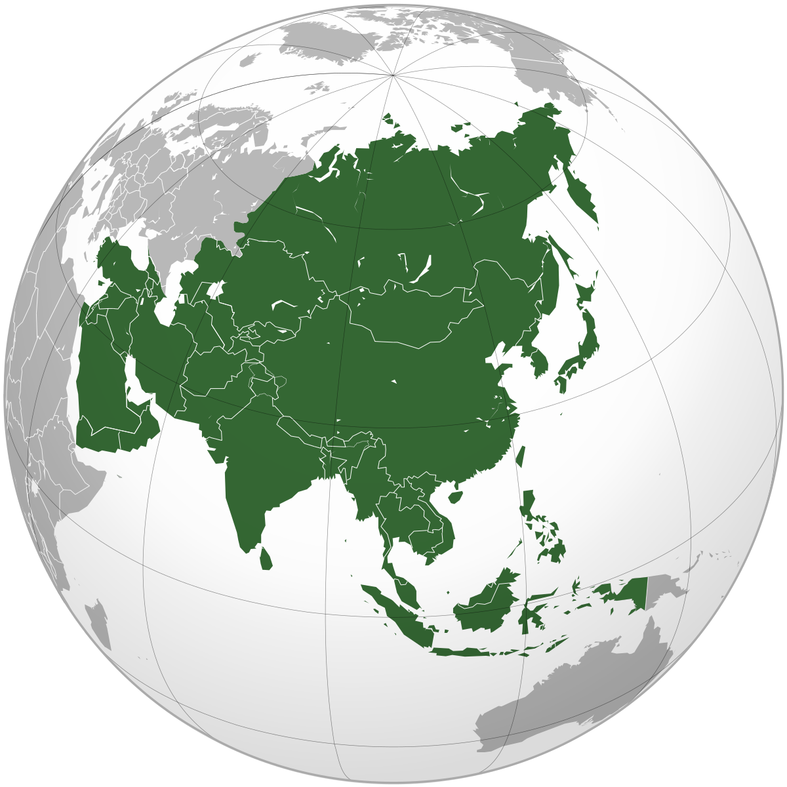

Affordable Learning Georgia (ALG) Grant
Asian Studies Program
Kennesaw State University

Compiled in fall 2023 by
Dr. May Hongmei Gao, Dr. Ginny Zhan, Dr. Sha Huang, and Dr. Hye Won Kim.

All Readings and videos grouped into seven Units:

UNIT #1: Academic and Career Opportunities
Travel to Asia: Work, Study, Life
Unit-1A: Academic Articles

Gao, H. and Womack, D. F. (2007) "Approaching Chinese Culture: Strategies American Expatriates Adopt for Learning Chinese Culture," Global Business Languages: Vol. 12 Article 6. Available at:
https://docs.lib.purdue.edu/gbl/vol12/iss1/6/

Unit-1B: Information Links:
BA in Asian Studies curriculum (new with more flexibility, since August 1, 2023)
Program: Asian Studies, B.A. - Kennesaw State University - Acalog ACMS™
BA in Asian Studies & MBA Double Owl Pathway (You can pay undergraduate tuition for MBA courses)
https://www.kennesaw.edu/double-owl/pathways/rchss/asian-studies-business-administration.php
Asian Studies Minor Curriculum (15-credit) at KSU:
https://catalog.kennesaw.edu/preview_program.php?catoid=38&poid=4667&returnto=3040
How Asians View America (and China), by Brookline Institute
https://www.brookings.edu/articles/how-asians-view-america-and-china/

The Asia Foundation. (2016). Asian Views on America’s Role in Asia. Asian Foundation: The Future of the Rebalance. Available at: https://asiafoundation.org/wp-content/uploads/2016/11/Asian-Views-on-Americas-Role-in-Asia_Nov17.pdf
Hollywood relies on China to stay afloat.
https://www.npr.org/2022/02/21/1081435029/china-hollywood-movies-censorship-erich-schwartzel

Unit-1C: YouTube Videos:
Golden Opportunities for KSU Asian Studies Majors
https://youtu.be/OS0u_y4up7g
Hiring KSU Asian Studies Interns for Success
https://youtu.be/6uR2UaJGMrE

SAUPO 10-year Tribute YouTube Video: https://youtu.be/gqEtQ2Dl1UM
SAUPO 2023 Summary Video: https://youtu.be/SchFmi2lRt4
SAUPO 2022 Summary Video: https://www.youtube.com/watch?v=4JpEsaDOlTc
1-minute video I made with iMovie App about Asian Studies Internship course: https://www.youtube.com/watch?v=nAq8XYCH35s

Episode 2: The Story of India, a Documentary by BBC: (Origin of Buddhism & Non-violence)
https://www.youtube.com/watch?v=F9c7gYcBE8o

Unit #2: Asian Histories, Philosophies, Religions, Art and Cultures
Unit-2A: Academic Articles (4 PDFs)
Bentley, J. (1999). Asia in World History. Education About Asia. V. 4. N. 1. Available at:
Asia in World History

Lubeck, E. B. (2002). Breaking Free: Reflections on Stereotypes in South Asian History. Education About Asia. V. 07:2. Available at:
https://www.asianstudies.org/publications/eaa/archives/breaking-free-reflections-on-stereotypes-in-south-asian-history-2/

Steger, What is Neoliberalism
https://kennesaw.view.usg.edu/d2l/le/content/2718474/viewContent/45376331/View

Nye, J. & Kim, Y. (2019). Soft power and the Korean Wave. in Kim, Y (Ed.) South Korean Popular Culture and North Korea. London. UK: Routledge.
https://kennesaw.view.usg.edu/d2l/le/content/2718474/viewContent/45376333/View

Lee, Sangjoon, A Decade of Hallyu Scholarship
https://kennesaw.view.usg.edu/d2l/le/content/2718474/viewContent/45376332/View

Kim, Suk-Young, K-Pop Live, Ch. 1
https://kennesaw.view.usg.edu/d2l/le/content/2718474/viewContent/45376334/View

Fuller, J. (2010). Hinduism: Ancient or Modern. Education About Asia. V. 15:2
https://www.asianstudies.org/publications/eaa/archives/teaching-modern-hinduism/

Lee, Yasukuni and Hiroshima in Clash
https://kennesaw.view.usg.edu/d2l/le/content/2718474/viewContent/45376326/View

Teaching About Comfort Women
https://kennesaw.view.usg.edu/d2l/le/content/2718474/viewContent/45376328/View

Sneider, The Debate Over Wartime Memory
https://kennesaw.view.usg.edu/d2l/le/content/2718474/viewContent/45376329/View

Nothing Ever Dies Vietnam and the Memory of War
https://kennesaw.view.usg.edu/d2l/le/content/2718474/viewContent/45376330/View

Asian Regionalism, Context and Scope
https://aric.adb.org/emergingasianregionalism/pdfs/Final_ear_chapters/chapter%202.pdf

Unit-2B: Information Links:
Shintoism
https://www.worldhistory.org/Shinto/

Religions in India: Tolerance and Segregation
https://www.pewresearch.org/religion/2021/06/29/religion-in-india-tolerance-and-segregation/

The Life and Ideas of Confucius:
https://www.britannica.com/biography/Confucius

The Three Pillars of Ancient China: Confucianism, Taoism, Buddhism
https://education.nationalgeographic.org/resource/chinese-religions-and-philosophies/

Introduction to Daoism (Taoism)
https://plato.stanford.edu/entries/daoism/

Religion in India: Tolerance and Segregation
https://www.pewresearch.org/religion/2021/06/29/religion-in-india-tolerance-and-segregation/

Language of East and Southeast Asia
https://owlcation.com/humanities/Aural-Identification-of-East-Asian-and-Southeast-Asian-Languages

Meiji Restoration of Japan
https://en.wikipedia.org/wiki/Meiji_Restoration#:~:text=The%20Meiji%20Restoration%20(%E6%98%8E%E6%B2%BB%E7%B6%AD%E6%96%B0,in%201868%20under%20Emperor%20Meiji.

How do Chinese and Japanese view each other?
https://www.pewresearch.org/global/2016/09/13/hostile-neighbors-china-vs-japan/

Economies in Asia
https://www.britannica.com/place/Asia/Economy

The Five Pillars of Islam
https://www.metmuseum.org/learn/educators/curriculum-resources/art-of-the-islamic-world/unit-one/the-five-pillars-of-islam

Main Ideas of Buddhism (PBS)
https://www.pbs.org/edens/thailand/buddhism.htm#:~:text=The%20Four%20Noble%20Truths%20comprise,to%20the%20end%20of%20suffering.

The Heart Sutra
http://webspace.ship.edu/cgboer/heartsutra.html

Hinduism (History website)
https://www.history.com/topics/religion/hinduism

Popular Culture
The Chinese Government’s Unlikeliest Standoff is with… fandom
https://www.vox.com/culture/23404571/china-vs-fandom-danmei-censorship-qinglang-social-media

China erases thousands of social media accounts for vulgarity, negativity and more

https://www.npr.org/2022/03/03/1084310580/china-erases-thousands-of-social-media-accounts-for-vulgarity-negativity-and-mor

Hollywood relies on China to stay afloat. What does that mean for movies?
https://www.npr.org/2022/02/21/1081435029/china-hollywood-movies-censorship-erich-schwartzel

How the Chinese and Japanese View Each Other
https://www.pewresearch.org/global/2016/09/13/hostile-neighbors-china-vs-japan/

China's Belt and Road Initiative: Changing the Rules of Globalization
https://www.researchgate.net/publication/325342944_China%27s_Belt_and_Road_Initiative_Changing_the_Rules_of_Globalization#page=331

Unit-2C: YouTube Videos:
Video: Taiji (Yin & Yang) Demonstration
https://www.youtube.com/watch?v=8TSEnoAa39s

Video: Chinese History in 30 Minutes
https://www.youtube.com/watch?v=Fz_uQNQBK0g

Why Home Depot Failed in China? CNBC interviews Dr. May Gao
https://youtu.be/d7QxeBwWXvY

The History of Asia at a Glimpse
https://youtu.be/3S734SZ4bcc

Confucius the Movie: Chinese with English Subtitles (2-hour)
https://www.youtube.com/watch?v=IM5BiR7PeHA

Bollywood: A Documentary (1-hour)
https://youtu.be/0Sos85PrNuo

Laozi: How to love yourself (17 minutes)
https://youtu.be/TMWaqfaup-0

Taoism: The Power of Letting Go
https://youtu.be/B-F319b5SuQ?si=c3pdHHZNiDeIHB31

A Documentary about Meiji Restoration:
https://youtu.be/oPgypU8iTYA?si=VZlV4-61QnY25vss

A video that introduced Chinese ink painting
https://www.youtube.com/watch?v=wIpLzItqCqk&t=203s

An Online Gallery of Japanese Woodblock Prints
https://www.roningallery.com/collections

The Great Wave off Kanagawa: Famous Japanese Painting
https://www.youtube.com/watch?v=IBcB_dYtGUg

The UK-Qing Opium War in 1840 and 184s2 and their Impact on China
https://youtu.be/62BABCgJSO8?si=MdLyvJaAn3hMJD9_

Unit #3: Doing Business with Asia

List of Asian Economies by GDP:
https://statisticstimes.com/economy/asian-countries-by-gdp.php

The Economy of Asia in Encyclopedia Britannica:
https://www.britannica.com/place/Asia/Economy

Hostile Neighbors: China vs. Japan
https://www.pewresearch.org/global/2016/09/13/hostile-neighbors-china-vs-japan/

Korean Business Culture & Etiquette
https://asialinkbusiness.com.au/republic-of-korea/conducting-business-in-korea/korean-business-culture-and-etiquette?doNothing=1

Japanese Business Culture & Etiquette
https://asialinkbusiness.com.au/japan/conducting-business-in-japan/japanese-business-culture-and-etiquette?doNothing=1

Japanese Business Culture: Five Things You should Know
https://nhglobalpartners.com/japan-business-culture-five-things-you-should-know/

Japanese Culture:
https://culturalatlas.sbs.com.au/japanese-culture/japanese-culture-business-culture

Cultural Atlas website with tips on all cultures:
https://culturalatlas.sbs.com.au/countries

Hollywood Relies on China for Business:
https://www.npr.org/2022/02/21/1081435029/china-hollywood-movies-censorship-erich-schwartzel

Unit-3C: YouTube Videos:
Why Home Depot Failed in China? CNBC interview with Dr. May Gao
https://youtu.be/d7QxeBwWXvY

Chinese Ink painting & Japanese art:
https://www.youtube.com/watch?v=wIpLzItqCqk&t=203s

https://www.youtube.com/watch?v=IBcB_dYtGUg

Chinese tea: The elixir of the orient, made by the Confucius Institute at KSU
https://youtu.be/vTBq19RK5ZM

Modern marvels: The history of tea, by History Channel
https://youtu.be/az5lkJD_MMA

Everything you need to know about Japanese Green Tea
https://youtu.be/0XtC8PnqE7s

Unit #4: Paradigms for Asian Studies:
Orientalisms, Modernity & Globalization

Unit 4A: Academic Publications
Said, E. Orientalism. London, UK: Routledge & Kegan Paul Ltd.
Available at: https://sites.evergreen.edu/politicalshakespeares/wp-content/uploads/sites/33/2014/12/Said_full.pdf

Gao, M. H. (2018). Chapter 17: Globalization 5.0 Led by China: Powered by Positive Frames for BRI. In Zhang, W., Alon, I., and Lattermann, C. (eds.), China's Belt and Road Initiative: Changing the Rules of Globalization. Cham, Switzerland: Palgrave MacMillan. pp. 321-335.
https://www.researchgate.net/publication/325342944_China%27s_Belt_and_Road_Initiative_Changing_the_Rules_of_Globalization#page=331

Sylvia Shin Huey Chong, Orientalism
https://kennesaw.view.usg.edu/d2l/le/content/2718474/viewContent/45329759/View

Yun You, The new Orientalism education policy borrowing and representations of East Asia
https://kennesaw.view.usg.edu/d2l/le/content/2718474/viewContent/45329760/View

David Birch, Chapter 1 The Idea of Asia in Asia: Cultural politics in the global age (2001)
https://kennesaw.view.usg.edu/d2l/le/content/2718474/viewContent/45329860/View

Asian Regionalism
https://aric.adb.org/emergingasianregionalism/pdfs/Final_ear_chapters/chapter%202.pdf

Unit 4B: Information Links
The Meiji Restoration and Modernization
http://afe.easia.columbia.edu/special/japan_1750_meiji.htm

Unit 4C: YouTube Videos
Video: Edward Said and the concept of “Orientalism” explained
https://www.youtube.com/watch?v=RfeAxw502Hs

Why do we say “Asian American” not “Oriental”
https://www.youtube.com/watch?v=1ZJUgv_3IMk

The history of Asian representation in film:
https://www.youtube.com/watch?v=k5KwDTXWgSA

What is “Post-Colonialism?”
https://www.youtube.com/watch?v=c99SbGYKrGw

Unit #5: Gender and sexuality in Asia

Readings
Women in Traditional China - short article in Asia Society
https://asiasociety.org/education/women-traditional-china

Gender and income - Research article on effects of traditional gender attitude and income inequality in China.
https://asiasociety.org/education/women-traditional-china

Gender equality in South Asia -short report from UNICEF
https://www.unicef.org/rosa/what-we-do/gender-equality

Viewings
Men and women’s speech difference in Japanese language - YouTube video
https://www.google.com/search?q=gender+in+japanese+language&rlz=1C1GCEU_enUS873US873&sxsrf=APwXEdehtSlVyX1bU9UfctSQs699Ef6fLA:1683127776099&source=lnms&tbm=vid&sa=X&ved=2ahUKEwjgvtLJu9n-AhVIk2oFHciDDZIQ0pQJegQIBxAE&biw=1600&bih=690&dpr=1.2#fpstate=ive&vld=cid:e6605914,vid:D34dbEfQERc

On her honor: combating inequality in Asian culture - Georgia Tech TED Talk by Aiman Shahab.
https://www.youtube.com/watch?v=nOz5GNlcDR0

Raise the Red Lantern - movie
https://www.google.com/search?q=red+lantern+movie&rlz=1C1GCEU_enUS873US873&sxsrf=APwXEdeu5Lq5I5PuBVNp4xpJjWxdrj1BdA:1683126945472&source=lnms&tbm=vid&sa=X&ved=2ahUKEwi6_ci9uNn-AhUNl2oFHQbADQEQ0pQJegQIBxAE&biw=1600&bih=762&dpr=1.2#fpstate=ive&vld=cid:1581e622,vid:BMwHE8Po-oc
Wiki description: Set in the 1920s, the film tells the story of a young woman who becomes the fourth wife of a wealthy man during the Warlord Era. It is noted for its opulent visuals and sumptuous use of colors. The film was shot in the Qiao Family Compound near the ancient city of Pingyao, in Shanxi Province.
Unit # 6 Languages and Education in Asia

Readings

Languages of East Asia
https://www.milestoneloc.com/languages-of-east-asia/

Languages of East and Southeast Asia
https://owlcation.com/humanities/Aural-Identification-of-East-Asian-and-Southeast-Asian-Languages

Chinese Writing System
https://www.britannica.com/topic/Chinese-writing

The Confucian View: Putting East Asian Education in Context- A short article on the online journal Global Asia
https://www.globalasia.org/v10no2/cover/the-confucian-view-putting-east-asian-education-in-context_cheng-kai-ming

Viewing

Introduction to Japanese Writing System
https://www.youtube.com/watch?v=CFq2Y43DY0U

An introduction to Korean Writing System
https://www.youtube.com/watch?v=pT4k7LC91Cw

The School that turned Chinese(Episode 1): A BBC Document
https://search.alexanderstreet.com/preview/work/bibliographic_entity%7Cvideo_work%7C3366408

Chinese School (Episode 2): A BBC Document
https://www.youtube.com/watch?v=ZxTCVGqP8-c

Unit #7: Contemporary Issues

The Loner in South Korea
https://i-d.vice.com/en/article/d3k75j/the-death-of-romance-and-the-rise-of-the-loner-in-collectivist-south-korea

Lee, Mixed Race Youth in South Korea
https://kennesaw.view.usg.edu/d2l/le/content/2718474/viewContent/45376336/View

Yang, Yuan China's Millennials
https://kennesaw.view.usg.edu/d2l/le/content/2718474/viewContent/45376337/View

McLaughlin, How Milk Tea Became an Anti-China Symbol - The Atlantic
https://kennesaw.view.usg.edu/d2l/le/content/2718474/viewContent/45376338/View

Himawan et al, Asian Single Profiles
https://kennesaw.view.usg.edu/d2l/le/content/2718474/viewContent/45376339/View

China’s Gen Z Is Dejected, Underemployed and Slowing the Economy
https://www.bloomberg.com/news/articles/2022-07-25/xi-s-covid-rules-and-tech-crackdown-push-gen-z-in-china-to-bailan

Korean Marriages Slump to Record Low
https://www.bloomberg.com/news/articles/2023-03-16/korean-marriages-slump-to-fresh-record-low-in-blow-to-fertility

