Affordable Learning Georgia Affordable Materials Grants  
Research Grants Final Report

## Description

Research Projects will end with a Research Report due at the end of the Final Semester of the project. This will be a manuscript that is well-developed, concise, and suitable for publication. Research reports will be shared in an ALG repository under a [Creative Commons Attribution License 4.0.](https://creativecommons.org/licenses/by/4.0/) Supplementary files, such as data sets, will not be shared in the repository.

While there is no specific page limit, award recipients are strongly encouraged to produce succinct Research Reports; these should be written with a broad public audience in mind, including faculty and professional staff of all disciplines. A template will be provided, but an outline is provided here for planning purposes.

# General Information

**Date:** May 13, 2025

**RG Grant Number:** RG012

**Institution Name(s):** Georgia Southern University

**Project Lead: Christine Whitlock**

**Team Members (Name, Title, Department, Institutions if different, and email address for each):**

Christine Whitlock, Department of Biochemistry, Chemistry & Physics, Georgia Southern University, cwhitlock@georgiasouthern.edu

Shainaz Landge, Department of Biochemistry, Chemistry & Physics, Georgia Southern University, [slandge@georgiasouthern.edu](mailto:slandge@georgiasouthern.edu)

Leah Williams, Department of Biochemistry, Chemistry & Physics, Georgia Southern University, [lcwilliams@georgiasouthern.edu](mailto:lcwilliams@georgiasouthern.edu)

Dawn Cannon-Rech, Zach S. Henderson Library, Georgia Southern University, dcannonrech@georgiasouthern.edu

**Course Name(s) and Course Numbers if applicable:**

Organic Chemistry I (CHEM 3401)

Organic Chemistry II (CHEM 3402)

**Semester Project Began:** Spring 2024

**Final Semester:** Spring 2025

# Narrative

As the largest regional university in southeast Georgia serving more than 26,000 students across three campuses, Georgia Southern University (GS) values student learning and equitable access. Lowering the overburdening cost of student expenses in the organic chemistry sequence has the potential to benefit not only low-income students but every STEM major required to take organic chemistry courses. Having no-cost options for students helps to guarantee that each student has access to the critical learning materials needed to succeed. This project investigated resource usage and student outcomes following the implementation of a series of Open Educational Resources (OER), including a textbook, a lab techniques book, homework materials, and light board videos over five years. Data was collected from students under the same instructor at various points of implementation. The impacts of each new OER addition to student usage and student outcomes will be presented.

This study focused on student outcomes and resource usage before and after implementation of OER materials in the Organic Chemistry II course (CHEM 3402) at Georgia Southern University on the Statesboro campus. All students that participated in the study were enrolled in Organic Chemistry II with the corresponding author as the instructor. Only the corresponding author’s courses were selected to remove the effect of different instructors and pedagogical styles on student success in the course. Data was collected across four different semesters to capture the addition of each new resource.

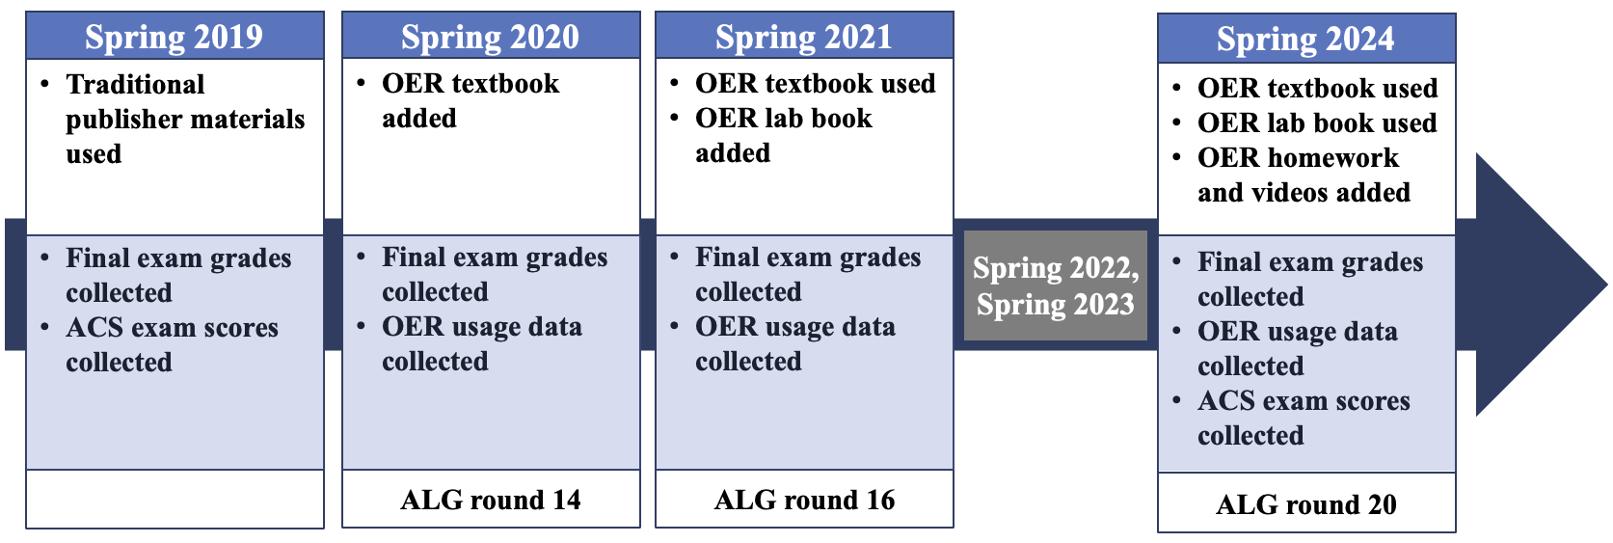

The student usage of newly introduced OER resources is an important variable to consider when considering a change in format of course materials. Equitable access is only accomplished if students access the material. This study demonstrates no statistically significant increase in textbook usage of the publisher-provided materials when compared to the freely available OER materials. This result would suggest that expensive resources are not necessarily advantageous. In addition, it provided faculty the freedom and flexibility to edit OER materials that align with the course objectives and to tailor to students’ needs. This flexibility is not found in traditional publisher provided materials.

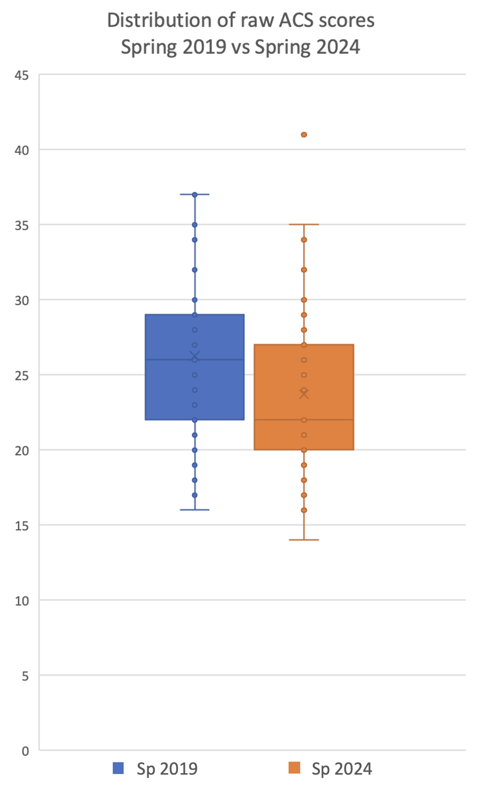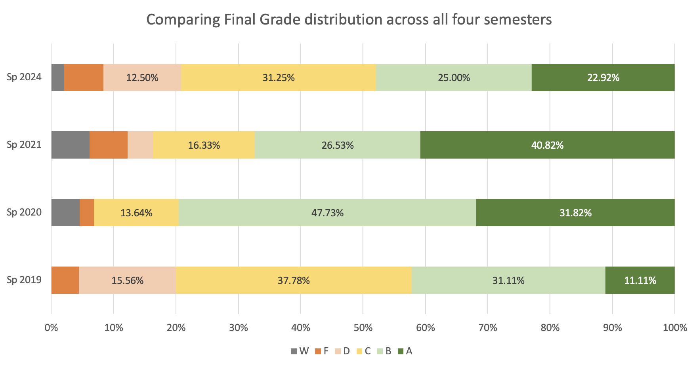

# 2. Resulting Practice Recommendations

* The statistical difference in final grades after each implementation is likely due to the COVID interruption and not actual usage.
* Lower ACS exam scores from Spring 2019 to Spring 2024 are also likely due to a “learning gap” caused by COVID accommodations.
* The low usage of the critical laboratory techniques book must be investigated to determine if students are bypassing the preliminary material all together.

# 3. Future Plans

* Plans are underway to increase student usage of the OER textbook and lab manual, as well as the lightboard videos.
* A poster presentation, entitled “Comparative Study of Usage and Student Outcomes after an Open Educational Resource Implementation in Organic Chemistry,” was presented at the SoTL Commons Conference in Savannah, Georgia (February 2025).
* A publication, entitled “Comparative Study of Usage and Student Outcomes after an Open Educational Resource Implementation in Organic Chemistry,” has been submitted to the Journal of Open Educational Resources in Higher Education.

# 4. Supplementary Files

*Give a description of any supplementary files provided to ALG, such as data sets or figures. Indicate whether these files can be shared with the public.*