## Preface

*A free and open-source calculus*



First and foremost, this text is mostly an adaptation of two very excellent open-source textbooks: *Active Calculus* by Dr. Matt Boelkins and *APEX Calculus* by Drs. Gregory Hartman, Brian Heinold, Troy Siemers, Dimplekumar Chalishajar, and Jennifer Bowen. Both texts can be found at

http://aimath.org/textbooks/approved-textbooks/.

Dr. Boelkins also has a great blog for open source calculus at

https://opencalculus.wordpress.com/.

The authors of this text have combined sections, examples, and exercises from the above two texts along with some of their own content to generate this text. The impetus for the creation of this text was to adopt an open-source textbook for Calculus while maintaining the typical schedule and content of the calculus sequence at our home institution.

Several fundamental ideas in calculus are more than 2000 years old. As a formal subdiscipline of mathematics, calculus was first introduced and developed in the late 1600s, with key independent contributions from Sir Isaac Newton and Gottfried Wilhelm Leibniz. Mathematicians agree that the subject has been understood rigorously since the work of Augustin Louis Cauchy and Karl Weierstrass in the mid 1800s when the field of modern analysis was developed, in part to make sense of the infinitely small quantities on which calculus rests. Hence, as a body of knowledge calculus has been completely understood by experts for at least 150 years. The discipline is one of our great human intellectual achievements: among many spectacular ideas, calculus models how objects fall under the forces of gravity and wind resistance, explains how to compute areas and volumes of interesting shapes, enables us to work rigorously with infinitely small and infinitely large quantities, and connects the varying rates at which quantities change to the total change in the quantities themselves.

While each author of a calculus textbook certainly offers her own creative perspective on the subject, it is hardly the case that many of the ideas she presents are new. Indeed, the mathematics community broadly agrees on what the main ideas of calculus are, as well as their justification and their importance; the core parts of nearly all calculus textbooks are very similar. As such, it is our opinion that in the 21st century - an age where the internet permits seamless and immediate transmission of information - no one should be required to purchase a calculus text to read, to use for a class, or to find a coherent collection of problems to solve. Calculus belongs to humankind, not any individual author or publishing company. Thus, the main purpose of this work is to present a new calculus text that is *free.* In addition, instructors who are looking for a calculus text should have the opportunity to download the source files and make modifications that they see fit; thus this text is *open-source.*

Because the text is free and open-source, any professor or student may use and/or change the electronic version of the text for no charge. Presently, a .pdf copy of the text and its source files may be obtained by download from Github (insert link here!!) This work is licensed under the Creative Commons Attribution-NonCommercial-ShareAlike 4.0 Unported License. The graphic

that appears throughout the text shows that the work is licensed with the Creative Commons, that the work may be used for free by any party so long as attribution is given to the author(s), that the work and its derivatives are used in the spirit of "share and share alike," and that no party may sell this work or any of its derivatives for profit, with the following exception: *it is entirely acceptable for university bookstores to sell bound photocopied copies to students at their standard markup above the copying expense.* Full details may be found by visiting

http://creativecommons.org/licenses/by-nc-sa/4.0/

or sending a letter to Creative Commons, 444 Castro Street, Suite 900, Mountain View, California, 94041, USA.



Page 7

## Acknowledgments

We would like to thank Affordable Learning Georgia for awarding us a Textbook Transformation Grant, which allotted a two-course release for each of us to generate this text. Please see

http://affordablelearninggeorgia.org/

for more information on this initiative to promote student success by providing affordable textbook alternatives.

We will gladly take reader and user feedback to correct them, along with other suggestions to improve the text.

Jared Schlieper & Michael Tiemeyer

This page was intentionally left blank.

## Contents

O Introduction to Calculus 11

0.1 Why do we study calculus?............. 11

0.2 How do we measure velocity?............ 15

1 Limits 23

1.1 The notion of limit.................. 23

1.2 Limits involving infinity............... 41

1.3 Continuity....................... 49

1.4 Epsilon-Delta Definition of a Limit......... 59

2 Derivatives 67

2.1 Derivatives and Rates of Change.......... 67

2.2 The derivative function................ 83

2.3 The second derivative ................ 95

2.4 Basic derivative rules ................. 107

2.5 The product and quotient rules ........... 119

2.6 The chain rule ..................... 135

2.7 Derivatives of functions given implicitly ...... 149

2.8 Derivatives of inverse functions ........... 161

3 Applications of Derivatives 177

3.1 Related rates ...................... 177

3.2 Using derivatives to identify extreme values of a function ........................ 191

3.3 Global Optimization ................. 207

3.4 Applied Optimization ................ 215

3.5 The Mean Value Theorem .............. 225

3.6 The Tangent Line Approximation .......... 231

3.7 Using Derivatives to Evaluate Limits ........ 243

3.8 Newton's Method................... 257

4 Integration 265

4. 1 Determining distance traveled from velocity . . . 265

4.2 Riemann Sums .................... 277

4.3 The Definite Integral................. 291

4.4 The Fundamental Theorem of Calculus, Part I . . 303

4.5 The Fundamental Theorem of Calculus, part II . . 313

4.6 Integration by Substitution ............. 329

4.7 More with Integrals.................. 343

5 Topics of Integration 353

5.1 Integration by Parts.................. 353

5.2 Trigonometric Integrals................ 367

5.3 Trigonometric Substitution.............. 377

5.4 Partial Fractions.................... 385

5.5 Improper Integrals .................. 395

5.6 Numerical Integration ................ 409

5.7 Other Options for Finding Antiderivatives . . . . 427

6 Applications of Integration 433

6.1 Using Definite Integrals to Find Volume...... 433

6.2 Volume by The Shell Method ............ 445

6.3 Arc Length and Surface Area ............ 453

6.4 Density, Mass, and Center of Mass ......... 463

6.5 Physics Applications: Work, Force, and Pressure . 473

6.6 An Introduction to Differential Equations ..... 491

6.7 Separable differential equations ........... 505

6.8 Hyperbolic Functions ................. 521

7 Sequences & Series 529

7. 1 Sequences ....................... 529

A A Short Table of Integrals 539



# Chapter 6

*Applications of Integration*

## 6.1 Using Definite Integrals to Find Volume

### Motivating Questions

*In this section, we strive to understand the ideas generated by the following important questions:*

• How can we use a definite integral to find the volume of a three-dimensional solid of revolution that results from revolving a two-dimensional region about a particular axis?

• In what circumstances do we integrate with respect to *y* instead of integrating with respect to *x?*

• What adjustments do we need to make if we revolve about a line other than the *x-* or y-axis?

### Introduction

Figure 6.1: A right circular cylinder.

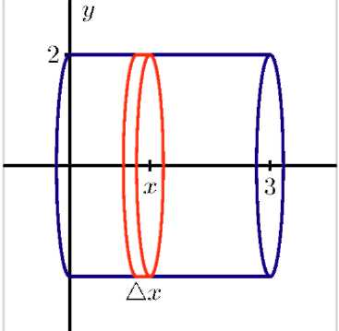

Just as we can use definite integrals to add up the areas of rectangular slices to find the exact area that lies between two curves, we can also employ integrals to determine the volume of certain regions that have cross-sections of a particular consistent shape. As a very elementary example, consider a cylinder of radius 2 and height 3, as pictured in Figure 6.19. While we know that we can compute the area of any circular cylinder by the formula



if we think about slicing the cylinder into thin pieces, we see that each is a cylinder of radius r = 2 and height (thickness)



Hence, the volume of a representative slice is

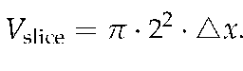

Letting



and using a definite integral to add the volumes of the slices, we find that

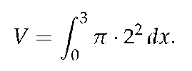

Moreover, since

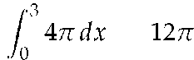

we have found that the vol-

ume of the cylinder is



The principal problem of interest in

our upcoming work will be to find the volume of certain solids whose cross-sections are all thin cylinders (or washers) and to do so by using a definite integral. To that end, we first consider another familiar shape in Preview Activity 6.1: a circular cone.

### Preview Activity 6.1

Figure 6.2: The circular cone described in Preview Activity 6.1

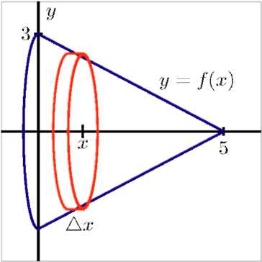

Consider a circular cone of radius 3 and height 5, which we view horizontally as pictured in Figure 6.2. Our goal in this activity is to use a definite integral to determine the volume of the cone.

(a) Find a formula for the linear function *y = f(x)* that is pictured in Figure 6.2.

(b) For the representative slice of thickness



that is located horizontally at a location x (somewhere between *x* = 0 and *x* = 5), what is the radius of the representative slice? Note that the radius depends on the value of x.

(c) What is the volume of the representative slice you found in (b)?

(d) What definite integral will sum the volumes of the thin slices across the full horizontal span of the cone? What is the exact value of this definite integral?

(e) Compare the result of your work in (d) to the volume of the cone that comes from using the formula



### The Volume of a Solid of Revolution

A solid of revolution is a three dimensional solid that can be generated by revolving one or more curves around a fixed axis. For example, we can think of a circular cylinder as a solid of revolution: in Figure 6.19, this could be accomplished by revolving the line segment from (0,2) to (3,2) about the x-axis. Likewise, the circular cone in Figure 6.2 is the solid of revolution generated by revolving the portion of the line



from *x =* 0

to *x =* 5 about the x-axis. It is particularly important to notice in any solid of revolution that if we slice the solid perpendicular to the axis of revolution, the resulting cross-section is circular.

We consider two examples to highlight some of the natural issues that arise in determining the volume of a solid of revolution.

Example 1

Find the volume of the solid of revolution generated when the region *R* bounded by *y* = 4 — *x2* and the x-axis is revolved about the x-axis.

Solution. First, we observe that *y* = 4 — x2 intersects the x-axis at the points (—2,0) and (2,0). When we take the region *R* that lies between the curve and the x-axis on this interval and revolve it about the x-axis, we get the three-dimensional solid pictured in Figure 6.3.

Taking a representative slice of the solid located at a value *x* that lies between *x = —2* and *x = 2,* we see that the thickness of such a slice is



(which is also the height of the cylinder-shaped slice), and that the

radius of the slice is determined by the curve



Hence, we find

that



since the volume of a cylinder of radius *r* and height *h* is



Using a definite integral to sum the volumes of the representative slices, it follows that

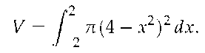

It is straightforward to evaluate the integral and find that the volume is



Figure 6.3: The solid of revolution in Example 1.

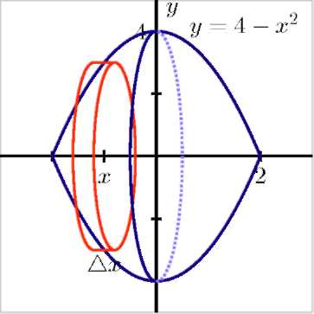

For a solid such as the one in Example 1, where each cross-section is a cylindrical disk, we first find the volume of a typical cross-section (noting particularly how this volume depends on *x),* and then we integrate over the range of x-values through which we slice the solid in order to find the exact total volume. Often, we will be content with simply finding the integral that represents the sought volume; if we desire a numeric value for the integral, we typically use a calculator or computer algebra system to find that value.

The general principle we are using to find the volume of a solid of revolution generated by a single curve is often called the *disk method.*

### Disk Method

If *y = r(x)* is a nonnegative continuous function on *[a,b],* then the volume of the solid of revolution generated by revolving the curve about the x-axis over this interval is given by

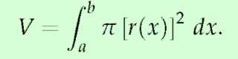

Example 2

Find the volume of the solid formed by revolving the curve y *= 1/x,* from *x* = 1 to *x = 2,* about the y-axis.

Solution. Since the axis of rotation is vertical, we need to convert the function into a function of *y* and convert the x-bounds to y-bounds. Since y = 1*1x* defines the curve, we rewrite it as *x = 1/y.* The bound *x* = 1 corresponds to the y-bound y = 1, and the bound *x = 2* corresponds to

the y-bound *y =* 1/2.

Thus we are rotating the curve *x =* 1/y, from y = 1/2 to y = 1 about the y-axis to form a solid. The curve and sample differential element are sketched in Figure 6.4-(a), with a full sketch of the solid in Figure 6.4-(b).

We integrate to find the volume:

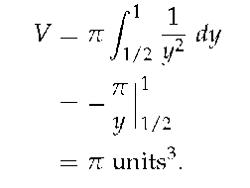

A different type of solid can emerge when two curves are involved, as we see in the following example.

Figure 6.4: Sketching the solid in Example 2.

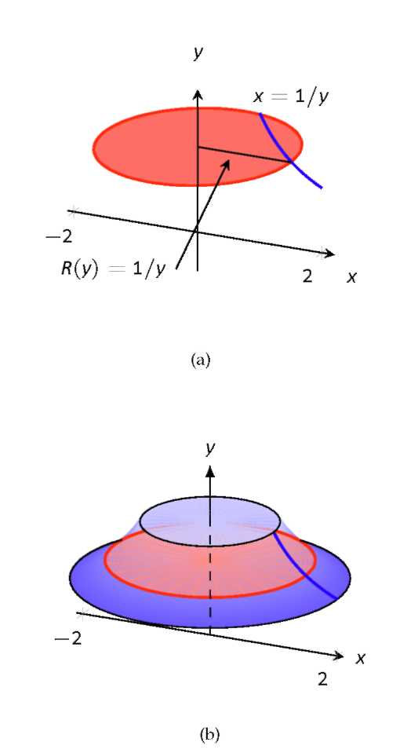

Example 3

Find the volume of the solid of revolution generated when the finite region R that lies between



and y = x + 2 is revolved about the

x-axis.

Figure 6.5: At left, the solid of revolution in Example 3. At right, a typical slice with inner radius r(x) and outer radius R(x).

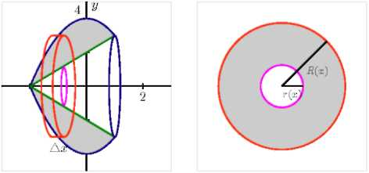

Solution. First, we must determine where the curves



and

y = x + 2 intersect. Substituting the expression for y from the second equation into the first equation, we find that



Rearranging,

it follows that



and the solutions to this equation are x = —2 and x = 1. The curves therefore cross at (—2,0) and (1,1).

When we take the region R that lies between the curves and revolve it about the x-axis, we get the three-dimensional solid pictured at left in Figure 6.5.

Immediately we see a major difference between the solid in this example and the one in Example 2: here, the three-dimensional solid of revolution isn't "solid" in the sense that it has open space in its center. If we slice the solid perpendicular to the axis of revolution, we observe that in this setting the resulting representative slice is not a solid disk, but rather a *washer,* as pictured at right in Figure 6.5. Moreover, at a given location x between x = —2 and x = 1, the small radius r(x) of the inner circle is determined by the curve y = x + 2, so r(x) = x + 2. Similarly, the big radius R( x) comes from the function



and

thus



Thus, to find the volume of a representative slice, we compute the volume of the outer disk and subtract the volume of the inner disk. Since



it follows that the volume of a typical slice is



Hence, using a definite integral to sum the volumes of the respective

slices across the integral, we find that

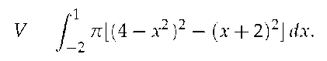

Evaluating the integral, the volume of the solid of revolution is *V =*



The general principle we are using to find the volume of a solid of revolution generated by a single curve is often called the *washer method.*

### Washer Method

If y = *R(x)* and y = r(x) are nonnegative continuous functions on [a, b] that satisfy



for all x in [a, b], then the volume of the solid of revolution generated by revolving the region between them about the *x*-axis over this interval is given by

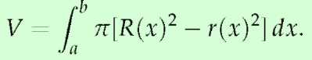

### Activity 6.1-1

In each of the following questions, draw a careful, labeled sketch of the region described, as well as the resulting solid that results from revolving the region about the stated axis. In addition, draw a representative slice and state the volume of that slice, along with a definite integral whose value is the volume of the entire solid.

(a) The region S bounded by the x-axis, the curve



and the line

x = 4; revolve S about the x-axis.

(b) The region *S* bounded by the *x*-axis, the curve



and the line

y = 2; revolve S about the x-axis.

(c) The finite region S in the first quadrant bounded by the curves y =



and



revolve S about the x-axis.

(d) The finite region S bounded by the curves



and y =



revolve S about the x-axis.

(e) The region S bounded by the y-axis, the curve



and the line

y = 2; revolve S about the y-axis. How does the problem change considerably when we revolve about the y-axis?

Revolving about the y-axis

As seen in Activity 6.1-1, problem (e), the problem changes considerably when we revolve a given region about the y-axis. Foremost, this is due to the fact that representative slices now have

thickness



which means that it becomes necessary to integrate with respect to *y.* Let's consider a particular example to demonstrate some of the key issues.

Example 4

Find the volume of the solid of revolution generated when the finite region *R* that lies between



and



is revolved about the

y-axis.

Figure 6.6: At left, the solid of revolution in Example 4. At right, a typical slice with inner radius *r(y)* and outer radius *R(y).*

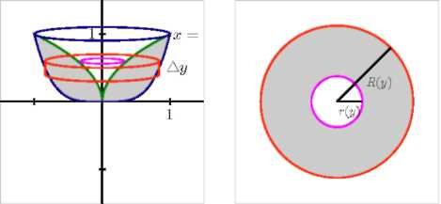

Solution. We observe that these two curves intersect when *x* = 1, hence at the point (1,1). When we take the region *R* that lies between the curves and revolve it about the y-axis, we get the three-dimensional solid pictured at left in Figure 6.6.

Now, it is particularly important to note that the thickness of a representative slice is



and that the slices are only cylindrical washers in nature when taken perpendicular to the y-axis. Hence, we envision slicing the solid horizontally, starting at y = 0 and proceeding up to y = 1. Because the inner radius is governed by the curve



but from the

perspective that *x* is a function of y, we solve for *x* and get



In the same way, we need to view the curve



(which governs the

outer radius) in the form where *x* is a function of y, and hence



Therefore, we see that the volume of a typical slice is



Using a definite integral to sum the volume of all the representative slices from y = 0 to y = 1, the total volume is

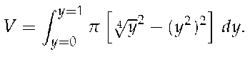

It is straightforward to evaluate the integral and find that

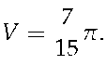

### Activity 6.1-2

In each of the following questions, draw a careful, labeled sketch of the region described, as well as the resulting solid that results from revolving the region about the stated axis. In addition, draw a representative slice and state the volume of that slice, along with a definite integral whose value is the volume of the entire solid.

(a) The region *S* bounded by the y-axis, the curve



and the line

y = 2; revolve S about the y-axis.

(b) The region *S* bounded by the x-axis, the curve



and the line

*x* = 4; revolve S about the y-axis.

(c) The finite region S in the first quadrant bounded by the curves y = *2x* and



revolve *S* about the x-axis.

(d) The finite region S in the first quadrant bounded by the curves y = *2x* and



revolve *S* about the y-axis.

(e) The finite region *S* bounded by the curves



and y =

x — 1; revolve S about the y-axis

Revolving about horizontal and vertical lines other than the coordinate axes

Just as we can revolve about one of the coordinate axes (y = 0 or x = 0), it is also possible to revolve around any horizontal or vertical line. Doing so essentially adjusts the radii of cylinders or washers involved by a constant value. A careful, well-labeled plot of the solid of revolution will usually reveal how the different axis of revolution affects the definite integral we set up. Again, an example is instructive.

Example 5

Find the volume of the solid of revolution generated when the finite region S that lies between



and y = x is revolved about the line

y = —1.

Figure 6.7: The solid of revolution described in Example 5.

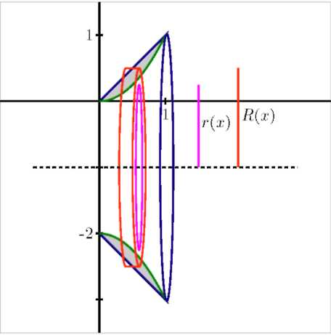

Solution. Graphing the region between the two curves in the first quadrant between their points of intersection ((0, 0) and (1, 1)) and then revolving the region about the line y = — 1, we see the solid shown in Figure 6.7. Each slice of the solid perpendicular to the axis of revolution is a washer, and the radii of each washer are governed by the curves



and y = x. But we also see that there is one added change: the axis of revolution adds a fixed length to each radius. In particular, the inner radius of a typical slice, r(x), is given by



while the

outer radius is *R(x) = x* + 1. Therefore, the volume of a typical slice is



Finally, we integrate to find the total volume, and

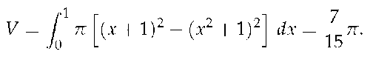

### Activity 6.1-3

In each of the following questions, draw a careful, labeled sketch of the region described, as well as the resulting solid that results from revolving the region about the stated axis. In addition, draw a representative slice and state the volume of that slice, along with a definite integral whose value is the volume of the entire solid. For each prompt, use the finite region S in the first quadrant bounded by the curves y = 2x and



(a) Revolve S about the line y = —2.

(b) Revolve S about the line y = 4.

(c) Revolve S about the line x = —1.

(d) Revolve S about the line x = 5.

### Volumes of Other Solids

Given an arbitrary solid, we can approximate its volume by cutting it into n thin slices. When the slices are thin, each slice can be approximated well by a general right cylinder. Thus the volume of each slice is approximately its cross-sectional area x thickness. (These slices are the differential elements.)

By orienting a solid along the x-axis, we can let



repre-

sent the cross-sectional area of the ith slice, and let



represent

the thickness of this slice (the thickness is a small change in x). The total volume of the solid is approximately:

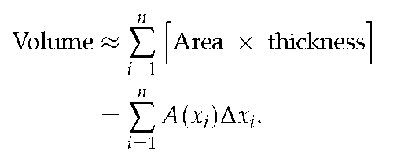

Recognize that this is a Riemann Sum. By taking a limit (as the thickness of the slices goes to 0) we can find the volume exactly.

### Volume By Cross-Sectional Area

The volume V of a solid, oriented along the x-axis with cross-sectional area A(x) from x = a to x = b, is

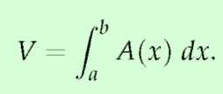

Figure 6.8: Orienting a pyramid along the x-axis in Example 6.

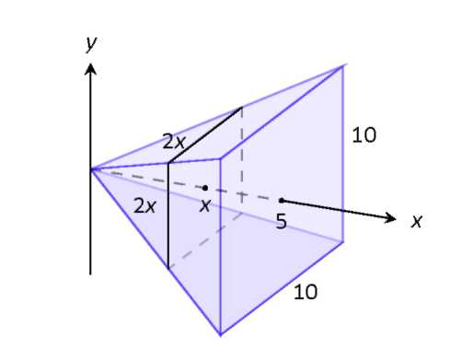

Example 6

Find the volume of a pyramid with a square base of side length 10 in and a height of 5 in.

Solution. There are many ways to "orient" the pyramid along the x-axis; Figure 6.8 gives one such way, with the pointed top of the pyramid at the origin and the x-axis going through the center of the base.

Each cross section of the pyramid is a square; this is a sample differential element. To determine its area A(x), we need to determine the side lengths of the square.

When x = 5, the square has side length 10; when x = 0, the square has side length 0. Since the edges of the pyramid are lines, it is easy to figure that each cross-sectional square has side length 2x, giving A(x) =



We have

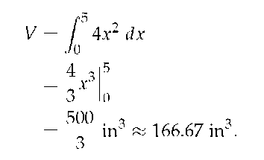

We can check our work by consulting the general equation for the volume of a pyramid (see the back cover under "Volume of A General Cone"):

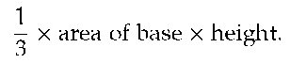

Certainly, using this formula from geometry is faster than our new method, but the calculus-based method can be applied to much more than just cones.

### Summary

*In this section, we encountered the following important ideas:*

• We can use a definite integral to find the volume of a three-dimensional solid of revolution that results from revolving a two-dimensional region about a particular axis by taking slices perpendicular to the axis of revolution which will then be circular disks or washers.

• If we revolve about a vertical line and slice perpendicular to that line, then our slices are horizontal and of

thickness



This leads us to integrate with respect to *y,* as opposed to with respect to *x* when we slice a solid vertically.

• If we revolve about a line other than the *x-* or *y*-axis, we need to carefully account for the shift that occurs in the radius of a typical slice. Normally, this shift involves taking a sum or difference of the function along with the constant connected to the equation for the horizontal or vertical line; a well-labeled diagram is usually the best way to decide the new expression for the radius.

### Exercises

Terms and Concepts

1) T/F: A solid of revolution is formed by revolving a shape around an axis.

2) In your own words, explain how the Disk and Washer Methods are related.

3) Explain the how the units of volume are found in the integral: if A(x) has units of in2, how does



have units of in3?

### Problems

In Exercises 4-7, a region of the Cartesian plane is shaded. Use the Disk/Washer Method to find the volume of the solid of revolution formed by revolving the region about the x-axis.

In Exercises 8-11, a region of the Cartesian plane is shaded. Use the Disk/Washer Method to find the volume of the solid of revolution formed by revolving the region about the y-axis.

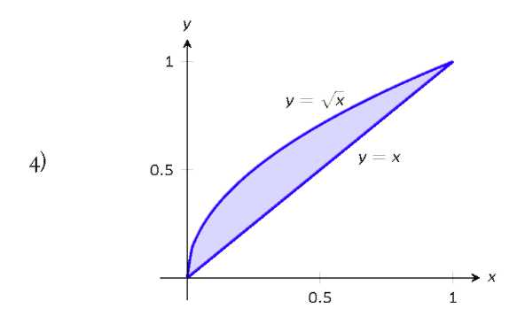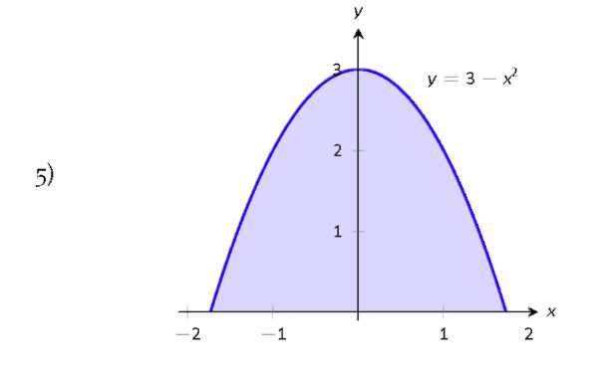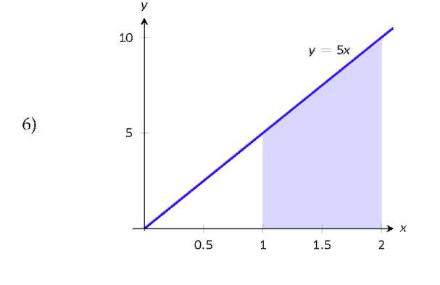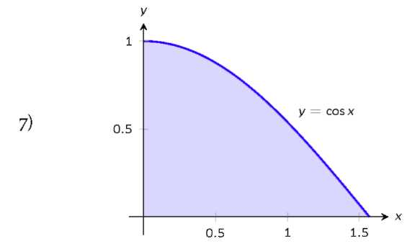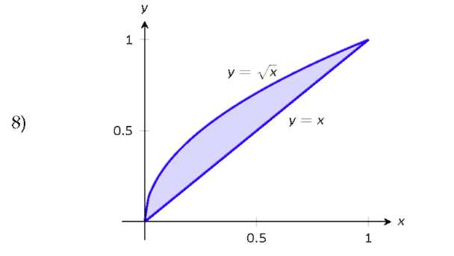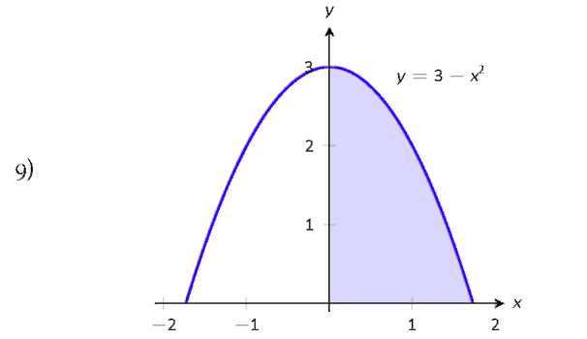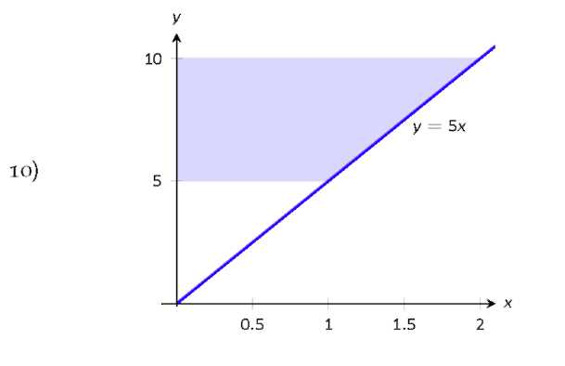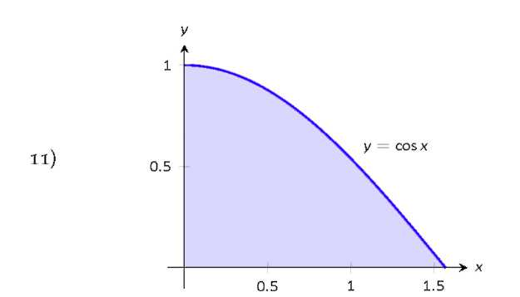

(Hint: Integration By Parts will be necessary, twice.

First let



then let *u* = arccos *x.)*

In Exercises 12-17, a region of the Cartesian plane is described. Use the Disk/Washer Method to find the volume of the solid of revolution formed by rotating the region about each of the given axes.

12) Region bounded by:



*y =* 0 and *x =* 1.

Rotate about:

(a) the *x*-axis

(b) *y* = 1

(c) the *y*-axis

(d) *x* = 1

13) Region bounded by:



and *y* = 0.

Rotate about:

(a) the *x*-axis

(b) *y =* 4

(c) *y =* —1

(d) *x* = 2

14) The triangle with vertices (1,1), (1,2) and (2,1). Rotate about:

(a) the *x*-axis

(b) *y* = 2

(c) the *y*-axis

(d) *x* = 1

15) Region bounded by



and *y* = 2*x* — 1.

Rotate about:

(a) the *x*-axis

(b) *y* = 1

(c) *y =* 5

16) Region bounded by



*x =* —1, *x =* 1

and the *x*-axis. Rotate about:

(a) the *x*-axis

(b) *y* = 1

(c) *y =* —1

17) Region bounded by *y =* 2x, *y = x* and *x =* 2. Rotate about:

(a) the *x*-axis

(b) *y* = 4

(c) the *y*-axis

(d) *x* = 2

In Exercises 18-21, a solid is described. Orient the solid along the x-axis such that a cross-sectional area function *A(x)* can be obtained, then find the volume of the solid.

18) A right circular cone with height of 10 and base radius of 5.

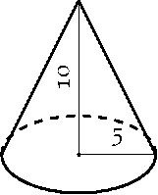

19) A skew right circular cone with height of 10 and base radius of 5. (Hint: all cross-sections are circles.)

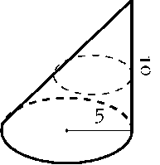

20) A right triangular cone with height of 10 and whose base is a right, isosceles triangle with side length 4.

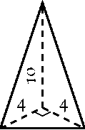

21) A solid with length 10 with a rectangular base and triangular top, wherein one end is a square with side length 5 and the other end is a triangle with base and height of 5.

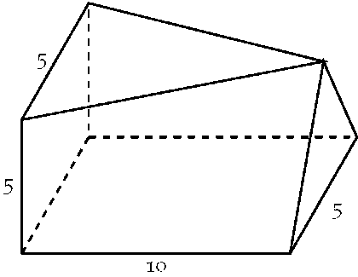

This page was intentionally left blank

## 6.2 Volume by The Shell Method

### Motivating Questions

In this section, we strive to understand the ideas generated by the following important questions:

• Is there other methods to use a definite integral to find the volume of a three-dimensional solid or a solid of revolution that results from revolving a two-dimensional region about a particular axis?

• In what circumstances do we integrate with respect to y instead of integrating with respect to x?

• When is it better to use the Shell Method as oppossed to the Washer Method?

### Introduction

Often a given problem can be solved in more than one way. A particular method may be chosen out of convenience, personal preference, or perhaps necessity. Ultimately, it is good to have options.

The previous section introduced the Disk and Washer Methods, which computed the volume of solids of revolution by integrating the cross-sectional area of the solid. This section develops another method of computing volume, the Shell Method. Instead of slicing the solid perpendicular to the axis of rotation creating cross-sections, we now slice it parallel to the axis of rotation, creating "shells."

The Preview Activity 6.2 introduces a situation where using the Washer Method from Section 6.1 becomes very tedious.

### Preview Activity 6.2

Figure 6.9: The circular cone described in Preview Activity 6.2

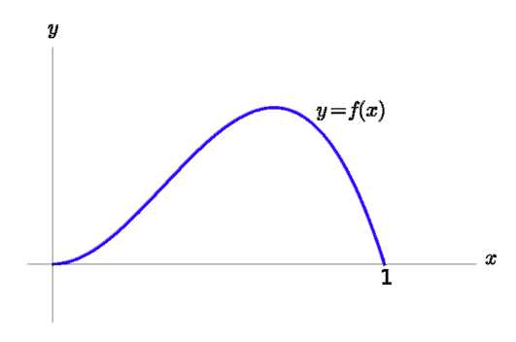

Consider the function



whose graph is in Figure 6.9. Our goal in this activity is to use a definite integral to determine the volume of the solid formed by revolving the region bounded by f (x) and y = 0 about the y-axis.

(a) Using the Washer Method, find an expression for the inner and outer radii of a slice.

(b) Set up a definite integral to find the volume. If you try to evaluate the integral, what do you notice that happens?

(c) Find where the local maximum occurs.

(d) Use the results of past c) to split the solid into two pieces. Set up two definite integrals to find the volume of the original solid.

Consider Figure 6.1o-(a), where the region shown rotated around the y-axis forming the solid shown in Figure 6.10-(b). A small slice of the region is drawn in Figure 6.1o-(a), parallel to the axis of rotation. When the region is rotated, this thin slice forms a cylindrical shell, as pictured in Figure 6.1o-(c). The

previous section approximated a solid with lots of thin disks (or washers); we now approximate a solid with many thin cylindrical shells.

Figure 6.10: Introducing the Shell Method.

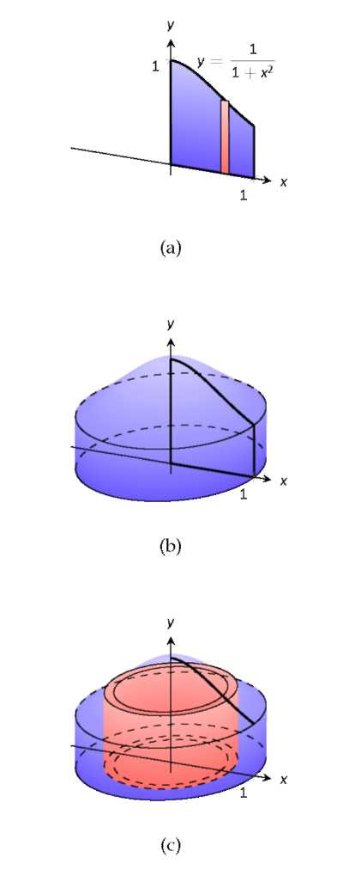

To compute the volume of one shell, first consider the paper label on a soup can with radius r and height *h.* What is the area of this label? A simple way of determining this is to cut the label and lay it out flat, forming a rectangle with height *h* and length



Thus the area is



see Figure 6.11-(a).

Figure 6.11: Determining the volume of a thin cylindrical shell.

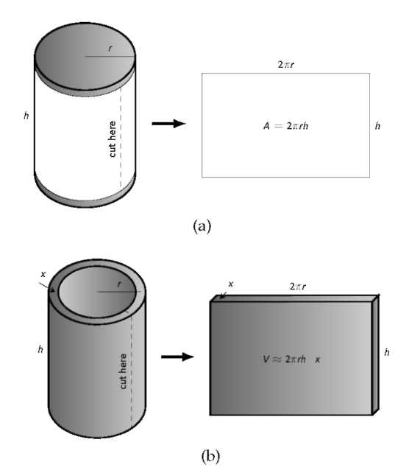

Do a similar process with a cylindrical shell, with height *h,* thickness



and approximate radius r. Cutting the shell and

laying it flat forms a rectangular solid with length



height

*h* and depth



Thus the volume is



see Figure 6.11-(b). (We say "approximately" since our radius was an approximation.)

By breaking the solid into *n* cylindrical shells, we can approximate the volume of the solid as

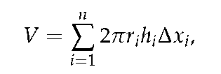

where ri, *hi* and



are the radius, height and thickness of the *i*th shell, respectively.

This is a Riemann Sum. Taking a limit as the thickness of the shells approaches 0 leads to a definite integral.

### The Shell Method

Let a solid be formed by revolving a region *R,* bounded by *x = a* and *x = b,* around a vertical axis. Let *r(x)* represent the distance from the axis of rotation to *x* (i.e., the radius of a sample shell) and let *h(x)* represent the height of the solid at *x* (i.e., the height of the shell). The volume of the solid is

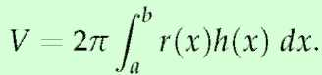

Special Cases:

1) When the region *R* is bounded above by *y = f(x)* and below by *y = g(x),* then *h(x) = f(x) — g(x).*

2) When the axis of rotation is the y-axis (i.e., *x =* 0) then *r(x) = x.*

Let's practice using the Shell Method.

Example 1

Find the volume of the solid formed by rotating the region bounded by

y = 0



*x* = 0 and *x* = 1 about the y-axis.

Figure 6.12: Graphing a region in Example 1.

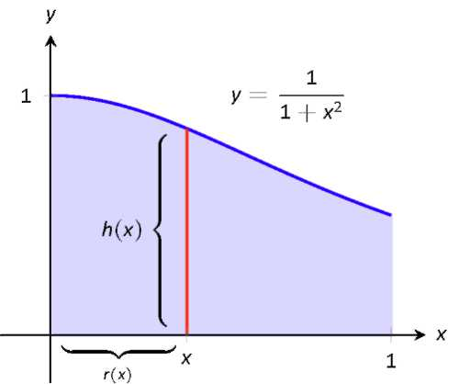

Solution. This is the region used to introduce the Shell Method in Figure 6.10, but is sketched again in Figure 6.12 for closer reference. A line is drawn in the region parallel to the axis of rotation representing a shell that will be carved out as the region is rotated about the y-axis. (This is the differential element.)

The distance this line is from the axis of rotation determines r(x); as the distance from x to the y-axis is x, we have r(x) = x. The height of this line determines h(x); the top of the line is at



whereas the

bottom of the line is at y = 0. Thus



The region is bounded from x = 0 to x = 1, so the volume is

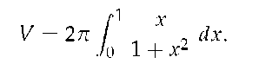

This requires substitution. Let



so *du* = 2x *dx.* We also change the bounds: u(0) = 1 and u(1) = 2. Thus we have:

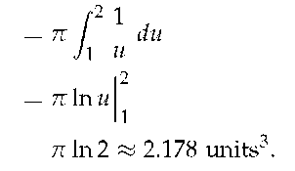

Note: in order to find this volume using the Disk Method, two integrals would be needed to account for the regions above and below y = 1/2.

With the Shell Method, nothing special needs to be accounted for to compute the volume of a solid that has a hole in the middle, as demonstrated next.

Example 2

Find the volume of the solid formed by rotating the triangular region determined by the points (0,1), (1,1) and (1,3) about the line x = 3.

Figure 6.13: Graphing a region in Example 2.

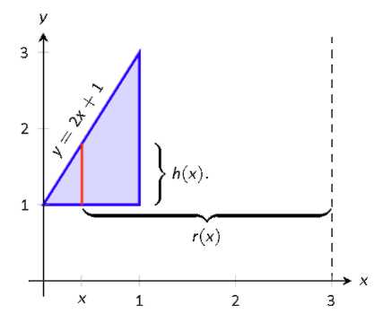

Solution. The region is sketched in Figure 6.13 along with the differential element, a line within the region parallel to the axis of rotation.

The height of the differential element is the distance from y = 1 to y = 2x + 1, the line that connects the points (0,1) and (1,3). Thus h(x) = 2x + 1 — 1 = 2x. The radius of the shell formed by the differential element is the distance from x to x = 3; that is, it is r(x) = 3 — x. The

x-bounds of the region are x = 0 to x = 1, giving

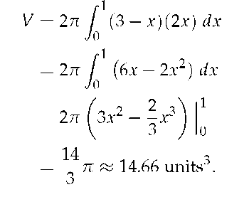

Figure 6.14: Graphing a region in Example 2.

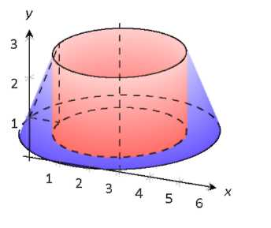

### Activity 6.2-1

In each of the following questions, draw a careful, labeled sketch of the region described, as well as the resulting solid that results from revolving the region about the stated axis. In addition, draw a representative slice and state the volume of that slice, along with a definite integral whose value is the volume of the entire solid. It is not necessary to evaluate the integrals you find.

(a) The region S bounded by the y-axis, the curve



and the line

y = 2; revolve S about the y-axis.

(b) The region S bounded by the x-axis, the curve



and the line

x = 4; revolve S about the y-axis.

(c) The finite region S in the first quadrant bounded by the curves y = 2x and



revolve S about the y-axis.

(d) The finite region S bounded by the curves



and y =

x — 1; revolve S about the y-axis.

(e) How do you answers to this activity compare to the results of Ac-tivty 6.1-2?

When revolving a region around a horizontal axis, we must consider the radius and height functions in terms of y, not x.

Example 3

Find the volume of the solid formed by rotating the region given in Example 2 about the x-axis.

Figure 6.15: Graphing a region in Example 3.

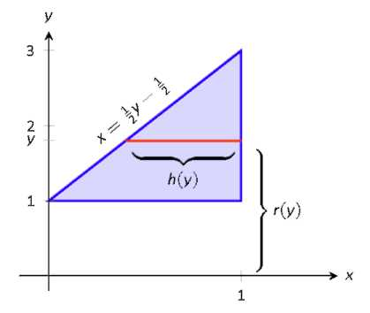

Solution. The region is sketched in Figure 6.15 with a sample differential element and the solid is sketched in Figure 6.16. (Note that the region looks slightly different than it did in the previous example as the bounds on the graph have changed.)

The height of the differential element is an x-distance, between x =



and x = 1. Thus



The radius is

the distance from y to the x-axis, so r(y) = y. The y bounds of the region are y = 1 and y = 3, leading to the integral

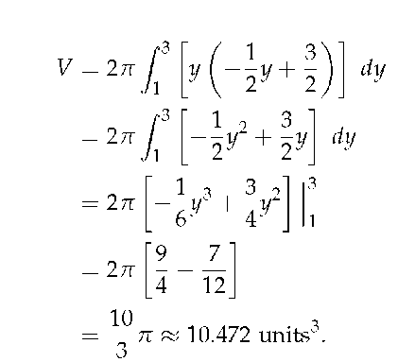

Figure 6.16: Graphing a region in Example 3.

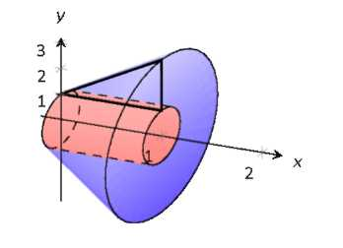

### Activity 6.2-2

In each of the following questions, draw a careful, labeled sketch of the region described, as well as the resulting solid that results from revolving the region about the stated axis. In addition, draw a representative slice and state the volume of that slice, along with a definite integral whose value is the volume of the entire solid. It is not necessary to evaluate the integrals you find.

(a) The region S bounded by the y-axis, the curve



and the line

y = 2; revolve S about the y-axis.

(b) The region S bounded by the x-axis, the curve



and the line

*x =* 4; revolve S about the y-axis.

(c) The finite region S in the first quadrant bounded by the curves y = 2x and



revolve S about the x-axis.

(d) The finite region S in the first quadrant bounded by the curves y = 2x and



revolve S about the y-axis.

(e) The finite region S bounded by the curves



and y =

x — 1; revolve S about the y-axis

At the beginning of this section it was stated that "it is good to have options." The next example finds the volume of a solid rather easily with the Shell Method, but using the Washer Method would be quite a chore.

Example 4

Find the volume of the solid formed by revolving the region bounded by y = sin(x) and the x-axis from x = 0 to



about the y-axis.

Figure 6.17: Graphing a region in Example 4.

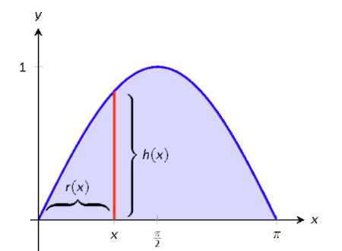

Solution. The region and the resulting solid are given in Figure 6.17 and Figure 6.18 respectively.

The radius of a sample shell is r(x) = x; the height of a sample shell is h(x) = sin(x), each from x = 0 to



Thus the volume of the solid

is

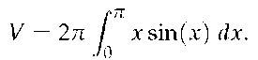

Figure 6.18: Graphing a region in Example 4.

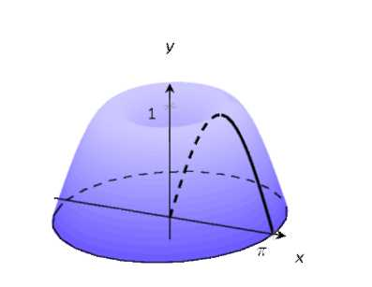

This requires Integration By Parts. Set *u = x* and *dv =* sin(x) dx; we leave it to the reader to fill in the rest. We have:

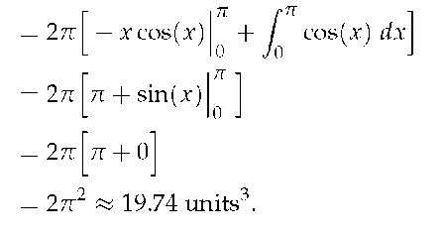

Note that in order to use the Washer Method, we would need to solve *y* = sin( *x)* for *x,* requiring the use of the arcsine function. We leave it to the reader to verify that the outside radius function is *R( y)* = *n —* arcsin(y) and the inside radius function is *r(y) =* arcsin(y). Thus the volume can be computed as

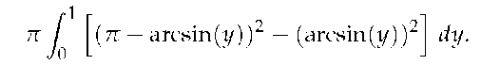

This integral isn't terrible given that the arcsin2 *(y)* terms cancel, but it is more onerous than the integral created by the Shell Method.

### Summary

*In this section, we encountered the following important ideas:*

• We can use a definite integral to find the volume of a three-dimensional solid of revolution that results from revolving a two-dimensional region about a particular axis by taking slices parallel to the axis of revolution which will then be cylindrical shells.

• If we revolve about a vertical line and slice perpendicular to that line, then our shells are vertical and of thickness



This leads us to integrate with respect to *x.*

• If we revolve about a horizontal line and slice parallel to that line, then our shells are horizontal and of thickness



This leads us to integrate with respect to *y,* as opposed to with respect to *x* when we slice a solid vertically.

• Let a region *R* be given with *x*-bounds *x = a* and *x = b* and *y*-bounds *y = c* and *y = d.*

|  |  |  |
| --- | --- | --- |
|  | Washer Method | Shell Method |
| Horizontal Axis |  |  |
| Vertical Axis |  |  |

### Exercises

Terms and Concepts

1) T/F: A solid of revolution is formed by revolving a shape around an axis.

2) T/F: The Shell Method can only be used when the Washer Method fails.

3) T/F: The Shell Method works by integrating cross-sectional areas of a solid.

4) T/F: When finding the volume of a solid of revolution that was revolved around a vertical axis, the Shell Method integrates with respect to x.

### Problems

In Exercises 5-8, a region of the Cartesian plane is shaded. Use the Shell Method to find the volume of the solid of revolution formed by revolving the region about the y-axis.

5)

*y =* 3 - x2

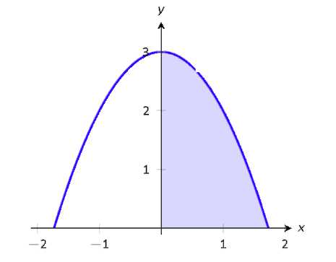

6)

*y =* 5x

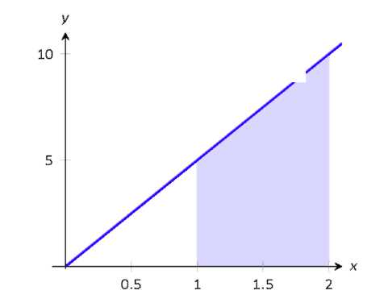

7)

*y = cos x*

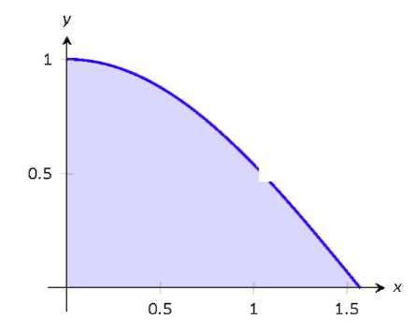

8)



In Exercises 9-12, a region of the Cartesian plane is shaded. Use the Shell Method to find the volume of the solid of revolution formed by revolving the region about the *x*-axis.

9)

*y =* 3 - x2

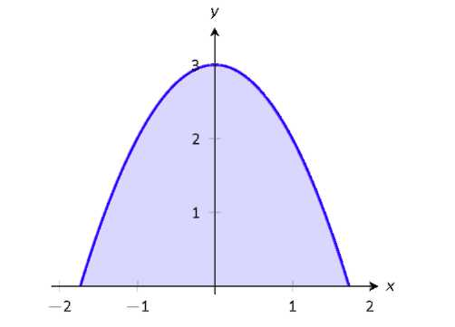

10)

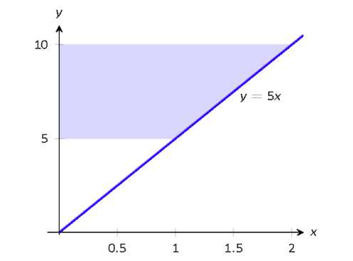

11)

*y* = cos *x*

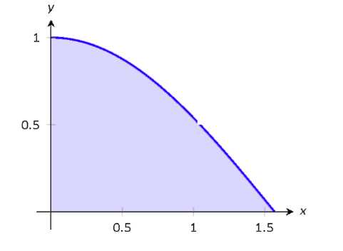

12)

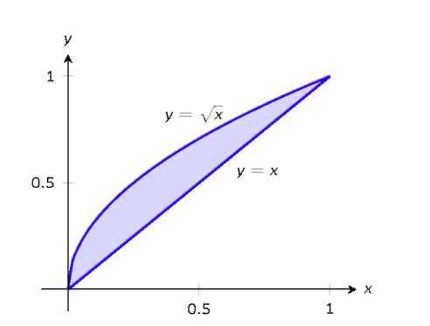

In Exercises 13-18, a region of the Cartesian plane is described. Use the Shell Method to find the volume of the solid of revolution formed by rotating the region about each of the given axes.

13) Region bounded by:



*y =* 0 and *x =* 1.

Rotate about:

(a) the y-axis (c) the x-axis

(b) *x =* 1 (d) *y =* 1

14) Region bounded by: *y =* 4 — x2 and *y =* 0. Rotate about:

(a) *x =* 2 (c) the *x*-axis

(b) *x =* —2 (d) *y =* 4

15) The triangle with vertices (1,1), (1,2) and (2,1). Rotate about:

(a) the *y*-axis (c) the *x*-axis

(b) *x =* 1 (d) *y =* 2

16) Region bounded by *y = x2 — 2x +* 2 and *y = 2x —* 1 Rotate about:

(a) the *y*-axis (c) *x =* — 1

(b) *x =* 1

17) Region bounded by

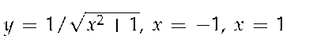

and the *x*-axis. Rotate about:

(a) the *y*-axis (c) *y =* — 1

(b) *x =* 1

18) Region bounded by *y =* 2*x, y = x* and *x =* 2. Rotate about:

(a) the *y*-axis (c) the *x*-axis

(b) *x =* 2 (d) *y =* 4

## 6.3 Arc Length and Surface Area

### Motivating Questions

*In this section, we strive to understand the ideas generated by the following important questions:*

• How can a definite integral be used to measure the length of a curve?

• How can a definite integral be used to measure the surface area of a solid of revolution?

### Introduction

Early on in our work with the definite integral, we learned that if we have a nonnegative velocity function, *v,* for an object moving along an axis, the area under the velocity function between *a* and *b* tells us the distance the object traveled on that time interval. Moreover, based on the definition of the definite integral, that area is given precisely by



Indeed, for any non-

negative function *f* on an interval [a, b], we know that



measures the area bounded by the curve and the *x*-axis between *x = a* and *x = b,* as shown in Figure 6.19.

Through our upcoming work in the present section and chapter, we will explore how definite integrals can be used to represent a variety of different physically important properties. In Preview Activity 6.1, we begin this investigation by seeing how a single definite integral may be used to represent the area between two curves.

Figure 6.19: The area between a nonnegative function *f* and the *x*-axis on the interval *[a, b].*

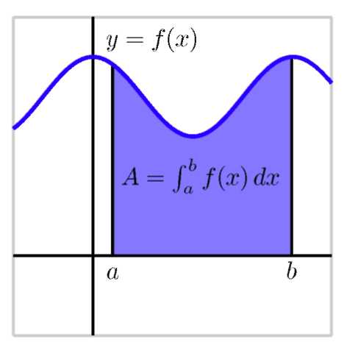

### Preview Activity 6.3

In the following, we consider the function *f( x)* = 1 — *x2* over the interval [-1,1]. Our goal is to estimate the length of the curve.

(a) Graph *f (x)* over the interval [-1,1]. Label the points on the curve that correspond to *x* = — 1,



,0,1/2, and 1.

(b) Draw the secant line connecting the points ( -1, *f* ( -1) and



Use the distance formula to find the length of the

secant line from *x* = — 1 to *x* =



(c) Repeat drawing a secant line between the remaining points starting

with



and (0, *f*(0)). For each line segment , use the

distance formula to find the length of the segment.

(d) Add the distances together to get an approximation to the length of the curve.

(e) How can we improve our approximation? Write a Riemann sum that will give an improvement to our approximation.

### Finding the length of a curve

In addition to being able to use definite integrals to find the volumes of solids of revolution, we can also use the definite integral to find the length of a portion of a curve. We use the same fundamental principle: we take a curve whose length we cannot easily find, and slice it up into small pieces whose lengths we can easily approximate. In particular, we take a given curve and subdivide it into small approximating line segments, as shown at left in Figure 6.20.

Figure 6.20: At left, a continuous function *y = f(x)* whose length we seek on the interval *a = Xo* to *b = X3.* At right, a close up view of a portion of the curve.

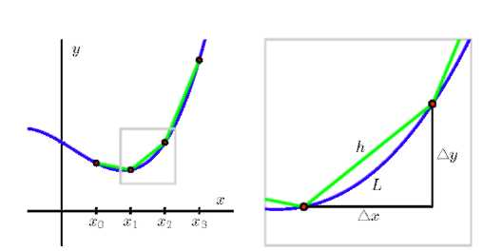

To see how we find such a definite integral that measures arc length on the curve *y = f(x)* from *x = a* to *x = b,* we think

about the portion of length,



that lies along the curve on

a small interval of length



and estimate the value of



using a well-chosen triangle. In particular, if we consider the right triangle with legs parallel to the coordinate axes and hypotenuse connecting two points on the curve, as seen at right in Figure 6.20, we see that the length, *h,* of the hypotenuse approx-

imates the length,



of the curve between the two selected

points. Thus,

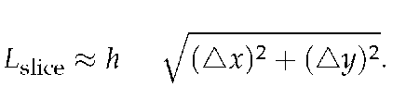

By algebraically rearranging the expression for the length of the hypotenuse, we see how a definite integral can be used to compute the length of a curve. In particular, observe that by remov-

ing a factor of



we find that

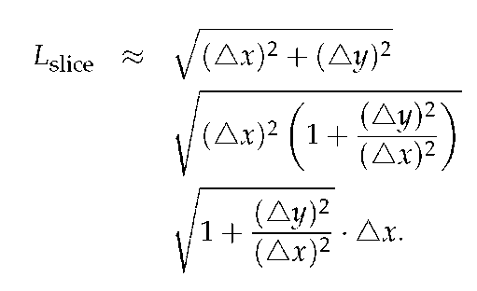

Furthermore, as



and



it follows that

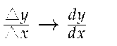

Thus, we can say that

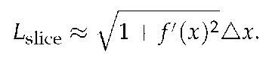

Taking a Riemann sum of all of these slices and letting



we arrive at the following fact.

### Arc Length

Given a differentiable function f on an interval [a, b], the total arc length, L, along the curve y = f (x) from x = *a* to x = b is given by

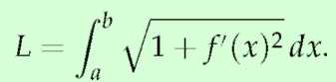

Example 1

Find the arc length of f (x) =



from x = 0 to x = 4.

Solution. We begin by finding



Using the formula, we

find the arc length L as

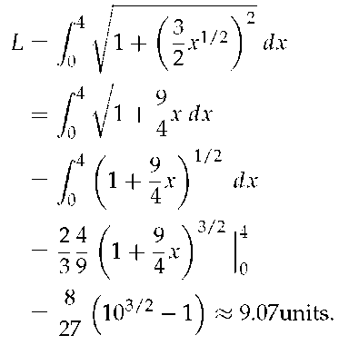

A graph of f is given in Figure 6.21.

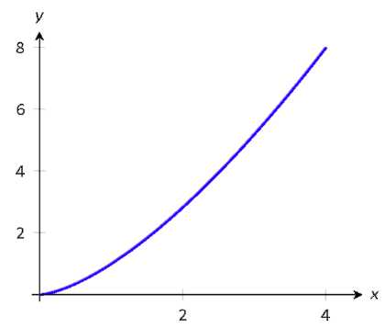

Figure 6.21: A graph of f (x) =



from Exam-

ple 1.

Example 2

Find the arc length of f( x) =

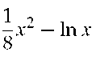

from x = 1 to x = 2.

Solution. This function was chosen specifically because the resulting

integral can be evaluated exactly. We begin by finding



The arc length is

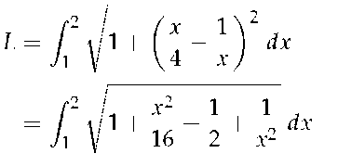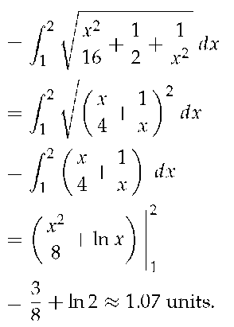

A graph of f is given in Figure 6.22; the portion of the curve measured in this problem is in bold.

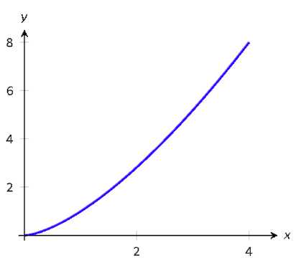

Figure 6.22: A graph of f (x) =



from

Example 2.

Example 3

Find the length of the sine curve from x = 0 to x =



Solution. This is somewhat of a mathematical curiosity; in Activity 4.51 (b) we found the area under one "hump" of the sine curve is 2 square units; now we are measuring its arc length.

The setup is straightforward: f( x) = sin x and



Thus

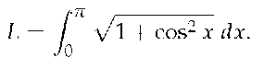

This integral *cannot* be evaluated in terms of elementary functions so we will approximate it with Simpson's Method with n = 4.

Table 6.1: A table of values of



to

evaluate a definite integral in Example 3.

Table 6.1 gives



evaluated at 5 evenly spaced points in



Simpson's Rule then states that

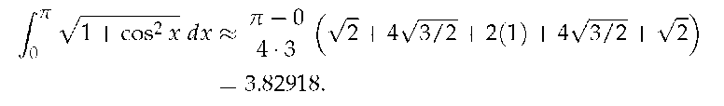

Using a computer with n = 100 the approximation is



our

approximation with n = 4 is quite good.

### Activity 6.3-1

Each of the following questions somehow involves the arc length along a curve.

(a) Use the definition and appropriate computational technology to determine the arc length along y = x2 from x = — 1 to x = 1.

(b) Find the arc length of



on the interval



Find

this value in two different ways: (a) by using a definite integral, and (b) by using a familiar property of the curve.

(c) Determine the arc length of y = xe3x on the interval [0,1].

(d) Will the integrals that arise calculating arc length typically be ones

Page *457*

that we can evaluate exactly using the First FTC, or ones that we need to approximate? Why?

(e) A moving particle is traveling along the curve given by *y* = *f( x)* = 0.1x2 + 1, and does so at a constant rate of 7 cm/sec, where both *x* and *y* are measured in cm (that is, the curve *y* = *f( x)* is the path along which the object actually travels; the curve is not a "position function"). Find the position of the particle when *t =* 4 sec, assuming that when *t =* 0, the particle's location is (0, *f* (0)).

### Surface Area of Solids of Revolution

Figure 6.23: Establishing the formula for surface area.

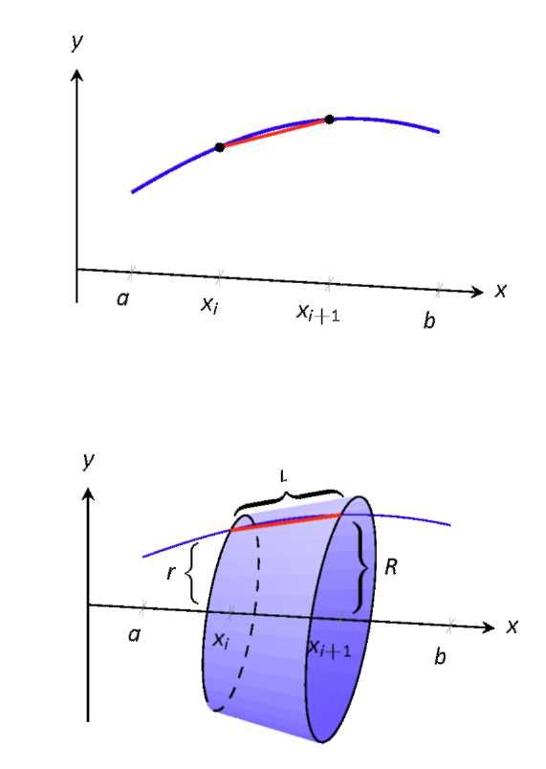

We have already seen how a curve *y = f (x)* on [a, b] can be revolved around an axis to form a solid. Instead of computing its volume, we now consider its surface area.

We begin as we have in the previous sections: we partition the interval [ *a, b]* with *n* subintervals, where the *i* th subinterval ]. On each subinterval, we can approximate the curve *y = f (x)* with a straight line that connects *f (xi)* and *f* (xi+i) as shown in Figure 6.23 (a). Revolving this line segment about the *x*-axis creates part of a cone (called the *frustum* of a cone) as shown in Figure 6.23 (b). The surface area of a frustum of a cone is



length • average of the two radii *R* and r.

The length is given by *L;* we use the material just covered by arc length to state that

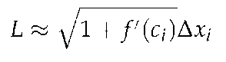

for some *ci* in the *i*th subinterval. The radii are just the function evaluated at the endpoints of the interval. That is,

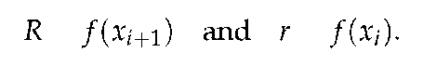

Thus the surface area of this sample frustum of the cone is approximately

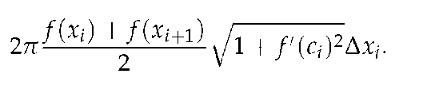

Since *f* is a continuous function, the Intermediate Value The-

orem states there is some *di* in [



such that

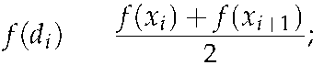

we can use this to rewrite the above

equation as

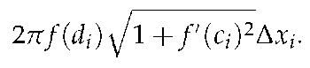

Summing over all the subintervals we get the total surface area to be approximately

Surface Area

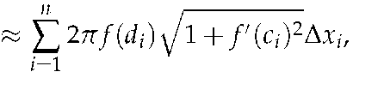

which is a Riemann Sum. Taking the limit as the subinterval lengths go to zero gives us the exact surface area, given in the following Key Idea.

### Surface Area of a Solid of Revolution

Let *f* be differentiable on an open interval containing [a, b]

where



is also continuous on [a, b].

1 ) The surface area of the solid formed by revolving the

graph of *y = f (x),* where *f (x)*



about the *x*-axis is

Surface Area =

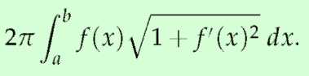

2) The surface area of the solid formed by revolving the

graph of *y = f( x)* about the *y*-axis, where *a, b*



is

Surface Area =

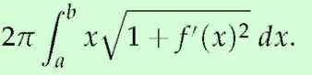

Example 4

Figure 6.24: Revolving *y =* sin *x* on



about the

x-axis.

When revolving *y = f (x)* about the y-axis, the radii

of the resulting frustum are *xi* and



their aver-

age value is simply the midpoint of the interval. In the limit, this midpoint is just *x.*

Find the surface area of the solid formed by revolving *y =* sin *x* on



around the *x*-axis, as shown in Figure 6. 24.

Solution. The setup is relatively straightforward; we have the surface

area *SA* is:

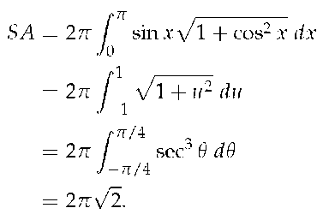

The integration above is nontrivial, utilizing Substitution, Trigonometric Substitution, and Integration by Parts.

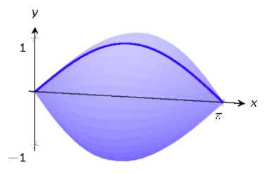

Example 5

Figure 6.25: The solids used in Example 5

(a)

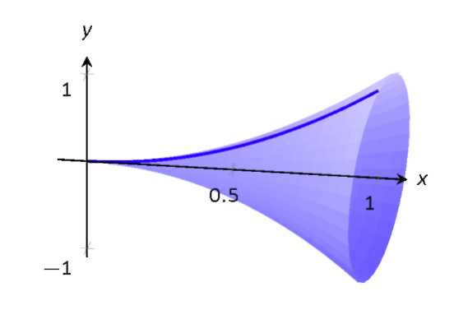

(b)

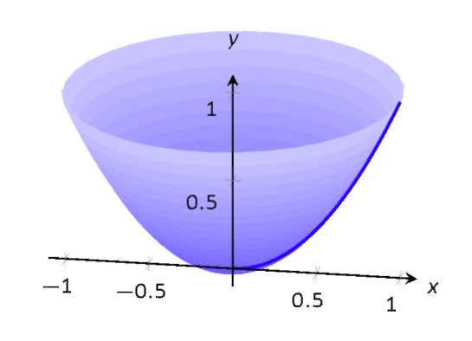

Find the surface area of the solid formed by revolving the curve y = x2 on [0, 1] about:

1) the x-axis

2) the y-axis.

Solution.

1) The integral is straightforward to setup:

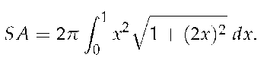

Like the integral in Example 4, this requires Trigonometric Substitution.

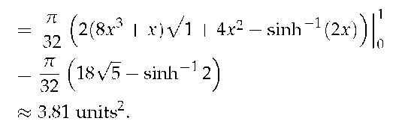

The solid formed by revolving y = x2 around the x-axis is graphed in Figure 6.25-(a).

2) Since we are revolving around the y-axis, the "radius" of the solid is not f( x) but rather x. Thus the integral to compute the surface area is:

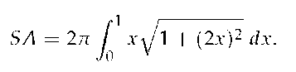

This integral can be solved using substitution. Set u = 1 + 4x2; the new bounds are u = 1 to u = 5. We then have

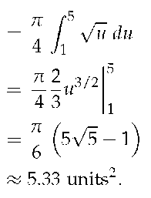

The solid formed by revolving y = x2 about the y-axis is graphed in Figure 6.25-(b).

This last example is a famous mathematical "paradox." Example 6

Consider the solid formed by revolving y = 1/x about the x-axis on



Find the volume and surface area of this solid. (This shape, as

graphed in Figure 6.26, is known as "Gabriel's Horn" since it looks like a very long horn that only a supernatural person, such as an angel, could

play.)

Figure 6.26: A graph of Gabriel's Horn.

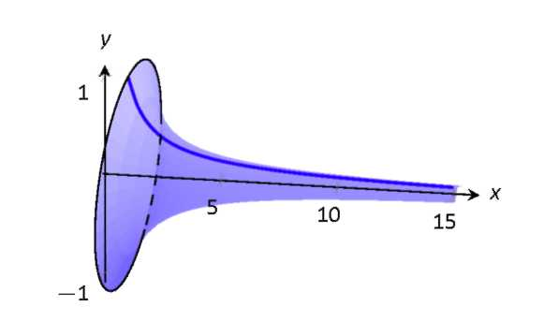

Solution. To compute the volume it is natural to use the Disk Method. We have:

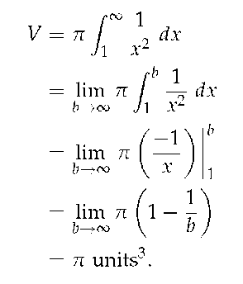

Gabriel's Horn has a finite volume of



cubic units. Since we have al-

ready seen that objects with infinite length can have a finite area, this is not too difficult to accept.

We now consider its surface area. The integral is straightforward to setup:

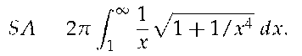

Integrating this expression is not trivial. We can, however, compare it to

other improper integrals. Since 1



on



we can state

that

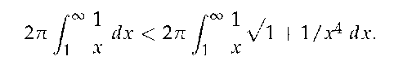

The improper integral on the left diverges. Since the integral on the right is larger, we conclude it also diverges, meaning Gabriel's Horn has infinite surface area.

Hence the "paradox": we can fill Gabriel's Horn with a finite amount of paint, but since it has infinite surface area, we can never paint it.

Somehow this paradox is striking when we think about it in terms of volume and area. However, we have seen a similar paradox before, as

referenced above. We know that the area under the curve



on



is finite, yet the shape has an infinite perimeter. Strange things can

occur when we deal with the infinite.

### Summary

*In this section, we encountered the following important ideas:*

• To find the area between two curves, we think about slicing the region into thin rectangles. If, for instance,

the area of a typical rectangle on the interval *x = a* to *x = b* is given by



then

the exact area of the region is given by the definite integral

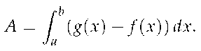

• The shape of the region usually dictates whether we should use vertical rectangles of thickness



or

horizontal rectangles of thickness



We desire to have the height of the rectangle governed by the

difference between two curves: if those curves are best thought of as functions of y, we use horizontal rectangles, whereas if those curves are best viewed as functions of x, we use vertical rectangles.

• The arc length, L, along the curve y = f (x) from x = a to x = b is given by

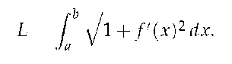

### Exercises

Terms and Concepts

1) T/F: The integral formula for computing Arc Length was found by first approximating arc length with straight line segments.

2) T/F: The integral formula for computing Arc Length includes a square-root, meaning the integration is probably easy.

### Problems

In Exercises 3-11, find the arc length of the function on the given integral.

3) f (x) = x on [0,1]

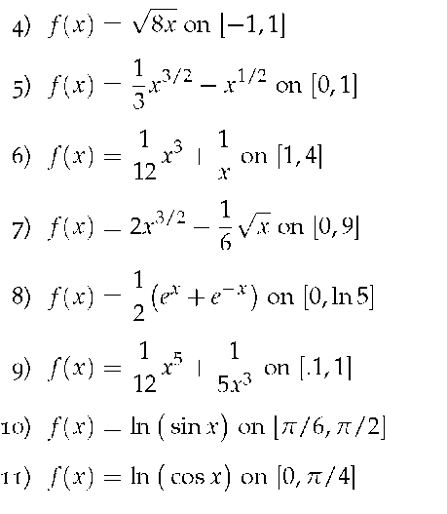

In Exercises 12-19, set up the integral to compute the arc length of the function on the given interval. Try to compute the integral by hand, and use a CAS to compute the integral. Also, use Simpson's Rule with n = 4 to approximate the arc length.

12) f (x) = x2 on [0,1].

13) f (x) = x10 on [0,1]

14) f(x) =



on [0,1]

15) f( x) = ln x on [ 1, e]

16) f(x) =



on [ — 1, 1 ]. (Note: this describes the

top half of a circle with radius 1.)

17) f(x) =



on [—3,3]. (Note: this describes

the top half of an ellipse with a major axis of length 6 and a minor axis of length 2.)

18) f(x) =



on [1, 2]

19) f( x) = sec x on



In Exercises 20-24, find the surface area of the described solid of revolution.

20) The solid formed by revolving y = 2x on [0,1] about the x-axis.

21) The solid formed by revolving y = x2 on [0,1] about the y-axis.

22) The solid formed by revolving y = x3 on [0,1] about the x-axis.

23) The solid formed by revolving y =



on [ 0, 1 ] about

the x-axis.

24) The sphere formed by revolving y =



on

[—1,1] about the x-axis.

## 6.4 Density, Mass, and Center of Mas*s*

### Motivating Questions

*In this section, we strive to understand the ideas generated by the following important questions:*

• How are mass, density, and volume related?

• How is the mass of an object with varying density computed?

• What is the center of mass of an object, and how are definite integrals used to compute it?

Introduction

We have seen in several different circumstances how studying the units on the integrand and variable of integration enables us to better understand the meaning of a definite integral. For instance, if *v( t)* is the velocity of an object moving along an axis, measured in feet per second, while *t* measures time in seconds, then both the definite integral and its Riemann sum approximation,

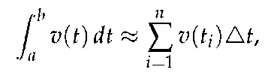

have their overall units given by the product of the units of *v( t)* and *t:*

(feet/sec)-(sec) = feet.

Thus,



measures the total change in position (in feet) of

the moving object.

This type of unit analysis will be particularly helpful to us in what follows. To begin, in the following preview activity we consider two different definite integrals where the integrand is a function that measures how a particular quantity is distributed over a region and think about how the units on the integrand and the variable of integration indicate the meaning of the integral.

### Preview Activity 6.4

In each of the following scenarios, we consider the distribution of a quantity along an axis.

(a) Suppose that the function *c(x) =* 200 + 100e—0.1x models the density of traffic on a straight road, measured in cars per mile, where *x* is number of miles east of a major interchange, and consider the

definite integral



i. What are the units on the product



ii. What are the units on the definite integral and its Riemann sum

approximation given by

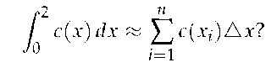

iii. Evaluate the definite integral



and write one sentence to explain the meaning of the value you find.

(b) On a 6 foot long shelf filled with books, the function *B* models the distribution of the weight of the books, measured in pounds per inch, where *x* is the number of inches from the left end of the book-

shelf. Let *B(x)* be given by the rule *B(x) =* 0.5 +



i. What are the units on the product



ii. What are the units on the definite integral and its Riemann sum approximation given by

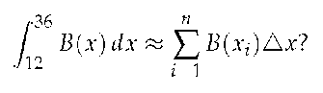

iii. Evaluate the definite integral



and write one sentence to explain the meaning of the value you find.

### Density

The *mass* of a quantity, typically measured in metric units such as grams or kilograms, is a measure of the amount of a quantity. In a corresponding way, the *density* of an object measures the distribution of mass per unit volume. For instance, if a brick has mass 3 kg and volume 0.002 m3, then the density of the brick is

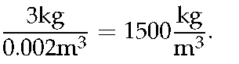

As another example, the mass density of water is 1000 kg/m3. Each of these relationships demonstrate the following general principle.

### Density, Mass, & Volume

For an object of constant density *d,* with mass *m* and volume V,

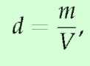

or *m = d • V*.

But what happens when the density is not constant? If we consider the formula *m = d • V,* it is reminiscent of two other equations that we have used frequently in recent work: for

a body moving in a fixed direction, distance = rate • time, and, for a rectangle, its area is given by *A = I • w.* These formulas hold when the principal quantities involved, such as the rate the body moves and the height of the rectangle, are *constant.* When these quantities are not constant, we have turned to the definite integral for assistance. The main idea in each situation is that by working with small slices of the quantity that is varying, we can use a definite integral to add up the values of small pieces on which the quantity of interest (such as the velocity of a moving object) are approximately constant.

For example, in the setting where we have a nonnegative velocity function that is not constant, over a short time interval



we know that the distance traveled is approximately



since *v{i)* is almost constant on a small interval, and for a constant rate, distance = rate • time. Similarly, if we are thinking about the area under a nonnegative function / whose value is

changing, on a short interval



the area under the curve is

approximately the area of the rectangle whose height is *f(x)*

and whose width is



Both of these principles are

represented visually in Figure 6.27.

Figure 6.27: At left, estimating a small amount

of distance traveled,



and at right, a small

amount of area under the curve,

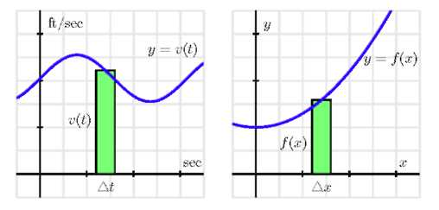

In a similar way, if we consider the setting where the density of some quantity is not constant, the definite integral enables us to still compute the overall mass of the quantity. Throughout, we will focus on problems where the density varies in only one dimension, say along a single axis, and think about how mass is distributed relative to location along the axis.

Let's consider a thin bar of length *b* that is situated so its left end is at the origin, where *x =* 0, and assume that the bar has constant cross-sectional area of 1 cm2. We let the function *p(x)* represent the mass density function of the bar, measured in grams per cubic centimeter. That is, given a location *x, p(x)* tells us approximately how much mass will be found in a one-centimeter wide slice of the bar at *x.*

Figure 6.28: A thin bar of constant cross-sectional area 1 cm2 with density function p(x) g/cm3.

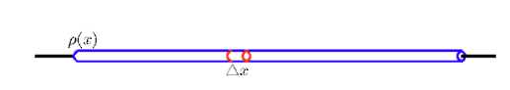

If we now consider a thin slice of the bar of width



as

pictured in Figure 6.28, the volume of such a slice is the cross-

sectional area times



Since the cross-sections each have con-

stant area 1 cm2, it follows that the volume of the slice is



cm3. Moreover, since mass is the product of density and volume (when density is constant), we see that the mass of this given slice is approximately

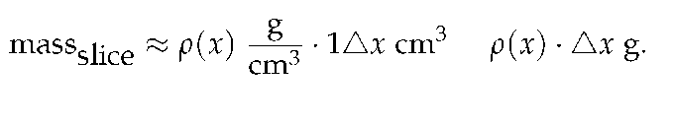

Hence, for the corresponding Riemann sum (and thus for the integral that it approximates),

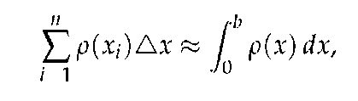

we see that these quantities measure the mass of the bar between 0 and b. (The Riemann sum is an approximation, while the integral will be the exact mass.)

At this point, we note that we will be focused primarily on situations where mass is distributed relative to horizontal location, x, for objects whose cross-sectional area is constant. In that setting, it makes sense to think of the density function p(x) with units "mass per unit length," such as g/cm. Thus, when we

compute



on a small slice



the resulting units are

g/cm • cm = g, which thus measures the mass of the slice. The general principle follows.

### Mass

For an object of constant cross-sectional area whose mass is distributed along a single axis according to the function p(x) (whose units are units of mass per unit of length), the total mass, M of the object between x = a and x = b is given

by

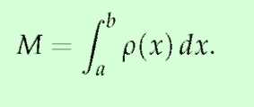

Example 1

A thin bar occupies the interval



and it has a density in kg/m

of p(x) = 1 + x2. Find the mass of the bar.

Solution. The mass of the bar in kilograms is

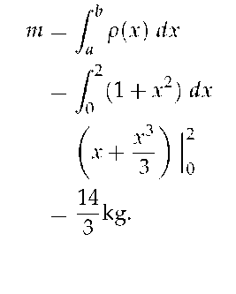

### Activity 6.4-1

Consider the following situations in which mass is distributed in a non-constant manner.

(a) Suppose that a thin rod with constant cross-sectional area of 1 cm2 has its mass distributed according to the density function p(x) = 2e—0.2x, where x is the distance in cm from the left end of the rod, and the units on p(x) are g/cm. If the rod is 10 cm long, determine the exact mass of the rod.

(b) Consider the cone that has a base of radius 4 m and a height of 5 m. Picture the cone lying horizontally with the center of its base at the origin and think of the cone as a solid of revolution.

i. Write and evaluate a definite integral whose value is the volume of the cone.

ii. Next, suppose that the cone has uniform density of 800 kg/m3. What is the mass of the solid cone?

iii. Now suppose that the cone's density is not uniform, but rather that the cone is most dense at its base. In particular, assume that the density of the cone is uniform across cross sections parallel to its base, but that in each such cross section that is a distance x units from the origin, the density of the cross section is given

by the function p(x) = 400 +



measured in kg/m3. Deter-

mine and evaluate a definite integral whose value is the mass of this cone of non-uniform density. Do so by first thinking about the mass of a given slice of the cone x units away from the base; remember that in such a slice, the density will be essentially constant.

(c) Let a thin rod of constant cross-sectional area 1 cm2 and length 12 cm have its mass be distributed according to the density function



measured in g/cm. Find the exact location z at

which to cut the bar so that the two pieces will each have identical mass.

Table 6.2: A college student's semester grades.

|  |  |  |  |
| --- | --- | --- | --- |
| class | grade | grade points | credits |
| chemistry | B+ | 3.3 | 5 |
| calculus | A- | 3.7 | 4 |
| history | B- | 2.7 | 3 |
| psychology | B- | 2.7 | 3 |

Weighted Averages

The concept of an average is a natural one, and one that we have used repeatedly as part of our understanding of the meaning of the definite integral. If we have n values a1, a2, ..., an, we know that their average is given by

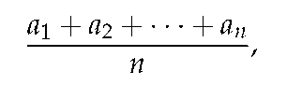

and for a quantity being measured by a function f on an interval [a, b], the average value of the quantity on [a, b] is

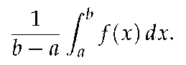

As we continue to think about problems involving the distribution of mass, it is natural to consider the idea of a weighted

average, where certain quantities involved are counted more in the average.

A common use of weighted averages is in the computation of a student's GPA, where grades are weighted according to credit hours. Let's consider the scenario in Table 6.2.

If all of the classes were of the same weight (i.e., the same number of credits), the student's GPA would simply be calculated by taking the average

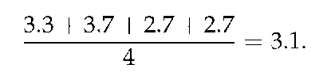

But since the chemistry and calculus courses have higher weights (of 5 and 4 credits respectively), we actually compute the GPA according to the weighted average

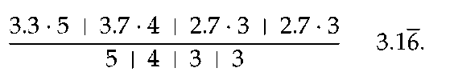

The weighted average reflects the fact that chemistry and calculus, as courses with higher credits, have a greater impact on the students' grade point average. Note particularly that in the weighted average, each grade gets multiplied by its weight, and we divide by the sum of the weights.

In the following activity, we explore further how weighted averages can be used to find the balancing point of a physical system.

### Activity 6.4-2

For quantities of equal weight, such as two children on a teeter-totter, the balancing point is found by taking the average of their locations. When the weights of the quantities differ, we use a weighted average of their respective locations to find the balancing point.

(a) Suppose that a shelf is 6 feet long, with its left end situated at x = 0. If one book of weight 1 lb is placed at x1 = 0, and another book of weight 1 lb is placed at x2 = 6, what is the location of x, the point at which the shelf would (theoretically) balance on a fulcrum?

(b) Now, say that we place four books on the shelf, each weighing 1 lb: at x1 = 0, at x2 = 2, at x3 = 4, and at x4 = 6. Find



the balancing

point of the shelf.

(c) How does



change if we change the location of the third book?

Say the locations of the 1-lb books are x1 = 0, x2 = 2, x3 = 3, and

x4 = 6.

(d) Next, suppose that we place four books on the shelf, but of varying weights: at x1 = 0 a 2-lb book, at x2 = 2 a 3-lb book, and x3 = 4 a 1-lb book, and at x4 = 6 a 1-lb book. Use a weighted average of the

locations to find



the balancing point of the shelf. How does the

balancing point in this scenario compare to that found in (b)? (e) What happens if we change the location of one of the books? Say

that we keep everything the same in (d), except that x3 = 5. How

does



change?

(f) What happens if we change the weight of one of the books? Say that we keep everything the same in (d), except that the book at x3 = 4

now weighs 2 lbs. How does



change?

(g) Experiment with a couple of different scenarios of your choosing where you move the location of one of the books to the left, or you decrease the weight of one of the books.

(h) Write a couple of sentences to explain how adjusting the location of one of the books or the weight of one of the books affects the location of the balancing point of the shelf. Think carefully here about how your changes should be considered relative to the location of the balancing point



of the current scenario.

### Center of Mass

In Activity 6.4-2, we saw that the balancing point of a system

of point-masses1

1 In the activity, we actually used *weight* rather than *mass.* Since weight is computed by the gravitational constant times mass, the computations for the balancing point result in the same location regardless of whether we use weight or mass, since the gravitational constant is present in both the numerator and denominator of the weighted average.

(such as books on a shelf) is found by taking a weighted average of their respective locations. In the activity, we were computing the *center of mass* of a system of masses distributed along an axis, which is the balancing point of the axis on which the masses rest.

Center of Mass

For a collection of *n* masses *m1, ..., mn* that are distributed along a single axis at the locations x1*, ..*., *xn,* the *center of mass* is given by

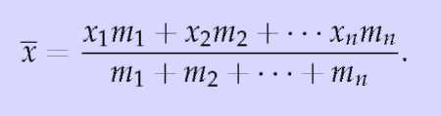

Figure 6.29: A thin bar of constant cross-sectional area with density function p(x) g/cm.

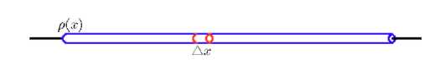

What if we instead consider a thin bar over which density is distributed continuously? If the density is constant, it is obvious that the balancing point of the bar is its midpoint. But if density is not constant, we must compute a weighted average. Let's say that the function *p(x)* tells us the density distribution along the bar, measured in g/cm. If we slice the bar into small sections, this enables us to think of the bar as holding a collection of

adjacent point-masses. For a slice of thickness



at location *Xi,*

note that the mass of the slice, *mi,* satisfies



Taking *n* slices of the bar, we can approximate its center of mass by

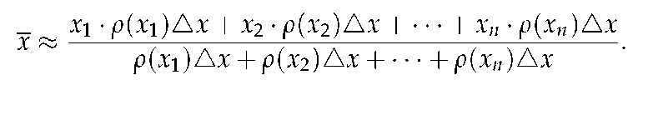

Rewriting the sums in sigma notation, it follows that

(6.1)

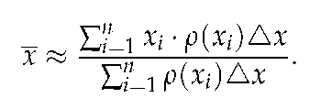

Moreover, it is apparent that the greater the number of slices, the more accurate our estimate of the balancing point will be, and that the sums in Equation (6.1) can be viewed as Riemann

sums. Hence, in the limit as



we find that the center of

mass is given by the quotient of two integrals.

Center of Mass

For a thin rod of density *p(x)* distributed along an axis from *x = a* to *x = b,* the center of mass of the rod is given by

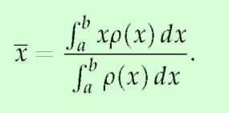

Note particularly that the denominator of



is the mass of the

bar, and that this quotient of integrals is simply the continuous version of the weighted average of locations, *x,* along the bar.

Example 2

A thin bar occupies the interval



and it has a density in kg/m

of *p(x) =* 1 + x2. Find the center of mass of the bar.

Solution. From Example 1, the mass of the bar in kilograms is



We just need to find

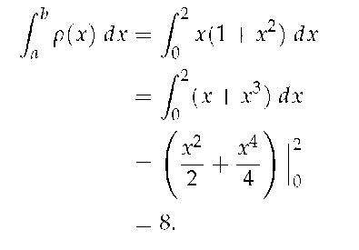

The center of mass,



### Activity 6.4-3

Consider a thin bar of length 20 cm whose density is distributed according to the function *p(x) =* 4 + 0.1x, where *x =* 0 represents the left end

of the bar. Assume that *p* is measured in g/cm and *x* is measured in cm.

(a) Find the total mass, *M,* of the bar.

(b) Without doing any calculations, do you expect the center of mass of the bar to be equal to 10, less than 10, or greater than 10? Why?

(c) Compute



the exact center of mass of the bar.

(d) What is the average density of the bar?

(e) Now consider a different density function, given by *p(x) =* 4e0.020732x, also for a bar of length 20 cm whose left end is at *x =* 0. Plot both *p( x)* and *p( x)* on the same axes. Without doing any calculations, which bar do you expect to have the greater center of mass? Why?

(f) Compute the exact center of mass of the bar described in (e) whose density function is *p(x) =* 4e0.020732x. Check the result against the prediction you made in (e).

### Summary

*In this section, we encountered the following important ideas:*

• For an object of constant density D, with volume *V* and mass m, we know that *m = D •* V.

• If an object with constant cross-sectional area (such as a thin bar) has its density distributed along an axis according to the function p(x), then we can find the mass of the object between *x = a* and *x = b* by

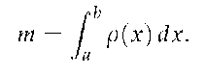

• For a system of point-masses distributed along an axis, say *m1,* . . . , *mn* at locations *x1,* . . . , *xn* , the center of

mass,



is given by the weighted average

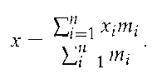

If instead we have mass continuously distributed along an axis, such as by a density function *p( x)* for a thin bar of constant cross-sectional area, the center of mass of the portion of the bar between *x = a* and *x = b* is given by

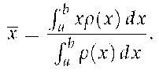

In each situation,



represents the balancing point of the system of masses or of the portion of the bar.

### Exercises

Terms and Concepts

1) T/F: The integral formula for computing Arc Length was found by first approximating arc length with straight line segments.

2) T/F: The integral formula for computing Arc Length includes a square-root, meaning the integration is probably easy.

### Problems

3) Let a thin rod of length a have density distribution function p(x) = 10e—0.1x, where x is measured in cm and *p* in grams per centimeter.

(a) If the mass of the rod is 30 g, what is the value of a?

(b) For the 30g rod, will the center of mass lie at its midpoint, to the left of the midpoint, or to the right of the midpoint? Why?

(c) For the 30g rod, find the center of mass, and compare your prediction in (b).

(d) At what value of x should the 30g rod be cut in order to form two pieces of equal mass?

4) Consider two thin bars of constant cross-sectional area, each of length 10 cm, with respective mass den-

sity functions



and p(x) = e 0.1x.

(a) Find the mass of each bar.

(b) Find the center of mass of each bar.

(c) Now consider a new 10 cm bar whose mass density function is f (x) = p(x) + p(x).

i. Explain how you can easily find the mass of this new bar with little to no additional work.

ii. Similarly, compute



as simply

as possible, in light of earlier computations. iii. True or false: the center of mass of this new bar is the average of the centers of mass of the two earlier bars. Write at least one sentence to say why your conclusion makes sense.

5) Consider the curve given by y = f (x) = 2xe—1.25x + (30 — x)e—0.25(30—x).

(a) Plot this curve in the window x = 0 . . . 30, y = 0... 3 (with constrained scaling so the units on the x and y axis are equal), and use it to generate a solid of revolution about the x-axis. Explain why this curve could generate a reasonable model of a baseball bat.

(b) Let x and y be measured in inches. Find the total volume of the baseball bat generated by revolving the given curve about the x-axis. Include units on your answer

(c) Suppose that the baseball bat has constant weight density, and that the weight density is 0. 6 ounces per cubic inch. Find the total weight of the bat whose volume you found in (b).

(d) Because the baseball bat does not have constant cross-sectional area, we see that the amount of weight concentrated at a location x along the bat is determined by the volume of a slice at location x. Explain why we can think about the function



(where f is the function given

at the start of the problem) as being the weight density function for how the weight of the baseball bat is distributed from x = 0 to x = 30. (e) Compute the center of mass of the baseball bat.

## 6.5 Physics Applications: Work, Force, and Pressure

### Motivating Questions

*In this section, we strive to understand the ideas generated by the following important questions:*

• How do we measure the work accomplished by a varying force that moves an object a certain distance?

• What is the total force exerted by water against a dam?

• How are both of the above concepts and their corresponding use of definite integrals similar to problems we have encountered in the past involving formulas such as "distance equals rate times time" and "mass equals density times volume"?

### Introduction

In our work to date with the definite integral, we have seen several different circumstances where the integral enables us to measure the accumulation of a quantity that varies, provided the quantity is approximately constant over small intervals. For instance, based on the fact that the area of a rectangle is *A = l •* w, if we wish to find the area bounded by a nonnegative curve *y = f (x)* and the x-axis on an interval [a, b], a representative

slice of width



has area



and thus as we let

the width of the representative slice tend to zero, we find that the exact area of the region is

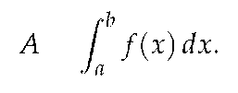

In a similar way, if we know that the velocity of a moving object is given by the function *y = v( t),* and we wish to know the distance the object travels on an interval [a, *b]* where *v(t)* is nonnegative, we can use a definite integral to generalize the fact that *d =* r • *t* when the rate, r, is constant. More specifically,

on a short time interval



is roughly constant, and hence

for a small slice of time,



and so as the width of

the time interval



tends to zero, the exact distance traveled is given by the definite integral

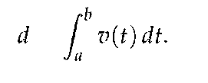

Finally, when we recently learned about the mass of an object of non-constant density, we saw that since *M = D • V* (mass equals density times volume, provided that density is constant), if we can consider a small slice of an object on which the density is approximately constant, a definite integral may be used to

determine the exact mass of the object. For instance, if we have a thin rod whose cross sections have constant density, but whose density is distributed along the x axis according to the function y = p(x), it follows that for a small slice of the rod that is Ax

thick,



In the limit as



we then find

that the total mass is given by

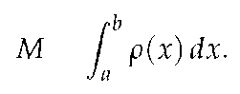

Note that all three of these situations are similar in that we have a basic rule (A = l • w, d = r • t, M = D • V) where one of the two quantities being multiplied is no longer constant; in each, we consider a small interval for the other variable in the formula, calculate the approximate value of the desired quantity (area, distance, or mass) over the small interval, and then use a definite integral to sum the results as the length of the small intervals is allowed to approach zero. It should be apparent that this approach will work effectively for other situations where we have a quantity of interest that varies.

We next turn to the notion of work: from physics, a basic principal is that work is the product of force and distance. For example, if a person exerts a force of 20 pounds to lift a 20-pound weight 4 feet off the ground, the total work accomplished is

W = F • d = 20 • 4 = 80 foot-pounds.

If force and distance are measured in English units (pounds and feet), then the units on work are foot-pounds. If instead we work in metric units, where forces are measured in Newtons and distances in meters, the units on work are Newton-meters.

Of course, the formula W = F • d only applies when the force is constant while it is exerted over the distance d. In Preview Activity 6.5, we explore one way that we can use a definite integral to compute the total work accomplished when the force exerted varies.

### Preview Activity 6.5

A bucket is being lifted from the bottom of a 50-foot deep well; its weight (including the water), B, in pounds at a height h feet above the water is given by the function B( h). When the bucket leaves the water, the bucket and water together weigh B( 0) = 20 pounds, and when the bucket reaches the top of the well, B( 50) = 12 pounds. Assume that the bucket loses water at a constant rate (as a function of height, h) throughout its journey from the bottom to the top of the well.

(a) Find a formula for B(h).

(b) Compute the value of the product



where



Include units on your answer. Explain why this product represents the approximate work it took to move the bucket of water from h = 5 to h = 7.

(c) Is the value in (b) an over- or under-estimate of the actual amount of work it took to move the bucket from h = 5 to h = 7? Why?

(d) Compute the value of the product



where



feet.

Include units on your answer. What is the meaning of the value you found?

(e) More generally, what does the quantity



measure

for a given value of h and a small positive value of



(f) Evaluate the definite integral



What is the meaning of

the value you find? Why?

### Work

Because work is calculated by the rule W = F • d, whenever the force F is constant, it follows that we can use a definite integral to compute the work accomplished by a varying force. For example, suppose that in a setting similar to the problem posed in Preview Activity 6.5, we have a bucket being lifted in a 50-foot well whose weight at height h is given by B(h) = 12 + 8e—0.1h.

In contrast to the problem in the preview activity, this bucket is not leaking at a constant rate; but because the weight of the bucket and water is not constant, we have to use a definite integral to determine the total work that results from lifting the bucket. Observe that at a height h above the water, the approximate work to move the bucket a small distance



is

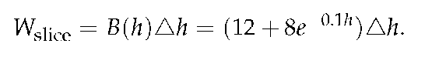

Hence, if we let



tend to 0 and take the sum of all of the

slices of work accomplished on these small intervals, it follows that the total work is given by

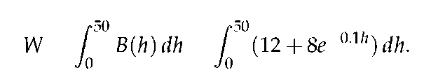

While is a straightforward exercise to evaluate this integral exactly using the Fundamental Theorem of Calculus, in applied settings such as this one we will typically use computing technology to find accurate approximations of integrals that are of

interest to us. Here, it turns out that



679.461 foot-pounds.

Our work in the most recent example above employs the following important general principle.

Page 476

Work

For an object being moved in the positive direction along an axis, x, by a force F(x), the total work to move the object from *a* to b is given by

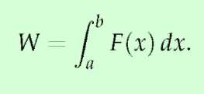

How much work is performed pulling a 60 m climbing rope up a cliff face, where the rope has a mass of 66 g/m?

Solution. We need to create a force function F(x) on the interval [0,60]. To do so, we must first decide what x is measuring: it is the length of the rope still hanging or is it the amount of rope pulled in? As long as we are consistent, either approach is fine. We adopt for this example the convention that x is the amount of rope pulled in. This seems to match intuition better; pulling up the first 10 meters of rope involves x = 0 to x = 10 instead of x = 60 to x = 50.

As x is the amount of rope pulled in, the amount of rope still hanging is 60 — x. This length of rope has a mass of 66 g/m, or 0.066 kg/m. The the mass of the rope still hanging is 0.066(60 — x) kg; multiplying this mass by the acceleration of gravity, 9.8 m/s2, gives our variable force function



Thus the total work performed in pulling up the rope is

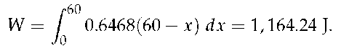

By comparison, consider the work done in lifting the entire rope 60 meters. The rope weights 60 x 0.066 x 9.8 = 38.808 N, so the work applying this force for 60 meters is 60 x 38.808 = 2,328.48 J. This is exactly twice the work calculated before (and we leave it to the reader to understand why.)

Example 2

A box of 100 lb of sand is being pulled up at a uniform rate a distance of 50 ft over 1 minute. The sand is leaking from the box at a rate of 1 lb/s. The box itself weighs 5 lb and is pulled by a rope weighing .2 lb/ft.

1 . How much work is done lifting just the rope?

2. How much work is done lifting just the box and sand?

3. What is the total amount of work performed? Solution.

1. We start by forming the force function *Fr( x)* for the rope (where the subscript denotes we are considering the rope). As in the previous example, let *x* denote the amount of rope, in feet, pulled in. (This is the same as saying *x* denotes the height of the box.) The weight of the rope with *x* feet pulled in is *Fr (x) =* 0.2(50 — *x) =* 10 — 0.2x. (Note that we do not have to include the acceleration of gravity here, for the *weight* of the rope per foot is given, not its *mass* per meter as before.) The work performed lifting the rope is

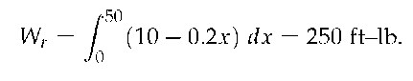

2. The sand is leaving the box at a rate of 1 lb/s. As the vertical trip is to take one minute, we know that 60 lb will have left when the box reaches its final height of 50 ft. Again letting *x* represent the height of the box, we have two points on the line that describes the weight of the sand: when *x =* 0, the sand weight is 100 lb, producing the point *(* 0, 100) ; when *x =* 50, the sand in the box weighs 40 lb, producing

the point (50,40). The slope of this line is



giving the

equation of the weight of the sand at height *x* as *w(x) =* —1.2x + 100. The box itself weighs a constant 5 lb, so the total force function is *Fb(x) =* —1.2x + 105. Integrating from *x =* 0 to *x =* 50 gives the work performed in lifting box and sand:

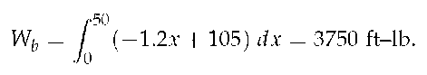

3. The total work is the sum of *Wr* and Wb: 250 + 3750 = 4000 ft-lb. We can also arrive at this via integration:

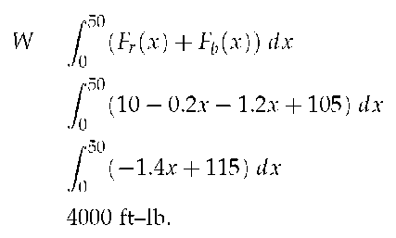

Example 3

Hooke's Law states that the force required to compress or stretch a spring *x* units from its natural length is proportional to *x;* that is, this force is *F( x) = kx* for some constant *k.*

A force of 20 lb stretches a spring from a length of 7 inches to a length of 12 inches. How much work was performed in stretching the spring to this length?

Solution. In many ways, we are not at all concerned with the actual length of the spring, only with the amount of its change. Hence, we do not care that 20 lb of force stretches the spring to a length of 12 inches, but

rather that a force of 20 lb stretches the spring by 5 in. This is illustrated in Figure ??; we only measure the change in the spring's length, not the overall length of the spring.

Converting the units of length to feet, we have

F(5/12) = 5/12k = 20 lb.

Thus k = 48 lb/ft and F(x) = 48x.

We compute the total work performed by integrating F(x) from x = 0

to x = 5/12:

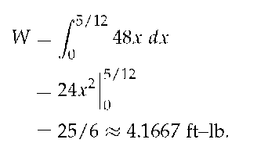

### Activity 6.5-1

Consider the following situations in which a varying force accomplishes work.

(a) Suppose that a heavy rope hangs over the side of a cliff. The rope is 200 feet long and weighs 0.3 pounds per foot; initially the rope is fully extended. How much work is required to haul in the entire length of the rope? (Hint: set up a function F(h) whose value is the weight of the rope remaining over the cliff after h feet have been hauled in.)

(b) A leaky bucket is being hauled up from a 100 foot deep well. When lifted from the water, the bucket and water together weigh 40 pounds. As the bucket is being hauled upward at a constant rate, the bucket leaks water at a constant rate so that it is losing weight at a rate of 0.1 pounds per foot. What function B(h) tells the weight of the bucket after the bucket has been lifted h feet? What is the total amount of work accomplished in lifting the bucket to the top of the well?

(c) Now suppose that the bucket in (b) does not leak at a constant rate, but rather that its weight at a height h feet above the water is given by B(h) = 25 + 15e—0.05h. What is the total work required to lift the bucket 100 feet? What is the average force exerted on the bucket on

the interval h = 0 to h = 100?

(d) From physics, Hooke's Law for springs states that the amount of force required to hold a spring that is compressed (or extended) to a particular length is proportionate to the distance the spring is compressed (or extended) from its natural length. That is, the force to compress (or extend) a spring x units from its natural length is F(x) = kx for some constant k (which is called the spring constant.) For springs, we choose to measure the force in pounds and the distance the spring is compressed in feet.

Suppose that a force of 5 pounds extends a particular spring 4 inches (1/3 foot) beyond its natural length.

i. Use the given fact that F(1/3) = 5 to find the spring constant

k.

ii. Find the work done to extend the spring from its natural length to l foot beyond its natural length.

iii. Find the work required to extend the spring from l foot beyond its natural length to 1.5 feet beyond its natural length.

Figure 6.30: A sump crock.

2 Image credit to

http://www.warreninspect.com/basement-moisture.

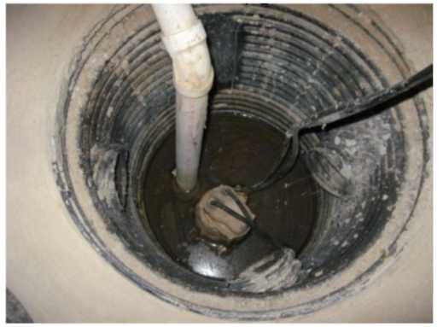

Work: Pumping Liquid from a Tank

In certain geographic locations where the water table is high, residential homes with basements have a peculiar feature: in the basement, one finds a large hole in the floor, and in the hole, there is water. For example, in Figure 6.30 where we see a *sump crock2.* Essentially, a sump crock provides an outlet for water that may build up beneath the basement floor; of course, as that water rises, it is imperative that the water not flood the basement. Hence, in the crock we see the presence of a floating pump that sits on the surface of the water: this pump is activated by elevation, so when the water level reaches a particular height, the pump turns on and pumps a certain portion of the water out of the crock, hence relieving the water buildup beneath the foundation. One of the questions we'd like to answer is: how much work does a sump pump accomplish?

Figure 6.31: A sump crock with approximately cylindrical cross-sections that is 4 feet deep, 1.5 feet in diameter at its base, and 3 feet in diameter at its top.

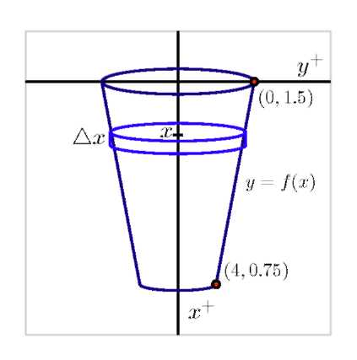

To that end, let's suppose that we have a sump crock that has the shape of a frustum of a cone, as pictured in Figure 6.31. Assume that the crock has a diameter of 3 feet at its surface, a diameter of 1.5 feet at its base, and a depth of 4 feet. In addition, suppose that the sump pump is set up so that it pumps the water vertically up a pipe to a drain that is located at ground level just outside a basement window. To accomplish this, the pump must send the water to a location 9 feet above the surface of the sump crock.

It turns out to be advantageous to think of the depth below the surface of the crock as being the independent variable, so, in problems such as this one we typically let the positive x-axis point down, and the positive x-axis to the right, as pictured in the figure. As we think about the work that the pump does, we first realize that the pump sits on the surface of the water, so it makes sense to think about the pump moving the water one "slice" at a time, where it takes a thin slice from the surface, pumps it out of the tank, and then proceeds to pump the next slice below.

For the sump crock described in this example, each slice of water is cylindrical in shape. We see that the radius of each approximately cylindrical slice varies according to the linear function *y = f(x)* that passes through the points (0,1.5) and (4,0.75), where *x* is the depth of the particular slice in the tank; it is a straightforward exercise to find that *f(x) =* 1.5 — 0.375x.

Now we are prepared to think about the overall problem in several steps: (a) determining the volume of a typical slice; (b) finding the weight3 of a typical slice (and thus the force that must be exerted on it); (c) deciding the distance that a typical slice moves; and (d) computing the work to move a representative slice. Once we know the work it takes to move one slice, we use a definite integral over an appropriate interval to find the total work.

3 We assume that the weight density of water is 62.4 pounds per cubic foot.

Consider a representative cylindrical slice that sits on the surface of the water at a depth of *x* feet below the top of the crock. It follows that the approximate volume of that slice is given by

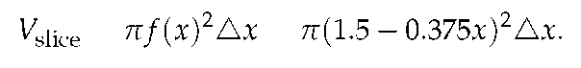

Since water weighs 62.4 lb/ft3, it follows that the approximate weight of a representative slice, which is also the approximate force the pump must exert to move the slice, is



Because the slice is located at a depth of *x* feet below the top of the crock, the slice being moved by the pump must move *x* feet to get to the level of the basement floor, and then, as stated in the problem description, be moved another 9 feet to reach the drain at ground level outside a basement window. Hence, the total distance a representative slice travels is

dslice = *x* + 9.

Finally, we note that the work to move a representative slice is given by



since the force to move a particular slice is constant.

We sum the work required to move slices throughout the tank

(from *x =* 0 to *x =* 4), let



and hence

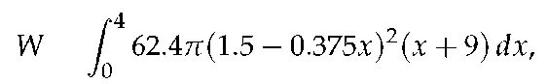

which, when evaluated using appropriate technology, shows

that the total work is



The preceding example demonstrates the standard approach to finding the work required to empty a tank filled with liquid. The main task in each such problem is to determine the volume of a representative slice, followed by the force exerted on the

slice, as well as the distance such a slice moves. In the case where the units are metric, there is one key difference: in the metric setting, rather than weight, we normally first find the mass of a slice. For instance, if distance is measured in meters, the mass density of water is 1000 kg/m3. In that setting, we can find the mass of a typical slice (in kg). To determine the force required to move it, we use *F = ma,* where *m* is the object's mass and *a* is the gravitational constant 9.81 N/kg3. That is, in metric units, the weight density of water is 9810 N/m3.

Figure 6.32: Illustrating a water tank in order to compute the work required to empty it in Example 4.

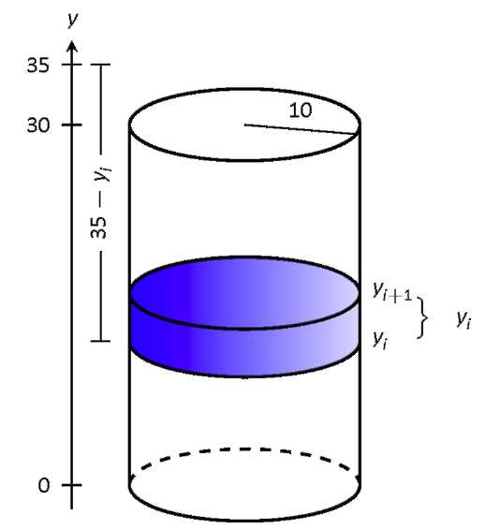

Example 4

A cylindrical storage tank with a radius of 10 ft and a height of 30 ft is filled with water, which weighs approximately 624 lb/ft3. Compute the amount of work performed by pumping the water up to a point 5 feet above the top of the tank.

Solution. We will refer often to Figure 6.32 which illustrates the salient aspects of this problem.

We start as we often do: we partition an interval into subintervals. We orient our tank vertically since this makes intuitive sense with the base of the tank at y = 0. Hence the top of the water is at *y* = 30, meaning we are interested in subdividing the y-interval [0,30] into *n* subintervals as



Consider the work Wi of pumping only the water residing in the ith subinterval, illustrated in Figure 6.32. The force required to move this water is equal to its weight which we calculate as volume x density. The

volume of water in this subinterval is



its density is 62.4

lb/ft3. Thus the required force is



We approximate the distance the force is applied by using any y-value contained in the ith subinterval; for simplicity, we arbitrarily use y,- for now (it will not matter later on). The water will be pumped to a point 5 feet above the top of the tank, that is, to the height of y = 35 ft. Thus the distance the water at height yi travels is 35 — yi ft.

In all, the approximate work Wi performed in moving the water in the *i*th subinterval to a point 5 feet above the tank is

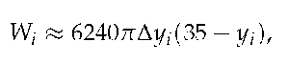

and the total work performed is

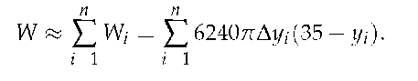

This is a Riemann sum. Taking the limit as the subinterval length goes

to o gives

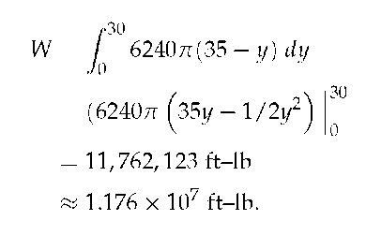

Figure 6.33: A graph of the conical water tank t in Example 5.

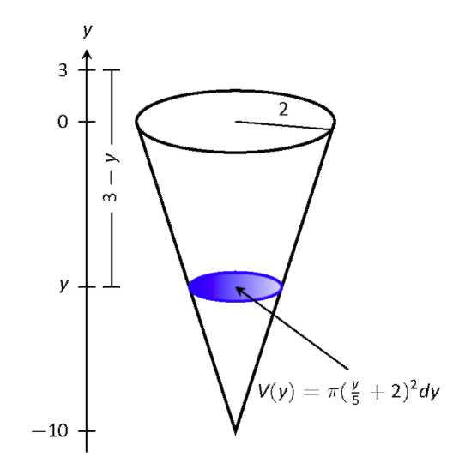

Example 5

A conical water tank has its top at ground level and its base 10 feet below ground. The radius of the cone at ground level is 2 ft. It is filled with water weighing 62.4 lb/ft3 and is to be emptied by pumping the water to a spigot 3 feet above ground level. Find the total amount of work performed in emptying the tank.

Solution. The conical tank is sketched in Figure 6.33. We can orient the tank in a variety of ways; we could let *y* = 0 represent the base of the tank and *y* = 10 represent the top of the tank, but we choose to keep the convention of the wording given in the problem and let *y* = 0 represent ground level and hence *y* = —10 represents the bottom of the tank. The actual "height" of the water does not matter; rather, we are concerned with the distance the water travels.

The figure also sketches a differential element, a cross-sectional circle. The radius of this circle is variable, depending on *y.* When *y =* —10, the circle has radius o; when *y* = 0, the circle has radius 2. These two points, ( — 10,0) and (0,2), allow us to find the equation of the line that gives the radius of the cross-sectional circle, which is *r(y) = l/5y + 2.* Hence

the volume of water at this height is



where

*dy* represents a very small height of the differential element. The force required to move the water at height *y* is *F(y)* = 62.4 x *V(y).*

The distance the water at height *y* travels is given by *h(y)* = 3 — *y.* Thus the total work done in pumping the water from the tank is

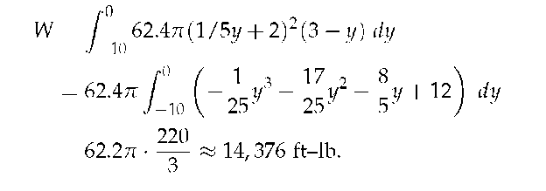

Example 6

A rectangular swimming pool is 20 ft wide and has a 3 ft "shallow end" and a 6 ft "deep end." It is to have its water pumped out to a point 2 ft above the current top of the water. The cross-sectional dimensions of the water in the pool are given in Figure 6.34; note that the dimensions are for the water, not the pool itself. Compute the amount of work performed in draining the pool.

Figure 6.34: The cross-section of a swimming pool filled with water in Example 6.

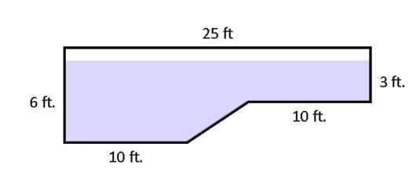

Figure 6.35: Orienting the pool and showing differential elements for Example 6.

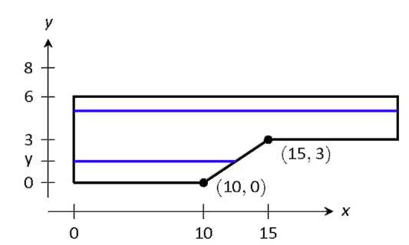

Solution. For the purposes of this problem we choose to set *y =* 0 to represent the bottom of the pool, meaning the top of the water is at *y =* 6.

Figure 6. 35 shows the pool oriented with this *y*-axis, along with 2 differential elements as the pool must be split into two different regions.

The top region lies in the y-interval of [3,6], where the length of the differential element is 25 ft as shown. As the pool is 20 ft wide, this differential element represents a this slice of water with volume *V(y) =* 20 • 25 • dy. The water is to be pumped to a height of *y =* 8, so the height function is *h(y) =* 8 — y. The work done in pumping this top region of water is

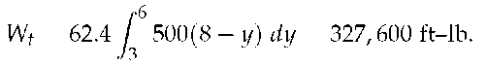

The bottom region lies in the *y*-interval of [0, 3]; we need to compute the length of the differential element in this interval.

One end of the differential element is at *x =* 0 and the other is along the line segment joining the points (10,0) and (15,3). The equation of this line is *y =* 3/5( *x* — 10); as we will be integrating with respect to *y,* we rewrite this equation as *x =* 5/3y *+* 10. So the length of the differential element is a difference of x-values: *x =* 0 and *x =* 5/3y *+* 10, giving a length of *x =* 5/3y *+* 10.

Again, as the pool is 20 ft wide, this differential element represents a thin slice of water with volume *V(y) =* 20 • (5/3y *+* 10) • dy; the height function is the same as before at *h( y) =* 8 — *y.* The work performed in emptying this part of the pool is

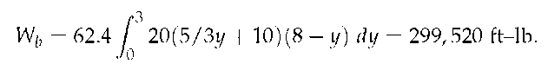

The total work in emptying the pool is

*W = Wb + Wt =* 327,600 *+* 299,520 *=* 627,120 ft-lb.

Notice how the emptying of the bottom of the pool performs almost as much work as emptying the top. The top portion travels a shorter distance but has more water. In the end, this extra water produces more work.

Figure 6.36: A trough with triangular ends, as described in Activity 6.4-2, part (c).

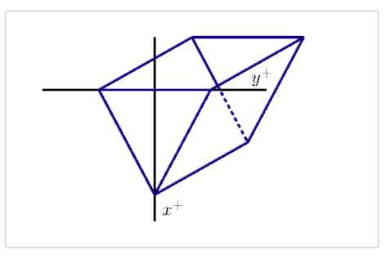

### Activity 6.5-2

In each of the following problems, determine the total work required to accomplish the described task. In parts (b) and (c), a key step is to find a formula for a function that describes the curve that forms the side boundary of the tank.

(a) Consider a vertical cylindrical tank of radius 2 meters and depth 6 meters. Suppose the tank is filled with 4 meters of water of mass density 1000 kg/m3, and the top 1 meter of water is pumped over the top of the tank.

(b) Consider a hemispherical tank with a radius of 10 feet. Suppose that the tank is full to a depth of 7 feet with water of weight density 62.4 pounds/ft3, and the top 5 feet of water are pumped out of the tank to a tanker truck whose height is 5 feet above the top of the tank.

(c) Consider a trough with triangular ends, as pictured in Figure 6.36, where the tank is 10 feet long, the top is 5 feet wide, and the tank is 4 feet deep. Say that the trough is full to within 1 foot of the top with water of weight density 62.4 pounds/ft3, and a pump is used to empty the tank until the water remaining in the tank is 1 foot deep.

Force due to Hydrostatic Pressure

When a dam is built, it is imperative to for engineers to understand how much force water will exert against the face of the dam. The first thing we realize is the the force exerted by the fluid is related to the natural concept of pressure. The pressure a force exerts on a region is measured in units of force per unit of area: for example, the air pressure in a tire is often measured in pounds per square inch (PSI). Hence, we see that the general relationship is given by

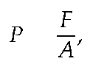

or F = P • A,

where P represents pressure, F represents force, and A the area of the region being considered. Of course, in the equation F = PA, we assume that the pressure is constant over the entire region A.

Most people know from experience that the deeper one dives underwater while swimming, the greater the pressure that is exerted by the water. This is due to the fact that the deeper one dives, the more water there is right on top of the swimmer: it is the force that "column" of water exerts that determines the pressure the swimmer experiences. To get water pressure measured in its standard units (pounds per square foot), we say that the total water pressure is found by computing the total weight of the column of water that lies above a region of area 1 square foot at a fixed depth. Such a rectangular column with a 1 x 1 base and a depth of d feet has volume V = 1 • 1 • *d* ft3, and thus the corresponding weight of the water overhead is 62.4d. Since this is also the amount of force being exerted on a 1 square foot region at a depth d feet underwater, we see that P = 62.4d (lbs/ft2) is the pressure exerted by water at depth d.

The understanding that P = 62.4d will tell us the pressure exerted by water at a depth of d, along with the fact that F = PA, will now enable us to compute the total force that water exerts on a dam, as we see in the following example.

Example 7

Consider a trapezoid-shaped dam that is 60 feet wide at its base and 90

Figure 6.37: A trapezoidal dam that is 25 feet tall, 60 feet wide at its base, 90 feet wide at its top, with the water line 5 feet down from the top of its face.

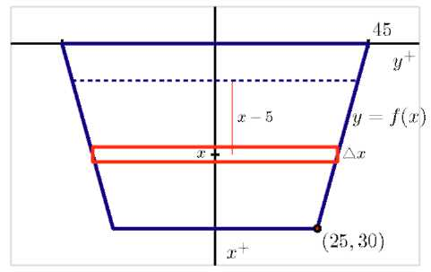

feet wide at its top, and assume the dam is 25 feet tall with water that rises to within 5 feet of the top of its face. Water weighs 62.5 pounds per cubic foot. How much force does the water exert against the dam?

Solution. First, we sketch a picture of the dam, as shown in Figure 6.37. Note that, as in problems involving the work to pump out a tank, we let the positive x-axis point down.

It is essential to use the fact that pressure is constant at a fixed depth. Hence, we consider a slice of water at constant depth on the face, such as the one shown in the figure. First, the approximate area of this slice is the area of the pictured rectangle. Since the width of that rectangle depends on the variable x (which represents the how far the slice lies from the top of the dam), we find a formula for the function *y = f(x)* that determines one side of the face of the dam. Since *f* is linear, it is

straightforward to find that



Hence, the approximate

area of a representative slice is



At any point on this slice, the depth is approximately constant, and thus the pressure can be considered constant. In particular, we note that since x measures the distance to the top of the dam, and because the water rises to within 5 feet of the top of the dam, the depth of any point on the representative slice is approximately (x — 5). Now, since pressure is given by *P* = 62.4*d,* we have that at any point on the representative slice

Pslice = 62.4(x-5).

Knowing both the pressure and area, we can find the force the water exerts on the slice. Using F = *PA,* it follows that



Finally, we use a definite integral to sum the forces over the appropriate range of x-values. Since the water rises to within 5 feet of the top of the dam, we start at x = 5 and slice all the way to the bottom of the dam, where x = 30. Hence,

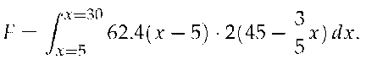

Using technology to evaluate the integral, we find



Figure 6.38: A thin plate in the shape of an isosceles triangle in Example 8.

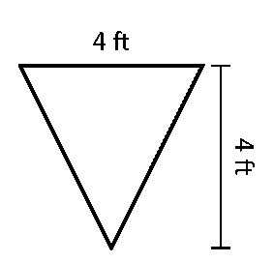

Example 8

Consider a thin plate in the shape of an isosceles triangle as shown in Figure 6.38 submerged in water with a weight-density of 62.4 lb/ft3. If the bottom of the plate is 10 ft below the surface of the water, what is the total fluid force exerted on this plate?

Solution. We approach this problem in two different ways. First we will let *y* = 0 represent the surface of the water, then we will consider an alternate convention.

Figure 6.39: Sketching the triangular plate in Example 8 with the convention that the water level is at y = 0.

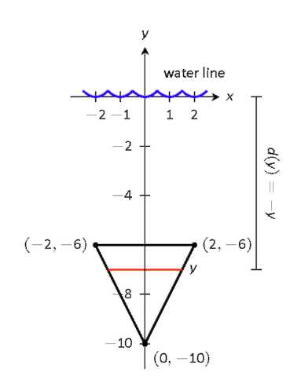

1 . We let y = 0 represent the surface of the water; therefore the bottom of the plate is at y = —10. We center the triangle on the y-axis as shown in Figure 6.39. The depth of the plate at y is y as indicated by the Key Idea. We now consider the length of the plate at y. We need to find equations of the left and right edges of the plate. The right hand side is a line that connects the points (0, —10) and (2, —6): that line has equation x = 1/2(y + 10). (Find the equation in the familiar y = mx + b format and solve for x.) Likewise, the left hand side is described by the line x = —1/2(y + 10). The total length is the distance between these two lines: £(y) = 1/2(y + 10) — ( —1/2(y +

10)) = y +10.

The total fluid force is then:

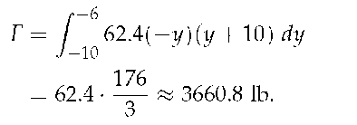

Figure 6.40: Sketching the triangular plate in Example 8 with the convention that the base of the triangle is at ( 0, 0) .

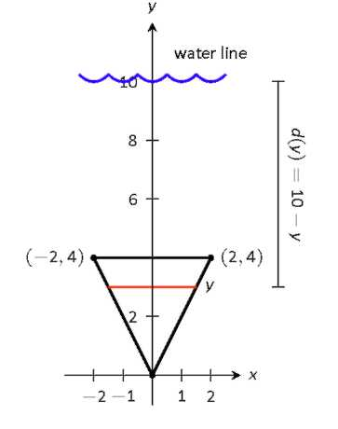

2. Sometimes it seems easier to orient the thin plate nearer the origin. For instance, consider the convention that the bottom of the triangular plate is at ( 0, 0) , as shown in Figure 6.40. The equations of the left and right hand sides are easy to find. They are y = 2x and y = — 2x, respectively, which we rewrite as x = 1/2y and x = 1/2y. Thus the length function is £(y) = 1/2y — (—1/2y) = y.

As the surface of the water is 10 ft above the base of the plate, we have that the surface of the water is at y = 10. Thus the depth function is the distance between y = 10 and y; d(y) = 10 y. We compute the total fluid force as:

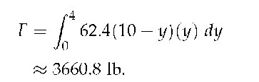

The correct answer is, of course, independent of the placement of the plate in the coordinate plane as long as we are consistent.

Figure 6.41: Measuring the fluid force on an underwater porthole in Example 9.

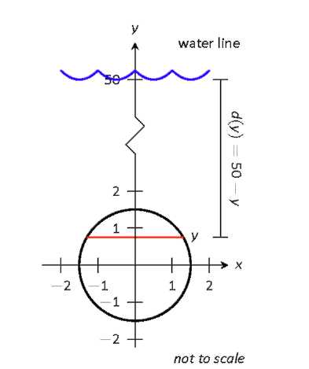

Example 9

An underwater observation tower is being built with circular viewing portholes enabling visitors to see underwater life. Each vertically oriented porthole is to have a 3 ft diameter whose center is to be located 50 ft underwater. Find the total fluid force exerted on each porthole. Also, compute the fluid force on a horizontally oriented porthole that is under 50 ft of water.

Solution. We place the center of the porthole at the origin, meaning the surface of the water is at y = 50 and the depth function will be d(y) = 50 — y; see Figure 6.41

The equation of a circle with a radius of 1.5 is x2 + y2 = 2.25; solving

for x we have



where the positive square root corresponds to the right side of the circle and the negative square root corresponds to the left side of the circle. Thus the length function at depth y

is



Integrating on [—1.5,1.5] we have:

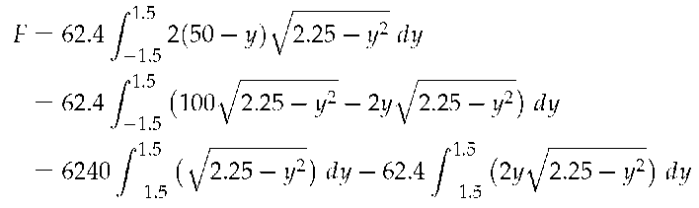

The second integral above can be evaluated using Substitution. Let u = 2.25 — y2 with du = —2ydy. The new bounds are: u(—1.5) = 0 and u(1.5) = 0; the new integral will integrate from u = 0 to u = 0, hence the integral is 0.

The first integral above finds the area of half a circle of radius 1.5, thus

the first integral evaluates to



Thus the total

fluid force on a vertically oriented porthole is 22,054 lb.

Finding the force on a horizontally oriented porthole is more straightforward:

F = Pressure x Area =



That these two forces are equal is not coincidental; it turns out that the fluid force applied to a vertically oriented circle whose center is at depth d is the same as force applied to a horizontally oriented circle at depth

d.

Figure 6.42: A trough with triangular ends, as described in Activity 6.4-3, part (c).

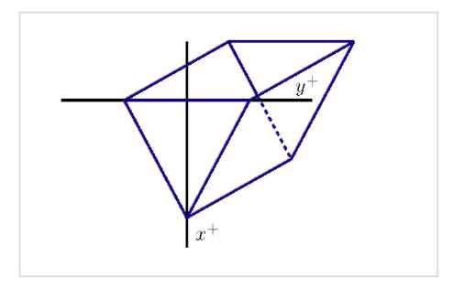

### Activity 6.5-3

In each of the following problems, determine the total force exerted by water against the surface that is described.

(a) Consider a rectangular dam that is 100 feet wide and 50 feet tall, and suppose that water presses against the dam all the way to the top.

(b) Consider a semicircular dam with a radius of 30 feet. Suppose that the water rises to within 10 feet of the top of the dam.

(c) Consider a trough with triangular ends, as pictured in Figure 6.42, where the tank is 10 feet long, the top is 5 feet wide, and the tank is 4 feet deep. Say that the trough is full to within 1 foot of the top with water of weight density 62.4 pounds/ft3. How much force does the water exert against one of the triangular ends?

While there are many different formulas that we use in solving problems involving work, force, and pressure, it is important to understand that the fundamental ideas behind these problems are similar to several others that we've encountered in applications of the definite integral. In particular, the basic idea is to take a difficult problem and somehow slice it into more manageable pieces that we understand, and then use a definite integral to add up these simpler pieces.

### Summary

*In this section, we encountered the following important ideas:*

• To measure the work accomplished by a varying force that moves an object, we subdivide the problem into pieces on which we can use the formula *W = F • d,* and then use a definite integral to sum the work accomplished on each piece.

• To find the total force exerted by water against a dam, we use the formula *F = P • A* to measure the force exerted on a slice that lies at a fixed depth, and then use a definite integral to sum the forces across the appropriate range of depths.

• Because work is computed as the product of force and distance (provided force is constant), and the force water exerts on a dam can be computed as the product of pressure and area (provided pressure is constant), problems involving these concepts are similar to earlier problems we did using definite integrals to find distance (via "distance equals rate times time") and mass ("mass equals density times volume").

### Exercises

Terms and Concepts

1) What are the typical units of work?

2) If a man has a mass of 80 kg on Earth, will his mass on the moon be bigger, smaller, or the same?

3) If a woman weighs 130 lb on Earth, will her weight on the moon be bigger, smaller, or the same?

### Problems

4) A 100 ft rope, weighing 0.1 lb/ft, hangs over the edge of a tall building.

(a) How much work is done pulling the entire rope to the top of the building?

(b) How much rope is pulled in when half of the total work is done?

5) A 50 m rope, with a mass density of 0.2 kg/m, hangs over the edge of a tall building.

(a) How much work is done pulling the entire rope to the top of the building?

(b) How much work is done pulling in the first 20 m?

6) A rope of length *I* ft hangs over the edge of tall cliff. (Assume the cliff is taller than the length of the rope.) The rope has a weight density of *d* lb/ft.

(a) How much work is done pulling the entire rope to the top of the cliff?

(b) What percentage of the total work is done pulling in the first half of the rope?

(c) How much rope is pulled in when half of the total work is done?

7) A 20 m rope with mass density of 0.5 kg/m hangs over the edge of a 10 m building. How much work is done pulling the rope to the top?

8) A crane lifts a 2,000 lb load vertically 30 ft with a 1" cable weighing 1.68 lb/ft.

(a) How much work is done lifting the cable alone?

(b) How much work is done lifting the load alone?

(c) Could one conclude that the work done lifting the cable is negligible compared to the work done lifting the load?

9) A 100 lb bag of sand is lifted uniformly 120 ft in one minute. Sand leaks from the bag at a rate of 1/4 lb/s. What is the total work done in lifting the bag?

10) A box weighing 2 lb lifts 10 lb of sand vertically 50 ft. A crack in the box allows the sand to leak out such that 9 lb of sand is in the box at the end of the trip. Assume the sand leaked out at a uniform rate. What is the total work done in lifting the box and sand?

11) A force of 1000 lb compresses a spring 3 in. How much work is performed in compressing the spring?

12) A force of 2 N stretches a spring 5 cm. How much work is performed in stretching the spring?

13) A force of 50 lb compresses a spring from 18 in to 12 in. How much work is performed in compressing the spring?

14) A force of 20 lb stretches a spring from 6 in to 8 in. How much work is performed in stretching the spring?

15) A force of 7 N stretches a spring from 11 cm to 21 cm. How much work is performed in stretching the spring?

16) A force of *f* N stretches a spring *d* m. How much work is performed in stretching the spring?

17) A 20 lb weight is attached to a spring. The weight rests on the spring, compressing the spring from a natural length of 1 ft to 6 in.

How much work is done in lifting the box 1.5 ft (i.e, the spring will be stretched 1 ft beyond its natural

length)?

18) A 20 lb weight is attached to a spring. The weight rests on the spring, compressing the spring from a natural length of 1 ft to 6 in.

How much work is done in lifting the box 6 in (i.e, bringing the spring back to its natural length)?

19) A 5 m tall cylindrical tank with radius of 2 m is filled with 3 m of gasoline, with a mass density of 737.22 kg/m3. Compute the total work performed in pumping all the gasoline to the top of the tank.

20) A 6 ft cylindrical tank with a radius of 3 ft is filled with water, which has a weight density of 62.4 lb/ft3. The water is to be pumped to a point 2 ft above the top of the tank.

(a) How much work is performed in pumping all the water from the tank?

(b) How much work is performed in pumping 3 ft of water from the tank?

(c) At what point is 1/2 of the total work done?

21) A gasoline tanker is filled with gasoline with a weight density of 45.93 lb/ft3. The dispensing valve at the base is jammed shut, forcing the operator to empty the tank via pumping the gas to a point 1 ft above the top of the tank. Assume the tank is a perfect cylinder, 20 ft long with a diameter of 7.5 ft.

How much work is performed in pumping all the gasoline from the tank?

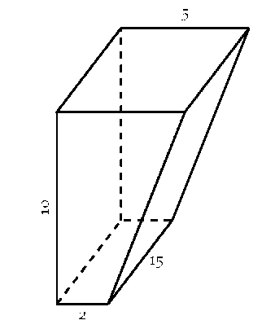

22) A fuel oil storage tank is 10 ft deep with trapezoidal sides, 5 ft at the top and 2 ft at the bottom, and is 15 ft wide (see diagram below). Given that fuel oil weighs 55.46 lb/ft3, find the work performed in pumping all the oil from the tank to a point 3 ft above the top of the tank.

23) A conical water tank is 5 m deep with a top radius of 3 m. The tank is filled with pure water, with a mass density of 1000 kg/m3.

(a) Find the work performed in pumping all the water to the top of the tank.

(b) Find the work performed in pumping the top 2.5 m of water to the top of the tank.

(c) Find the work performed in pumping the top half of the water, by volume, to the top of the tank.

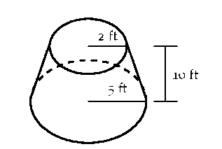

24) A water tank has the shape of a truncated cone, with dimensions given below, and is filled with water with a weight density of 62.4 lb/ft3. Find the work performed in pumping all water to a point 1 ft above the top of the tank.

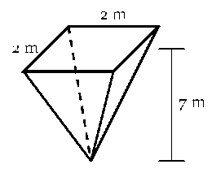

25) A water tank has the shape of an inverted pyramid, with dimensions given below, and is filled with water with a mass density of 1000 kg/m3. Find the work performed in pumping all water to a point 5 m above the top of the tank.

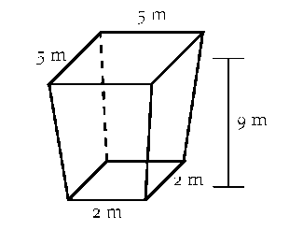

26) A water tank has the shape of an truncated, inverted pyramid, with dimensions given below, and is filled

with water with a mass density of 1000 kg/m3. Find the work performed in pumping all water to a point 1 m above the top of the tank.

27) A cylindrical tank, buried on its side, has radius 3 feet and length 10 feet. It is filled completely with water whose weight density is 62.4 lbs/ft3, and the top of the tank is two feet underground.

(a) Set up an integral expression that represents the amount of work required to empty the top half of the water in the tank to a truck whose tank lies 4.5 feet above ground.

(b) With the tank now only half-full, set up an integral expression that represents the total force due to hydrostatic pressure against one end of the tank.

## 6.6 An Introduction to Differential Equations

### Motivating Questions

In this section, we strive to understand the ideas generated by the following important questions:

• What is a differential equation and what kinds of information can it tell us?

• How do differential equations arise in the world around us?

• What do we mean by a solution to a differential equation?

• What is a slope field and how can we use a slope field to obtain qualitative information about the solutions of a differential equation?

• What are stable and unstable equilibrium solutions of an autonomous differential equation?

### Introduction

In previous chapters, we have seen that a function's derivative tells us the rate at which the function is changing. More recently, the Fundamental Theorem of Calculus helped us to determine the total change of a function over an interval when we know the function's rate of change. For instance, an object's velocity tells us the rate of change of that object's position. By integrating the velocity over a time interval, we may determine by how much the position changes over that time interval. In particular, if we know where the object is at the beginning of that interval, then we have enough information to accurately predict where it will be at the end of the interval.

In this section, we will introduce the concept of differential equations and explore this idea in more depth. Simply said, a differential equation is an equation that provides a description of a function's derivative, which means that it tells us the function's rate of change. Using this information, we would like to learn as much as possible about the function itself. For instance, we would ideally like to have an algebraic description of the function.

### Preview Activity 6.6

The position of a moving object is given by the function s( t), where s is measured in feet and t in seconds. We determine that the velocity is v(t) = 4t + 1 feet per second.

(a) How much does the position change over the time interval [0, 4]?

(b) Does this give you enough information to determine s(4), the position at time t = 4? If so, what is s(4)? If not, what additional information would you need to know to determine s( 4) ?

(c) Suppose you are told that the object's initial position s(0) = 7. De

termine s(2), the object's position 2 seconds later.

(d) If you are told instead that the object's initial position is s(0) = 3,

what is s(2)?

(e) If we only know the velocity v(t) = 4t + 1, is it possible that the object's position at all times is s(t) = 2t2 + t — 4? Explain how you know.

(f) Are there other possibilities for s(t)? If so, what are they?

(g) If, in addition to knowing the velocity function is v(t) = 4t + 1, we know the initial position s(0), how many possibilities are there for

s(t)?

What is a differential equation?

A differential equation is an equation that describes the derivative, or derivatives, of a function that is unknown to us. For instance, the equation

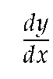

= x sin( x)

is a differential equation since it describes the derivative of a function y( x) that is unknown to us.

As many important examples of differential equations involve quantities that change in time, the independent variable in our discussion will frequently be time t. For instance, in the preview activity, we considered the differential equation



= 4t +1.

Knowing the velocity and the starting position of the object, we were able to find the position at any later time.

Because differential equations describe the derivative of a function, they give us information about how that function changes. Our goal will be to take this information and use it to predict the value of the function in the future; in this way, differential equations provide us with something like a crystal ball.

Differential equations arise frequently in our every day world. For instance, you may hear a bank advertising:

Your money will grow at a *3%* annual interest rate with us.

This innocuous statement is really a differential equation. Let's translate: A(t) will be amount of money you have in your account at time t. On one hand, the rate at which your money grows is the derivative dA/dt. On the other hand, we are told that this rate is 0.03A. This leads to the differential equation

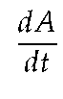

= 0.03A.

This differential equation has a slightly different feel than the

previous equation



= 4t + 1. In the earlier example, the rate

of change depends only on the independent variable t, and we may find s(t) by integrating the velocity 4t + 1. In the banking example, however, the rate of change depends on the dependent variable A, so we'll need some new techniques in order to find

A(t).

### Activity 6.6-1

Express the following statements as differential equations. In each case, you will need to introduce notation to describe the important quantities in the statement so be sure to clearly state what your notation means.

(a) The population of a town grows at an annual rate of 1.25%.

(b) A radioactive sample loses 5.6% of its mass every day.

(c) You have a bank account that earns 4% interest every year. At the same time, you withdraw money continually from the account at the rate of $1000 per year.

(d) A cup of hot chocolate is sitting in a 70° room. The temperature of the hot chocolate cools by 10% of the difference between the hot chocolate's temperature and the room temperature every minute.

(e) A can of cold soda is sitting in a 70° room. The temperature of the soda warms at the rate of 10% of the difference between the soda's temperature and the room's temperature every minute.

Differential equations may be classified based on certain characteristics they may possess. Indeed, you may see many different types of differential equations in a later course in differential equations. For now, we would like to introduce a few terms that are used to describe differential equations.

A first-order differential equation is one in which only the first derivative of the function occurs. For this reason,

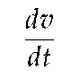

= 1.5 — 0.5v

is a first-order equation while

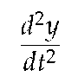

= — 10y

is a second-order equation.

A differential equation is autonomous if the independent variable does not appear in the description of the derivative. For instance,



= 1.5 — 0.5v

is autonomous because the description of the derivative dv/dt

does not depend on time. The equation



= 1.5t — 0.5y,

however, is not autonomous.

Differential equations in the world around us

As we have noted, differential equations give a natural way to describe phenomena we see in the real world. For instance, physical principles are frequently expressed as a description of how a quantity changes. A good example is Newton's Second Law, an important physcial principle that says:

*The product of an object's mass and acceleration equals the force applied to it.*

For instance, when gravity acts on an object near the earth's surface, it exerts a force equal to *mg,* the mass of the object times the gravitational constant *g.* We therefore have

*ma = mg,* or

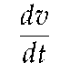

*= g*

where *v* is the velocity of the object, and *g =* 9.8 meters per second squared. Notice that this physical principle does not tell us what the object's velocity is, but rather how the object's velocity changes.

### Activity 6.6-2

Shown are two graphs depicting the velocity of falling objects. One is the velocity of a skydiver, while the other is the velocity of a meteorite entering the Earth's atmosphere.

(a) Begin with the skydiver's velocity and use the given graph to measure the rate of change *dv/dt* when the velocity is *v =* 0.5,1.0,1.5,2.0, and 2.5. Plot your values on the graph below. You will want to think carefully about this: you are plotting the derivative *dv/ dt* as a function of *velocity.*

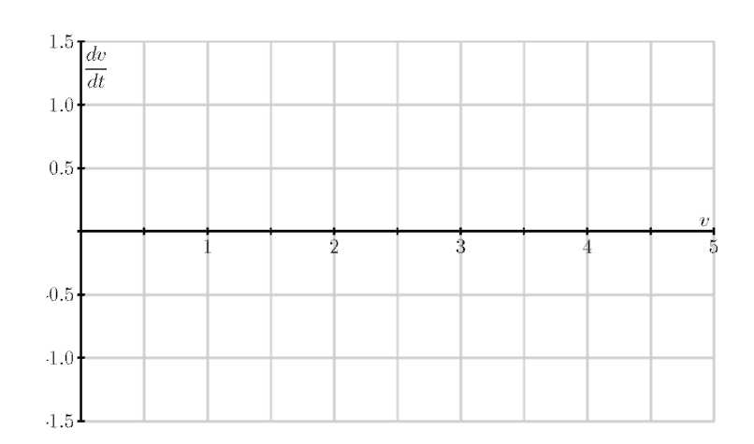

Figure 6.43: Graphs of velocities used in Activity 6.6-2.

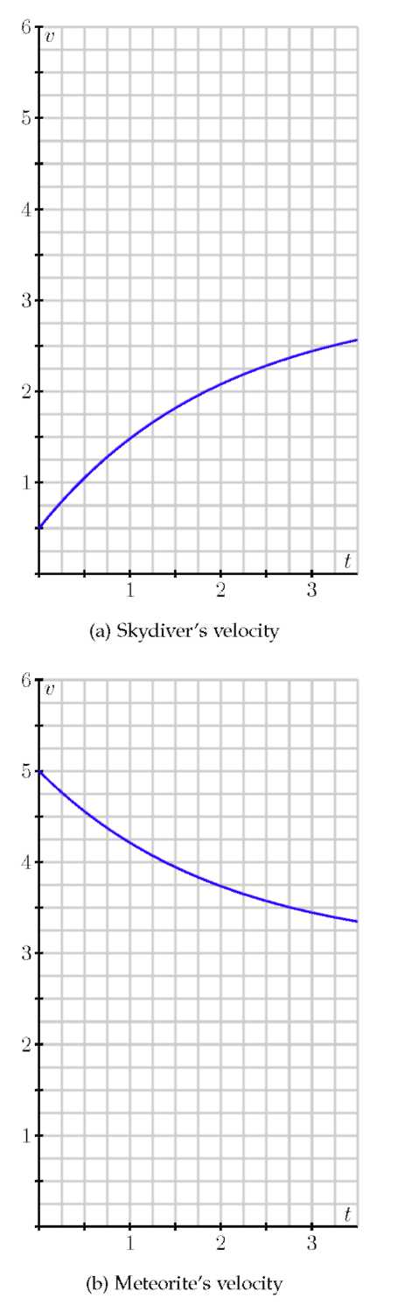

(b) Now do the same thing with the meteorite's velocity: use the given graph to measure the rate of change *dv/dt* when the velocity is *v =* 3.5,4.0,4.5, and 5.0. Plot your values on the graph above.

(c) You should find that all your points lie on a line. Write the equation of this line being careful to use proper notation for the quantities on the horizontal and vertical axes.

(d) The relationship you just found is a differential equation. Write a complete sentence that explains its meaning.

(e) By looking at the differential equation, determine the values of the velocity for which the velocity increases.

(f) By looking at the differential equation, determine the values of the velocity for which the velocity decreases.

(g) By looking at the differential equation, determine the values of the velocity for which the velocity remains constant.

The point of this activity is to demonstrate how differential equations model processes in the real world. In this example, two factors are influencing the velocities: gravity and wind resistance. The differential equation describes how these factors influence the rate of change of the objects' velocities.

Solving a differential equation

We have said that a differential equation is an equation that describes the derivative, or derivatives, of a function that is unknown to us. By a *solution* to a differential equation, we mean simply a function that satisfies this description.

For instance, the first differential equation we looked at is



= 4t +1,

which describes an unknown function s(t). We may check that s(t) = 2t2 +1 is a solution because it satisfies this description. Notice that s(t) = 2t2 + t + 4 is also a solution.

If we have a candidate for a solution, it is straightforward to check whether it is a solution or not. Before we demonstrate, however, let's consider the same issue in a simpler context. Suppose we are given the equation 2x2 — 2x = 2x + 6 and asked whether x = 3 is a solution. To answer this question, we could

rewrite the variable x in the equation with the symbol



To determine whether x = 3 is a solution, we can investigate the value of each side of the equation separately when the value 3 is

placed in □

and see if indeed the two resulting values are equal.

Doing so, we observe that



and



Therefore, x = 3 is indeed a solution.

We will do the same thing with differential equations. Consider the differential equation

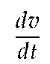

= 1.5 — 0.5v, or

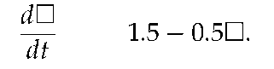

Let's ask whether v(t) = 3 — 2e 0.5t is a solution4.

4 At this time, don't worry about why we chose this function; we will learn techniques for finding solutions to differential equations soon enough.

Using this

formula for v, observe first that

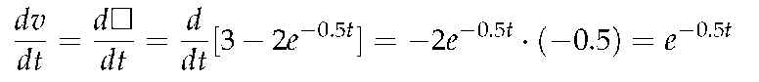

and

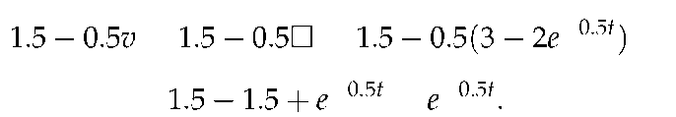

Since



and 1.5 — 0.5v agree for all values of t when v = 3 —

2e , we have indeed found a solution to the differential equation.

### Activity 6.6-3

Consider the differential equation



= 1.5 — 0.5v.

Which of the following functions are solutions of this differential equation?

(a) v(t) = 1.5t 0.25t2.

(b) *v(t) =* 3 + 2e—0.5t.

(c) *v(t) =* 3.

(d) *v(t) =* 3 + *Ce—0.5t* where *C* is any constant.

Figure 6.44: The family of solutions to the differential equation ^ = 1.5 — 0.5v.

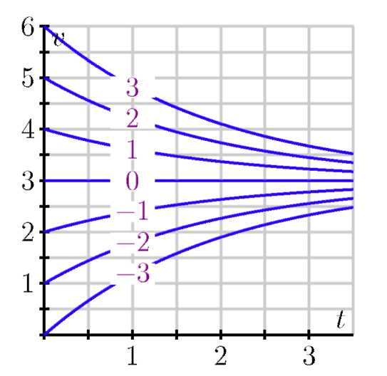

This activity shows us something interesting. Notice that the differential equation has infinitely many solutions, which are parameterized by the constant *C* in *v(t) =* 3 + *Ce—*0.5t. In Figure 6.44, we see the graphs of these solutions for a few values of *C,* as labeled.

Notice that the value of *C* is connected to the initial value of the velocity v(0), since v(0) = 3 + C. In other words, while the differential equation describes how the velocity changes as a function of the velocity itself, this is not enough information to determine the velocity uniquely: we also need to know the initial velocity. For this reason, differential equations will typically have infinitely many solutions, one corresponding to each initial value. We have seen this phenomenon before, such as when given the velocity of a moving object v(t), we were not able to uniquely determine the object's position unless we also know its initial position.

If we are given a differential equation and an initial value for the unknown function, we say that we have an *initial value problem.* For instance,



= 1.5 — 0.5v, v(0) = 0.5

is an initial value problem. In this situation, we know the value of *v* at one time and we know how *v* is changing. Consequently, there should be exactly one function *v* that satisfies the initial value problem.

Figure 6.45: Beginnings of the slope field for



*t —* 2..

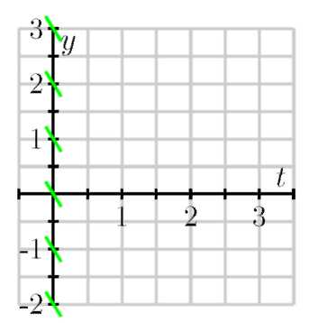

### Slope Fields

We may sketch the solution to an initial value problem if we know an appropriate collection of tangent lines. Because we may use a given differential equation to determine the slope of the tangent line at any point of interest, by plotting a useful collection of these, we can get an accurate sense of how certain solution curves must behave.

Let's investigate the differential equation



= *t* — 2. If *t* = 0,

this equation says that *dy/dt =* 0 — 2 = —2. Note that this value holds regardless of the value of *y.* We will therefore sketch tangent lines for several values of *y* and *t* = 0 with a slope of — 2; see Figure 6.45.

Let's continue in the same way: if *t* = 1, the differential equation tells us that *dy/ dt* = 1 — 2 = — 1, and this holds regardless

of the value of *y.* We now sketch tangent lines for several values of *y* and *t =* 1 with a slope of —1; see Figure 6.45-(a).

Similarly, we see that when *t =* 2, *dy/dt =* 0 and when *t =* 3, *dy/dt =* 1. We may therefore add to our growing collection of tangent line plots; see Figure 6.45-(b). In this figure, you may see the solutions to the differential equation emerge. However, for the sake of clarity, we will add more tangent lines to provide the more complete picture shown in Figure 6.46-(c).

Figure 6.46: Generating the slope field for

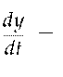

t — 2..

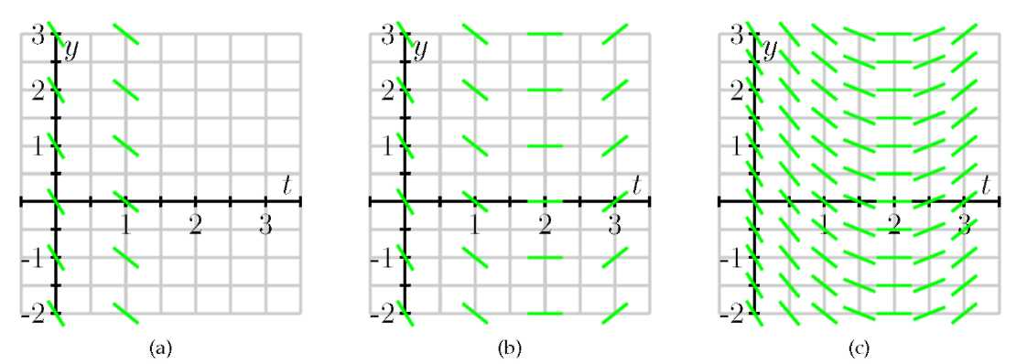

Figure 6.46-(c) is called a *slope field* for the differential equation, allows us to sketch solutions of the differential equation. Here, we will begin with the initial value y(0) = 1 and start sketching the solution by following the tangent line, as shown in Figure 6.47.

We then continue using this principle: whenever the solution passes through a point at which a tangent line is drawn, that line is tangent to the solution. Doing so leads us to the following sequence of images.

Figure 6.47: Sketching a solution curve for



*t —* 2..

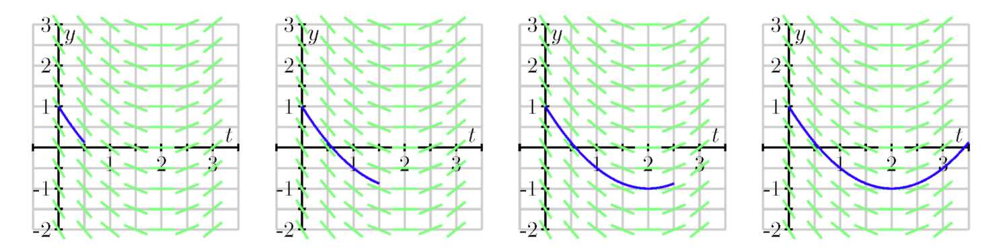

In fact, we may draw solutions for any possible initial value, and doing this for several different initial values for y(0) results in the graphs shown in Figure 6.48.

Just as we have done for the most recent example with



t — 2, we can construct a slope field for any differential equation of interest. The slope field provides us with visual information about how we expect solutions to the differential equation to behave.

Figure 6.48: Several solution curves for



= t — 2..

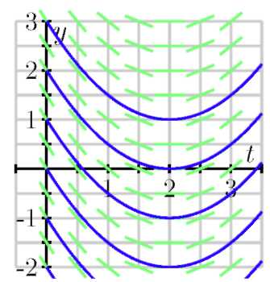

### Activity 6.6-4

Consider the autonomous differential equation

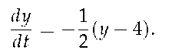

(a) Make a plot of



versus y on the axes provided. Looking at the

graph, for what values of y does y increase and for what values of y does y decrease?

(b) Next, sketch the slope field for this differential equation on the axes provided.

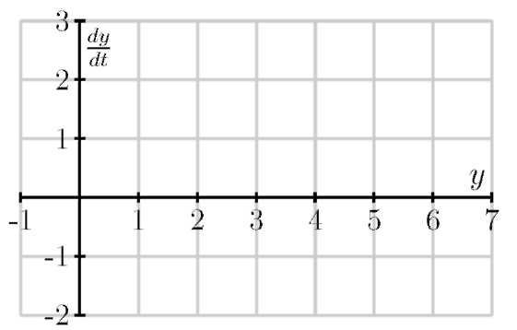

(c) Use your work in (b) to sketch the solutions that satisfy y(0) = 0, y(0)= 2, y(0)= 4 and y(0) = 6.

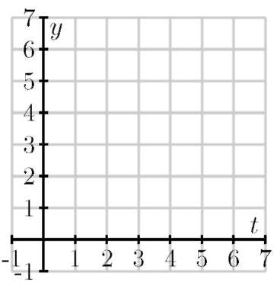

(d) Verify that y(t) = 4 + 2e—1/2 is a solution to the given differential equation with the initial value y( 0) = 6. Compare its graph to the one you sketched in (c).

(e) What is special about the solution where y(0) = 4?

### Equilibrium solutions and stability

As our work in Activity 6.6-4 demonstrates, first-order autonomous solutions may have solutions that are constant. In fact, these are quite easy to detect by inspecting the differential equation dy/ dt = f( y) : constant solutions necessarily have a zero derivative so dy/dt = 0 = f (y).

For example, in Activity 6.6-4, we considered the equation

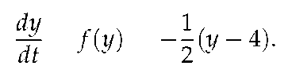

Constant solutions are found by setting f(y) =



(y 4) = 0,

which we immediately see implies that y = 4.

Values of y for which f (y) = 0 in an autonomous differential

equation



are usually called or equilibrium solutions of

the differential equation.

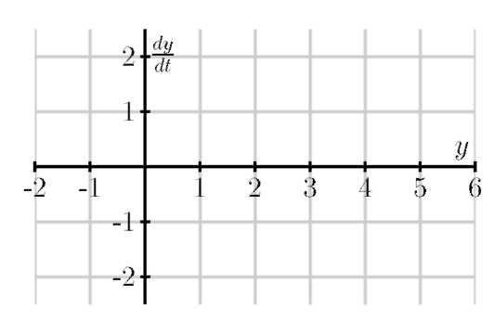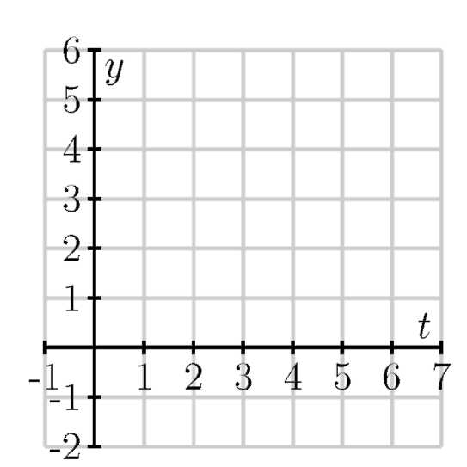

### Activity 6.6-5

Consider the autonomous differential equation

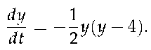

(a) Make a plot of



versus y. Looking at the graph, for what values

of y does y increase and for what values of y does y decrease?

(b) Identify any equilibrium solutions of the given differential equation.

(c) Now sketch the slope field for the given differential equation.

(d) Sketch the solutions to the given differential equation that correspond to initial values y (0) = —1,0,1,..., 5.

(e) An equilibrium solution



is called stable if nearby solutions con-

verge to



This means that if the initial condition varies slightly

from



then



Conversely, an equilibrium solution



is called unstable if nearby

solutions are pushed away from



Using your work above, classify the equilibrium solutions you found in (b) as either stable or unstable.

(f) Suppose that y(t) describes the population of a species of living organisms and that the initial value y( 0) is positive. What can you say about the eventual fate of this population?

(g) Remember that an equilibrium solution



satisfies



If we

graph dy/ dt = f( y) as a function of y, for which of the following

differential equations is



a stable equilibrium and for which is



unstable? Why?

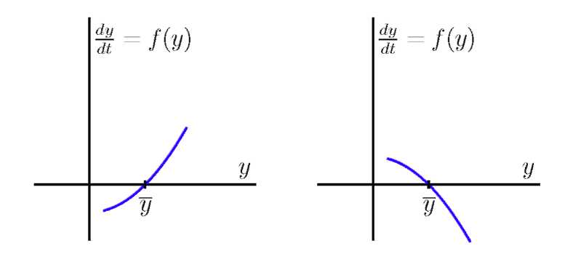

### Summary

*In this section, we encountered the following important ideas:*

• A differential equation is simply an equation that describes the derivative(s) of an unknown function.

• Physical principles, as well as some everyday situations, often describe how a quantity changes, which lead to differential equations.

• A solution to a differential equation is a function whose derivatives satisfy the equation's description. Differential equations typically have infinitely many solutions, parameterized by the initial values.

• A slope field is a plot created by graphing the tangent lines of many different solutions to a differential equation.

• Once we have a slope field, we may sketch the graph of solutions by drawing a curve that is always tangent to the lines in the slope field.

• Autonomous differential equations sometimes have constant solutions that we call equilibrium solutions. These may be classified as stable or unstable, depending on the behavior of nearby solutions.

### Exercises

Problems

1) Suppose that T(t) represents the temperature of a cup of coffee set out in a room, where T is expressed in degrees Fahrenheit and t in minutes. A physical principle known as Newton's Law of Cooling tells us that

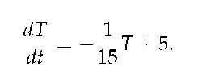

(a) Supposes that T(0) = 105. What does the differ-

ential equation give us for the value of



Explain in a complete sentence the meaning of these two facts.

(b) Is T increasing or decreasing at t = 0?

(c) What is the approximate temperature at t = 1?

(d) On the graph below, make a plot of dT/dt as a function of T.

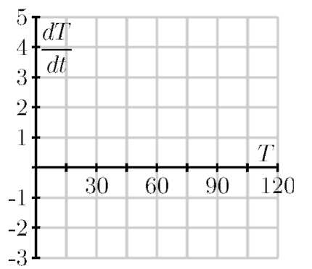

(e) For which values of T does T increase? For which values of T does T decrease?

(f) What do you think is the temperature of the room? Explain your thinking.

(g) Verify that T(t) = 75 + 30e—1/15 is the solution to the differential equation with initial value T( 0) = 105. What happens to this solution after a long time?

2) Suppose that the population of a particular species is described by the function P( t), where P is expressed in millions. Suppose further that the population's rate of change is governed by the differential equation

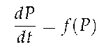

where f( P) is the function graphed below.

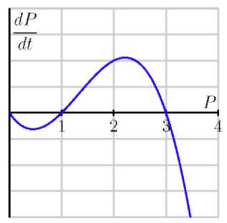

(a) For which values of the population P does the population increase?

(b) For which values of the population P does the population decrease?

(c) If P(0) = 3, how will the population change in time?

(d) If the initial population satisfies



what will happen to the population after a very long time?

(e) If the initial population satisfies



what will happen to the population after a very long time?

(f) If the initial population satisfies



what

will happen to the population after a very long time?

(g) This model for a population's growth is sometimes called "growth with a threshold." Explain why this is an appropriate name.

3) In this problem, we test further what it means for a function to be a solution to a given differential equation.

(a) Consider the differential equation

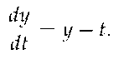

Determine whether the following functions are solutions to the given differential equation.

(i) y(t) = t + 1 + 2et

(ii) y(t) = t +1

(iii) y(t) = t +2

(b) When you weigh bananas in a scale at the grocery store, the height h of the bananas is described by the differential equation

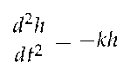

where k is the spring constant, a constant that depends on the properties of the spring in the scale. After you put the bananas in the scale,

bserve that the height of the baby h(t) = 4sin(3t). What is the

ring constant?

This page was intentionally left blank.

## 6.7 Separable differential equations

### Motivating Questions

In this section, we strive to understand the ideas generated by the following important questions:

• What is a separable differential equation?

• How can we find solutions to a separable differential equation?

• Are some of the differential equations that arise in applications separable?

• How can we use differential equations to describe and understand phenomena in the world around us?

### Introduction

Given the frequency with which differential equations arise in the world around us, we would like to have some techniques for finding explicit algebraic solutions of certain initial value problems. In this section, we focus on a particular class of differential equations (called separable) and develop a method for finding algebraic formulas for solutions to these equations.

A separable differential equation is a differential equation whose algebraic structure permits the variables present to be separated in a particular way. For instance, consider the equation

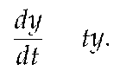

We would like to separate the variables t and y so that all occurrences of t appear on the right-hand side, and all occurrences of y appears on the left and multiply dy/dt. We may do this in the preceding differential equation by dividing both sides by y:

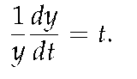

Note particularly that when we attempt to separate the variables in a differential equation, we require that the left-hand side be a product in which the derivative dy/ dt is one term.

Not every differential equation is separable. For example, if we consider the equation

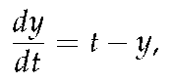

it may seem natural to separate it by writing

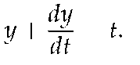

As we will see, this will not be helpful since the left-hand side

is not a product of a function of y with



Page506

### Preview Activity 6.7

In this preview activity, we explore whether certain differential equations are separable or not, and then revisit some key ideas from earlier work in integral calculus.

(a) Which of the following differential equations are separable? If the

equation is separable, write the equation in the revised form *g(y]*



=

*h(t).*

(a)



*= -*3y.

(b)



= ty — y.

(c)



= t + 1.

(d)



= t2 — y2.

(b) Explain why any autonomous differential equation is guaranteed to be separable.

(c) Why do we include the term "+C" in the expression

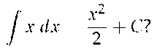

(d) Suppose we know that a certain function f satisfies the equation



What can you conclude about f ?

Solving separable differential equations

Before we discuss a general approach to solving a separable differential equation, it is instructive to consider an example.

Example 1

Find all functions y that are solutions to the differential equation

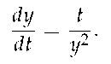

Solution. We begin by separating the variables and writing

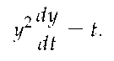

Integrating both sides of the equation with respect to the independent variable t shows that



Next, we notice that the left-hand side allows us to change the variable

of antidifferentiation from *t* to *y.* In particular, *dy =*



*dt,* so we now

have

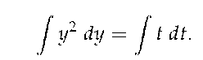

This is why we required that the left-hand side be written as a product in which dy/ dt is one of the terms. This most recent equation says that two families of antiderivatives are equal to one another. Therefore, when we find representative antiderivatives of both sides, we know they must differ by arbitrary constant C. Antidifferentiating and including the integration constant C on the right, we find that

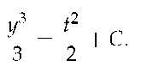

Again, note that it is not necessary to include an arbitrary constant on both sides of the equation; we know that y3/3 and t2/2 are in the same family of antiderivatives and must therefore differ by a single constant.

Finally, we may now solve the last equation above for y as a function of t, which gives

y(t) =

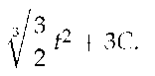

Of course, the term 3C on the right-hand side represents 3 times an unknown constant. It is, therefore, still an unknown constant, which we will rewrite as C. We thus conclude that the function

y(t) =

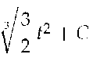

is a solution to the original differential equation for any value of C.

Notice that because this solution depends on the arbitrary constant C, we have found an infinite family of solutions. This makes sense because we expect to find a unique solution that corresponds to any given initial value.

For example, if we want to solve the initial value problem

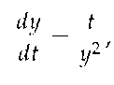

y(0) = 2,

we know that the solution has the form y( t) =



for some con-

stant C. We therefore must find the appropriate value for C that gives the initial value y(0) = 2. Hence,

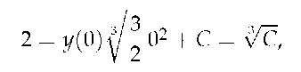

which shows that C = 23 = 8. The solution to the initial value problem is then

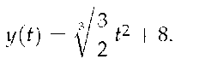

The strategy of Example 1 may be applied to any differential equation of the form



and any differential

equation of this form is said to be separable. We work to solve a separable differential equation by writing

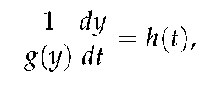

and then integrating both sides with respect to *t.* After integrating, we strive to solve algebraically for *y* in order to write *y* as a function of *t.*

We consider one more example before doing further exploration in some activities.

Example 2

Solve the differential equation



= 3*y.*

Solution. Following the same strategy as in Example 1, we have

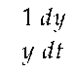

Integrating both sides with respect to *t,*

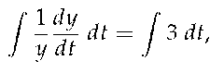

and thus

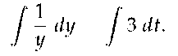

Antidifferentiating and including the integration constant, we find that



*= 3t + C.*

Finally, we need to solve for *y.* Here, one point deserves careful attention. By the definition of the natural logarithm function, it follows that



*= e3t+C = e3teC.*

Since *C* is an unknown constant, *eC* is as well, though we do know that it is positive (because *ex* is positive for any *x).* When we remove the absolute value in order to solve for *y,* however, this constant may be either positive or negative. We will denote this updated constant (that accounts for a possible + or —) by *C* to obtain

*y(t) =* Ce3t.

There is one more slightly technical point to make. Notice that *y =* 0 is an equilibrium solution to this differential equation. In solving the equation above, we begin by dividing both sides by *y,* which is not allowed if *y =* 0. To be perfectly careful, therefore, we will typically consider the equilibrium solutions separably. In this case, notice that the final form of our solution captures the equilibrium solution by allowing *C =* 0.

### Activity 6.7-1

Suppose that the population of a town is increases by 3% every year.

(a) Let *P(t)* be the population of the town in year t. Write a differential equation that describes the annual growth rate.

(b) Find the solutions of this differential equation.

(c) If you know that the town's population in year 0 is 10,000, find the population *P( t).*

(d) How long does it take for the population to double? This time is called the *doubling time.*

(e) Working more generally, find the doubling time if the annual growth rate is *k* times the population.

### Activity 6.7-2

Suppose that a cup of coffee is initially at a temperature of 105° F and is placed in a 75° F room. Newton's law of cooling says that



*= —k(T —* 75),

where *k* is a constant of proportionality.

(a) Suppose you measure that the coffee is cooling at one degree per minute at the time the coffee is brought into the room. Use the differential equation to determine the value of the constant *k.*

(b) Find all the solutions of this differential equation.

(c) What happens to all the solutions as



Explain how this

agrees with your intuition.

(d) What is the temperature of the cup of coffee after 20 minutes?

(e) How long does it take for the coffee to cool to 80°?

### Activity 6.7-3

Solve each of the following differential equations or initial value problems.

(a)



— (2 — *t)y =* 2 — t

(b)

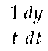

= et2—2y

(c)



= 2y + 2, y(0)= 2

(d)



= 2y2, *y(—*1)= 2

(e)



y(0) = 4

### Developing a differential equation

In our work to date, we have seen several ways that differential equations arise in the natural world, from the growth of a population to the temperature of a cup of coffee. Now, we will look more closely at how differential equations give us a natural way to describe various phenoma. As we'll see, the key is to focus on understanding the different factors that cause a quantity to

change.

### Activity 6.7-4

Any time that the rate of change of a quantity is related to the amount of a quantity, a differential equation naturally arises. In the following two problems, we see two such scenarios; for each, we want to develop a differential equation whose solution is the quantity of interest.

(a) Suppose you have a bank account in which money grows at an annual rate of 3%.

(i) If you have $10,000 in the account, at what rate is your money growing?

(ii) Suppose that you are also withdrawing money from the account at $1,000 per year. What is the rate of change in the amount of money in the account? What are the units on this rate of change?

(b) Suppose that a water tank holds 100 gallons and that a salty solution, which contains 20 grams of salt in every gallon, enters the tank at 2 gallons per minute.

(i) How much salt enters the tank each minute?

(ii) Suppose that initially there are 300 grams of salt in the tank. How much salt is in each gallon at this point in time?

(iii) Finally, suppose that evenly mixed solution is pumped out of the tank at the rate of 2 gallons per minute. How much salt leaves the tank each minute?

(iv) What is the total rate of change in the amount of salt in the tank?

Activity 6.7-4 demonstrates the kind of thinking we will be doing. In each of the two examples we considered, there is a quantity, such as the amount of money in the bank account or the amount of salt in the tank, that is changing due to several factors. The governing differential equation results from the total rate of change being the difference between the rate of increase and the rate of decrease.

Figure 6.49: Plot of



vs. P.

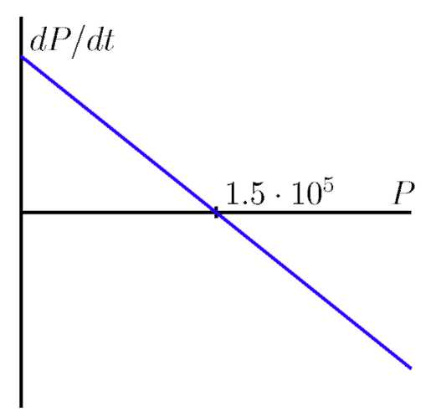

Example 3

In the Great Lakes region, rivers flowing into the lakes carry a great deal of pollution in the form of small pieces of plastic averaging 1 millimeter in diameter. In order to understand how the amount of plastic in Lake Michigan is changing, construct a model for how this type pollution has built up in the lake.

Solution. First, some basic facts about Lake Michigan.

• The volume of the lake is 5 • 1012 cubic meters.

• Water flows into the lake at a rate of 5 • 1010 cubic meters per year. It flows out of the lake at the same rate.

• Each cubic meter flowing into the lake contains roughly 3 • 10— 8 cubic meters of plastic pollution.

Let's denote the amount of pollution in the lake by P(t), where *P* is measured in cubic meters of plastic and *t* in years. Our goal is to describe the rate of change of this function; in other words, we want to develop a differential equation describing *P( t)* .

First, we will measure how *P(t)* increases due to pollution flowing into the lake. We know that 5 • 1010 cubic meters of water enters the lake every year and each cubic meter of water contains 3 • 10—8 cubic meters of pollution. Therefore, pollution enters the lake at the rate of

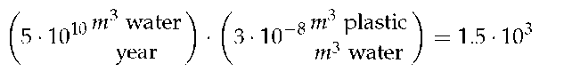

cubic meters of plastic per year.

Second, we will measure how *P(t)* decreases due to pollution flowing out of the lake. If the total amount of pollution is *P* cubic meters and the volume of Lake Michigan is 5 • 1012 cubic meters, then the concentration of plastic pollution in Lake Michigan is

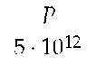

cubic meters of plastic per cubic meter of water.

Since 5 • 1010 cubic meters of water flow out each year,and we assume that each cubic meter of water that flows out carries with it the plastic pollution it contains, then the plastic pollution leaves the lake at the rate

of

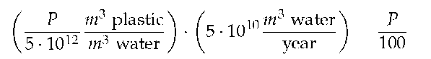

cubic meters of plastic per year.

The total rate of change of *P* is thus the difference between the rate at which pollution enters the lake minus the rate at which pollution leaves the lake; that is,

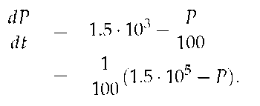

We have now found a differential equation that describes the rate at which the amount of pollution is changing. To better understand the behavior of *P( t)* , we now apply some of the techniques we have recently developed.

Since this is an autonomous differential equation, we can sketch *dP/ dt* as a function of *P* and then construct a slope field, as shown in Figure 6.49 and Figure 6.50.

These plots both show that *P =* 1.5 • 105 is a stable equilibrium. Therefore, we should expect that the amount of pollution in Lake Michigan will stabilize near 1.5 • 105 cubic meters of pollution.

Next, assuming that there is initially no pollution in the lake, we will solve the initial value problem

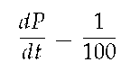

(1.5 • 105 — P), P(0) = 0.

Separating variables, we find that

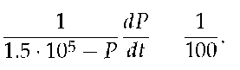

Figure 6.50: The slope field for the differential

equation



(1.5 • 105 — P).

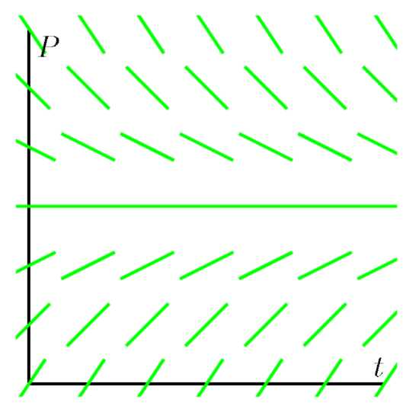

Figure 6.51: The solution P(t) and the slope field

for the differential equation



(1.5 • 105 — P).

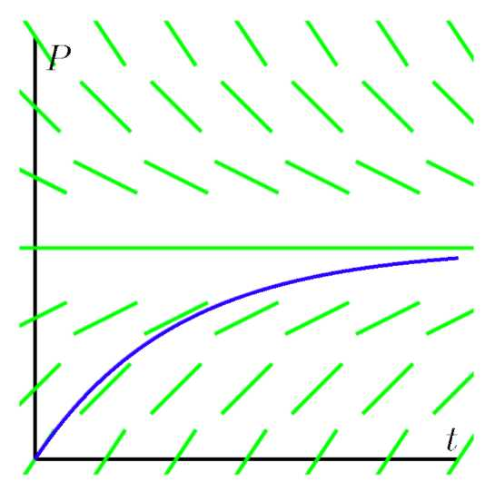

Integrating with respect to t, we have

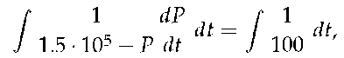

and thus changing variables on the left and antidifferentiating on both sides, we find that

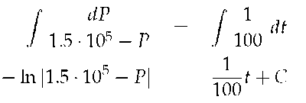

Finally, multiplying both sides by —1 and using the definition of the logarithm, we find that

1.5 • 105 — P = *Ce—*1/100. (6.2)

This is a good time to determine the constant C. Since P = 0 when t = 0, we have

1.5 • 105 — 0 = Ce0 = C.

In other words, C = 1.5 • 105.

Using this value of C in Equation (6.2) and solving for P, we arrive at the solution

P(t) = 1.5 • 105(1 — *e—*1/100).

Superimposing the graph of P on the slope field we saw in Figure 6.49 and Figure 6.50, we see, as shown in Figure 6.51.

We see that, as expected, the amount of plastic pollution stabilizes around 1.5 • 105 cubic meters.

There are many important lessons to learn from Example 3. Foremost is how we can develop a differential equation by thinking about the "total rate = rate in - rate out" model. In addition, we note how we can bring together all of our available under-

standing (plotting



vs. P, creating a slope field, solving the

differential equation) to see how the differential equation describes the behavior of a changing quantity.

Of course, we can also explore what happens when certain aspects of the problem change. For instance, let's suppose we are at a time when the plastic pollution entering Lake Michigan has stabilized at 1.5 • 105 cubic meters, and that new legislation is passed to prevent this type of pollution entering the lake. So, there is no longer any inflow of plastic pollution to the lake. How does the amount of plastic pollution in Lake Michigan now change? For example, how long does it take for the amount of plastic pollution in the lake to halve?

Restarting the problem at time t = 0, we now have the modified initial value problem

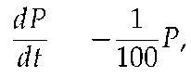

P(0) = 1.5 • 105.

It is a straightforward and familiar exercise to find that the solution to this equation is P(t) = 1.5 • 105e—1/100. The time that it

takes for half of the pollution to flow out of the lake is given by T where P(T) = 0.75 • 105. Thus, we must solve the equation

0.75 • 105 = 1.5 • 105e-T/100,

or



= e-T/100

It follows that

T = -100 ln

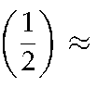

69.3 years.

In the activities that follow, we explore some other natural settings in which differential equation model changing quantities.

### Activity 6.7-5

Suppose you have a bank account that grows by 5% every year.

(a) Let A(t) be the amount of money in the account in year t. What is the rate of change of A?

(b) Suppose that you are also withdrawing $10,000 per year. Write a differential equation that expresses the total rate of change of A.

(c) Sketch a slope field for this differential equation, find any equilibrium solutions, and identify them as either stable or unstable. Write a sentence or two that describes the significance of the stability of the equilibrium solution.

(d) Suppose that you initially deposit $100,000 into the account. How long does it take for you to deplete the account?

(e) What is the smallest amount of money you would need to have in the account to guarantee that you never deplete the money in the account?

(f) If your initial deposit is $300, 000, how much could you withdraw every year without depleting the account?

### Activity 6.7-6

A dose of morphine is absorbed from the bloodstream of a patient at a rate proportional to the amount in the bloodstream.

(a) Write a differential equation for *M(t),* the amount of morphine in the patient's bloodstream, using k as the constant proportionality.

(b) Assuming that the initial dose of morphine is M0, solve the initial value problem to find M(t). Use the fact that the half-life for the absorption of morphine is two hours to find the constant k.

(c) Suppose that a patient is given morphine intraveneously at the rate of 3 milligrams per hour. Write a differential equation that combines the intraveneous administration of morphine with the body's

natural absorption.

(d) Find any equilibrium solutions and determine their stability.

(e) Assuming that there is initially no morphine in the patient's bloodstream, solve the initial value problem to determine M( t) .

(f) What happens to M(t) after a very long time?

(g) Suppose that a doctor asks you to reduce the intraveneous rate so that there is eventually 7 milligrams of morphine in the patient's bloodstream. To what rate would you reduce the intraveneous flow?

### Population Growth

We will now begin studying the earth's population. To get started, some data for the earth's population in recent years that we will use in our investigations is given in Table 6.3.

Table 6.3: The earth's recent population (in billions).

|  |  |
| --- | --- |
| Year | Population |
| 1998 | 5.932 |
| 1999 | 6.008 |
| 2000 | 6.084 |
| 2001 | 6.159 |
| 2002 | 6.234 |
| 2005 | 6.456 |
| 2006 | 6.531 |
| 2007 | 6.606 |
| 2008 | 6.681 |
| 2009 | 6.756 |
| 2010 | 6.831 |

### Activity 6.7-7

Our first model will be based on the following assumption:

The rate of change of the population is proportional to the population.

On the face of it, this seems pretty reasonable. When there is a relatively small number of people, there will be fewer births and deaths so the rate of change will be small. When there is a larger number of people, there will be more births and deaths so we expect a larger rate of change.

If P( t) is the population t years after the year 2000, we may express this assumption as

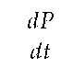

= kP

where k is a constant of proportionality. (a) Use the data in the table to estimate the derivative



using a

central difference. Assume that t = 0 corresponds to the year 2000.

(b) What is the population P(0)?

(c) Use these two facts to estimate the constant of proportionality k in the differential equation.

(d) Now that we know the value of k, we have the initial value problem



= kP, P(0) = 6.084.

Find the solution to this initial value problem.

(e) What does your solution predict for the population in the year 2010? Is this close to the actual population given in the table?

(f) When does your solution predict that the population will reach 12 billion?

(g) What does your solution predict for the population in the year 2500?

(h) Do you think this is a reasonable model for the earth's population? Why or why not? Explain your thinking using a couple of complete sentences.

Our work in Activity 6.7-7 shows that that the exponential model is fairly accurate for years relatively close to 2000. However, if we go too far into the future, the model predicts increasingly large rates of change, which causes the population to grow arbitrarily large. This does not make much sense since it is unrealistic to expect that the earth would be able to support such a large population.

The constant k in the differential equation has an important

interpretation. Let's rewrite the differential equation



= kP

by solving for k, so that we have

k=

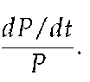

Viewed in this light, k is the ratio of the rate of change to the population; in other words, it is the contribution to the rate of change from a single person. We call this the per capita growth rate.

In the exponential model we introduced in Activity 6.7-7, the per capita growth rate is constant. In particular, we are assuming that when the population is large, the per capita growth rate is the same as when the population is small. It is natural to think that the per capita growth rate should decrease when the population becomes large, since there will not be enough resources to support so many people. In other words, we expect that a more realistic model would hold if we assume that the per capita growth rate depends on the population P.

In the previous activity, we computed the per capita growth rate in a single year by computing k, the quotient of ^ and P (which we did for t = 0). If we return data and compute the per capita growth rate over a range of years, we generate the data shown in Figure 6.52-(a), which shows how the per capita growth rate is a function of the population, P.

Figure 6.52: The data and approximations of the per capita growth as a function of population, P.

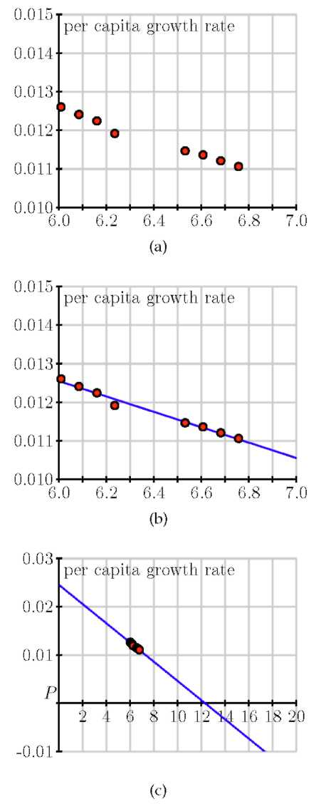

From the data, we see that the per capita growth rate appears to decrease as the population increases. In fact, the points seem to lie very close to a line, which is shown at two different scales in Figure 6.52-(b) and Figure 6.52-(c).

Looking at this line carefully, we can find its equation to be



= 0.025 — 0.002P.

If we multiply both sides by P, we arrive at the differential equation

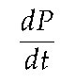

= P(0.025 — 0.002P).

Graphing the dependence of dP/dt on the population P, we see that this differential equation demonstrates a quadratic relation-

ship between



and P, as shown in Figure 6.53.

The equation



*= P*(0.025 — 0.002P) is an example of the

*logistic equation,* and is the second model for population growth that we will consider. We have reason to believe that it will be more realistic since the per capita growth rate is a decreasing function of the population.

Figure 6.53: A plot of



vs. *P* for the differential

equation



= P(0.025 — 0.002P).



Indeed, the graph in Figure 6.53 shows that there are two equilibrium solutions, *P =* 0, which is unstable, and *P =* 12.5, which is a stable equilibrium. The graph shows that any so-

lution with



will eventually stabilize around 12.5. In

other words, our model predicts the the world's population will eventually stabilize around 12.5 billion.

A prediction for the long-term behavior of the population is a valuable conclusion to draw from our differential equation. We would, however, like to answer some quantitative questions. For instance, how long will it take to reach a population of 10 billion? To determine this, we need to find an explicit solution of the equation.

Solving the logistic differential equation

Since we would like to apply the logistic model in more general situations, we state the logistic equation in its more general form,



*= kP( N — P).* (6.3)

The equilibrium solutions here are when *P =* 0 and 1 —



= 0,

which shows that *P = N.* The equilibrium at *P = N* is called the *carrying capacity* of the population for it represents the stable population that can be sustained by the environment.

We now solve the logistic equation (6.3). The equation is separable, so we separate the variables

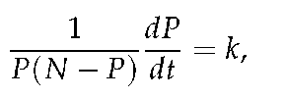

and integrate to find that

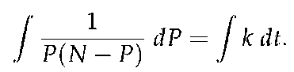

To find the antiderivative on the left, we use the partial fraction decomposition

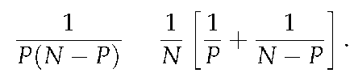

Now we are ready to integrate, with

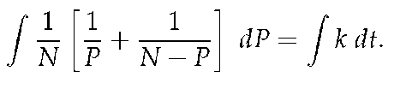

On the left, observe that *N* is constant, so we can remove the

factor of



and antidifferentiate to find that

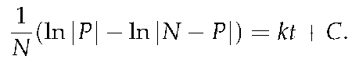

Multiplying both sides of this last equation by *N* and using an important rule of logarithms, we next find that

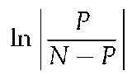

*= kNt + C.*

From the definition of the logarithm, replacing *eC* with C, and letting *C* absorb the absolute value signs, we now know that

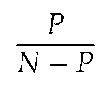

*= CekNt.*

At this point, all that remains is to determine *C* and solve algebraically for *P.*

If the initial population is P(0) = P0, then it follows that *C =*



so

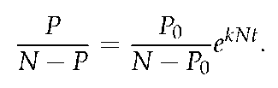

We will solve this most recent equation for *P* by multiplying both sides by *(N — P)(N — P0)* to obtain

*P( N — P0) = P0 (N — P)ekNt*

*= P0 NekNt — P0 PekNt*.

Swapping the left and right sides, expanding, and factoring, it follows that

P0 *NekNt = P( N — P0*)+ P0 *PekNt = P( N — P0* + P0 *ekNt*).

Dividing to solve for *P,* we see that

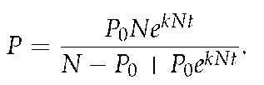

Finally, we choose to multiply the numerator and denominator

by



to obtain

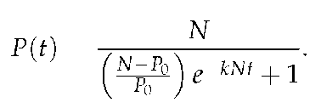

While that was a lot of algebra, notice the result: we have found an explicit solution to the initial value problem



= kP(N — P), P(0) = P0,

and that solution is

P(t) =

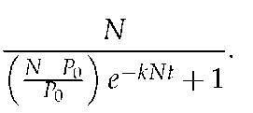

(6.4)

For the logistic equation describing the earth's population that we worked with earlier in this section, we have

k = 0.002, N = 12.5, and P0 = 6.084.

This gives the solution

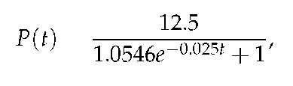

whose graph is shown in Figure 6.54

Figure 6.54: The solution to the logistic equation modeling the earth's population.

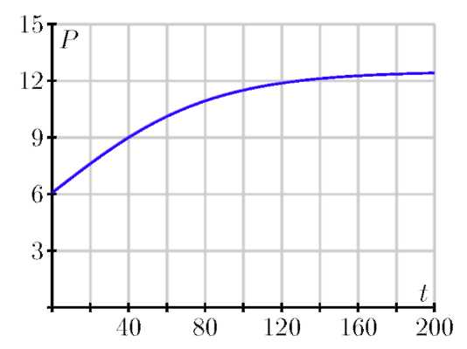

Notice that the graph shows the population leveling off at 12.5 billion, as we expected, and that the population will be around 10 billion in the year 2050. These results, which we have found using a relatively simple mathematical model, agree fairly well with predictions made using a much more sophisticated model developed by the United Nations.

The logistic equation is useful in other situations, too, as it is good for modeling any situation in which limited growth is possible. For instance, it could model the spread of a flu virus through a population contained on a cruise ship, the rate at which a rumor spreads within a small town, or the behavior of an animal population on an island. Again, it is important to realize that through our work in this section, we have completely solved the logistic equation, regardless of the values of the constants N, k, and P0. Anytime we encounter a logistic equation, we can apply the formula we found in Equation (6.4).

### Activity 6.7-8

Consider the logistic equation



= kP(N — P)

with the graph of



vs. P shown below.

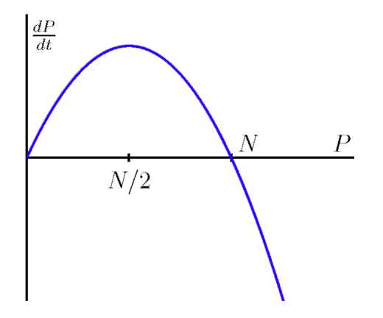

(a) At what value of *P* is the rate of change greatest?

(b) Consider the model for the earth's population that we created. At what value of *P* is the rate of change greatest? How does that compare to the population in recent years?

(c) According to the model we developed, what will the population be

in the year 2100?

(d) According to the model we developed, when will the population reach 9 billion?

(e) Now consider the general solution to the general logistic initial value problem that we found, given by

*P(t) =*

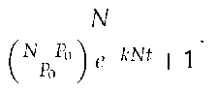

Verify algebraically that P(0) = Pq and that



### Summary

*In this section, we encountered the following important ideas:*

• A separable differential equation is one that may be rewritten with all occurrences of the dependent variable multiplying the derivative and all occurrences of the independent variable on the other side of the equation.

• We may find the solutions to certain separable differential equations by separating variables, integrating with respect to *t,* and ultimately solving the resulting algebraic equation for *y.*

• This technique allows us to solve many important differential equations that arise in the world around us. For instance, questions of growth and decay and Newton's Law of Cooling give rise to separable differential equations.

• If we assume that the rate of growth of a population is proportional to the population, we are led to a model in which the population grows without bound and at a rate that grows without bound.

• By assuming that the per capita growth rate decreases as the population grows, we are led to the logistic model of population growth, which predicts that the population will eventually stabilize at the carrying capacity.

### Exercises

Problems

1) The mass of a radioactive sample decays at a rate that is proportional to its mass.

(a) Express this fact as a differential equation for the mass M( t) using k for the constant of proportionality.

(b) If the initial mass is M0, find an expression for the mass M(t).

(c) The half-life of the sample is the amount of time required for half of the mass to decay. Knowing that the half-life of Carbon-14 is 5730 years, find the value of k for a sample of Carbon-14.

(d) How long does it take for a sample of Carbon-14 to be reduced to one-quarter its original mass?

(e) Carbon-14 naturally occurs in our environment; any living organism takes in Carbon-14 when it eats and breathes. Upon dying, however, the organism no longer takes in Carbon-14. Suppose that you find remnants of a pre-historic firepit. By analyzing the charred wood in the pit, you determine that the amount of Carbon-14 is only 30% of the amount in living trees. Estimate the age of the firepit. Note this approach is the basic idea behind radiocarbon dating.

2) Consider the initial value problem

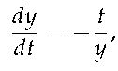

y(0) = 8

(a) Find the solution of the initial value problem and sketch its graph.

(b) For what values of t is the solution defined?

(c) What is the value of y at the last time that the solution is defined?

(d) By looking at the differential equation, explain why we should not expect to find solutions with the value of y you noted in (c).

3) Suppose that a cylindrical water tank with a hole in the bottom is filled with water. The water, of course, will leak out and the height of the water will decrease. Let h( t) denote the height of the water. A physical principle called Torricelli's Law implies that the height decreases at a rate proportional to the square root of the height.

(a) Express this fact using k as the constant of proportionality.

(b) Suppose you have two tanks, one with k = 1 and another with k = 10. What physical differences would you expect to find?

(c) Suppose you have a tank for which the height decreases at 20 inches per minute when the water is filled to a depth of 100 inches. Find the value of k.

(d) Solve the initial value problem for the tank in part (c), and graph the solution you determine.

(e) How long does it take for the water to run out of the tank?

(f) Is the solution that you found valid for all time t? If so, explain how you know this. If not, explain why not.

4) The Gompertz equation is a model that is used to describe the growth of certain populations. Suppose that P( t) is the population of some organism and that

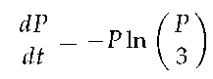

= —P(ln P — ln3).

(a) Sketch a slope field for P(t) over the range 0



P



6.

(b) Identify any equilibrium solutions and determine whether they are stable or unstable.

(c) Find the population P(t) assuming that P(0) = 1 and sketch its graph. What happens to P( t) after a very long time?

(d) Find the population P(t) assuming that P(0) = 6 and sketch its graph. What happens to P( t) after a very long time?

(e) Verify that the long-term behavior of your solutions agrees with what you predicted by looking at the slope field.

## 6.8 Hyperbolic Functions

### Motivating Questions

*In this section, we strive to understand the ideas generated by the following important questions:*

• What are hyperbolic functions?

• What properties do hyperbolic functions possess?

### Introduction

The hyperbolic functions are a set of functions that have many applications to mathematics, physics, and engineering. Among many other applications, they are used to describe the formation of satellite rings around planets, to describe the shape of a rope hanging from two points, and have application to the theory of special relativity. This section defines the hyperbolic functions and describes many of their properties, especially their usefulness to calculus.

### Hyperbolic Functions

These functions are sometimes referred to as the "hyperbolic trigonometric functions" as there are many, many connections between them and the standard trigonometric functions. Figure 6.55 demonstrates one such connection. Just as cosine and sine are used to define points on the circle defined by x2 + y2 *=* 1, the functions hyperbolic cosine and hyperbolic sine are used to define points on the hyperbola x2 — y2 *=* 1.

Figure 6.55: Using trigonometric functions to define points on a circle and hyperbolic functions to define points on a hyperbola. The area of the shaded regions are included in them.

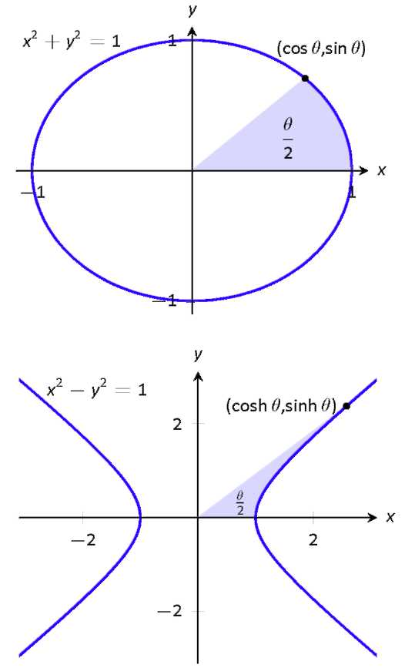

Hyperbolic Functions

|  |  |  |  |
| --- | --- | --- | --- |
| 1) sinh*(x) =* |  | 4) csch( *x) =* |  |
| 2) cosh( *x) =* |  | 5) sech( *x) =* |  |
| 3) tanh( *x) =* |  | 6) coth( *x) =* |  |
|

These hyperbolic functions are graphed in Figure 6.56. In the graphs of cosh(x) and sinh(x), graphs of *ex*/2 and *e—x*/2 are included with dashed lines. As *x* gets "large," cosh(x) and sinh( *x)* each act like *e*x/2; when *x* is a large negative number,

cosh(x) acts like e—x/2 whereas sinh(x) acts like —e—x/2.

Notice the domains of tanh( x) and sech( x) are



whereas

both coth(x) and csch(x) have vertical asymptotes at x = 0. Also

note the ranges of these function, especially tanh( x): as



both sinh(x) and cosh(x) approach e x/2, hence tanh(x) approaches 1.

Pronunciation Note:

"cosh" rhymes with "gosh," "sinh" rhymes with "pinch," and "tanh" rhymes with "ranch."

Figure 6.56: Graphs of the hyperbolic functions.

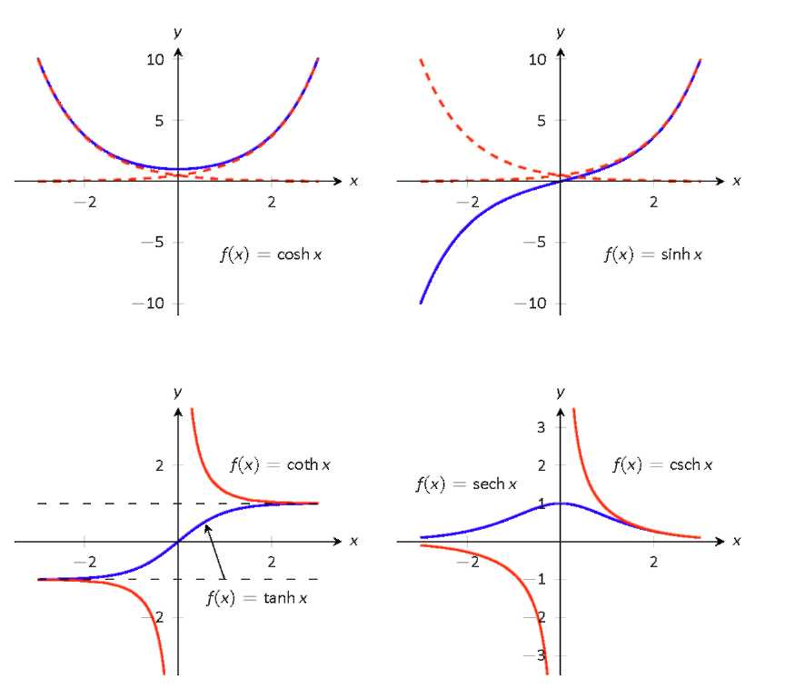

The following example explores some of the properties of these functions that bear remarkable resemblance to the properties of their trigonometric counterparts.

Example 1

Use the definitions of the hyperbolic functions to rewrite the following expressions.

1) cosh2(x) — sinh2(x)

2) tanh2 (x) + sech2 (x)

3) 2 cosh( x) sinh( x)

4)



cosh( x)

5)



sinh( x)

6)



tanh( x)

Solution.

1) cosh2(x) — sinh2(x)

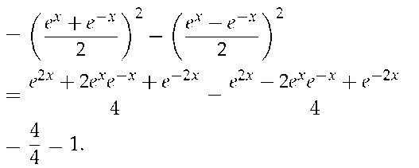

So cosh2(x) — sinh2(x) = 1.

2) tanh2(x) + sech2(x)

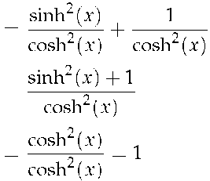

Now use identity from #1)

So tanh2 (x) + sech2 (x) = 1.

3) 2 cosh( x) sinh( x)

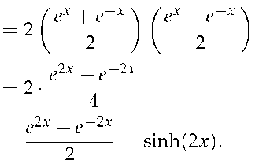

Thus 2 cosh( x) sinh( x) = sinh( 2x).

4)

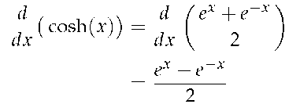

= sinh( x)

So



cosh( x) = sinh( x) .

5)

d

dx

sinh( x)

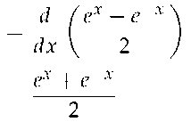

= cosh( x)

So



sinh( x) = cosh( x) .

6)



tanh( x) =

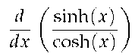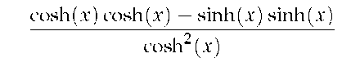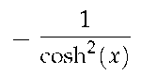

= sech2(x)

So



tanh(x) = sech2(x).

### Activity 6.8-1

Compute the following limits.

1)



cosh(x)

2)



sinh(x)

3)



tanh(x)

4)



(cosh(x) — sinh(x))

The following concept summarizes many of the important identities relating to hyperbolic functions. Each can be verified by referring back to the definition of the hyperbolic functions.

### Useful Hyperbolic Function Properties

Basic Identities

1) cosh2 *(x) —* sinh2(x) = 1

2) tanh2 *(x)* + sech2 *(x) =* 1

3) coth2(x) — csch2(x) = 1

4) cosh(2x) = cosh2 *(x)* + sinh2(x)

5) sinh(2x) = 2sinh(x) cosh(x)

6) cosh*2(x) =*

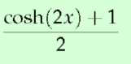

7) sinh*2(x) =*

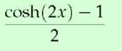

Derivatives

1)



cosh( *x)* = sinh( *x)*

2)



sinh( *x)* = cosh( *x)*

3)



tanh*(x)* = sech*2(x)*

4)



sech( *x)* = — sech( *x)* tanh( *x)*

5)



csch( *x)* = — csch( *x)* coth( *x)*

6)



coth*(x)* = — csch*2(x)*

Integrals

1)



cosh(x) *dx =* sinh(x) + *C*

2)



sinh(x) *dx =* cosh(x) + *C*

3)



tanh(x) *dx =* ln(cosh(x)) + *C*

4)



Example 2

Evaluate the following derivatives and integrals.

1)



cosh(2*x)*

2)



sech2 (7t — 3) *dt*

3)

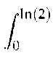

cosh( *x) dx*

Solution.

1) Using the Chain Rule directly, we have



(cosh(2x)) = 2sinh(2x).

Just to demonstrate that it works, let's also use the Basic Identity

cosh(2x) = cosh2 (x) + sinh2(x).



cosh(2*x) =*



(cosh2 (x) + sinh2 (x))

= 2cosh(x) sinh(x) + 2sinh(x) cosh(x) = 4 cosh( *x)* sinh( *x)* .

Using another Basic Identity, we can see that 4cosh(x) sinh(x) = 2 sinh( 2x) . We get the same answer either way.

2) We employ substitution, with u = 7t 3 and du = 7dt. Then we have:



sech2(7t 3) dt =



tanh(7t — 3) + C.

3)

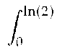

cosh( x) dx = sinh( x)



= sinh(ln(2)) sinh(0) = sinh(ln(2)).

We can simplify this last expression as sinh x is based on exponentials:

sinh(ln(2)) =

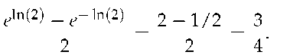

### Activity 6.8-2

Evaluate the following integrals.

1)



sinh(3x) + x3 dx

2)



tanh( x) dx)

3)



cosh2(x) dx

4)

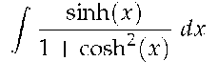

### Inverse Hyperbolic Functions

Table 6.4: Domains and ranges of the hyperbolic functions.

|  |  |  |
| --- | --- | --- |
| Function | Domain | Range |
| cosh( x) |  |  |
| sinh( x) |  |  |
| tanh( x) |  |  |
| sech( x) |  |  |
| csch( x) |  |  |
| coth( x) |  |  |

Table 6.5: Domains and ranges of the inverse hyperbolic functions.

|  |  |  |
| --- | --- | --- |
| Function | Domain | Range |
| cosh 1 ( x) |  |  |
| sinh 1 ( x) |  |  |
| tanh 1 ( x) |  |  |
| sech 1 ( x) |  |  |
| csch 1( x) |  |  |
| coth 1( x) |  |  |

Just as the inverse trigonometric functions are useful in certain integrations, the inverse hyperbolic functions are useful with others. Table 6.5 shows the restrictions on the domains to make each function one-to-one and the resulting domains and ranges of their inverse functions. Their graphs are shown in Figure 6.57.

Because the hyperbolic functions are defined in terms of exponential functions, their inverses can be expressed in terms of logarithms. It is often more convenient to refer to sinh—1 x than

to ln



especially when one is working on theory

and does not need to compute actual values. On the other hand, when computations are needed, technology is often helpful but many hand-held calculators lack a convenient sinh 1 x button. (Often it can be accessed under a menu system, but not conveniently.) In such a situation, the logarithmic representation is useful.

In next concept, both the inverse hyperbolic and logarithmic function representations of the antiderivative are given. Again, these latter functions are often more useful than the former. Note how inverse hyperbolic functions can be used to solve integrals we used Trigonometric Substitution to solve in Section 5.3.

### Logarithmic definitions of Inverse

Figure 6.57: Graphs of the hyperbolic functions and their inverses.

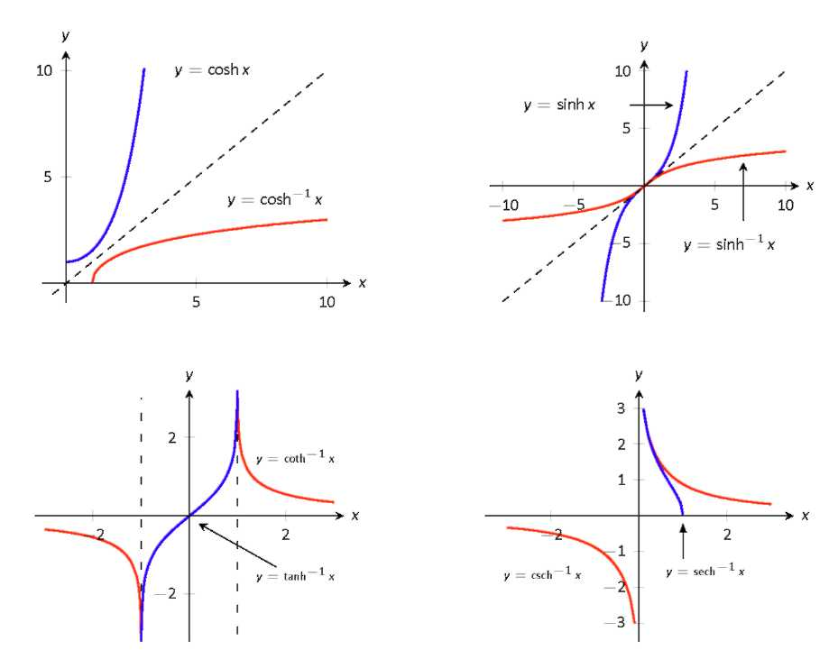

Hyperbolic Functions

1) cosh 1(x) = ln

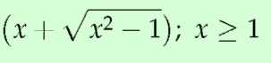

2) tanh 1( x) =

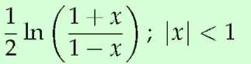

3) sech 1 (x) = ln

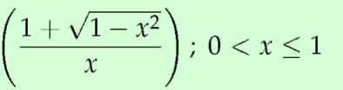

4) sinh 1 (x) = ln

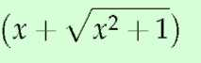

5) coth 1( x) =

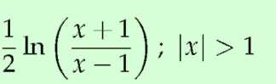

6) csch 1 (x) = ln

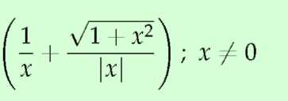

The following concepts give the derivatives and integrals relating to the inverse hyperbolic functions.

### Derivatives Involving Inverse Hyperbolic Functions

1)

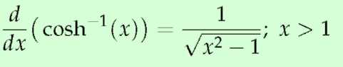

2)

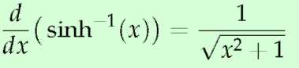

3)

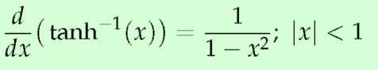

4)

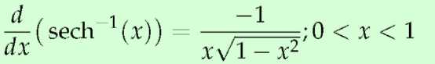

5)

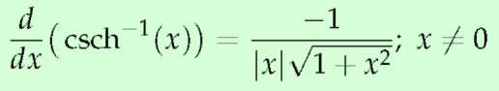

6)

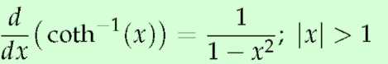

### Activity 6.8-3

Differentiate the following functions.

1)



(sinh(3*x + x3))*

2)



(arccos(tanh*(x)))*

3)



(sinh—1(3 tanh(3*x)))*

4)



( cosh—1



5) Show that *f(t) =*



is a solution to the dif-

ferential equation



— 3 *f=* 0.

Integrals Involving Inverse Hyperbolic Functions

1)

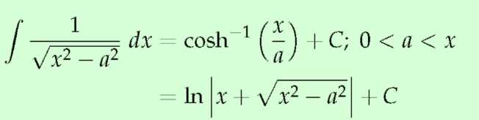

2)

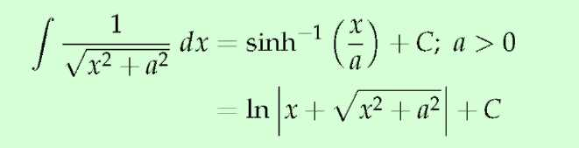

3)

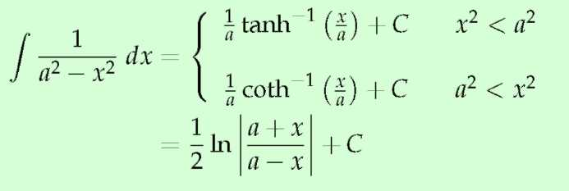

4)

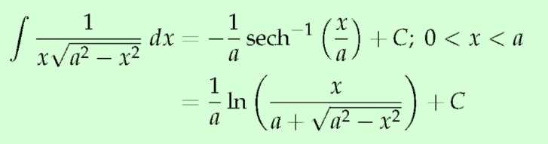

5)

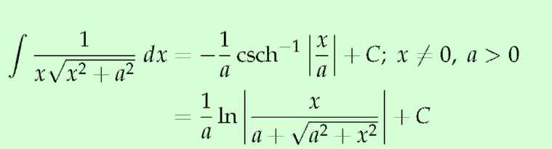

Example 3

Evaluate the following.

1)



Solution.

1 ) Applying the concepts along with the Chain Rule gives:

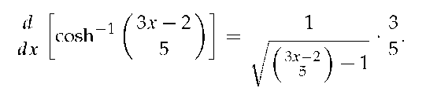

2) Multiplying the numerator and denominator by ( — 1) gives:

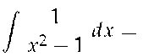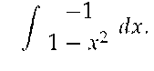

The second integral can be solved with a direct applica-

tion of item #3 from the integral concepts, with a = 1. Thus

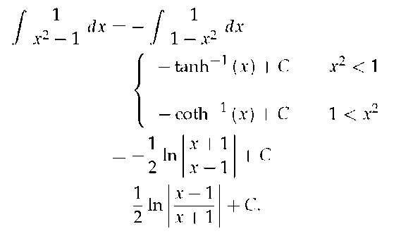

3) This requires a substitution; let u = 3x, hence du = 3dx. We have

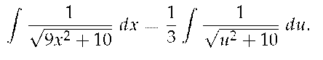

Note a2 = 10, hence a =



Now apply the integral rule.

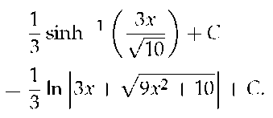

e encountered the following important ideas:

lic functions are similar to trigonometric functions in that they both can represent distances gin to a conic section.

### Exercises

Problems

In Exercises 1-8, verify the identity.

1) coth2 x — csch2 x = 1

2) cosh 2x = cosh2 x + sinh2 x

3) cosh2 x =

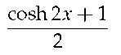

4) sinh2 x =

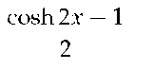

5)



[sech x] = — sech x tanh x

6)



[coth x] = — csch2 x

7)



tanh x dx = ln( cosh x) + C

8)



coth x dx = ln



+ C

In Exercises 9-19, differentiate the given function.

9) f( x) = cosh 2x

10) f( x) = tanh( x2)

11 ) f( x) = ln( sinh x)

12) f( x) = sinh x cosh x

13) f( x) = x sinh x — cosh x

14) f(x) = sech—1(x2)

15) f( x) = tanh— 1( cos x)

16) f (x) = cosh—1(sec x)

17) f( x) = sinh— 1( 3x)

18) f(x) = cosh—1(2x2)

19) f(x) = tanh—1(x+5)

In Exercises 20-24, produce the equation of the line tangent to the function at the given x-value.

20) f( x) = sinh x at x = 0

21) f( x) = cosh x at x = ln2

22) f( x) = sech2 x at x = ln 3

23) f (x) = sinh—1 x at x = 0

24) f (x) = cosh 1 x at x =



In Exercises 25-36, evaluate the given indefinite integral.

25)



tanh( 2x) dx

26)



cosh(3x — 7) dx

27)



sinh x cosh x dx

28)

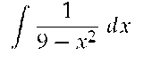

29)

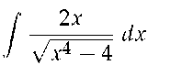

30)

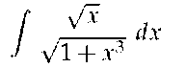

31)

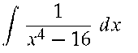

32)

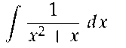

33)

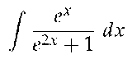

34)

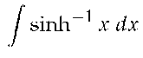

35)



36)



sech x dx (Hint: mutiply by



set u =

sinh x.)

In Exercises 37-39, evaluate the given definite integral.

37)



sinh x dx

38)

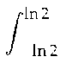

cosh x dx

39)



tanh 1 x dx