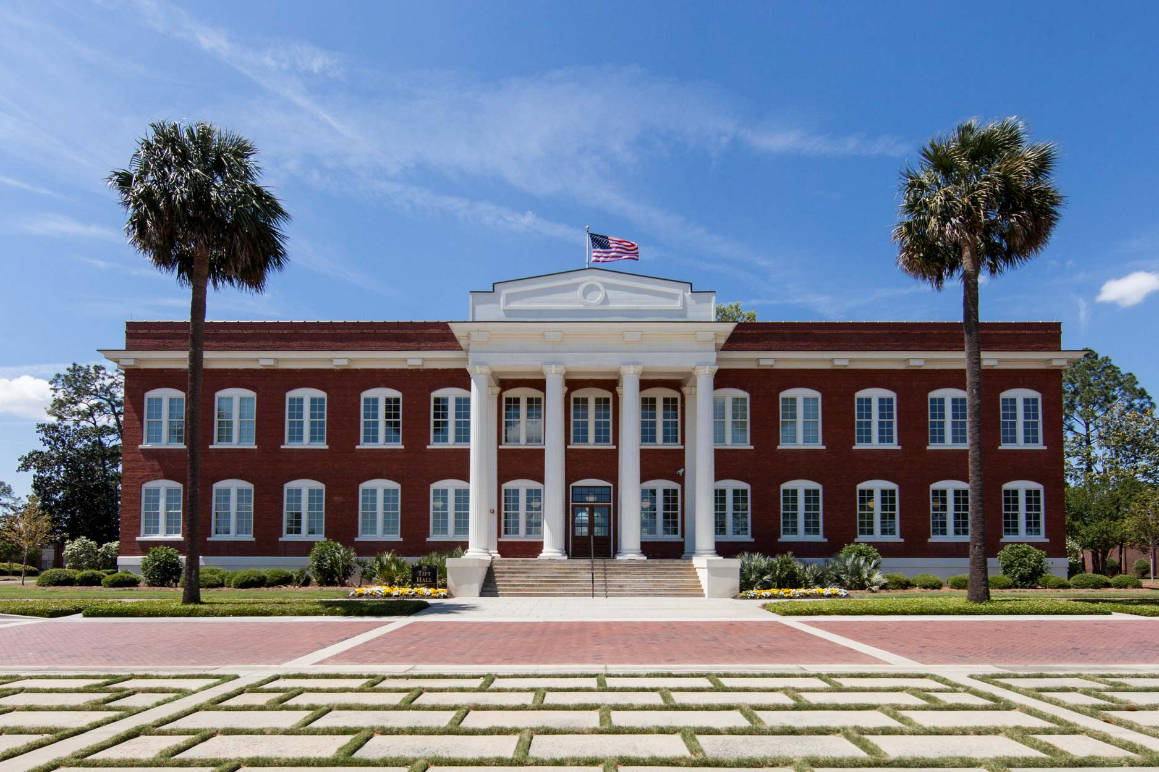
Quantitative Reasoning Workbook
Created and compiled by the mathematics faculty at Abraham Baldwin Agricultural College.

Tifton | Bainbridge | Moultrie | Blakely | Donalsonville
2020 | MATH 1001

Contributing Authors
C

April Abbott, Lecturer Elwanda Coston, Associate Professor
aabbott@abac.edu elwanda.coston@abac.edu
(229) 391-5160 (229) 243-3196

Gary Dicks, Assistant Professor Jan Gregus, Associate Professor
gdicks@abac.edu jgregus@abac.edu
(229) 391-5108 (229) 391-5110

Sheila McLendon, Associate Professor Amanda Urquhart, Assistant Professor
sheila.mclendon@abac.edu aurquhart@abac.edu
(229) 724-2442 (229) 391-5124

Table of Contents
C

Chapter 1 Problem Solving |  |  | 1
 | 1.1 Problem Solving |  | 2
 | 1.2 Inductive and Deductive Reasoning |  | 9
 | 1.3 Rounding and Percentages |  | 15
Chapter 2 Algebraic Equations and Graphs |  |  | 21
 | 2.1 Linear Equations |  | 22
 | 2.2 Linear Regression |  | 31
 | 2.3 Systems of Linear Equations |  | 39
 | 2.4 Quadratic Equations and Graphs |  | 45
 | 2.5 Variation and Proportion |  | 53
 | 2.6 Exponential and Logarithmic Equations |  | 61
Chapter 3 Set Theory |  |  | 69
 | 3.1 The Language of Sets |  | 70
 | 3.2 Comparing Sets |  | 77
 | 3.3 Set Operations |  | 83
 | 3.4 Survey Problems |  | 91
Chapter 4 Logic |  |  | 97
 | 4.1 Statements, Connectives, and Quantifiers |  | 98
 | 4.2 Truth Tables |  | 107
 | 4.3 The Conditional and Bi-conditional |  | 115
 | 4.4 Verifying Arguments |  | 121
 | 4.5 Verifying Syllogisms using Euler Diagrams |  | 129
Chapter 5 Counting Methods |  |  | 135
 | 5.1 Introduction to Counting |  | 136
 | 5.2 The Fundamental Counting Principle |  | 143
 | 5.3 Permutations and Combinations |  | 151
 | 5.4 Counting and Gambling |  | 161
Chapter 6 Probability |  |  | 167
 | 6.1 Random Experiments and the Definition of Probability |  | 168
 | 6.2 Probability for Complements and Unions of Events |  | 179
 | 6.3 Conditional Probability and Intersections of Events |  | 187
 | 6.4 Expected Value |  | 195
Chapter 7 Descriptive Statistics |  |  | 201
 | 7.1 Introduction to Statistics |  | 202
 | 7.2 Measures of Central Tendency |  | 209
 | 7.3 Standard Deviation |  | 217
 | 7.4 Normal Distribution |  | 223
Review Materials |  |  | 231
 | Formula Sheet |  | 233
 | Unit I Review |  | 235
 | Unit II Review |  | 239
 | Unit III Review |  | 243
 | Unit IV Review |  | 247
 | Final Exam Review |  | 249

1 Problem
Solving

C

Objectives:
- Use Polya’s approach to problem solving
- Distinguish between inductive and deductive reasoning
- Use inductive or deductive reasoning to solve problems
- Round numerical values to a specified accuracy

1.1 Problem Solving

List George Polya’s four-step approach to problem solving.

Choose an appropriate strategy and answer each question.

- Strategy: Five friends meet up for lunch. They all shake each other’s hands. How many handshakes take place?
- Strategy: How many ways can you flip two coins?
- Strategy: What would be a good name for the head side of a coin?
Tail side?
What would be a good variable for all the jacks in a deck of cards?
- Strategy: Cari wants to buy a new phone. She has three additional features she can choose to add to her plan: extended warranty, extended-life battery, or extended memory. In how many ways can she select these additional features?
- Strategy: The following Venn diagram represents various
groups of dogs. $T$ is the set of dogs that are tall and
$H$ is the set of long-haired dogs. Describe the dogs
in each of the regions $r_{1}$, $r_{2}$, $r_{3}$, and $r_{4}$.
$$\begin{matrix}\begin{matrix} 1 \\ \end{matrix} \\ \begin{matrix}\begin{matrix} 1 & 1 \end{matrix} \\ \\ \end{matrix} \\ \begin{matrix}\begin{matrix}_________ & _________ & _________\end{matrix} \\ \\ \end{matrix} \\ \begin{matrix}\begin{matrix}_________ & _________ & _________ & _________\end{matrix} \\ \\ \end{matrix} \\ \begin{matrix}\begin{matrix}_________ & _________ & _________ & _________ & _________\end{matrix} \\ \end{matrix}\end{matrix}$$
$r_{1} r_{2} r_{3} r_{4}$
$T$ $H$
- Strategy:
Use pattern recognition to complete the next three
rows of Pascal’s Triangle:
- Strategy: Use pattern recognition to determine the next three items in each sequence.
  - $5, 8, 11, 14, ________, _________, ________$
  - $Ab, Ac, Bc, Bd, Cd, Ce, ________, ________, ________$
  - $1, 1, 2, 3, 5, 8, 13, ________, _________, ________$
  - $3, 9, 27, 81, ________, _________, ________$
- Strategy: You have $1.25 in only dimes and nickels and there are sixteen coins in total. How many dimes and how many nickels do you have?
- Strategy:
George has a concession stand at a local baseball park. During games, he sells hot dogs for $2 each and hamburgers for $3 each. During one inning, he sells a total of 9 items for $20. How many of each item did George sell?
- Strategy: Find an example to illustrate the statement $\left(x-y\right)\left(x+y\right)=x^{2}-y^{2}$.
- Which step of Polya’s four steps would involve reviewing the problem and recording any information?

- In the following scenario, which of Polya’s four steps, if any, were not performed correctly? Select all that apply
A homework assignment required the students to solve an equation for $x$. Wyatt decided to try to isolate all of the $x$-terms to one side and then divide out the coefficient of $x$ from those terms. He moved all of the $x$-terms to one side of the equation and all of the terms without $x$ to the other side. Then Wyatt divided out by the coefficient of $x$ and simplified the result, which gave him the value $x=13$.
(a) Understand the problem. (d) Look back.
(b) Devise a plan. (e) All of Polya’s four steps were used correctly.
(c) Carry out the plan.

Notes:

Name: Date:

Use George Polya’s four-step approach to problem solving to answer each question.

- Draw an appropriate diagram to illustrate four friends shaking hands with one another.
- Draw an appropriate diagram to illustrate four friends exchanging text messages with one another.
- The following Venn diagram represents various
groups of cats. $C$ is the set of cats that are calico and
$H$ is the set of long-haired cats. Describe the cats
in regions $r_{1}$ and $r_{2}$.
$r_{1} r_{2} r_{3} r_{4}$
$C$ $H$
- Use pattern recognition to determine the next three items in each sequence.
  - $zzz, zzy, zzx, zyy, zyx, zyw, ________, _________, ________$
  - $\left(1, 1\right), \left(2, 2\right), \left(3, 3\right), ________, ________, ________$
  - $4, -8, 12, -16, 20, ________, _________, ________$
  - $2, 3, 5, 7, 11, 13, 17, 19, ________, _________, ________$

1.2 Inductive and Deductive Reasoning

Define inductive reasoning.

Understand and use inductive reasoning.

- Find the pattern and use inductive reasoning to predict the next three numbers in each sequence.
  - $5, 25, 125, ________, _________, ________$
  - $1, 7, 13, 19, ________, _________, ________$
  - $5, 5, 10, 30, 120, ________, _________, ________$
  - $3, 4, 7, 11, 18, ________, _________, ________$
- Determine if the following is an example of inductive reasoning: Last week, I ran out of gas when I drove to Mom’s house. I ran out of gas when I drove to Mom’s house today. I always run out of gas when I drive to Mom’s house.

Define deductive reasoning.

Understand and use deductive reasoning.

- Given the facts listed below, what is a reasonable conclusion to draw about Charlie?
- All frogs are amphibians.
- Amphibians live in water.
- Charlie is a frog.
- Given the facts listed below, what is a reasonable conclusion to draw about Amy? Choose from statements (a)-(d).
- Eskimos live in Russia, Alaska, Canada, and Greenland.
- Amy lives in Louisiana.
  - Amy is an Eskimo. c) Amy is not an Eskimo.
  - Amy does not live in Louisiana. d) Eskimos must live in Louisiana.

For each of the following statements, determine the type of reasoning used: inductive reasoning or deductive reasoning.

- Your professor calculates your test average using your previous scores.
- The Patriots have won a majority of the previous Super Bowl games. They will win the next Super Bowl game.
- Garrison notices a pattern in fuel consumption of the bipedal airplanes that use her airport. Her friend Keller flies a bipedal airplane. She suggests to him that he save fuel.
- It has rained at every Brown family reunion. Bill Brown suspects it will rain again this year.
- Lian is a private investigator. After investigating leads, she was able to find the missing woman, Teresa.

Notes:

Name: Date:

- Use inductive reasoning to predict the next two terms in each sequence.
  - $2, 5, 8, 11, ________, _________$
  - $2, 6, 18, 54, ________, _________$
  - $-1, 5, -25, 125, ________, _________$
- A magic square is a grid filled with numbers so that the total in each row, each column, and each main diagonal are all the same. Use the numbers 1 through 9 to complete the following magic square. Each number should only be used once.
 |  | 2
1
8 | 3

- Is solving a magic square an example of inductive reasoning or deductive reasoning?

1.3 Rounding and Percentages

- List the places of each digit in the following number: 123,456.789.

Estimate a value by rounding to a whole number.
- Round the following numbers to the given digit.
  - 7163 to the nearest hundred
  - 3342 to the nearest thousand
  - 9819 to the nearest ten
  - 45.398 to the nearest tenth
  - 332.451 to the nearest hundredth
  - $1,122.359 to the nearest cent
- At a carnival, Carl won 11 frogs, 14 baseballs, and 9 hats. Estimate how many prizes Carl won to the nearest ten.
- After running errands, Sally spent $119.67 at the grocery store, $42.29 at the cleaners, $99.87 at the utility company, and $19.97 at the gift shop. Estimate how much Sally spent to the nearest dollar.

Estimate using a pie chart or bar graph.
- A school wanted to find out how many students were in manufacturing and culinary programs. They surveyed 1000 students and represented
the results in the following pie chart. If people who were
enrolled in manufacturing are represented by the light blue
section, how many students are enrolled in the culinary
program, represented in brown?
- Refer to the pie chart below. The number of people in the household (1, 2, 3, 4, and 5 or more) and the associated percentages are given. In a
recent census, the state of Florida had a population of
approximately 2,300,000 households. Approximate how
many households had three or fewer members.

Notes:

Name: Date:

- Refer to the pie chart below. The number of people in the household (1, 2, 3, 4, and 5 or more) and the associated percentages are given. In a
recent census, the state of Arkansas had a population
of approximately 4,300,000 households. Approximate
how many households had two or more members.
- Round the following numbers to the given digit.
  - 7163.839 to the nearest hundredth
  - 3342.3982 to the nearest thousand
  - 9819.193 to the nearest ten

2 Algebraic Equations
and
Graphs

Objectives:
- Solve linear equations
- Find intercepts of the graph of a linear or quadratic equation
- Use slope-intercept form to solve linear applications
- Find the vertex of a quadratic equation
- Use regression to determine the line or quadratic of best fit for a given set of data
- Solve application problems using ratios and proportions
- Solve application problems involving compound interest
- Use direct variation and inverse variation to solve application problems
- Solve systems of linear equations graphically and by elimination
- Solve exponential and logarithmic equations

2.1 Linear Equations

A point (or ordered pair) is an $x$-coordinate and $y$-coordinate in the form $\left(x, y\right)$. Points are graphed on the Cartesian plane.

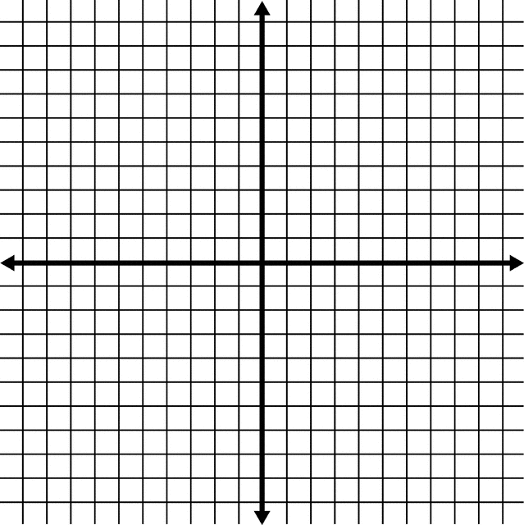
- Graph the following ordered pairs on the given plane.
  - $\left(8, 9\right)$
  - $\left(-5, 5\right)$
  - $\left(-7, 1\right)$
  - $\left(3, 0\right)$
  - $\left(0, -5\right)$
  - $\left(-4, -9\right)$

A linear equation is a set of points in a straight line. The general form of a linear equation is

There are two special points in a line: the $x$-intercept and the $y$-intercept.

The $x$-intercept is

It is found by

The $y$-intercept is

It is found by

Example A: Find the $x$-intercept and the $y$-intercept of the line given by $-3x+9y=27$.
Find $x$-intercept (let $y=0$): |  | Find $y$-intercept (let $x=0$):
 | $$\begin{matrix}\begin{matrix}-3x+9\left(0\right) & = & 27 \\ -3x & = & 27 \\ \frac{-3x}{-3} & = & \frac{27}{-3} \\ x & = & -9\end{matrix}\end{matrix}$$ |  | $$\begin{matrix}\begin{matrix}-3\left(0\right)+9y & = & 27 \\ 9y & = & 27 \\ \frac{9y}{9} & = & \frac{27}{9} \\ y & = & 3\end{matrix}\end{matrix}$$
 | $x$-intercept @ $\left(-9, 0\right)$ |  | $y$-intercept @ $\left(0, 3\right)$

State the $x$-intercept and $y$-intercept for each of the following linear equations.
- $2x-y=4$
- $x+2y=8$

Another form of a linear equation is the point-slope form:

The slope of a line is the ratio of the change in $y$-values to the change in $x$-values, or rate of change.

You might recall it as over . The formula
for finding slope is $m=$

There are four types of slopes of a linear equation. List the type and illustrate each below.
__________________ | __________________ | __________________ | __________________
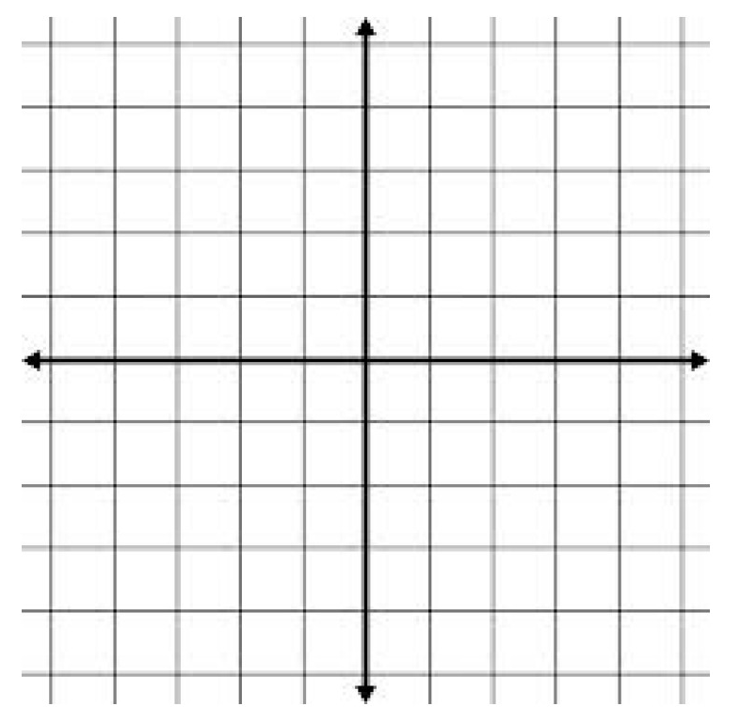

Find the slope and $y$-intercept for each linear equation.
- $3x-y=5$
- $4x+3y=6$
- $y=3x+5$
Find the slope of the line through each pair of points.
- $\left(2, -1\right)$, $\left(-4, 1\right)$
- $\left(-3, 2\right)$, $\left(2, 5\right)$
- $\left(-5, -4\right)$, $\left(2, 3\right)$
- $\left(6, -3\right)$, $\left(-1, 5\right)$

Find the equation of the line (linear function) described.
- Find the equation of the line that has slope 4 and contains the point $\left(-1, 3\right)$.
- Find the equation of the line that has slope 2 and contains the point $\left(3, -1\right)$.
- Find the equation of the line that has slope $\frac{1}{3}$ and contains the point $\left(2, -5\right)$.
- Find the equation of the line that contains the points $\left(-4, 3\right)$ and $\left(5, -7\right)$.
- Find the equation of the line that contains the points $\left(2, -1\right)$ and $\left(6, -4\right)$.
- Find the equation of the line that contains the points $\left(3, -5\right)$ and $\left(6, 10\right)$.

Notes:

Name: Date:

- Find the slope, $x$-intercept, and $y$-intercept of each of the following linear equations.
  - $y=\frac{1}{3}x-5$
  - $6x+5y=7$
  - $3y-4x=24$
  - $5x-2y=10$
- Find the equation of the line that has slope $\frac{3}{4}$ and contains the point $\left(-16, 3\right)$.
- What is the equation, in slope-intercept form, of the line whose graph is shown below?
$-10$ $-8$ $-6$ $-4$ $-2$ 2 4 6 8 10
10

8

6

4

2

$-2$

$-4$

$-6$

$-8$

$-10$

2.2 Linear Regression

Linear regression is

Linear correlation is

The Pearson Linear Correlation Coefficient is represented by the letter .

Properties of the Linear Correlation Coefficient:
$r$ is a number between ________ and ________.
If $r$ is positive, then
If $r$ is negative, then
If $r$ is close to 1, then
If $r$ is close to $-1$, then
If $r$ is close to 0, then

Find and interpret the correlation coefficient.

- Classify the following correlation coefficients as indicating a strong positive correlation, a strong negative correlation, a weak positive correlation, or a weak negative correlation.
  - $-0.875$
  - $0.$014
  - $0.$726
  - $-0.273$
- Given the following scatter plots and corresponding linear regression lines, classify each as indicating a strong positive correlation, a strong negative correlation, a weak positive correlation, or a weak negative correlation.
a) | 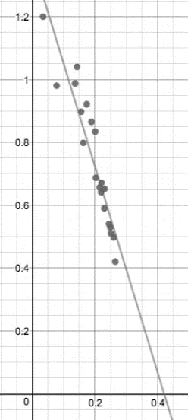 | b) | 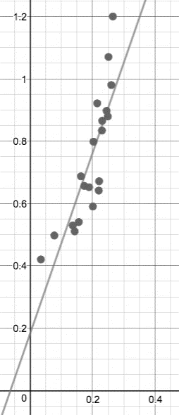 | c) | 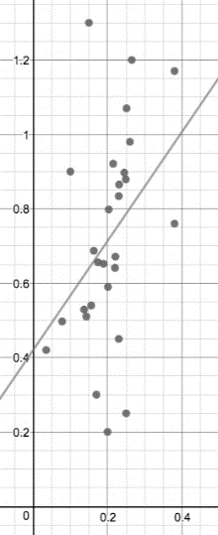 | d) | 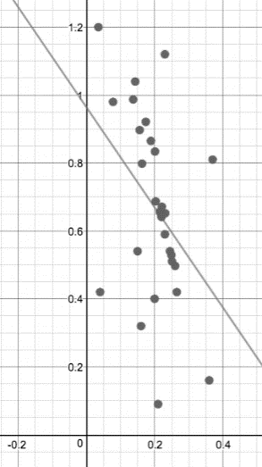

Make predictions using a line of best fit.

- The linear regression that fits the table of brain mass and body mass for a variety of
mammals below is: $y=$
Brain Mass in kg  $$\left(x\right)$$ | 0.023 | 0.060 | 0.120 | 0.280 | 0.501 | 0.550 | 0.785
Body Mass in kg  $$\left(y\right)$$ | 0.300 | 1.00 | 1.00 | 1.90 | 4.00 | 2.40 | 3.50

  - Make a prediction using the line of best fit to determine the mass of a mammal whose brain is 0.3 kg. Is this interpolation or extrapolation?
  - Make a prediction using the line of best fit to determine the mass of a mammal whose brain is 2 kg. Is this interpolation or extrapolation?

Calculate the correlation coefficient using technology (calculator).

- The following data set represents temperature and number of days for a hummingbird’s eggs to hatch. Use a calculator to calculate the correlation coefficient to see if there is a link between temperature and number of days to hatch. Round to two decimal places, then answer the question below.
Describe the relationship between temperature and time to hatch in terms of weak or strong, positive or negative.
What is the correlation coefficient?
Temperature in $℉$  $$\left(x\right)$$ | 68 | 72 | 76 | 80 | 84
Number of Days  $$\left(y\right)$$ | 21 | 19 | 18 | 16 | 15

- The following data set represents age and number of hours of TV watched per day. Use a calculator to calculate the correlation coefficient to see if there is a link between age and number of hours of TV watched. Round to two decimal places, then answer the questions below.
Describe the relationship between temperature and time to hatch in terms of weak or strong, positive or negative.
What is the correlation coefficient?
Age  $$\left(x\right)$$ | 12 | 23 | 34 | 46 | 58
Hours of TV  $$\left(y\right)$$ | 6 | 3 | 4 | 6 | 5

Determine the best fit linear regression using technology (calculator).

- Use a calculator to find the best fit linear regression for the data given in (4) above.
  - What is the line of best fit?
  - Estimate the number of days humming bird eggs take to hatch in $90℉$ weather.
- The chart below shows Medicaid spending in Maine (in billions of dollars) for the years 2000, 2003, 2005, 2006, and 2008. Let the year 2000 represent $x=0$.
Use your TI graphing calculator to find the regression equation for the line of best fit for the relationship between time and money spent.
Use this regression equation to predict the Medicaid spending in Maine for 2011.
Years after 2000  $$\left(x\right)$$ | 0 | 3 | 5 | 6 | 8
Spending, in billions of dollars  $$\left(y\right)$$ | 2.10 | 2.20 | 4.45 | 5.73 | 6.00

Notes:

Name: Date:

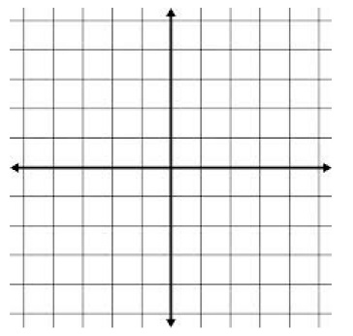
- Draw a positive linear correlation scatter plot.
- Draw a negative linear correlation scatter plot.
- Draw a scatter plot with no correlation.
- The chart below shows Medicaid spending in Maine (in billions of dollars) for the years 2000, 2006, 2009, 2011, and 2012. Let the year 2000 represent $x=0$.
Use your TI graphing calculator to find the regression equation for the line of best fit for the relationship between time and money spent.
Use this regression equation to predict the Medicaid spending in Maine for 2022.
Years after 2000  $$\left(x\right)$$ | 0 | 6 | 9 | 11 | 12
Spending, in billions of dollars  $$\left(y\right)$$ | 1.10 | 2.18 | 3.45 | 4.70 | 5.00

2.3 Systems of Linear Equations

A system of linear equations is

There are three types of solutions. Name and illustrate each below.
_____________________ | _____________________ | _____________________

Systems can be solved by graphing, substitution, or elimination.

Solve each system of linear equations.

- $\begin{matrix} \\ \left\{\begin{matrix}x+y=10 \\ x-y=6\end{matrix}\right.\end{matrix}$
- $\begin{matrix} \\ \left\{\begin{matrix}2x+3y=4 \\ 4x-3y=-10\end{matrix}\right.\end{matrix}$
- $\begin{matrix} \\ \left\{\begin{matrix}2x-3y=5 \\ 3x+y=-9\end{matrix}\right.\end{matrix}$
- $\begin{matrix} \\ \left\{\begin{matrix}x-2y=10 \\ 4x+7y=25\end{matrix}\right.\end{matrix}$
- A movie theater sells tickets for $9.00 each and senior citizen tickets for $6.50 each. One evening, the theater sold 600 tickets and took in $4597.50 in revenue. How many senior citizen tickets were sold?
- Adam sold 254 tickets to a concert for $2,537. If the price of a student ticket was $5.50 and the price of an adult ticket was $15, how many adult tickets did Adam sell?
- Suppose your family is going to purchase a new air conditioning unit. One brand costs $1,000 to purchase and $60 a month to operate. A more expensive brand costs $1,800 to purchase, but is more efficient and costs only $30 a month to operate. Find the break-even point (the number of months when the total cost of either unit would be the same).

Notes:

Name: Date:

Solve each system of linear equations.

- $\begin{matrix} \\ \left\{\begin{matrix}6x-y=11 \\ -2x-3y=-7\end{matrix}\right.\end{matrix}$
- $\begin{matrix} \\ \left\{\begin{matrix}2x-3y=-1 \\ x-y=1\end{matrix}\right.\end{matrix}$
- $\begin{matrix} \\ \left\{\begin{matrix}3x+y=9 \\ 5x-4y=-2\end{matrix}\right.\end{matrix}$
- $\begin{matrix} \\ \left\{\begin{matrix}4x+3y=-3 \\ 2x-y=11\end{matrix}\right.\end{matrix}$
- Adam sold 276 tickets to a concert for $1,876. If the price of a student ticket was $3.50 and the price of an adult ticket was $10, how many adult tickets did Adam sell?

2.4 Quadratic Equations and Graphs

A quadratic equation is of the form ,

where $a$, $b$, and $c$ are real numbers $\left(a≠0\right)$ and the ordered pair _____________ is the $y$-intercept.

The graph of a quadratic equation is a ____________________. The parabola opens _____________ if $a>0$

and opens _____________ if $a<0$.

If $a>0$: | If $a<0$:

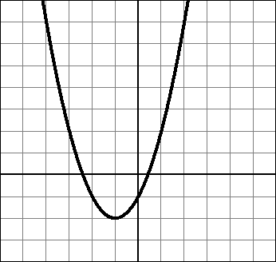
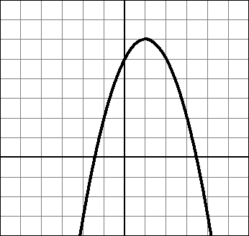

The vertex is

The $x$-coordinate of the vertex is $h=$ _______________ and the $y$-coordinate of the vertex is found by
substituting the $x$-coordinate into the quadratic equation and solving for $y$, or by calculating
$k=$ _______________. The $x$-intercept(s), if any, are found by letting $y=0$ and solving for $x$ by using
the quadratic formula $x=$ __________________________________________.

Example A: Find the $x$-intercept(s), if any, of the graph of $y=-2x^{2}+5x+4$.
$$\begin{matrix}\begin{matrix}-2x^{2}+5x+4 & = & 0 \\ x & = & \frac{-\left(5\right)±\sqrt{{\left(5\right)}^{2}-4\left(-2\right)\left(4\right)}}{2\left(-2\right)} \\ x & = & \frac{-5±\sqrt{57}}{-4} \\ x & ≈ & -0.64, 3.14\end{matrix} \\ \left(-0.64, 0\right) and \left(3.14, 0\right) \end{matrix}$$

Example B: Find the $x$-intercept(s), if any, of the graph of $y=3x^{2}-4x+1$.
$$\begin{matrix}\begin{matrix}3x^{2}-4x+1 & = & 0 \\ x & = & \frac{-\left(-4\right)±\sqrt{{\left(-4\right)}^{2}-4\left(3\right)\left(1\right)}}{2\left(3\right)} \\ x & = & \begin{matrix}\frac{-4±\sqrt{4}}{6} & = & \frac{4±2}{6} & = & \frac{2±1}{3}\end{matrix} \\ x & = & \frac{1}{3},1\end{matrix} \\ \left(\frac{1}{3}, 0\right) and \left(1, 0\right) \end{matrix}$$

Example C: Find the vertex of the graph of $y=x^{2}-4x+1$.
$$h=-\frac{b}{2a}=\frac{-\left(-4\right)}{2\left(1\right)}=2 \\ k={\left(2\right)}^{2}-4\left(2\right)+1=3$$
Vertex @ $(2,3)$

- Solve $14m^{2}+35m=-14$ by using the quadratic formula. Give an exact answer and simplify any fractions.
- Solve $w\left(2w+9\right)+1=0$ by using the quadratic formula. Give an exact answer and simplify any fractions.
Determine if the graph opens up or down. Find the $x$-intercept(s) (if any), the $y$-intercept, and the vertex.
- $y=2x^{2}+9x+10$
- $y=-x^{2}+4x+5$

- $y=x^{2}+11x+30$

- $y=3x^{2}-6x$

- $y=3x^{2}+5x-1$
- $y=x^{2}-4$

- $y=-2x^{2}+x+1$
- $y=-x^{2}+4x-4$
- The revenue from selling $x$ products is $R=100x-2x^{2}$. Determine the number of products sold that maximizes the revenue. Also find the maximum revenue.
- An object is launched straight upward so that its height, $h$ (in feet), $t$ seconds after the launch is $h=-16t^{2}+32t$. Determine the maximum height the object can reach. Also determine the time when the object will land on the ground.

- Find the equation of the quadratic regression curve of best fit. Round each coefficient to four decimal places.
$$x$$ | 12 | 18 | 22 | 25
$$y$$ | 5 | 8 | 17 | 5

Notes:

Name: Date:

- Determine if the graph opens up or down. Find the $x$-intercept(s) (if any), the $y$-intercept, and the vertex.
  - $y=-2x^{2}+8x$
  - $y=2x^{2}+7x-4$
  - $y=3x^{2}-6x+4$
- Solve each equation by using the quadratic formula. Give an exact answer and simplify any fractions.
  - $2x\left(x+5\right)+10=0$
  - $14x^{2}+32x=-34$
- An object is launched straight upward so that its height, $h$ (in feet), $t$ seconds after the launch is $h=-16t^{2}+32t+48$. Find the maximum height the object can reach. Also, how long will it take for the object to land on the ground?
- A study was done to compare the speed $x$ (in miles per hour) with the mileage $y$ (in miles per gallon) of an automobile. The results are shown in the table. Use a graphing utility to find the curve of best fit for the data.
$$x$$ | 15 | 20 | 25 | 30 | 35 | 40 | 45 | 50 | 55 | 60 | 65 | 70 | 75
$$y$$ | 22.3 | 25.5 | 27.5 | 29.0 | 28.8 | 30.0 | 29.9 | 30.2 | 30.4 | 28.8 | 27.4 | 25.3 | 23.3

2.5 Variation and Proportion

A ratio is __________________________________________________________________________________________.

A proportion is __________________________________________________________________________________.

A proportion can be solved using cross-multiplication.

- Sarah is traveling to Mexico and needs to exchange $300, in US dollars, into Mexican pesos. If each dollar is worth 11.39 pesos, how many pesos will she have for the trip?

- Todd drinks a 16 oz soda with 160 calories per 12 oz. How many calories did he drink?

If $y$ is ________________________________________ to $x$, then the ratio $\frac{y}{x}$ is equal to the constant of proportionality, $k$, where $y=kx$.

If $y$ is ________________________________________ to $x$, then the product $xy$ is equal to the constant of proportionality, $k$, where $y=\frac{k}{x}$.

Example A: The value of $y$ varies directly with $x$, and $y=3$ when $x=9$. Find $y$ when $x=21$.
$$\begin{matrix}\begin{matrix}y & = & kx \\ 3 & = & k\left(9\right) \\ k & = & \frac{1}{3}\end{matrix} & & \begin{matrix}when x=21: \\ \\ \\ \end{matrix} & \begin{matrix}y & = & \frac{1}{3}\left(21\right) \\ y & = & 7 \\ & & \end{matrix}\end{matrix}$$

Example B: The value of $y$ varies inversely with $x$, and $y=4$ when $x=5$. Find $y$ when $x=10$.
$$\begin{matrix}\begin{matrix}y & = & \frac{k}{x} \\ 4 & = & \frac{k}{5} \\ k & = & 20\end{matrix} & & \begin{matrix}when x=10: \\ \\ \\ \\ \end{matrix} & \begin{matrix}y & = & \frac{20}{10} \\ y & = & 2 \\ & & \\ & & \end{matrix}\end{matrix}$$

Using the given information, find the requested value.

- Suppose $y$ varies directly with $x$ so that $y=30$ when $x=5$. Find $y$ when $x=13$.
- Suppose $s$ varies directly with $t$ so that $s=28$ when $t=4$. Find $t$ when $s=189$.
- Suppose $d$ varies directly with $t^{2}$ so that $d=36$ when $t=3$. Find $d$ when $t=11$.
- Suppose $y$ varies inversely with $x$ so that $y=\frac{1}{5}$ when $x=15$. Find $y$ when $x=4$.
- Suppose $s$ varies inversely with $t$ so that $s=9$ when $t=5$. Find $t$ when $s=18$.
- Suppose $f$ varies inversely with $r^{2}$ so that $f=\frac{1}{2}$ when $r=10$. Find $f$ when $r=5$.
- The amount of money raised at a school fundraiser is directly proportional to the number of people who attend. Last year, the amount of money raised for 100 attendees was $2,500. How much money will be raised if 1000 people attend this year?
- The distance that Joseph travels varies directly to how long he drives. He travels 325 miles in 5 hours. Write the equation that relates the distance, $d$, to the time $t$. How many miles can Joseph travel in 8 hours?
- The circumference of a circle varies directly with the radius. A circular pizza with a radius of 3 inches has a circumference of about 18.84 inches. Write the equation using direct variation that relates the circumference, $C$, to the radius, $r$. What is the circumference, in square inches of a personal pizza with a radius of 2 inches?
- The fuel consumption, in miles per gallon, of a car varies inversely with its weight. Suppose a car that weighs 3,000 lbs gets 28.7 miles per gallon on the highway. Write the equation that relates $y$, the fuel consumption in miles per gallon, to the car’s weight, $w$ lbs. How many miles per gallon would a car get if it weighs 4,100 lbs?
- On a stringed instrument, the length of a string varies inversely as the frequency of its vibrations. An 11-inch string on a violin has a frequency of 400 cycles per second. Write the equation that relates the string length, $l$, to its frequency, $f$. What would be the frequency of a 10-inch string?

Notes:

Name: Date:

Using the given information, find the requested value.

- Suppose $y$ varies directly with $x$ so that $y=35$ when $x=7$. Find $y$ when $x=12$.
- Suppose $y$ varies inversely with $x$ so that $y=45$ when $x=5$. Find $y$ when $x=9$.
- Suppose $s$ varies inversely with $t$ so that $s=0.2$ when $t=15$. Find $t$ when $s=12$.
- At a constant temperature, the gas pressure, $p$, varies inversely with the volume $V$. It has been measured that the pressure in a cylinder with volume 1.5 liters was 210 kilopascals. What will the pressure be after the gas is compressed down to 0.8 liter?
- Terri needs to make some pies for a fundraiser. The number of apples, $a$, varies directly with the number of pies, $p$. It takes 9 apples to make 2 pies. Write the equation that relates $a$ to $p$. How many apples would Terri need for 6 pies?

2.6 Exponential and Logarithmic
Equations

Exponential equations have the form $y=a^{x}$, where $a>0$ and $a≠1$.
If $a>1$: | If $0<a<1$:
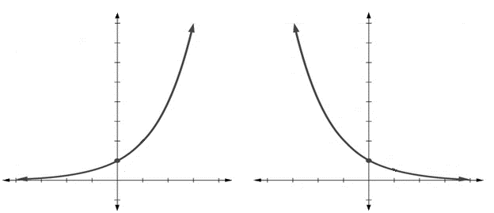

Example A: Graph the exponential equation given by $y={\left(\frac{1}{3}\right)}^{x}$.
$$x$$ | $$y$$
$$0$$ | $$1$$
$$1$$ | $\frac{1}{3}$
$$-1$$ | $$3$$
$$2$$ | $\frac{1}{9}$
$$-2$$ | $$9$$
$$-3$$ | $$27$$

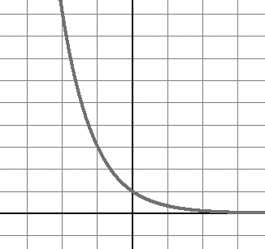

Example B: Graph the exponential equation given by $y=2^{x}$.
$$x$$ | $$y$$
$$0$$
$$1$$
$$-1$$
$$2$$
$$-2$$
$$-3$$

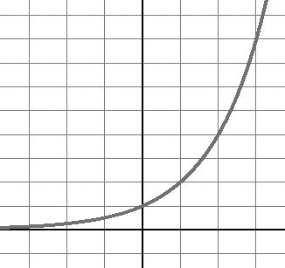

- Which of the points below are on the graph of $y=4^{x}$?
a) $\left(1, 0\right)$ b) $\left(0, 1\right)$ c) $\left(2, 8\right)$ d) $\left(3, 12\right)$
- Which of the points below are NOT on the graph of $y={\left(\frac{1}{5}\right)}^{x}$?
a) $\left(2,\frac{1}{25}\right)$ b) $\left(1,\frac{1}{5}\right)$ c) $\left(3, 15\right)$ d) $\left(0, 1\right)$

The formula for the accumulated amount of an investment earning compound interest is given by

the formula $A=$ ___________________________________, where $A$ is the accumulated amount, $P$ is the principle, or initial investment, $r$ is the interest rate, $n$ is the number of compound periods per year, and $t$ is the time of investment (in years). Therefore, it follows that if we invest a principal, $P$, at an annual interest rate, $r$, compounded continuously, then after $t$ years the final amount will

be given by $A=$ ___________________________________.

Example C: Suppose you invest $10,000 at 12% interest for 10 years. What will your balance be if your investment is compounded (a) annually, (b) quarterly, (c) monthly, (d) daily, (e) semiannually?
Annually: $A=10000{\left(1+\frac{0.12}{1}\right)}^{1\left(10\right)}=\$31,058.48$
Quarterly: $A=10000{\left(1+\frac{0.12}{4}\right)}^{4\left(10\right)}=\$32,620.38$
Monthly: $A=10000{\left(1+\frac{0.12}{12}\right)}^{12\left(10\right)}=\$33,003.87$
Daily: $A=10000{\left(1+\frac{0.12}{365}\right)}^{365\left(10\right)}=\$33,194.62$
Semiannually: $A=10000{\left(1+\frac{0.12}{2}\right)}^{2\left(10\right)}=\$32,071.35$

- If $6,000 is invested with quarterly compounding at 3.5% annual interest rate, what will the accumulated amount be in 5 years? Round to the nearest hundredth.

- If $9,500 is invested with semiannual compounding at 7.8% annual interest rate, what will the accumulated amount be in 10 years? Round to the nearest hundredth.
- Dalia deposits $1,200 in an account that earns 5% interest per year, compounded continuously. How much will the account be worth in 3 years? Round your answer to the nearest dollar.

The logarithmic equation $y=\log_{a}\left(x\right)$ means the same as the exponential equation

_______________________________________________________, where $a>0$, $a≠1$, and $y≠0$.

Example D: $\begin{matrix}3=\log_{2}\left(8\right)\end{matrix}$ means $2^{3}=8$

The power rule states that

Example E: How long will it take for an initial investment of $30,000 to grow to $110,000 with an interest rate of 10% compounded continuously?
$$\begin{matrix}A & = & Pe^{rt} \\ 110,000 & = & 30,000e^{0.10t} \\ \frac{110,000}{30,000} & = & e^{0.10t} \\ \ln\left(\frac{11}{3}\right) & = & 0.10t\ln\left(e\right) \\ \frac{\ln\left({11}/3\right)}{0.10} & = & t∙1 \\ t & ≈ & 13 years\end{matrix}$$

- For an initial investment of $3,000, compounded continuously at 3.25% annual interest, find, to the nearest tenth of a year, when this investment grows to $7,000 in value.

- For an initial investment of $2,000, compounded continuously at 6.82% annual interest, find, to the nearest tenth of a year, when this investment grows to $11,000 in value.

Example F: Solve the exponential equation $5^{x}=125$.
$$\begin{matrix}5^{x} & = & 125 \\ ln⁡(5^{x}) & = & ln⁡(125) \\ x(\ln{5)} & = & \ln{(125)} \\ x & = & \frac{\ln\left(125\right)}{\ln{(5)}} \\ x & = & 3 \\ x & = & \end{matrix}$$

Solve for $x$ in each of the following exponential equations.

- $5=5^{x}$
- ${10}^{x}=1,000$
- $40=7^{x}$
- $69=2^{x}$
- $e^{3x}=20$
- $e^{0.09x}=3$

Notes:

Name: Date:

- You take out $8,000 in direct unsubsidized loans at the beginning of college. Unsubsidized loans collect interest compounded quarterly at a rate of 6.5%. How much would you owe after 4 years? Round to the nearest hundredth.
- You get your first credit card. This credit card is compounded monthly at a rate of 11.2%. You buy a laptop for $600 and don’t pay on the credit card for two years. How much money would you owe? Round to the nearest hundredth.
- You buy your first car for $30,000 with a loan that will be compounded quarterly at 5.6%. If it takes you 6 years to pay the car off, how much did you pay overall?
- You buy your first house for $97,000 with a loan that will compound monthly at 3.7% interest rate. The loan is set to be paid off in 30 years. How much will you have paid the mortgage company by the end? Round to the nearest hundredth.

Solve for $x$.

- $18=9^{x}$
- $4^{x}=63$
- The formula $A=Pe^{rt}$ gives the accumulated amount, $A$, of an investment when $P$ is the initial investment or principle, $r$ is the annual interest rate, and $t$ is the time in years for an account that compounds interest continuously. For an initial investment of $8,000, compounded continuously at 3.25% annual interest, to the nearest tenth of a year, find when this investment grows to $15,000 in value.
- The formula $A=Pe^{rt}$ gives the accumulated amount, $A$, of an investment when $P$ is the initial investment or principle, $r$ is the annual interest rate, and $t$ is the time in years for an account that compounds interest continuously. For an initial investment of $2,000, compounded continuously at 6.5% annual interest, to the nearest tenth of a year, find when this investment grows to $16,000 in value.

3 Set
Theory

Objectives:
- Write sets by listing elements and using set-builder notation
- Identify set theory symbols and know how to use them
- Distinguish between the concepts of equality and equivalence
- Construct Venn diagrams using set theory operations
- Determine the number of subsets of any given set
- Use Venn diagrams to solve survey problems

3.1 The Language of Sets

A set is

The items in a set are called ______________________________ or ______________________________. There are two ways to write a set. One way is by listing all the elements within braces.

Example A: The set $M$ can be written as $M=\left\{Jan., Feb., Mar., …, Nov., Dec.\right\}$.

The three dots are called an ellipsis and they represent

The other method of writing set is by using set-builder notation.

Example B: The set $M$ can be written as $M=\left\{x :x is a month of the year\right\}$.

Represent each set using the listing method.

- The set containing all odd numbers more than one and less than fifteen.
- The set containing all negative integers greater than $-10$.
Represent each set using set-builder notation.

- The set of all positive even integers greater than 20.
- The set of all odd integers.

The universal set, represented by __________, is defined as

The empty set, represented by __________, is defined as

The element symbol, __________, is used

Fill in the blank with $∈$ or $∉$ to make each statement true.

- red ______ $\left\{x :x is a color of the USA flag\right\}$
- 4 ______ $\left\{y :y is an even number\right\}$
- magenta ______ $\left\{t :t is a color of the rainbow\right\}$
- $\left\{5\right\}$ ______ $\left\{4, 5, 6, 7\right\}$
The cardinal number of a set is

and is represented by the symbol .

Example C: Let $T=\left\{a, b, c, d\right\}$. What is the cardinal number of $T$?
$n\left(T\right)=4$ because there are four elements in the set.

Find the cardinal number for each set.

- $\left\{13, 7, 4, 22, 16, 12\right\}$
- The set of consonants in the alphabet.
- The set of states in the US.
- $A=\left\{r :r is a state in the continental US\right\}$
- The set of unique letters in the word “Mississippi.”
- Use set-builder notation to express the set of all cubes of integers between 1 and 500, exclusive.
- Use set-builder notation to express the set of all positive integers.
- Use set-builder notation to express the set of all negative integers between $-50$ and $-1$, exclusive.
- Use set-builder notation to express the set of all real numbers except the number $-3$.

Notes:

Name: Date:

List all the elements of each set. Remember to list the elements between a pair of braces.

- $\left\{d :d is a day of the week\right\}$
- $\left\{y :y is a day of the week containing the letter r\right\}$
- $\left\{x :x is a state in the US that borders no other state\right\}$
- $\left\{n :n is a natural number greater than 3 and less than 9\right\}$
- $\left\{r :r is a multiple of 3 from 9 to 21, inclusive\right\}$
Write each set using set-builder notation.

- $\left\{Saturday, Sunday\right\}$
- $\left\{Aries, Taurus, Gemini, …, Aquarius, Pisces\right\}$
- $\left\{Alabama, Georgia\right\}$
- $\left\{5, 10, 15, 20, 25\right\}$
- $\left\{4, 6, 8, 10\right\}$
Fill in the blank with $∈$ or $∉$ to make each statement true.

- 7 ______ $\left\{n :n is an even number\right\}$
- 0 ______ $∅$
- Florida ______ $\left\{q :q is a state north of Maine\right\}$
- Florida ______ $\left\{f :f is a state south of Georgia\right\}$

Find the cardinal number for each set.

- $\left\{x:x is a US state north of Alaska\right\}$
- $\left\{4, 5, 6, …, 11, 12\right\}$
- $\left\{p :p is a living president born after 1800\right\}$
- $\left\{a :a is a US state that starts with "New"\right\}$
- $\left\{x :x is a letter in the word "coffee"\right\}$

3.2 Comparing Sets

The set $A$ is a subset $B$ if

This is written as $A$ ______ $B$.

Example A: If $A=\left\{3, 4, 7, 10\right\}$ and $B=\left\{1, 2, 3, …, 9, 10, 11\right\}$, then $A⊆B$.

The set $A$ is a proper subset of $B$ if

This is written as $A$ ______ $B$.

Example B: If $A=\left\{x :x is a letter in the word "aunt"\right\}$ and
$B=\left\{x :x is a letter in the word "aunts"\right\}$, then $A⊂B$.

- Let $M=\left\{x :x is a positive integer\right\}$, $N=\left\{0, 1, 2, 3, …, 100\right\}$, $T=\left\{100, 200, 300, 400, 500\right\}$, and $U=\left\{y :y is a real number\right\}$. Determine if the following statements are true or false and explain your reasoning.
  - $N⊆M$
  - $T⊂M$
  - $T$ and $N$ have at least one element in common.
  - $T⊆N$
  - $T⊆T$
  - $∅⊆M$
  - $T⊂U$

The number of subsets of a set is found by using the formula

The number of proper subsets of a set is

Determine the number of subsets and proper subsets for each set below.

- $A=\left\{1, 3\right\}$
- $S=\left\{Monday, Tuesday, Wednesday, Thursday, Friday\right\}$
- $T=\left\{100, 200, 300, 400, 500, 600, 700, 800, 900\right\}$
- $E=\left\{blue, black, yellow, orange, red, green, purple, pink\right\}$
- $M=\left\{1, 4, 9, 16\right\}$

Two set are equal if

If the set $A$ is equal to the set $B$, we write $A$ ________ $B$.

Two sets are equivalent if

If the set $A$ is equivalent to the set $B$, we write $A$ ________ $B$.

- Are the sets $A=\left\{3, 36, 7, 90, 99\right\}$ and $B=\left\{13, 4, 6, 10, 11\right\}$ equivalent?
- Determine if the set containing all the days in January, $J$, is equivalent to the set
$B=\left\{6, 9, 15, 10, 1, 0, 8, 4, 11\right\}$.
- Are the sets $A=\left\{red, blue, white\right\}$ and $B=\left\{x :x is a color of the French flag\right\}$ equal?
- Are the sets $C=\left\{4, 5, 6, j\right\}$ and $D=\left\{j, 6, 4, 9\right\}$ equal?
- Are the sets $F=\left\{1, 3, 7, 11, 15\right\}$ and $H=\left\{7, 15, 1, 11, 3\right\}$ equal, equivalent, both, or neither?
- Are the sets $A=\left\{1, 4, 7, 16, 21, 45\right\}$ and $B=\left\{6, 13, 9, 63, 0, 2, 11\right\}$ equal, equivalent, both, or neither?

Notes:

Name: Date:

Determine whether each statement is true or false.

- $\left\{chow, cocker spaniel, lab, collie\right\}⊆\left\{d :d is a breed of dog\right\}$
- $\left\{4, 5, 6, 7\right\}⊂\left\{4, 5, 6, 7\right\}$
- $\left\{t :t is a letter in the word "saw"\right\}⊂\left\{q :q is a letter in the word "saws" \right\}$
- $\left\{r :r is a letter in the word "merry"\right\}⊆\left\{x :x is a letter in the word "merriest"\right\}$
Determine whether the pairs of sets are equal.

- $\left\{a, b, c, …, y, z\right\}$ and $\left\{z, y, x, …, b, a\right\}$
- and $\left\{x :x is a living person born before 1900\right\}$
- $∅$ and $\left\{∅\right\}$
Determine whether the pairs of sets are equivalent.

- $∅$ and
- $\left\{x :x is a color of the USA flag\right\}$ and $\left\{3, 9, r\right\}$
- $\left\{34, 55, 66\right\}$ and $\left\{Makayla, April\right\}$
List the number of subsets for each set.

- $\left\{4, v, 5\right\}$
- $\left\{y, 2, 9, 11, 12\right\}$

3.3 Set Operations

The union of sets $A$ and $B$ is

In set notation, this is written as

- Draw the Venn diagram of the union of sets $A$ and $B$.
$A$ $B$
- Find $A∪B$ when $A=\left\{1, 3, 5, 7\right\}$ and $B=\left\{2, 3, 4, 6\right\}$.
The intersection of sets $A$ and $B$ is

In set notation, this is written as

- Draw the Venn diagram of the intersection of sets
$A$ and $B$.
$A$ $B$
- Find $A∩B$ when $A=\left\{1, 3, 5, 7\right\}$ and $B=\left\{2, 3, 4, 6, 7\right\}$.
- Find $R∩C$ when $R=\left\{1, 3, 5, 7\right\}$ and $C=\left\{2, 4, 6\right\}$.

If $A$ is a subset of the universal set $U$, the complement of $A$ is the set

In set notation, complement is represented by the symbol
$A$
- Draw the Venn diagram of the complement of $A$.
- Find the complement of $A$ if $U=\left\{1, 2, 3, …, 9, 10\right\}$ and $A=\left\{1, 3, 5, 7\right\}$.
- Consider the sets $A=\left\{proton, neutron, electron\right\}$,
$U=\left\{proton, electron, neutron, quark, neutrino, muon, tau\right\}$.
$A$
  - Construct a Venn diagram for $U$ and $A$.
  - Find $A'$.
- Consider the sets $A=\left\{married, single, divorced\right\}$,
$U=\left\{married, single, divorced, widowed, separated\right\}$. Find $A'$.
The difference of sets $B$ and $A$ is the set of

The difference between set $B$ and set $A$ is written as

The difference between set $A$ and set $B$ is written as
$A$ $B$
- Draw the Venn diagram for $B-A$.
- Suppose $A=\left\{2, 3, 4, 5, 6\right\}$ and $B=\left\{1, 2, 3, 6, 7\right\}$.
  - Find $B-A$.
  - Find $A-B$.
- Let $U=\left\{1, 2, 3, …, 9, 10\right\}$, $E=\left\{x :x is an even number in the universal set\right\}$,
$B=\left\{1, 3, 4, 5, 8\right\}$, and $A=\left\{1, 2, 4, 7, 8\right\}$. Perform the indicated operations.
  - $A∩B$
  - $B'$
  - $A'∪\left(B'∩E\right)$
  - $E^{'}-A$
  - $U-A$
  - $∅∩B$
Illustrate the sets below using both a Venn diagram and set
notation.
$A$ $B$

- Draw a Venn diagram that correctly represents the
sets $A=\left\{2, 4, 15, 17\right\}$, $B=\left\{2, 5, 15, 16, 35\right\}$, and the
universal set $U=\left\{2, 4, 5, 15, 16, 17, 35\right\}$.
  - What is $A'$?
$$B$$
$C$
$$A$$
  - What is $B'$?
- Suppose $A=\left\{0, 1, 4, 7, 11, 17\right\}$, $B=\left\{1, 2, 3, 7, 9, 17\right\}$, and
$C=\left\{x :x is an odd number from 1 to 17, inclusive\right\}$.
Complete the Venn diagram to accurately represent $A$,
$B$, and $C$. Assume the universal set $U$ is the union of the
three sets.
- Let $A=\left\{1, 3, 9, 13\right\}$, $B=\left\{1, 3, 4, 5, 9\right\}$, and $C=\left\{0, 4, 5, 9, 11, 13\right\}$. Find $\left(A∩B\right)∩C$.
- Let $A=\left\{1, 2, 7, 9, 16, 21\right\}$, $B=\left\{2, 3, 5, 11, 16, 21\right\}$, and $C=\left\{0, 2, 4, 10, 16, 21\right\}$. Find $\left(A∪B\right)∩C$.
$$B$$
$C$
$$A$$
$$5$$
$$6$$
$$3$$
$$7$$
$$1$$
$$2$$
$$4$$
Use the illustrated Venn diagrams to
determine if the following statements are
true or false.
$$B$$
$C$
$$A$$
6
$$5$$
$$7$$
$$1$$
$$3$$
$$4$$
$$2$$
- $\left(A∪B\right)∩C=\left(A∩B\right)∪\left(A∩C\right)$
- $A∪\left(B∩C\right)=\left(A∪B\right)∩\left(A∪C\right)$

- Given the following sets, determine the cardinal number of $A$, $B$, $A∪B$, and $A∩B$.
  - $A=\left\{daisies, roses, chrysanthemums, ranunculus\right\}$,
$B=\left\{roses, rhododendrons, radishes, ranunculus, rhubarb\right\}$
  - $A=\left\{2, 8, 14, 20, 6\right\}$, $B=\left\{1, 2, 4, 10, 14, 16, 22, 6\right\}$

Notes:

Name: Date:

For Exercises (1)-(4), let $U=\left\{1, 2, 3, …, 10\right\}$, $A=\left\{3, 8, 9, 10\right\}$, $B=\left\{1, 3, 4, 5, 8\right\}$, and
$C=\left\{1, 2, 4, 7, 8\right\}$. Perform the indicated operations.

- $A∩B$
- $C'$
- $A'∪\left(B∩C'\right)$
- $C-A$
For Exercises (5)-(8), let $U=\left\{apple, spear, chips, banana, TV, phone, fish, peanut\right\}$. Let $M=\left\{x :x is man made\right\}$, $G=\left\{y :y is grown on a tree\right\}$, and $E=\left\{x :x is edible\right\}$. Perform the indicated operations.
- $M'$
- $E-G$
- $\left(M∩E\right)'$
- $G-E$
For Exercises (9)-(10), describe the shaded region using set notation.
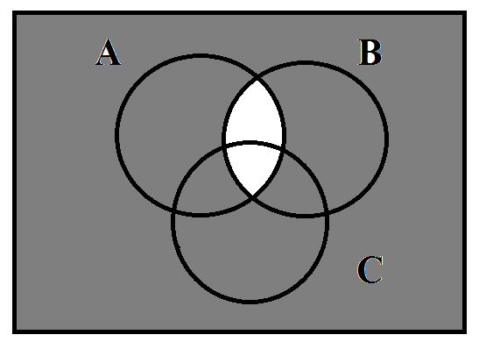
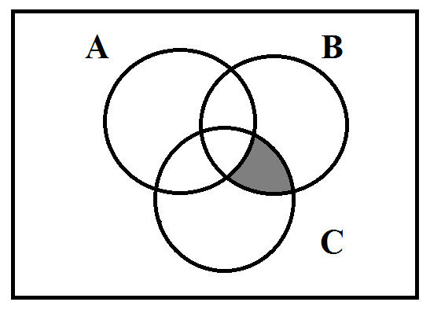
- (10)

3.4 Survey Problems

- The numbers in the regions of the given Venn diagram indicate the number of elements in each region. Use the diagram to state the cardinal number of each set.
11 3 5 9
4
2 6
7
$A$ $B$

$C$
  - $n\left(A\right)$
  - $n\left(B∩C\right)$
  - $n\left(C∩B∩A\right)$
  - $n\left(C'\right)$
  - $n\left(C-A\right)$
- Determine which numbered regions make up the indicated set.
$r_{1} r_{2} r_{3} r_{4}$
$A$ $B$
  - $A$
  - $B$
  - $A∩B$
  - $B-A$
  - $B'$

- Determine which numbered regions make up the indicated set.
$P$ $Q$

$T$
$$r_{1} r_{2} r_{3} r_{4}$$

$r_{5} r_{6} r_{7}$
${ r}_{8}$
  - $P$
  - $P∪Q$
  - $\left(Q∩T\right)'$
  - $P∪Q∪T$
  - $P∩Q∩T$
  - $\left(P∩T\right)-Q$
  - $P'$
- Given that $G$ and $H$ are sets with $n\left(G\right)=12$, $n\left(H\right)=17$, and $n\left(G∩H\right)=11$. What is $n\left(G∪H\right)$?
- Given that $P$ and $R$ are sets with $n\left(P\right)=21$, $n\left(R\right)=10$, and $n\left(P∪R\right)=25$. What is $n\left(P∩R\right)$?
- A survey of 200 students found 150 like study hall, 120 like gym class, and 70 like both. How many like study hall or gym class?
- A group of 86 students were asked what kind of computer they have at home. According to the survey, 45 students have a laptop, 27 students have a desktop, and 28 students responded with neither. Of the students with a computer at home, 14 said they have both a laptop and a desktop at home.
  - Draw a Venn diagram to represent the results of the survey.
  - How many students do not have a laptop?
  - How many students have either a laptop or a desktop?

Notes:

Name: Date:

- The numbers in the regions of the given Venn diagram indicate the number of elements in each region. Use the diagram to state the cardinal number of each set.
$A$ $B$

$$C$$
1 7 9 3
2 5 6

13
  - $n\left(A^{'}\right)$
  - $n\left(B∪C^{'}\right)$
  - $n\left(C∪B∪A\right)$
  - $n\left({\left(C∪A\right)}^{'}\right)$
  - $n\left(B-C\right)$

- One hundred people had their blood analyzed for $A$, $B$, and $Rh$ components. It was found:
- 3 had $Rh$, $A$, and $B$ components, | - 17 had $A$ components but not $Rh$,
- 13 had $A$ and $B$ components, | - 40 had $A$ or $B$ components,
- 9 had $Rh$ and $B$ components, | - 20 had no $Rh$, $A$, or $B$ components
- 12 had $A$ and $Rh$ components,

  - How many people have $A$ in their blood?
  - How many do not have $B$?

4 Logic

Objectives:
- Identify a statement and its truth value
- Write negations of statements both with and without quantifiers
- Write compound statements in symbolic form
- Determine the truth value of a compound statement
- Produce truth tables for compound statements
- Identify logically equivalent forms of a conditional
- Write the converse, inverse, and contrapositive forms of a conditional
- Identify common valid arguments and fallacies
- Use Euler diagrams to verify syllogisms

4.1 Statements, Connectives, and
Quantifiers

A statement in logic is defined as

We represent statements with lowercase letters such as

Example A: The following are considered statements:
- Baseball accidents are the number one killer in women.

Example B: The following are not considered statements:

- Let’s go to lunch.

A _________________________________________ contains a single idea. A ________________________________________
contains several ideas combined together with ______________________________________.

Example C: Simple statement: Today is Thursday.
Compound statement: If today is Thursday, then we will have fried chicken.

The five connectives we will use are:

Negation is a negation of a statement’s truth value (from true to false or from false to true). It is

denoted by the symbol __________.

Negate the following statements.

- The blue whale is the largest living creature.
- Fries cost $1.50.
- It is not true that dogs have fur.
- $5≤6$
- $3≠\frac{6}{2}$
A conjunction joins two statements with the idea ’and’. It is denoted by the symbol __________.

- Consider the following statements:
$p$: The tenant pays rent.
$q$: The sky is blue.
$r$: Today is Tuesday.
  - Write $p∧q$.
  - Write $q∧r$.

A disjunction joins two statements with the idea ‘or’. It is denoted by the symbol __________.

- Consider the following statements:
$q$: The ground is pink.
$r$: Today is Tuesday.
Write $r∨q$.

A conditional joins two statements with the idea ‘if…then’. It is denoted by the symbol __________.

- Consider the following statements:
$p$: Today is Sunday.
$q$: The ground is pink.
$r$: The Falcons will win the Super Bowl.
- Write $p→r$.
- Write $r→\left(\sim q\right)$.
A bi-conditional joins two statements with the idea ‘if and only if’. It is denoted by the symbol
__________.

- Consider the following statements:
$p$: Today is Sunday.
$q$: We eat turnip greens.
Write $p↔q$.

Quantifiers are statements that tell express the idea of ‘how many’. There are three levels of

quantifiers: _____________, _____________, and _____________. When negating quantifiers, the negation should be positioned in front of the quantifier.

Negate the following quantified statements. List two possibilities for 15 and 16.

- All boys run.
- Some dogs swim.
- No cats bark.
Identify the connectives in the following compound statements.

- If you take Quantitative Reasoning, then you can take Statistics.
- I can solve a Rubik’s cube or I can build a ship.
- Belize is on the gulf if and only if the gulf is south of Florida and not east of Cuba.
- $5≤9<10$
Consider the following statements:
$p$: This meal is delicious.
$q$: Busy people do not eat.
$y$: You eat the meal.

- Translate the following sentences into symbolic form.
- You eat the meal if and only if this meal is delicious.
- Busy people do not eat or this meal is not delicious.
- If you eat this meal, then busy people eat or this meal is delicious.
- Translate the following compound statements from symbolic form to a complete sentence.
- $\sim q$
- $y↔q$
- $\left(\sim p\right)∨\left(\sim q\right)$

- Which of the following statements are equivalent to the statement “There is at least one book on that subject in the library”?
(a) Some of the books in the library are on that subject.
(b) All of the books in the library are on that subject.
(c) Not all of the books in the library are on that subject.
- Write an equivalent statement to “Every good dog is cute.”
- Write the negative of the statement “Some rabbits are not smart.”

Notes:

Name: Date:

Determine which of the following are statements.

- Jim Bob works from home.
- Honey roasted peanuts are made with honey.
- Are you hungry?
- The Falcons are the best team to win the Super Bowl.
- Come clubbing with me Friday night.
- You are a wolf in sheep’s clothing.
- Will you still love me when I’m old and gray?
- The TI-83 calculator was created in 1999.

Determine if the statements are simple or compound. Identify the connectives used in the compound statements.
- In the middle of every difficulty lies opportunity.
- Two roads diverged in a wood, and I took the one less traveled by.
- Necessity is the mother of invention.
- If life is like a box of chocolates, then you never know what you’re going to get.
- Tell me and I forget, teach me and I remember, or involve me and I learn.
- The woodpecker sighs if and only if the bark on the tree is not as soft as the skies.
- $15<16<17$

Consider the following statements:
$p$: Minecraft is a game.
$q$: Busy people do not play games.
$r$: You are busy.

- Translate the following sentences into symbolic form.
  - If you are busy then busy people do not play games.
  - Minecraft is a game and busy people do play games if and only if you are busy.
- Translate the following compound statements from symbolic form to a complete sentence.
  - $\left(\sim p\right)∧\left(\sim r\right)$
  - $q∨p$
Negate the following statements.

- Bees can hum.
- All birds can fly.
- Some dogs sing.

4.2 Truth Tables

Truth tables are convenient methods for determining the truth value of a compound statement based off the truth values of the simple statements involved. We’ll discuss the truth tables for each of the connectives in the previous section and then practice creating tables for more complicated compound statements.

Negation works in logic exactly as it does in everyday language. If $p$ is a true statement, then $\sim p$ is
a _____________ statement. If $p$ is a false statement, then $\sim p$ is
a _____________ statement. The conjunction connective is only
true when both statements involved are _____________. The
disjunction connective is only false when both statements
involved are _____________. These concepts provide the truth tables to the right.
$$p$$ | $$q$$ | $$\sim p$$ | $$p∧q$$ | $$p∨q$$
T | T | F | T | T
T | F | F | F | T
F | T | T | F | T
F | F | T | F | F

Use the truth tables above to determine the truth value of each compound statement.

- Today ends in a “y” and a deck of cards has four aces.
- $4-1=3$ and $5-3=3$.
- $5<3$ and “ranger” contains five different letters.
- “Pie” has four letters and $2+2=5$.
- Today ends in “day” or there are sixty minutes in an hour.
- Today is Saturday or there are 24 hours in a day.
- $2+2=4$ or $2∙3=7$.
- “Rangers” contains five different letters or there are 59 minutes in an hour.
Compute a truth table for each of the following compound statements. Be sure to pay careful attention to the order of operations in constructing the columns of your table.
$$p$$ | $$q$$ | _________ | _________ | _____________
T | T | _________ | _________ | _____________
T | F | _________ | _________ | _____________
F | T | _________ | _________ | _____________
F | F | _________ | _________ | _____________

$$p$$ | $$q$$ | $$\sim p$$ | $$\left(\sim p\right)∧q$$
T | T | _________ | _________
T | F | _________ | _________
F | T | _________ | _________
F | F | _________ | _________

- $\left(\sim p\right)∧q$
- $\sim \left(p∨\left(\sim q\right)\right)$
- $\left(\left(\sim p\right)∧q\right)∨\left(p∧q\right)$
$$p$$ | $$q$$ | _________ | _________ | _________ | _________________________
T | T | _________ | _________ | _________ | _________________________
T | F | _________ | _________ | _________ | _________________________
F | T | _________ | _________ | _________ | _________________________
F | F | _________ | _________ | _________ | _________________________

Number of Rows in a Truth Table: If a compound statement has $k$ statements then its truth table will have $2^{k}$ rows.

- How many rows would be in the truth table for $\left(\left(\sim p\right)∧q\right)∨\left(\sim r\right)$?
- Construct a truth table for $\left(\left(\sim p\right)∧q\right)∨\left(\sim r\right)$.
$$p$$ | $$q$$ | $$r$$ | _________ | _________ | _________ | _________________________
T | T | T | _________ | _________ | _________ | _________________________
T | T | F | _________ | _________ | _________ | _________________________
T | F | T | _________ | _________ | _________ | _________________________
T | F | F | _________ | _________ | _________ | _________________________
F | T | T | _________ | _________ | _________ | _________________________
F | T | F | _________ | _________ | _________ | _________________________
F | F | T | _________ | _________ | _________ | _________________________
F | F | F | _________ | _________ | _________ | _________________________

- Let $p$ represent a false statement and let $q$ represent a true statement. Find the truth value of the compound statement $p∨\left(\sim q\right)$.
- Let $p$ represent a true statement and let $q$ represent a true statement. Find the truth value of the compound statement $\left(\left(\sim p\right)∧q\right)∨\left(\sim q\right)$.
- Let $p$ represent a true statement, let $q$ represent a false statement, and let $r$ represent a false statement. Find the truth value of the statement $\left(\sim \left(\left(\sim p\right)∧q\right)\right)∨\left(\left(\sim r\right)∨\left(\sim q\right)\right)$.

Notes:

Name: Date:

Let $p$ represent a false statement, let $q$ represent a true statement, and let $r$ represent a true statement. Find the truth value of the given compound statement.

- $p∧\left(\sim r\right)$
- $\sim \left(r∧\left(\sim q\right)\right)$
- $\left(\sim \left(p∨\left(\sim r\right)\right)\right)∨q$
- $\left(\sim p\right)∧\left(r∨\left(\sim q\right)\right)$

Construct a truth table for each compound statement below.

- $\left(\sim p\right)∨q$
- $\sim \left(p∧q\right)$

4.3 The Conditional and Bi-conditional

$$p$$ | $$q$$ | $$p→q$$
T | T | T
T | F | F
F | T | T
F | F | T

For a conditional $p→q$, statement $p$ is called the _____________________ and $q$
is called the _____________________. A conditional connective is false only
when the hypothesis is __________ and the conclusion is __________. This
provides us with the truth table to the right.

- Consider the following compound statement: If you work for me on Saturday, then I will pay you. Choose appropriate letters to represent the simple statements involved and translate the compound statement into symbolic form. Then, rewrite the compound statement as a complete sentence four times according to the rows in the truth table. Be sure to indicate the only one of these four compound statements that is false.

- Construct a truth table for the statement $\left(\left(\sim p\right)∨q\right)→\left(\left(\sim p\right)∧\left(\sim q\right)\right)$. Remember to be careful with the order in which you should address each connective.
$$p$$ | $$q$$ | _________ | _________ | _________ | _____________ | ________________________________
T | T | _________ | _________ | _________ | _____________ | ________________________________
T | F | _________ | _________ | _________ | _____________ | ________________________________
F | T | _________ | _________ | _________ | _____________ | ________________________________
F | F | _________ | _________ | _________ | _____________ | ________________________________

- If $p$ is some true statement, $q$ is some false statement, and $r$ is some true statement, find the truth value of $\left(\sim \left(p→\left(\sim q\right)\right)\right)→\left(r∨q\right)$.
Example B: Consider the following compound statement: If the price of movies increases, then people will copy them illegally. Choose appropriate letters to represent the simple statements involved and translate the compound statement into symbolic form. Complete the provided truth table. For any of the columns of the truth table that end up with the same pattern of T/F values, rewrite the corresponding compound statements to see if they seem logically equivalent.
$p$: The price of movies increases.
$q$: People will copy them illegally.
$$p$$ | $$q$$ | $$\sim p$$ | $$\sim q$$ | Conditional  $$p→q$$ | Converse  $$q→p$$ | Inverse  $$\left(\sim p\right)→\left(\sim q\right)$$ | Contrapositive  $$\left(\sim q\right)→\left(\sim p\right)$$
T | T | F | F | T | T | T | T
T | F | F | T | F | T | T | F
F | T | T | F | T | F | F | T
F | F | T | T | T | T | T | T

So, the Conditional $p→q$ is logically equivalent to the Contrapositive $\left(\sim q\right)→\left(\sim p\right)$.
So, the Converse $q→p$ is logically equivalent to the Inverse $\left(\sim p\right)→\left(\sim q\right)$.

Contrapositive:

Converse:

Inverse:

$$p$$ | $$q$$ | $$p↔q$$
T | T | T
T | F | F
F | T | F
F | F | T

Bi-conditional statements are only true when the hypothesis and

conclusion are .

It can be helpful to think of the bi-conditional symbol as an equal sign.

Notes:

Name: Date:

Let $p$ represent a false statement, let $q$ represent a true statement, and let $r$ represent a true statement. Find the truth value of the given compound statement.

- $p→\left(\sim r\right)$
- $r→\left(\sim q\right)$
- $\sim \left(p∨\left(\sim r\right)\right)→q$
- $\left(\sim p\right)↔\left(r∨\left(\sim q\right)\right)$

Construct a truth table for each compound statement below.

- $\left(\sim p\right)↔q$
- $\sim \left(p→q\right)$
Write the converse, inverse, and contrapositive of each statement.
- If it rains, then it pours.
- If you get As, then you will pass.
- If $x$ evenly divides 2, then it evenly divides 4.

4.4 Verifying Arguments

An _____________________ is a series of statements called _____________________ followed by a single

statement called the _____________________. An argument is _____________________ if, whenever all the

premises are _____________________, then the conclusion must also be _____________________.

$$\begin{matrix} premises \left\{\underline{\begin{matrix}p→q \\ p\end{matrix}}\right. \\ conclusion ∴q\end{matrix}$$
Example A: If Maggie passed the bar exam, then she is qualified to practice law.
Maggie passed the bar exam.
Therefore, Maggie is qualified to practice law.

Verifying an Argument
- Write the argument symbolically.
- Join the premises together using a conjunction.
- Form a conditional statement using this conjunction and the conclusion of the argument.
- Construct a truth table for the conditional statement.
- If there are any false results in the final column, then the argument is not valid.

- Determine the validity of the argument below.
If you subscribe to the most popular Netflix DVD rental plan, then you have unlimited rentals per month.
You do not have unlimited rentals per month.
∴ You do not subscribe to the most popular Netflix DVD rental plan.
$$p$$ | $$q$$ | _________ | _________ | _________ | _____________ | ________________________________
T | T | _________ | _________ | _________ | _____________ | ________________________________
T | F | _________ | _________ | _________ | _____________ | ________________________________
F | T | _________ | _________ | _________ | _____________ | ________________________________
F | F | _________ | _________ | _________ | _____________ | ________________________________

Common Arguments: Laws and Fallacies
Valid Arguments
Law of Detachment | Law of Contraposition | Law of Syllogism | Disjunctive Syllogism
$$\begin{matrix}\underline{\begin{matrix}p→q \\ p\end{matrix}} \\ ∴ q\end{matrix}$$ | $$\begin{matrix}\underline{\begin{matrix}p→q \\ \sim q\end{matrix}} \\ ∴\sim p\end{matrix}$$ | $$\begin{matrix}\underline{\begin{matrix}p→q \\ q→r\end{matrix}} \\ ∴ p→r\end{matrix}$$ | $$\begin{matrix}\underline{\begin{matrix}p∨q \\ \sim p\end{matrix}} \\ ∴ q\end{matrix}$$
Invalid Arguments
Fallacy of the Converse |  | Fallacy of the Inverse
$$\begin{matrix}\underline{\begin{matrix}p→q \\ q\end{matrix}} \\ ∴ p\end{matrix}$$ |  | $$\begin{matrix}\underline{\begin{matrix}p→q \\ \sim p\end{matrix}} \\ ∴\sim q\end{matrix}$$

Identify the following law or fallacy.

- If my car runs out of gas, then I will not make it home.
My car did not run out of gas.
∴ I made it home.
law/fallacy
- If it rains, then squirrels hide.
It is raining.
∴ The squirrels are hiding.
law/fallacy
- You should eat lunch or you should eat dinner.
You didn’t eat lunch.
∴ You eat dinner.
law/fallacy
- If you brush your teeth, then you have good gums.
If you have good gums, then your dentist loves you.
∴ If you brush your teeth, then your dentist loves you.
law/fallacy
- If it rains, then the squirrels hide.
The squirrels are not hiding.
∴ It is not raining.
law/fallacy
Write the conclusion to the argument. If the argument in not one of the four common laws, we cannot reach any conclusion.

- If we are baking cookies, then they are chocolate chip.
We are baking muffins.
$$∴$$
- If a person is female, then they are good at math.
Stephanie is female.
$∴$

Notes:

Name: Date:

Identify the following law or fallacy.

- If you use a calculator, then you will pass the test.
You didn’t use a calculator.
∴ You didn’t pass the test.
law/fallacy
- If you can do it, then you should do it.
You can do it.
∴ You should do it.
law/fallacy
- If you use a calculator, then you will pass the test.
You passed the test.
∴ You used a calculator.
law/fallacy
- You can go see a movie or you can study.
You didn’t see the movie.
∴ You studied.
law/fallacy
- If you use a calculator, then you will pass the test.
If you pass the test, then you can be president.
∴ If you use a calculator, then you can be president.
law/fallacy
- If you use a calculator, then you will pass the test.
You did not pass the test.
∴ You did not use a calculator.
law/fallacy

4.5 Verifying Syllogisms
using Euler Diagrams

A syllogism is similar to an argument. It contains a series of statements called ______________________

and ends with a ______________________. Unlike arguments, syllogisms may contain

______________________.

Example A: All farmers eat corn.
Jimmy is a farmer.
∴ Jimmy eats corn.

A syllogism is ______________________ when the premises and conclusion are true. Similarly, a

syllogism is ______________________ when the premises are true and the conclusion is false. We can

use an ______________________ diagram to help determine if a syllogism is valid or invalid.

Steps to Constructing an Euler Diagram
- Draw the first premise as two circles: disjoint, overlapping, or concentric.
- Draw the second premise as a single dot.
- Use the diagram to determine if the stated conclusion is valid or invalid.
people who
eat corn
farmers
J
∴ The syllogism is valid.

Example B: Use an Euler diagram to determine if the syllogism stated in
Example A is valid or invalid.

Use an Euler diagram to determine if the syllogism is valid or invalid.

- All bears eat honey.
Dan eats honey.
∴ Dan is a bear.
- All cubes have six sides.
That ball has no sides.
∴ That ball is a cube.
- All milk products have vitamin D.
Spinach has vitamin D.
∴ Spinach is not a milk product.
- All ABAC students wear green.
Lavender does not wear green.
∴ Lavender is not an ABAC student.
- All nurses must clock in to work.
Bill is a nurse.
∴ Bill doesn’t clock in.
- All engineers have a degree.
Jane is an engineer.
∴ Jane has a degree.

Notes:

Name: Date:

Use an Euler diagram to determine if the syllogism is valid or invalid.

- All dogs love treats.
Jackson loves treats.
∴ Jackson is a dog.
- All panda bears eat leaves.
Peggy is a panda bear.
∴ Peggy eats leaves.
- All professors lie.
Robert doesn’t lie.
∴ Robert isn’t a professor.
- All writers eat cereal.
Lila doesn’t eat cereal.
∴ Lila is a writer.

5 Counting
Methods

C

Objectives:
- Use the Fundamental Counting Principle to determine the number of outcomes in a sample space
- Determine when to use combinations and permutations
- Determine the number of permutations and combinations
- Use the Fundamental Counting Principle in the topic of gambling with slot machines and 5-card poker

5.1 Introduction to Counting

A vital part of counting theory is knowing how to determine sample spaces from an experiment. A

sample space of an experiment is the set of all possible ____________________ when the experiment is

conducted. An ____________________ is any result after the experiment is performed.

There are two important questions to consider when counting:

Example A: When a coin is tossed twice, the sample space of
outcomes can be found using a tree diagram. We can list the
elements of the sample space as follows, using $H$ for ‘heads’
and $T$ for ‘tails’: $\left\{HH, HT, TH, TT\right\}$.

Example B: Suppose a set of five students {Adreas, Jessica,
Carl, Sandy, Kiwana} are working on a class project. Their
teacher tells them that they need to choose three people to
work on putting a poster together and two people to conduct
research. The students decide to randomly choose three
people to work on the poster. How many possible ways can
the students decide this? What is the sample space of this
experiment?
In a later section, we will see how to determine that there are
ten possible arrangements for the two groups of students. We can focus on listing the three
students two are designated to work on the poster, since it follows that the other two students
will conduct research.
1: Adreas, Jessica, Carl 5: Adreas, Sandy, Carl 8: Jessica, Carl, Kiwana
2: Adreas, Jessica, Sandy 6: Adreas, Carl, Kiwana 9: Jessica, Sandy, Kiwana
3: Adreas, Jessica, Kiwana 7: Jessica, Carl, Sandy 10: Carl, Sandy, Kiwana
4: Adreas, Sandy, Kiwana
We can write the sample space as $S=\left\{AJC, AJS, AJK, ASK, ASC, ACK, JCS, JSK, JCK, CSK\right\}$.

Determine the sample space for each experiment listed below. Use set notation.

- Tossing a coin three times.
- Rolling a single die once.
- Choosing a vowel from the letters of the alphabet.
- Choosing an even number from $\left\{2, 4, 6, 8, 10, …, 38, 40\right\}$.
- Choosing a state that begins with the letter W from the set of states in the US.
- Choosing a multiple of 5 from $\left\{1, 2, 3, 4, …, 73, 74, 75\right\}$.
- Choosing a reptile from $\left\{human, bird, snake, daisy, alligator, goldfish, ant, lizard\right\}$.
- Create the sample space for rolling two dice. [You will use this sample space often, so creating it will help you become more familiar with it.]
 | 1 | 2 | 3 | 4 | 5 | 6
1 | _____________ | _____________ | _____________ | _____________ | _____________ | _____________
2 | _____________ | _____________ | _____________ | _____________ | _____________ | _____________
3 | _____________ | _____________ | _____________ | _____________ | _____________ | _____________
4 | _____________ | _____________ | _____________ | _____________ | _____________ | _____________
5 | _____________ | _____________ | _____________ | _____________ | _____________ | _____________
6 | _____________ | _____________ | _____________ | _____________ | _____________ | _____________

- Creating a two-digit number from the numbers 1, 2, 3, 4, 5, and 6 if order matters and repetition is not allowed.
- Rolling two six-sided dice and getting a sum of 4.
- A person chooses a single gumdrop from a jar filled with flavors apple, peach, pear, and strawberry. What is the sample space in this experiment?
(a) $\left\{peach, pear, pear, strawberry\right\}$ (b) $\left\{peach, apple, pear\right\}$
(c) $\left\{apple, peach, pear, strawberry\right\}$ (d) $\left\{1, 2, 3, 4\right\}$
- A person chooses one odd number between the set of numbers from 3 to 9, inclusive. What is the sample space in this experiment?
(a) $\left\{5, 7\right\}$ (b) $\left\{3, 4, 5, 6, 7, 8, 9\right\}$ (c) $\left\{4, 6, 8\right\}$ (d) $\left\{3, 5, 7, 9\right\}$
- A person chooses a single number that is a factor of 6. Find the set representing the event $E$ that the number is odd. Give your answer as a set.
- A person chooses a single number in a set containing the numbers from 10 to 15. Find the set representing the event $E$ of choosing an odd number. Give your answer as a set.

Notes:

Name: Date:

- A sample space is defined as
- A sample space is usually presented in ______________________________ notation.
- The sample space for rolling two dice has _______________ elements.
- When two six-sided dice are rolled, the number of outcomes with a sum of eight is
_______________.
- The sample space for the vowels chosen from the alphabet has _______________ elements.
- Construct a tree diagram to find the sample space from tossing a coin four times. List your sample space as a set.

5.2 The Fundamental Counting Principle

We can use tree diagrams and charts to determine total outcomes, which can become very tedious with large numbers of outcomes. To avoid this, we use a basic theory in counting called the Fundamental Counting Principle.

The Fundamental Counting Principle:

Example A: Herman has five different suits, eight different shirts, ten different ties, and seven different pairs of shoes. In how many different ways can this man wear a suit, a shirt, a tie, and a pair of shoes?
$5∙8∙10∙7=2800$ possible ways

Use the Fundamental Counting Principle to solve the following.

- Pizza Party Restaurant offers four sizes of pizza, four types of crust, and fifteen toppings. How many possible combinations of pizza can you create with one topping?
- Alex’s college course of study will allow him to choose from three foreign languages, three mathematics courses, five sciences, six physical education classes, four social sciences, and five English literature courses. How many different arrangements of his schedule are possible?
- The college dining hall at XYZ College has a menu consisting of four soups, five salads, six entrees, and eight desserts. How many meal combinations are possible?

Some types of problems are solved very nicely by using slot diagrams. A slot diagram uses lines to represent the positions, and then we place the number of possibilities in each space. Finally, we multiply these numbers to get the final answer.

Example B: A certain state’s license plates have three letters followed by four numbers. How many combinations are possible? Repetition is allowed.
$\begin{matrix}\underline{ 26 } & ∙ & \underline{ 26 } & ∙ & \underline{ 26 } & ∙ & \underline{ 10 } & ∙ & \underline{ 10 } & ∙ & \underline{ 10 } & ∙ & \underline{ 10 }\end{matrix}=175,760,000$ possibilities

Solve the following problems using slot diagrams.

- In a certain country, license plate numbers have three letters followed by three digits. How many different license plate numbers can be formed?
  - Suppose repetition is allowed.
  - Suppose repetition is not allowed.
- An ABAC club is preparing to elect a president, vice president, secretary, and treasurer. Only four people want to hold offices. How many ways can this be done?
- A company has ten board members. One person will be chosen as CEO and another person as Executive Assistant. How many different ways can these choices be made?
- Harry, Candace, Maury, and Peaches are waiting in line to buy concert tickets. In how many different ways can they stand in line?
- A computer password is created by using two lower-case letters followed by four digits. Determine how many passwords are possible. Repetition is not allowed.
- A computer password is created by using four lower-case letters, followed by three digits, followed by one of these special characters: $, &, or @. Determine how many passwords are possible.
- You take a multiple-choice exam that has ten questions, and each question has five answers. How many different ways can the exam be answered?
- At the Ajax Printing Company, ID cards have five numbers.
  - How many ID cards can be formed if repetition of the digit is allowed?
  - How many ID cards can be formed if repetition of the digit is not allowed?
- Dr. X gave you an eight-question quiz. The quiz has four true/false questions followed by four multiple-choice questions. For each multiple-choice question, there are five possible answers. In how many different ways is it possible to answer the eight questions?
Example C: In how many ways can eight people be arranged in a line?
$8∙7∙6∙5∙4∙3∙2∙1=40,320$ ways

Computations like the one used in Example C are common in counting problems. This format is

called _________________________ notation.

The factorial of a number is the product of that number and all of the natural numbers less than or equal to that number.

$$a!=a∙\left(a-1\right)∙\left(a-2\right)⋯3∙2∙1$$

Solve the following problems.

- 5!
- 10!
- 0!
- $\left(8-2\right)!$
- $\frac{6!}{2! 4!}$
- $\frac{101!}{99!}$
- $\frac{5!}{3!}$
- $\frac{12!}{\left(12-7\right)!}$
- $\frac{12!}{10!2!}$
- $\frac{15!}{13!2!}$

Notes:

Name: Date:

- How many license plates can you make with four letters and two digits?
- How many outcomes will you have if you roll a four-sided die?
- How many outcomes will you have if you roll an eight-sided die twice?
- How many outcomes will you have if you roll an eight-sided die and a twenty-sided die?
- How many ways can you select a meal from six starters, 18 entrees, and five desserts?
True/False. If the statement is false, give the correct value.

- $0=0!$
- $\frac{15!}{5!}=3!$
- $3!∙4!=144$
- $2!∙5!=10!$
- $\frac{85!}{85!}=1$
- $\frac{9!}{8!}=9$
- $9∙8!=72!$

5.3 Permutations and Combinations

A permutation is

Its notation is ____________________, where $n$ is _______________________________________________ and $r$ means

The formula for a permutation is

Example A: How many ways can we make a two-digit number from seven numbers if the numbers can’t be repeated?
${}_{7}^{}{P_{2}^{}}=P\left(7, 2\right)=\frac{7!}{\left(7-2\right)!}=42$

Example B: There are twelve people in a club. In how many ways can five people be chosen as president, vice president, secretary, treasurer, and parliamentarian?
${}_{12}^{}{P_{5}^{}}=P\left(12, 5\right)=\frac{12!}{\left(12-5\right)!}=95,040$
Important Facts about Permutations:
- Order matters.
- Permutations generally deal with lists or line-ups.
- Permutations include all possible arrangements.

Answer each of the following questions.

- List all possible arrangements of the numbers 1, 2, and 3.
- List all possible arrangements of the letters T, V, and W, taken two at a time.
- Calculate the following.
  - ${}_{5}^{}{P_{2}^{}}=P\left(5, 2\right)$
  - ${}_{10}^{}{P_{5}^{}}=P\left(10, 5\right)$
  - ${}_{8}^{}{P_{8}^{}}=P\left(8, 8\right)$
- How many ways can four members from a family of six line up for a photo session if the order matters?
- How many six-letter words can we make using the letters in the word “liberty” without repetitions?
- In how many ways can seven runners finish a race?
- In how many ways can you select a manager, team leader, and assistant from ten workers?
- In how many ways can a president, a treasurer, and a secretary be chosen from among seven candidates in your school organization?
- There are 28 students in an Ag Communications class. In how many different arrangements can five students give a presentation to the class?
- A professor is creating an exam of nine questions from a test bank of twelve questions. How many ways can she select and arrange the questions?

A combination is

Its notation is ____________________, where $n$ is ________________________________________________ and $r$ means

The formula for a combination is

Example C: Let’s take a group of three girls: Abby, Marlo, and Kyla. We want to separate them into committees of two for a special psychology class project. List the relevant possibilities.
All possible arrangements: (Abby, Marlo), (Abby, Kyla), (Marlo, Kyla), (Marlo, Abby),
(Kyla Abby), (Kyla, Marlo). But the last three are duplicates and need not be listed. So, we
started with six possible arrangements and removed half of them. In other words, we
computed $\frac{3!}{2!}=\frac{6}{2}=3$.

Example D: There are 12 people in a club. In how many ways can five people be chosen as a nomination committee as club elections approach?
${}_{12}^{}{C_{5}^{}}=C\left(12, 5\right)=\frac{12!}{\left(12-5\right)!5!}=792$
Important Facts about Combinations:
- Order does not matter.
- Combinations generally deal with groups, such as committees.
- Combinations do not include the arrangements that are the same.

Answer each of the following questions.

- List all possible combinations of the numbers 1, 2, 3, and 4, taken two at a time.
- List all possible combinations of the letters T, V, and W, taken two at a time.
- Calculate each of the following.
  - ${}_{5}^{}{C_{2}^{}}=C\left(5, 2\right)$
  - ${}_{10}^{}{C_{5}^{}}=C\left(10, 5\right)$
  - ${}_{8}^{}{C_{8}^{}}=C\left(8, 8\right)$
  - ${}_{15}^{}{C_{12}^{}}=C\left(15, 12\right)$
- A team of three students is to be formed out of six students. In how many ways can this happen?
- How many five-person committees can be chosen from a group of nine people?
- There are seven things in a hat. How many ways can you pick four things from the hat at once?
- How many different ways can you choose three books from a summer reading book list of six books?
- How many ways can you pick five students for the Ag Business Club’s Rules Committee when there are twelve people interested?
- How many different ways can you invite four of your seven friends to the movies?
- At the ABAC Library, a student found six books of interest but he can only borrow four books. How many possible selections can he make?
- In the game of poker, each player is dealt a hand of five cards. How many different poker hands are there?
- At All Out Buffet, there were ten desserts on the menu. How many ways could I have chosen three desserts?
- A student chooses 10 books from a library collection of 30 to read that year. What is the size of the sample space in this experiment?
- A child is picking 3 days of the 7 days of the week to have Jello® for lunch. What is the size of the sample space in this experiment?
- There are 12 candidates running for any of 6 district positions in a school’s student council. In how many different ways could the six positions be filled?
- There are 6 athletes on a cross country team. At a photoshoot, two of the athletes need to be chosen and arranged in the front row. In how many ways can this be done?
- Christina is organizing a 5-day cycling race. For each day of the race, she will choose one of 9 possible routes. If no route is to be repeated during the race, how many different route arrangements are possible?
- Douglas is going to visit 6 cities this summer. He will choose from 12 different cities and the order in which he visits the cities does not matter. How many different city combinations are possible for the summer travelling?
- Edward will choose 8 songs to listen to during his exercise workout. If there are 11 songs to choose from, how many different exercise song combinations are possible?
- A teacher will select 5 students in a class of 11 to participate in a social experiment. How many different groups are possible?

Notes:

Name: Date:

- A permutation is defined as
- In permutations, _________________________ matters.
- Permutations generally deal with
- A combination is defined as
- In combinations, order _________________________ matter.
- Combinations generally deal with
True/False. If the statement is false, provide a detailed correction or explanation.

- ${}_{10}^{}{P_{2}^{}}=P\left(10, 2\right)$
- The answer to the question “How many ways can a president, vice president, and historian be selected from nine members?” is 84.
- On my combination lock for my gym locker, order matters.
- A permutation can be negative.
- $5!=5$
- ${}_{5}^{}{P_{3}^{}}=P\left(5, 3\right)$ is the permutation of three things taken five at a time.
- ${}_{10}^{}{C_{2}^{}}=C\left(10, 2\right)=45$
- There are 14,980 combinations of four different letters chosen from the 26 letters of the alphabet.

Tell if the problem uses a permutation or a combination, and then work the problem.

- There are 26 people at a meeting. They each shake hands with everyone else. How many handshakes were there?
- A group of 30 people are going to run a race. The top three runners earn gold, silver, and bronze medals. How many ways?
- From a 52-card deck, how many five-card hands can be dealt?
- In how many ways can six kindergarteners line up to go to the playground?

5.4 Counting and Gambling

A standard deck of cards has __________ cards. Cards are separated into __________ suits:

____________________, ____________________, ____________________, and ____________________. The
____________________ and ____________________ suits are red. The ____________________ and ____________________

suits are black. There are thirteen ranks:

____________________, ____________________, and ____________________ are face cards.

- Stud poker is a type of poker in which each player is dealt five cards. Use a combination to determine how many different hands are possible in a game of stud poker.

Poker Hands (In Strength Order):
Royal Flush – 10, J, Q, K, and A, all of the same suit
Straight Flush – Five cards in sequence, all of the same suit
Four of a Kind – Four cards of one rank, plus another card
Full House – Three cards of one rank and two of another
Flush – All five cards from the same suit
Straight – Any five cards in sequence
Three of a Kind – Three cards of one rank and two other cards that are different from each
other
Two Pairs – Two different pairs of cards and a fifth card that is different from the first four
Pair – Two cards of the same rank and three other cards, all of which are different from each
other
Nothing – None of the above hands

- When drawing five cards from a standard 52-card deck, in how many ways can you draw a full house?
- How many ways could you make a five-card hand from all red cards?
- How many ways could you make a seven-card hand from all clubs?
Reel 1 | Reel 2 | Reel 3

An iconic gambling pastime is playing the slot machines. Almost
all slot machines in casinos are electronic. Imagine the following
image is the layout of an early mechanical slot machine.

- How many outcomes can happen with this 3-reel slot
machine?
- How many ways can you get all airplanes?
- How many ways can you get all bells?
- How many ways can you get all skulls?
- How many ways can you get skulls on the first two wheels only?

Notes:

Name: Date:

Reel 1 | Reel 2 | Reel 3

Using the slot machine figure to the right, answer the following
questions.

- How many ways can you get all telephones?
- How many ways can you get lips on the first reel only?
- How many ways can you get eyes on the last two wheels?

Using your knowledge of cards, answer the following questions.

- Show the work behind the number of ways to obtain a flush in 5-card stud poker.
- How many ways can you make a 4-card hand from the face cards?
- How many ways can you make a 2-card hand from the diamonds?

6 Probability

C

Objectives:
- Calculate the probability of an event given a certain sample space
- Determine the odds against and in favor of an event
- Determine the complement, union, and intersection of given probabilities
- Calculate conditional probabilities
- Compute the expected value of a random variable
- Use expected value to solve application problems

6.1 Random Experiments and the
Definition of Probability

An ________________________________________________ is a planned operation carried out under controlled

conditions. A ________________________________________________ is one instance of an experiment taking

place. An ________________________________________________ is any of the possible results of the

experiment. A ________________________________________________ is an experiment whose result cannot be

predicted with certainty. For each random experiment, the set of all possible outcomes is called

the ________________________________________________ for that experiment. An ________________________________

$E$ is a set of specific outcomes, the outcomes that fit the given description.

Example A: An exam is given to a group of 120 students. Here, giving the exam is the experiment. A trial here is one student taking the exam. An outcome is any of the students’ scores on the exam.

- At a sports event, a fair coin is flipped to determine which team has possession of the ball to start. The coin has two sides: heads and tails. Identify the correct experiment, trial, and outcome below.
(a) The experiment is identifying whether a heads or tails is flipped.
(b) The experiment is flipping the coin.
(c) A trial is flipping a heads.
(d) A trial is one flip of the coin.
(e) An outcome is flipping a tails.
(f) An outcome is flipping a coin once.

Example B: List the sample space for rolling a single die once.
$S=\left\{1, 2, 3, 4, 5, 6\right\}$

List the sample space for each of the following random experiments.

- Two (different) dice are each rolled once.
- A single coin is flipped once.
- Three coins are flipped once.
- A single coin is flipped three times.
- A single card is drawn from a standard deck. (Hint: Consult the following image.)
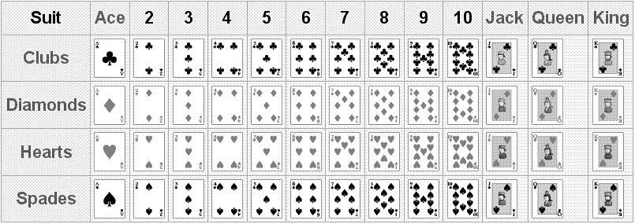

Example C: A single die is rolled once. Define the event $E$ as rolling a number greater than four. List the event $E$ as a set.
$E=\left\{5, 6\right\}$

For each of the given random experiments, list all the outcomes belonging to the given event $E$ as a set.

- Experiment: Two different dice are each rolled once.
Event: Rolling a total more than 9
- Experiment: A single coin is flipped once.
Event: Tails is on the top.
- Experiment: Three coins are flipped once.
Event: Two heads and one tails have occurred.
- Experiment: A single card is drawn from a standard deck.
Event: A face card is drawn.
Recall that the cardinal number of a set $A$ is the number of elements in $A$ and is denoted by $n\left(A\right)$.

If a random experiment has _______________ equally likely possible outcomes, and if _______________ is the number of these outcomes that fit the description of an event $E$, then the probability of an event $E$ is defined as
$$p\left(E\right)=\frac{n\left(E\right)}{n\left(S\right)}.$$

Suppose $S$ is a sample space for a random experiment and $E$ is an event in $S$. The empty set, $∅$, represents the empty subset of $S$: the subset containing elements that are impossible under the guidelines of the random experiment. If $E=∅$, then $n\left(E\right)=\underline{ }$. So, it must be true that

$$\frac{n\left(E\right)}{n\left(S\right)}=\frac{}{n\left(S\right)}=\underline{ }=p\left(∅\right)$$

If $E=S$, then the event $E$ allows for the same possible outcomes as the random experiment. So, $n\left(E\right)=\underline{ }$. Then,
$$\frac{n\left(E\right)}{n\left(S\right)}=\frac{}{n\left(S\right)}=\underline{ }=p\left(S\right).$$
We can view probability on a sliding scale from 0 to 1. The closer $p\left(E\right)$ is to 1, the
$0$
$$0.5$$
$1$
impossible
guaranteed
just as likely as unlikely
_______________ likely an event is
to occur. The closer $p\left(E\right)$ is to 0,

the _______________ likely an event is to occur.

Example D: We are rolling a single die.
- Find the number of all possible outcomes, $n\left(S\right)$.
$\begin{matrix}S=\left\{1, 2, 3, 4, 5, 6\right\} & ⟹ & n\left(S\right)=6\end{matrix}$
- List all outcomes greater than four.
$E=\left\{5, 6\right\}$
- Find $n\left(E\right)$ and $p\left(E\right)$.
$\begin{matrix}n\left(E\right)=2 & ⟹ & p\left(E\right)=\frac{n\left(E\right)}{n\left(S\right)}=\frac{2}{6}=\frac{1}{3}=0.\overline{3}\end{matrix}$
- Find the probability that we roll a number less than four.
$\begin{matrix}F=\left\{1, 2, 3\right\} & ⟹ & n\left(F\right)=3 & ⟹ & p\left(F\right)=\frac{n\left(F\right)}{n\left(S\right)}=\frac{3}{6}=\frac{1}{2}=0.5\end{matrix}$

- We are rolling two dice.
  - Find the number of all possible outcomes, $n\left(S\right)$.
  - List all the pairs with the total of ten. Call this event $E$.
  - Find $n\left(E\right)$.
  - Find $p\left(E\right)$.
  - List all pairs with the total of more than nine. Call this event $F$.
  - Find $n\left(F\right)$.
  - Find $p\left(F\right)$.
  - Find the probability that we roll a total of less than 13.
  - Find the probability that we roll a total of less than 2.
- We are flipping a coin five times.
  - Find the number of all possible outcomes, $n\left(S\right)$.
  - Calculate the number of outcomes with heads occurring three times as ${}_{5}^{}{C_{3}^{}=n\left(3 heads\right)}$.
  - Find $p\left(3 heads\right)$.
  - Find the probability that tails occurs two times.
- We draw a single card from a standard deck.
  - Find the number of all possible outcomes, $n\left(S\right)$.
  - Find the number of all kings, $n\left(king\right)$.
  - Find $p\left(king\right)$.
  - Find the probability that the card we draw is a face card, $p\left(face\right)$.
- A car dealership finds that a certain model of new car has something wrong with its transmission 15% of the time. How likely is it that a particular model of that car has something wrong with its transmission?
(a) Very likely, the probability is close to 1.
(b) Somewhat likely, the probability is closer to 1 than to 0.
(c) Unlikely, the probability is close to 0.
(d) Somewhat unlikely, the probability is closer to 0 than it is to 1.
(e) Equally likely, the probability is 0.5.
- A lake has 435 trout, 726 bass, and 629 catfish. We randomly pick a fish from this lake.
  - What is the probability that it will be a catfish? Round to three decimal places.
  - What is the probability that it will NOT be a catfish? Round to three decimal places.
- A bag contains 53 marbles, 11 of which are red. A marble is randomly selected from the bag, and it is blue. This blue marble is not placed back in the bag. A second marble is randomly drawn from the bag. Find the probability that this second marble is not red.
- The table to the right gives the age of 120 adult
residents in a certain neighborhood together with
information if they own or rent their home or
apartment. If a random adult resident of this
neighborhood is picked, find the probability that it
will be:
Age | Rent | Own | Totals
20-29 | 22 | 6 | 28
30-39 | 10 | 26 | 36
40-49 | 8 | 32 | 40
50-59 | 4 | 12 | 16
Totals | 44 | 76 | 120

  - A person who rents his/her home/apartment.
  - A person between 40 and 59 years old.
  - A homeowner between 30 and 49 years old.
- Sickle-cell anemia is a hereditary blood disease such that if a person has two sickle-cell genes then the person will have the disease, a person with one
sickle-cell gene (and one normal) will be a carrier, and a person
inheriting both normal genes will be normal (will neither have
the disease nor will be a carrier). Suppose both
parents are carriers of the disease. Fill out the
table with all possible outcomes (the Punnett
square) and find the probability that the child
will be a carrier.
 |  | Second Parent
 |  | sickle-cell (s) | normal cell (n)
First Parent | sickle-cell (s)
 | normal cell (n)

Notes:

Name: Date:

- We are randomly picking a month of the year.
  - List the sample space, $S$.
  - Find the probability that we pick a month that starts with “J.”
- We are rolling two dice. Find the probability that:
  - We will roll a total less than six.
  - We will roll a double.
- We are flipping a coin six times. Find the probability that heads comes out three times.
- We are drawing a single card from a standard deck of 52 cards. Find the probability that:
  - The card is a queen.
  - The card is a black face card.
  - The card is not a heart.
- A bowl of Halloween candy contains 11 Snickers bars, 12 Milky Way bars, 15 Tootsie Rolls, and 7 packs of M&M’s. If a child randomly picks a piece of candy, find the probability that it will be:
  - A Tootsie Roll.
  - A candy bar.
- The table to the right gives the body
weight for 160 office employees in a
certain company. If we randomly pick
an office employee, what is the
probability that it will be:
Body Weight (lbs) | Males | Females | Totals
140-159 | 2 | 28 | 30
160-179 | 7 | 23 | 30
180-199 | 18 | 15 | 33
200-219 | 19 | 7 | 26
220-239 | 17 | 3 | 20
240-259 | 15 | 2 | 17
260-280 | 4 | 0 | 4
Totals | 82 | 78 | 160

  - A male.
  - A person weighing between 180 and 199 lbs.
  - A female weighing between 160 and 199 lbs.

6.2 Probability for Complements
and Unions of Events

The complement of an event $E$ is the set of all the remaining possible outcomes that do not
belong to $E$. The complement of $E$ is denoted
$$S$$
$$E$$
$$E'$$
by ______________. Because of this definition, it is

always true that ______________________________________,

and, especially ________________________________________.

Example A: We are rolling a single die. Let $E$ represent the set of events where we roll more than 4. Find $n\left(E\right)$, $n\left(E^{'}\right)$, $p\left(E\right)$, and $p\left(E^{'}\right)$.
$\begin{matrix}S=\left\{1, 2, 3, 4, 5, 6\right\} & ⟹ & E=\left\{5, 6\right\}\end{matrix}$
$\begin{matrix}\begin{matrix}n\left(E\right)=2 \\ n\left(E^{'}\right)=4\end{matrix} & ⟹ & \begin{matrix}p\left(E\right)=\frac{2}{6}=\frac{1}{3} \\ p\left(E^{'}\right)=1-\frac{1}{3}=\frac{2}{3}\end{matrix}\end{matrix}$

- A flu vaccine is known to be 98% effective. What is the probability that, after being vaccinated, you still get the flu?
- Thirty students took a calculus exam. Of the students who passed the exam, 8 students earned an A, 9 earned a B, 6 earned a C, and 3 earned a D. If a single student is randomly chosen, what is the probability that the student did NOT pass the exam? Give the answer as a fraction.
- Bags of dog food are labeled 1 through 50. What is the probability that the dog will choose a bag that is not numbered with a multiple of 11?
- A spinner contains the numbers 1 through 50. What is the probability that the spinner will land on a number that is not a multiple of 8?

When $p\left(E\right)$ is complicated to calculate, sometimes it is quite a bit easier to calculate $p\left(E^{'}\right)$, especially when $E$ is described as “at least…” or “at most…”.

- We are flipping six coins. Find the probability that we get at least one tails. Notice that the event that we get at least one tails is complement to the event that we get no tails at all.
- We are rolling two dice. Find the probability that:
  - We will roll a total of at least four.
  - We will roll a total of at most eleven.

A union of two events, $E$ and $F$, is an event formed by the outcomes that fit the description of

event $E$, event $F$, or both events $E$ and $F$. This union is denoted by

An intersection of two events, $E$ and $F$, is an event formed by the outcomes that fit the description

of both event $E$ and event $F$. The intersection is denoted by
$$S$$
$$E$$
$$F$$
$$E∩F$$
$$S$$
$$E∪F$$

Because $E∪F$ contains outcomes fitting $E$ __________ $F$, that increases the number of possible

outcomes for $E∪F$. To prevent counting the outcomes in $E∩F$ twice, we use the formulas below

for cardinality and probability.
$$\begin{matrix}n\left(E∪F\right)=n\left(E\right)+n\left(F\right)-n\left(E∩F\right) & ⟹ & \begin{matrix}p\left(E∪F\right)=p\left(E\right)+p\left(F\right)-p\left(E∩F\right) \\ p\left(E or F\right)=p\left(E\right)+p\left(F\right)-p\left(E and F\right)\end{matrix}\end{matrix}$$

- Find $p\left(E∪F\right)$ if $p\left(E\right)=0.24$, $p\left(F\right)=0.88$, and $p\left(E∩F\right)=0.30$.
- Find $p\left(E∩F\right)$ if $p\left(E\right)=0.34$, $p\left(F\right)=0.86$, and $p\left(E∪F\right)=0.82$.
- Find $p\left(F\right)$ if $p\left(E\right)=0.24$, $p\left(E∪F\right)=0.88$, and $p\left(E∩F\right)=0.12$.
- We draw a single card from the standard deck.
  - Find the probability that the card is a king or a spade.
  - Find the probability that the card is a 10 or a face card.
  - Find the probability that the card is red or a face card.
  - Find the probability that the card is neither a diamond nor a queen.
- We are rolling two dice. Find the probability that we roll a total that is even or more than 10.
- A deck of cards contains red cards numbered 1 and 2; blue cards numbered 1, 2, and 3; and green cards numbered 1, 2, 3, and 4. If a single card is picked at random, what is the probability that the card is blue or has an odd number?

- The table to the right gives an eye color of 120 people. If we randomly pick a person, what is the probability that it will be:
 | Males | Females | Totals
Black | 4 | 8 | 12
Brown | 22 | 15 | 37
Blue | 14 | 11 | 25
Green | 20 | 14 | 34
Gray | 7 | 5 | 12
Totals | 67 | 53 | 120

  - A female or a person with brown
eyes.
  - A male or a person with blue eyes.
  - A person with black or gray eyes.

The odds against an event $E$ is defined as _______________. Similarly, the odds in favor of an event

$E$ is defined as _______________.

Example B: Calculate the odds against rolling a five when a single die is rolled.
$S=\left\{1, 2, 3, 4, 5, 6\right\}, E=\left\{5\right\}, E^{'}=\left\{1, 2, 3, 4, 6\right\}$
$\begin{matrix}p\left(E\right)=\frac{1}{6} & & p\left(E^{'}\right)=\frac{5}{6}\end{matrix}$
odds against rolling a 5: $\frac{5/6}{1/6}=5$

- Calculate the odds in favor of rolling a total of 10 when two dice are rolled.

Notes:

Name: Date:

- Find $p\left(E∪F\right)$ when $p\left(E\right)=0.87$, $p\left(F\right)=0.33$, and $p\left(E∩F\right)=0.43$.
- Find $p\left(E∩F\right)$ when $p\left(E\right)=0.66$, $p\left(F\right)=0.35$, and $p\left(E∪F\right)=0.93$.
- If a chance to win in a raffle is 1 in 1200, what is the probability that we will not win (if we have one ticket)?
- Find the odds against rolling a six when we roll a single die.
- Find the odds in favor of rolling a total of 11 when we roll two die.
- We are drawing a single card from the standard deck. Find the probability that the card is:
  - A heart or a queen.
  - Not a face card.
  - A face card or a 10.
- On a particular Saturday, the probability of rain is 54%, probability that the temperature will fall below 50$℉$ is 47%, and the probability that both would occur is 17%.
  - For this Saturday, find the probability that there will be rain or the temperature below 50$℉$.
  - Suppose you decided not to go fishing on this Saturday if it rained or if the temperature was below 50$℉$. What is the probability that you will go fishing?
- The table to the right
gives information about
available apartments in
a certain apartment
building. If we pick a
random apartment in
this building, find the probability that it will be:
Floor | 1 bedroom | 2 bedrooms | 3 bedrooms | Totals
1st | 6 | 2 | 2 | 10
2nd | 4 | 4 | 2 | 10
3rd | 2 | 6 | 2 | 10
Totals | 12 | 12 | 6 | 30

  - A 2-bedroom apartment.
  - A 3-bedroom apartment or a 2nd floor apartment
  - Not a 1-bedroom apartment

6.3 Conditional Probability and
Intersections of Events

The conditional probability of $F$, given $E$, is defined as

$$p\left(F | E\right)=\frac{n\left(F∩E\right)}{n\left(E\right)}=\frac{p\left(F∩E\right)}{p\left(E\right)}.$$
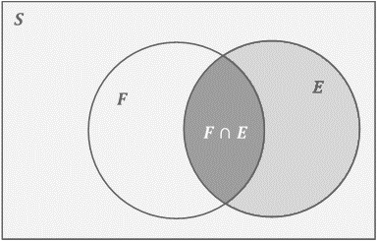
Conditional probability is the fraction of outcomes that
belong to both events $F$ and $E$ out of the outcomes that
belong to $E$, because “given $E$” means that event $E$ has
occurred with certainty, thus reducing all possible
outcomes to only those belonging to $E$.

- Let $W$ be the event that a randomly chosen
person drinks sixty-four ounces of water per
day. Let $V$ be the event that a randomly
chosen person has varicose veins. Let $Z$ be the
event that a randomly chosen person has kidney stones. Write each of the following in correct symbolic form.
  - Given that the person drinks sixty-four ounces of water per day, the probability that a randomly chosen person has varicose veins.
  - The probability that a randomly chosen person has kidney stones, given that he/she has varicose veins.

Example A: Suppose we randomly pick a figure from the set below.

- Find the probability $p\left(circle | solid\right)$, i.e. the conditional probability that we select a circle given that the figure we selected was solid.
$p\left(circle | solid\right)=\frac{n\left(circle and solid\right)}{n\left(solid\right)}=\frac{1}{3}$
- Find the probability $p\left(square | solid\right)$.
$p\left(square | solid\right)=\frac{n\left(square and solid\right)}{n\left(solid\right)}=\frac{2}{3}$
- Find the probability $p\left(solid | square\right)$.
$p\left(solid | square\right)=\frac{n\left(solid and square\right)}{n\left(square\right)}=\frac{2}{4}=\frac{1}{2}$

- We are drawing a single card from a standard deck. Find the probabilities:
  - $p\left(king | heart\right)$
  - $p\left(heart | king\right)$
  - $p\left(7 | face\right)$
- We are rolling a single die. Find the probabilities:
  - $p\left(even | less than 5\right)$
  - $p\left(less than 5 | even\right)$
- In a certain retirement home, 45% of the residents play poker, 55% are gardening, and 20% go to the gym. It is also known that 15% of them play poker and go to the gym, and 35% play poker and are gardening. If a random resident is selected, find the probability that:
  - The resident plays poker, given that he/she is gardening.
  - The resident goes to the gym, given that he/she plays poker.
- Given that the probability of a student spending time watching TV is 0.89, the probability of a student spending time reading is 0.44, and the probability of a student spending time reading and watching TV is 0.11, what is the probability of a student spending time reading given that the student spends time watching TV?
- The table to the right gives the age
of 100 people together with their
preferred drink. If we randomly
pick one of these people, what is
the probability that it will be:
Age | Soda | Coffee | Tea | Water | Totals
20-29 | 10 | 8 | 5 | 2 | 25
30-39 | 11 | 9 | 2 | 3 | 25
40-49 | 8 | 9 | 1 | 7 | 25
50-59 | 9 | 8 | 3 | 5 | 25
Totals | 38 | 34 | 11 | 17 | 100

  - A person preferring water,
given that he/she is between 20 and 39.
  - A person preferring soda, given that he/she is between 40 and 59.
When the probabilities $p\left(E\right)$, $p\left(F\right)$, and $p\left(F | E\right)$ are known, the probability of the intersection of events $E$ and $F$ can be calculated according to the following formulas. When events $E$ and $F$ are independent, i.e. their outcomes do not affect each other,

$$p\left(E∩F\right)=p\left(E\right)p\left(F\right).$$

When events $E$ and $F$ are dependent, i.e. their outcomes do affect each other,

$$p\left(E∩F\right)=p\left(E\right)p\left(F | E\right).$$

- We are drawing two cards, with replacement, from the standard deck. Find the probability that:
  - Both are kings.
  - Neither card is a king.
- A student is taking a quiz with five multiple choice questions, each question having four choices (only one is correct). The student did not study at all and decides to guess each answer.
  - What is the probability that the student will guess all five answers correctly?
  - What is the probability that the student will guess all five answers incorrectly?
- The probability that a person is afraid of thunderstorms is 0.35. If we ask three random people, what is the probability that all three will be afraid of thunderstorms?
- We draw two cards, without replacement, from a standard deck. Find the probability that:
  - Both are kings.
  - We draw a queen after a king.
0.07
0.93
0.98
0.02
0.02
0.98
- The following tree diagram gives probabilities and conditional
probabilities in the process of testing for a disease. $D$ means
the person has the disease, $D'$ means the person does not have
it. $T$ means that the person tested positive,
$T'$ means the person tested negative. The
links connecting labeled points give
conditional probabilities, i.e.
$p\left(T | D\right)=0.98$ is the probability that a
person will test positive, given that
he/she has the disease. If a person is
randomly selected, find the following probabilities
that the person:
  - Will test negative, given that he/she has the disease.
  - Will both have the disease and test negative.
  - Will test negative.
  - Has the disease, given that he/she tested negative.

Notes:

Name: Date:

- We draw a single card from a standard deck. Find the probability that the card will be:
  - A king, given that it is a club.
  - A queen, given that it is a face card.
- We are rolling two dice. Find the probability that we roll a total that is an even number, given that it is more than nine.
- For a population of catfish in a certain pond, the probability that a catfish weighs more than 2 lbs is 0.56, the probability that a catfish is longer than 12 inches is 0.54, and the probability that a catfish is both longer than 12 inches and weighs more than 2 lbs is 0.47. If we catch a random catfish from this pond, find the probability that it weighs more than 2 lbs, given that it is longer than 12 inches.
- We are drawing two cards from the standard deck, with replacement. Find the probability that:
  - Both are face cards.
  - None of them is a face card.
- We are rolling two dice two times. Find the probability that we will roll a total of ten both times.
- We are drawing two cards from the standard deck, with replacement. Find the probability that:
  - Both are queens.
  - We draw a jack after a queen.
- The following table gives ages of employees of
a certain company. If we randomly pick an
employee, find the probability that it will be:
Age | Female | Male | Totals
20-29 | 10 | 8 | 18
30-39 | 20 | 19 | 39
40-49 | 8 | 7 | 15
Totals | 38 | 34 | 72

  - A male, given that the person is between
20 and 29 years old.
  - Between 30 and 39 years old, given that the person is a female.

6.4 Expected Value

If, in a random experiment, some quantity has $n$ possible values $V_{1}, V_{2}, V_{3}, …, V_{n}$, each occurring with a corresponding probability $p_{1}, p_{2}, p_{3}, …, p_{n}$, then the expected value for this quantity is defined as

$$\underline{ }.$$

Note that the values can be _________________ (for gain) or _________________ (for loss). If the given

random experiment is a gambling game, then the expected value represents an average gain per

game. A game is said to be fair when the expected value is __________.

$$V$$ | 6 | 8 | $$-3$$ | 4 | $$-2$$ | 1
$$p$$ | 0.12 | 0.14 | 0.45 | 0.20 | 0.06 | 0.03

Example A: Find the expected value for the
following list of possible values, given with their
probabilities.
$E=0.12\left(6\right)+0.14\left(8\right)+0.45\left(-3\right)+0.20\left(4\right)+0.06\left(-2\right)+0.03\left(1\right)=1.2$

- We are playing a game where a single die
is rolled and we win the same number of
dollars as the number rolled. Find the
expected value for this game.
$$V$$ | 1 | 2 | 3 | 4 | 5 | 6
$$p$$ | ______ | ______ | ______ | ______ | ______ | ______

- We are playing a game where a single die is rolled. It costs $1 to play this game. If we roll 6, we win $6. If we roll 1 or 2, we win $2. Otherwise, we lose the $1 we paid to play.
  - Find the expected value for the game.
  - Find the price to play that makes this a fair game.
- We are playing a game where two dice are rolled. It costs $3 to play this game. If we roll a total of 2 or 12, we win $20. If we roll a total of 7, we win $10. Otherwise, we lose the $3 we paid to play.
  - Find the expected value for the game.
  - Find the price to play that makes this a fair game.
- “Marble Madness” is a local carnival game, costing $2. There are 100 total marbles in a bag: 2 red, 8 orange, 10 yellow, 30 green, 30 blue, and 20 black.
- If a red marble is pulled, you win $6, an orange marble wins $4, and a yellow marble wins $2. A green, blue, and black marble result in a loss. What is the expected value of a marble pull?
- During a school fundraiser, 1000 raffle tickets were sold at $5 each. There is one first prize of $1000 and three second prizes at $200 each. Find the expected value if we buy one ticket.
- Suppose the probability of a 24-year-old male living to age 25 (based on mortality tables) is 0.996. If a $2000 one-year-term policy for a 24-year-old male costs $10, what is the expected value?

Notes:

Name: Date:

- Find the expected value for the following list of possible values, given with their probabilities.
$$V$$ | 8 | 5 | $$-4$$ | 4 | $$-1$$ | 2
$$p$$ | 0.1 | 0.16 | 0.4 | 0.25 | 0.06 | 0.03

- We are playing a game where two dice are rolled. It costs $2 to play this game. If we roll a total of 11 or 12, we win $20. If we roll a total of 6, we win $10. Otherwise, we lose the $2 we paid to play.
  - Find the expected value for the game.
  - Find the cost that would make this a fair game.
- During a charity fundraiser, 2000 raffle tickets were sold at $3 each. There is one first prize of $2000, one second prize of $200, and three third prizes of $100 each. Find the expected value if we buy one ticket.
- Suppose the probability of a 30-year-old female living to age 31 is 0.998. If a $4000 one-year-term policy for a 30-year-old female costs $9.50, what is the expected value?

7 Descriptive
Statistics
C

Objectives:
- Understand and use frequency tables and histograms
- Calculate the mean, median, mode, standard deviation, and 5-number summary of a data set
- Construct and understand box-and-whisker plots
- Identify the area of sections under a normal distribution curve
- Compute the value of raw $z$-scores
- Use normal distribution to solve application problems

7.1 Introduction to Statistics

_________________________________ is the number of times a value in a data set occurs. A frequency

table is an arrangement of the data in order, from least to greatest, with their corresponding

_________________________________.

To Construct a Frequency Table from a Data Set
- Construct a two-column table, labeling the left as Data and the right as Frequency.
- Order the data from least to greatest in the left column.
- Looking through the data set, determine how many times each value occurs and list on right column across from the corresponding data value.

The total number of data values is the sum of the _____________________ column. Relative frequency

is the ___________________ of the number of times a certain data value occurs to the total number of

data values. Relative frequency can be expressed as a ___________________ or a ___________________.

Cumulative relative frequency is the ___________________ of the previous relative frequencies.

A ___________________________ is a bar graph that consists of adjoining boxes and can show the shape, center, and spread of the data. An advantage of histograms is the ability to readily display large data sets. Histograms have a horizontal axis labeled with the represented data and a vertical axis showing either the frequency or the relative frequency.

- Given the histogram for a data set below, how many values in the data set are greater than 8.5 but less than 10.5?
6.5 7.5 8.5 9.5 10.5 11.5 12.5 13.5 14.5 15.5
- Sixteen people were asked how many miles they commute to work each day. The data are as follows:
$$2, 5, 7, 3, 2, 10, 18, 5, 10, 10, 5, 7, 13, 12, 2, 5.$$Construct a frequency table for this data.
Age | Frequency | Relative Frequency
17 | 2
18 | 4
19 | 6
20 | 7
21 | 5
22 | 1

- The frequency table below shows the ages of
the students in a programming class. Complete
the Relative Frequency column of the table.
Enter your answers as either fractions or
decimals.
Number of Pets | Relative Frequency
0 | 0.30
1
2 | 0.15
3 or more | 0.20

- A group of students were surveyed about the number of
pets they have. Their responses are summarized in the
relative frequency table below. What is the missing
relative frequency?
- A data set is summarized in the frequency table below.
Using the table, determine the number of values greater
than or equal to 8. Give your answer as a single number.
Value | Frequency
1 | 1
2 | 2
3 | 1
4 | 2
5 | 2
6 | 3
7 | 4
8 | 4
9 | 6
10 | 8
11 | 4
12 | 5

Notes:

Name: Date:

- To plan the budget for the next
fiscal year, the campus tutoring
center surveyed the number of
students using the center hourly
between 9pm and midnight for a
semester to decide if it should hire
more tutors for the upcoming year.
Use the results in the given graph to
answer the questions.
- What was the smallest number of
students in the tutoring center and
how many times did it occur?
- What was the smallest student count between 5 and 8, inclusive? How many times did that occur?
- For how many hours was the survey taken?
- For what fractional part of the total number of hours were fewer than 5 students present?
Value | Frequency
0 – 1 | 4
2 – 3 | 8
4 – 5 | 7
6 – 7 | 9
8 – 9 | 5
10 or more | 7

- A group of students were surveyed about the number of
times the went to a movie theater last year. Their
responses are summarized in the frequency table below.
How many students responded to the survey?
- A data set is summarized in the frequency table below.
Using the table, determine the number of values less than
or equal to 3.
Value | Frequency
1 | 5
2 | 6
3 | 5
4 | 6
5 | 0
6 | 5
7 | 8
8 | 4
9 | 4
10 | 3
11 | 3

- Given the frequency table to the right, construct the corresponding relative frequency table.
Value | Frequency
3 | 8
4 | 5
5 | 8
6 | 9

- The students in a first grade class were all asked to time how long they could hold their breath, in seconds. The results were tallied and are presented in the following histogram. How many of those students held their breath for more than 12.5 seconds but less than 15.5 seconds?
6.5 7.5 8.5 9.5 10.5 11.5 12.5 13.5 14.5 15.5

7.2 Measures of Central Tendency

The ______________________________ is one of the measures of the center of a data set. It is the middle value when the data set is arranged in numerical order. Because this measure of the center is not affected by the numerical values of extreme values or outliers, it is generally a better measure of the center of a data set.

Finding the Median of a Data Set:
- Sort the data values in numerical order, from smallest to largest.
- Count the number of values in the data set.
  - If the data set has an odd number of values, the median will be the data value exactly in the middle of the data set.
  - If the data set has an even number of values, the median will be the average of the two middle numbers of the data set.

Find the median of each of the following data sets.

- 3, 8, 5, 10, 4, 7, 8, 4, 9
- 22, 15, 18, 23, 19, 20, 11, 17, 16, 15, 18, 20
The center of a data set is a way of describing location. The two main measures of the center of a

data set are the _______________________ and the _______________________. The mean is the most common

measure of the center and is the average of the data set.

Calculating the Mean
- Add all the data values in the set.
- Divide the sum of the data values by the total number of data values in the set.

- Find the mean of the following data set: 7, 8, 5, 6, 4, 8, 10, 3, 11, 15

The sample mean, $\overline{x}$, is the average of values of a _______________________ of an entire population. The

population mean, $μ$, is the average of _______________________ value in the population.

Finding the Mean from a Frequency Table:
- For each row in the table, multiply the data value times its corresponding frequency.
- Add the values from the previous step together to find the total of all the data values.
- Add the values in the frequency column to find the total number of data values.
- To find the mean, divide the sum all the data values by the sum of the frequencies.
$$x$$ | frequency
2 | 5
4 | 6
7 | 3
8 | 4
10 | 2

- Use the frequency table to the right to find the mean of the
data set.

When dealing with grouped data intervals, we are able to ____________________ the mean, but not

necessarily find an exact mean. We can find the estimated mean by dividing the sum of the

_______________________ by the number of data values.

$$\begin{matrix}mean=\frac{sum of data values}{number of data values} & & estimated mean=\frac{sum of midpoints}{number of data values}\end{matrix}$$

The mode is the number, or numbers, that occur the _____________________ in a data set. It is possible to have one, more than one, or no mode in a data set.

Find the mode(s) of the following data sets.

- 44, 56, 34, 52, 48, 44, 39, 32, 55, 56, 47, 56, 58, 41, 39, 59
- 22, 19, 28, 23, 27, 12, 19, 23, 18, 16, 17, 23, 13
Finding the 5-Number Summary:
- Arrange the values in the data set from least to greatest.
- Identify the minimum and maximum values.
- Find the median. This will be $Q_{2}$.
- Find the median of the lower half of the data set. This will be $Q_{1}$.
- Find the median of the upper half of the data set. This will be $Q_{3}$.

- Find the 5-number summary for the following data set: 23, 18, 19, 25, 30, 15, 26, 29, 17, 22, 33, 28, 36

A _________________________________________ plot will show the distribution of data into quartiles. The
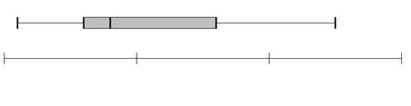
min $Q_{1}$ $Q_{2}$ $Q_{3}$ max
interquartile range is the difference

between _____________________ and

_____________________. Approximately 50% of the data will fall inside this box.

Examining a Box-and-Whisker Plot:
- A wide box with long whiskers indicates the data probably doesn’t cluster.
- A small box with short whiskers indicates the data probably clusters.
- A small box with long whiskers shows the data clusters but may have outliers which should be investigated further.

- Draw a box-and-whisker plot for the data in the previous exercise.

Notes:

Name: Date:

- Find the mean of the data values: 25, 23, 27, 22, 26.
- Find the mean of the data values given in the following frequency table.
$$x$$ | frequency
52 | 4
53 | 6
54 | 3
55 | 8
56 | 4
57 | 3

- Find the median of the ages of our presidents at the time of inauguration: 42, 51, 56, 55, 51, 54, 51, 60, 61, 43, 55, 56, 61, 52, 69, 64, 46.

- Use the data values and frequency table in Exercise (2) to find the 5-number summary and draw a box-and-whisker plot for the data.

- List the mode for each data set.
  - 9, 18, 17, 19, 20, 9, 10, 9
  - 1, 0, 1, 0, 1, 0, 1
  - 1, 2, 3, 4, 5, 6, 6, 5, 4, 3, 2, 1

- An art collector bought 20 paintings at an art fair and wants to know the average price of her new paintings. She adds the prices of all the paintings and divides this number by 20 to find an average price of $350. Is this price a sample mean or a population mean, and which symbol would we use to denote it?
- The following frequency table summarizes a set of data. What is the five-number summary?
(a) Min: 3, $Q_{1}$: 5, Median: 6, $Q_{3}$: 11, Max: 12
(b) Min: 3, $Q_{1}$: 6, Median: 8, $Q_{3}$: 10, Max: 12
(c) Min: 3, $Q_{1}$: 4, Median: 6, $Q_{3}$: 11, Max: 12
(d) Min: 3, $Q_{1}$: 8, Median: 9, $Q_{3}$: 10, Max: 12
(e) Min: 3, $Q_{1}$: 6, Median: 8, $Q_{3}$: 9, Max: 12
$$x$$ | frequency
3 | 1
5 | 2
6 | 2
7 | 1
8 | 3
10 | 3
11 | 1
12 | 2

7.3 Standard Deviation

The ______________________ of a data set is the difference between the largest and smallest values.

The difference between a data value and the mean is called its
Finding the Standard Deviation: | Sample | Population
- Find the mean of the data set. | $$\overline{x}$$ | $$μ$$
- Find the deviations of the mean by subtracting the
mean from each data value. | $$x-\overline{x}$$ | $$x-μ$$
- Square each deviation. | $${\left(x-\overline{x}\right)}^{2}$$ | $${\left(x-μ\right)}^{2}$$
- Find the sum of the squared deviations. | $$\sum{{\left(x-\overline{x}\right)}^{2}}$$ | $$\sum{{\left(x-μ\right)}^{2}}$$
- Find the variance, the sum of the squared
deviations divided by $n-1$ (or $N$ as appropriate). | $$\frac{\sum{{\left(x-\overline{x}\right)}^{2}}}{n-1}$$ | $$\frac{\sum{{\left(x-μ\right)}^{2}}}{N}$$
- Take the square root of the variance. | $$s=\sqrt{\frac{\sum{{\left(x-\overline{x}\right)}^{2}}}{n-1}}$$ | $$σ=\sqrt{\frac{\sum{{\left(x-μ\right)}^{2}}}{N}}$$

- Find the range, variance and standard deviation of the following data set: 66, 70, 75, 80, 84.
$$x$$ | frequency
37 | 1
38 | 2
39 | 5
40 | 5
41 | 4
42 | 2

- Use the frequency table to calculate the standard
deviation of the data set.

The standard deviation is a measure of how the data is spread out. If the data values tend to concentrate around the mean, then the data set will have a lower standard deviation. The wider the data is spread out the higher or larger the standard will become.

- Find the sample variance of the following set of data: 12, 7, 6, 4, 11. Round the final answer to one decimal place.
- Find the sample standard deviation for the data set in the previous problem. Round your final answer to one decimal place.
- You have collected the ages of all 30 students in a statistics class and are interested in the “spread” of the data. Would you employ calculations for the sample standard deviation or the population standard deviation for this dataset?
- Which of the data sets represented by the following box-and-whisker plots has the smallest standard deviation?
A
B
C
D
B
C
D
C
D
D

Notes:

Name: Date:

$$x$$ | frequency
27 | 8
28 | 5
29 | 12
30 | 16
31 | 9

- Use the frequency table to calculate the standard
deviation of the data set.
- Ten friends scored the following grades on their end-of-year math exam: 23, 37, 45, 49, 56, 63, 63, 70, 72, and 82. What was the standard deviation of their grades?
- A class of students took a math exam. Their professor found that the mean score on the exam was an 85% and that the set of exam grades had a very small standard deviation. Explain (in words) what this might mean about the exam scores.
- The data below are the heights in feet of five trees from a plant nursery. Find the sample variance of the heights: 6, 8, 7, 11, 3. Round the final answer to one decimal place.
- Using the dataset from the previous problem, calculate the sample standard deviation of the heights of the trees. Round the final answer to one decimal place.
- The following dataset represents the salaries, in thousands of dollars, for all six employees at a small start-up company: 55, 59, 63, 67, 71, 75. Find the mean, variance, and standard deviation for this dataset. Round your answers to one decimal place.
- Which of the following datasets has the smallest standard deviation?
(a) 13, 12, 12, 13, 11, 12, 12, 14, 13, 11
(b) 25, 26, 23, 17, 21, 28, 28, 23, 25, 16
(c) 5, 21, 13, 12, 19, 10, 16, 19, 8, 7
(d) 17, 16, 9, 10, 14, 6, 8, 16, 16, 2
(e) 33, 33, 30, 32, 31, 24, 28, 23, 24, 23

7.4 Normal Distribution

A _____________________________________________ is an arrangement of a data set in which most values

cluster in the middle of the range and the rest taper off symmetrically toward either extreme. A
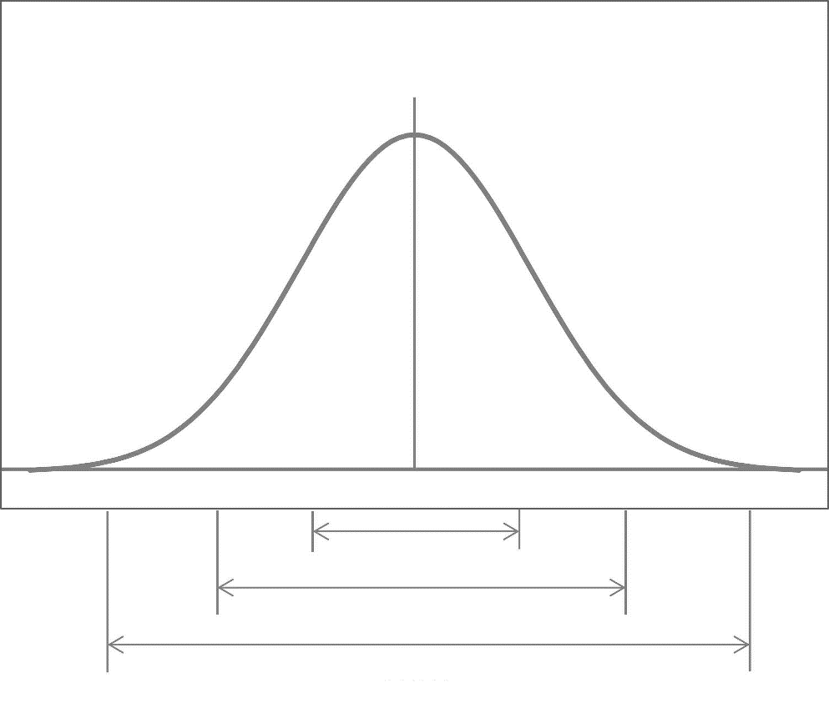
$μ-3σ$ $μ-2σ$ $μ-σ$ $μ$ $μ-σ$ $μ-2σ$ $μ-3σ$
$$68\%$$
$$95\%$$
$$99.7\%$$
Normal Curve
graphical representation of a

normal distribution is sometimes

called a _______________________________

because of its flared shape. In a

normal distribution, the

__________________________,

__________________________,

and __________________________ are all

the same.

$$s$$
Properties of a Normal Distribution:
- A normal curve is bell shaped.
- The curve is symmetric with respect to its mean, where the curve reaches its highest point.
- The mean, median, and mode of the distribution are the same.
- The total area under the curve is 1.
- Roughly 68% of the data values are within 1 standard deviation from the mean, 95% of the data values are within 2 standard deviations from the mean, and 99.7% of the data values are within 3 standard deviations of the mean.

- The heights of male adults are normally distributed with mean 1.7m and standard deviation 0.2m. In a population of 400 male adults, how many would you expect to have a height between 1.4m and 1.6m?

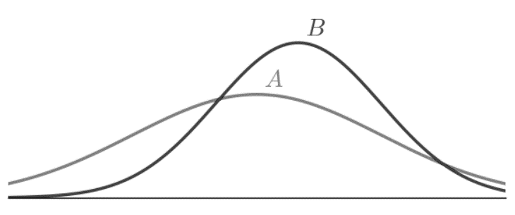
- Given the plot of normal distributions $A$ and $B$ below, which of the following statements is/are true? Select all correct answers.
(a) $A$ has the larger mean.
(b) $B$ has the larger mean.
(c) The means of $A$ and $B$ are equal.
(d) $A$ has the larger standard deviation.
(e) $B$ has the larger standard deviation.
(f) The standard deviations of $A$
and $B$ are the same.

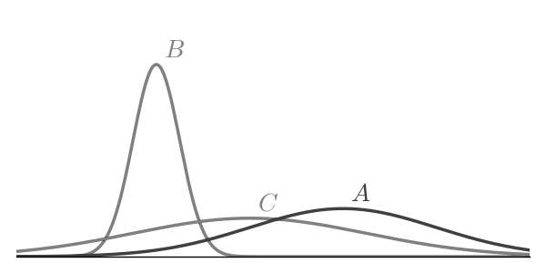
- The graph below shows the graphs of several normal distributions, labeled $A$, $B$, and $C$, on the same axis. Determine which normal distribution has the smallest standard deviation.

A _______________________ indicates how many standard deviations an element is from the mean.

$z$-Score Formula: $z=\frac{x-μ}{σ}$

Use the $z$-score formula above to answer the following.

- Thomas averages 18 points per game (his points represent a normal distribution). If he scored 12 points during his last game and this value has a $z$-score of $-3$, what is the standard deviation?
- A $z$-score of 2 indicates that the $x$-value of 14 is two standard deviations to the right of the mean. If the standard deviation is 1.5, what is the mean?
- Marc’s points per game of bowling are normally distributed with a standard deviation of 13 points. If Marc scores 231 points, and the $z$-score of this value is 4, then what is his mean points in a game?
- Two runners, Howard and Lisa, want to find out who has the faster time when compared to each of their teams. Howard has a time of 17 minutes 20 seconds, and his team has a mean time of 18 minutes 15 seconds and a standard deviation of 45 seconds. Lisa has a time of 16 minutes 30 seconds, and her team has a mean of 18 minutes 45 seconds and a standard deviation of 30 seconds. Who has the faster time when compared to each of their teams?

Notes:

Name: Date:

Given that a set of exams is normally distributed with a mean of 80 and a standard deviation of 5, answer the following questions.

- What percent of the population scored below 70?
- What percent of the population scored between 75 and 85?
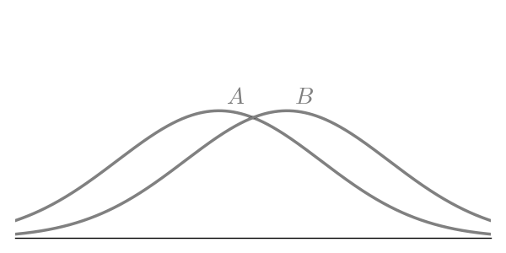
- What percent of the population scored below 95?
- Given the plot of normal distributions $A$ and $B$ below, which of the following statements is/are true? Select all correct answers.
(a) $A$ has the larger mean.
(b) $B$ has the larger mean.
(c) The means of $A$ and $B$ are equal.
(d) $A$ has the larger standard deviation.
(e) $B$ has the larger standard
deviation.
(f) The standard deviations
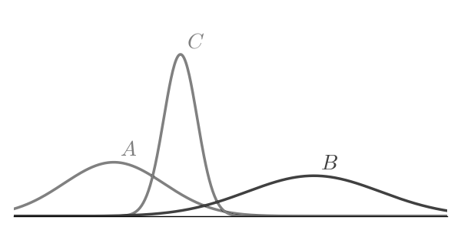
of $A$ and $B$ are the same.

- The graph below shows the graphs of several
normal distributions, labeled $A$, $B$, and $C$, on
the same axis. Determine which normal
distribution has the smallest mean.

Use the following information to find the missing value.

- If the mean is 65, the raw score is 98, and the standard deviation is 4, what is the raw $z$-score?
- If the mean is 40, the $z$-score is 2.3, and the standard deviation is 10, what is the raw score?
- If the mean is 38, the raw score is 29, and the standard deviation is 5, what is the raw $z$-score?

- Greg’s points per basketball game are normally distributed with a standard deviation of 4 points. If Greg scores 43 points, and the $z$-score of this value is 4, then what is his mean points in a game?
- Two pitchers, Thomas and Peter, want to find out who has the faster pitch when compared to each of their teams. Thomas has a speed of 85 miles per hour, and his team has a mean speed of 90 miles per hour and a standard deviation of 3.5 miles per hour. Peter has a speed of 84 miles per hour, and his team has a mean of 91 miles per hour and a standard deviation of 3 miles per hour. Who has the faster pitch when compared to each of their teams?

Review Materials

Formula Sheet

Linear Functions & Relations | Slope-intercept form: $y=mx+b$  Standard form: $Ax+By=C$  Slope formula: $m=\frac{y_{2}-y_{1}}{x_{2}-x_{1}}$
$z$-Score Formula | $$z=\frac{x-μ}{σ}$$
Direct Variation Applications | $$\frac{y_{1}}{x_{1}}=\frac{y_{2}}{x_{2}} or y=kx where k is a constant$$
Quadratic Functions | General form: $y=ax^{2}+bx+c, a≠0$  Standard form: $y=a{\left(x-h\right)}^{2}+k, a≠0$  Vertex: $\left(-\frac{b}{2a}, c-\frac{b^{2}}{4a}\right)=\left(-\frac{b}{2a}, substitute x=-\frac{b}{2a} back into equation\right)$
The Quadratic Formula | The solutions to the equation $ax^{2}+bx+c=0$, $a≠0$, are given by  $$x=\frac{-b±\sqrt{b^{2}-4ac}}{2a}.$$
Inverse Variation Applications | $$x_{1}y_{1}=x_{2}y_{2} or y=\frac{k}{x} where k is a constant$$
Compound Interest Formulas | $$\begin{matrix}\begin{matrix}\begin{matrix}A=accumulated amount \\ r=annual interest rate \\ t=time (years)\end{matrix} & & \begin{matrix}P=principle \\ n=compound periods per year \\ \end{matrix}\end{matrix} \\ \begin{matrix}A=P{\left(1+\frac{r}{n}\right)}^{nt} & & A=Pe^{rt}\end{matrix}\end{matrix}$$
Statistics Formulas | $$\begin{matrix}s=\sqrt{\frac{\sum{{\left(x-\overline{x}\right)}^{2}}}{n-1}} & & σ=\sqrt{\frac{\sum{{\left(x-μ\right)}^{2}}}{N}}\end{matrix}$$
Logic and Counting | $$\begin{matrix}\begin{matrix}Number of permutations of \\ n things taken r at a time: \\ {}_{n}^{ }{P_{r}^{ }}=\frac{n!}{\left(n-r\right)!}\end{matrix} \\ \\ \begin{matrix}Number of combinations of \\ n things taken r at a time: \\ {}_{n}^{ }{C_{r}^{ }}=\frac{n!}{\left(n-r\right)!r!}\end{matrix}\end{matrix}$$
Valid Arguments | $$\begin{matrix}\begin{matrix}\underline{Law of Detachment} \\ \begin{matrix}\underline{\begin{matrix}p→q \\ p\end{matrix}} \\ ∴ q\end{matrix}\end{matrix} & \begin{matrix}\underline{\begin{matrix}Law of \\ Contraposition\end{matrix}} \\ \begin{matrix}\underline{\begin{matrix}p→q \\ \sim q\end{matrix}} \\ ∴\sim p\end{matrix}\end{matrix} & \begin{matrix}\underline{Law of Syllogism} \\ \begin{matrix}\underline{\begin{matrix}p→q \\ q→r\end{matrix}} \\ ∴ p→r\end{matrix}\end{matrix} & \begin{matrix}\underline{\begin{matrix}Disjunctive \\ Syllogism\end{matrix}} \\ \begin{matrix}\underline{\begin{matrix}p∨q \\ \sim p\end{matrix}} \\ ∴ q\end{matrix}\end{matrix}\end{matrix}$$
Invalid Arguments | $$\begin{matrix}\begin{matrix}\underline{Fallacy of the Converse} \\ \begin{matrix}\underline{\begin{matrix}p→q \\ q\end{matrix}} \\ ∴ p\end{matrix}\end{matrix} & \begin{matrix}\underline{Fallacy of the Inverse} \\ \begin{matrix}\underline{\begin{matrix}p→q \\ \sim p\end{matrix}} \\ ∴\sim q\end{matrix}\end{matrix}\end{matrix}$$

$$p$$ | $$q$$ | $$p∨q$$ | $$p∧q$$ | $$p→q$$ | $$p↔q$$
T | T | T | T | T | T
T | F | T | F | F | F
F | T | T | F | T | F
F | F | F | F | T | T

Unit I Review

  - List George Poly’s four steps to problem solving. Use complete sentences.
  - What type of reasoning is used in the following example? Deductive or Inductive?
Latasha noticed that on every true/false quiz so far in biology, her instructor has given twice as many false questions as true questions. On the next quiz, if she is not sure of an answer, she will guess false.
  - Use inductive reasoning to predict the next three terms in each of the following sequences.
    - 2, 8, 14, 20, 26, _____, _____, _____
    - 5, 15, 45, 135, _____, _____, _____
    - 1, $-4$, 16, $-64$, 256, _____, _____, _____
  - Refer to the pie chart. The number of people in the household
(1, 2, 3, 4, 5, and 6+) and the associated percentages are given. In a
recent census, the state of Georgia had a population of approx-
imately 7,500,000 households. Approximate how many households
had four or fewer members.
  - Find the $x$- and $y$-intercepts of the graphs given by each of the following equations.
    - $2x-4y=48$
    - $-3x+9y=-81$
  - Grace Baptist Church held its annual spaghetti supper and fed a total of 200 people. They charged $7 for adults and $4 for children. If they took in a total of $1,160, how many adults attended the supper?
  - If $y$ varies directly with $x$, and $y=45$ when $x=7.5$, find $y$ when $x=13$.
  - Kanya is considering two satellite TV systems. Global Communications charges $150 for installation and $40 per month. World Communications charges $600 for installation and $20 per month. Find the break-even point (the point where getting either system would cost the same).
  - Find an equation of the line that passes through the points $\left(4, 3\right)$ and $\left(8, -5\right)$.
  - The formula $A=Pe^{rt}$ gives the accumulated amount, $A$, of an investment when $P$ is the initial investment or principle, $r$ is the annual interest rate, and $t$ is the time in years. We are assuming continuous compounding and no deposits or withdrawals. For an initial investment of $5,000, compounded continuously at 4.25% annual interest, find, to the nearest tenth of a year, when the investment grows to $25,000 in value.
  - The chart below shows Blue Cross spending in Georgia, in billions of dollars, for the years 2000 (let this be year 0), 2002, 2004, 2006, and 2008.
Year | 0 | 2 | 4 | 6 | 8
Spending | 2.7 | 4.8 | 5.9 | 7.3 | 9.5

  - Use your TI graphing calculator to find the
regression equation for the line of best fit for the
relationship between time and money spent.
  - Use this regression equation to predict the Blue Cross spending in Georgia for 2020 and round to the nearest million.

  - Solve the system $\left\{\begin{matrix}-3x+y=-2 \\ x+y=-6\end{matrix}\right.$.
  - Find the $x$-intercept(s), if any, of the graph of the quadratic equation $y=3x^{2}-5x+2$.
  - The formula for the accumulated amount of an investment is $A=P{\left(1+\frac{r}{n}\right)}^{nt}$. If $5,000 is to be invested in an account with monthly compounding at 4.85% interest, what will the accumulated amount be in 2 years? Round to the nearest cent.
  - An engineer collects data showing the speed $s$ of a given car model (in miles per hour) and its average fuel efficiency $M$ (in miles per
gallon). Find the equation of the quadratic
regression curve of best fit. Round each
coefficient to four decimal places.
Speed | 30 | 35 | 40 | 45 | 50 | 55 | 60
Fuel Efficiency | 20 | 22 | 28 | 35 | 40 | 25 | 20

  - Which of the following points does not lie on the graph of $y=7^{x}$?
    - $\left(-3,\frac{1}{343}\right)$ b) $\left(-1,\frac{1}{7}\right)$ c) $\left(0, 7\right)$ d) $\left(3, 343\right)$
  - The height in feet, $h$, of a projectile can be approximated over time in seconds, $t$, using the formula $h=-16t^{2}+102t$.
    - Find the maximum height of the projectile. Round to the nearest tenth of a foot.
    - Approximate the duration of the object’s flight to the nearest tenth of a second.

Answer to Unit I Review

- Step 1 – Understand the problem.
Step 2 – Devise a plan.
Step 3 – Carry out your plan.
Step 4 – Check your answer.
- inductive
- a) 32, 38, 44
b) 405, 1215, 3645
c) $-1024$, 4096, $-16384$
- 6,600,000 households
- a) $\left(24, 0\right)$, $\left(0, -12\right)$
b) $\left(27, 0\right)$, $\left(0, -9\right)$
- 120 adults
- 78
- 22.5 months
- $y=-2x+11$
- 37.9 years
- a) $y=0.805x+2.82$
b) $18.92 billion
- $\left(-1, -5\right)$
- $\left(1, 0\right)$, $\left(\frac{2}{3},0\right)$
- $5,508.22
- $M=-0.0686s^{2}+6.3s-110.6429$
- C
- a) 162.6 ft
b) 6.4 seconds

Unit II Review

- Decide whether the sets $\left\{1, 2, 3, 4\right\}$ and $\left\{a, b, d, e\right\}$ are equal. Justify your answer.
- Use an alternative method to express each set.
a) $\left\{2, 4, 6, 8, …, 20\right\}$ b) $\{x :x is a day of the week that has the letter u in it\}$
- Find the cardinal number of each set.
a) $A=\left\{1, 3, 5, 7, …, 11\right\}$ b) $C=\left\{x :x is a day in February in a leap year\right\}$
- Decide whether each statement is true or false. Justify your answer.
  - $Florida∈\{x :x is a state north of Pennsylvania\}$
  - $\left\{rose, daisy, sunflower, orchid\right\}⊂\left\{rose, orchid, sunflower, daisy, carnation\right\}$
- Decide whether the sets $\{x :x is a letter in the word song\}$ and
$\left\{x :x is a letter in the word songs\right\}$ are equivalent. Justify
your answer.
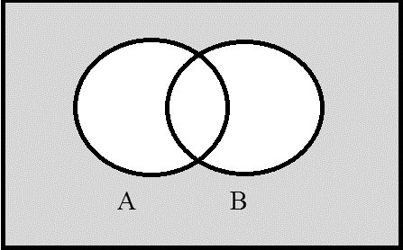
- Let $U=\left\{0, 1, 2, 3, 4, 5, 6, 7, 8, 9\right\}$, $A=\left\{1, 6, 7, 8\right\}$,
$B=\left\{1, 3, 4, 5, 6\right\}$, and $C=\left\{1, 3, 8, 9\right\}$. Find the following sets.
a) $A∩B'$ b) $B-C$ c) $\left(B^{'}∩C\right)∩A$
- Describe the shaded region:
- Represent each set using a Venn diagram.
a) $B'$ b) $\left(A∪B\right)-C$
U A B

8 3 11

2 6 10

12 4 C
- How many subsets are there of the set $\left\{a, b, ∃, t, i, e, 1\right\}$?
- The following are the results of a survey of young
adults regarding their exercise programs.
  - What is $n\left(\left(A∪B\right)-C\right)$?
  - What is $n\left(\left(A∪C\right)'\right)$?
- Which of the following are statements?
  - The Walking Dead is a popular TV show about
undertakers.
  - Will you still love me when I’m 64?
- Consider the statements:
$g$ : Global warming will increase. $c$ : Congress will pass new energy legislation.
Write the following statement in symbolic form: Global warming will increase or Congress will not pass new energy legislation.
- Consider the following statements:
$t$ : The radial tires are included. $w$ : The seats have warmers. $s$ : The sunroof is extra.
Write the following statement in a single complete sentence: $\left(t∨\left(\sim s\right)\right)→w$.
- Negate the statement “All married couples must file a joint tax return.” Select one.
  - No married couples must file the joint tax return.
  - Some married couples must file the joint tax return.
  - Some married couples don’t have to file the joint tax return.
  - All married couples must file the joint tax return.
- Let $p$ represent some true statement, $q$ some false statement, and $r$ some true statement. Determine the truth value of the following statements.
a) $q∨\left(\left(\sim p\right)∧\left(\sim r\right)\right)$ b) $\left(\sim \left(p∨q\right)\right)→\left(\sim p\right)$ c) $r→\left(\left(\sim p\right)∧q\right)$
- Write the other forms of the conditional for the statement “If it rains, then it pours.”
a) Converse b) Contrapositive c) Inverse
- Identify the form of each argument.
  - Either my MP3 player is defective or this download is corrupt.
My player is not defective.
Therefore, this download is corrupt.
  - If Robb marries a Frey then he will win the war.
Robb didn’t win the war.
Therefore, he didn’t marry a Frey.
  - If Phillippe joins the basketball team, then he will not be able to work part time.
Phillippe did not join the basketball team.
Therefore, he is able to work part time.

Answers to Unit II Review

- Not equal
- a) $\{x :x is an even integer between 2 and 20, inclusive\}$
b) $\left\{Tuesday, Thursday, Saturday, Sunday\right\}$
- a) 6
b) 29
- a) False
b) True
- Equivalent
- a) $\left\{7, 8\right\}$
b) $\left\{4, 5, 6\right\}$
c) $\left\{8\right\}$
- $\left(A∪B\right)'$
- a)
b)
$$B$$
$$A$$
$$C$$
$$B$$
- 128
- a) 22
b) 23
- a) yes
b) no
- $g∨\left(\sim c\right)$
- If tires are included or sunroof is not extra, then the seats are warmed.
- (C)
- a) False
b) True
c) False
- a) If it pours, then it rains.
b) If it does not pour, then it does not rain.
c) If it does not rain, then it does not pour.
- a) disjunctive syllogism, valid
b) law of contraposition, valid
c) fallacy of inverse, invalid

Unit III Review

- List all the ways you can select two members from the set $\left\{O, P, Q, R\right\}$ if the order you select the members is not important and repetition is allowed.
- The special at TGIF’s consists of a drink, appetizer, entrée, and dessert. If there are five drinks, eight appetizers, twelve entrées, and four desserts, how many different meals are possible?
- The Equestrian Club has 12 members. If the club wants to select a president, vice president, rodeo clown, and a secretary, how many ways can this be done?
- The research director at NASA must choose five experiments for the next space shuttle. If 8 experiments are proposed, in how many ways can this decision be made if order does matter?
- If automobile license plates consist of four letters followed by two digits, how many different possible license plates are possible if letters and number may be repeated.
- How many ways can a 4-card poker hand consist of all face cards?
- Describe each event as a set of outcomes.
  - When four coins are flipped, we obtain exactly two tails.
  - When two dice are rolled, we obtain a sum of 2 or 9 on the dice.
- If a single card is drawn from a standard 52-card deck, find the probability that we select:
  - A black nine
  - A face card or a club
  - A nine or an ace
- If a gambler rolls two die and gets a sum of four, she wins $50, and if she gets a sum of ten, she wins $90. The cost to play this game is $10. What is the expected value of this game? Round to the nearest hundredth.
$$A$$
$$B$$
$$C$$
$$B$$
- Spin the following spinner.
  - What is the probability of landing in a region marked $A$?
  - Spin the spinner 800 times. How many times can you expect to land
in a region marked $A$?
- A coin is tossed six times. Find the probability of getting exactly four
heads. Round to four decimal places.
- If a gambler rolls two dice and gets a sum of nine, he wins $50, and if he
gets a sum of eight, he wins $20. The cost to play this game is $15. What is the expected value of this game? Round to the nearest hundredth.
- Friendly City College needs to raise money to buy several computers. They decide to conduct a raffle. A single cash prize of $6000 is to be awarded. If they sell 3000 tickets at $5 each, find the expected gain if you buy one ticket. There is only one winning ticket. Round to the nearest hundredth.
- Using a standard 52-card deck, find the conditional probability of drawing a face card given that it is a heart, $p\left(face | heart\right)$.
- If a team has a 0.45 probability of winning, find the odds against them winning.

Answers to Unit III Review

- $\left\{OO, OP, OQ, OR, PP, PQ, PR, QQ, QR, RR\right\}$
- 1920
- ${}_{12}^{ }{P_{4}}=11,880$
- ${}_{8}^{ }{P_{5}}=6,720$
- $45,697,600$
- ${}_{12}^{ }{C_{4}}=495$
- a) $\left\{HHTT, HTHT, THHT, HTTH, THTH, TTHH\right\}$
b) $\left\{\left(1,1\right), \left(3, 6\right), \left(4, 5\right), \left(5, 4\right), \left(6, 3\right)\right\}$
- a) $\frac{1}{26}≈0.038$
b) $\frac{11}{26}≈0.423$
c) $\frac{2}{13}≈0.154$
- $\$1.67$
- a) $12.5\%=0.125$
b) $100 times$
- $p\left(four H\right)=\frac{15}{64}≈0.234$
- $-\$6.67$
- $-\$3.00$
- $p\left(face | heart\right)=\frac{3}{13}≈0.231$
- $odds against winning=\frac{11}{9}$

Unit IV Review

- Construct a frequency table and a relative frequency table for the following data set, which gives the t-shirt sizes recently purchased at a local sporting goods store:
S, XL, XL, S, S, M, XL, XL, L, XXL, M, XXL, S, L, L, XL, L, XL, XL, L
- The lists below represent the ages of actors (M) and actresses (F) at the time they won an Academy Award from 1980 to 2010.
M: 67, 45, 52, 33, 42, 54, 45, 18, 46, 20, 40, 52, 33, 25, 31, 47, 37, 65, 39, 51, 45, 36
F: 68, 43, 28, 37, 32, 45, 80, 39, 34, 79, 55, 49, 29, 25, 58, 35, 31, 38, 61, 20, 41, 26
Find the 5-number summary for your gender. Draw a box-and-whisker plot for the data set.
- Here is a sample of golf scores for Gary Putter, Jr. so far this year:
110, 94, 98, 82, 114, 120, 119, 110, 103
a) Find the mean. Round to the nearest tenth.
b) Find the median.
c) Find the standard deviation. Round to the nearest tenth.
- A set of 300 test grades has a normal distribution where the mean was 75 with a standard deviation of 2. How many students scored between 73 and 75?
- If a distribution has a mean of 33 and a standard deviation of 4, what is the $z$-score for a raw score of 44?
- If a distribution has a mean of 44 and a standard deviation of 4, what is the raw score associated with a $z$-score of $-1.30$?
- Draw a box-and-whisker plot for the following data set: 10, 16, 25, 40, 76, 41, 15
$$x$$ | frequency
0 | 8
1 | 8
2 | 12
3 | 12
4 | 10
5 | 8
6 | 9
7 | 8
8 | 12
9 | 13

- The frequency table to the right gives the frequency of each number
occurring in the first 100 digits of the number pi $\left(π\right)$. Find the
variance and standard deviation of this data set.

Answers to Unit IV Review

$$x$$ | frequency
S | 4
M | 2
L | 5
XL | 7
XXL | 2

- M : 18, 33, 43.5, 51, 67
F : 20, 31, 38.5, 55, 80
- a) $\overline{x}=105.6$
b) 110
c) $s=12.5$
- 102.45 students
- 2.75
- 38.8
- $variance=8.51\overline{10}$, $standard deviation≈2.9174$

Final Exam Review

- At T.G.I. Friday’s, there are 8 appetizers, 22 entrees, and 10 desserts on the menu. How many different meals can you choose if you select one appetizer, one entrée, and one dessert?
- Hector is building a home theater system consisting of a tuner, an optical disk player, speakers, and a high definition TV. If he can select from three tuners, six speakers, three optical disk players, and five TVs, in how many ways can he configure his system?
- Use inductive reasoning to predict the next three terms in the following sequences:
  - 22, 19, 16, 13, _____, _____, _____
  - 1, 3, 9, 27, _____, _____, _____
  - 2, 3, 5, 8, 13, _____, _____, _____
- Let $U=\left\{1, 2, 3, 4, 5, 6, 7, 8, 9, 10\right\}$, $A=\left\{1, 4, 7\right\}$, $B=\left\{1, 2, 3, 4, 5\right\}$, and $C=\left\{1, 2, 4, 8\right\}$. Find the following sets:
  - $B-A$
  - $A'∩\left(B'∪C\right)$
- How many subsets are there of the set $\left\{a, b, c\right\}$?
- How many subsets are there of the set $\left\{∆, ∞, ∝, ∀, ⊞\right\}$?
- Let $p$ represent some true statement, $q$ some false statement, and $r$ some false statement. Determine the truth value of the following statements:
  - $\left(p∧\left(\sim q\right)\right)∨\left(\sim r\right)$
  - $\left(q∧\left(\sim r\right)\right)→p$
- Write in words the converse and the inverse for the statement: “If it glitters, then it is gold.”
- Identify the form of the argument.
  - I’ll major in music or art history.
I am not majoring in music.
Therefore, I am majoring in art history.
  - If Felicia enjoys spicy food, then she will enjoy this Cajun chicken meal.
Felicia does not enjoy this Cajun chicken meal.
Therefore, Felicia does not enjoy spicy food.
- Negate the following statement: “Some cats are jerks.”
- Negate the following statement: “All men eat.”
- Refer to the pie chart. The number of people in the
household (1, 2, 3, 4, 5, and 6 or more) and the
associated percentages are given. In a recent
census, the state of Georgia had a population of
approximately 5,120,000 households. Approximate
how many households had 4 or less members.

- Here is a sample of golf scores for Gary Putter, Jr.
so far this year: 89, 90, 87, 95, 86, 81, 109, 105.
  - Find the mean.
  - Find the median.
  - Find the standard deviation.
  - Find the min, $Q_{1}$, $Q_{2}$, $Q_{3}$, and max. Make a box plot.
- Here is a sample of test scores for Gary Putter: 70, 50, 80, 12, 90, 50, 100, 95, 77.
  - Find the mean.
  - Find the median.
  - Find the standard deviation.
  - Find the min, $Q_{1}$, $Q_{2}$, $Q_{3}$, and max. Make a box plot.
- If a distribution has a mean of 78 and a standard deviation of 5, to what $z$-score does a raw score of 87 correspond?
- Find the $x$- and $y$-intercepts of:
  - $2x+3y=6$
  - $-4x+8y=11$
- a) Find a linear equation whose graph passes through $\left(3, 5\right)$ and $\left(4, -2\right)$.
- Find the linear equation whose graph passes through $\left(5, 6\right)$ and has a slope of 3.
- Find a linear equation whose graph passes through $\left(-4, 2\right)$ and $\left(2, 5\right)$.
- a) Use the data given to find the line of best.
b) State the quadratic equation of best fit.
$$x$$ | 5 | 6 | 7 | 8 | 9 | 10 | 11 | 12 | 13
$$y$$ | 4 | $$-2$$ | 8 | 7 | 10 | 11 | $$-2$$ | 5 | 7

- Kenya is considering two satellite TV systems. Global Communications charges $240 for installation and $35 per month. World Communications charges $350 for installation and $28 per month. After how many months will World Communications be the better buy?
- Construct an Euler diagram for the following syllogism and state whether it’s valid or invalid.
All humans are mortal.
Jerry is a human.
Therefore, Jerry is not mortal.
- Solve the quadratic equations:
  - $-2x^{2}+x+3=0$
  - $x^{2}+2x-3=0$
- Solve the system of linear equations by elimination:
  - $\left\{\begin{matrix}2x-y=10 \\ -x+2y=-5\end{matrix}\right.$
  - $\left\{\begin{matrix}3x-9y=6 \\ -x+3y=-2\end{matrix}\right.$

- Find the vertex of the parabola given by the following equations:
  - $y=2x^{2}+8x+4$
  - $y=4x^{2}-8x+4$
- Which of the following points does NOT lie on the graph of $y=7^{x}$?
  - $\left(2, 49\right)$
  - $\left(1, 7\right)$
  - $\left(-1, 7\right)$
  - $\left(3, 343\right)$
- Which of the following points does NOT lie on the graph of $y={11}^{x}$?
  - $\left(1, 11\right)$
  - $\left(0, 1\right)$
  - $\left(2, 22\right)$
  - $\left(3, 1331\right)$
- The formula for the accumulated amount of an investment is given by $A=P{\left(1+\frac{r}{n}\right)}^{nt}$, where $P$ is the principle, $r$ is the annual interest rate, $t$ is time (in years), and $n$ is the number of compounding periods per year. If $2600 is to be invested with quarterly compounding at 5.2% annual interest rate, what will the accumulated amount be in 5 years? Round your solution to the nearest hundredth.
- The formula $A=Pe^{rt}$ gives the accumulated amount, $A$, of an investment when $P$ is the initial investment, $r$ is the annual interest rate, and $t$ is the time (in years). We are assuming continuous compounding and no deposits or withdrawals. For an initial investment of $4000, compounded continuously at 3.2% annual interest, find, to the nearest tenth of a year, when this investment will grow to $7000 in value.
- a) If a gambler rolls two dice and gets a sum of 9, he wins $2, and if he gets a sum of two, he
wins $10. The cost to play this game is $1. What is the expected value of this game?
Round to the nearest hundredth.
b) If a gambler rolls two dice and gets a sum of 5, he wins $15, and if he gets a sum of three,
he wins $40. The cost to play this game is $10. What is the expected value of this game?
Round to the nearest hundredth.
- a) The rock climbing club has 20 members. If the club wants to select a president, vice
president, secretary, historian, and treasurer, in how many ways can this be done?
b) The research director at NASA must choose four experiments for the next space shuttle.
If 12 experiments are proposed, in how many ways can this decision be made if order
doesn’t matter?

- If a single card is drawn from a standard 52-card deck, find the probability that we select
  - a red non-face card.
  - a heart or a jack.

- If a coin is tossed four times, what is the probability of
  - getting exactly 4 heads.
  - getting exactly 3 tails.

- If automobile license plates consist of two letters followed by six digits, how many different possible license plates are possible if letters and numbers may be repeated?
- If automobile license plates consist of one letter followed by five digits, how many different possible license plates are possible if letters and numbers may be repeated?

- The height, in feet, of a projectile can be approximated over time $t$, in seconds, using the formula $h=-16t^{2}+150t$.
  - Find the maximum height of the projectile. Round to the nearest tenth of a foot.
b) Approximate the duration of the object’s flight to the nearest tenth of a second.

- The chart below shows Blue Cross spending in Georgia, in billions of dollars, for the year 2000 (let this be year 0), 2002, 2004, 2007, and 2009. Use your TI graphing calculator to find the regression equation for the line of best fit for the relationship between time and money spent. Use this regression equation to predict
the Blue Cross spending in Georgia for 2015 and
round to the nearest million.
Year | 0 | 2 | 4 | 7 | 9
Spending | 2.5 | 3.7 | 3.69 | 3.73 | 3.9

- John sold 200 tickets to a concert for $1375. If the price of a student ticket was $5 and the price of an adult ticket was $10, how many adult tickets did John sell?
- a) If $x$ varies directly as $r$, and $x=16$ when $r=4$, find $r$ when $x=25$.
b) If $x$ varies inversely as $y$, and $x=20$ when $y=4$, find $y$ when $x=25$.

- How many ways can a five-card poker hand consist of
  - black cards?
  - face cards?

- Construct an Euler Diagram for the following syllogism and state whether it is valid or invalid.
All dogs love bones.
Rex doesn’t love bones.
Therefore, Rex is not a dog.
- a) Find the conditional probability of drawing a king given a face card was drawn first:
$p\left(king | face\right)$.
b) Find the conditional probability of drawing a six given a spade was drawn first:
$p\left(6 | spade\right)$.
- Let $p$ be the statement “You eat breakfast,” $q$ be the statement “You need coffee,” and $r$ be the statement “You will pass the test.” Write the verbal translation of $\left(\left(\sim p\right)→q\right)∧\left(\sim r\right)$.

Answers

- 1760
- 270
- 10, 7, 4; 81, 243, 729; 21, 34, 55
- $\left\{2, 3, 5\right\}$; $\left\{2, 6, 8, 9, 10\right\}$
- 8
- 32
- true; true
- If it’s gold then it glitters; If it doesn’t glitter, then it’s not gold.
- Disjunctive syllogism; contrapositive
- No cats are jerks.
- Not all men eat.
- 4,556,800
- 92.75; 89.5; 9.69; $\left\{81, 86.5, 89.5, 100, 109\right\}$
- 69.33; 77; 27.92; $\left\{12, 50, 77, 92.5, 100\right\}$
- 1.8
- $\left(3, 0\right)$, $\left(0, 2\right)$; $\left(-\frac{11}{4},0\right)$, $\left(0,\frac{11}{8}\right)$
- $y=-7x+26$; $y=3x-9$
- $y=\frac{1}{2}x+4$
- $y=0.28x+2.78$; $y=-0.24x^{2}+4.67x-15.31$
- 15.7 month
- invalid
mortals
humans
J
- $\left(-1, 0\right)$, $\left(\frac{3}{2},0\right)$; $\left(-3, 0\right)$, $\left(1, 0\right)$
- $\left(5,0\right)$; infinite solutions
- $\left(-2, -4\right)$; $\left(1, 0\right)$
- C
- C
- $3366.37
- 17.5 years
- $-\$0.50$; $-\$6.11$
- 1,860,480; 495
- $\frac{5}{13}$; $\frac{4}{13}$
- $\frac{1}{16}$; $\frac{1}{4}$
- 676,000,000
- 2,600,000
- 351.6 ft; 9.4 seconds
- 4.750 billion or 4,750,000,000
- 125 students, 75 adults
- 6.25; 0.3125
- ${{}_{26}^{}C}_{5}^{}$; ${{}_{12}^{}C}_{5}^{}$
- valid
loves
bones
dogs
R
- $\frac{1}{4}$; $\frac{1}{13}$
- If you don’t eat breakfast, then you will need coffee and you will not pass the test.

