ACHE OER Workshop 2025 Handout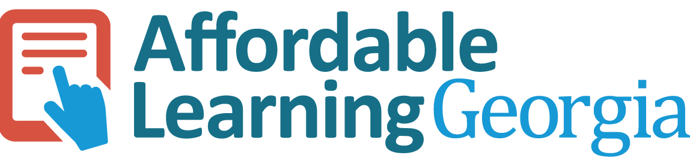

## Champion Network Model (Affordable Learning Georgia)

Affordable Learning Georgia (ALG) created a network of Champions to drive systemwide impact across 26 institutions. Champions act as local advocates, bridging faculty, libraries, instructional design, and administration. They raise awareness, support colleagues, and connect campuses with statewide initiatives.

## Champion Roles

1. **Faculty Champion** - Promotes OER adoption, peer advocacy, course redesigns.
2. **Library Champion** - Curates OER, manages copyright, provides access to resources.
3. **Design Champion** - Supports open pedagogy, instructional design, accessibility.

## Impact of Champions

* Supported grant proposals and compliance processes
* Conducted info sessions & OER awareness campaigns on campuses
* Helped institutions run OER Summits & events
* Contributed to statewide outcomes since 2014:
  + $198M in student savings/1.5 M students impacted/700+ affordable learning projects
* Growing adoption of OER and open pedagogy

## How ALG Supports Champions

|  |  |
| --- | --- |
| **Supports & resources provided**:   * Monthly meetings (updates, recognition, guest speakers, resource sharing). * Champion resources website & ALG newsletter. * New Champion Welcome Training * Data and reporting | **New support & resources planned**   * Champion toolkits. * Recognition through awards and ALG Awareness Week. * Communities of Practice |

## Resources

* [Affordable Learning Georgia](https://www.affordablelearninggeorgia.org/)
* [ALG Champion Welcome Training](https://sites.google.com/view/welcome-training/home)
* [SPARC Open Education resources](https://sparcopen.org/open-education/)
* [Open Education Network (OEN)](https://open.umn.edu/oen)
* [The OER Starter Kit for Program Managers](https://press.rebus.community/oerstarterkitpm/)