ACHE OER Workshop 2025 Outline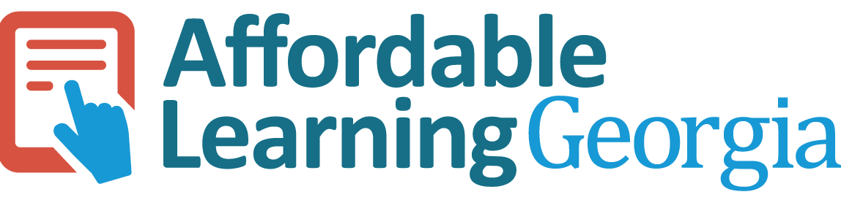

# Building a Statewide Advocacy Network for Affordable Learning: Lessons from Georgia

## **Timing Breakdown**

* Preliminaries: 5 min
* Why a Network (Origins): 10 min
* Champion Model: 15 min
* Champion Impact: 10 min
* Supporting Champions: 10 min
* Designing Networks: 15 min
* Wrap-Up: 5 min

### **1. Preliminaries (5 minutes)**

* **Welcome and Objectives**
  + Introduce yourself and the purpose of the workshop.
  + Outcomes:
    - Learn what ALG is and why the Champion network was created.
    - Understand the roles and impact of Champions.
    - Explore how ALG supports its network.
    - Draft strategies for building a network in your own state/system.
* Quick participant poll & group set up: Who’s in the room (faculty, librarian, ID, admin)?
  + Form small groups with representatives from each category as much as possible, explaining a few group activities are coming up.
  + Have each role stand together, then pull one or two representatives from each role to form groups until all have been assigned.

### **2. Why a Network? The Origin Story (10 minutes)**

* **Context that led to ALG**
  + Affordability + equity challenges in USG.
  + Early roots in instructional design (eCore, USG Share), library collaboration, and first open textbooks.
  + Launch of Affordable Learning Georgia in 2014 with state funding.
* **Why create Champions?**
  + System needed local advocates to bridge silos.
  + Mandates weren’t an option → had to build buy-in.
  + Faculty, librarians, and designers as trusted campus leaders.

### **3. The ALG Champion Model (15 minutes)**

* **Champion Roles**
  + Faculty Champion → peer-to-peer adoption and advocacy.
  + Library Champion → curation, copyright, access.
  + Design Champion → open pedagogy, instructional design.
* **How the network functions**
  + Liaisons between ALG and campuses.
  + Monthly system-wide meetings plus campus advocacy.
  + Advisory group providing feedback to ALG.
  + Serve as connectors across silos (faculty ↔ library ↔ CETLs)
  + Open-ended volunteer role – we provide guidance, but Champions decide what their involvement looks like.
* **Why this works**
  + Champions raise awareness in their own ways but with ALG brand and designation backing them.
  + They provide help with grants, deadlines, and business office processes when on ground help is needed.
  + They run campus info sessions and initiatives that expand ALG’s reach.
* Activity: What’s MISSING in AL? *Map who in your state/system could fill Champion roles for peer-to-peer adoptions and advocacy, curation, copyright, access, and open pedagogy and design.*

### **4. Champion Impact: Driving Systemwide Change (10 minutes)**

* Concrete examples:
  + Increased awareness and participation in grants.
  + Campus-hosted OER Summits and info sessions.
  + Improved faculty success in navigating proposals and compliance.
  + Expanded adoption of OER, contributing to >$150M in student savings since 2014.
* Anecdotal but clear: ALG’s systemwide growth is tied to Champions’ local advocacy.
* Reflection: *“What kinds of impact would you want your network to have in its first 3 years?”*

### **5. How ALG Supports Its Champions (10 minutes)**

* **Supports & resources provided**:
  + Monthly meetings (updates, recognition, guest speakers, resource sharing).
  + Roadshow campus visits.
  + Champion resources website + newsletter.
  + New Champion Welcome Training (history, grants, accessibility, pedagogy).
  + Data, reporting,
* **New support & resources planned**
  + Champion toolkits.
  + Recognition through awards and ALG Awareness Week.
  + Communities of Practice
* **Key takeaway:** Support makes the network sustainable → Champions volunteer, so all this matters to their ability to make an impact.
* Small-group brainstorm: *What support structures would your network need to thrive?*

### **6. Designing Your Own Network (15 minutes)**

* **Core components to defne**:
  + Mission/values (affordability, equity, student success).
  + Structure (formal vs. grassroots, state vs. system).
  + Roles (Champions, coordinators, advisory group).
  + Communication strategies (listservs, summits, newsletters).
* **Practical strategies to start**:
  + Begin with a pilot team.
  + Offer onboarding/training.
  + Provide incentives or small grants where possible.
  + Celebrate early wins (data + stories).
* Activity: Group design exercise – draft a 3-part plan for launching a network in your state/system.

### **7. Wrap-Up and Action Planning (5 minutes)**

* Individual reflection: *“What’s one concrete step I can take when I return to campus?”*
* Pair-and-share commitment.
* Provide resources (ALG site, SPARC, Open Education Network).
* Thank participants and invite ongoing collaboration.

*AI Disclosure: Workshop materials were created with assistance from ChatGPT.* Building a Statewide Advocacy Network for Affordable Learning: Lessons from Georgia © 2025 by Nakita Afaha is licensed under CC BY 4.0