Affordable Learning Georgia Textbook Transformation Grants
Final Report for Mini-Grants

General Information
Date: June 8, 2020
Grant Round: 13
Grant Number: M73
Institution Name(s): Georgia Gwinnett College
Team Members (Name, Title, Department, Institutions if different, and email address for each): Rabia Shahbaz, Assistant Professor, Mathematics, rshahbaz@ggc.edu; Janice Alves, Lecturer, Mathematics, jalves@ggc.edu
Project Lead: Rabia Shahbaz
Course Name(s) and Course Numbers: College Algebra Math 1111
Final Semester of Project: Spring 2020
If applicable to your project:
Average Number of Students Per Course Section: 25
Number of Course Sections Affected by Implementation of Revised Resources: 7
Total Number of Students Affected by Implementation of Revised Resources: 175

Project Narrative
Purpose: The purpose of this project was to develop instructional resources and explore a cost free homework platform for college algebra students. Algebra is a required math course for many undergraduate majors. Due to the high failure rate of students in algebra, it has been named as a gatekeeper to post-secondary success of students. The reasons behind students’ lack of success in college algebra are varied; nonetheless, their struggles are exacerbated by the lack of helpful class resources. We, the project team, had noted that the course material developed through earlier ALG grants is limited to videos, textbook pages, and notes that do not cover all topics of college algebra. Through this revision, we planned to do the following:
- Develop comprehensive and student-friendly guided notes,
- Develop problem-based in-class activities/worksheets, and
- Explore a free Online platform for homework assignments.

Currently-Existing Resource(s) to be Revised
URL: http://libguides.gcsu.edu/math1111
http://faculty.ung.edu/bkidane/CoACRN%206984&9422.html
On average, GGC offers 45-50 sections of college algebra per semester. With an average of 25 students in each section, the number of students taking college algebra each semester ranges between 1,125 and 1,250. In the regular college algebra sections, students are required to buy Pearson mymathlab access code (Book: Algebra and Trigonometry, 6th Edition, Author: Robert Blitzer), which costs $119.95. By using the free homework platform we made the course free of cost.
Timeline:

Spring 2019 In spring 2019 semester, we prepared instructional materials and guided notes for each of the required topics. These materials included the following:
- Guided notes, which include definitions, theorems and problems to show as examples;
- Problem based in-class assignments, which include applications pertaining to real-life situations; and
- Explored an open educational resource (OER) platform for Homework Assignments called Myopenmath. By adopting open textbooks, we developed a college algebra course on this platform for our students and added videos for each skill as an additional resource.

Summer 2019 In summer 2019, Dr. Shahbaz implemented the instructional resources in her class. She also piloted the Myopenmath platform for Homework. After analyzing the data and the surveys gathered modifications and adjustments were made for the fall 2019 semester.

Fall 2019 At the beginning of fall 2019, we shared these resources with all full time and part time faculty scheduled to teach college algebra. We implemented the instructional resources and Myopenmath. We collected student feedback during this semester and compared students’ grades with previous semesters’ data to determine the overall impact of the new curriculum.

Spring 2020 In January 2020, we presented this project at the Joint Math Meeting held in Denver, Colorado. We also presented our findings with our discipline, which consists of 47 full time and 34 part-time faculty members. Both team members were not assigned a college algebra course to teach. But, several part time and full time instructors implemented the instructional resources.

A course page was developed to share the instructional material developed though this grant with the math faculty at GGC. Below is the screenshot of the course page.
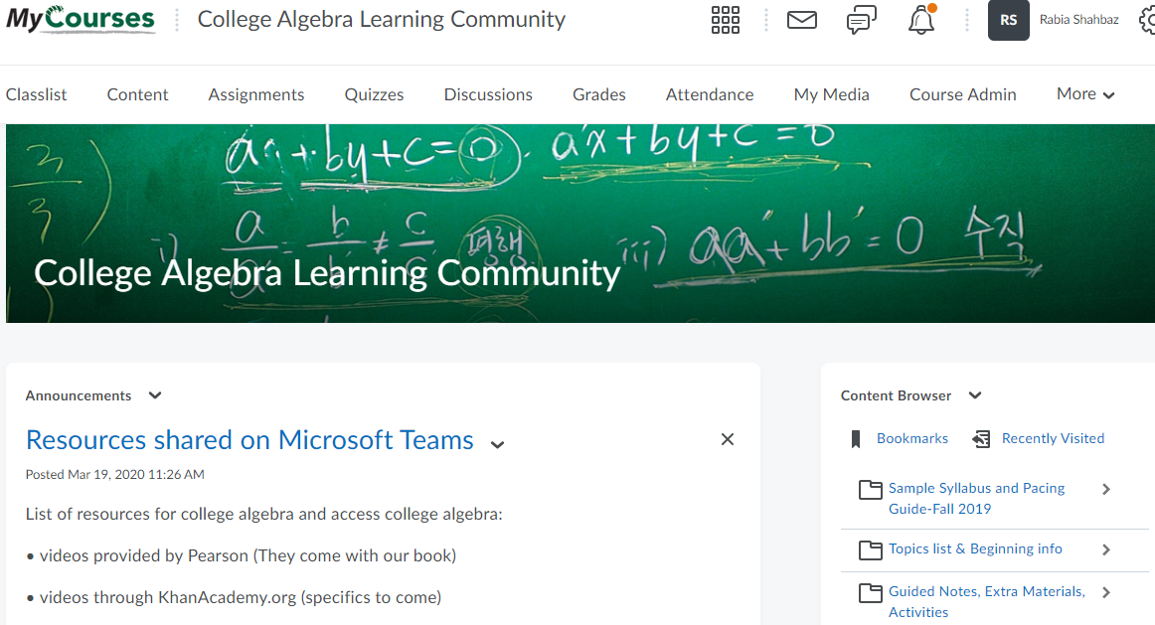

Student Feedback:
Below is some of the student feedback that was collected during fall 2019.
How did you use the guided notes? Check all that apply?
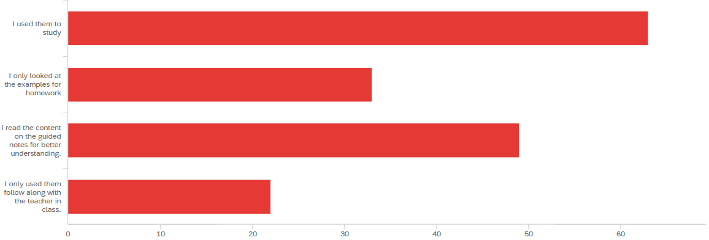
How did the guided notes help you in this course? Check all that apply?
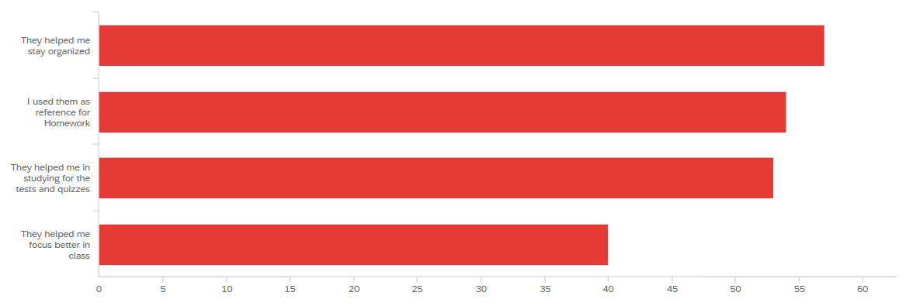

What features of MyopenMath did you find the most helpful? Check all that apply?
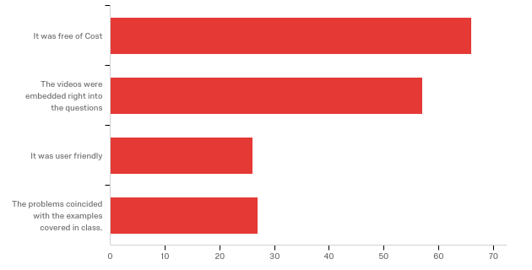

Impact of the Project:
1. The local impact of this project is that we have a quality instructional resources for college algebra course, which is one of the largest multi sectional course at our institute.
2. We have a course page in our learning management system (brightspace) dedicated for college algebra. All new part-time and full-time faculty who is scheduled to teach college algebra is added to this page and get an access to all the instructional material.
3. The successful implementation of myopenmath and the positive feedback from students has encouraged our discipline to explore other options of free educational resources to make other mathematics courses free of cost.
4. By adding these resources on open educational resource, we are providing everyone a global access to these resources.

Materials Description
The guided notes developed through this grant are uploaded at the Galileo open learning materials repository.

Materials Links

Future Plans
Our future plans include the following:
- We will continue to improve our guided notes as well as develop mini projects to improve students’ understanding of the algebra concepts.
- We are planning to write a journal article for publication to share our experience and student data with a larger audience
- We will continue to explore and add questions to our course in Myopenmath
- We will seek additional grants to make other math courses free of cost for our students.

