STEPS TO SUCCESS: A GUIDE TO EXCELLING IN COLLEGE AND BEYOND
Contributing Authors: Jennifer Hurst-Kennedy, Kenan Kurspahic, Rolando Marquez, Charlotte Reames, Catherine Thomas, and Cara Werner

This work is licensed under a Creative Commons Attribution-NonCommercial-ShareAlike 4.0 International License.

Chapter 1: Creating Community

Summary
After reading this chapter, you will be able to familiarize yourself with your college campus and the campus community. You will explore various aspects of your campus, such as interacting with other peers, professors, and staff across GGC. This chapter will also discuss the importance of communication and interactions amongst various groups in the campus community, as well as participating in campus activities and organizations.

Learning Objectives
After reading this chapter, you will be able to:
- Explain the benefits of social interactions with a variety of people in the college environment.
- List personal characteristics and skills that contribute to one’s ability to get along well with others.
- Improve your communication skills.
- Describe several benefits of participating in campus life by joining organized groups and participating in campus activities.
- List several ways you can learn about groups and activities on your own campus.

Recognize the Value of Social Interaction
Building good relationships is important for happiness and a successful college experience. College offers the opportunity to meet many people you would likely not meet otherwise in life. Make the most of this opportunity to gain a few benefits:
- A growing understanding of diverse other people, how they think, and what they feel that will serve you well throughout your life and in your future career
- A heightened sense of your own identity, especially as you interact with others with different personalities and from different backgrounds
- Emotional comfort from friendship with someone who understands you and with whom you can talk about your problems, joys, hopes, and fears
- An opportunity to grow with wider intellectual and emotional horizons

Humans are social creatures—it’s simply in our nature. We continually interact with other students and instructors, and we can learn a great deal from these interactions that heighten the learning process. This frequent interaction with others forms a state of interdependence. College students depend on their instructors, but just as importantly, they depend on other students in many ways.

Communication Skills
Communication is at the core of almost all social interactions, including those involved in friendships and relationships with your instructors. Communication with others has a huge effect on our lives, what we think and feel, and what and how we learn. Communication is, many would say, what makes us human.
Oral communication involves not only speech and listening, of course, but also nonverbal communication: facial expressions, tone of voice, and many other body language signals that affect the messages sent and received. Many experts think that people pay more attention, often unconsciously, to how people say something than to what they are saying. When the nonverbal message is inconsistent with the verbal (spoken) message, miscommunication may occur, just as when the verbal message itself is unclear because of poorly chosen words or vague explanations.

Activity 1: Practice Effective Communication
- List three or four guidelines for interacting successfully with others.
- You are talking after class to a classmate you’d like to be friends with, but you’re distracted by a test for which you must study. If you’re not careful, what nonverbal communication signals might you accidentally send that could make the other person feel you are not friendly? Describe two or three nonverbal signals that could give the wrong impression.
- What are the best things to say when you’re actively engaged in listening to another?
- For each of the following statements about effective communication, circle T for true or F for false.
  - Avoid eye contact until you’ve gotten to know the person well enough to be sure they will not misinterpret your interest.
  - Using the same slang or accent as other people will show them you respect them as they are.
  - Communicating your ideas with honesty and confidence is usually more effective than just agreeing with what others are saying.
  - Communicating with people online is seldom as effective as calling them on the telephone or seeing them in person.
  - It’s usually best to accept spontaneous opportunities for social interaction, because you’ll always have time later for your studies.
- You are upset because your roommate (or a family member) always seems to have several friends over just when you need to study most. Write in the space below what you might say to this person to explain the problem, using “I statements” rather than “you statements.”
- If another person is acting very emotional and is harassing you, what should you not do at that moment?

Campus Groups
The college social experience also includes organized campus groups and activities. Participating in organized activities requires taking some initiative—you can’t be passive and expect these opportunities to come knocking on your door—but is worthwhile for fully enriching college interactions. The active pursuit of a stimulating life on campus offers many benefits:
- Organized groups and activities speed your transition into your new life. New students can be overwhelmed by their studies and new life, and they may be slow to build a support system. Rather than waiting for it to come along on its own, you can immediately begin broadening your social contacts and experiences by joining groups that share your interests.
- Organized groups and activities help you experience a much greater variety of social life than you might otherwise. New students often tend to interact more with other students their own age and with similar backgrounds—this is just natural. But if you simply go with the flow and don’t actively reach out, you are much less likely to meet and interact with others from the broader campus diversity: students who are older and have a perspective you may otherwise miss, upper-level students who have much to share from their years on campus, and students of diverse heritage or culture with whom you might otherwise be slow to interact.
- Organized groups and activities help you gain new skills, whether technical, physical, intellectual, or social. Such skills may find their way into your résumé when you next seek a job or an application for a scholarship or other future educational opportunity. Employers and others like to see well-rounded students with a range of proficiencies and experiences.

Participating in Groups and Activities
College campuses offer a wide range of clubs, organizations, and other activities open to all students. College administrators view this as a significant benefit and work to promote student involvement in such groups. When you made your decision to attend your college, you likely received printed materials or studied the college’s Web site and saw many opportunities. But you may have been so busy attending to academic matters that you haven’t thought of these groups since. It’s a good time now to check out the possibilities:
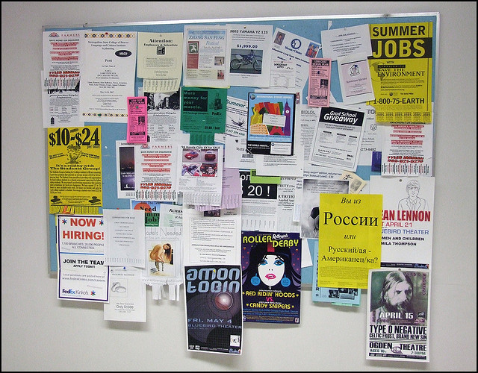
Figure 1.1. Check bulletin boards on campus to learn about cultural events.
Jeffrey Beall – College Campus Bulletin Board – CC BY-ND 2.0.

- Browse the college Web site, where you’re likely to find links to pages for student clubs and organizations.
- Watch for club fairs, open houses, and similar activities on campus. Especially near the beginning of the year, an activity fair may include tables set up by many groups to provide students with information. Talk with the representatives from any group in which you may be interested.
- Look for notices on bulletin boards around campus. Student groups really do want new students to join, so they usually try to post information where you can find it.
- Stop by the appropriate college office, such as the student affairs or student activities office or cultural center.
- If you are looking for a group with very specialized interests, check with the academic offices of departments where many students with that interest may be majoring.
- Consider a wide variety of types of organizations. Some are primarily social; some are political or activist; some are based on hobbies (photography, chess, equestrianism, bird watching, videogaming, computer programming); some involve the arts (instrumental music, choral singing, painting, poetry writing, drama club); some are forms of physical recreation (rock-climbing, ballroom dancing, archery, yoga, table tennis, tai chi, team sports); some focus on volunteerism (tutoring other students, community service projects, food drives); and others are related to academic or intellectual pursuits (nursing club, math club, chess club, engineering club, debate club, student literary magazine).

Activity 2: Explore Your Interests for College Clubs and Organizations

Checkpoint Exercise
Write things you may be interested in doing with others in each of these categories.
- Clubs Related to Hobbies and Personal Interests
- Sports, Exercise, Physical Fitness
- Interests Related to Your Major Area of Study
- Purely for Fun

Questions for Reflection
- Why are communication skills necessary for college?
- How will you seek out help and ask questions?
- How does participating on campus prepare you for future goals and aspirations?

Attribution
- Parts of this chapter have been adopted and modified from "College Success" by Open Textbook Library, University of Minnesota Libraries is licensed under CC BY-NC-SA 4.0 / A derivative from the original work

Chapter 2: Time Management 101

Summary
In this chapter, you will learn about time management and strategies to utilize in your personal, academic, and professional life. Time management skills are ones that you continue to learn, build, and modify. It is important to build upon these skills to be successful in college. In high school, you were given more detailed directions to complete assignments, work on group projects, and study for exams, whereas college requires you to use self-direction and manage your own time for the same tasks. Time management is a transferable skill that will also be valuable when entering the workforce. No matter how well you define your goals and develop your action plans you will still need to have an effective time management system to accomplish them. There are 24 hours and you need to plan them out to effectively use your time!
But how do we manage time? Planning what you do to meet your needs in the time that you have available is the key to feeling in control of your situation. The first step in time management is understanding your time personality and profile. Most students have more than just school commitments so it is important to plan for all of your time commitments!

Learning Objectives
After reading this chapter, you will be able to:
- Discover your time personality and know where your time goes
- Understand the principles of time management and planning
- Explain effective time management techniques for balancing school with work, family, and outside obligations
- Use a calendar planner and daily to-do list to plan for study tasks and manage your time effectively
- Describe time management strategies to help ensure your academic success
- Understand procrastination and how to control it

Time and Your Personality
People have unique body rhythms and habits that affect how they deal with time. The time of day when we are the most productive varies. Some people have a lot of energy and focus first thing in the morning, while others do their best work at the end of the day. Other ways our time personalities differ is how we manage time. Some people are chronically late and rushing to get work done whereas their counterparts tend to start work early and get it done early. Since there are so many different “time personalities,” it’s important to realize how you approach time. The more that you understand your own time-related behaviors, the better that you can create a schedule that maximizes your strengths, reduce stress, and be productive in your classes and class work.
Think about your time analysis in Activity 1. Where do you feel like you spend your most time in a week? People who estimate too high often feel they don’t have enough time. People who often can’t account for how they use all their time may have a more relaxed attitude. They may not actually have any more free time, but they may be wasting more time than they want to admit with less important things.

Activity 1: Where Does the Time Go?

Checkpoint Exercise
In this activity you will try to account for how much time you spend in a week on an activity. For each of the activity categories listed, make your best estimate of how many hours a week you spend on the activity. For categories that you spend the same amount of time every day, multiply the estimate for one day by seven. What patterns do you notice? What activities take up more of your time and which take up less?
- Sleeping
- Preparing and eating food
- Personal hygiene
- Working
- Volunteer service or internship
- Household chores i.e. cleaning
- Shopping (grocery, clothing, etc.)
- Attending class
- Classwork outside of class: studying, reading, writing, researching, etc.
- Transportation to work or school
- Campus activities: clubs, social events, etc.
- Community activities: church groups, sports teams, etc.
- Time with friends
- Attending events: concerts, movies, parties, etc.
- Alone time
- Screen time: movies, tv, YouTube, internet, etc.
- Exercise or sport activities
- Reading for fun
- Time on phone: texting, talking, snapchat, etc.

People also differ in how they respond to schedule changes. Some go with the flow and accept changes easily, while others function well only when following a planned schedule and may become upset if that schedule changes. If you do not react well to an unexpected disruption in your schedule, plan extra time for catching up if something throws you off. This is all part of understanding your time personality. It is important to know how much time that you do spend for these activities so you can best plan out your weekly time.
While you may not be able to change your “time personality,” you can learn to manage your time more successfully. The key is to be realistic. How accurate is the number of hours you wrote down in Activity 1? The best way to know how you spend your time is to record what you do all day in a time log, every day for a week, and then add that up.

Time Profile
Consider your personal time profile. A personal time profile is an individualized schedule created to best fit your natural rhythm. It helps you schedule your time in a way that takes advantage of your peak energy levels throughout the day. Consider the following time profile:
I go to bed late and get up late. I feel tired in the morning and don’t get going until 10:00 AM. I have lots of energy in the late afternoon and early evening.
I like to work on one thing for a while until I’m tired of it and then work on something else. I don’t like to have too many things to do, or I get overwhelmed.
Establish the schedule preferences that match your profile. Based on the time profile that you develop, list your preferences or map out an ideal schedule. Schedule classes, classwork, and studying for when you are the most productive. You should budget at least 2 hours of studying for every hour you are in class.
Another aspect of your time personality involves time of day. If you need to concentrate, such as when writing a class paper, are you more alert and focused in the morning, afternoon, or evening? Do you concentrate best when you look forward to a relaxing activity later on, or do you study better when you’ve finished all other activities? Do you function well if you get up early—or stay up late—to accomplish a task? How does that affect the rest of your day or the next day? Understanding this will help you better plan your study periods.

Activity 2: Mapping Actual Time Spent
For Activity 2, please print out a copy of the weekly schedule below and carry it with you for a whole week. Throughout the day, fill in what you have been doing and the times that you have been doing them. At the end of the week, add up the times.
You may be surprised that you spend a lot more time than you thought just hanging out with friends, surfing the Web, or playing around with Facebook. You might find that you study well early in the morning even though you thought you are a night person, or vice versa. You may learn how long you can continue at a specific task before needing a break.

Weekly Planner
Week _____ Term _____ Year_____
 | Mon | Tues | Wed | Thurs | Fri | Sat | Sun
7-8am
8-9am
9-10am
10-11am
11-12pm
12-1pm
1-2pm
2-3pm
3-4pm
4-5pm
5-6pm
6-7pm
7-8pm
8-9pm
9-10pm
10-11pm
Figure 2.1 Weekly Schedule Planner

Time Management
Time management tips for successful college studying involve these factors:
- Determining how much time you need to spend studying
- Knowing how much time you have for studying and increasing that time if needed
- Being aware of the times of day you are at your best and most focused
- Using effective long- and short-term study strategies
- Scheduling study activities in realistic segments
- Using a system to plan ahead and set priorities
- Staying motivated to follow your plan and avoid procrastination
As mentioned above, for every hour in the classroom, college students should spend, on average, about two hours on that class, counting reading, studying, writing papers, and so on. If you’re a full-time student with fifteen hours a week in class, then you need another thirty hours for the rest of your academic work. That forty-five hours is about the same as a typical full-time job. If you work part-time, time management skills are even more essential. These skills are still more important for part-time college students who work full-time and commute or have a family or other responsibilities. To succeed in college, virtually everyone must develop effective strategies for organizing their time.
Look back at the number of hours you wrote in Activities 1 and 2 for a week of studying. Do you have two hours of study time for every hour in class? Many students begin college not knowing how much time is needed. This is just an average amount of study time—you may need more or less for your own courses. To reserve this study time, you may need to adjust how much time you spend in other activities.
Time management planning ensures that college students have time for their studies without losing sleep or giving up their social life. But you may have less time for discretionary activities than in the past. The goal of time management is to prioritize the activities that you need to schedule time for and spend less time on non-essential activities. Another goal is to learn how to use the hours you do have as effectively as possible, especially the study hours.
For example, if you’re a typical college freshman who plans to study for three hours in an evening but then procrastinates, gets caught up in a conversation, loses time to checking e-mail and text messages, and listens to loud music while reading a textbook, then maybe you spent four hours “studying” but got only two hours of actual work done. So you end up behind and feeling like you’re still studying way too much. The result of good time management is to actually get three hours of studying done in three hours and have time for your life as well.
Special note for students who work. You may have almost no discretionary time at all left after all your “must-do” activities. If that is the case, you may have overextended yourself—a situation that inevitably will lead to problems. You can’t sleep two hours less every night for the whole school year, for example, without becoming ill or unable to concentrate well on work and school. It is better to recognize this situation now rather than set yourself up for a very difficult term and possible failure. If you cannot cut the number of hours for work or other obligations, see your academic advisor right away. It is better to take fewer classes and succeed than to take more classes than you have time for and risk failure.

Calendar Planners
Calendar planners and to-do lists are effective ways to organize your time. There are different types of academic planners in the forms of print, computer calendars, and app calendars. There is no right system. Decide which one works best for you and use it consistently. Calendars and planners help you look ahead and write in important dates and deadlines to help you keep track of them and remember them. They help you see the bigger picture of when an assignment is due and when you need to schedule time to complete that deadline. For example, if you have a 10-page paper due, you will need to schedule time to research, write an annotated bibliography, write an outline, write the rough draft, make edits to your rough draft, and finally submit your complete paper. It is important to schedule these tasks in your planner for multiple days as it would be impossible to complete this successfully on the day it is due.
You can easily do this by choosing time slots in your weekly planner over several days that you will commit to studying for this test. You don’t need to fill every time slot, or to schedule every single thing that you do, but the more carefully and consistently you use your planner, the more successfully will you manage your time.
Though a planner is a great resource to keep track of major due dates, it often does not have room to contain every single thing that you may need to accomplish in a day. For these items it is best to utilize a to-do list, which may be kept on a separate page in the planner.
If you’re surprised by this amount of planning, you may be the kind of student who used to think, “The paper’s due Friday—I have enough time Thursday afternoon, so I’ll write it then.” What’s wrong with that? First, college work is more demanding than many first-year students realize, and the instructor expects higher-quality work than you can churn out quickly without revising. Second, if you are tired on Thursday because you didn’t sleep well Wednesday night, you may be much less productive than you hoped—and without a time buffer, you’re forced to turn in a paper that is not your best work.
Figure 2.2 below shows what one student’s schedule looks like for a week. This is intended only to show you one way to block out time—you’ll quickly find a way that works best for you.
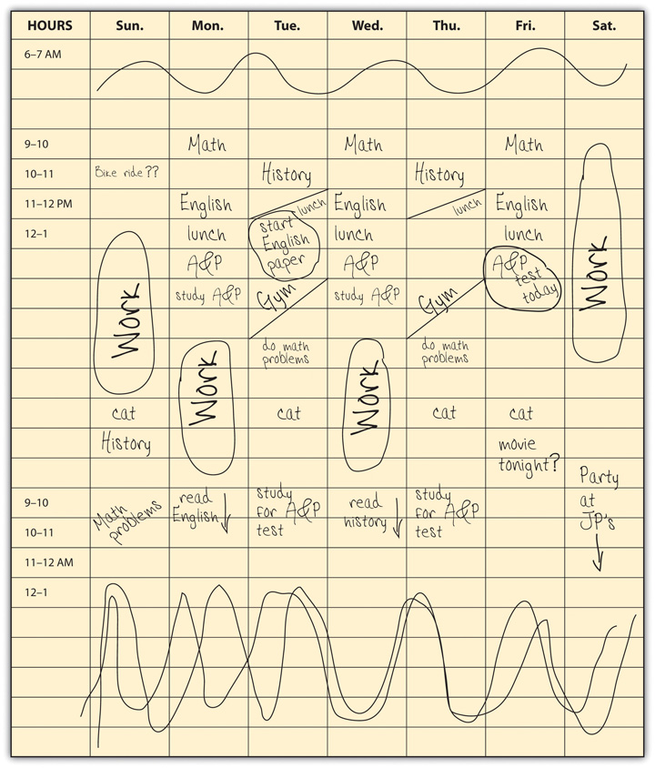
Figure 2.2 Student Sample Weekly Schedule

Activity 3: Planning Your Week

Checkpoint Exercises
Review the example of a weekly planner form above in Figure 2.1. Use it to begin your schedule planning. By using this first, you will find out whether these time slots are big enough for you or whether you’d prefer a separate planner page for each day. Fill in this planner form for next week. First write in all your class meeting times; your work or volunteer schedule; and your usual hours for sleep, family activities, and any other activities at fixed times. Don’t forget time needed for transportation, meals, and so on. Your first goal is to find all the blocks of “free time” that are left over.
Next, check the syllabus for each of your courses and write important dates in the planner. If you’re using an outside planner that has pages for the whole term, write in all exams and deadlines. Use red ink or a highlighter for these key dates. Write them in the hour slot for the class when the test occurs or when the paper is due, for example. (If you don’t yet have a planner large enough for the whole term, print a separate copy of Figure 2.1 Weekly Schedule Planner and write any deadlines on that. You need to know what’s coming next week to help schedule how you’re studying this week.)
Remember that for every hour spent in class, plan an average of two hours studying outside of class. These are the time periods you now want to schedule in your planner. These times change from week to week, with one course requiring more time in one week because of a paper due at the end of the week and a different course requiring more the next week because of a major exam. Make sure you block out enough hours in the week to accomplish what you need to do. As you choose your study times, consider what times of day you are at your best and what times you prefer to use for social or other activities.

Your Daily To-Do List
Many people find it useful to create a daily or weekly to-do list and check off the tasks as they are completed. A to-do list can be useful on an especially busy day, during exam week, or at any other time that you anticipate being overwhelmed.
To make a to-do list, write down what you need to do, code it, and organize it according to how important each task is. You can do this by coding the tasks with numbers, letters, color coding, or in an electronic format, by highlighting and font color tools. Prioritization helps you to focus the bulk of your energy and time on the most important tasks. Because many top-priority tasks occur at designated times, such as a due date for an assignment, coding helps you lock in these activities and schedule less urgent items around them.

Prioritizing levels:
- Priority 1: these tasks are the most crucial. You must do them! These include attending class, working a job, or paying a bill. Enter these obligations in your to-do list and planner first.
- Priority 2: these tasks are important but more flexible parts of your routine. Examples include study time, working out, or getting an oil change. Schedule these tasks around priority level 1 obligations.
- Priority 3: these tasks are least important. They are “nice to do” tasks but are not critical to complete. Examples would be calling a friend to catch up, or picking out a new book to read.
People use to-do lists in different ways, and you should find what works best for you. As with your planner, consistent use of your to-do list will make it an effective habit. Some people prefer to copy the key information for the day from their planner onto a to-do list. Using this approach, your daily to-do list starts out with your key scheduled activities and then adds other things you hope to do that day.
Some people use their to-do list only for things not on their planner, such as short errands, phone calls or e-mail, and the like. This still includes important things—but they’re not scheduled out for specific times. Although we call it a daily list, the to-do list can also include things you may not get to today but want to remember. Keeping these things on the list, even if they’re a low priority, helps ensure that eventually you’ll get to it.
You should start every day with a fresh to-do list written in a special small notebook or on a clean page in your planner. Check your planner for key activities for the day and check yesterday’s list for items remaining. Include a time estimate for assignment that will require a lot of time, so that later you can do them when you have enough free time. If you finish lunch and have twenty-five minutes left before your next class, what things on the list can you do now and check off?
Finally, use some system to prioritize things on your list. Some students use a 1, 2, 3 or A, B, C rating system for importance. Others simply highlight or circle items that are critical to get done today. Figure 2.3 below shows two different to-do lists—each very different but each effective for the student using it.
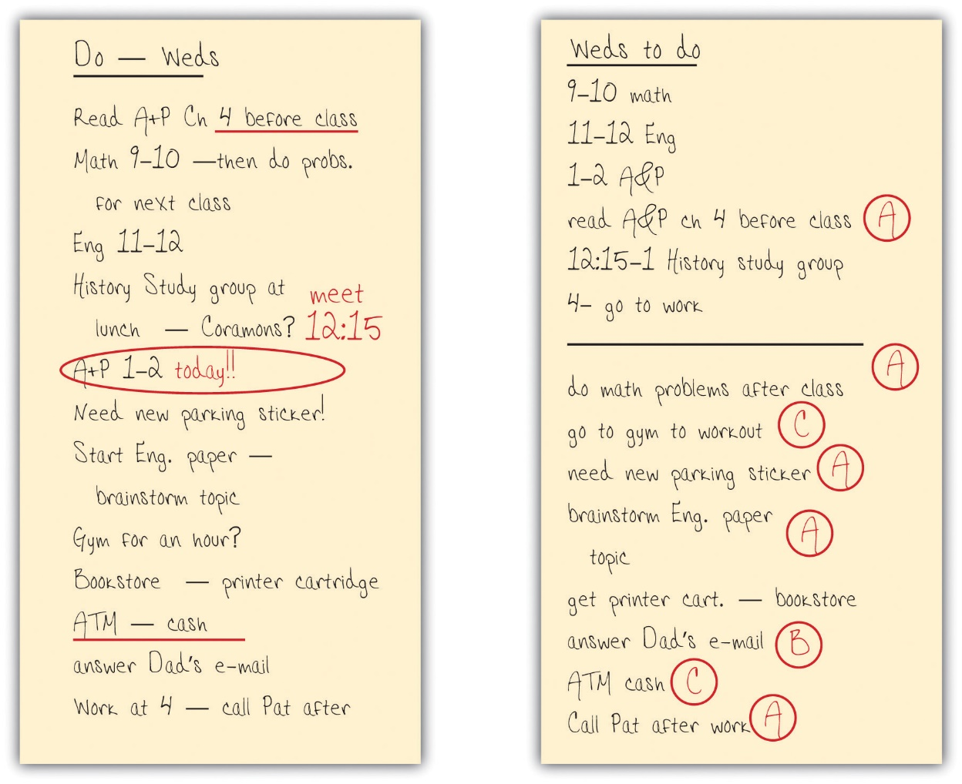
Figure 2.3 Examples of Two Different Students’ To-Do Lists

Here are some more tips for effectively using your daily to-do list:
- Be specific: “Read history chapter 2 (30 pages)”—not “History homework.”
- Put important things high on your list where you’ll see them every time you check the list.
- Make your list at the same time every day so that it becomes a habit.
- Don’t make your list overwhelming. If you added everything you eventually need to do, you could end up with so many things on the list that you’d never read through them all. If you worry you might forget something, write it in the margin of your planner’s page a week or two away.
- Use your list. Lists often include little things that may take only a few minutes to do, so check your list throughout the day you have a moment free.
- Cross out or check off things after you’ve done them—doing this becomes rewarding.
Don’t use your to-do list to procrastinate. Don’t pull it out to find something else you just “have” to do instead of studying

Time Management Strategies for Success
The following are some strategies you can begin using immediately to make the most of your time:
- Prepare to be successful. When planning ahead for studying, shift your thinking into the right mood. Focus on the positive. “When I get these chapters read tonight, I’ll be ahead in studying for the next test, and I’ll also have plenty of time tomorrow to do X.” Visualize yourself studying well!
- Use your best—and most appropriate—time of day. Different tasks require different mental skills. Some kinds of studying you may be able to start first thing in the morning as you wake, while others need your most alert moments at another time.
- Break up large projects into small pieces. Whether it’s writing a paper for class, studying for a final exam, or reading a long assignment or full book, students often feel daunted at the beginning of a large project. It’s easier to get going if you break it up into stages that you schedule at separate times—and then begin with the first section that requires only an hour or two.
- Do the most important studying first. When two or more things require your attention, do the more crucial one first. If something happens and you can’t complete everything, you’ll suffer less if the most crucial work is done.
- Alternatively, if you have trouble getting started, do an easier task first. Like large tasks, complex or difficult ones can be daunting. If you are stalling on the more crucial task, switch to an easier task you can accomplish quickly. That will give you momentum, and often you feel more confident tackling the difficult task after being successful in the first one.
- If you’re feeling overwhelmed and stressed because you have too much to do, revisit your time planner. Sometimes it’s hard to get started if you keep thinking about other things you need to get done. Review your schedule for the next few days and make sure everything important is scheduled, then relax and concentrate on the task at hand.
- If you’re really floundering, talk to someone. Maybe you just don’t understand what you should be doing. Talk with your instructor or another student in the class to get back on track.
- Take a break. We all need breaks to help us concentrate and avoid getting burned out. As a general rule, a short break every hour or so effectively recharges your study energy. Get up and move around to get your blood flowing, clear your thoughts, and work off stress.
- Use unscheduled times to work ahead. You’ve scheduled that hundred pages of reading for later today, but you have the textbook with you as you’re waiting for the bus. Start reading now, or flip through the chapter to get a sense of what you’ll be reading later. Either way, you’ll save time later. You may be amazed how much studying you can get done during downtimes throughout the day.
- Keep your momentum. Prevent distractions, such as multitasking, that will only slow you down. Check for messages, for example, only at scheduled break times.
- Reward yourself. It’s not easy to sit still for hours of studying. When you successfully complete the task, you should feel good and deserve a small reward. A healthy snack, a quick video game session, or social activity can help you feel even better about your successful use of time.
- Just say no. Always tell others nearby when you’re studying, to reduce the chances of being interrupted. Still, interruptions happen, and if you are frequently interrupted by a friend, it helps to have your “no” prepared in advance: “No, I really have to be ready for this test” or “That’s a great idea, but let’s do it tomorrow—I just can’t today.” You shouldn’t feel bad about saying no—especially if you told that person in advance that you needed to study.
- Have a life. Never schedule your day or week so full of work and study that you have no time at all for yourself, your family and friends, and your larger life.
- Use a calendar planner and daily to-do list. We looked at these time management tools in the previous section.

Controlling Procrastination
Procrastination is the action of delaying or postponing something. Often, procrastinators think, “I can just do it later,” even if it should be done now. For example, a college student may think, “I should be working on my paper, but I’ll just hang out with my friends for a little bit and work on it later.” It allows you to rationalize not doing your work at a specific time. Some people battle it daily, others only occasionally. With poor time management skills procrastination can threaten one’s ability to do well on an assignment or test.
There are multiple reasons why people procrastinate. Some people are too relaxed in their priorities, seldom worry, and easily put off responsibilities. Others worry constantly, and that stress keeps them from focusing on the task at hand. Some procrastinate because they fear failure; others procrastinate because they fear success or are perfectionists. Some are dreamers. Many different factors are involved, and there are different styles of procrastinating.
The different types of procrastination have different solutions. Good time management strategies described previously in the chapter can help you avoid procrastination. Because this is a psychological issue—a way of thinking—some additional psychological strategies can also help:
- Since procrastination is usually a habit, accept that and work on breaking it as you would any other bad habit: one day at a time. Every time you overcome feelings of procrastination, the habit becomes weaker—and eventually you’ll have a new habit of being able to start studying right away.
- As noted earlier, schedule times for studying using a daily or weekly planner. Carry it with you and look at it often. Just being aware of the time and what you need to do today can help you get organized and stay on track.
- If you keep thinking of something else you might forget to do later (making you feel like you “must” do it now), write yourself a note about it for later and get it out of your mind.
- Counter a negative with a positive. If you’re procrastinating because you’re not looking forward to a certain task, try to think of the positive future results of doing the work.
- Fear can cause procrastination. In this situation don’t dwell on the thought of failing. Use a positive mindset. (You will learn more about this in chapter 4.)
- Find a study partner or group within your class with other students who are motivated and have good time management skills.
- Keep a study journal. At least once a day, write an entry about how you have used your time and whether you succeeded with your schedule for the day. If not, identify what factors kept you from doing your work. This journal will help you see your own habits and distractions so that you can avoid things that lead to procrastination.
- Get help if this is an issue that you would like to be coached through. You can get help within the advising center and/or counseling center.
As the activities, tips, and strategies of this chapter have shown, good time management is something you can learn and practice for academic success. Consider how you can reorganize and reprioritize your time to avoid procrastination and ensure you are prepared for class—all without creating unwelcome stress! Then put your plan into action and be open to changing things if they aren’t working for you.

Questions for Reflection
- What time management strategies do you feel will work best for you? Why?
- What did you learn from the different time management activities? What planning techniques will you employ going forward?
- To what extent are you a procrastinator? What are some key methods to avoid procrastinating?

Attribution
- Parts of this chapter were adopted and modified from "College Success" by Amy Baldwin, OpenStax, Rice University is licensed under CC BY 4.0 / A derivative from the original work
- Parts of this chapter have been adopted and modified from "College Success" by Open Textbook Library, University of Minnesota Libraries is licensed under CC BY-NC-SA 4.0 / A derivative from the original work

Chapter 3: Campus Communication

Summary
There are many types of communication, which vary in tone, structure, and formality (i.e., texting a friend vs. sending a professional email to a business vs. having a face-to-face conversation with your boss). Each type of communication has a general set of accepted “rules,” such as shorthand and improper grammar being acceptable in a text, but not in professional correspondence. As a college student, one challenge you will face is determining which type of communication is best to use in different situations.
Communicating with professors and campus staff can be intimidating for many college students. However, it is important to remember that professors and staff are there to support your academic success and want to talk to you. As a student, you will often communicate with your professors and staff by email. These emails should be polite, concise, and formal (including a salutation, body, and signature). Effectively communicating with your professors will help you get the academic support you need as well as grow your professional network. Professors you have a relationship with can serve as mentors, write you letters of reference, and recommend you for internships and/or research opportunities.

Learning Objectives
After reading this chapter, you will be able to:
- Explain the differences between professional correspondence (ex: email to professor) and less formal communication (ex: texting a friend)
- Identify effective methods of communication with professors
- Describe the structure of a formal email
- Identify ways to communicate effectively with instructors and campus staff

Activity 1: The “Rules” of Communication

Checkpoint Exercises
In your opinion, what are the rules for different forms of communication? List the rules or guidelines related to each communication form listed in the table below. An example of a rule for the telephone might be identifying yourself when you call, in case the person didn’t recognize your number.
- Face-to-face
- Phone
- Printed letter
- Email
- Texting
- Social media
- Instant messaging/group chat

Variations in Communication
Were you able to discern different rules for the various forms of communication in the activity above? Do you find yourself following these rules when texting, sending an email, or talking to someone face-to-face? These questions are something to consider as we move through this chapter.
Technology has created new rules for interacting through new structures of communication, from emoji protocols, to truncated words and spelling, to etiquette and how we form communication networks. AAMOF it is important to understand communication. However, BTAIM, you might think it is a CWOT. FWIW this chapter will help you navigate the myriad ways of communicating. SLAP? (AAMOF = as a matter of fact, BTAIM = be that as it may, CWOT = complete waste of time, FWIW = for what it’s worth, SLAP = sounds like a plan).
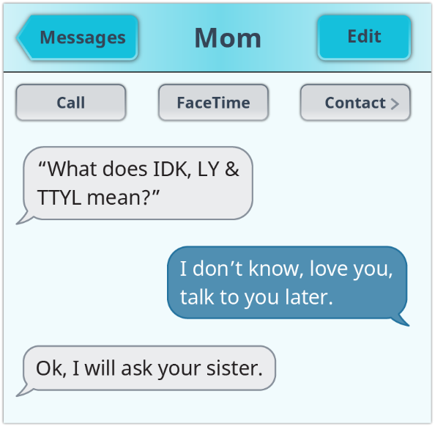
Figure 3.1 Overuse of acronyms can be confusing. Use them sparingly.

Although using the acronyms (symbols of communication) above allows us to say more in less space and time, we need to be careful about how we pass information to others as well as think more clearly about what is being communicated to us. Certainly, with the scope of the internet, we are seeing briefer messages, a wider reach, and greater immediacy.
We know that the transfer of information can be done vocally—voice, phone, face-to-face, over the radio, or television. It can come to us in a written format such as correspondence or printed or digital media. We obtain information visually in logos, pictures, maps, menus, and street signs. And, of course, we find ourselves learning things nonverbally by observing body language, tone of voice, gestures, and so forth.
Communication means that there is at least one sender and one recipient, and in between, there is the message. The kind of communication tool you choose to use also affects the message being conveyed. Will you choose a pencil? Pen? Phone? Email? Text? Picture? Or perhaps a face-to-face opportunity? Your method of choice for communicating with one person or a group of people guides how effectively you send your message. Additionally, there are always emotions behind a message. You could just be sharing a picture of yourself on the beach or sending out a call for help on a class assignment, or perhaps feeling sad because a friend is sick. Each of these situations would affect how you might communicate.
Have you ever sent a message to someone too quickly? For example, you heard that a friend just broke up with her boyfriend and is terribly heartbroken. You immediately think you should send some kind of “hope you are ok” comment and decide to use Facebook to do so. Later you find out that she didn’t want people to know about it at all and you jumped the gun on your condolences. How did you feel? Could you have gone about it in any other way? Perhaps waited until she told you about it herself? A private email or phone call? This is the type of situation where you have to step back for a moment and clarify for yourself that what you are about to send will be received the way you intended. Learning a little about the concept of emotional intelligence (EQ) will also be helpful to your decision about how to communicate in various situations.
Additionally, other significant variables play an important role in communicating. These range from ethnicity to culture to age to gender and are meaningful to what one is trying to “say” to someone else. As an example, in some European cultures, it is common to greet people by kissing them on the cheeks. People that were not raised in a culture where cheek kissing is widespread might be uncomfortable with this type of greeting. Another example is generational differences in phone use. Many younger Americans prefer texting and emailing, while many older Americans prefer to communicate by phone. Unfortunately, sometimes the message is lost or misconstrued because neither the sender nor the receiver has considered these important aspects of successful communication.
It is also essential to understand the audience and context of your communication. In other words, to whom are you talking? Why are you talking to this person or people? What, exactly, do you hope to achieve out of the communication you initiate? An effective communicator understands the audience to whom they are trying to send a message. This means using the venue that makes the most sense for the particular situation—face-to-face conversation, phone, email, text, written letter, or picture. This way your message can reach your audience (professor, boss, colleague, friend, parent, teammate) productively, and hopefully, the message you intend to convey is received accordingly.
An example of context might be the following: you need to ask your professor about a grade you received on an assignment because you think the grade was too low for the work you did. Would it be appropriate for you to send a text asking why you received the grade? Might it be better to give your professor a call and hope she is available to talk with you? Or do you think it could be more useful and productive if you found out the professor’s office hours and went in to discuss your concerns in person? These are decisions you have to make carefully so you can make the most of what you are trying to communicate.

Successful Communication with Professors
College students are sometimes surprised to discover that instructors enjoy getting to know students. The human dimension of college really matters, and as a student, you are an important part of your instructor’s world. Most instructors are happy to work with you during their office hours, talk a few minutes after class, respond to digital messages, or talk on the phone. These are some of the many methods of communication you and your instructors can use.
Just as digital messaging has become a primary form of communication in business and society, it has a growing role in education and has become an important and valuable means of communicating with instructors. Most college students are familiar with digital messaging, such as email, texting, and messages via the online course learning management system. Using digital messaging respects other people’s time, allowing them to answer at a time of their choosing.
However, digital communication with instructors is a written form of communication that differs from communicating with friends. Students who text with friends often adopt shortcuts, such as not spelling out full words, excluding capitalization and punctuation, and not focusing on grammar or using full sentences. Such texts are usually very informal and are not an appropriate style for communicating with instructors.
While some faculty will communicate with their students by text, you will primarily correspond with your instructors by email. Your instructors expect you to use a professional, respectful tone and fairly formal style when emailing:
- Use a professional email name. If you have a nickname you use with friends, create a different account with a professional name to use with instructors, work supervisors, and others. “BoatyMcBoatface” is not an appropriate, professional email name.
- Include something in the subject line that specifically communicates the purpose/topic of your email: “May I make an appointment?” says something; “Help!” doesn’t.
- Get to your point quickly and concisely.
- Write as you would in a paper for class, avoiding sarcasm, criticism, or negative language.
- Avoid abbreviations, nonstandard spelling, slang, and emoticons like smiley faces.
- Be courteous, accommodating, and respectful. Avoid stating expectations like, “I’ll expect to hear from you soon” or “If I haven’t heard by 4 p.m., I’ll assume you’ll accept my late paper.”
- When you reply to a message, leave the original message within yours.
- Proofread your message before sending it.
- Wait to send if you are upset. With any important message, it’s a good idea to wait and review the message later before sending it. You may have expressed an emotion or thought that you will think better about later. Many problems have resulted when people send messages too quickly without thinking.
- Format your message as a formal email (see next section.)

Structuring a Formal Email
Formal emails are structured similarly to printed business letters. These emails should contain a salutation, body text, and signature.
Salutation: Salutations are how you greet the recipient of your email. A common, appropriate salutation is “Dear Professor [Professor’s last name],” or “Dear Dr. [Professor’s last name]”. You also can use “Good morning (or afternoon or evening) Professor (or Dr.) [Professor’s last name]”.

- One difference between high school and college is that many of your instructors will have Ph.Ds. (also called “doctorates”). In the U.S., those that have earned Ph.D. degrees are called “Doctor.” Therefore, it is more appropriate to address instructors with Ph.Ds as “Dr.” rather than “Mrs.”, “Ms.”, or “Mr.” If you are unsure if your instructor has a Ph.D., look to see if this information is in their email signature. Alternatively, you can default to using “Professor,” since it is degree- and gender-neutral.
- Use your instructor’s last name in your salutation. Do not use your professor’s first name unless you have been explicitly told by them that you may. Addressing someone by their first name presumes a casual relationship and a level of familiarity that is not appropriate in this setting.

Body Text: Be clear, concise, and polite in the body of your email. If you are asking a question, make sure it is clearly stated. Professors often have very busy schedules. If you are requesting to schedule a meeting, make sure you are flexible with your availability and offer many possible times to meet.
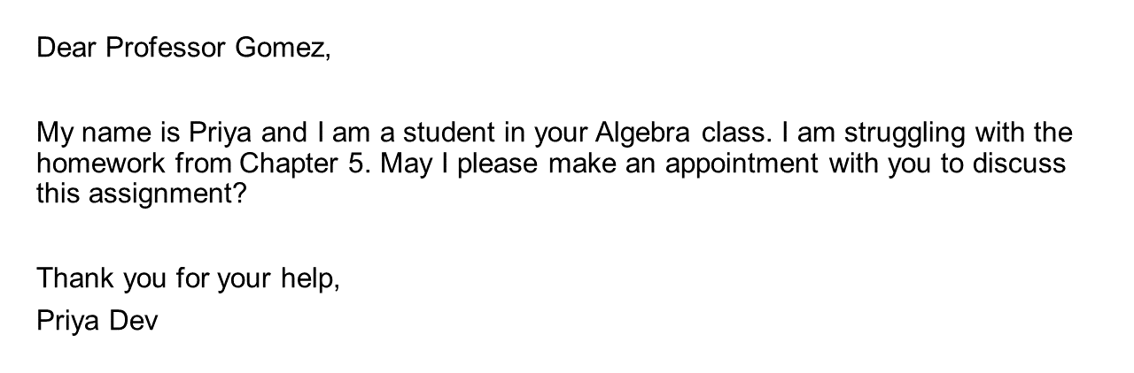
Figure 3.2. Example of a formal email from a student to a professor.
Signature: End your email by signing your full name. You may also include common closings such as “Thank you”, “Best”, “Sincerely,” or “Kind regards.”

Activity 2: Improve These Less-Than-Stellar Student Emails

Checkpoint Exercises
Below are some examples of less effective emails to professors. After reading the examples, list at least three improvements that can be made.
EXAMPLES | IMPROVEMENTS
hey i wont be in class cuz im sick
Dear Professor,
I need to set up a meeting with you tomorrow in your office from 3-3:15. Please respond ASAP.
Sincerely,
Student
Miss (Professor’s First Name),
I need a letter of recommendation. It is due Thursday.
-Student

Working with Professors: Key Points

- Go the extra mile: Talk to your professor when you:
- need an extension
- need clarification on course material
- are experiencing challenges in your personal life that impact your academic performance
- are considering pursuing a major or graduate degree in their subject area
- Visit early: Building rapport with your professors early in the semester will pay off if you need an extension or extra help later on. Professors like it when you visit office hours, but they don’t appreciate it when panicked students ask for an extension an hour before an assignment is due. Most professors will be very accommodating if you ask for help well in advance.
- Show your interest: Professors want you to be as interested in their subject as they are. Nothing excites them more than knowing you are passionate about what they teach. You can show your interest by participating in class, attending office hours, and emailing your professors if you have questions. Even if the class subject matter isn't your favorite, showing a commitment to the work will put you in good stead with your instructor and classmates.
- Meet your professor: Professors have many responsibilities to juggle including research, teaching, traveling to conferences, and administrative tasks. However, they DO want to talk with you. Contact your professors to schedule a time to meet them!
- Build relationships: Believe it or not, your professors are really interesting people. You might just enjoy their company. They can also open doors to academic research, serve as mentors, and may write you a reference letter down the road. Build strong relationships with your professors while you have the chance.

Questions for Reflection
- What some differences between informal and formal communication? Give an example of both.
- Your friend is nervous about emailing their professor for help. What advice would you give them?
- What are some of the benefits of communicating well with your professors?

Attributions
- Parts of this chapter were adopted and modified from "Learning Framework: Effective Strategies for College Success " by Heather Syrett, OER Commons, ISKME is licensed under CC BY-NC-SA 4.0 / A derivative from the original work
- Figure 3.1. “Overuse of acronyms can be confusing. Use them sparingly.” was adopted from "Learning Framework: Effective Strategies for College Success " by Heather Syrett, OER Commons, ISKME is licensed under CC BY-NC-SA 4.0 / A derivative from the original work
- Figure 3.2. “Example of a formal email from a student to a professor.” was created by Jennifer Hurst-Kennedy.

Chapter 4: Mindset and Campus Resources

Summary
In the first part of this chapter, we discuss mindsets and how critical certain mindsets can be to your success as a college student. Mindsets can be described as either more “growth” or “fixed” in orientation. Those with growth mindsets view their skills and talents as things about themselves that can grow and change over time. In contrast, those with a fixed mindset believe that people are born with certain levels of skills and talents that do not change. A growing body of evidence shows that students with growth mindsets are more likely to be successful in college because they are resilient in the face of challenges.
We also discuss how other factors, such as purpose, social belonging, and self-efficacy play important roles in your development as a college student. Part of cultivating a growth mindset and navigating challenges, academic and otherwise, involves establishing a support system and asking for help. Campus resources provide programming to serve in these capacities. In the second part of this chapter, we introduce you to all the exciting GGC campus resources to support you during your time as a Grizzly! GGC staff are here to help and offer an array of services to support your academic, social, physical, and financial wellbeing.

Learning Objectives
After reading this chapter, you will be able to:
- Explain the difference between fixed and growth mindsets and how they impact learning
- Define “GPS” and self-efficacy and explain how these concepts contribute to student success
- Identify GGC campus resources that can assist you in your college journey

Growth Mindset Vs. Fixed Mindset
What is the difference between students with a growth mindset and students with a fixed mindset? Students with a growth mindset believe that intelligence and skill can be developed. These students focus on learning over just looking smart, see effort as the key to success, and thrive in the face of a challenge. Alternatively, students with a fixed mindset believe that people are born with a certain amount of intelligence, and they can’t do much to change that. These students focus on looking smart over learning, see effort as a sign of low ability, and wilt in the face of a challenge. Many people are somewhere between the two mindsets and/or fluctuate between growth and fixed mindsets depending on the situation or subject. This is normal. The goal is to develop more of a growth orientation to build your resilience and flexibility.
Carol Dweck, author of the 2006 book Mindset: The New Psychology of Success, defined both fixed and growth mindsets: “In a fixed mindset, students believe their basic abilities, their intelligence, their talents, are just fixed traits. They have a certain amount, and that’s that, and then their goal becomes to look smart all the time and never look dumb. In a growth mindset, students understand that their talents and abilities can be developed through effort, good teaching, and persistence. They don’t necessarily think everyone’s the same or anyone can be Einstein, but they believe everyone can get smarter if they work at it.”
Which student do you think has more success in college? Think about this statement: You can learn new things, but you can’t really change your basic intelligence. People who really agree with this statement have a more fixed-oriented mindset. People who really disagree with this statement have a more growth-oriented mindset, and, of course, people might be somewhere in the middle.
It turns out that the more students disagree with statements like these, the more they have a growth mindset, the better they do in school. This is because students with a growth mindset approach school differently than students with a fixed mindset. They have different goals in school. The main goal for students with a fixed mindset is to show how smart they are or to hide how unintelligent they are. This makes sense if you think that intelligence is something you either have or you don’t have.
Students with a fixed mindset often will avoid asking questions when they don’t understand something because they want to preserve the image that they are smart or hide that they’re not smart. But the main goal for students with a growth mindset is to learn. This also makes a lot of sense. If you think that intelligence is something that you can develop, the way you develop your intelligence is by learning new things. So students with a growth mindset will ask questions when they don’t understand something because that’s how they’ll learn. Similarly, students with a fixed mindset view effort negatively. They think, “if I have to try, I must not be very smart at this.” Students with a growth mindset view effort as the way that you learn, the way that you get smarter.
Where you’ll really see a difference in students with fixed and growth mindsets is when they are faced with a challenge or setback. Students with a fixed mindset will give up because they think their setback means they’re not smart, but students with a growth mindset actually like challenges. If they already knew how to do something, it wouldn’t be an opportunity to learn, to develop their intelligence. Given that students with a growth mindset try harder in school, especially in the face of a challenge, it’s no surprise that they do better in school.
Students with a growth mindset view mistakes as a challenge rather than a wall. Many students shy away from challenging schoolwork and get discouraged quickly when they make mistakes. These students are at a significant disadvantage in school—and in life more generally—because they end up avoiding the most difficult work and giving up when there are disappointments or significant challenges. Making mistakes is one of the most useful ways to learn. Our brains develop when we make a mistake and think about the mistake. This brain activity doesn’t happen when we get the answers correct on the first try. What’s wrong with easy? According to Dweck, “it means you’re not learning as much as you could. If it was easy, well, you probably already knew how to do it.”

Activity 1: What’s Your Mindset?

Checkpoint Exercises
This activity will assess whether you have a fixed mindset, a growth mindset, or some of both mindset types.
Read each set of statements below. For each set, keep track of whether you agree more with statement A or statement B.
Set 1:
- Everyone is born with a certain level of skills and talents.
- A person’s skills and talents can change over time.
Set 2:
- Failure shows me the limits of my abilities.
- Failure shows me opportunities to grow.
Set 3:
- I like to stick with what I know.
- I like to try new things.
Set 4:
- I am what I am.
- I can grow and change.
Set 5:
- I feel threatened when I see others succeed.
- I feel inspired when I see others succeed.

Reflect on your answers. If you agree more strongly with the A statements, you have more of a fixed mindset. Conversely, if you agree more strongly with the B statements, you have more of a growth mindset.
After completing Activity 1, reflect on your results and how a fixed or growth mindset can impact your college experience. There will be many challenges during college. Cultivating a growth mindset will help you develop the flexibility needed to move through these challenges and be successful.

Growth-Purpose-Social Belonging (GPS)
As previously discussed, having a growth mindset is important for college students. However, a growth mindset isn’t the only contributor to student success. Instead, it is part of a larger theory called GPS (Hulleman and Happel, 2018), which stands for Growth, Purpose, and Social Belonging:
- G is for Growth. “Growth” here refers to having a growth mindset. As outlined in the previous section, having a growth mindset refers to holding the belief that one’s skills and talents can evolve and grow over time. A growth mindset can help students build the resilience needed to meet their goals in school and beyond.

- P is for Purpose. Have you ever asked yourself in class, “Why are the instructors making me do this?” It can be difficult to care about academics when what you are studying doesn’t seem relevant. Taking time to reflect on how your coursework aligns with your career goals and core values can help with motivation and focus.

- S is for Social Belonging. Wanting to fit in is human nature. Feelings of insecurity and stress when starting college are normal, but they can be isolating and intensify thoughts that “you don’t belong.” But you do belong! Sharing your anxieties with others helps normalize them. Also, while potentially nerve-wracking, reaching out and connecting with your fellow students—whether it be in class, in student clubs, or campus service organizations—can help increase your sense of belonging.

Self-Efficacy
A concept that was first introduced by Albert Bandura in 1977, self-efficacy is the belief that you are capable of carrying out a specific task or of reaching a specific goal (Bandura, 1977). Note that the belief and the action or goal are specific. Self-efficacy is a belief that you can write an acceptable term paper, for example, or repair an automobile, or make friends with the new student in the class. These are relatively specific beliefs and tasks. Self-efficacy is not about whether you believe that you are intelligent in general, whether you always like working with mechanical things, or think that you are generally a likable person. Self-efficacy is not a trait—there are not certain types of people with high self-efficacies and others with low self-efficacies (Stajkovic & Luthans, 1998). Rather, people have self-efficacy beliefs about specific goals and life domains. For example, if you believe that you have the skills necessary to do well in school and believe you can use those skills to excel, then you have high academic self-efficacy.
Self-efficacy may sound similar to a concept you may be familiar with already—self-esteem—but these are very different notions. Self-esteem refers to how much you like or “esteem” yourself—to what extent you believe you are a good and worthwhile person. Self-efficacy, however, refers to your self-confidence to perform well and to achieve in specific areas of life such as school, work, and relationships. Self-efficacy does influence self-esteem because how you feel about yourself overall is greatly influenced by your confidence in your ability to perform well in areas that are important to you and to achieve valued goals. For example, if performing well in athletics is very important to you, then your self-efficacy for athletics will greatly influence your self-esteem; however, if performing well in athletics is not at all important to you, then your self-efficacy for athletics will probably have little impact on your self-esteem.
Self-efficacy beliefs are not the same as “true” or documented skill or ability. They are self-constructed, meaning that they are personally developed perceptions. There can sometimes be discrepancies between a person’s self-efficacy beliefs and their abilities. You can believe that you can write a good term paper, for example, without actually being able to do so, and vice versa: you can believe yourself incapable of writing a paper, but discover that you can do so. In this way, self-efficacy is like the everyday idea of confidence, except that it is defined more precisely. And as with confidence, it is possible to have either too much or too little self-efficacy. The optimum level seems to be either at or slightly above true capacity (Bandura, 1997).
Previously, we discussed how a growth mindset can help you be resilient during challenges you encounter as a college student. Similarly, a strong sense of self-efficacy can help boost your academic success. Students with high self-efficacy believe in their potential to be successful, which leads to better motivation and emotional well-being, helping them to develop academic success habits.

Campus Resources for Success
So far, we have discussed how a strong academic mindset—growth mindset, GPS, and self-efficacy—can help you make the most of your experience in college. Part of developing this academic mindset is building a support system to promote your success. There are many resources available at Georgia Gwinnett College that can help you succeed during your time here and beyond. Being familiar with these resources, and being committed to using them when needed, is essential to your success. Up-to-date links and contact information can be found on the GGC Campus Resource List.

Academic Support
- Academic Enhancement Center (AEC): The AEC provides many services to support your academic success. These include one-on-one tutoring, academic skills workshops, and study resources.
  - Campus Location: Building W, Room 1160
  - 678.407.5191
  - aec@ggc.edu
  - https://www.ggc.edu/student-engagement-and-success/academic-enhancement-center/
  - Social Media:
    - https://www.facebook.com/ggcaec/
    - https://www.instagram.com/ggcaec/

- Daniel J. Kaufman Library: The library provides many physical and electronic resources for research. There are also rooms students can reserve for studying.
- Campus Location: Building L
- 678.407.5317
- circulation@ggc.edu
- https://www.ggc.edu/academics/library/
- Social Media:
- https://www.instagram.com/ggclibrary/
- https://www.facebook.com/ggckaufmanlibrary/
- https://twitter.com/ggclibrary

- Peer Supplemental Instruction (PSI): PSI is an academic support model that features peer-led, pre-planned study sessions. Study sessions, led by student leaders who previously passed the course, facilitate active, group learning.
  - psi@ggc.edu
  - https://www.ggc.edu/academics/schools/school-of-science-and-technology/research-internships-service-learning/peer-supplemental-instruction-program/
  - Social Media:
    - https://www.facebook.com/PSIGGC/

Mentoring and Advising
- Career Development and Advising Center (CDAC): The CDAC office provides a variety of services to help students develop job search skills and locate employment as well as help you discover your career path and course of study. CDAC staff can counsel you on your career and interest assessment and help you connect your results to a degree plan of study.
- Campus Location: Student Center (Building E), Room 2130
- 678.407.5702
- careerservices@ggc.edu
- https://www.ggc.edu/student-life/student-services/career-development-and-advising/
- Social Media:
- https://twitter.com/ggccareercenter
- https://www.instagram.com/ggccareercenter/
- https://www.facebook.com/ggccareerservices

- Student Success and Advising Center: Student Success Advisors mentor and advise most first-year students, including those enrolled in Student Success English and Math classes. They provide advice on course plans, testing and graduation requirements, and academic skill development and offer academic success coaching.
  - Campus Location: Building D, Suite 1329
  - 678.407.5645
  - SESadvising@ggc.edu
  - https://www.ggc.edu/student-engagement-and-success/student-success-advising-center/
  - Social Media:
    - https://www.facebook.com/georgiagwinnett/
    - https://www.instagram.com/ggc_advising/?utm_medium=copy_link

Grizzly Spirit
- GGC Bookstore: The GGC Bookstore is managed by Barnes & Noble and offers a wide selection of textbooks in new, used, rental, and e-book formats, along with supplies, study aids, snacks, and GGC apparel.
  - Campus Location: Student Center (Building E), Room 2122
  - 678.407.5986
  - sm595@bncollege.com
  - https://www.ggc.edu/student-life/student-services/bookstore/

- Student Involvement: The Office of Student Involvement is the center for out-of-classroom activities at GGC. Participating in co-curricular activities helps you gain valuable teamwork and leadership skills that complement your academic work and enrich your college experience.
- Campus Location: Student Center, Building E, Suite 3120
- 678.407.5582
- getinvolved@ggc.edu
- https://www.ggc.edu/student-life/student-involvement/
- GGC Get Involved (link to all registered student organizations): https://ggc.presence.io/
- Social Media:
- https://www.instagram.com/ggc_getinvolved/
    - https://www.instagram.com/ggc_greenlight/
- https://www.facebook.com/GetInvolvedGGC/

Health and Wellness
- Counseling and Psychology Services (CAPS): CAPS offers free, confidential mental health services to all current GGC students, including individual and group counseling and crisis assistance.
  - Campus Location: Building I, Suite 1101
  - 678.407.5592
  - https://www.ggc.edu/student-life/student-services/counseling-and-psychological-services/

- Health Services: Health Services is staffed by a nurse practitioner and medical assistants. Students can receive over-the-counter medication, treatment for minor illnesses and injuries, and health education materials.
  - Campus Location: Building H, Suite 1102
  - 678.407.5675
  - immunizations@ggc.edu
  - healthservices@ggc.edu
  - https://www.ggc.edu/student-life/student-services/health-services/

- Wellness and Recreation Center: The Wellness and Recreation Center offers a variety of fitness classes and exercise equipment to students, faculty, and staff. It also has a pool, indoor track, and basketball and racquetball courts.
  - Campus Location: Building F
  - 678.407.5970
  - wellnessrec@ggc.edu
  - https://www.ggc.edu/student-life/student-services/wellness-and-recreation/wellness-and-recreation-center/
  - Social Media:
    - https://www.instagram.com/ggcwrc/
    - https://www.facebook.com/GGCWRC/

Student Services
- Disability Services: Disability Services provides accommodations for students with documented disabilities to support their academic success and development.
  - Campus Location: Building D, Suite 1406
  - 678.407.5883
  - disabilityservices@ggc.edu
  - https://www.ggc.edu/student-life/student-services/disability-services/

- Financial Aid: All you need to know about paying for your education at GGC starts here – from completing the FAFSA, to understanding payment deadlines, to pursuing scholarships and loans.
  - Campus Location: Building D (Admissions)
  - 678.407.5701
  - ggcfinancialaid@ggc.edu
  - https://www.ggc.edu/admissions/financial-aid/

- Office of Internationalization: International Student Services is eager to guide international students toward a rewarding college experience. They offer information on all of GGC’s many study abroad programs.
  - Campus Location: 2nd Floor of Building D
  - 678.407.5300
  - internationalization@ggc.edu
  - https://www.ggc.edu/academics/internationalization/

- Office of Veteran Success: GGC wants veterans to achieve the college and career goals they have set for themselves. Our Veteran Affairs specialists will help you navigate the college enrollment process and enjoy the full value of your active duty or veteran’s educational benefits.
  - Campus Location: Building D, 1112
  - 678.407.5543
  - veterans@ggc.edu
  - https://www.ggc.edu/admissions/financial-aid/veterans-success/

- Technology Services (Help Desk): The GGC Help Desk assists students with email configuration, password resets, and trouble-shooting GGC-owned software.
  - Campus Location: Building A, Suite 1040
  - 678.407.5611
  - helpdesk@ggc.edu
  - https://www.ggc.edu/faculty-and-staff/information-technology/technology-support-services/

Activity 2: Campus Resource Scenarios

Checkpoint Exercises
Through this assignment, you will learn about the various resources and services available to you at GGC, understand which to access when challenges arise, and locate them on campus. For each scenario, please read the passage and consider which campus resource or office would best assist you (either in providing support or helping your decision‐making).
- You knew that college was going to require more work than high school did for the same grades, but you did not expect it to be this hard! You do not necessarily think you need tutors, but you could sure use some guidance as far as some studying tips and getting more organized. None of your new friends seem to be good examples to follow in these areas, so where can you go to access workshops on Student Success?
- The first few weeks of the semester have been great and everything that comes along with being a college student has started to settle in. Recently, though, you’ve started to experience some anxiety about balancing your classes and social life. In addition to being overwhelmed about how things are going here at GGC, you start to not feel like yourself and just want to sleep all the time. Where is there someone you can talk to?
- College seemed like a good idea, that is, until you got here. You don’t know many people; all your friends from high school and your significant other go to other colleges and universities not nearby. You express feelings of homesickness to your parents over the phone and they suggest getting out and meeting new people, but you’re not sure where to get started. Where can you go, or what can you do, to make new friends in a new place?
- Midterms are upon you and you feel terrible. You’re pretty sure that the other day you had a fever, but all you did was take some Advil and sleep all day. Now you have a persistent cough. You are extremely uncomfortable and wish that you could go home to have Mom take care of you, but unfortunately you have three exams to prepare for. Where should you go?
- Your Psychology 1102 professor has assigned you your first college research paper, and it is on a subject you have never heard a thing about besides a short paragraph in the textbook. You try searching for information on your own but begin to get discouraged when you don’t find much. Research for term papers has never been your strong suit, so where can you go to get some help finding useful information to write this paper?
- After taking Anthropology 1102 “Intro to Anthropology” you think you might want to major in Anthropology, but you don’t really know much about the subject other than enjoying the class. You’re hoping that whatever subject you chose to major in will give you some direction as to a possible career after graduation. Where can you go to learn more about careers connected to the subject of Anthropology?
- By the end of January you’re realizing that you might not have been as prepared for the math class you are taking as you originally thought. Your grades have not been anything to write home about, and for the sake of your GPA, you know you should get out of the class. Where should you go or whom should you talk to about withdrawing from this course?
- For some reason, your password for e‐mail and D2L is not working. You don’t remember getting any e‐mails notifying you that it is time to update your password, so you have no idea what could be causing the problem. Whom can you contact about this problem?
- Your English 1101 instructor announced to the class about a week ago that you could earn extra credit for the class if you went to see a particular speaker’s presentation. You remember that the speaker is coming tomorrow at the LVIS. Where is the LVIS located?
- You’ve gotten tired of the dining hall food sooner than you thought you would and now find yourself eating off‐campus a lot with your classmates. Also, you find yourself compelled to purchase all the GGC gear you can find, and add a little green and grey to your wardrobe. Suddenly you discover that your monetary funds are running low, and mom and dad aren’t able to supply you with the cash. Where can you go to find out about getting a part‐time job on or nearby campus?
- After a few months here on campus you are feeling confident and interested in trying new things. You’ve seen advertisements around campus for the study abroad program. You’re pretty sure that you might be ready to get out of the country next year and experience something new. Where can you go to get more information?
- Your first exam in MUSC 1100 is coming up, and it’s going to be multiple choice and short essay. Your professor told you to bring in a scantron sheet and a “blue book.” You also want to pick up some dry erase markers for studying in the library. Where should you go to get these items on campus?
- You’ve put on the dreaded “freshman fifteen” and want to start exercising and eating healthier so you can get back in shape, but it’s too cold to walk around campus. You’re thinking about joining the boot camp or going to a yoga class. Where do these classes take place?
- You’ve decided you want to take summer classes, but you’re not sure how to pay for them. You need to talk to someone about whether or not you have financial aid available for summer term and to discuss options for student loans. Where should you go to schedule an appointment with someone who can help you?
- It’s the fourth week of classes, and things are really starting to pick up. You are feeling relatively confident about your performance in most of your classes, but it seems that your Chemistry 1211K class is moving at a pace you are increasingly uncomfortable with. You are struggling and want to get help before your grade begins to suffer. Where should you go for extra assistance?

Questions for Reflection
- Define “fixed mindset.” How can having a fixed mindset impact someone’s academic success?
- What is the difference between self-esteem and self-efficacy?
- Read through the list of GGC campus resources. Name 3-4 resources you will use this semester. Why will these resources be helpful to you as a college student?

Associated Videos
- BYU First-Year Mentoring. (2016, Jun 22). Do you have a growth or fixed mindset? (Video Quiz) [Video]. Youtube. https://www.youtube.com/watch?v=pamzG81yt7g
- TedXTalks. (2014, Sep 12). The power of yet | Carol S Dweck | TEDxNorrköping [Video]. Youtube. https://www.youtube.com/watch?v=J-swZaKN2Ic

References
Dweck, C. S. (2006). Mindset: The New Psychology of Success. United States: Random House Publishing Group.
Bandura, A. (1977). Self-efficacy: toward a unifying theory of behavioral change. Psychological Review, 84(2), 191.
Hulleman, C. and Happel, L. (2018). Help Students Navigate Life’s Transitions With a Mindset GPS. Behavioral Scientist. https://behavioralscientist.org/help-students-navigate-lifes-transitions-with-a-mindset-gps/
Stajkovic, A. D. and Luthans, F. (1998). Self-Efficacy and Work-Related Performance: A Meta-Analysis. Psychological Bulletin.

Attribution
- Parts of this chapter were adopted and modified from "Learning Framework: Effective Strategies for College Success " by Heather Syrett, OER Commons, ISKME is licensed under CC BY-NC-SA 4.0 / A derivative from the original work

Chapter 5: Cultivating a Critical Reading Practice

Summary
This chapter explores an important skill you probably think you already understand—reading. But the goal is to make sure you’ve honed this skill well enough to lead you to success in college. Reading and consuming information are increasingly important today because of the amount of information we encounter. Not only do we need to read critically and carefully, but we also need to read with an eye to distinguishing fact from opinion and identifying solid sources. Reading helps us make sense of the world—from simple reminders about picking up milk to complex treatises on global concerns, we read to comprehend, and in so doing, our brains expand. By the time you finish this chapter, you should be able to do the following:

Learning Objectives
After reading this chapter, you will be able to:
- Explain several different purposes for and processes involved in critical reading
- Discuss the way reading differs in college and how to successfully adapt to that change

Types of Reading
We may read small items purely for immediate information, such as notes, e-mails, or directions to an unfamiliar location. You can find all sorts of information online about how to fix a faucet or tie a secure knot. You won’t have to spend too much time reading these sorts of texts because you have a specific goal in mind for them, and once you have accomplished that goal, you do not need to prolong the reading experience. These encounters with texts may not be memorable or stunning, but they don’t need to be. However, when we consider why we read longer pieces—outside of reading for pleasure—we can usually categorize the reasons into about two categories: 1) reading to introduce ourselves to new content, and 2) reading to comprehend familiar content more fully.

Introduce New Content
When we read to introduce new content, we can start off small and increase to better and more sophisticated sources. Much of our further study and reading depends on the sources we originally read, our purpose for finding out about this new topic, and our interest level.
In academic settings, much of what you read in your courses may be relatively new content to you. You may have heard the word volcano and have a general notion of what it means, but until you study geology and other sciences in depth, you may not have a full understanding of the environmental origins, ecological impacts, and societal and historic responses to volcanoes. These perspectives will come from reading and digesting various material. When you are working with new content, you may need to schedule more time for reading and comprehending the information to look up unfamiliar terminology or pause more frequently to make sure you are truly grasping what the material means.

Reading to Comprehend Familiar Content
Reading about unfamiliar content is one thing, but what if you do know something about a topic already? Do you still need to keep reading about it? Probably. With familiar content, you can do some initial skimming to determine what you already know in the book or article, and mark what may be new information or a different perspective. You may not have to give your full attention to the information you know, but you will need to spend more time on the new viewpoints so you can expand your ideas with this new data.
When college students encounter material in a discipline-specific context and have some familiarity with the topic, they sometimes can allow themselves to become a bit overconfident about their knowledge level. Just because a student may have read an article or two or may have seen a TV documentary on a subject such as the criminal mind, that does not make them an expert. An expert is a person who thoroughly studies a subject, usually for years, and understands all the possible perspectives of a subject as well as the potential for misunderstanding due to personal biases and the availability of false information about the topic.

Allowing Adequate Time for Reading
You should determine the reading requirements and expectations for every class very early in the semester. You also need to understand why you are reading the text you are assigned. Do you need to read closely for minute details that determine cause and effect? Or is your instructor asking you to skim several sources so you become more familiar with the topic? Knowing this reasoning will help you decide your timing, what notes to take, and how best to undertake the reading assignment. How fast you read and digest information will also help you determine how much time you should allot for reading and taking notes on a text.

Determining Reading Speed and Pacing
To determine your reading speed, select a section of text—passages in a textbook or pages in a novel. Time yourself reading that material for exactly 5 minutes and note how much reading you accomplished in those 5 minutes. Multiply the number of pages you read in 5 minutes by 12 to determine your average reading pace (5 times 12 equals the 60 minutes of an hour). Of course, your reading pace will be different and take longer if you are taking notes while you read, but this calculation of reading pace gives you a good way to estimate your reading speed that you can adapt to other forms of reading.
Sample Reading Times
Reader | Pages Read in 5 Minutes | Pages per Hour | Approximate Hours to Read 500 Pages
Marta | 4 | 48 | 10 hours, 30 minutes
Jordi | 3 | 36 | 13 hours
Estevan | 5 | 60 | 8 hours, 20 minutes

Reading as a Process
People often say writing is rewriting. For college courses, reading is rereading. Strong readers engage in numerous steps, sometimes combining more than one step simultaneously, but knowing the steps, nonetheless. They include, not always in this order:
- Bringing any prior knowledge about the topic to the reading session
- Asking pertinent questions, both orally and in writing, about the content you are reading
- Inferring and/or implying information from what you read
- Learning unfamiliar discipline-specific terms
- Evaluating what you are reading
- Later, applying what you’re reading to other learning and life situations you encounter
Let’s break these steps into manageable chunks, because you are doing quite a lot when you read.

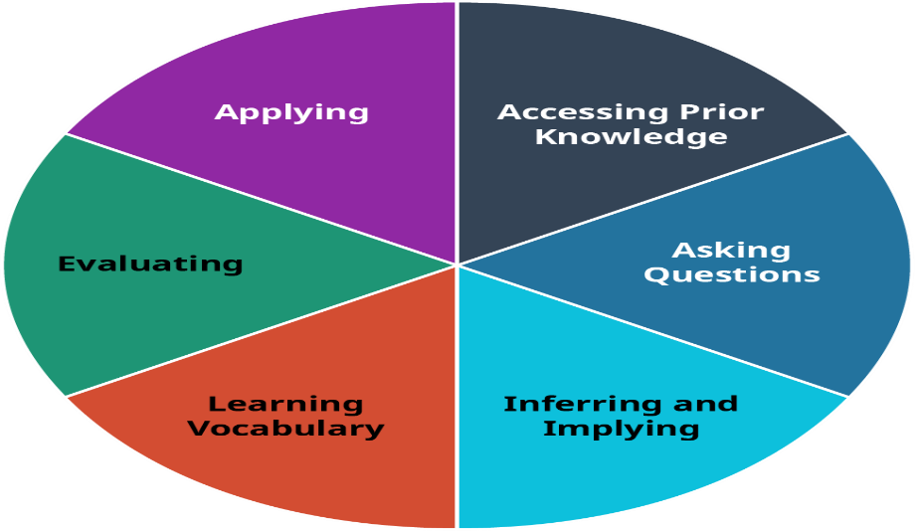
Figure 5.1 The Activities of Reading

Whenever you tackle a reading assignment, first consider your purpose(s) in doing the reading. Then identify some strategies to get the most out of your reading experience. Spending a couple of minutes on the front end thinking about your goals and outcomes with a text can save you time in the long-run and ensure you absorb more of the material necessary to be successful.

Questions for Reflection
- How can distinguishing between reading processes help you academically and personally?

- How can you best prepare to read for college?

Attribution
- Parts of this chapter were adopted and modified from "College Success" by Amy Baldwin, OpenStax, Rice University is licensed under CC BY 4.0 / A derivative from the original work

Chapter 6: Notetaking, Study Skills, and Exam Preparation

Summary
Exams in college can be stressful! One of the best ways to lessen this stress is to have a “plan of attack” to prepare yourself to do your best. This starts with attending class and taking quality notes. You might use notetaking styles such as outlining, concept mapping, or the Cornell Method. Next, make a study plan. One effective strategy for this is to use the Study Cycle, a five-step method (prepare, attend, review, study, and assess) to help you efficiently prepare for exams and retain course content. On exam day, make sure to arrive early, visualize success, and scan through the entire test before answering any questions. Remember that different types of questions (i.e., multiple-choice or essays) require different strategies. Despite best efforts to prepare, students can still be struck by test anxiety. If this happens, try a mini-meditation before your test. Also, making sure you get a good night’s sleep and eat nutritious meals can go a long to make you feel calmer and more confident.

Learning Objectives
After reading this chapter, you will be able to:
- Explain the importance of taking quality notes during class and describe notetaking methods such as the outlines, concept mapping, and the Cornell Method
- Describe the different stages of the study cycle
- Describe best practices for preparing for and taking exams
- Define test anxiety and discuss strategies to lessen test anxiety

Notetaking: Why is this important?
Do you take notes often? What kind of notes? In college, your instructors expect you to make connections between class lectures and reading assignments; they expect you to create an opinion about the material presented; they expect you to make connections between the material and life beyond college. Your notes are your roadmaps for these thoughts. After learning to listen, notetaking is the most important skill to ensure your success in a class. Effective notetaking is important because it:
- Supports your listening efforts.
- Allows you to test your understanding of the material.
- Helps you remember the material better when you write key ideas down.
- Gives you a sense of what the instructor thinks is important.
- Creates your “ultimate study guide.”

Effective note-taking helps students retain what they learned in class so that they can use the material to study, build their knowledge, and tackle more complex concepts later on. Whether you prefer to write summaries or make visual guides and diagrams in your notes, the important thing is to find a note-taking strategy that works for you.
There are various forms of taking notes, and which one you choose depends on both your style and the instructor’s approach to the material. Each can be used in a notebook, index cards, or in a digital form on your laptop. No specific type is good for all students and all situations, so we recommend that you develop your own style, but you should also be ready to modify it to fit the needs of a specific class or instructor.
The following are a few recommendations to try out:
- Stay organized: Keep your notes and handouts separate for each class. For example, you might have a different notebook and folder for each class or a large notebook with a different tab for each class. This will save you the time of trying to organize and locate your notes when studying for an exam.
- Use your paper: Many students try to fit all of a day’s class notes onto one page and are often left with many extra blank pages in their notebooks. Instead, every time your instructor changes topics, flip to a new page. This allows you to find the material easily and makes your notes much cleaner. Similarly, if you are taking notes digitally, leave space between topics. For example, if you are taking notes in MS Word, you can use the “page break” function between topics.
- Use visual cues: Try highlighting, underlining, or drawing arrows or exclamation points next to any main or difficult concepts. This will call attention to these sections and remind you to spend more time reviewing them.
- Group together similar concepts: Grouping or “chunking” material is a good way to make studying and memorization easier. You can try drawing the main concept and connecting it to smaller, related concepts or making an outline of the information. Either one can serve as an effective study guide.
- Make notes legible: Some people have messy handwriting. However, writing as clearly as possible when you take notes will make it easier to review them later. It’s also helpful if you’re asked to share your notes with another student who missed class. If laptop use is permitted during class, you can also type your notes.

Notetaking Styles

The Outline Method
The outline method allows you to prioritize the material. Key ideas are written to the left of the page, subordinate ideas are then indented, and details of the subordinate ideas can be indented further (Figure 6.1). To further organize your ideas, you can use the typical outlining numbering scheme (starting with Roman numerals for key ideas, moving to capital letters on the first subordinate level, Arabic numbers for the next level, and lowercase letters following.) At first, you may have trouble identifying when the instructor moves from one idea to another. This takes practice and experience with each instructor, so don’t give up! In the early stages, you should use your syllabus to determine what key ideas the instructor plans to present. Your reading assignments before class can also give you guidance in identifying the key ideas.
If you’re using your laptop computer for taking notes, a basic word processing application (like Microsoft Word or Works) is very effective. Format your document by selecting the outline format from the format bullets menu. Use the increase or decrease indent buttons to navigate the level of importance you want to give each item. The software will take care of the numbering for you!
After class, be sure to review your notes and then summarize the class in one or two short paragraphs using your own words. This summary will significantly affect your recall and will help you prepare for the next class.
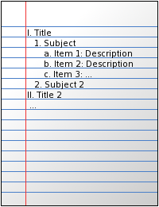
Figure 6.1. Outline Notetaking. In this method of notetaking, designate major topics or themes using Roman numerals and list related information underneath with numbers and letters.

The Concept Map Method
This is a very graphic method of note-taking that is especially good at capturing the relationships among ideas. Concept maps harness your visual sense to understand complex material “at a glance.” They also give you the flexibility to move from one idea to another and back easily and are helpful if your instructor moves freely through the material.
To develop a concept map, start by using your textbook and/or in-class notes syllabus to rank the ideas you will listen to by level of detail (from high-level or abstract ideas to detailed facts). Select an overriding idea (high level or abstract) from the instructor’s lecture and place it in a circle in the middle of the page. Then create branches off that circle to record the more detailed information, creating additional limbs as you need them. Arrange the branches with others that interrelate closely (Figure 6.2). When a new high-level idea is presented, create a new circle with its own branches. Link together circles or concepts that are related. Use arrows and symbols to capture the relationship between the ideas. For example, an arrow may be used to illustrate cause or effect, a double-pointed arrow to illustrate dependence, or a dotted arrow to illustrate impact or effect.

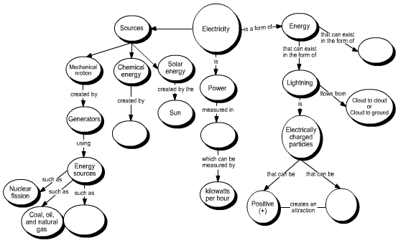
Figure 6.2. Concept mapping. Concept mapping is a style of notetaking that involves making a “map” of connections between key terms and concepts. The above is an electricity concept map by NASA.

The Cornell Method
The Cornell method was developed in the 1950s by Professor Walter Pauk at Cornell University. It is recommended by most colleges because of its usefulness and flexibility. This method captures notes, defines priorities, and provides a very helpful study tool.
The Cornell method follows a very specific format that consists of four boxes: a header, two columns, and a footer. The header is a small box across the top of the page. In it, you write identification information like the course name, topic, and the date of the class. Underneath the header are two columns: a narrow one on the left (no more than one-third of the page) and a wide one on the right. The wide column, called the “notes” column, takes up most of the page and is used to capture your notes using any of the methods outlined earlier. The left column, known as the “cue” or “recall” column, is used to jot down main ideas, keywords, questions, clarifications, and other notes. It should be used both during the class and when reviewing your notes after class. Finally, use the box in the footer to write a summary of the class in your own words. This will help you make sense of your notes in the future and is a valuable tool to aid with recall and studying (Figure 6.3).
Some students like to use index cards to take notes. These actually lend themselves quite well to the Cornell method. Use the “back” or lined side of the card to write your notes in class. Use one card per key concept. The “front” unlined side of the card replaces the left hand “cue” column. Use it after class to write keywords, comments, or questions. When you study, the cards become flashcards with questions on one side and answers on the other. Write a summary of the class on a separate card and place it on the top of the deck as an introduction to what was covered in the class.
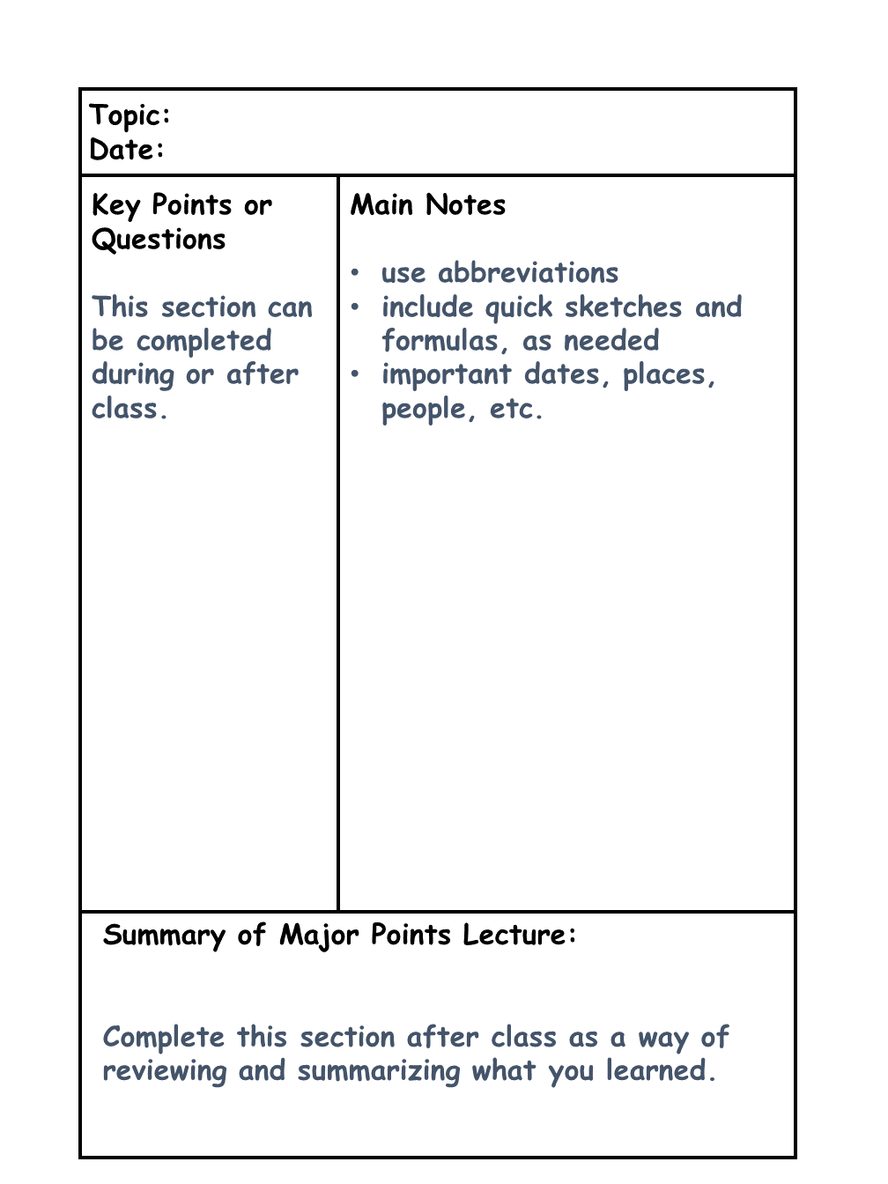
Figure 6.3. The Cornell Method of Notetaking. The Cornell Method uses a specific template. Each page has a header (for topic, date, etc.), a footer (for a summary), and two columns: one for key points and questions (“cues”) and one for your main notes.

Activity 1: Notetaking Style Test Drive

Checkpoint Exercises
Choose at least one of the notetaking styles described above (outline concept mapping, of the Cornell Method) and take notes in this style during your classes this week. Afterwards, reflect on these questions: 1) Using this notetaking style, was I able to record the most important information from class? 2) Will my notes serve as an effective study tool? 3) Is this style of notetaking better for certain classes (i.e., chemistry vs. art history)?

How to Study
In general, college students know the importance of studying, but how to study can be confusing. Students may not be clear on which study techniques to use and/or how much time they should dedicate to each class. One method for effectively studying and managing your time is the Study Cycle (Louisiana State University, 2015). The Study Cycle is a scheduled study plan comprising pre-class, in-class, and after-class activities.

- Preview (5 to 15 minutes before class). Before class, scan through the textbook. Pay attention to bolded words, figures, and chapter summaries.
- Attend. Go to class! It’s important to attend every class session and take quality notes (see the previous section on notetaking). Also, ask your instructor questions and participate in class discussions because it will help you remember key information and deepen your understanding of the content.
- Review (5 to 15 minutes immediately after class). After class, spend time rereading your notes and summarizing key information. Write down any questions you have.
- Study (1-3 hours per class session with mini-breaks). Study actively using some of these techniques:
  - Make concept maps
  - Predict test questions
  - Practice teaching the material to others
  - Self-quiz with flashcards
- Assess. It’s important to check your understanding after studying. Ask yourself how well you know the information. One key indicator that you know material well is if you would feel confident teaching the material to a friend or classmate. So, ask yourself—do I know this well enough to teach it to someone else?

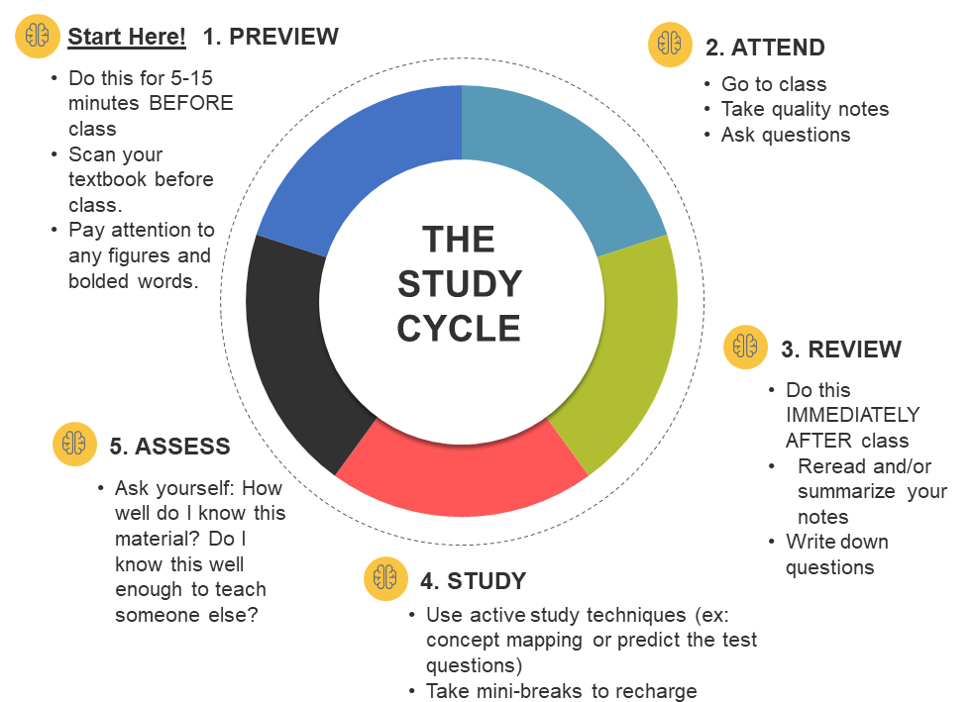
Figure 6.4. The Five Stages of the Study Cycle. Modified from the Louisiana State University Study Cycle.

Exam Preparation
Exams are an inevitable part of college. In this section, we will discuss ways to prepare for exams to help you feel more confident and less stressed. To begin, complete the pre-test checklist (Activity 2).

Activity 2: Pre-Test Checklist

Checkpoint Exercise
How do you get ready for test day? Put a check mark next to the pre-test strategies you already employ.
____ Organize your notebook and other class materials the first week of classes.
____ Take notes on key points from lectures and other materials.
____ Make sure you understand the information as you go along.
____ Access your instructor’s help and the help of a study group, as needed.
____ Organize a study group, if desired.
____ Create study tools such as flashcards, graphic organizers, etc. as study aids.
____ Complete all homework assignments on time.
____ Review likely test items several times beforehand.
____ Maintain an active learner attitude.
____ Schedule extra study time in the days just prior to the test.
____ Gather all notes, handouts, and other materials needed before studying.
____ Review all notes, handouts, and other materials.
____ Create and use mnemonic devices to aid memory.
____ Put key terms, formulas, etc., on a single study sheet that can be quickly reviewed.
____ Schedule study times short enough (1-2 hours) so you don’t get burned out.
____ Get plenty of sleep the night before.
____ Set a back-up alarm in case the first alarm doesn’t sound or you sleep through it.
____ Have a good breakfast with complex carbs and protein to see you through.
____ Show up 5-10 minutes early to get completely settled before the test begins.
____ Use the restroom beforehand to minimize distractions.
By reviewing the pre-test checklist, above, you have likely discovered new ideas to add to what you already use. Make a list of them!

What to Do During the Exam
Here is a list of the most common–and useful–strategies to survive this universal college experience.
- Scan the test, first, to get the big picture of how many test items there are, what types there are (multiple-choice, matching, essay, etc.), and the point values of each item or group of items.
- Determine which way you want to approach the test: Some students start with the easy questions first, that is, the ones they immediately know the answers to, saving the difficult ones for later, knowing they can spend the remaining time on them. Some students begin with the biggest-point items first, to make sure they get the most points.
- Determine a schedule that takes into consideration how long you have to test and the types of questions on the test. Essay questions, for example, will require more time than multiple-choice or matching questions.
- Keep your eye on the clock.
- If you can mark on the test, put a checkmark next to items you are not sure of just yet. It is easy to go back and find them to answer later on. You might just find help in other test questions covering similar information.
- Sit where you are most comfortable. That said, sitting near the front has a couple of advantages: You may be less distracted by other students. If a classmate comes up with a question for the instructor and there is an important clarification given, you will be better able to hear it and apply it, if needed.
- Wear earplugs if noise distracts you.
- You do NOT have to start with #1! If you are unsure of it, mark it to come back to later.
- Bring water. This helps calm the nerves, for one, and water is also needed for optimum brain function.

If despite all your best efforts to prepare for a test you just cannot remember the answer to a given item for multiple-choice, matching, and/or true/false questions, employ one or more of the following educated guessing (also known as “educated selection”) techniques. By using these techniques, you have a better chance of selecting the correct answer. It is usually best to avoid selecting an extreme or all-inclusive answer (also known as 100% modifiers) such as “always,” and “never”. Choose, instead, answers that use words such as “usually,” “sometimes,” etc. (also known as in-between modifiers). If the answers are numbers, choose one of the middle numbers. If you have options such as “all of the above,” or “both A and B,” make sure each item is true before selecting those options.
Make sure to match the grammar of the question and answer. For example, if the question indicates a plural answer, look for the plural answer. Regarding matching tests: count both sides to be matched. If there are more questions than answers, ask if you can use an answer more than once. Pay close attention to items that ask you to choose the “best” answer. This means one answer is better or more inclusive than a similar answer. Choose the longest, or most inclusive, answer. Read all of the response options.

Strategies for Preventing and Controlling Test Anxiety
For many test-takers, preparing for a test and taking a test can easily cause worry and anxiety. In fact, most students report that they are more stressed by tests and schoolwork than by anything else in their lives, according to the American Test Anxiety Association. Most of us have experienced this. It is normal to feel stress before an exam, and in fact, that may be a good thing. Stress motivates you to study and review, generates adrenaline to help sharpen your reflexes and focus while taking the exam, and may even help you remember some of the material you need. But suffering too many stress symptoms or suffering any of them severely will impede your ability to show what you have learned.
Test anxiety is a psychological condition in which a person feels distressed before, during, or after a test or exam to the point where stress causes poor performance. Anxiety during a test interferes with your ability to recall knowledge from memory as well as your ability to use higher-level thinking skills effectively.
There are steps you should take if you find that stress is getting in your way, many of which are common test prep strategies:
- Be prepared. A primary cause of test anxiety is not knowing the material. If you take good class and reading notes and review them regularly, this stressor should be greatly reduced if not eliminated. You should be confident going into your exam (but not overconfident).
- Practice! One of the best ways to prepare for an exam is to take practice tests. To overcome test-taking anxiety, practice test-taking in a test-like environment, like a study room in the library. Practice staying calm, relaxed and confident. If you find yourself feeling overly anxious, stop and start again.
- Avoid negative thoughts. Your own negative thoughts—“I’ll never pass this exam” or “I can’t figure this out, I must be really stupid!”—may move you into a spiraling stress cycle that in itself causes enough anxiety to block your best efforts. When you feel you are brewing a storm of negative thoughts, stop what you are doing and clear your mind. Allow yourself to daydream a little; visualize yourself in pleasant surroundings with good friends. Don’t go back to work until you feel the tension release. Sometimes it helps to take a deep breath and shout “STOP!” in your head and then proceed with clearing your mind. Once your mind is clear, repeat a reasonable affirmation to yourself—“I know this stuff”—before continuing your work.
- Visualize success. Picture what it will feel like to get that A. Translate that vision into specific, reasonable goals and work toward each individual goal. Take one step at a time and reward yourself for each goal you complete.
- It’s all about you! Don’t waste your time comparing yourself to other students in the class, especially during the exam. Keep focused on your own work and your own plan. Exams are not a race, so it doesn’t matter who turns in their paper first. Certainly, you have no idea how they did on their exam, so a thought like “Kristen is already done, she must have aced it, I wish I had her skills” is counterproductive and will only cause additional anxiety.
- Have a plan and follow it. As soon as you know that an exam is coming, you can develop a plan for studying. As soon as you get your exam paper, you should develop a plan for the exam itself. We’ll discuss this later in this chapter. Don’t wait to cram for an exam at the last minute; the pressure you put on yourself and the late-night will cause more anxiety, and you won’t learn or retain much.
- Make sure you eat well and get a good night’s sleep before the exam. Hunger, poor eating habits, energy drinks, and lack of sleep all contribute to test anxiety.
- Chill! You perform best when you are relaxed, so learn some relaxation exercises you can use during an exam. Before you begin your work, take a moment to listen to your body. Which muscles are tense? Move them slowly to relax them. Tense them and relax them. Exhale, then continue to exhale for a few more seconds until you feel that your lungs are empty. Inhale slowly through your nose and feel your ribcage expand as you do. This will help oxygenate your blood and reenergize your mind.
- Come early and prepared. Come to the exam with everything you need like your pencils, erasers, calculator, etc. Arrive to class early so you aren’t worried about time. Try to avoid the pre-exam chatter of your classmates, as this may contribute to your anxiety. Instead, pick your favorite chair and focus on relaxing.
- Put it in perspective. Take a minute to think about the three most important things in your life. They may be your family, your health, your friendships. Will you lose any of these important things as a result of the exam? An exam is not life or death, and it needs to be put in perspective.

Health and wellness cannot be overstated as factors in test anxiety. Studying and preparing for exams can be easier when you take care of your mental and physical health. Eating well, healthy stress reduction activities, and getting sufficient sleep can all make you feel healthier, leading to better focus and better grades.

Questions for Reflection
- Which of the notetaking, study, or exam strategies discussed in this chapter will you try in your classes? Make a plan to start using these new strategies this week!
- How can the study cycle help prepare you for exams?
- What are 1-2 methods for coping with test anxiety?

Associated Videos
- Sacremento City College Website Media. (2016, May 19). Cornell Notes Method of Taking Notes [Video]. Youtube. https://www.youtube.com/watch?v=lsR-10piMp4
- LSU Center for Academic Success. (2021, Jan 110. The Study Cycle: Study Better in College [Video]. Youtube. https://www.youtube.com/watch?v=ppPIYbe3D68
- HeadSpace. (2018, Nov 2). Mini-meditation [Video]. Youtube. https://www.youtube.com/watch?v=cEqZthCaMpo

References
Louisiana State University (2015). How to Study for Note-Based Courses. LSU Center for Academic Success. https://www.lsu.edu/cas/earnbettergrades/note-based.php

Attributions
- Parts of this chapter were adopted and modified from "Learning Framework: Effective Strategies for College Success " by Heather Syrett, OER Commons, ISKME is licensed under CC BY-NC-SA 4.0 / A derivative from the original work
- Parts of this chapter were adopted and modified from "Blueprint for Success in College and Career" by Dave Dillon, OER Commons, ISKME is licensed under CC BY 4.0 / A derivative from the original work
- Figure 6.1. “Outline Notetaking” was adopted from "NotesOutline" by Icez~enwikibooks, Wikimedia commons, MediaWiki is licensed under CC BY 4.0
- Figure 6.2. “Concept mapping” was adopted from "Electricity Concept Map" by NASA, Wikimedia commons, MediaWiki is licensed under CC BY 4.0
- Figure 6.3. “The Cornell Method of Notetaking,” Created by Jennifer Hurst-Kennedy, adopte and modified from "Cornell Note-Taking Method" by Icez~enwikibooks, WikiMedia Commons, MediaWiki is licensed under CC BY 4.0 / A derivative from the original work
- Figure 6.4. “The Five Stages of the Study Cycle,” Created by Jennifer Hurst-Kennedy, was adopted and modified from "The Five Stages of the Study Cycle", Louisiana State University is licensed under CC BY 4.0

Chapter 7: Stress Management and Emotional Wellness

Summary
Taking care of your mental and emotional health is equally as important as taking care of your physical health, especially as a college student. In this chapter, we discuss factors that broadly influence emotional well-being and give you tools to explore how aspects of your life (social, financial, intellectual, etc.) impact your own mental health. We also discuss the impact of stress on your mental and physical well-being as well as effective tools for managing stress, such as mindfulness, deep breathing, and practicing gratitude.

Learning Objectives
After reading this chapter, you will be able to:
- Describe factors that influence your mental health
- Describe the symptoms of stress and how stress can impact your physical health
- Explain healthy strategies to cope with stress

Mental Health Basics
Knowing how to take care of your mental health when you’re in college is just as important as maintaining your physical health. Having good mental health doesn’t necessarily mean being happy or successful all the time. Most people feel depressed, lonely, or anxious now and then, but those with good mental health can take these feelings in stride and move through them. When such feelings or moods persist and interfere with a person’s ability to function normally, though, it may be a sign of a more serious mental health problem and time to seek help.
Many things can influence your mental health, including these indicators:
- Emotional well-being: life satisfaction, happiness, cheerfulness, peacefulness.
- Psychological well-being: self-acceptance, personal growth including openness to new experiences, optimism, hopefulness, purpose in life, control of one’s environment, spirituality, self-direction, and positive relationships.
- Social well-being: social acceptance, belief in the potential of people and society as a whole, personal self-worth and usefulness to society, and a sense of community.

Let’s explore elements that can influence your mental health. Complete the Wellness Wheel (Activity 1) to examine how physical, financial, intellectual, emotional, social, and spiritual factors are contributing to your mental well-being.

Activity 1: Wellness Wheel

Checkpoint Exercises
Read each of the 36 statements below and fill in the corresponding section on the Wellness Wheel to the extent to which you agree with the statement. For example, if you agree with the first statement “I eat a balanced, nutritional diet.” completely, color the entire section #1 orange. If you agree that you eat a balanced, nutritional diet half of the time, color section #1 orange to the 50% line. Repeat this for the other statements. There is no “correct” Wellness Wheel. Everyone’s wheel will be different.
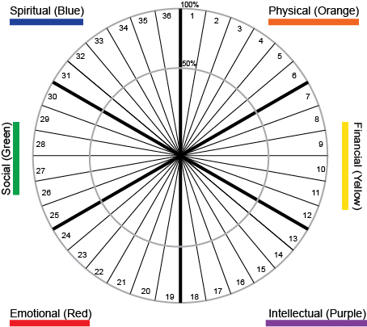
Figure 7.1 Wellness Wheel. Modified from Robertson and Microys, University of California, Irvine.

Physical: Orange  1. I eat a balanced, nutritional diet.  2. I exercise at least three times a week.  3. I take responsibility for my physical health.  4. I am generally free from illness.  5. I have annual check-ups and specific medical checks as prescribed.  6. If at all, I use tobacco, alcohol, or prescribed drugs responsibly and moderately. | Emotional: Red  19. I have a sense of control in my life and am able to adapt to change.  20. I perceive “problems” as opportunities for growth.  21. I am able to comfort or console myself when I am troubled.  22. I have a sense of fun and can laugh at myself.  23. Others would describe me as emotionally stable.  24. I believe I am responsible for my feelings and how I express them.
Financial: Yellow  7. I live within my means and take responsibility for my financial decisions.  8. My spending and saving habits reflect my values and beliefs.  9. I actively plan for periods in my life when I may not have income.  10. I pay bills on time and positively manage credit.  11. I balance present-day spending with saving for the future.  12. I have similar financial beliefs and practices as those with whom I am close. | Social: Green  25. I have at least three people with whom I have a close, trusting relationship.  26. I am able to resolve conflicts in all areas of my life.  27. I have satisfying social interactions with others.  28. I am aware and able to set and respect my own and others’ boundaries.  29. I am aware of the feelings of others and can respond appropriately.  30. I have a sense of belonging to a group or within organizations.
Intellectual: Purple  13. I enjoy learning new skills and information.  14. I have positive thoughts (low degree of negativity & cynicism).  15. I am generally satisfied with my vocation/major.  16. I commit time and energy to professional growth and self-development.  17. My work is stimulating, rewarding, and reflects my values.  18. I pursue mentally stimulating interests and hobbies. | Spiritual: Blue  31. I have a sense of meaning and purpose in my life.  32. I have a general sense of serenity.  33. I am happy with the beliefs I hold.  34. I practice prayer, meditation, or engage in some type of reflective growth.  35. Principles/ethics/morals provide guides for my life.  36. I trust others and am able to forgive others and myself.

After completing the Wellness Wheel, reflect on these questions: What are your highest and lowest categories? Are you surprised by your results? Are there any changes you want to make in your life to “balance” your Wellness Wheel? If so, make a plan and set a date to check in with yourself on your progress. Share your plan with a friend to help keep you accountable.

Understanding Stress
As a student, you’re probably plenty familiar with the experience of stress—a condition characterized by symptoms of physical or emotional tension. What you may not know is that it’s a natural response of the mind and body to a situation in which a person feels threatened or anxious. Stress can be positive (e.g., preparing for a wedding) or negative (e.g., dealing with a natural disaster).
Stress can hit you when you least expect it—before a test, after losing a job, or during a conflict in a relationship. If you’re a college student, it may feel like stress is a persistent fact of life. While stress can be good (for example, if it helps you develop skills to manage a challenging situation), a prolonged bout of it can affect your health and ability to cope with life. That’s why social support and self-care are important. They can help you see your problems in perspective and ease stressful feelings.
.

Signs and Effects of Stress
The following are all ways in which stress manifests itself:
- Disbelief and shock
- Tension and irritability
- Fear and anxiety about the future
- Difficulty making decisions
- Being numb to one’s feelings
- Loss of interest in normal activities
- Loss of appetite (or increased appetite)
- Nightmares and recurring thoughts about the event
- Anger
- Increased use of alcohol and drugs
- Sadness and other symptoms of depression
- Feeling powerless
- Crying
- Sleep problems
- Headaches, back pains, and stomach problems
- Trouble concentrating

Ways of Managing Stress
The best strategy for managing stress is by taking care of yourself in the following ways:
- Manage your time. Work on prioritizing and scheduling your commitments. This will help you feel in better control of your life, which, in turn, will mean less stress.
- Find support. Seek help from a friend, family member, partner, counselor, doctor, or clergy person. Having a sympathetic listening ear and talking about your problems and stress really can lighten the burden.
- Connect socially. When you feel stressed, it’s easy to isolate yourself. Try to resist this impulse and stay connected. Make time to enjoy being with classmates, friends, and family; try to schedule study breaks that you can take with other people.
- Slow down and cut out distractions for a while. Take a break from your phone, email, and social media.
- Avoid drugs and alcohol. They may seem to be a temporary fix to feel better, but in the long run, they can create more problems and add to your stress—instead of taking it away.
- Take care of your health.
- Eat a healthy, well-balanced diet
- Exercise regularly
- Get plenty of sleep
- Try a relaxation technique, such as meditation or yoga, or treat yourself to a massage
- Maintain a normal routine

Mindfulness, Deep Breathing, and Gratitude
Mindfulness, deep breathing, and a practice of gratitude are some of the most effective ways to manage stress and take care of your emotional health.

Mindfulness
Mindfulness means being present with your thoughts, feelings, bodily sensations, and surrounding environment. Mindfulness is also without judgment—meaning there is no right or wrong way to think or feel in a given moment. When we practice mindfulness, our thoughts tune into what we’re sensing in the present moment rather than rehashing the past or imagining the future.
Anything that keeps you present in the moment and gives your prefrontal cortex (the reasoning and thinking part of your brain) a break is practicing mindfulness. Mindfulness can mean a slow walk; looking intently at the grass, trees, flowers, or buildings; and being aware of what you are sensing and feeling. Mindfulness can be sitting quietly—even sitting still in a quiet place for as little as a few minutes can reduce heart rate and blood pressure.
Developing a practice of mindfulness is easier than you may think:
- Slow down. From brushing your teeth, to washing your face, to shampooing your hair—can you take the speed out of getting ready in the morning? Focus on the activity, pay attention to what you are doing, stay present (this means don’t think about what happened last night or what’s in store for the day, just stay focused on the activity), and take your time.
- Focus on your breath. How fast are you breathing? Is your breath coming from your chest or your belly? Can you feel the air come through your nose on the inhale? Can you slow down the exhale? Can you feel your body relax when you slow the exhale?
- Connect to your environment. Walk for a few minutes, focused on the world around you—look at the leaves on the trees or the light at the corner, listen to the sounds around you, stay with your surroundings, and observe what you see and hear around you.

Deep Breathing
When people hear mindfulness they often think of meditation. Meditation is one method of mindfulness, and there are others you can practice. Deep breathing helps lower stress and reduce anxiety. It is simple yet very powerful. A 2-4-6-8 breathing pattern is a very useful tool that can be used to help bring a sense of calm and to help mild to moderate anxiety. It takes almost no time, requires no equipment, and can be done anywhere:
- Start by quickly exhaling any air in your lungs (to the count of 2)
- Breathe through your nose, inhale to the count of 4
- Hold your breath for a count of 6
- Slowly exhale through your mouth to the count of 8
This is one round. Do not repeat the quick exhale again. Instead start round two with an inhale through your nose to the count of 4, hold for 6, and exhale to 8. Repeat for three more rounds to relax your body and mind. With practice, 2-4-6-8 breathing will become a useful tool for times when you experience tension or stress.

Gratitude
Too often people think it is the external factors that bring us joy and happiness when it’s related to internal work. A healthy emotional self-care practice, called gratitude journaling, involves writing down a list of 2-3 things you are thankful for each day. These can be good experiences you have had or when you see something that makes you smile. Thinking about what experiences feel good and why can reduce stress, improve your positivity and self-esteem, and help you relax.

Seeking Help
As previously stated, experiencing stress as a college student is common. However, if the coping techniques outlined above are not helpful, you may want to seek professional help. Some students may feel uncomfortable or embarrassed about speaking to a counselor, but asking for help is good self-care and should not be stigmatized. The Counseling and Psychological Services (CAPS) Center at GGC is available to all current students (See the GGC Campus Resource List for how to contact CAPS). CAPS offers individual and group counseling and crisis assistance. CAPS services are free for current students and confidential between you and your counselor.

Activity 2: Healthy Coping Mechanisms

Checkpoint Exercises
Stress coping mechanisms can be healthy (examples: meditation, journaling, exercise, relaxing with friends) and unhealthy (examples: binging a show to avoid a problem, overindulging in food or alcohol, getting too much or too little sleep). Using the prompts below, reflect on unhealthy and/or unhelpful ways you respond to stress and make a plan to improve these.
- Identify at least three things you currently do to cope with stress that aren’t working or aren’t good for you.
- Identify healthy replacements for each of them, and write yourself a “stress-relief prescription” that you plan to follow for one week. Try to include one stress management technique to use every day. At the end of the week, respond to the following prompts in a short reflection (200-500 words): Which ineffective or unhealthy coping strategies did you set out to change and why? Which healthy stress-relief techniques did you try during the week and how effective were they?

Questions for Reflection
- Why is managing your mental health important? How could neglecting your mental health impact your academic success?
- Consider different stress coping mechanisms discussed in this chapter. Which of these are you most likely to use? Explain your choice.

Associated Videos
- Macmillan Learning. (2020, Jun 10). Wellness: Self Care and Adaptive Coping [Video]. Youtube. https://www.youtube.com/watch?v=F3qucBq_CFo
- Macmillan Learning. (2020, Jun 10). Mindfulness Exercise #3: Deep Breathing [Video]. Youtube. https://www.youtube.com/watch?v=TYnUTiHRzag
- Tedx Talks. (2015, Jun3). Shedding Light on Student Depression [Video]. Youtube. https://www.youtube.com/watch?v=ur8TZf6HWSs&t=1s

References
Robertson, R. and Microys, G. (2001) Life Balance Assessment and Action Planning Guide, Your Guide to the Wellness Wheel. Lutheran Social Services of Michigan.

Attributions
- Parts of this chapter were adopted and modified from "Learning Framework: Effective Strategies for College Success " by Heather Syrett, OER Commons, ISKME is licensed under CC BY-NC-SA 4.0 / A derivative from the original work
- Parts of this chapter were adopted and modified from "Blueprint for Success in College and Career" by Dave Dillon, OER Commons, ISKME is licensed under CC BY 4.0 / A derivative from the original work
- Parts of this chapter were adopted and modified from "College Success" by Amy Baldwin, OpenStax, Rice University is licensed under CC BY 4.0 / A derivative from the original work
- Figure 7.1. Activity 1 Graphic, Created by Jennifer Hurst-Kennedy, was adopted and modified from "Life Balance Assessment and Action Planning Guide, Your Guide to the Wellness Wheel" by Robertson and Microys, University of California, Irvine is licensed under CC BY 4.0 / A derivative from the original work

Chapter 8: Major Exploration and Understanding Academic Program Plans

Summary
This chapter will help you develop personal skills and identify the resources, tools, and support people to help you make sense of your choices and formulate a personal academic and career plan. We will also consider how to take those first steps toward making your plan a reality and what to do if or when you realize you are off track from where you had hoped to be. Students can anticipate increased freedom of choice in college and the ability to begin to piece together how their values, interests, and developing knowledge and skills will unfold into a career that meets their goals and dreams.

Learning Objectives
After reading this chapter, you will be able to:
- Use your personal values to guide your decision-making, set short-term goals that build toward a long-term goal, and plan how you will track progress toward your goals
- List the types of college certificates, degrees, special programs, and majors you can pursue, as well as general details about their related opportunities and requirements
- Take advantage of resources to draft and track an academic plan
- Recognize decision-making and planning as continuous processes, especially in response to unexpected change

Values—What are They, and Why Are They Important?
Values are the basic beliefs that guide our thinking and actions. Whether we are consciously aware of them or not, values influence both our attitudes and our actions. They help us determine what is important and what makes us happy. It is important to think about and reflect on your values, especially as you make decisions.
Another way to recognize the important influence of values is to consider if you have ever made a decision that you later regretted. Did you reflect on your values prior to making that choice? Sometimes others ask us to do things that are inconsistent with our values. Knowing what you value and making plans accordingly is an important effort to help you stay on track toward your goals.

Activity 1: Determining Your Values

Checkpoint Exercise
To begin to identify some of your personal values, consider the examples listed below. As a first step, select the five that you find most important, that bring you the greatest happiness, or that make you feel the proudest. Then, rank those five values in order of importance. Feel free to write in other options that are relevant to you.
Achievement | Efficiency | Hard Work | Positivity
Adventure | Empathy | Health | Security
Ambition | Equality | Honesty | Selflessness
Balance | Excellence | Honor | Service
Belonging | Exploration | Humility | Simplicity
Calm | Fairness | Independence | Spontaneity
Challenge | Faith | Intelligence | Stability
Commitment | Family | Joy | Strength
Community | Fitness | Justice | Success
Competition | Flexibility | Love | Trustworthiness
Contribution | Freedom | Loyalty | Understanding
Control | Friends | Making a Difference | Uniqueness
Creativity | Fun | Merit
Curiosity | Generosity | Openness
Dependability | Growth | Originality
Diversity | Happiness | Perfection

Goals and Planning
Have you ever put together a jigsaw puzzle? Many people start by looking for the edge and corner pieces to assemble the border. Some will then group pieces with similar colors, while others just try to fit in new pieces as they pick them up. Regardless of strategy, a jigsaw puzzle is most easily solved when people have a picture to reference. When you know what the picture should look like, you can gauge your progress and avoid making mistakes. If you were to put a puzzle together facedown (cardboard side up, rather than picture side up), you could still connect the pieces, but it would take you much longer to understand how it should fit together. Your attempts, beyond the border, would be mostly by trial and error. Pursuing anything without goals and a plan is like putting together an upside-down puzzle. You can still finish, or get to where you are meant to be, but it will take you much longer to determine your steps along the way.

Long-Term Goals
You might assume that short-term and long-term goals are different goals that vary in the length of time they take to complete. Given this assumption, you might give the example of a long-term goal of learning how to create an app and a short-term goal of remembering to pay your cell phone bill this weekend. These are valid goals, but they do not exactly demonstrate the intention of short- and long-term goals for the purposes of effective planning.
Instead of just being bound by the difference of time, short-term goals are the action steps that take less time to complete than a long-term goal, but that help you work toward your long-term goals. To determine your best degree option, it might make sense to do some research to determine what kind of career you are most interested in pursuing. Or, if you recall that short-term goal of paying your cell phone bill this weekend, perhaps this short-term goal is related to a longer-term goal of learning how to better manage your budgeting and finances.

Setting Long- and Short-Term Goals
Sunil’s story provides an example of effective goal setting. While meeting with an academic advisor at his college to discuss his change of major, Sunil was tasked with setting long- and short-term goals aligned with that major. He selected a degree plan in business administration, sharing with his advisor his intention to work in business and hopefully human relations in particular. His advisor discussed with him how he could set short-term goals that would help his progress on that plan. Sunil wondered if he should be as specific as setting short-term goals week by week or for the successful completion of every homework assignment or exam. His advisor shared that he could certainly break his goals down into that level of specificity if it helped him to stay focused but recommended that he start by outlining how many credits or courses he would hope to complete. Sunil drafted his goals and planned to meet again with his advisor in another week to discuss.
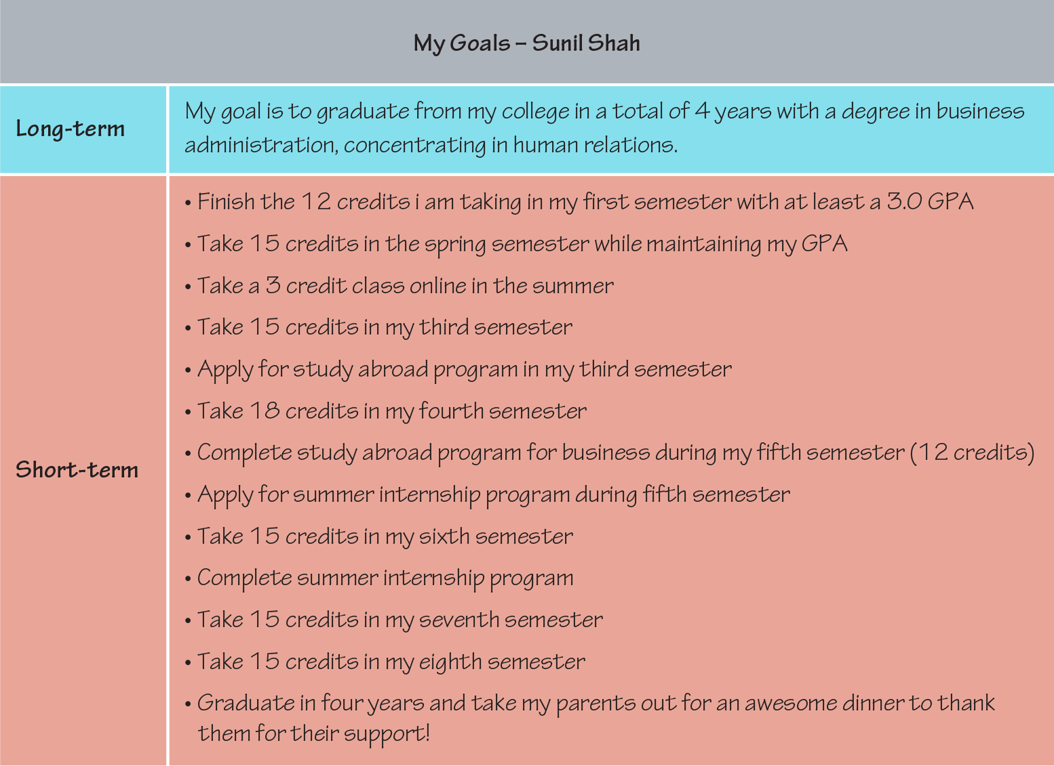
Figure 8.1 Goal Setting Illustration

Planning for Adjustments
A helpful goal-setting model known as SMART goals (Specific-Measurable-Attainable-Relevant—Time-based) stipulates that goals should be both measurable and attainable. Far too often, however, we set goals with the best of intentions but then fail to keep track of our progress or adjust our short-term goals if they are not helping us to progress as quickly as we would like. When setting goals, the most successful planners also consider when they will evaluate their progress. At that time, perhaps after each short-term goal should have been met, they may reflect on the following:
- Am I meeting my short-term goals as planned?
  - If so, celebrate!
  - If not, you may want to additionally consider:
- Are my short-term goals still planned across time in a way where they will meet my long-term goals?
  - If so, continue your path.
  - If not, reconsider the steps you need to take to meet your long-term goal. If you have gotten off track or if you have learned that other steps must be taken, set new short-term goals with timelines appropriate to each step. You may also want to seek some additional advice from others who have successfully met long-term goals that are like your own.
- Are my long-term goals still relevant, or have my values changed since I set my goals?
  - If your goals are still relevant to your interests and values, then continue your path, seeking advice and support as needed to stay on track.
  - If your goals are no longer relevant or aligned with your values, consider setting new goals.
While departing from your original goals may seem like a failure, taking the time to reflect on goals before you set them aside to develop new ones is a success. Pivoting from one goal to new, better-fitting goal involves increased self-awareness and knowledge about the processes surrounding your specific goal (such as the details of a college transfer, for example). With careful reflection and information seeking, your change in plans may even demonstrate learning and increased maturity!

Types of Degrees
To set goals for your academic and career path, you must first understand the options available for you to pursue and the requirements you will need to meet. The next section provides an overview of academic programs and college degrees that are common among many colleges and universities in the United States. Please note that each institution will have its own specific options and requirements, so the intention of this section is both to help you understand your opportunities and to familiarize you with language that colleges typically use to describe these opportunities. After reviewing this section, you should be better able to formulate specific questions to ask at your school or be better prepared to navigate and search your own college’s website.
Whereas in most states high school attendance through the 12th grade is mandatory, or compulsory, a college degree may be pursued voluntarily. There are fields that do not require a degree. Bookkeeping, computer repair, massage therapy, and childcare are all fields where certification programs—tracks to study a specific subject or career without need of a complete degree—may be enough.
However, many individuals will find that an associate’s or bachelor’s degree is a requirement to enter their desired career field. According to United States Census data published in 2017, more than one-third of the adult population in the country has completed at least a bachelor’s degree, so this may be the degree that is most familiar to you.

Questions to consider:
- What types of college degrees or certifications can I pursue?
- What is the difference between majors and minors?
- How do preprofessional programs differ from other majors?
- Do some majors have special requirements beyond regular coursework?

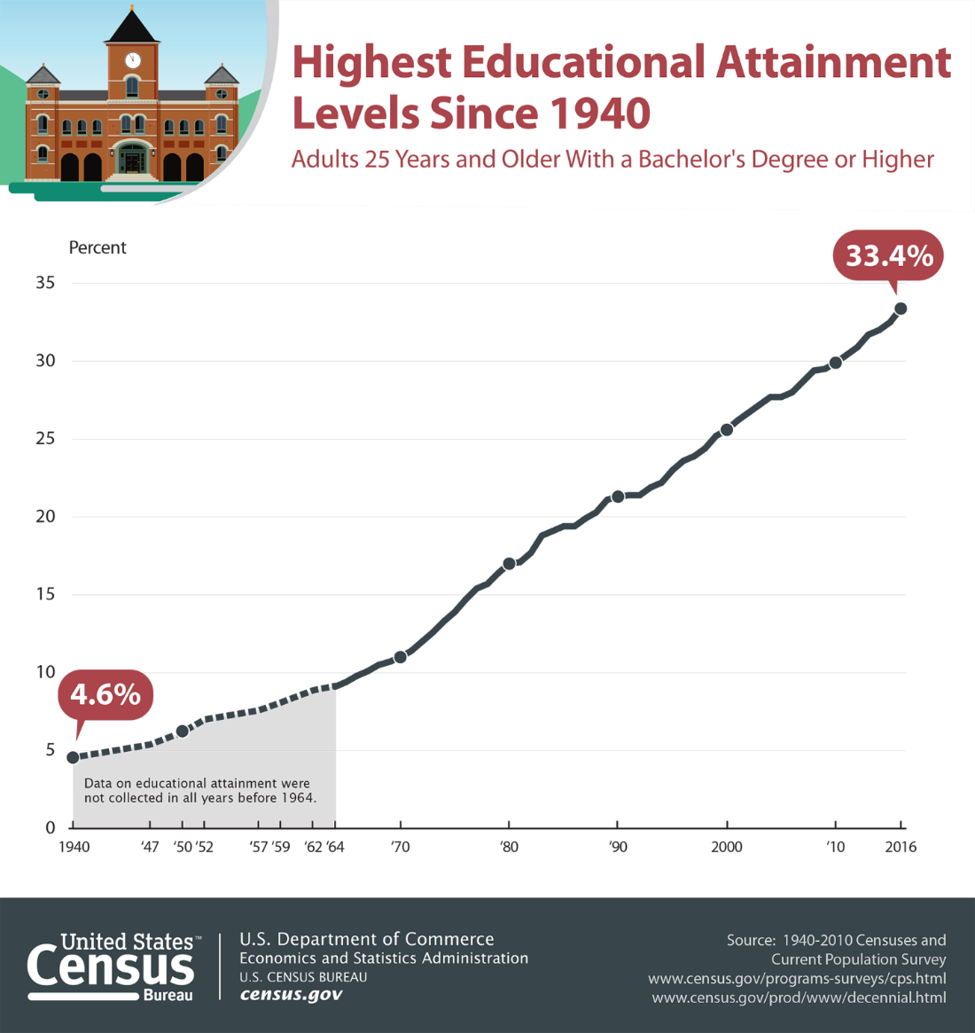
Figure 8.2 Educational Attainment Levels

Not every job requires a bachelor’s degree, and some require even higher degrees or additional specialized certifications. As you develop your academic plan, it is important to research your field of interest to see what requirements might be necessary or most desirable.

Require associate degrees | Require Bachelor’s Degrees | Require Additional Certifications | Require Graduate Degrees
Radiology Technician | Nurse | Public School Teacher | Lawyer
Dental Hygienist | Computer/Information Systems Manager | Accountant | College or University Professor
Web Developer | Airline Pilot | Financial Advisor | Pharmacist
Graphic Designer | Electrical Engineer |  | Marriage and Family Therapist
Automotive Technician | Construction Manager |  | Occupational Therapist
Table 8-1 Sample Jobs by Minimum Degree Qualification2

Associate degrees
To enter an associate degree program, students must have a high school diploma or its equivalent. Associate degree programs may be intended to help students enter a technical career field, such as automotive technology, graphic design, or entry-level nursing in some states. Such technical programs may be considered an Associate of Applied Arts (AAA) or Associate of Applied Science (AAS) degrees, though there are other titles as well.
Other associate degree programs are intended to prepare a student with the necessary coursework to transfer into a bachelor’s degree program upon graduation. These transfer-focused programs usually require similar general education and foundational courses that a student would need in the first half of a bachelor’s degree program. Transfer-focused associate degrees may be called Associate of Arts (AA) or Associate of Science (AS), or other titles, depending on the focus of study.

Bachelor’s Degrees
When someone generally mentions “a college degree,” they are often referring to the bachelor’s degree, or baccalaureate degree. Because it takes four years of full-time attendance to complete a bachelor’s degree, this degree is also referred to as a “four-year degree.” Similar to an associate degree, to enter a bachelor’s degree program a student must have completed a high school diploma or its equivalent. Both associate degrees and bachelor’s degrees are considered undergraduate degrees, thus students working toward these degrees are often called undergraduates. A student with an associate degree may transfer that degree to meet some (usually half) of the requirements of a bachelor’s degree; however, completion of an associate degree is not necessary for entry into a bachelor’s degree program.
A bachelor’s degree is usually completed with a minimum of 120 credits, or approximately 40 courses. Some specialized degree programs may require more credits. (If an associate degree has been transferred, the number of credits from that degree usually counts toward the 120 credits. For example, if an associate degree was 60 credits, then a student must take 60 additional credits to achieve their bachelor’s degree.)
Bachelor of Arts (BA), Bachelor of Science (BS), Bachelor of Science in Nursing (BSN), and Bachelor of Fine Arts (BFA) are the most popular degree titles at this level and differ primarily in their focus on exploring a broader range of subject areas, as with a BA, versus focusing in more depth on a particular subject, as with a BS, BSN, or BFA. Regardless of whether a student is pursuing a BA, BS, BSN, or BFA, each of these programs requires a balance of credits or courses in different subject areas. In the United States, a bachelor’s degree comprises courses from three categories: general education courses, major courses, and electives. A fourth category of courses would be those required for a minor, which we will discuss in more detail in the section on majors and minors.

Major Courses
Major courses are courses in your field of interest and provide you with the foundational knowledge required for further study in that field or with the skills necessary to enter your career. Some schools may refer to these as career studies courses. Major courses often have a series of prerequisites, or courses that must be taken in sequence prior to other courses, starting with an introductory course and progressing into more depth. Major courses usually make up about a fourth or more of a bachelor’s degree (30 credits, or approximately 10 courses). A BS or BFA degree may require more major courses than a BA degree. Colleges and universities usually require students to select a major by the time they have completed 30 total credits.

Electives
Electives are free-choice courses. Though you may have a choice to select from a menu of options to meet general education and major requirements, electives are even less restricted. Some students may be able to take more electives than others due to their choice of major or if they are able to take courses that meet more than one requirement (for example, a sociology course may be both a major requirement and a general education social science course). Some colleges intentionally allow room for electives in a program to ensure that students, particularly those students who are undecided about their major, can explore different programs without exceeding the total number of credits required to graduate with a bachelor’s degree. In other cases, students may have taken all their major courses and fulfilled their general education requirements but still need additional credits to fulfill the minimum to graduate. The additional courses taken to meet the total credit requirement (if necessary) are considered electives.

Majors and Minors
One of the most common questions an undergraduate college student will be asked is “What’s your major?” As we already noted, your major is only one part of your undergraduate (associate’s or bachelor’s) degree, but it is the part that most demonstrates your interests and possible future goals. At some point during your studies, you will be asked to decide on, or declare, a major. You may also be able to select a minor or additional concentration. Whereas a major comprises approximately 10–12 courses of a bachelor’s degree program and is required, a minor is usually 5–8 courses, is often optional, and may count toward or contribute to exceeding the total number of credits required for graduation.

Service Learning
While service learning may not be required of a specific major, you may see this special requirement for a course or as a general graduation requirement for your college or university. It’s also an excellent opportunity to try out something that interests you, something that could lead to or be part of your eventual career.
Service learning is very much like volunteering or community service. The purpose of service learning is to interact with and meet the needs of your local community. Service learning does differ from volunteering in that it is more structured to meet specific learning goals. For example, if you were engaging in service learning for an environmental science course, your activities would likely be focused on local environmental issues. Or, if you were engaging in service learning for a sociology course, you would likely be working with local community groups or organizations not only to assist these organizations, but also to observe how groups interact. Like fieldwork, service learning provides you an opportunity to observe and apply concepts learned in the classroom in a real-world setting. Students are often asked to reflect on their service-learning activities in the context of what they’ve been learning in class, so if you’re engaged in service learning, be thinking about how the activities you do relate to what you’ve learned and know.

Curriculum Maps
Many colleges and universities will provide curriculum maps, or course checklists, to illustrate the sequence of courses necessary to follow this timeline (Figure 8.3). These timelines often assume that you are ready to take college-level math and English courses and that you will be attending college as a full-time student. If placement tests demonstrate a need for prerequisite math and English coursework to get you up to speed, your timeline will likely be longer.
Many students attend college part-time, often because of family or work responsibilities. This will obviously have an impact on your completion timeline as well. Programs that have special requirements may also require that you plan for additional time. For example, it may be the case that you cannot take other courses while completing clinicals or student teaching, so you will need to plan accordingly. Alternatively, you may be able to speed up, or accelerate, your timeline to degree by taking courses during summer or winter terms. Or if you take fewer than 15 credits per semester, you can take courses during the summer terms to “make up” those credits and stay on track toward those two- or four-year graduation goals.

Activity 2: Draft an Academic Plan

Checkpoint Exercises
With the assistance of your instructor or academic advisor, find the curriculum map for your major or for an example major that you might be considering if you’re still exploring. Use the information in the curriculum map to draft an academic plan for your undergraduate degree. This plan should include both a semester-by-semester sequence of courses and a list of related activities to help you progress toward your career or graduate school goals.
Keep in mind any personal circumstances that may impact your plan (such as whether you’ll need to attend part-time or full-time). You may use the grid provided or utilize your college’s student planning software if available. For your reference, you will find the start of an example grid from a dedicated environmental science student below. Note: If your college offers courses using the quarter system rather than semesters, you may need to draft your own grid. You can find example planning grids for quarter systems online.

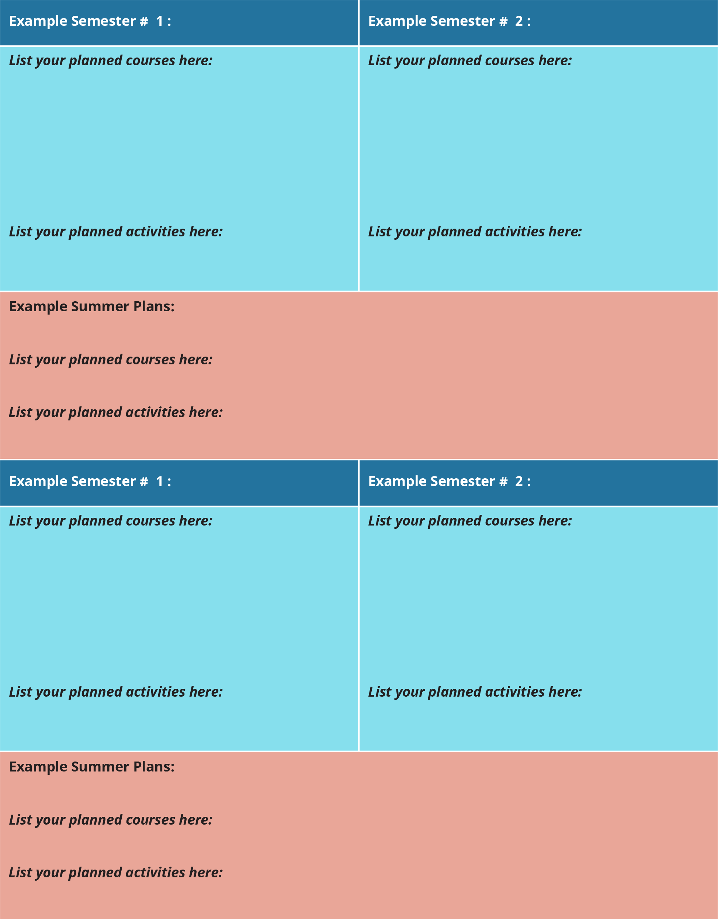
Figure 8.3 Course Planning

Questions for Reflection
- Now that you have set some goals, what is your plan to track your progress on those goals? Can you identify a time you will set aside to intentionally reflect on your progress and whether you need to set any new short-term goals or perhaps adjust your larger plans?

- How do your goals inform your plans for a particular major? Are you pretty certain about your chosen major or still exploring? What information do you need to discover to help you confirm your choice?

References
Hall, K. (2005) Alter Your Life: Overbooked, Overworked, Overwhelmed? Oak Haven Press, Georgia.
Brookdale Community College Office of Career and Leadership Development. (2016). Your Career Checklist. Retrieved from: http://www.brookdalecc.edu/career
United States Census Bureau. (2019, February 21). Number of people with Master’s and Doctoral degrees doubles since 2000. Retrieved from: https://www.census.gov/library/stories/2019/02/number-of-people-with-masters-and-phd-degrees-double-since-2000.html

Attributions
- Parts of this chapter were adopted and modified from "College Success" by Amy Baldwin, OpenStax, Rice University is licensed under CC BY 4.0 / A derivative from the original work
- Parts of this chapter have been adopted and modified from "College Success" by Open Textbook Library, University of Minnesota Libraries is licensed under CC BY-NC-SA 4.0 / A derivative from the original work

Chapter 9: Career Research

Summary
Career exploration is an ongoing process that self-reflection to better understand yourself to understand which career would be the best fit for you. In the previous chapter you learned about major exploration and in this chapter you will learn about how to start the career exploration process. In this chapter you will learn about the four phases in career exploration that will guide you in selecting the right career for you. There will also be information on how to gain experience to understand your career and make you competitive in the job market.

Learning Objectives
After reading this chapter, you will be able to:
- Identify your personality type based of off Dr. Holland’s theory.
- Explore careers that are out there based off of your personality type.
- Understand factors that affect your career choice.
- Identify how to gain experience while in college.

Phase A: Who am I?
Getting to know who you are, who you really are, is the first step to career exploration. Base your self-discovery on what you think, not what others think or want from you. This is all about you.
You are a unique with a distinct combination of likes, dislikes, personality traits, and skills. But you are not so different that you can’t be identified with certain personality types, and those types may help you narrow your career choices. When visiting your school’s career center they have a variety of tests and inventories to define your personality type.
One of the most prominent personality test on career theory is developed by Dr. John Holland. Holland's theory posits that people can be categorized according to six personality types—Realistic, Investigative, Artistic, Social, Enterprising, and Conventional—known collectively as RIASEC.
- Realistic. These people describe themselves as honest, loyal, and practical. They are doers more than thinkers. They have strong mechanical, motor, and athletic abilities; like the outdoors; and prefer working with machines, tools, plants, and animals.
- Investigative. These people love problem solving and analytical skills. They are intellectually stimulated and often mathematically or scientifically inclined; like to observe, learn, and evaluate; prefer working alone; and are reserved.
- Artistic. These people are the “free spirits.” They are creative, emotional, intuitive, and idealistic; have a flair for communicating ideas; dislike structure and prefer working independently; and like to sing, write, act, paint, and think creatively. They are similar to the investigative type but are interested in the artistic and aesthetic aspects of things more than the scientific.
- Social. These are “people” people. They are friendly and outgoing; love to help others, make a difference, or both; have strong verbal and personal skills and teaching abilities; and are less likely to engage in intellectual or physical activity.
- Enterprising. These people are confident, assertive risk takers. They are sociable; enjoy speaking and leadership; like to persuade rather than guide; like to use their influence; have strong interpersonal skills; and are status conscious.
- Conventional. These people are dependable, detail oriented, disciplined, precise, persistent, and practical; value order; and are good at clerical and numerical tasks. They work well with people and data, so they are good organizers, schedulers, and project managers.

Activity 1: Identifying Your Occupational Traits

Checkpoint Exercise
Using the descriptions above, choose the three types that most closely describe you and list them in order in the following table. Most people are combinations of two or sometimes three types. Then list the specific words or attributes that made you think you fit in that type description.
 | Occupational Type | Words and attributes that closely describe me
Primary type (the one I identify with most closely)
Secondary type
Tertiary type
Note: Your Holland occupational code is made up of the initials of the three personality types you selected, in order.

Phase B: What’s out there?
Once you have determined your occupational personality type, you can begin to explore what types of careers that best suited to you. Activity 1 is a rough beginning to find your occupational type, but you should still seek out more detailed results through your career development office. In this chapter’s module you will do further personality exploration through personality inventories. Your schools career development center is also a great resource to speak with a career counselor one on one regarding your results and how to interpret them.
The Focus 2 assessment will provide you with a profile of careers you might want to consider, but if you have not taken the Focus 2, your career development center is the best place to start on campus. Career guidance tests are based on Holland’s work. Holland studied people who were successful and happy in many occupations and matched their occupations to their occupational type, creating a description of the types of occupations that are best suited to each personality type. Just as many individuals are more than one personality type, many jobs show a strong correlation to more than one occupational type.

Occupational Options by Type
 | Ideal Environments | Sample Occupations
Realistic | - Structured  - Clear lines of authority  - Work with things and tools  - Casual dress  - Focus on tangible results or well-thought-out goals | - Contractor  - Emergency medical technician (EMT)  - Mechanic  - Military career  - Packaging engineer
Investigative | - Nonstructured  - Research oriented  - Intellectual  - Work with ideas and data | - Pharmacist  - Lab technician  - Nanotechnologist  - Geologist  - College professor
Artistic | - Nonstructured  - Creative  - Rewards unconventional and aesthetic approaches  - Creation of products and ideas | - Advertising career  - Architect  - Animator  - Musician  - Journalist
Social | - Collaborative  - Collegial  - Work with people and on people-related problems/issues  - Work as a team or community | - Teacher  - Geriatric counselor  - Correctional officer  - Coach  - Nurse
Enterprising | - Typical business environment  - Results oriented  - Driven  - Work with people and data  - Entrepreneurial  - Power focused | - Sales manager  - Banker  - Lawyer  - Business owner  - Restaurant manager
Conventional | - Orderly  - Clear rules and policies  - Consistent processes  - Work with systems to manipulate and organize data  - Control and handling of money | - Auditor  - Insurance underwriter  - Bank teller  - Office manager  - Database manager
Table 9-1 Occupational Types and Sample Careers
Use the occupational code you defined in Activity 1 to identify careers you might want to consider. Your career guidance or placement office should be a good resource for this activity.
Also review the Department of Labor’s O*Net (http://online.onetcenter.org/find) to get a deeper understanding of your occupation. For each occupation, O*Net lists the type of work, the work environment, the skills and education required, and the job outlook for that occupation. This is a truly rich resource that you should get to know.

Phase C: What Factors Might Affect My Choice?
You may now have a list of careers you want to explore. But there are other factors you will need to take into consideration as well. It is important to use your creative thinking skills to come up with alternative “right” answers to factors that may present an obstacle to pursuing the right career.
- Timing. How much time will I have to invest before I actually start making money in this career? Will I need additional degrees post bachelor’s degree? Is there a certification process that requires a specific amount of experience? If so, can I afford to wait?
- Finances. Will this career provide me with the kind of income I need in the short term and the security I’ll want in the longer term? What investment will I need to make to be successful in this field (education, tools, franchise fees, etc.)?
- Location. Does this career require me to relocate? Is the ideal location for this career somewhere I would like to live? Is it somewhere my family would like to live?
- Family/personal. How will this career affect my personal and family life? Do friends and family members who know me well feel strongly (for or against) about this career choice? How important is their input?

Phase D: Where Do I Go from Here?
It is never too early to begin thinking about your life after graduation. You have already begun to make decisions about your future when you started college. You will need to focus your studies by first choosing a focus area and a major. It is important to find opportunities to explore the career(s) that interest you. You can ensure that you are building the right kind of experience on which to base a successful career. These steps will make your dreams come to life and make them achievable.
Start by developing a relationship with your student success advisor and/or faculty mentor. Share with them your major and career goals. You can also do further exploration by meeting with the counselors in the career development center. Do not wait till the end of your degree to engage with the career development center. But these counselors can be of great help in matching your interests to a career and in ensuring you are gathering the right kind of experience to make your qualified and completive in the job market.
Keep in mind that deciding on and pursuing a career is an ongoing process. The more you learn about yourself and the career options that best suit you, the more you will need to fine-tune your career plan. Don’t be afraid to consider new ideas, but don’t make changes without careful consideration. Career planning is exciting: learning about yourself and about career opportunities, and considering the factors that can affect your decision, should be a core part of your thoughts while in college.
Experience is the third set of qualifications employers look for, and it’s the one that often stumps students. Relevant experience is not only important as a job qualification; it can also provide you with a means to explore or test out occupational options and build a contact list that will be valuable when networking for your career. But how can you gain relevant experience without experience to begin with? You should consider three options: volunteering, internships, and part-time employment.
Volunteering is especially good for students looking to work in social and artistic occupations, but students looking for work in other occupation types should not shy away from this option. You can master many transferable skills through volunteering. With a little brainstorming and an understanding of your career field, you should be able to come up with relevant volunteer experiences for just about any career.
Internships focus on gaining practical experience related to a course or program of study. Interns work for an organization or company for a reduced wage or stipend or volunteer in exchange for practical experience. A successful internship program should create a win-win situation: the intern should add value to the company’s efforts, and the company should provide a structured program in which the student can learn or practice work-related skills. Internships are typically held during summers or school vacation periods, though on occasion they can be scheduled for a set block of time each week during the course of a regular school term.
Remember that a key objective of your internship is to develop relationships you can use for mentoring and networking during your career. Befriend people, ask questions, go the extra mile in terms of what is expected of you, and generally participate in the enterprise. The extra effort will pay dividends in the future.
Part-time employment may be an option if your study schedule provides enough free time. If so, be sure to investigate opportunities in your field of study. Ask your instructors and the career guidance or placement office to help you generate job leads, even if they are not specifically in the area you want to be working in. It is valuable and relevant to hold a job designing Web sites for an advertising agency, for example, if your specific job objective is to produce event marketing. The understanding of how an advertising agency works and the contacts you make will make the experience worthwhile.
If have a job in your field of study already and are using your college experience to enhance your career opportunities, be sure to link what you are learning to what you do on the job—and what you do on the job to what you are learning. Ask your supervisor and employer about ideas you have picked up in class, and ask your instructors about the practices you can apply at work. This cross-linking will make you a much stronger candidate for future opportunities and a much better student in the short term.

Questions for Reflection
- Using your occupational type, identify a career opportunity you might be suited for that you have not yet considered.
- What factors are impacting you career choice?
- How do you plan to gain experience while attending college?

Attributions
- Parts of this chapter were adopted and modified from "College Success" by Amy Baldwin, OpenStax, Rice University is licensed under CC BY 4.0 / A derivative from the original work
- Parts of this chapter have been adopted and modified from "College Success" by Open Textbook Library, University of Minnesota Libraries is licensed under CC BY-NC-SA 4.0 / A derivative from the original work

Chapter 10: Career Readiness

Summary
In this chapter, you will learn about the difference between a job and a career. You will identify the primary types of work and which you are best suited for, as well as learn about exploring work options. Employers will look at your education, skills, and experience. Making sure you have the “right stuff” in these three areas is what you should focus on in your college experience.

Learning Objectives
After reading this chapter, you will be able to:
- Explore the benefits of a four-year college education.
- Understand the difference between work-based skills and transferable skills.
- Learn how to use jobs, internships, and volunteering.

Career Exploration
A job lets you enjoy a minimal level of financial security. It requires you to show up and do what is required of you; in exchange, you get paid. Most jobs are short-term experiences that focus on getting a specific task done as opposed to focusing on your professional development. A career involves holding jobs, but it is more a means of achieving personal fulfillment. In a career, your jobs follow a sequence that leads to increasing mastery, professional development, and personal and financial satisfaction. A career requires planning, knowledge, and skills. If it is to be a fulfilling career, it requires that you bring into play your full set of analytical, critical, and creative thinking skills to make informed decisions that will affect your life in both the short term and the long term.

What Do You Want to Do When You “Grow Up”?
The Department of Labor defines 840 occupations in its Standard Occupation Classification system—and new occupations are being created at an ever-faster rate. Just ten years ago, would anyone have imagined the job of a social media marketing specialist? How about the concept of a competitive chef? As new careers develop and old careers morph into almost unrecognizable versions of their original, it’s OK if you can’t pinpoint exactly what occupation or career will be your lifetime passion. However, it is important to define as best you can what field you will want to develop your career in, because that will help dictate your major and your course selections.
The process of career exploration can be a lot of fun, as it allows you to discover a world of possibilities. Even those students who have a clear idea of what they want to do should go through this process because they will discover new options as backups and occasionally a new direction even more attractive than their original choice. The career exploration process involves four phases.

The Transfer Ticket
Are you in a two-year program or community college? Perhaps you decided to attend your college to save some money or to be able to explore a career before committing to a four-year program. Now you may find that a bachelor’s degree is worth pursuing because it appears to be a requirement for the kind of career you want or because you will be able to boost your income opportunities. If you are thinking about transferring to a four-year program, be sure to follow these steps:
- Find out about the transfer program at your college. Most two-year colleges have a program designed to make sure you have the right kind of general education courses, electives, and courses related to your major so that you can transfer seamlessly into a junior year at a four-year institution.
- Make sure your credits are transferable. Each four-year college or university has its own policies about what kind of credits it accepts. If you are considering one or two four-year colleges, find out about their transfer policies as you lay out your plan of studies. These policies are typically described in the college catalogs. Read them carefully to ensure you can transfer most if not all your credits.
- Talk to your advisor. Now. If you haven’t met with your advisor to discuss your ideas about transferring, do so soon. Your advisor will be a great help in formulating a plan of studies that meets your requirements for your associate’s degree and maximizes your transferable credits.
- Does your college have articulation agreements? These agreements between your college and four-year institutions define specific requirements for transferring and make it easier for you to transfer from your college to the bachelor’s program in a four-year school.
If you are in a four-year college already but think your career objectives might be better filled in a program at another college, you should also go through steps two and three as soon as possible. It can save you a great deal of time, money, and heartbreak.

Skilled Labor
An important requirement for employment is skills. Many of the skills you will need are career specific: we call those work-based skills. These include knowing how to use equipment that is specific to your career and mastering processes that are used in your field. While some of these skills are learned and perfected on the job, you may be in a vocational track program (such as for homeland security officers, nurse’s aides, or paralegals) where you are learning your work-based skills.
These are not the only skills you will need to be successful. The second set of skills you must acquire have been called transferable skills because they can be used in almost all occupations. These include thinking skills, communication skills, listening skills—in fact, most of the skills for college success we have been stressing throughout this book are transferable skills because they are also key to success in life. This skill set is very broad, and your extent of mastery will vary from skill to skill; therefore, you should identify those skills that are most important to your career objective and develop and master them. Review your occupation profile on O*Net (http://online.onetcenter.org/find) to determine which skills you need to prove to potential employers you have mastered.

Activity 1: Transferable Skills Inventory

Checkpoint Exercise
In the list of forty transferable skills that follows, underline five skills you believe you have mastered and then describe specific ways in which you have used each skill successfully. Then circle five skills you think are important to your career that you have not mastered yet. Describe specific steps you plan to take to master those skills.
Active listening | Decision making | Negotiating | Researching
Active learning | Editing | Observing | Selling
Analyzing | Evaluating | Organizing | Speaking a second language
Budgeting | Forecasting | Perceiving Feelings | Supervising
Coaching | Goal setting | Persuading | Teaching
Communicating | Handling a crisis | Planning | Teamwork
Consulting | Handling details | Problem solving | Time management
Creative thinking | Manipulating numbers | Public speaking | Training
Critical thinking | Mentoring | Reading | Visualizing
Customer service | Motivating | Reporting | Writing

Skills I have mastered:
Examples of how I used them:
Skills I still need to master:
How I will master them:

Going over the list in the exercise, you will find that you have at least some experiences in many of them, but you probably haven’t thought that much about them because you use them in so many ways that you take them for granted. It is important to think about all your activities and consider the skills you have applied successfully; your transferable skills inventory is larger than you may think. For example, if you volunteer as a big brother or big sister, you have skills in active listening, mentoring, time management, and probably coaching. If you have written a college paper, you have skills in visualizing, researching, communicating, and writing.
Be aware of the ways you develop and master transferable skills. Keep a list of them and update it every month or two. That will be a valuable tool for you as you work with your career development and ultimately with job applications.

Take Advantage of Every Resource You Can While in School
Your college has a wealth of departments, programs, and people dedicated to your success. The more you work to discover and engage with these groups, the more successfully you’ll establish networks of support and build skills and knowledge for your career.
Make plans to drop by your career services or a related office early in your time in school. There, you’ll learn about events you can attend, and you’ll get to know some of the people there who can help you. The department may offer the formal assessments discussed earlier in this chapter, including aptitude testing, which can help you discover some of your areas of strength and give your insight into some high-potential career destinations. Career services may also have skills/interest inventories. These can help you match your attributes and ambitions with potential careers and suggest additional resources to explore.
Your college is also likely to have a resource that goes far beyond the campus itself: the alumni association. College alumni often maintain a relationship with the school and with their fellow graduates. Just by attending the same college, you have something in common with them.

Resumes and Profiles: The College Version
You may already have a resume or a similar profile (such as LinkedIn), or you may be thinking about developing one. Usually, these resources are not required for early college studies, but you may need them for internships, work-study, or other opportunities. When it comes to an online profile, something that is a public resource, be very considerate and intentional when developing it.

Resume
A resume is a summary of your education, experience, and other accomplishments. It is not simply a list of what you’ve done; it’s a showcase that presents the best you have to offer for a specific role. While most resumes have a relatively similar look and feel, there are some variations in the approach. Especially when developing your first résumé or applying in a new area, you should seek help from resources such as career counselors and others with knowledge of the field. Websites can be very helpful but be sure to run your résumé by others to make sure it fits the format and contains no mistakes.
A resume is a one-page summary (two, if you are a more experienced person) that generally includes the following information:
- Name and contact information
- Objective and/or summary
- Education—all degrees and relevant certifications or licenses
  - While in college, you may list coursework closely related to the job to which you’re applying.
- Work or work-related experience—usually in reverse chronological order, starting with the most recent and working backward. (Some resumes are organized by subject/skills rather than chronologically)
- Career-related/academic awards or similar accomplishments
- Specific work-related skills
While you’re in college, especially if you went into college directly after high school, you may not have formal degrees or significant work experience to share. That’s okay. Tailor the résumé to the position for which you’re applying, and include high school academic, extracurricular, and community-based experience. These show your ability to make a positive contribution and are a good indicator of your work ethic. Later, in this chapter, we’ll discuss internships and other programs through which you can gain experience, all of which can be listed on your resume. Again, professionals and counselors can help you with this.
If you have significant experience outside of college, you should include it if it’s relatively recent, relates to the position, and/or includes transferable skills (discussed above) that can be used in the role for which you’re applying. Military service or similar experience should nearly always be included. If you had a long career with one company quite some time ago, you could summarize that in one resume entry, indicating the total years worked and the final role achieved. These are judgment calls, and again you can seek guidance from experts.
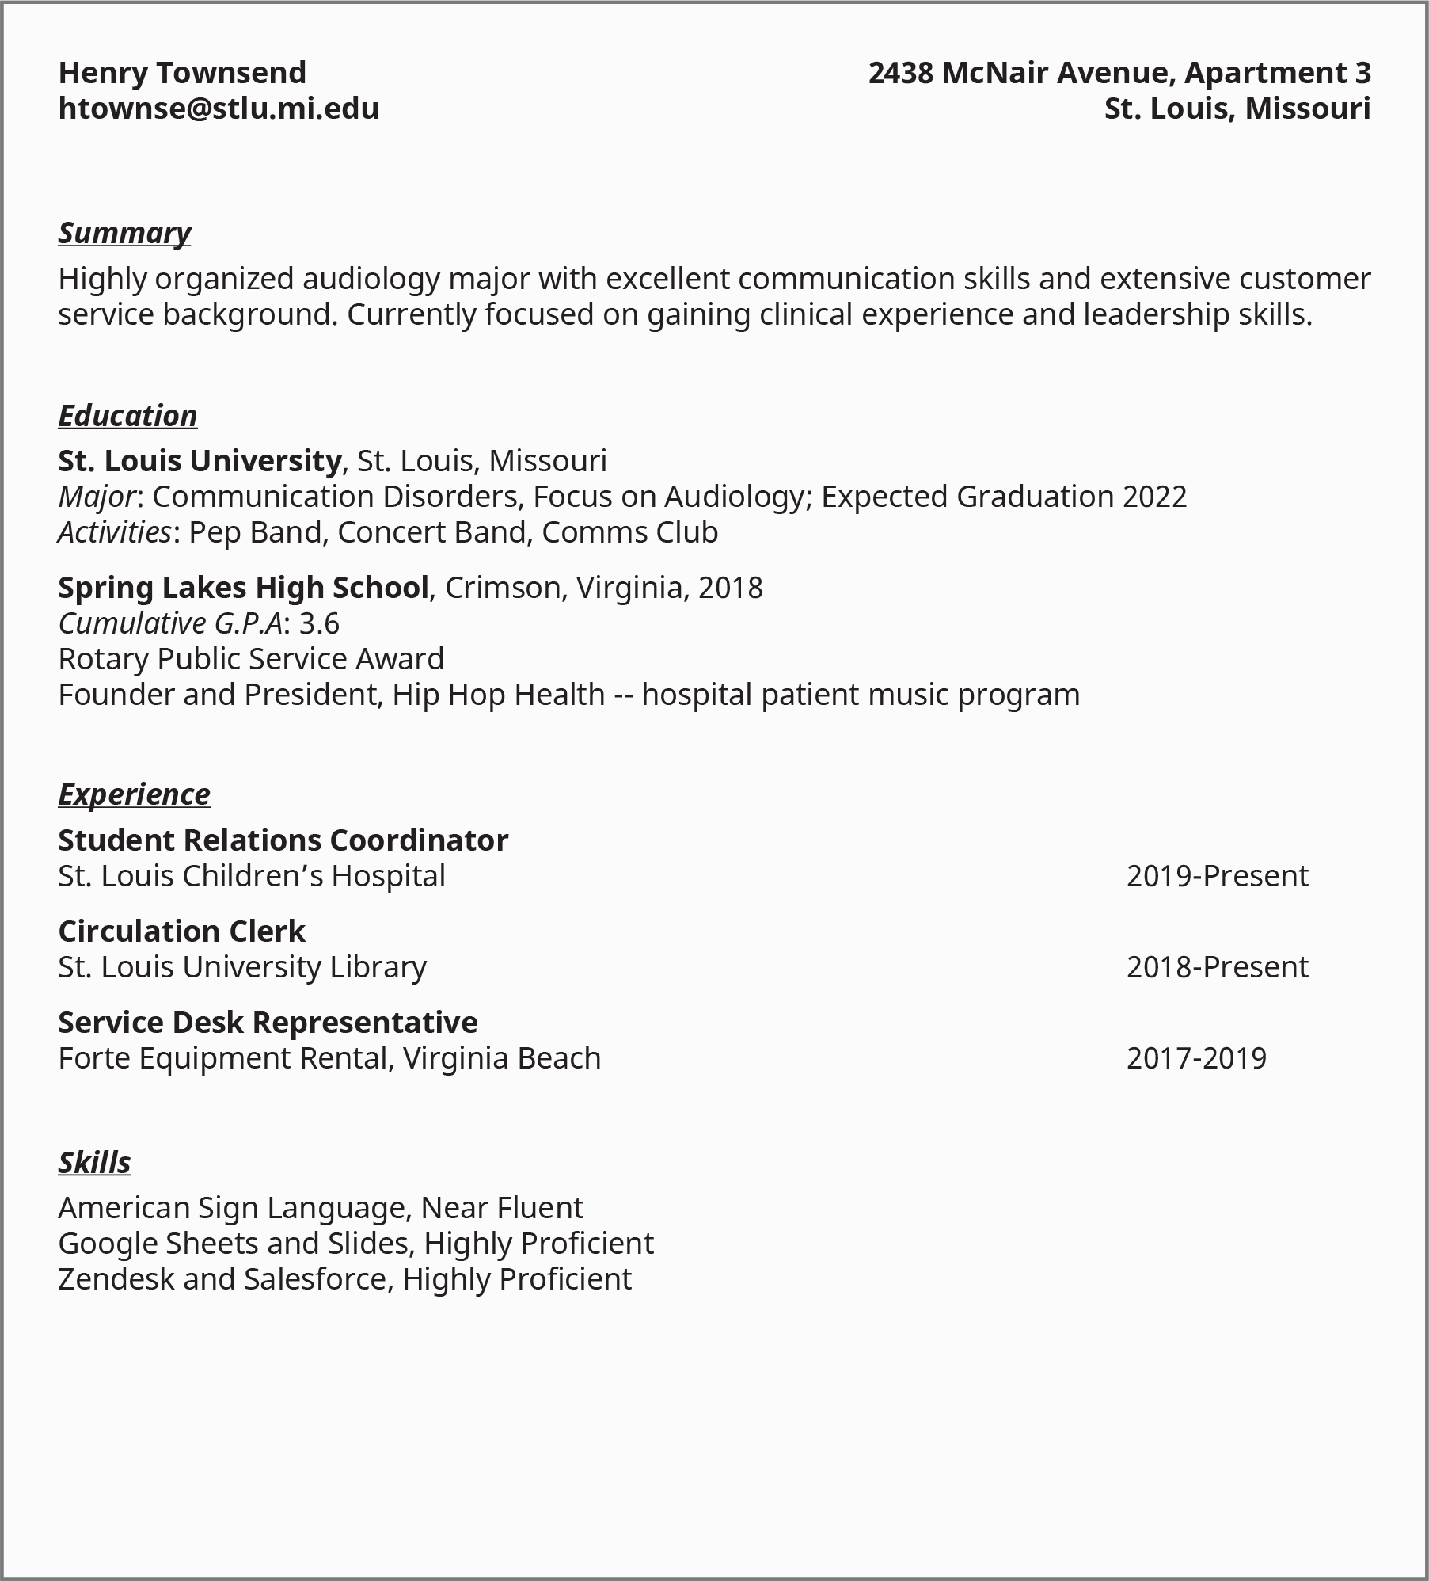
Figure 10.1 Resumes summarize your accomplishments, education, skills, and experience.

Digital Profiles
An online profile is a nearly standard component of professional job seeking and networking. LinkedIn is a networking website used by people from nearly every profession. It combines elements of résumés and portfolios with social media. Users can view, connect, communicate, post events and articles, comment, and recommend others. Employers can recruit, post jobs, and process applications. Alternatives include Jobcase, AngelList, Hired, and Nexxt. These varying sites work in similar ways, with some unique features or practices.
Some professions or industries have specific LinkedIn groups or subnetworks. Other professions or industries may have their own networking sites, to be used instead of or in addition to LinkedIn. Industry, for example, is a networking site specifically for culinary and hospitality workers.
As a college student, it might be a great idea to have a LinkedIn or related profile. It can help you make connections in a prospective field and provide access to publications and posts on topics that interest you. Before you join and develop a public professional profile, however, keep the following in mind:
- Be professional. Write up your profile information, any summary, and job/education experience separately, check for spelling and other errors, and have someone review before posting. Be sure to be completely honest and accurate.
- Your profile isn’t a contest. As a college student, you may only have two or three items to include on your profile. That’s okay. Overly long LinkedIn profiles—like overly long resumes—aren’t effective anyway, and a college student’s can be brief.
- Add relevant experience and information as you attain it. Post internships, summer jobs, awards, or work-study experiences as you attain them. Don’t list every club or organization you’re in if it doesn’t pertain to the professional field, but include some, especially if you become head of a club or hold a competitive position, such as president or member of a performance group or sports team.
- Don’t “overconnect.” As you meet and work with people relevant to your career, it is appropriate to connect with them through LinkedIn by adding a personal note on the invite message. But don’t send connection invites to people with whom you have no relationship, or to too many people overall. Even alumni from your own school might be reluctant to connect with you unless you know them relatively well.
- Professional networking is not the same as social media. While LinkedIn has a very strong social media component, users are often annoyed by too much nonprofessional sharing (such as vacation/child pictures); aggressive commenting or arguing via comments is also frowned upon. As a student, you probably shouldn’t be commenting or posting too much at all. Use LinkedIn as a place to observe and learn. And in terms of your profile itself, keep it professional, not personal.
- LinkedIn is not a replacement for a real resume.
There’s no need to rush to build and post an online professional profile—certainly not in your freshman year. But when the time is right, it can be a useful resource for you and future employers.

Questions for Reflection
- What should you consider when choosing a career?
- How do you separate career myths from reality?
- How can you build your professional portfolio to apply for jobs you want?

Attributions
- Parts of this chapter were adopted and modified from "College Success" by Amy Baldwin, OpenStax, Rice University is licensed under CC BY 4.0 / A derivative from the original work
- Parts of this chapter have been adopted and modified from "College Success" by Open Textbook Library, University of Minnesota Libraries is licensed under CC BY-NC-SA 4.0 / A derivative from the original work

Chapter 11: Financial Aid 101

Summary
Sourcing funding for tuition can be a stressful part of applying for college. Many students, particularly first-generation students, do not even know how to find resources for navigating financial aid. Though many obstacles may hinder students in achieving entry into college, not understanding financial aid should not be one of them. After they move on from their education, students must also be able to shoulder the financial burden of their student loans. The key to this is to be well-informed about loans and their obligations before accepting them.
In this chapter, you will be given an overview of what financial aid is, so that you can feel better prepared for funding your education. This will cover how to use the services that are available to you to help fund your college education. We will discuss how to navigate the Free Application for Financial Aid, learn about the differences in student loans, and determine how much money to borrow. We will also learn the differences between grants and scholarships and discover how to apply for them. This information is important to know and understand even if you are not currently receiving financial aid. The information in this chapter is a general overview. Make sure to get more information from your campus’s financial aid office and speak with a financial aid advocate one-on-one for guidance in funding your education.

Learning Objectives
After reading this chapter, you will be able to:
- Understand the importance of researching and applying for financial aid every year
- Understand how to navigate applying for FASFA
- Identify key differences among scholarships and grants, student loans, and work study programs
- Avoid excessive student loans and setting yourself up for future financial difficulties
- Understand Academic Standing Standards and Eligibility

Applying for Financial Aid
For financial aid administered by your college, only one general application form is required, along with detailed information on your financial situation (and those of your parents or guardians, if you are receiving their support). This information is collected from the student by filling out the FAFSA (Free Application for Federal Student Aid). If you have not already done this application, learn more at http://www.fafsa.ed.gov. Outside loans and scholarships are generally applied for separately.
Follow these general rules to ensure you receive any aid for which you are qualified:
- Apply to your college for financial aid every year, even if you do not receive financial aid in your first year or term. Your situation may change, and you want to always remain eligible in the future by filing the application.
- Talk to the financial office immediately if you (or your family) have any change in your circumstances.
- Complete your application accurately, fully, and honestly. Financial records are required to verify your data. Pay attention to the deadlines for all applications.
- Research possible outside financial aid based on other criteria. Many private scholarships or grants are available, for example, for the dependents of employees of certain companies, students pursuing a degree in a certain field, or students of a certain ethnic status or from a certain religious or geographical background, and the like.
- Do not pay for financial aid resource information. Some online companies try to profit from the anxieties of students about financial aid by promising to find financial aid for you for a fee. Legitimate sources of financial aid information are free.

Determine how much you should borrow
You can determine whether you need a loan and how much you need to borrow by adding up the total cost of your education (tuition, fees, room and board, etc.) and subtracting the amount of scholarships, grants, and savings you have to contribute to those costs. You should borrow only what you need and consider the earning potential in your chosen profession to determine how easily you'll be able to repay your debt. You can find salary estimates for various occupations in the U.S. Department of Labor’s Occupational Outlook Handbook at https://www.bls.gov/ooh. Your student loan payments should be only a small percentage of your salary after you graduate.

Types of Aid
It is important to understand the different aid options that are available to students to help fund their college education. The types of aid that will be overviewed are scholarship, grants, student loans, and work study.

Scholarships
A scholarship is generally awarded based on merit rather than demonstrated financial need. These merits can be based on past grades, test scores, achievements, or experiences, including personal qualifications such as athletic ability, skills in the arts, community or volunteer experiences, and so on. Scholarships are not only awarded to students with high grades. Many scholarships, for example, honor those with past leadership or community experience or the promise of future activities. Even the grades and test scores needed for academic scholarships are relative: a grade point average (GPA) that does not qualify for a scholarship at one college may earn a scholarship at another. Never assume that you’re not qualified for any kind of scholarship or grant.
Scholarships are offered through GGC and also can be found outside of the school. You can search outside of GGC through different platforms such as www.collegeboard.org

Grants
A grant is financial assistance to pay for college, which does not need to be paid back. Grants are often awarded based on demonstrated financial need. A grant may be offered by the college, a federal or state program, or a private organization or civic group. The largest grant program for college students is the federal government’s Pell Grants program. Learn more about Pell Grants and other scholarship and grant programs from your college’s financial aid office or the online resources listed later.

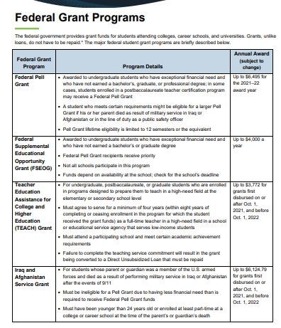
Figure 11.1 Federal Grant Programs

First, determine if you have been awarded any grants or scholarships to help cover your tuition. If you still need assistance for paying and do not have the funds to pay out of pocket you may need a student loan to help cover the cost of your education. There are two categories of student loans. They are federal student loans and private student loans. Both federal and private student loans are borrowed funds that you must repay with interest, but federal student loans usually offer lower interest rates and have more flexible repayment terms and options than private student loans.

Federal Student Loans
A federal student loan is made through a loan program administered by the federal government. There are different types of federal student loans.

- William D. Ford Federal Direct Stafford Subsidized Loan: allows students to borrow money from the federal government at a low interest rate. Interest rates are fixed based on current Federal Stafford loan rates. No repayments are due and no interest accrues until six months after the student graduates, leaves the college, or ceases to be a half-time student. Listed in Figure 11.2 is the maximum amount a student may borrow each academic year of college.
- William D. Ford Federal Direct Stafford Unsubsidized Loan: Any student, regardless of need, may borrow from the William D. Ford Federal Direct Unsubsidized Stafford Loan Program. The procedures to receive a loan are the same as for the William D. Ford Federal Direct Subsidized Stafford Loan. The annual loan limits are the same and include any funds borrowed through the guaranteed program. Repayment of the loan is deferred as long as the student is enrolled at least half-time; however, interest on the loan starts accruing from the initial disbursement date and is recommended to be paid while the student is in school. The interest can also be deferred but would be compounded to the principal of the loan.
- William D. Ford Federal Direct Parent Loan for Undergraduate Students (PLUS): This program is available to parents of dependent students. Parent borrowers may borrow from the federal government up to the cost of attendance at GGC minus other aid. The interest rate is fixed based on the current PLUS loan rates. Parents are allowed to select their loan amount. However, a credit check is required. The student will be allowed to borrow under the William D. Ford Federal Direct Unsubsidized Stafford Loan Program if the parents cannot borrow under the PLUS Loan Program.

Private Student Loans
A private student loan is a non-federal loan made by a private lender, such as a bank or credit union. The terms and conditions of private student loans are set by the lender, not the federal government. If you’re not sure whether you’re being offered a private loan or a federal loan, check with the financial aid office at your school. Federal student loans offer many benefits that don’t typically accompany private loans. These include fixed interest rates, income-based repayment plans, loan cancellation for certain types of employment, deferment (postponement) options, and interest rate reduction based on repayment method. Also, private loans usually require a credit check, while most federal loans for students do not. For these reasons, students and parents should always exhaust federal student loan options first before considering a private loan.

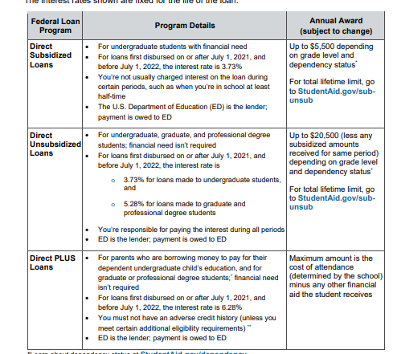
Figure 11.2 Types of Federal Loans

Work Study
Federal Work Study provides part-time jobs for undergraduate and graduate students with financial need, allowing them to earn money to help pay education expenses. The program encourages community service work and work related to the student’s course of study. Work study provides part-time employment while a student is enrolled in school. These positions are available to undergraduate, graduate, and professional students with financial need. One can be a part-time or full-time student. Students can apply for federal work study positions on the employment page searching under student opportunities.

Eligibility
General eligibility requirements to receive financial aid include that you have financial need, are a U.S. citizen or eligible noncitizen, and are enrolled in an eligible degree or certificate program at your college or career school. You can view the basic eligibility criteria on your school’s financial aid website.
It is also important to maintain your eligibility each semester to receive financial aid. You will need to make satisfactory academic progress (SAP) each semester to be eligible to continue to receive aid each semester. SAP consists of a percentage of attempted and successfully passed course credits and GPA (grade point average). Please see your school’s financial aid webpages for details.

Questions for Reflection
- How often do you need to complete a FASFA?
- What are the benefits for applying for scholarships? Where can you search for scholarships?
- What are the differences between a federal and private student loan?

Attributions
- Parts of this chapter were adopted and modified from "College Success" by Amy Baldwin, OpenStax, Rice University is licensed under CC BY 4.0 / A derivative from the original work
- Parts of this chapter have been adopted and modified from "College Success" by Open Textbook Library, University of Minnesota Libraries is licensed under CC BY-NC-SA 4.0 / A derivative from the original work

Chapter 12: Budget Planning

Summary
While attending college it is important for college students to understand the cost of attending college, their living expenses, and other expenses and have a financial plan to pay for these expenses. Financial stress is a large contributing factor to students not being able to complete their degree. It is important to have a plan to pay for college as well as living expenses to be able to complete your degree. In this chapter you will learn to identify your financial goals while in college and after graduation. You will also learn how to create a budget to manage your monthly income and expenses to accomplish these goals. While in college you may need to borrow money to pay for school with student loans, we will discuss how to create a plan to avoid building up too much debt in the process. This way you can learn how to maximize the money you do have and minimize the debt you will acquire when in college.

Learning Objectives
After reading this chapter, you will be able to:
- Identify your financial goals
- Create your own budget
- Manage your budget
- Avoid occurring excess debt while attending college

Financial Goals
Creating financial goals helps you identify what expenses are important for you to have a plan to pay for. While in college your financial goals change from what they were in high school. You now must create a plan to pay for college as we discussed in the previous semester as well as identify how you will pay for other critical expenses such as living expenses, textbooks, and materials that are required for your classes. Here are questions to ask yourself as you start to explore your financial goal:

Activity 1: Financial Reflection Questions

Checkpoint Exercise
Read the following questions and write your answers down:
- How much debt are you comfortable graduating with?
- How do you plan to spend summer break? Will you be working during this time period? Do you plan on doing a summer study abroad trip? Taking summer classes? Will you be working a paid or unpaid internship?
- Is your plan to graduate within four years? Or do you plan to take a reduced course load and graduate in more than four years?
- Where do you plan on living while attending college?

The questions above are examples of financial goals that you may want to establish while attending school. Each student has different obligations and lifestyles outside of the classroom that will impact their financial goals. In the previous chapter you learned about financial aid and the different type of aid that is available for students to pay for college. It is important to establish how you will pay for college as well as your living expenses. It is important to establish what your financial needs versus your financial wants are. This way you can identify the expenses that are critical for you to pay each month.
It is also important to see how your financial goals align with your academic goals. As a college student you have an academic goal to graduate and enter your career path. It is important to have those plans in place so you will be able to complete your degree and avoid excess debt. While it is advisable to work to graduate in four years to avoid additional fees and expenses, some people will be going to school while working full-time or acting as caregivers which might impact their time to completion. It is important to consult your advisor to create your own plan to graduate.

Budgeting
Once you have established your financial goals, creating a budget is the next step in accomplishing these goals. A budget is a guide that keeps you on the path to reach your financial goals. Budgeting keeps your finances under control, gives you a tool to evaluate your spending, and helps you determine where your money goes instead of wondering where it all went.

Budgeting helps you answer these important questions:
- What money do I have coming in?
- Where does my money go?
- Is there a way to spend less money?
- How will I handle unexpected expenses?
- How can putting money into savings help me with some of my bigger financial goals?
In addition, budgeting can help you:
- Achieve your personal, academic, career and financial goals. Writing down your financial goal is the first step in creating a plan to make them into reality. A budget will help you prepare for unexpected expenses and obstacles. Budgeting involves challenging decision-making, but setting goals makes your goals more realistic and attainable. As you create a budget, you’ll want to set short-, medium-, and long-term financial goals and track your progress toward achieving them.
- Plan, save, and control your expenses. When you set up your budget, you will be able to see whether your expenses exceed your income and then identify expenses that can be reduced. Once you are aware of your income and spending, you can make informed decisions that will help you meet your financial goals. Following a budget can help you save money for the things that really matter to you.
- Avoid debt and improve your credit. When you stick to a budget, you minimize spending more than you earn and which can help lower or reduce your debt. If you have received student loans to pay for your tuition, fees and/or living expenses, a budget will help you maximize the amount you have borrowed. A budget can also help you determine how long it will take to repay your debt and how much it will cost. If you do borrow, being able to pay what you owe on time each month will have a positive impact on your creditworthiness and your financial future.

Creating a Budget
Budgeting involves analyzing your income and expenses so you can see where your money is going and gain the tools to reflect and adjust when needed to avoid debt. At first budgeting can seem complex or time consuming, but once you have gone through the basics, you will find it is an easy and valuable tool for controlling your personal finances. Going to college changes your financial situation and there are many new expenses that go along with attending college, such as, paying for books, access codes and required class materials. Without establishing a budget, you risk spending more money than you have coming in. It is important to create a budget so you can manage your money coming in and coming out while attending college. You do not want financial stress to impact your ability to focus on your academics and do well in your classes.
Creating a budget is a process that requires you to track your monthly income and expenses within a monthly period. In your monthly budget you need information for the following 3 categories:
- Your income what you earn. Income traditionally comes from employment. When listing your income for your monthly budget, you should use your net pay, the amount that you receive after taxes and other deductions. Other types of income that you may receive are from various types of support, scholarships, grants or student loans.

- Fixed Expenses what you spend that remains the same in price each month. Rent, insurance costs, and utilities (power, water) are fixed: they cost about the same every month and are predictable based on your arrangement with the provider.

- Flexible Expenses what you spend throughout the month which can very month to month. I.e. Going out to eat. You have a good degree of control over your flexible expenses. You can begin organizing your expenses by categorizing each one as either fixed or variable.

Here are several examples of budgeting systems that you may find helpful:

Envelope method: The envelope budgeting system divides your income into different spending categories—bills, groceries, gas, and so on. Once you've decided how much you should spend on each category, you'll take that amount in cash and place it into an envelope. Then, only spend what's available in that envelope for that category's bills or purchases. The aim is to prevent you from overspending by limiting what is available to spend. More information is available here at The Balance website

Zero-Based budget: This budgeting method is best for people who have a set income each month or at least can reasonably estimate their monthly income. After calculating your monthly income, add up your monthly spending and savings to equal that income amount.

50/30/20 budget: The 50/30/20 budgeting method is straightforward and requires less work than the zero-based and envelope budgets. The idea is to break down your expenses into three categories:
- Necessary expenses (50%)
- Discretionary expenses (30%)
- Savings and debt payments (20%)

Balancing Your Budget
Balancing your budget requires you to track your income and expenses monthly and then review your balance. Set a day in your calendar to review your budget each month. Items to review when balancing your budget are: did you spend more than you earned, or did you have money left over? If you spent more than you earned, what expenses can you cut down or spend less next month? If you have money left over create a plan on how to save it.

How do I balance a job and school?
For some students, working while in college is a necessity; for others, it is a way to build a résumé or earn extra money. Whatever the reason, it's important to learn how to balance your time while attending school.
If you have a job, determine how many hours a week you’ll be able to work and still be able to stay on track with school demands. For example, if you want to earn more money and potentially reduce your need for student loans (or reduce the amount that you borrow), then you could consider working more hours. Managing a schedule with limited free time is an excellent way to prepare for your future. But remember, you may also need to take fewer classes to accommodate your work schedule. Keep in mind that part-time enrollment will delay your graduation, postpone your ability to earn a higher income, and possibly impact your eligibility for some federal aid. Tuition and fees may also be higher for part-time enrollment.
You may opt to work fewer hours and maximize the benefit of your student loans by taking a heavier class load instead of the minimum requirements. By taking extra classes, you may be able to graduate earlier. Alternatively, you may find that taking classes during the summer leaves you better able to balance work and school during the academic year and still stay on track to graduate on time. Keep in mind that the longer it takes to complete your program of study, the more you will pay in total.

Make More or Spend Less?
This is a common question that college students face. When you are committing to your college education you typically will need to work less to be a full-time student. The rule is for every hour you spend in the classroom you need to set aside at least 2 hours to study. For a full-time student with 12-15 credit hours, you will be spending 12 hours a week in the classroom and 24 hours of classwork outside of class time. This is a total of 36 hours a week, the same amount of time that you would spend in a full-time job. It is very hard to have time to work more than 20 hours a week with a full-time schedule. This means that you will have less income coming in so you will need to set up a realistic budget and sticking to it so you do not overspend and enter into debt. A budget is simply the best way to balance the money that comes in with the money that goes out.
For most college students, the only way to increase the “money coming in” side of the budget is to work. Even with financial support from your family, financial aid from the college, your savings from past jobs, and the like, you will still need to work if all your resources do not equal the “money going out” side of the budget. The major theme of this chapter is avoiding debt except when necessary to finance your education.
It is important to point out that working too much can have a negative impact by taking up time you might need for studying. It’s crucial, therefore, whenever you think about your own financial situation and the need to work, to also think about how much you need to work—and consider whether you would be happier spending less if that meant you could work less and focus more on school.

What should I know about budgeting after I leave school?
Your expenses will change after you leave school. For example, if you recently graduated, you usually won’t be required to begin paying off your student loans for six months, but when that payment is added to your monthly expenses, it will have a big impact on your budget. Federal student loan borrowers can choose between two categories of repayment plans:
Time-based repayment – This option offers a 10 or 25-year repayment with a fixed interest rate for the life of the loan. Paying off a loan in 10 years will typically result in the smallest amount of repayment.
Income-based repayment – these plans base the monthly payments on a family size and a percentage of the individual’s discretionary income. The payments will change annually depending on these factors. Every year, borrowers must recertify their income and household size for the program.
Public Service Loan Forgiveness Program – While not a repayment category in itself, the PSLF program is designed to encourage borrowers to go into potentially lower-paying public service jobs by offering loan balance forgiveness. Eligible borrowers can have their remaining debt erased if they make 120 payments—which don’t need to be consecutive.
When you leave school, you’ll want to update your budget to include student loan payments, as well as your new income and living costs. Leaving school can be an exciting (and stressful) time, but you don’t want to stop tracking and managing your finances.
As you move through changes in your life, you'll need to constantly reevaluate your income and expenses. Your goals will change as well. You may want to buy a car, get married, have children, continue your education, or start a business, and all these activities affect your budget in some way. Think of your budget as a living document. You have the power to revise it at any time to keep track of your finances and reach your goals.

Questions for Reflection
- What system can you use to create a budget and maintain it?
- What are ways that you can save money and expenses while attending classes?
- Is it important for you to take more classes to graduate in 4 years? Or you should take less classes are graduate in 5-6 years?

Attributions
- Parts of this chapter were adopted and modified from "College Success" by Amy Baldwin, OpenStax, Rice University is licensed under CC BY 4.0 / A derivative from the original work
- Parts of this chapter were adopted and modified from "Budgeting " by Federal Student Aid is licensed under CC BY-ND 4.0

Chapter 13: Understanding Diversity and Cultivating Cultural Competence

Summary
In this chapter you will learn about diversity and how it plays a role in personal, civic, academic, and professional aspects of our lives. You also will learn some ways to cultivate your cultural competence—the ability to value diversity and effectively engage in discussions and situations with people from various backgrounds, identity positions, and perspectives. As technology and transportation reduce the distances between us, it is increasingly important to communicate clearly, respectfully, and with an appreciation that for differences that can enrich and strengthen communities. Understanding diversity, especially in the context of our country’s history, is an important part of being an engaged citizen who can help us to adapt to a changing world. Diversity goes hand in hand with the concepts of equity and inclusion, which increase the chances of equal opportunity and representation.

Learning Objectives
After reading this chapter, you will be able to:
- Understand the importance of including and actively listening to a wide variety of voices in a given conversation
- Describe categories of identity and experience that contribute to diverse points of view
- Explain concrete ways to appreciate and learn from diverse individuals and perspectives

Student Profile
“For the vast majority of my life, I thought being an Asian-American—who went through the Palo Alto School District—meant that I was supposed to excel in academics. But, in reality, I did the opposite. I struggled through college, both in classes and in seeking experiences for my future. At first, I thought I was unique in not living up to expectations. But as I met more people from all different backgrounds, I realized my challenges were not unique.

“I began capturing videos of students sharing their educational issues. Like me, many of my peers lack the study skills required to achieve our academic goals. The more I researched and developed videos documenting this lack of skill, the more I realized that student identities are often lost as they learn according to a traditional pedagogy. I began documenting students’ narratives and the specific strategies they used to overcome difficulty. Once we can celebrate a diverse student body and showcase their strengths and identities as well as the skills necessary to excel academically, my hope is that students of all backgrounds can begin to feel that they belong.”

—Henry Fan, Foothill College and San Jose State University

What Would Shakespeare Say?
Figure 13.1 William Shakespeare
In our classroom, everyone is the same…
Consider a classroom containing 25 college students and their instructor. In this particular class, all of the students and the instructor share the same racial group—White. In fact, everyone in the class is a White American from the Midwest.
The instructor is leading the class through reading a scene from William Shakespeare’s drama Romeo and Juliet. As students read their parts, each one is thinking carefully about the role he or she has been given.
One of the male students wonders what it would be like to read the part of Juliet; after all, men originally played the part in Shakespeare’s day. The young woman reading Juliet wonders if anyone would object to her taking the role if they knew she was a lesbian. What would it be like, she wonders, if Romeo, her love interest, were also played by a woman? One reader strongly identifies as German American, but he is reading the part of an Italian. Another student has a grandmother who is African American, but he looks like every other White student in the room. No one recognizes his mixed-race heritage.
After the students finish reading the scene, the instructor announces, “In our classroom, everyone is the same, but these days when Shakespeare is staged, there is a tendency for nontraditional casting. Romeo could be Black, Juliet could be Latina, Lady Montague could be Asian. Do you think that kind of casting would disrupt the experience of seeing the play?”
In this case, the instructor assumes that because everyone in the class looks the same, they are the same. What did the instructor miss about the potential for diversity in his classroom? Have you ever made a similar mistake?
Diversity is more than what we can recognize from external clues such as race and gender. Diversity includes many unseen aspects of identity, like sexual orientation, political point of view, veteran status, and many other aspects that you may have not considered. To be inclusive and civil within your community, it is essential that you avoid making assumptions about how other people define or identify themselves.
In this chapter we will discover that each person is more than the sum of surface clues presented to the world. Personal experience, social and family history, public policy, and even geography play a role in how diversity is constructed. We’ll also explore elements of civility and fairness within the college community.
One important objective of civility is to become culturally competent. Culturally competent people understand the complexity of their own personal identity, values, and culture. In addition, they respect the personal identities and values of others who may not share their identity and values. Further, culturally competent people remain open-minded when confronted with new cultural experiences. They learn to relate to and respect difference; they look beyond the obvious and learn as much as they can about what makes each person different and appreciated.

Activity 1A: DEI Pre-Reading Reflection

Checkpoint Exercise
How do you feel about diversity, equity, and inclusion (DEI)? These questions will help you determine how the chapter concepts relate to you right now. As you are introduced to new concepts and practices, it can be informative to reflect on how your understanding changes over time. We’ll revisit these questions at the end of the chapter to see whether your feelings have changed. Take this quick survey to figure it out, by ranking questions on a scale of 1–4, 1 meaning “least like me” and 4 meaning “most like me.”

- I'm aware of the different categories of diversity and the various populations I may encounter.
- I think we sometimes go too far in trying to be sensitive to different groups.
- I think nearly everybody in our society has equal opportunity.
- It’s not my role to ensure equity and inclusiveness among my peers or colleagues.

What Diversity Really Means and Why It Matters
Differences among people may involve where a person was born and raised, the person’s family and cultural group, factual differences in personal identity, and chosen differences in significant beliefs. Some diversity is primarily cultural, involving shared beliefs and behaviors (gender, ethnicity), other diversity may be biological (race, age, sex), and some diversity is defined in personal terms (sexual orientation, religion). Diversity generally involves things that may significantly affect some people’s perceptions of others—not just any way people happen to be different. For example, having different tastes in music, movies, or books is not what we usually refer to as diversity.
When discussing diversity, it is often difficult to avoid seeming to generalize about different types of people—and such generalizations can seem similar to dangerous stereotypes. Category descriptions are meant only to suggest that individuals are different from other individuals in many possible ways and that we can all learn things from people whose ideas, beliefs, attitudes, values, backgrounds, experiences, and behaviors are different from our own. This is a primary reason why college admissions departments frequently seek diversity in the student body.

Figure 13.2 US Embassy – Late February – The Year 12 History class at Pakuranga College and Ambassador Huebner
But why is diversity so important? There are many reasons:
- Experiencing diversity at college prepares students for the diversity they will encounter the rest of their lives. Learning to understand and accept people who are different from ourselves is very important in our world. While many high school students may not have met or gotten to know well many people with different backgrounds, this often changes in college. Success in one’s career and future social life also requires understanding people in new ways and interacting with new skills. Experiencing diversity in college assists in this process.
- Students learn better in a diverse educational setting. Encountering new concepts, values, and behaviors leads to thinking in deeper, more complex, and more creative ways, rather than furthering past ideas and attitudes. Students who experience the most racial and ethnic diversity in their classes are more engaged in active thinking processes and develop more intellectual and academic skills (and have higher grade point averages) than others with limited experience of diversity.
- Attention to diversity leads to a broader range of teaching methods, which benefits the learning process for all students. Just as people are different in diverse ways, people from different backgrounds and experiences learn in different ways. College teaching has expanded to include many new teaching techniques. All students gain when instructors make the effort to address the diverse learning needs of all students.
- Experiencing diversity on campus is beneficial for both minority and majority students. Students have more fulfilling social relationships and report more satisfaction and involvement with their college experience. Studies show all students on campus gain from diversity programs. All the social and intellectual benefits of diversity cited in this list hold true for all students.
- Diversity experiences help break the patterns of segregation and prejudice that have characterized American history. Discrimination against others—whether by race, gender, age, sexual orientation, or anything else—is rooted in ignorance and sometimes fear of people who are different. Getting to know people who are different is the first step in accepting those differences, furthering the goal of a society free of all forms of prejudice and the unfair treatment of people.
- Students of a traditional college age are in an ideal stage of development for forming healthy attitudes about diversity. Younger students may not yet have reached a point at which they can fully understand and accept very different ideas and behaviors in others. The college years are a time of growth and maturation intellectually, socially, and emotionally, and a sustained experience of diversity is an opportunity to heighten this process.
- Experiencing diversity makes us all better citizens in our democracy. When people can better understand and consider the ideas and perspectives of others, they are better equipped to participate meaningfully in our society. Democratic government depends on shared values of equality and the public good. An attitude of “us versus them,” in contrast, does not further the public good or advance democratic government. Studies have shown that college graduates with a good experience of diversity generally maintain patterns of openness and inclusivity in their future lives.
- Diversity enhances self-awareness. We gain insights into our own thought processes, life experiences, and values as we learn from people whose backgrounds and experiences are different from our own.
- Diversity encourages broader problem-solving capabilities. With a group of people holding different perspectives, there are likely a variety of ways problems can be viewed and therefore solved. Coming at issues or problems with different views enriches the conversation and potential for the best solution to be reached.
Multiculturalism is not political correctness. You may have heard jokes about “political correctness,” which suggests that we do or say certain things not because they are right but because we’re expected to pay lip service to them. Unfortunately, some people think of colleges’ diversity programs as just the politically correct thing to do. Use your critical thinking skills if you hear such statements. In the world of higher education, truth is discovered through investigation and research—and research has shown repeatedly the value of diversity as well as programs designed to promote diversity.
The United States of America is viewed the world over as a leader in democracy and democratic ideals. Our nation, young by most standards, continues to evolve to make the freedoms and opportunities available to all. Where the benefits of citizenship have been imperfect, discord over issues related to civil rights and inclusion have often been at the center of the conflict.
To understand the importance of civility and civil engagement, it is necessary to acknowledge our country’s history. The United States is a country born out of protest. Colonists protesting what they felt were unfair taxes under King George III was at the foundation of the Revolutionary War. Over time, many groups have been given their civil liberties and equal access to all that our country has to offer through that same spirit of protest and petition.

Figure 13.3 Pride parade
Historically, however, not all contributions and voices have been acknowledged equally or adequately. Some groups have had to struggle to have their contributions acknowledged, be treated fairly, and be allowed full participation in the civic life of the country. Entire populations of people have been oppressed as a part of the nation’s history, something important for Americans to confront and acknowledge. For example, in what is known as the Trail of Tears, the U.S. government forcibly removed Native Americans from their homelands and made them walk to reservations; some had to travel more than 1,000 miles, and over 10,000 died on the journey. Further, in an act of forced assimilation, Native American children were taken from their families and placed in schools where they were not allowed to practice cultural traditions or speak their Native languages. This practice continued as late as the 1970s. As a result, many Native American languages have been lost or are at risk of being lost.
The slavery of Africans occurred in America for close to 250 years. Much of the wealth in the United States during that time came directly from the labor of enslaved people; however, the enslaved people themselves did not benefit financially. During World War II, Japanese Americans were placed into internment camps and considered a danger to our country because our nation was at war with Japan.
For many years, all women and minority men were traditionally left out of public discourse and denied participation in government, industry, and even cultural institutions such as sports. For example, the United States Supreme Court was founded in 1789; however, the court’s first female justice, Sandra Day O’Connor, was not appointed until 1981, almost 200 years later. Jackie Robinson famously became the first African American major league baseball player in 1947 when he was hired by the Brooklyn Dodgers, although the major leagues were established in 1869, decades earlier. The absence of White women and minorities was not an accident. Their exclusion was based on legal discrimination or unfair treatment.
These are all examples of mistreatment, inequality, and discrimination, and they didn’t end without incredible sacrifice and heroism. The civil rights movement of the 1950s and 1960s and the equal rights movement for women’s rights in the 1970s are examples of how public protests work to bring attention to discriminatory practices and to create change. Because racism, anti-Semitism, sexism, and other forms of bias and intolerance still exist, civil engagement and protests continue, and policies must be constantly monitored. Many people still work to ensure the gains these communities have made in acquiring the rights of full citizenship are not lost.
Diversity refers to differences in the human experience. As different groups have gained in number and influence, our definition of diversity has evolved to embrace many variables that reflect a multitude of different backgrounds, experiences, and points of view, not just race and gender. Diversity takes into account age, socioeconomic factors, ability (such as sight, hearing, and mobility), ethnicity, veteran status, geography, language, sexual orientation, religion, size, and other factors. At one time or another, each group has had to make petitions to the government for equal treatment under the law and appeals to society for respect. Safeguarding these groups’ hard-won rights and public regard maintains diversity and its two closely related factors, equity and inclusion.

The Role of Equity and Inclusion
Equity plays a major part in achieving fairness in a diverse landscape. Equity gives everyone equal access to opportunity and success. For example, you may have seen interpreters for deaf or hard of hearing people in situations where a public official is making an announcement about an impending weather emergency. Providing immediate translation into sign language means that there is no gap between what the public official is saying and when all people receive the information. Simultaneous sign language provides equity.1 Similarly, many students have learning differences that require accommodations in the classroom. For example, a student with attention-deficit/hyperactivity disorder (ADHD) might be given more time to complete tests or writing assignments. The extra time granted takes into account that students with ADHD process information differently.
If a student with a learning difference is given more time than other students to complete a test, that is a matter of equity. The student is not being given an advantage; the extra time gives them an equal chance at success.
The Americans with Disabilities Act (ADA, 1990) is a federal government policy that addresses equity in the workplace, housing, and public places. The ADA requires “reasonable accommodations” so that people with disabilities have equal access to the same services as people without disabilities. For example, wheelchair lifts on public transportation, automatic doors, entrance ramps, and elevators are examples of accommodations that eliminate barriers of participation for people with certain disabilities.
Without the above accommodations, those with a disability may justly feel like second-class citizens because their needs were not anticipated. Further, they might have to use their own resources to gain equal access to services although their tax dollars contribute to providing that same access and service to other citizens.
Equity levels the playing field so that everyone’s needs are anticipated and everyone has an equal starting point. However, understanding equity is not enough.

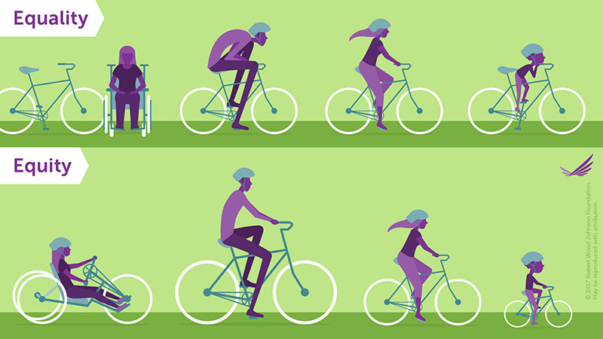

Figure 13.4 Equality is a meaningful goal, but it can leave people with unmet needs; equity is more empowering and fair. In equality portion of the graphic, people all sizes and a person who uses a wheelchair are all given the same bicycle, which is unusable for most. In the equity portion, each person gets a bicycle specifically designed for them, enabling them to successfully ride it.
When equity is properly considered, there is also inclusion. Inclusion means that there are a multiplicity of voices, skills, and interests represented in any given situation. Inclusion has played a major role in education, especially in terms of creating inclusion classrooms and inclusive curricula. In an inclusion classroom, students of different skill levels study together. For example, students with and without developmental disabilities study in the same classroom. Such an arrangement eliminates the stigma of the “special education classroom” where students were once segregated. In addition, in inclusion classrooms all students receive support when needed. Students benefit from seeing how others learn. In an inclusive curriculum, a course includes content and perspectives from underrepresented groups. For example, a college course in psychology might include consideration of different contexts such as immigration, incarceration, or unemployment in addition to addressing societal norms.
Inclusion means that these voices of varied background and experience are integrated into discussions, research, and assignments rather than ignored. You may have heard the phrase “the browning of America,” meaning it is predicted that today’s racial minorities will, collectively, be the majority of the population in the future. The graph from the Pew Research Center projects that by the year 2065, U.S. demographics will have shifted significantly. In 2019, the White population made up just over 60% of the population. In 2065, the Pew Research Center predicts that Whites will be approximately 46% of the population. The majority of Americans will be the non-White majority, 54% Hispanic/Latinos, Blacks, and Asians.

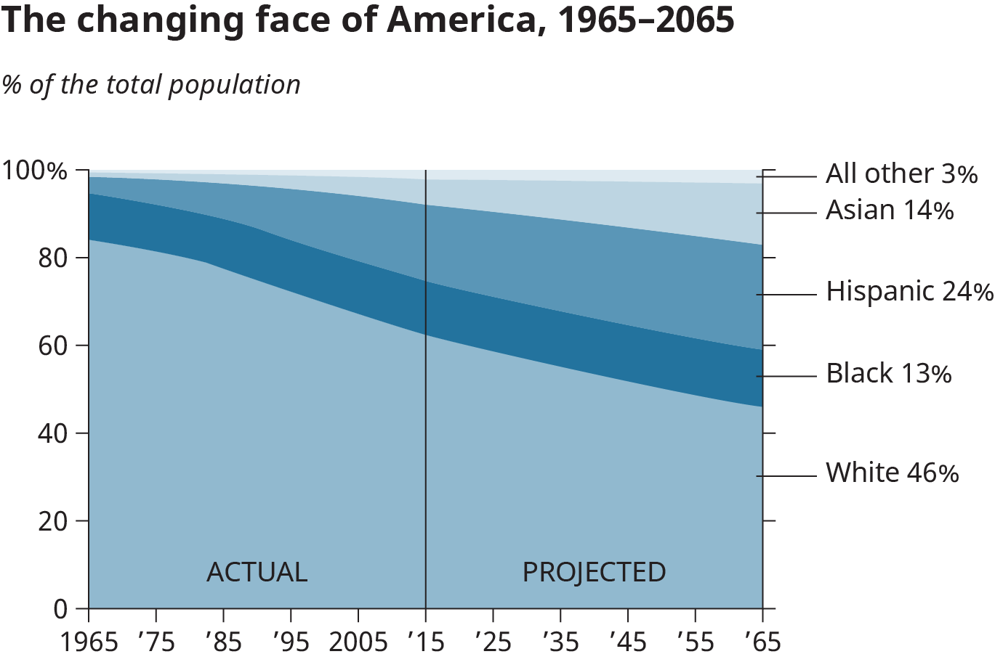

Figure 13.5 United States demographics (or statistical characteristics of populations) are changing rapidly. In just over 35 years, the country as a whole will be a “majority minority” nation, with ethnic/racial minorities making up more than half of the population.
What does this mean? It could mean that the United States begins accepting Spanish as a mainstream language since the Hispanic/Latino population will be significantly larger. It could mean a changing face for local governments. It could mean that our country will elect its second non-White president. Beyond anything specific, the shifting demographics of the United States could mean greater attention is paid to diversity awareness, equity, and inclusion.

Engaging in Civil Discourse
Healthy debate is a desirable part of a community. In a healthy debate, people are given room to explain their point of view. In a healthy airing of differences, people on opposing sides of an argument can reach common ground and compromise or even agree to disagree and move on.
However, incivility occurs when people are not culturally competent. An individual who is not culturally competent might make negative assumptions about others’ values, lack an open mindset, or be inflexible in thinking. Instead of being tolerant of different points of view, they may try to shut down communication by not listening or by keeping someone with a different point of view from being heard at all. Out of frustration, a person who is uncivil may resort to name-calling or discrediting another person only with the intention of causing confusion and division within a community. Incivility can also propagate violence. Such uncivil reaction to difficult issues is what makes many people avoid certain topics at all costs. Instead of seeking out diverse communities, people retreat to safe spaces where they will not be challenged to hear opposing opinions or have their beliefs contested.
Debates on difficult or divisive topics surrounding diversity, especially those promoting orchestrated change, are often passionate. People on each side may base their positions on deeply held beliefs, family traditions, personal experience, academic expertise, and a desire to orchestrate change. With such a strong foundation, emotions can be intense, and debates can become uncivil.
Even when the disagreement is based on information rather than personal feelings, discussions can quickly turn to arguments. For example, in academic environments, it’s common to find extremely well-informed arguments in direct opposition to each other. Two well-known economics faculty members from your college could debate for hours on financial policies, with each professor’s position backed by data, research, and publications. Each person could feel very strongly that they are right and the other person is wrong. They may even feel that the approach proposed by their opponent would actually do damage to the country or to certain groups of people. But for this debate—whether it occurs over lunch or on an auditorium stage—to remain civil, the participants need to maintain certain standards of behavior.
Civility is a valued practice that takes advantage of cultural and political systems we have in place to work through disagreements while maintaining respect for others’ points of view. Civil behavior allows for a respectful airing of grievances. The benefit of civil discussion is that members of a community can hear different sides of an argument, weigh evidence, and decide for themselves which side to support.
You have probably witnessed or taken part in debates in your courses, at social events, online, or even at family gatherings. What makes people so passionate about certain issues? First, some may have a personal stake in an issue, such as abortion rights. Convincing other people to share their beliefs may be intended to create a community that will protect their rights. Second, others may have deeply held beliefs based on faith or cultural practices. They argue based on deeply held moral and ethical beliefs. Third, others may be limited in their background knowledge about an issue but are able to speak from a “script” of conventional points of view. They may not want to stray from the script because they do not have enough information to extend an argument.

Rules for Fair Debate

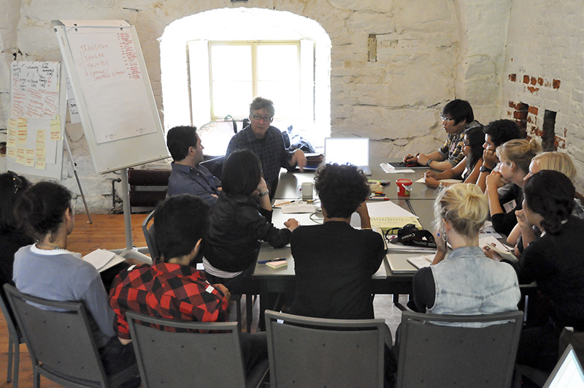
Figure 13.6 You’ll participate in classroom or workplace debate throughout your academic or professional career. Civility is important to productive discussions, and will lead to worthwhile outcomes.
The courtroom and the public square are not the only places where serious debate takes place. Every day we tackle tough decisions that involve other people, some of whom have strong opposing points of view. To be successful in college, you will need to master sound and ethical approaches to argument, whether it be for a mathematical proof or an essay in a composition class.
You probably already know how to be sensitive and thoughtful when giving feedback to a family member or friend. You think about their feelings and the best way to confront your disagreement without attacking them. Of course, sometimes it’s easier to be less sensitive with people who love you no matter what. Still, whether in a classroom, a workplace, or your family dinner table, there are rules for debating that help people with opposing points of view get to the heart of an issue while remaining civil:
- Avoid direct insults and personal attacks—the quickest way to turn someone away from your discussion is to attack them personally. This is actually a common logical fallacy called ad hominem, which means “to the person,” and it means to attack the person rather than the issue.
- Avoid generalizations and extreme examples—these are two more logical fallacies called bandwagon, or ad populum, and reduction to absurdity, or argumentum ad absurdum. The first is when you argue that everyone is doing something so it must be right. The second is when you argue that a belief or position would lead to an absurd or extreme outcome.
- Avoid appealing to emotions rather than facts—it’s easy to get emotional if you’re debating something about which you feel passionate. Someone disagreeing with you can feel like a personal affront. This fallacy, called argument to compassion, appeals to one’s emotions and happens when we mistake feelings for facts. While strong and motivating, our feelings are not great arbiters of the truth.
- Avoid irrelevant arguments—sometimes it’s easy to change the subject when we’re debating, especially if we feel flustered or like we’re not being heard. Irrelevant conclusion is the fallacy of introducing a topic that may or may not be sound logic but is not about the issue under debate.
- Avoid appeal to bias—you may not have strong opinions on every topic but, no doubt, you are opinionated about things that matter to you. This strong view can create a bias, or a leaning toward an idea or belief. While there’s nothing wrong with having a strong opinion, you must be mindful to ensure that your bias doesn’t create prejudice. Ask yourself if your biases influence the ways in which you interact with other people and with ideas that differ from your own.
- Avoid appeal to tradition—just because something worked in the past or was true in the past does not necessarily mean that it is true today. It’s easy to commit this fallacy, as we often default to “If it ain’t broke, don’t fix it.” It’s appealing because it seems to be common sense. However, it ignores questions such as whether the existing or old policy truly works as well as it could and if new technology or new ways of thinking can offer an improvement. Old ways can certainly be good ways, but not simply because they are old.
- Avoid making assumptions—often, we think we know enough about a topic or maybe even more than the person talking, so we jump ahead to the outcome. We assume we know what they’re referring to, thinking about, or even imagining, but this is a dangerous practice because it often leads to misunderstandings. In fact, most logical fallacies are the result of assuming.
- Strive for root cause analysis—getting at the root cause of something means to dig deeper and deeper until you discover why a problem or disagreement occurred. Sometimes, the most obvious or immediate cause for a problem is not actually the most significant one. Discovering the root cause can help to resolve the conflict or reveal that there isn’t one at all.
- Avoid obstinacy—in the heat of a debate, it’s easy to dig in your heels and refuse to acknowledge when you’re wrong. Your argument is at stake, and so is your ego. However, it’s important to give credit where it’s due and to say you’re wrong if you are. If you misquoted a fact or made an incorrect assumption, admit to it and move on.
- Strive for resolution—while some people like to debate for the sake of debating, in the case of a true conflict, both parties should seek agreement, or at least a truce. One way to do this is to listen more than you speak. Listen, listen, listen: you’ll learn and perhaps make better points of your own if you deeply consider the other point of view.

Online Civility
The Internet is the watershed innovation of our time. It provides incredible access to information and resources, helping us to connect in ways inconceivable just a few decades ago. But it also presents risks, and these risks seem to be changing and increasing at the same rate as technology itself. Because of our regular access to the Internet, it’s important to create a safe, healthy, and enjoyable online space.
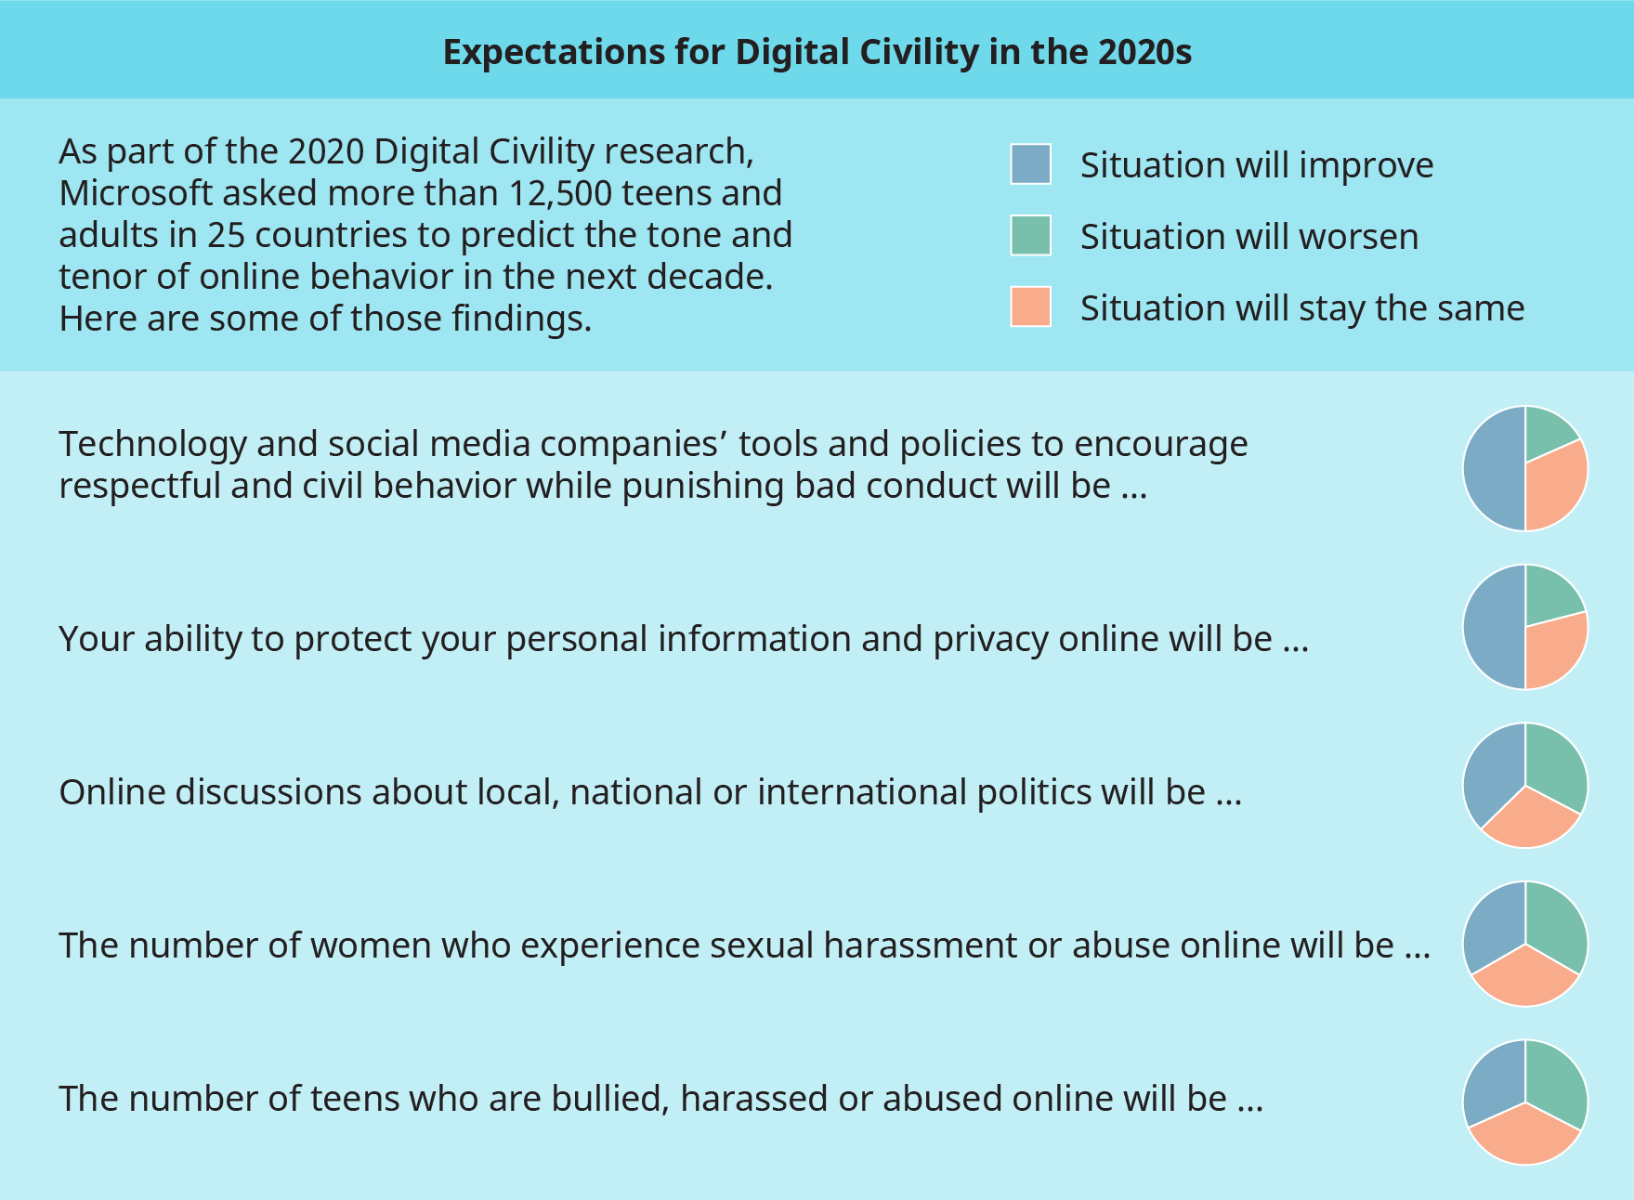

Figure 13.7 Microsoft’s Digital Civility Research survey asked people their opinions on the future of online behavior and communication. While in some cases, the respondents thought circumstances would improve, predictions about the others, such as harassment and bullying, are bleaker.
In the survey conducted by Microsoft, “nearly 4 in 10 [respondents] feel unwanted online contact (39%), bullying (39%) and unwelcome sexual attention (39%) will worsen [in 2020]. A slightly smaller percentage (35%) expect people’s reputations, both professional and personal, will continue to be attacked online. One-quarter (25%) of respondents see improvement across each of these risk areas in 2020.”
Digital civility is the practice of leading with empathy and kindness in all online interactions and treating each other with respect and dignity. This type of civility requires users to fully understand and appreciate potential harms and to follow the new rules of the digital road. You can find a discussion on best practices for online communication, often referred to as Netiquette, in Chapter 8 on Communicating. Following, are some basic guidelines to help exercise digital civility:
- Live the “Golden Rule” and treat others with respect and dignity both online and off.
- Respect differences of culture, geography, and opinion, and when disagreements surface, engage thoughtfully.
- Pause before replying to comments or posts you disagree with, and ensure responses are considerate and free of name-calling and abuse.
- Stand up for yourself and others if it’s safe and prudent to do so.

Cultivating Cultural Competency
By now you should be aware of the many ways diversity can be both observable and less apparent. Based on surface clues, we may be able to approximate someone’s age, weight, and perhaps their geographical origin, but even with those observable characteristics, we cannot be sure about how individuals define themselves. If we rely too heavily on assumptions, we may be buying into stereotypes, or generalizations.
Stereotyping robs people of their individual identities. If we buy into stereotypes, we project a profile onto someone that probably is not true. Prejudging people without knowing them, better known as prejudice or bias, has consequences for both the person who is biased and the individual or group that is prejudged. In such a scenario, the intimacy of real human connections is lost. Individuals are objectified, meaning that they only serve as symbolic examples of who we assume they are instead of the complex, intersectional individuals we know each person to be.
Stereotyping may be our way of avoiding others’ complexities. When we stereotype, we do not have to remember distinguishing details about a person. We simply write their stories for ourselves and let those stories fulfill who we expect those individuals to be. For example, a hiring manager may project onto an Asian American the stereotype of being good at math, and hire her as a researcher over her Hispanic counterpart. Similarly, an elementary school teacher may recruit an Indian American sixth-grader to the spelling bee team because many Indian American students have won national tournaments in the recent past. A real estate developer may hire a gay man as an interior designer because he has seen so many gay men performing this job on television programs. A coach chooses a White male student to be a quarterback because traditionally, quarterbacks have been White men. In those scenarios, individuals of other backgrounds, with similar abilities, may have been overlooked because they do not fit the stereotype of who others suspect them to be.
Earlier in this chapter, equity and inclusion were discussed as going hand in hand with achieving civility and diversity. In the above scenarios, equity and inclusion are needed as guiding principles for those with decision-making power who are blocking opportunity for nontraditional groups. Equity might be achieved by giving a diverse group of people access to internships to demonstrate their skills. Inclusion might be achieved by assembling a hiring or recruiting committee that might have a better chance of seeing beyond stereotypical expectations.
Being civil and inclusive does not require a deep-seated knowledge of the backgrounds and perspectives of everyone you meet. That would be impossible. But avoiding assumptions and being considerate will build better relationships and provide a more effective learning experience. It takes openness and self-awareness and sometimes requires help or advice, but learning to be sensitive—practicing assumption avoidance—is like a muscle you can strengthen.

Be Mindful of Microaggressions
Whether we mean to or not, we sometimes offend people by not thinking about what we say and the manner in which we say it. One danger of limiting our social interactions to people who are from our own social group is in being insensitive to people who are not like us. The term microaggression refers to acts of insensitivity that reveal our inherent biases, cultural incompetency, and hostility toward someone outside of our community. Those biases can be toward race, gender, nationality, or any other diversity variable. The individual on the receiving end of a microaggression is reminded of the barriers to complete acceptance and understanding in the relationship. Let’s consider an example. Ann is new to her office job. Her colleagues are friendly and helpful, and her first two months have been promising. She uncovered a significant oversight in a financial report, and, based on her attention to detail, was put on a team working with a large client. While waiting in line at the cafeteria one day, Ann’s new boss overhears her laughing and talking loudly with some colleagues. He then steps into the conversation, saying, “Ann, this isn’t a night at one of your clubs. Quiet down.” As people from the nearby tables look on, Ann is humiliated and angered.
What was Ann’s manager implying? What could he have meant by referring to “your clubs?” How would you feel if such a comment were openly directed at you? One reaction to this interaction might be to say, “So what? Why let other people determine how you feel? Ignore them.” While that is certainly reasonable, it may ignore the pain and invalidation of the experience. And even if you could simply ignore some of these comments, there is a compounding effect of being frequently, if not constantly, barraged by such experiences.

Consider the table below, which highlights common examples of microaggressions. In many cases, the person speaking these phrases may not mean to be offensive. In fact, in some cases the speaker might think they are being nice. However, appropriate terminology and other attitudes or acceptable descriptions change all the time. Before saying something, consider how a person could take the words differently than you meant them. As we discussed in Chapter 8, emotional intelligence and empathy can help understand another’s perspective.

Microaggressions
Category | Microaggression | Why It’s Offensive
Educational Status or Situation | “You’re an athlete; you don’t need to study.” | Stereotypes athletes and ignores their hard work.
 | “You don’t get financial aid; you must be rich.” | Even an assumption of privilege can be invalidating.
 | “Did they have honors classes at your high school?” | Implies that someone is less prepared or intelligent based on their geography.
Race, Ethnicity, National Origin | “You speak so well for someone like you.” | Implies that people of a certain race/ethnicity can’t speak well.
 | “No, where are you really from?” | Calling attention to someone’s national origin makes them feel separate.
 | “You must be good at _____.” | Falsely connects identity to ability.
 | “My people had it so much worse than yours did.” | Makes assumptions and diminishes suffering/difficulty.
 | “I’m not even going to try your name. It looks too difficult.” | Dismisses a person’s culture and heritage.
 | “It’s so much easier for Black people to get into college.” | Assumes that merit is not the basis for achievement.
Gender and Gender Identity | “They’re so emotional.” | Assumes a person cannot be emotional and rational.
 | “I guess you can’t meet tonight because you have to take care of your son?” | Assumes a parent (of any gender) cannot participate.
 | “I don’t get all this pronoun stuff, so I’m just gonna call you what I call you.” | Diminishes the importance of gender identity; indicates a lack of empathy.
 | “I can’t even tell you used to be a woman.” | Conflates identity with appearance, and assumes a person needs someone else’s validation.
 | “You’re too good-looking to be so smart.” | Connects outward appearance to ability.
Sexual Orientation | “I support you; just don’t throw it in my face.” | Denies another person’s right to express their identity or point of view.
 | “You seem so rugged for a gay guy.” | Stereotypes all gay people as being “not rugged,” and could likely offend the recipient.
 | “I might try being a lesbian.” | May imply that sexual orientation is a choice.
 | “I can’t even keep track of all these new categories.” | Bisexual, pansexual, asexual, and other sexual orientations are just as valid and deserving of respect as more binary orientations.
 | “You can’t just love whomever you want; pick one.”
Age | “Are you going to need help with the software?” | May stereotype an older person as lacking experience with the latest technology.
 | “Young people have it so easy nowadays.” | Makes a false comparison between age and experience.
 | “Okay, boomer.” | Dismisses an older generation as out of touch.
Size | “I bet no one messes with you.” | Projects a tendency to be aggressive onto a person of large stature.
 | “You are so cute and tiny.” | Condescending to a person of small stature.
 | “I wish I was thin and perfect like you.” | Equates a person’s size with character.
Ability | (To a person using a wheelchair) “I wish I could sit down wherever I went.” | Falsely assumes a wheelchair is a luxury; minimizes disabilities.
 | “You don’t have to complete the whole test. Just do your best.” | Assumes that a disability means limited intellectual potential.
 | “I’m blind without my glasses.” | Equating diminished capacity with a true disability.
Table 13.1 Have you made statements like these, perhaps without realizing the offense they might cause? Some of these could be intended as compliments, but they could have the unintended effect of diminishing or invalidating someone.

Everyone Has a Problem: Implicit Bias
One reason we fall prey to stereotypes is our own implicit bias. Jo Handelsman and Natasha Sakraney, who developed science and technology policy during the Obama administration, defined implicit bias.
According to Handelsman and Sakraney, “A lifetime of experience and cultural history shapes people and their judgments of others. Research demonstrates that most people hold unconscious, implicit assumptions that influence their judgments and perceptions of others. Implicit bias manifests in expectations or assumptions about physical or social characteristics dictated by stereotypes that are based on a person’s race, gender, age, or ethnicity. People who intend to be fair, and believe they are egalitarian, apply biases unintentionally. Some behaviors that result from implicit bias manifest in actions, and others are embodied in the absence of action; either can reduce the quality of the workforce and create an unfair and destructive environment.”7
The notion of bias being “implicit,” or unconsciously embedded in our thoughts and actions, is what makes this characteristic hard to recognize and evaluate. You may assume that you hold no racial bias, but messages from our upbringing, social groups, and media can feed us negative racial stereotypes no matter how carefully we select and consume information. Further, online environments have algorithms that reduce our exposure to diverse points of view. Psychologists generally agree that implicit bias affects the judgements we make about others.
Harvard University’s Project Implicit website offers an interactive implicit association test that measures individual preference for characteristics such as weight, skin color, and gender. During the test, participants are asked to match a series of words and images with positive or negative associations. Test results, researchers suggest, can indicate the extent to which there is implicit bias in favor of or against a certain group. Completing a test like this might reveal unconscious feelings you were previously aware you had.
The researchers who developed the test make clear that there are limitations to its validity and that for some, the results of the test can be unsettling. The test makers advise not taking the test if you feel unprepared to receive unexpected results.

Activity 2: Implicit Bias Self-Assessment

Checkpoint Exercise
Take the Project Implicit test and write a brief passage about your results.
Do you think the results accurately reflect your attitude toward the group you tested on? Can you point to any actions or thoughts you have about the group you tested on that are or are not reflected in the test results? Will you change any behaviors or try to think differently about the group you tested on based on your results? Why or why not?

Cultural Competency in the College Classroom
We carry our attitudes about gender, ethnicity, sexual orientation, age, and other diversity categories with us wherever we go. The college classroom is no different than any other place. Both educators and students maintain their implicit bias and are sometimes made uncomfortable by interacting with people different than themselves. Take for example a female freshman who has attended a school for girls for six years before college. She might find being in the classroom with her new male classmates a culture shock and dismiss male students’ contributions to class discussions. Similarly, a homeschooled student may be surprised to find that no one on campus shares his religion. He may feel isolated in class until he finds other students of similar background and experience.
Embedded in your classroom may be peers who are food insecure, undocumented, veterans, atheist, Muslim, or politically liberal or conservative. These identities may not be visible, but they still may separate and even marginalize these members of your community. If, in the context of classroom conversations, their perspectives are overlooked, they may also feel very isolated.
In each case, the students’ assumptions, previous experience with diversity of any kind, and implicit bias surface. How each student reacts to the new situation can differ. One reaction might be to self-segregate, that is, locate people they believe are similar to them based on how they look, the assumption being that those people will share the same academic skills, cultural interests, and personal values that make the student feel comfortable. The English instructor at the beginning of this chapter who assumed all of his students were the same demonstrated how this strategy could backfire.
You do not have to be enrolled in a course related to diversity, such as Asian American literature, to be concerned about diversity in the classroom. Diversity touches all aspects of our lives and can enter a curriculum or discussion at any time because each student and the instructor bring multiple identities and concerns into the classroom. Ignoring these concerns, which often reveal themselves as questions, makes for an unfulfilling educational experience.
In higher education, diversity includes not only the identities we have discussed such as race and gender, but also academic preparation and ability, learning differences, familiarity with technology, part-time status, language, and other factors students bring with them. Of course, the instructor, too, brings diversity into the classroom setting. They decide how to incorporate diverse perspectives into class discussions, maintain rules of civility, choose inclusive materials to study or reference, receive training on giving accommodations to students who need them, and acknowledge their own implicit bias. If they are culturally competent, both students and instructors are juggling many concerns.
How do you navigate diversity in the college classroom?

Academic Freedom Allows for Honest Conversations
Academic freedom applies to the permission instructors and students have to follow a line of intellectual inquiry without the fear of censorship or sanction. There are many heavily contested intellectual and cultural debates that, for some, are not resolved. A student who wants to argue against prevailing opinion has the right to do so based on academic freedom. Many point to a liberal bias on college campuses. Conservative points of view on immigration, education, and even science, are often not accepted on campus as readily as liberal viewpoints. An instructor or student who wants to posit a conservative idea, however, has the right to do so because of academic freedom.
Uncomfortable conversations about diversity are a part of the college classroom landscape. For example, a student might use statistical data to argue that disparities in degrees for men and women in chemistry reflect an advantage in analytical ability for men. While many would disagree with that theory, the student could pursue that topic in a discussion or paper as long as they use evidence and sound, logical reasoning.

“I’m just me.”
Remember the response to the “What are you?” question for people whose racial or gender identity was ambiguous? “I’m just me” also serves those who are undecided about diversity issues or those who do not fall into hard categories such as feminist, liberal, conservative, or religious. Ambiguity sometimes makes others feel uncomfortable. For example, if someone states she is a Catholic feminist unsure about abortion rights, another student may wonder how to compare her own strong pro-life position to her classmate’s uncertainty. It would be much easier to know exactly which side her classmate is on. Some people straddle the fence on big issues, and that is OK. You do not have to fit neatly into one school of thought. Answer your detractors with “I’m just me,” or tell them if you genuinely don’t know enough about an issue or are not ready to take a strong position.

Seek Resources and Projects That Contribute to Civility
A culturally responsive curriculum addresses cultural and ethnic differences of students. Even in classrooms full of minority students, the textbooks and topics may only reflect American cultural norms determined by the mainstream and tradition. Students may not relate to teaching that never makes reference to their socio-economic background, race, or their own way of thinking and expression. Educators widely believe that a culturally responsive curriculum, one that integrates relatable contexts for learning and reinforces cultural norms of the students receiving the information, makes a difference.
The K-12 classroom is different than the college classroom. Because of academic freedom, college instructors are not required to be culturally inclusive. (They are usually required to be respectful and civil, but there are different interpretations of those qualities.) Because American colleges are increasingly more sensitive to issues regarding diversity, faculty are compelled to be inclusive. Still, diversity is not always adequately addressed. In his TED “Talk Can Art Amend History?” the artist Titus Kaphar tells the story of the art history class that influenced him to become an artist and provides an example of this absence of diversity in the college classroom. Kaphar explains that his instructor led his class through important periods and artists throughout history, but failed to spend time on Black artists, something that Kaphar was anxiously awaiting. The instructor stated that there was just not enough time to cover it. While the professor probably did not intend to be noninclusive, her choice resulted in just that. Kaphar let his disappointment fuel his passion and mission to amend the representation of Black figures in historical paintings. His work brings to light the unnoticed Black figures that are too often overlooked.

Figure 13.8 In Twisted Tropes, Titus Kaphar reworks a painting to bring a Black figure to the forefront of an arrangement in which she had previously been marginalized.
Any student can respond to a lack of diversity in a curriculum as Titus Kaphar did. Where you find diversity missing, when possible, fill in the gaps with research papers and projects that broaden your exposure to diverse perspectives. Take the time to research contributions in your field by underrepresented groups. Discover the diversity issues relevant to your major. Are women well-represented in your field? Is there equity when it comes to access to opportunities such as internships? Are veterans welcomed? Do the academic societies in your discipline have subgroups or boards focused on diversity and equity? (Most do.) Resources for expanding our understanding and inclusion of diversity issues are all around us.

Directly Confront Prejudice
To draw our attention to possible danger, the Department of Homeland Security has adopted the phrase, “If you see something, say something.” That credo can easily be adopted to confront stereotypes and bias: “If you hear something, say something.” Academic freedom protects students and instructors from reprisal for having unpopular opinions, but prejudice is never correct, nor should it be tolerated. Do not confuse hate speech, such as sexist language, anti-Semitism, xenophobia, and acts that reflect those points of view, with academic freedom. Yes, the classroom is a place to discuss these attitudes, but it is not a place to direct those sentiments toward fellow students, educators, or society in general.
Most higher education institutions have mission statements and codes of conduct that warn students about engaging in such behavior. The consequences for violators are usually probation and possibly dismissal. Further policies such as affirmative action and Title IX are instituted to evaluate and maintain racial and gender equity.

Privilege, Inclusivity, and Civility: What Role Can I Play?
Privilege is a right or exemption from liability or duty granted as a special benefit or advantage. Oppression is the result of the “use of institutional privilege and power, wherein one person or group benefits at the expense of another,” according to the University of Southern California Suzanne Dworak Peck School of Social Work.
Just as everyone has implicit bias, everyone has a certain amount of privilege, too. For example, consider the privilege brought by being a certain height. If someone's height is close to the average height, they likely have a privilege of convenience when it comes to many day-to-day activities. A person of average height does not need assistance reaching items on high store shelves and does not need adjustments to their car to reach the brake pedal. There’s nothing wrong with having this privilege, but recognizing it, especially when considering others who do not share it, can be eye-opening and empowering.
Wealthy people have privilege of not having to struggle economically. The wealthy can build retirement savings, can afford to live in the safest of neighborhoods, and can afford to pay out of pocket for their children’s private education. People with a college education and advanced degrees are privileged because a college degree allows for a better choice of employment and earning potential. Their privilege doesn’t erase the hard work and sacrifice necessary to earn those degrees, but the degrees often lead to advantages. And, yes, White people are privileged over racial minorities.
It is no one’s fault that they may have privilege in any given situation. In pursuit of civility, diversity, equity, and inclusion, the goal is to not exploit privilege but to share it. What does that mean? It means that when given an opportunity to hire a new employee or even pick someone for your study group, you make an effort to be inclusive and not dismiss someone who has not had the same academic advantages as you. Perhaps you could mentor a student who might otherwise feel isolated. Sharing your privilege could also mean recognizing when diversity is absent, speaking out on issues others feel intimidated about supporting, and making donations to causes you find worthy.
When you are culturally competent, you become aware of how your privilege may put others at a disadvantage. With some effort, you can level the playing field without making yourself vulnerable to falling behind.

“Eternal vigilance is the price of civility.”
The original statement reads, “Eternal vigilance is the price of liberty.” History sometimes credits that statement to Thomas Jefferson and sometimes to Wendell Holmes. Ironically, no one was paying enough attention to document it accurately. Still, the meaning is clear—if we relax our standards, we may lose everything.
Civility is like liberty; it requires constant attention. We have to adjust diversity awareness, policies, and laws to accommodate the ever-changing needs of society. Without the vigilance of civil rights workers, society could have lapsed back into the Jim Crow era. Without activists such as Betty Friedan, Gloria Steinem, and Flo Kennedy remaining vigilant, women might not have made the gains they did in the 1970s. Constant attention is still needed because in the case of women’s earning power, they only make about 80 cents for every dollar a man makes. Constant vigilance requires passion and persistence. The activism chronologies of Native Americans, African Americans, Asian Americans, the LGBTQ+ community, immigrants, students, labor, and other groups is full of stops and starts, twists and turns that represent adjustments to their movements based on the shifting needs of younger generations. As long as there are new generations of these groups, we will need to pursue diversity, equity, and inclusion.

Your Future and Cultural Competency
Where will you be in five years? Will you own your own business? Will you be a stay-at-home parent? Will you be making your way up the corporate ladder of your dream job? Will you be pursuing an advanced degree? Maybe you will have settled into an entry-level job with good benefits and be willing to stay there for a while. Wherever life leads you in the future, you will need to be culturally competent. Your competency will be a valuable skill not only because of the increasing diversity and awareness in America, but also because we live in a world with increasing global connections.
If you do not speak a second language, try to learn one. If you can travel, do so, even if it’s to another state or region of the United States. See how others live in order to understand their experience and yours. To quote Mark Twain, “Travel is fatal to prejudice, bigotry, and narrow-mindedness.” The more we expose ourselves to different cultures and experiences, the more understanding and tolerance we tend to have.
The United States is not perfect in its practice of diversity, equity, and inclusion. Still, compared to much of the world, Americans are privileged on a number of fronts. Not everyone can pursue their dreams as freely as Americans do. Our democratic elections and representative government give us a role in our future.

Understanding diversity and being culturally competent will make for a better future for everyone.

Activity 1B: DEI Post-Reading Reflection

Checkpoint Exercise
After reading this chapter, now how do you feel about diversity, equity, and inclusion? Retake the survey below to see whether your feelings have changed. Reflect on your results. What do they say about your cultural competency? What are some specific ways you can grow in that area?

Questions are ranked on a scale of 1–4, 1 meaning “least like me” and 4 meaning “most like me.”

- I'm aware of the different categories of diversity and the various populations I may encounter.
- I think we sometimes go too far in trying to be sensitive to different groups.
- I think nearly everybody in our society has equal opportunity.
- It’s not my role to ensure equity and inclusiveness among my peers or colleagues.

Questions for Reflection
- Have you ever witnessed incivility in a person or an argument in the news? Briefly describe what happened. Why do you think individuals are willing to shut down communication over issues they are passionate about?
- Describe a time when you could not reach an agreement with someone on a controversial issue. Did you try to compromise, combining your points of view so that each of you would be partially satisfied? Did either of you shut down communication? Was ending the conversation a good choice? Why or why not?
- Think about a regular activity such as going to a class. In what ways are you privileged in that situation? How can you share your privilege with others?

Attributions
- Parts of this chapter were adopted and modified from "College Success" by Amy Baldwin, OpenStax, Rice University is licensed under CC BY 4.0 / A derivative from the original work
- Parts of this chapter have been adopted and modified from "College Success" by Open Textbook Library, University of Minnesota Libraries is licensed under CC BY-NC-SA 4.0 / A derivative from the original work

