BIOL 2154K
General Zoology Laboratory Manual

General Zoology Laboratory Manual by Georgia Highlands College ©2019
is licensed under a Creative Commons Attribution 4.0 International License

Table of Contents
Table of Contents 2
Exercise 1: Classification and Evolution 3
The Taxonomic Classification of Living Caminalcules 5
The Comparative Approach to Phylogenetic Analysis 6
The Phylogeny of Caminalcules 7
Exercise 2: The Planaria Project 11
DAY 1 11
SET UP FOR REGENERATION 12
The Report 13
Exercise 3: Introduction to Invertebrates 15
ROUNDWORMS 16
MOLLUSKS 16
ANNELIDS 17
ARTHROPODS 18
Exercise 4: Introduction to Chordates 19
Chordates 19
Vertebrates 19
Hag fish 20
Shark 20
Bony Fish 21
Frog 21
Exercise 5: Vertebrates Continued 23
Fetal pig anatomy 23
Pigeon 24
Exercise 6: Mammalogy 26
Skulls 26
Teeth 26
Tracks 28
Class Activity 29
Goals 29

Exercise 1: Classification and Evolution

Caminalcules are imaginary animals invented by the evolutionary biologist Joseph Camin. They make ideal organisms for introducing students to two related topics: taxonomic classification and evolution. In this lab exercise the students first classify 14 "living" species into genera, families, etc. Then they construct an evolutionary tree of the Caminalcules using an additional 42 "fossil" species. This illustrates how modern classification schemes attempt to reflect evolutionary history. In the process of doing this exercise the students are also introduced to concepts such as convergent evolution and vestigial structures.

The pictures of the Caminalcules are copyrighted by the journal Systematic Biology and Robert R. Sokal. They are made available here with permission.

This lab has been modified with permission from Robert P. Gendron at Indiana University of Pennsylvania:
Robert P. Gendron Biology Department
Indiana University of Pennsylvania Indiana, PA 15705 rgendron@auxmail.iup.edu

*Note that in this lab we use only a subset of all the 77 Caminalcules. To use the entire set would increase the time needed to complete the lab without appreciably increasing its educational value. Thus, the phylogenetic tree that is reproduced here is a “pruned” version of the original. The branches that are not represented by this subset of Caminalcules were digitally removed. If you want the entire set of Caminalcules and the complete phylogenetic tree you can scan in the pictures from the original source (Sokal, R.R. 1983. A phylogenetic analysis of the Caminalcules. I. The data base. Systematic Zoology 323:159-184).

Humans classify almost everything, including each other. This habit can be quite useful. For example, when talking about a car someone might describe it as a 4-door sedan with a fuel injected V-8 engine. A knowledgeable listener who has not seen the car will still have a good idea of what it is like because of certain characteristics it shares with other familiar cars. Humans have been classifying plants and animals for a lot longer than they have been classifying cars, but the principle is much the same. As an example, biologists classify all organisms with a backbone as "vertebrates." In this case the backbone is a characteristic that defines the group. If, in addition to a backbone, an organism has gills and fins it is a fish, a subcategory of the vertebrates. This fish can be further assigned to smaller and smaller categories down to the level of the species. The classification of organisms in this way aids the biologist by bringing order to what would otherwise be a bewildering diversity of species. (There are probably several million species - of which about one million have been named and classified.) The field devoted to the classification of organisms is called taxonomy [Gk. taxis, arrange, put in order + nomos, law].

The modern taxonomic system was devised by Carolus Linnaeus (1707-1778). It is a hierarchical system since organisms are grouped into ever more inclusive categories from species up to kingdom. Figure 1.1 illustrates how four species are classified using this taxonomic system. Note that it is standard practice to italicize the genus name and specific epithet.

Figure 1.1
KINGDOM | Animalia |  |  | Plantae
PHYLUM | Chordata |  | Arthropoda Insecta Hymenoptera Apidae  Apis mellifera  (honeybee) | Angiospermophyta Monocotyledoneae Liliales  Liliaceae Alium sativum  (garlic)
CLASS | Mammalia
ORDER | Primate Hominidae Homo sapiens  (human) | Carnivora Canidae Canis lupus  (wolf)
FAMILY
GENUS
SPECIES

As a consequence of Darwin's work, it is now recognized that taxonomic
classifications are actually reflections of evolutionary history. For example, Linnaeus put humans and wolves in the class Mammalia within the phylum Chordata because they share certain characteristics (e.g. backbone, hair, homeothermy, etc.). We now know that this similarity is not a coincidence; both species inherited these traits from the same common ancestor. In general, the greater the resemblance between two species, the more recently they diverged from a common ancestor. Thus, when we say that the human and wolf are more closely related to each other than either is to the honeybee we mean that they share a common ancestor that is not shared with the honeybee.

Another way of showing the evolutionary relationship between organisms is in the form of a phylogenetic tree (Gk. phylon, stock, tribe + genus, birth, origin) such as in Figure 1.2 below.

The vertical axis in this figure represents time. The point at which two lines separate indicates when a particular lineage split.
For example, we see that mammals diverged from reptiles about 150 million years ago. The most recent common ancestor shared by mammals and reptiles is indicated by the point labeled A. The horizontal axis represents, in a general way, the amount of divergence that has occurred between different groups; the greater the distance, the more different their appearance. Note that because they share a fairly recent ancestor, species within the same taxonomic group (e.g. the class Mammalia) tend to be closer to each other at the top of the tree than they are to members of other groups.

Wolf
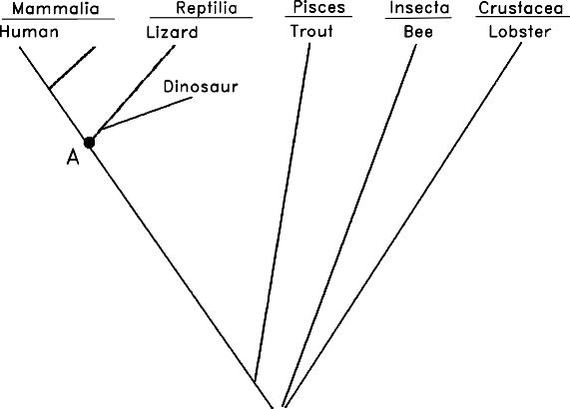
Figure 1.2

There are, however, pitfalls with the approach of creating groups based on characteristics. For example, some species resemble each other because they independently evolved similar structures in response to similar environments or ways of life, not because they share a recent common ancestor. This is called convergent evolution because distantly related species seem to converge in appearance (become more similar). Examples of convergent evolution include the wings of bats, birds and insects, or the streamlined shape of whales and fish. At first glance it might appear that whales are a type of fish. Upon further examination it becomes apparent that this resemblance is superficial, resulting from the fact that whales and fish have adapted to the same environment. The presence of hair, the ability to lactate and

homeothermy clearly demonstrate that whales are mammals. Thus, the taxonomist must take into account a whole suite of characteristics, not just a single one.

The fossil record can also be helpful for constructing phylogenetic trees. For example, bears were once thought to be a distinct group within the order Carnivora. Recently discovered fossils, however, show that they actually diverged from the Canidae (wolves, etc.) fairly recently. The use of fossils is not without its problems, however. The most notable of these is that the fossil record is incomplete. This is more of a problem for some organisms than others. For example, organisms with shells or bony skeletons are more likely to be preserved than those without hard body parts.

The Classification and Evolution of Artificial Organisms
In this lab you will develop a taxonomic classification and phylogenetic tree for a group of imaginary organisms called Caminalcules after the taxonomist Joseph Camin who devised them. At the back of this lab are pictures of the 14 "living" and 42 "fossil" species that you will use. Take a look at the pictures and note the variety of appendages, shell shape, color pattern, etc. Each species is identified by a number rather than a name. For fossil Caminalcules there is also a number in parentheses indicating the geological age of each specimen in millions of years. Most of the fossil Caminalcules are extinct, but you will notice that a few are still living (e.g. species #24 is found among the living forms but there is also a 2 million-year-old fossil of #24 in our collection).

THE TAXONOMIC CLASSIFICATION OF LIVING CAMINALCULES
Carefully examine the fourteen living species and note the many similarities and differences between them. In the space below create a hierarchical classification of these species, using the format in Table 1.1. Instead of using letters (A, B,
...), as in this example, use the number of each Caminalcule species. Keep in mind that Figure 3 is just a hypothetical example. Your classification may look quite different than this one.

Table 1.1
PHYLUM CAMINALCULA
CLASS 1 |  |  |  |  |  |  | CLASS 2
ORDER 1 |  |  |  |  |  |  | ORDER 2 |  |  | ORDER 3
FAMILY 1 |  |  |  |  | FAMILY 2 |  | FAMILY 3 |  |  | FAMILY 3
GENUS 1 |  | GENUS 2 |  | GENUS 3 | GENUS 4 |  | GENUS 5 |  |  | GENUS 6
A | G | H | D | B | J | L | E | K | C | F | I

The first step in this exercise is to decide which species
belong in the same genus. Species within the same genus share characteristics not found in any other genera (plural of genus). The Caminalcules numbered 19 and 20 are a good example; they are clearly more similar to each other than either is to any of the other living species so we would put them together in their own genus. Use the same procedure to combine the genera into families. Again, the different genera within a family should be more similar to each other than they are to genera in other families. Families can then be combined into orders, orders into classes and so on.
Depending on how you organize the species, you may only get up to the level of order or class. You do not necessarily have to get up to the level of Kingdom or Phylum.

Draw your living Caminalcule classification table below:

THE COMPARATIVE APPROACH TO PHYLOGENETIC ANALYSIS
You will now construct a phylogenetic tree based only on your examination of the 14 living species. A G
This tree should reflect your taxonomic classification. For example, let us say you have put species A and G into the same genus because you think they evolved from a common ancestor (x). Their part of the tree would look like Figure 1.3 on the right.
x
Figure 1.3

When there are three or more species in a genus you must decide which two of the species share a common ancestor not shared by the other(s). Figure 1.4 indicates that species E and K are more closely related to each other than either is to C. We hypothesize that E and K have a common ancestor (y) that is not shared by C. Similarly, two genera that more closely resemble each other
a
E K C
y
z

than they do other genera presumably share a common ancestor. Thus, even in the absence of Figure 1.4
fossil record it is possible to develop a phylogenetic tree. We can even infer what a common ancestor likely might have looked like.

Draw your living Caminalcule phylogenetic tree below:

THE PHYLOGENY OF CAMINALCULES

Using a large sheet of paper, construct a phylogenetic tree for the Caminalcules. Use a meter stick to draw 20 equally spaced horizontal line on the paper. Each line will be used to indicate an interval of one million years. Label each line so that the one at the bottom of the paper represents an age of 19 million years and the top line represents the present (0 years).

Cut out all the Caminalcules (including the living species). Put them in piles according to their age (the number in parentheses). Beginning with the oldest fossils, arrange the Caminalcules according to their evolutionary relationship. Figure 1.5 shows how to get started.
7
19
5
7
18
?
?
17 ?
Millions of Years Ago

Figure 1.5

Hints, Suggestions, and Warnings:
- Draw lines faintly in pencil to indicate the path of evolution. You may change your mind as you continue
- Branching should involve only two lines at a time:

Like this
Figure 1.6
Not this

- Some living forms are also found in the fossil record.
- There are gaps in the fossil record for some lineages.
- The Caminalcules were numbered at random; the numbers provide no clues to evolutionary relationships.
- There is only one correct phylogenetic tree in this exercise. This is because of the way that Joseph Camin derived his imaginary animals. He started with the most primitive form (#73) and gradually modified it using a process that mimics evolution in real organisms. After you complete your phylogeny compare it with Camin's original (posted after lab on D2L) and turn in next class with the answers to the problems below for a quiz grade.

Problems

  - You will notice that some lineages (e.g. the descendants of species) branched many times and are represented by many living species. Discuss the ecological conditions that you think might result in the rapid diversification of some lineages (A real world example would be the diversification of the mammals at the beginning of the Cenozoic, right after the dinosaurs went extinct.)

  - Some lineages changed very little over time. A good example of this would be “living fossils” like the horseshoe crab or cockroach. Again, discuss the ecological conditions that might result in this sort of long-term evolutionary stasis.

  - Find two additional examples of convergent evolution among the Caminalcules. This means finding cases where two or more species have a similar characteristic that evolved independently in each lineage. The wings of bats, birds and bees is an example of convergence since the three groups did not inherit the characteristic from their common ancestor.

  - List two additional real-world examples of convergent evolution (ones that we have not already talked about in class) and discuss what might have caused the convergence.

Figure 1.7 LIVING CAMINALCULES
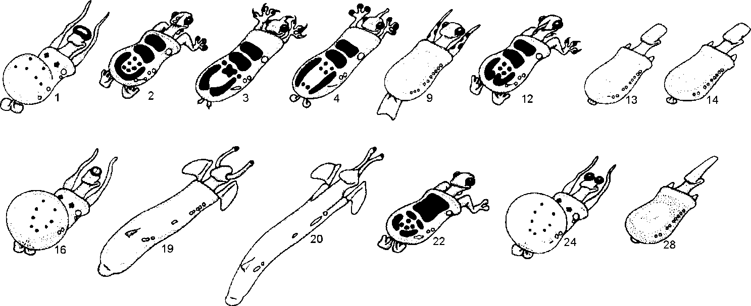

Figure 1.8 FOSSIL CAMINALCULES
(numbers in parentheses indicate age in millions of years)
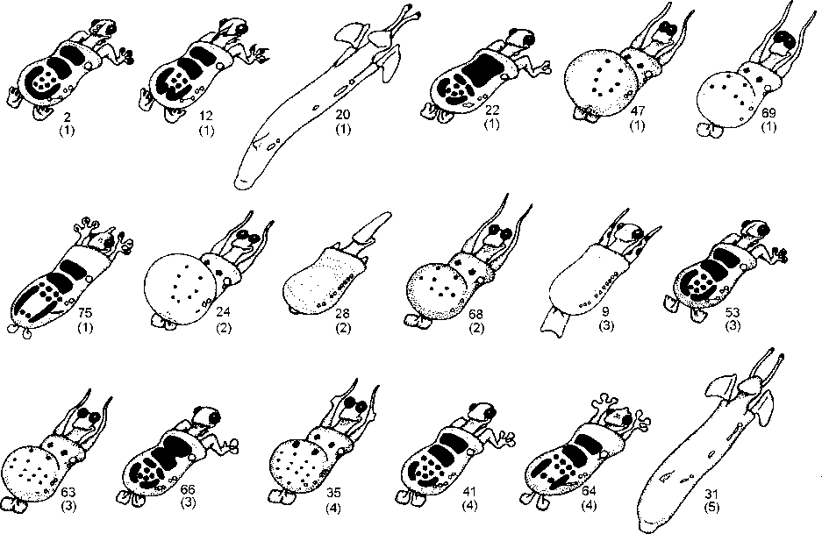

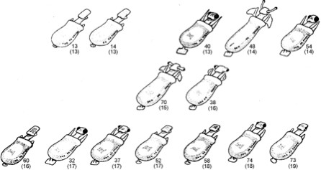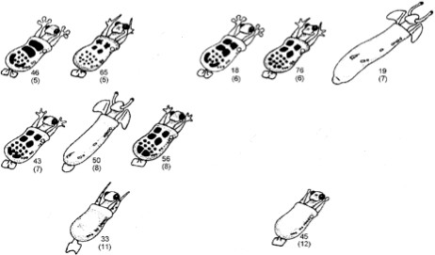Figure 1.9 FOSSIL CAMINALCULES CONTINUED

Exercise 2: The Planaria Project
Over a course of several weeks, we will be observing a nonparasitic flatworm commonly known as the Planaria. Each group of students will be responsible for the upkeep and maintenance of their own individual “pet” flatworm. Above all, these critters require clean water to survive, so clean their "cages" regularly by making sure they always have enough clean water!

We will be recording observations regarding the movement (taxis), mortality, and regeneration of these organisms. You will take notes every class period on the status of your organism.

DAY 1
To begin you should have a container per group of 4 with at least 4 Planaria. The first thing you should do is observe their basic anatomy. Use the space below to record any observations, these may be notes, pictures, drawings, etc…

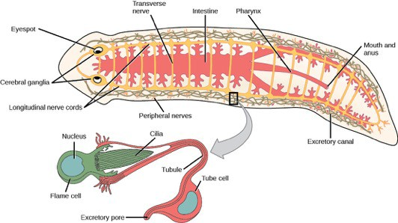
Figure 2.1. Planaria.
Credit: OpenStax Rice University
Now take one Planaria and place it in a petri dish. Place the dish on a light source and observe any internal anatomical structures you can observe. Use the space below to record any observations, these may be notes, pictures, drawings, etc…

Phototaxis
Now put all the Planaria back into the original larger container. Spend 5 minutes observing their behavior with all the lights turned off in the room. Indicate the left and right side of the container with a line drawn directly on the container or with a piece of paper placed under the clear container. Count how many times they cross the line, this can indicate how active they are. Also look for if they favor one side over the other or to be near the surface vs the bottom or any

other discernable patter to their behavior. Use the space below to record any observations, these may be notes, pictures, drawings, etc…

After the 5 minutes is up, add a bright light source to one side of the container, leaving the other side darker. Make the same observations as above but under these conditions. Use the space below to record any observations, these may be notes, pictures, drawings, etc…

Chemotaxis
After the light test turn the room lights back on. Now we want to test how your Planaria will be affected by the introduction of chemicals in the form of food. Follow the same procedure as with the Phototaxis in taking your notes. Use the space below to record any observations, these may be notes, pictures, drawings, etc…

SET UP FOR REGENERATION
Each group of 4 students will have 4 Planaria. You will make a different “treatment” for each Planaria in your group testing how much body is needed to regenerate a full Planaria, and how temperature affects this growth.

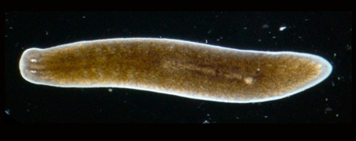Since 20% of a planaria’s cells are stem cells, they can regenerate their bodies if cut in two. Of your four Planaria, two will be cut directly in half (Figure 2.2), and two will be cut closer to the anterior end of the animal (Figure 2.3).
Figure 2.2
Figure 2.3

You should now have 2 planaria cut in half, and 2 planaria cut into unequal halves. One of each with then be placed in a refrigerator and the other two will be in an area that is room temperature. They will be left in these areas for the next 3 weeks. You will be checking in on them every week at the beginning of lab and making notes about their regeneration.

Things to ask yourself during the experiment should include: How long until you see evidence of regeneration?
How long until regeneration is complete? What is the survivorship of your Planaria?
(are both parts alive?, one part alive?, or both parts dead?)
Other notable things you and your group will be responsible for maintaining your notes from week to week.

Your personal observations from the anatomy and movement observations, the results of the regeneration experiments, and the combined class data for survivorship for different cuts and temps will be combined with your own background work and research into the natural history of the Planaria to produce your research paper.

THE REPORT
The information below will give you an idea of what is expected. The points associated with this paper are 50 points of the 250-point total for the lab.
Use the following format guidelines: 1" margins, 12 pt. font, double spaced Paper Guidelines:
Title Page: Be creative and have fun with your titles!
Body of the Paper
Introduction:
What did you set out to do?
Background:
What is the taxonomy and life history of your organism?
Personal Observations:
What did you see? What did you miss?
Remember the questions from the temperature and regeneration sections above.
Class Results:
What happened?

Did your worm live or die?
What did you discover?
Why do you think it happened this way?
Conclusion:
Why do you think you got the results you did? What did you learn/think?
Did you do what you set out to do?
Literature Cited: have at least 3 sources, and correct internal citation within your paper Citations can be in any format of your choosing (apa/mla)
Here are a few links to help with this: http://www.citationmachine.net/ https://www.refme.com/us/citation-generator/apa/ http://www.bibme.org/

Remember, DO NOT PLAGIARIZE!!! We will be following the guidelines for academic dishonesty of the University and would be required to give a failing grade. Final papers are individual and to be turned in electronically through D2L’s assignment folder. This way everyone is fairly checked to make sure that their papers are originally written and unique.

INTRODUCTION

Exercise 3: Introduction to Invertebrates

When surveying the animal kingdom, we find an incredible amount of diversity in structure and function.
Though there are over a million described species on earth, almost all of these species are invertebrates. Invertebrates are animals that lack a backbone. We can then subdivide the invertebrates based on a few characteristics such as symmetry, tissue development, and larvae development (Figure 3.1).
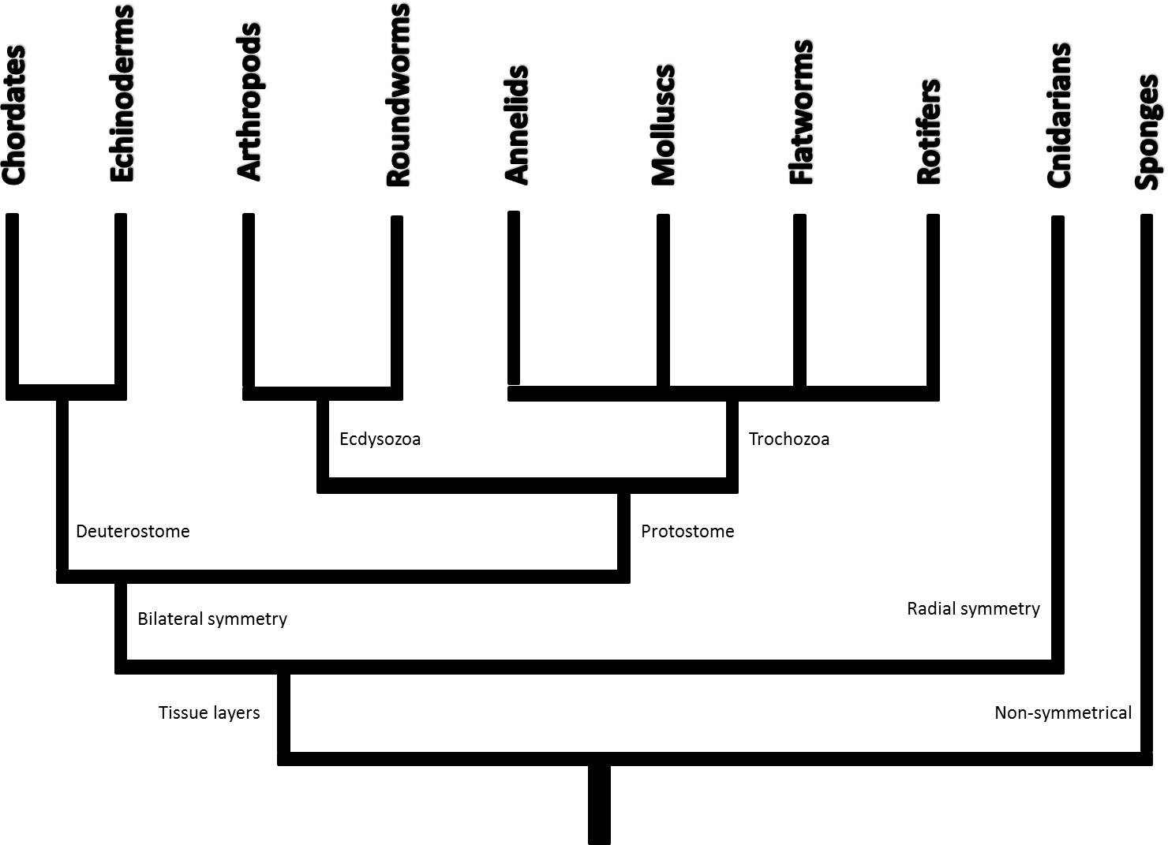

ay its divided, will be identical (ex. Sponges). Radial symmetry, as in Cnidarians, means no matter what way we slice the animal longitudinally the two halves will be identical. The other phyla have bilateral symmetry, meaning these animals have a defined right and left half. These bilateral organisms are further divided based on the first opening in embryonic development being the mouth (protostomes) or Anus (deuterostomes). Of our protostomes we then divide them into Ecdysozoa or Trochozoa. Ecdysozoa have a shedable exoskeleton, and trochozoans have a larval form that is free swimming. These characteristics help us divide the highly diverse species on earth into distinct related groups.
The first feature of interest in grouping is symmetry. Asymmetry means the animal, no matter what w
Figure 3.1: Evolutionary tree of animals
The organisms below are all similar to each other because they are all non-coelomates. Coelomates have a body cavity that has been completely lined by the mesoderm which allows for growth of complex organs. While there is a great diversity in invertebrate organisms, there simply isn’t time in lab to address all the differences in their anatomy and physiology. However, in this lab we have highlighted some examples to begin our comparative studies of invertebrate anatomy.

ROUNDWORMS
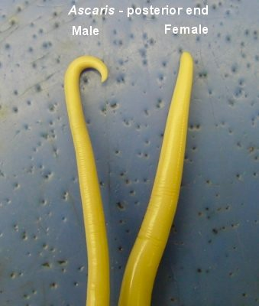
Roundworms are in the phylum Nematoda; they have bilateral symmetry, pseudocoelom, and a complete digestive tract. Most roundworms are parasitic and take their nutrients from both plants and animals. Human consumption of undercooked foods is a common pathway to an infection of roundworms. Ascaris is a tropical intestinal parasite that when ingested burrows through the intestinal wall and makes its way to the lungs. Ascaris has both a male and female form. You can observe both forums in the preserved specimens. This will be your first dissection; it is the simplest and best to begin with. Your instructor will show you when to make you incision and how to dissect this animal. You are looking for the following:
- A male vs a female
- Gonads

MOLLUSKS
Figure 3.2 Ascaris

Mollusks are in the phylum Mollusca. Mollusks come in many varieties including the bivalve (clam), chitons (flattened grazing marine invert.), gastropods (snails), and cephalopods (squids). All these groups share three characteristics: They have a muscular foot specialized for locomotion, visceral mass that includes the internal organs, and have a thin tissue that encloses the visceral mass called a mantle.
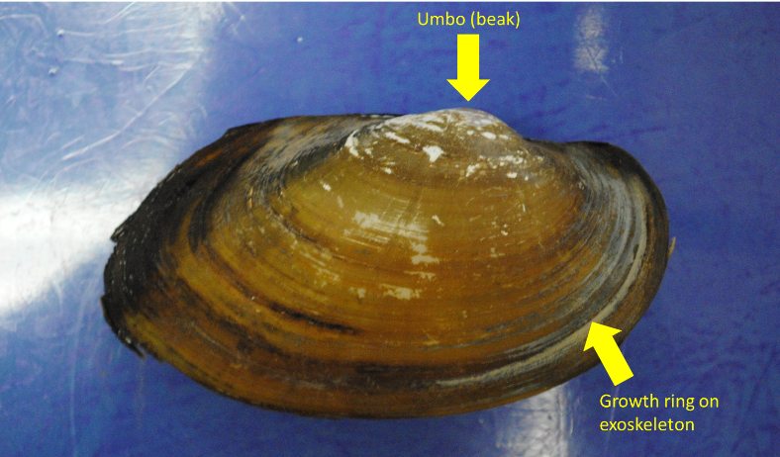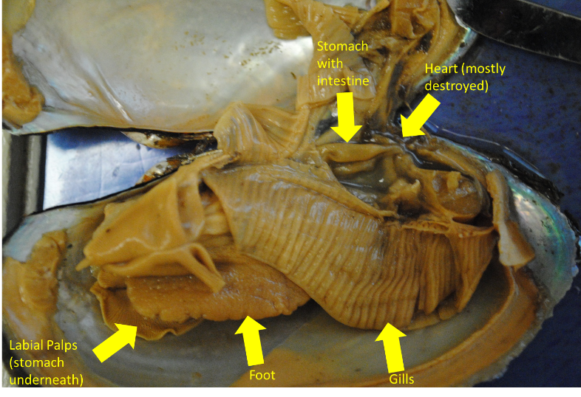Examine the clam, be able to identify the following structures: External
  - Hinge
  - Umbo
  - Growth ring
  - Exoskeleton

Internal a.
  - Heart
  - Kidney
  - Gills
  - Foot
  - Stomach
  - Intestine
  - Labial palps

Figure 3.3 Clam anatomy
    - exterior b. interior b.

Other Mollusks look quite different. One such of these groups is called the Cephalopods. these are highly adapted and, in many cases, highly intelligent group of animals that includes octopi, squid, nautili, and cuttlefish.
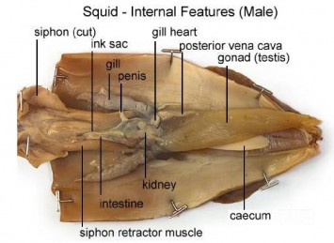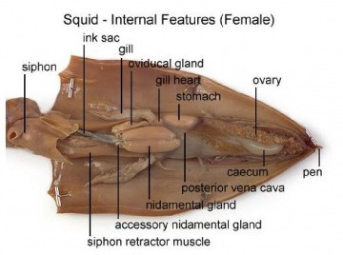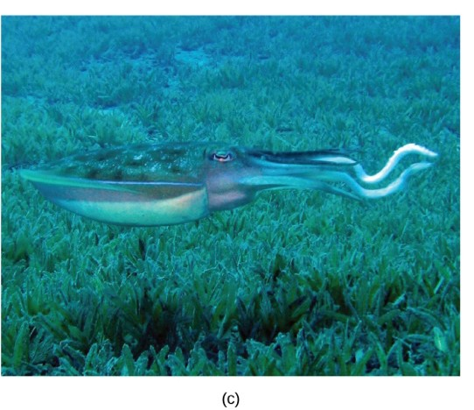Be able to identify the following squid structures: External
  - Fins
  - Tentacles
  - Beak
  - Eye
  - Mantle
  - Suction disks

Internal
  - Siphon
  - Stomach
  - Ovary
  - Testicle
  - Ink sac
  - heart

Figure 3.4 a. female squid internal structures, b. male squid internal structures, c. reef squid credit: OpenStax Rice University

ANNELIDS
Annelids are in the phylum Annelida. These are considered segmented worms because the body is divided into regions called somites. Among the annelids are a group called oligochaetes. They share all the characteristics of Annelids except they have few bristles called setae on their body. The most well-known of the oligochaetes is the earthworm.
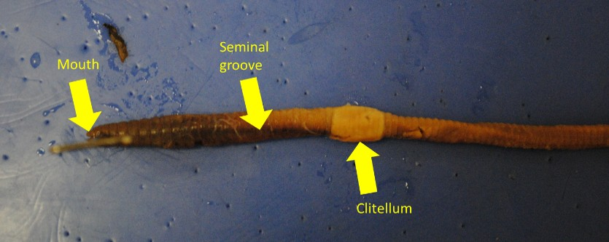
Be able to identify the following structures: External
  - Anus
  - Clitellum
  - Mouth
  - Seminal groove

Figure 3.5 annelid external structures

Internal
  - Brain
  - Pharynx
  - Heart’s
  - Esophagus
  - Seminal receptacles
  - Seminal vesicles
  - Crop
  - Gizzard
  - Intestine.
  - Septa
  - Dorsal blood vessel

ARTHROPODS

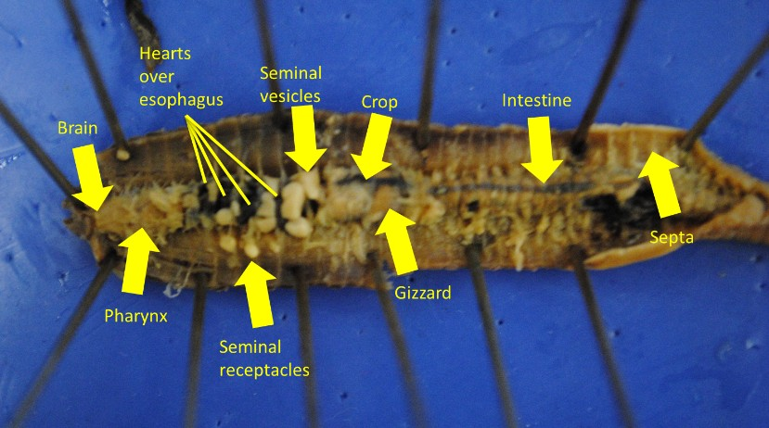
Figure 3.6 annelid internal structures

Arthropods are in the phylum Arthropoda. Arthropoda includes insects, arachnids, and crustaceans. They all share the same characteristics of a segmented body, exoskeleton, and jointed appendages. Insects are the most common of the arthropods; they contain three body regions, and three legs. Arachnids have four pair of legs, no antennae, and a fused head and thorax called a cephalothorax. Crustaceans have three to five pairs of legs and two pairs of antennae.

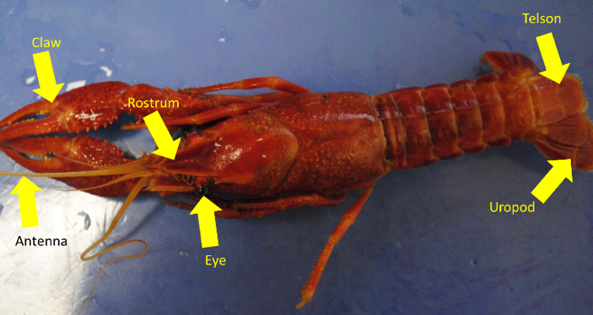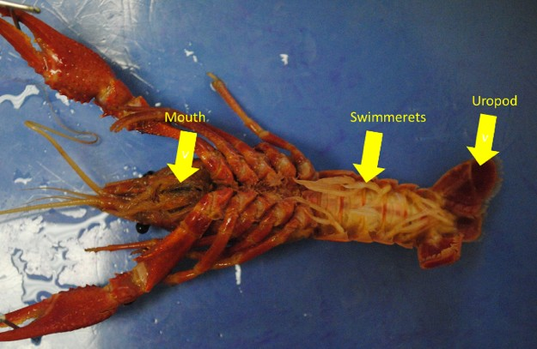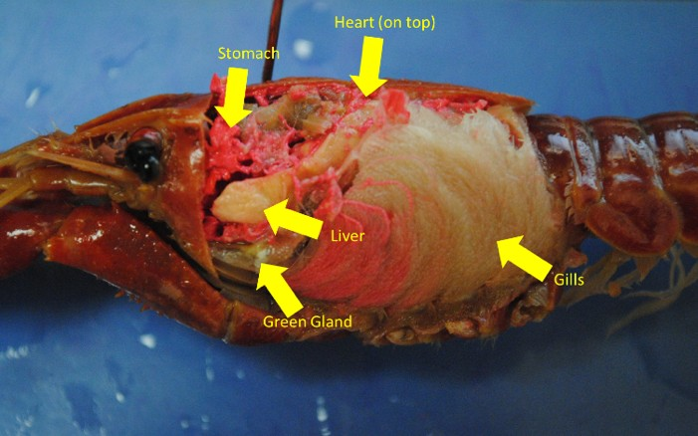Examine the crayfish (A Crustacean), you should be able to identify: External
  - Eye
  - Claw
  - Rostrum
  - Antenna
  - Mouth
  - Uropod
  - Telson a.
  - Swimmerets
  - Male or female

b.
Internal
  - Stomach
  - Digestive gland (liver)
  - Gills
  - Heart
  - Brain

c.
8
1
Figure 3.7 a. & b external crawfish anatomy, c internal anatomy

CHORDATES

Exercise 4: Introduction to Chordates

Chordates have a coelom and are a major branch of bilaterally symmetrical animals. We have looked at the major groups of the protostomes (molluscs, annelids, arthropods, etc…), now we will switch to looking at deuterostomes. Chordates are defined as having a notochord, pharyngeal slits, endostyle/ thyroid gland, dorsal hollow nerve cord, and post anal tail. The evolution of each of these structures has allowed for increased mobility, respiration, acquisition of nutrients, and reproduction. There are many organisms that display many but not all of these traits. One such group is the hemichordates. Hemichordates display half the characteristics of a chordates and half the characteristics of echinoderms (starfish, sea urchins, sea dollars, etc…). Chordates evolved early in the Cambrian period (about 530 million years ago), however the first real chordates most likely never left fossils because they did not evolve hard teeth and bones until later in the evolutionary timeline. Through half a billion years of evolution the basic body plan for vertebrates evolved leading to modern vertebrates.

VERTEBRATES
Vertebrates are true chordates possessing, at some point in their life, all five characteristics of chordates.
Beyond these characteristics vertebrates also have a vertebral column and a true cranium.
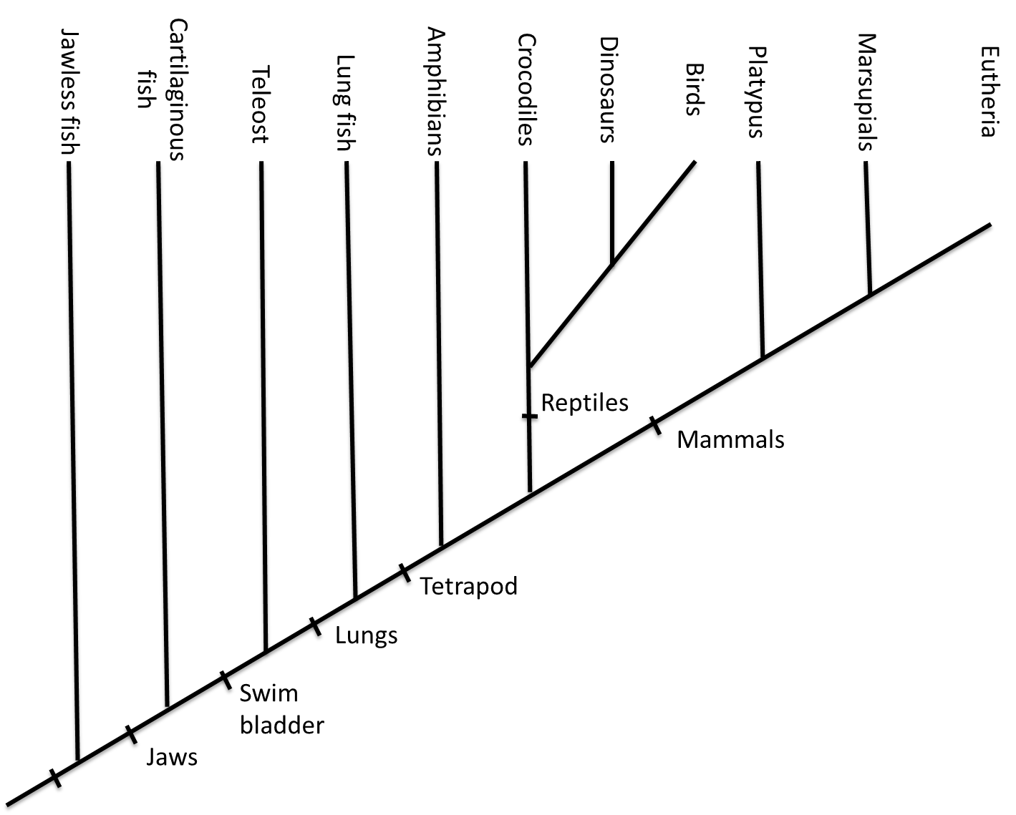
Figure 4.1: phylogenetic tree of vertebrates
Early vertebrates were all jawless fish, called agnathans. These fish were thought to be filter feeders using their large pharynxes to suck in organic particles. Living decedents of these agnathans are lamprey and hagfish. Quickly (relatively from a geological stand point ~ 50 million years) after the rise of vertebrates the first jawed fish (gnathostome) evolved. This gave fish a more efficient way to capture food. With more efficient ways to capture food other characteristics began to develop. Fish became more mobile to capture food; they began fighting gravity and moving off the sea floor and occupying different habitats. One early adaptation to aide in movement was the loss of calcification of cartilage into bone. This group of fishes still exists in sharks, skates, rays, and ratfish. However other adaptations were taking place leading to modern teleost (bony) fish with their swim bladders. By the late Devonian period (~350 million years ago) the

seas were thriving with many types of fish competing with each other. This new pressure started a chain of events that drove evolution into the development of limbs and lungs that allowed movement onto land where predators were fewer and competition for resources was greatly reduced.

Be able to identify the following structures from each animal:

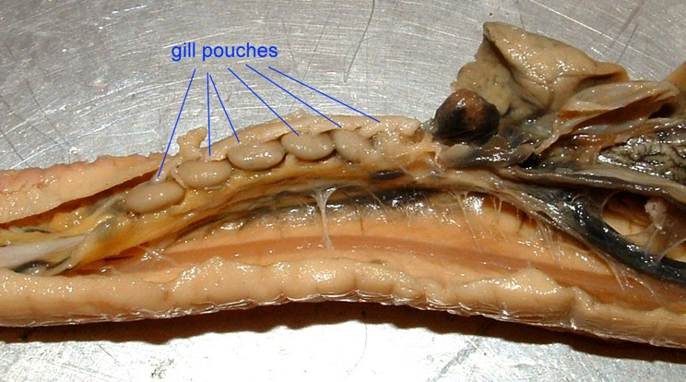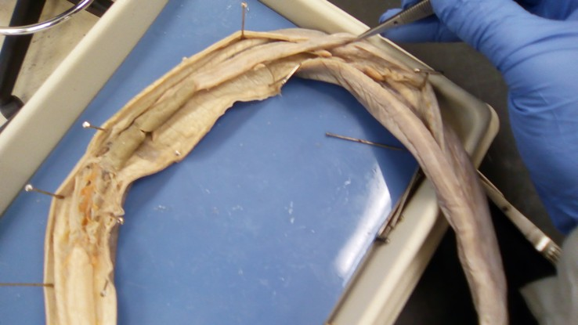HAG FISH
Liver
Heart
http://bio.sunyorange.edu
Liver
Intestine
Ovary with mature egg
External
- Barbel
- Mucus openings
- Mouth
- Anus

Internal a.
  - Pharynx
  - Gill pouch
  - Heart
Pharynx Notochord Slime Glands
  - Liver
  - Gall bladder
  - Intestine
  - Ovary
  - Notochord
  - Teeth
  - Slime gland

b.

Figure 4.2: a. & b. internal structures of a hagfish

SHARK
External
- Rostrum
- Ampullae of lorenzini
- Gills
- Spiracles
- External nares
- Male or female?
- Dorsal Fin
- Pectoral Fins
- Heterocercal caudal fin
- Pelvic fins
- Cloaca

Internal
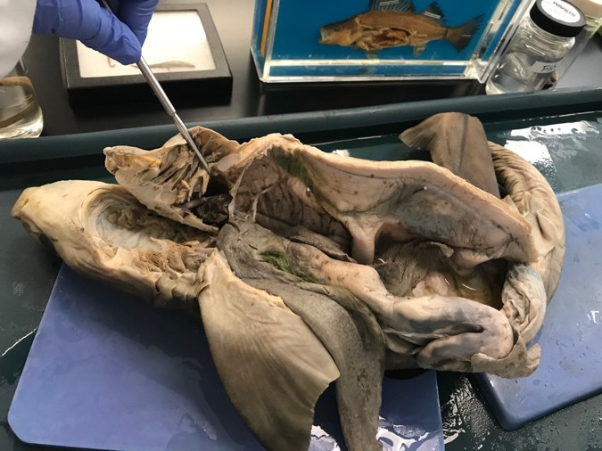
- Stomach
- Intestines
- Esophagus
- Liver
- Gallbladder
- Spleen
- Atrium
- Ventricle
- Testicle
- Ovary
- Rectal gland

Figure 4.3: internal structures of a shark

BONY FISH
External
  - Caudal fin
  - Dorsal fin
  - Anal fin
  - Anus
  - Pelvic fin
  - Pectoral fin
  - Gills
  - Opercula flap
  - Lateral line

Internal
  - Stomach
  - Liver
  - Air bladder
  - Intestine

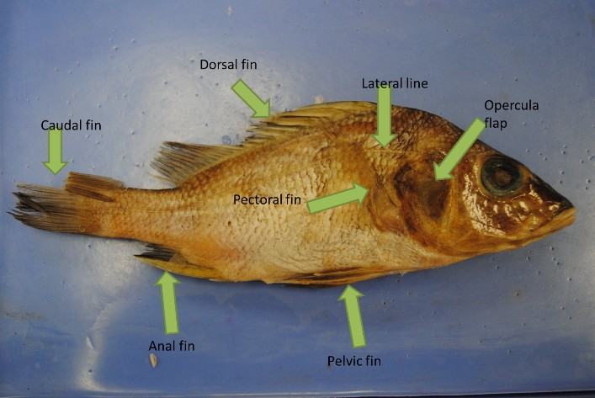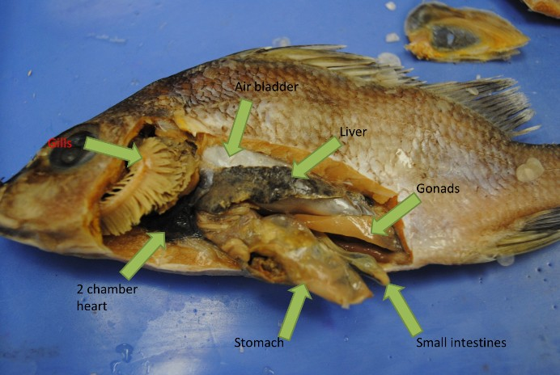
- b.
Figure 4.4: a. & b. internal structures of a perch

  - Is it male or female?
  - Heart
    - Dissect heart-how many chambers?

FROG
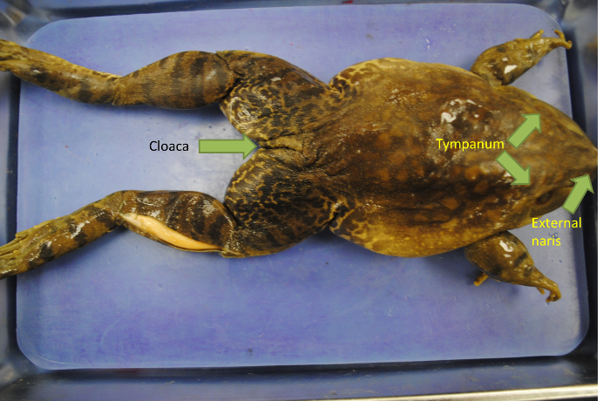
External
  - Tympanum
  - External naris
  - Cloaca
  - Internal nares (inside mouth)
  - Vomerine teeth (inside mouth)
  - Maxillary teeth (inside mouth) Internal
  - Stomach
  - Liver
  - Gallbladder (under liver) a.
  - Lung
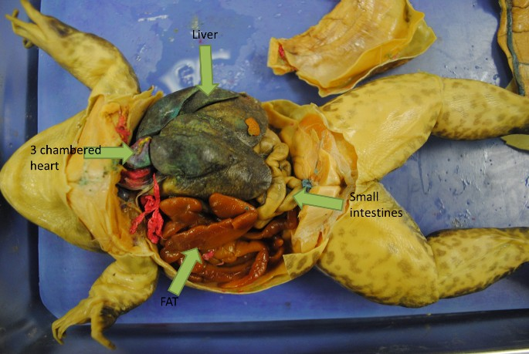
  - Intestine (both)
  - Pancreas (behind/ under stomach)
  - Male or female? (and associated structures)
  - Kidney
  - Spleen
  - Heart
    - Dissect heart-how many chambers?

Figure 4.5: a. & b. internal structures of a frog b.

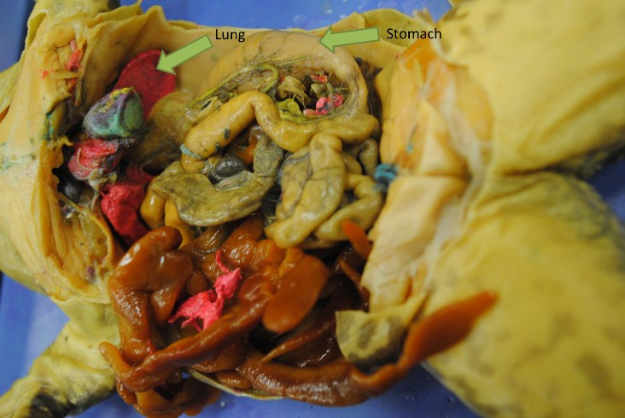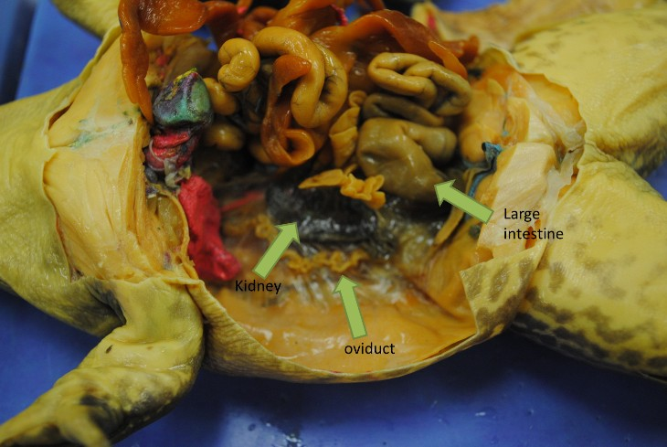
- Figure 4.6: a. & b. internal abdominothoracic structures of a frog b.

THINK ABOUT WHAT YOU SAW:
-How did the digestive system change from invertebrates to vertebrates?
  - How did the digestive system change from aquatic to terrestrial?
  - Could you find a kidney in the fish?
  - Was there a large intestine in the fish?
  - How did the cardiovascular system change from the invertebrates to the vertebrates?
  - How did it change from aquatic to terrestrial?
  - How did respiration change from aquatic to terrestrial?
  - How do bony fish and frogs reproduce?
  - What were the main differences between lamprey, sharks, and boney fish?

Exercise 5: Vertebrates Continued
At the end of the Devonian period (~360 million years ago), vertebrates first started walking on land. The first tetrapods were transitional forms between aquatic and terrestrial likely spending most of their lives in shallow waters venturing on land to predate on insects or to lay eggs. These organisms lead to modern day amphibians. Once tetrapod’s ventured onto land many adaptations had to take place to accommodate the new and different environment on land.

Locomotion vastly changes from an aquatic habitat to a terrestrial one. This is displayed in the pattern of bones in the limbs. The general development of these bones in tetrapods is: one bone (ex. humerus), two bones (ex. radius/ulna), many bones (wrist), and hand. Breathing becomes very different in air rather than water. Development of lungs also changes the circulatory system greatly. In fish and in amphibians reproduction takes place in water and eggs have a ready access to water. When organisms moved onto land other reproductive measures had to adapt. This creates two major splits in the vertebrate tree, the reptiles, that have hardened eggs to hold in moisture, and mammals, whom retain their offspring internally.

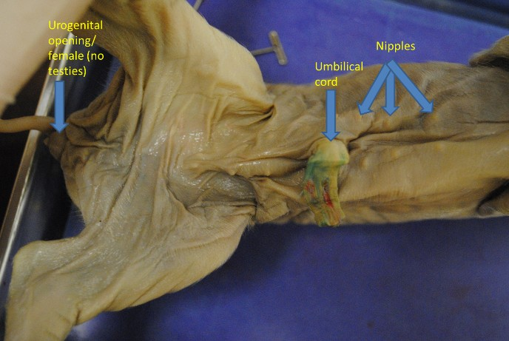
Be able to identify the following structures:

FETAL PIG ANATOMY

External:
  - Male or female?
  - Anus
  - Umbilical cord
  - Nipples
  - Urogenital opening
-

Internal
  - Hard palate
  - Soft palate
  - Incisor
  - Canine
  - Epiglottis
  - Tongue
  - Pharynx
  - Esophagus
  - Trachea
  - Thyroid
  - Heart (atrium, ventricles)
  - Lungs
  - Diaphragm
  - Liver
  - Gallbladder
  - Stomach
  - Spleen a.
  - Pancreas
  - 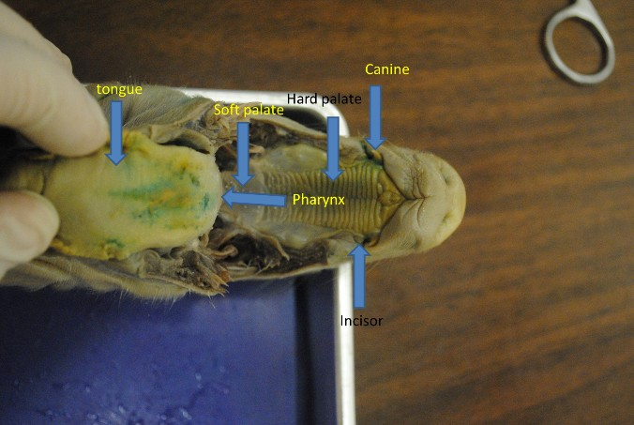Small intestine
  - Large intestine
  - Urinary bladder
  - Carotid artery
  - Kidney
  - Vena cava
  - Aorta
  - Iliac artery
  - Male or female? (and associated structures)
b.

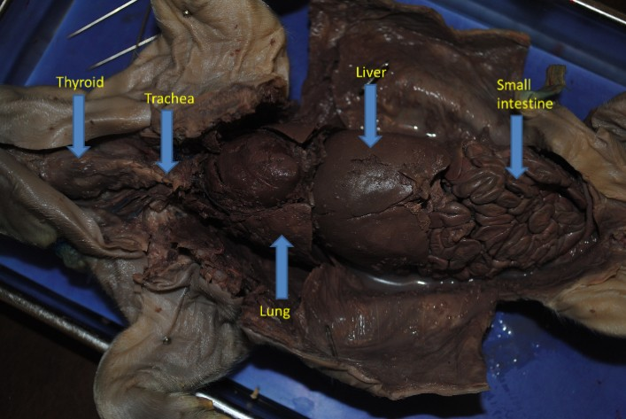
Figure 5.1: a. external structures of a fetal pig, b. internal oral structures of a fetal pig, c. internal structures of a fetal pig

2
3

c.

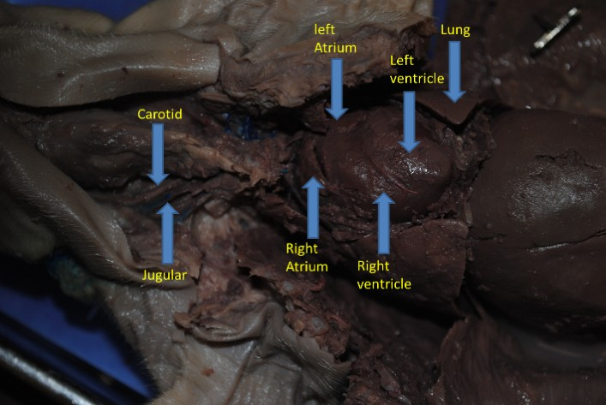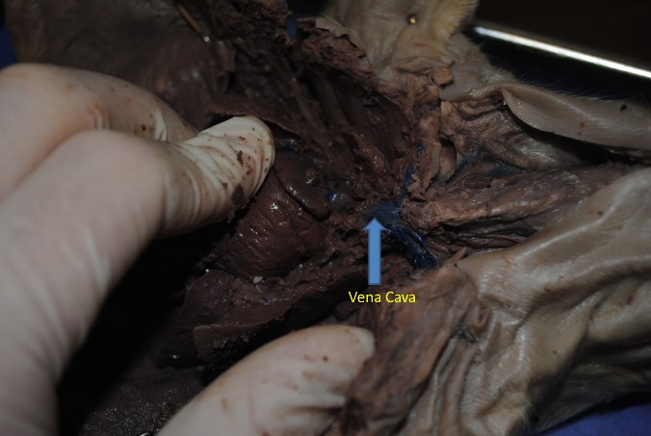
a.
b.

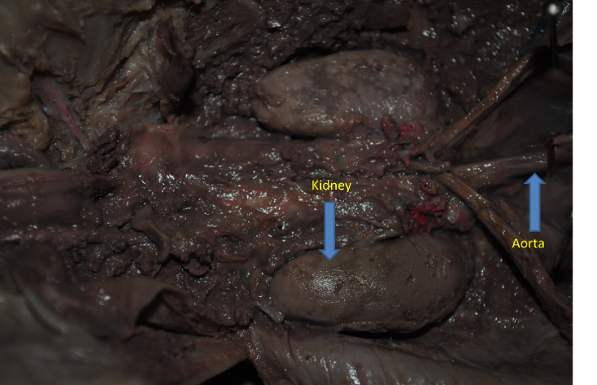Figure 5.2: a. & b. thoracic structures of a fetal pig
a.

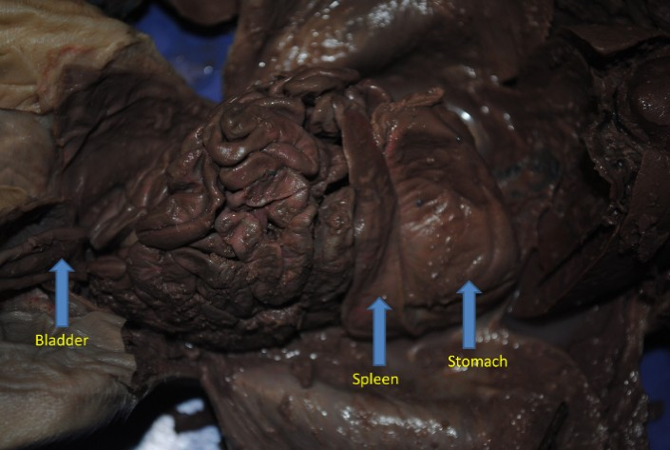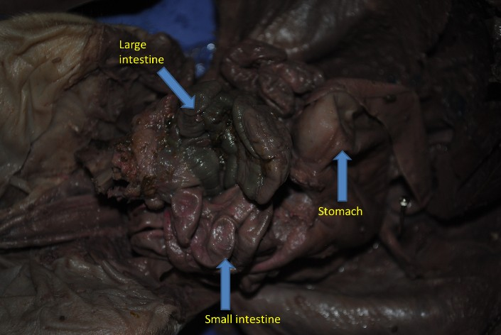
b.
c.
Figure 5.3: a., b., & c. abdominopelvic structures of a fetal pig

PIGEON
Avian anatomy:
    - Trachea
    - Esophagus
    - Crop
    - Gizzard
    - Small intestines
    - Air sac

  - Lung
  - Liver
  - Kidney
  - Cloaca
  - Heart (atrium, ventricles)

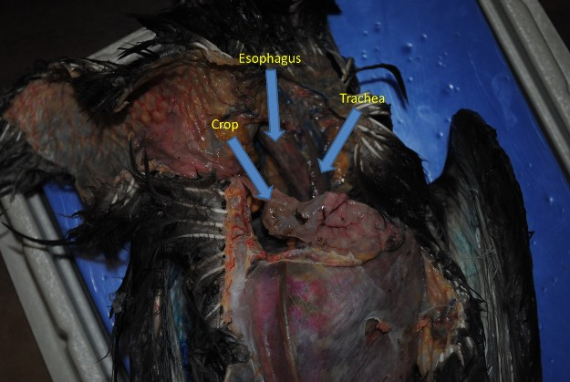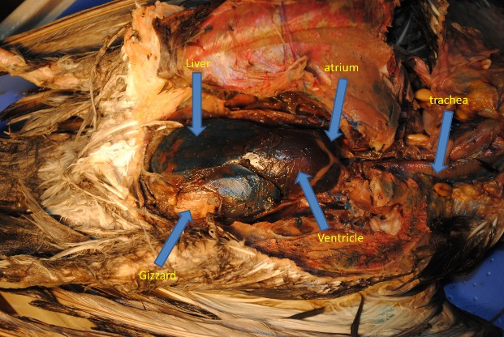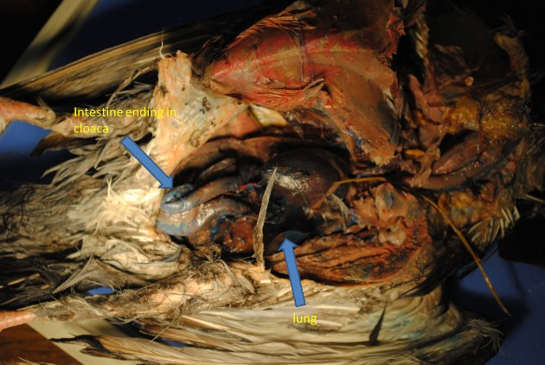
a.
b.
c.
Figure 5.5: a., b., & c. internal structures of a pigeon

Think about what you saw:
    - What were the main differences between the bird and pig?
    - Why does the bird need a more efficient respiratory system?
    - What is the difference in all the vertebrate’s cardiovascular systems?
    - What’s the difference between an anus and cloaca?

Exercise 6: Mammalogy
In this lab you should learn about the general morphology of mammals and how to identify some mammals common to our area.

SKULLS
Skull morphology is an important concept when Identifying wildlife. Review the bones found in a canine skull as it reflects similarities to other mammal skulls. Compare the canine skull to other skulls found in the lab.

Canine skull anatomy:
- 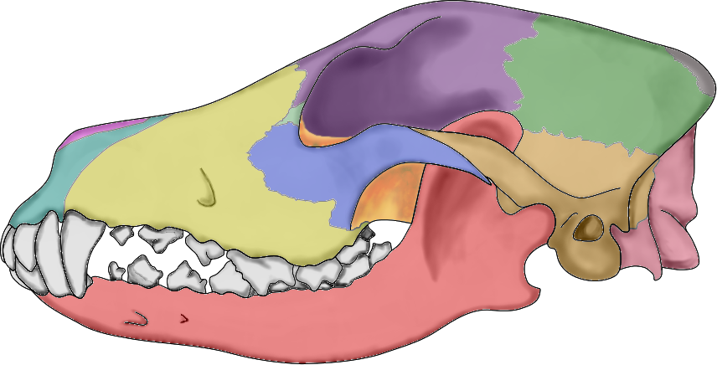maxilla
2
9
8
6
3
7
1
5
10
4
11
12
- frontal
- lacrimal
- palatine
- jugal
- nasal
- premaxilla
- parietal
- interparietal
- squamosal
- occipital
- mandible

TEETH
Figure 6.1 Lateral view of a dog skull
Credit: Przemek Maksim, Wikimedia Commons

Mammals have teeth in three different bones. Upper teeth are found in the premaxilla and maxilla; all lower
teeth are found in the mandible. The types of mammalian teeth most mammals have a heterodont dentition, meaning that different teeth in the jaw have different shapes, and, therefore, functions. We identify these different tooth types by several criteria, namely position, shape, and whether or not they are replaced. There are four types of teeth:

Incisors: When present, these are the anterior most teeth. Upper incisors are always found in the premaxilla.
The incisors of many mammals, such as yours, are designed for nipping off bits of food, but many variations exist. Incisors are usually replaced.
Canines: When present, canines lie right behind the incisors. Upper canines are therefore the anterior most teeth in the maxilla. Canines are generally conical, pointy teeth used for holding onto prey and in defense or intraspecific combat. The size of canines differs among mammals, usually being largest in carnivores, whereas many herbivorous mammals have small canines or have lost them altogether. Canines are usually replaced.
Premolars and molars: Premolars and molars are together referred to as the cheek teeth. Both types of teeth are usually specialized for grinding or processing food items before swallowing. Both types of upper teeth are found in the maxilla. Premolars are posterior to canines, and molars are posterior to premolars. Some premolars are replaced, whereas molars are never replaced. In fact, molars are defined as the unreplaced teeth that are posterior to the last replaced tooth. Molars are often more similar to deciduous premolars than to adult premolars, and you can actually think of molars as part of the deciduous generation that comes in late and is never replaced.

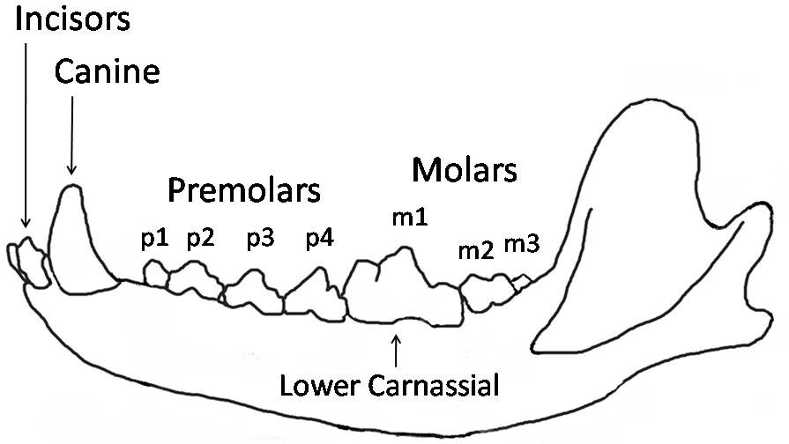
i1 i2 i3

Figure 6.2 Wolf mandible diagram showing the names and positions of the teeth. The dental notation for the upper-jaw teeth uses the upper-case letters I to denote incisors, C for canines, P for premolars, and M for molars, and the lower-case letters i, c, p and m to denote the mandible teeth. Teeth are numbered using one side of the mouth and from the front of the mouth to the back.
Credit: William Harris, Wikimedia Commons

Dental Formula
The number of each type of tooth differs from taxon to taxon. In some cases, the number of a type of tooth differs in the upper and lower jaws of the same species, but right and left are always the same. Thus, we can characterize each mammal taxon by a dental formula, representing the number of incisors, canines, premolars, and molars found in each half (right or left) of the upper and lower jaws. We write this formula as I n/n C n/n P n/n M n/n. I, C, P, and M refer to the four types of teeth (incisor, canine, premolar, and molar), and n/n refers to the number of upper and lower teeth of each type found on one side. As an example, consider our own dentition. Humans have a total of 32 teeth (including wisdom teeth), 16 in the upper jaw and 16 in the lower jaw. Of course, the 8 teeth on the right side of your upper jaw are basically a mirror image of the 8 on the left, and the same can be said of the lower jaw. Thus, the dental formula reflects the 16 teeth (8 upper, 8 lower) found on each side and looks like this: I 2/2 C1/1 P 2/2 M 3/3. It just so happens that humans have the same number of each tooth type in their upper and lower jaws, but this is not the case for every mammal. In Figure 6.2, for instance, the dental formula of a Canis lupus is: I 3/3 C 1/1 P 4/4 M 2/3.

Go around the room and look at the various skulls. Write down the dental formula for each animal.
Animal | Dental Formula
Coyote
Opossum
Rabbit
Raccoon
Bobcat
Beaver
Squirrel
Black Bear
White Tail Deer
Domestic Cat

TRACKS

One can often identify an animal just from the tracks it leaves behind in the mud, sand, or snow. Below in Figure 6.3 one can view the different animal tracks common to Florida as well as Georgia.
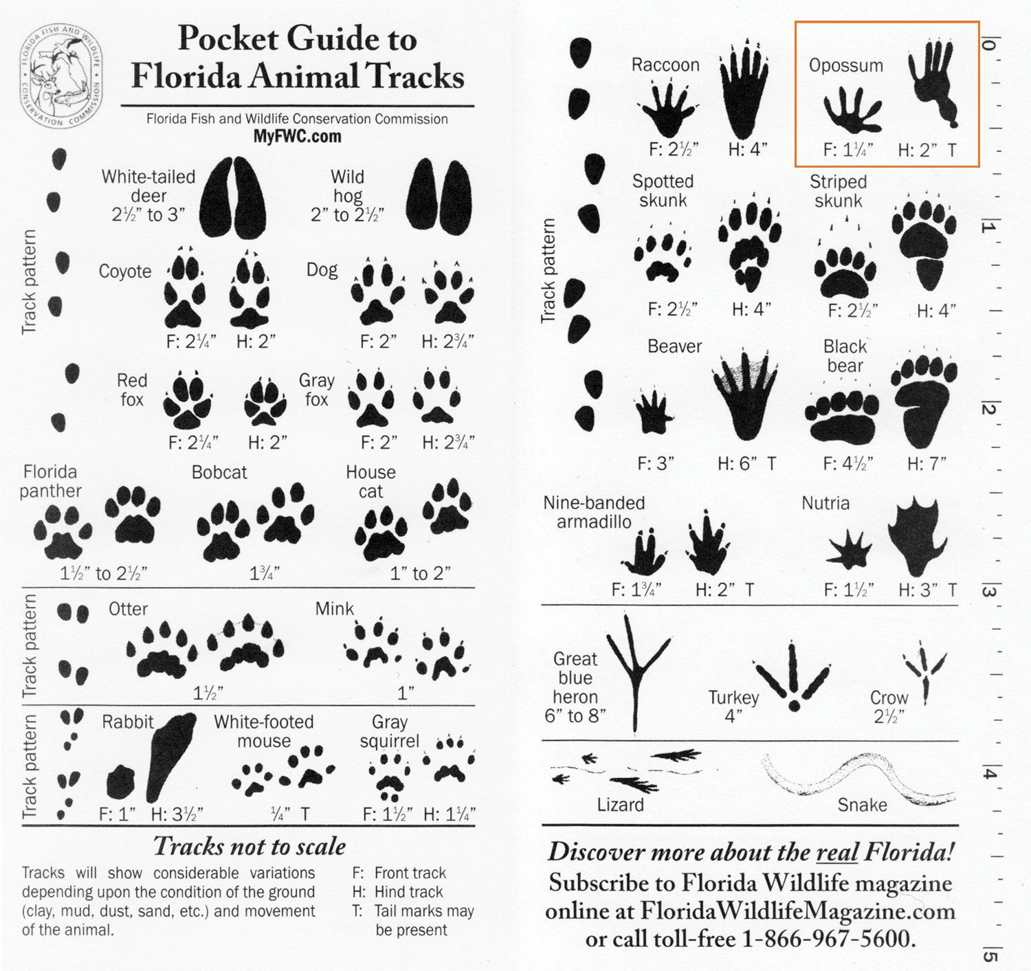
Figure 6.3 Pocket Guide to Florida Animal Tracks
Credit: Florida Fish & Wildlife Conservation Commission

Once you have familiarized yourself with both teeth dentition and animal tracks, see if you can identify the unknown animals on the back table of this laboratory.
1)
2)
3)
4)
5)

CLASS ACTIVITY: Make a plaster mold track of your own.

Supplies:
1 Cup Plaster of Paris Disposable paper/solo cup
½ Cup water
Popsicle stick/tongue depressor

Optional supplies: 2”x11” strip of paper Paper clip

Instructions:
- Go out into the field around your school or home to find an animal track. Open muddy areas near a water source are optimal places to find tracks.
- Once you have found your track you can surround the track with the paper strip and keep it in place with the paper clip. This will give you a mold to pour into.
- Now you should begin to mix your plaster of paris with water in your disposable cup using your tongue depressor. You want to add the water sparingly until you have the proper consistency. The plaster should be the consistency of smooth peanut butter or tooth paste. The thicker the mixture is the harder it is to pour. The thinner it is the more fragile a cast and the longer it takes to harden. Note: Do not take too much time with this step of the plaster will begin to set in your cup.
- Once you have your plaster mixture at the right consistency pour onto the track which should be surrounded by your paper mold. Allow proper time for the track to harden. (~1 hr. in dry warm weather, consult) Larger tracks will take longer to set than smaller tracks.
- Very carefully check to see if your track is hardened. If it is not, please wait until it is thoroughly dry. Once your track is hardened very carefully remove your track from the ground.
- Congratulations on making your very own animal track cast! Use this lab manual to identify what animal track you have captured.

GOALS. By the end of this lab, you should be able to:
- Identify the different types of bones found in the mammalian skull
- Identify the different types of teeth in the mammalian dentition
- Determine dental formula for various mammals
- Identify different tracks from common mammals

Collection Project

During the course of the semester, you will learn techniques for sampling and handling all different types of animals. You will also learn taxonomic skills to help you identify the organisms you capture. The purpose of this assignment is to utilize these skills to create your own collection of animals.

There are 3 options from which to choose to complete your project for full credit: Option 1: Collection
- You will need a total of 20 different wild (non-domestic) animals in your collection.
- All 20 must be collected and preserved according to proper protocols.
- All animals must be identified as followed:
  - Vertebrates must be identified to Genus and species (unless I give you permission to not go as far due to specific difficulties of some species).
  - Invertebrates must be identified to Order (extra credit will be assigned by going further down, this means you could end up with only 10 actual invertebrates all identified to family, or 20 identified to order or some combination in between).
  - All animals (collected) must be labeled with identification, location collected, and date collected.

Any dangerous animal collected or attempted to be collected will result in an immediate grade of 0 assigned for the assignment (it is very unlikely that you will pass the course with this grade). Dangerous animals include but are not limited to: snakes, other reptiles, wild mammals, and birds. Other animals that can result in a failing grade is any animal protected by state or federal law. A rule of thumb here is if you don’t know then don’t collect it.
Option 2: Photographs
- You will need a total of 40 different wild (non-domestic) animals in your collection
- These pictures must be your own and not pulled off of the internet.
- All animals must be identified as follows:
  - Vertebrates must be identified to Genus and species (unless I give you permission to not go as far due to specific difficulties of some species)
  - Invertebrates must be identified to Order (extra credit will be assigned by going further down, this means you could end up with only 20 actual invertebrates all identified to family, or 40 identified to order or some combination in between).
  - All animals photographed must be labeled with identification, location, and date photographed. Option 3: Hybrid
- You will need a total of 30 different wild (non-domestic) animals in your collection.
- You will have a minimum of 10 animals collected and preserved.
- The remaining 20 may be photographed by you and not pulled off the internet.
- All animals must be identified as described in Option 1 for preserved animals and Option 2 for Photographs.

Rubric for animal collection

Rubric- Option:
Total number of animals collected correct | 50pts
Animals identified correctly | 25pts
All animals labeled | 15pts
Finished product organized and neat | 10pts
Total | 100pts

