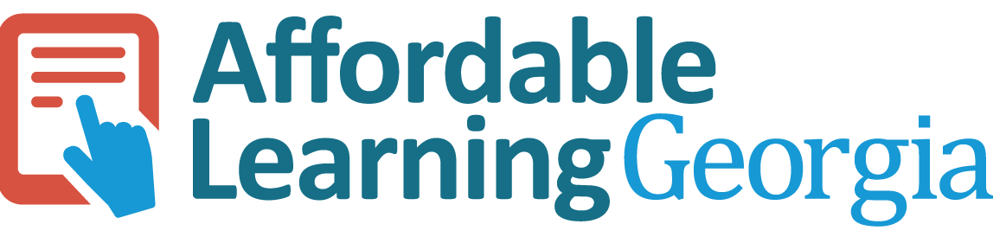

OER Accessibility Series: Captioning and Transcripts
Captioning and transcripts are text alternatives for audio-based content. There are a couple of important things to keep in mind about captioning and transcripts:
- A transcript is a document with all of the audio typed out on it from a media file; captions are transcripts that have been timed and coded into video files.
- Because accessibility laws call for an equivalent experience, transcripts are not enough for video content—there must be timed captions.
- It’s also important to make sure that your captions and transcripts are equally as understandable and readable as your audio. So as you edit, add in punctuation and capitalization to help with clarity and remove unnecessary “ums” and “uhs.”
- For copyright-protected videos or podcasts for which you have permission to include in your course, you should first check to see if they already have captions and/or transcripts. If they do not, work with the copyright holder to create them.
- Many universities have their own video hosting and captioning tools. It is recommended to use those university-supported tools, and to get help with them, you should contact your university information technology support team. This tutorial will provide free alternatives to your university supported tools.
This work by Tiffani Tijerina for Affordable Learning Georgia is licensed under a Creative Commons Attribution 4.0 International License.

Captioning Videos with YouTube
YouTube has an auto-captioning function that is activated when new videos are uploaded. Those auto-captions are probably about 80% accurate, but it gives you a place to start so that you don’t have to caption your whole video from scratch. YouTube also has a very easy-to-use caption editing function that you can then use to clean up those auto captions.
- Make sure you are logged into your Google account. Upload your video to YouTube by clicking the small add video icon, then click “Upload video.”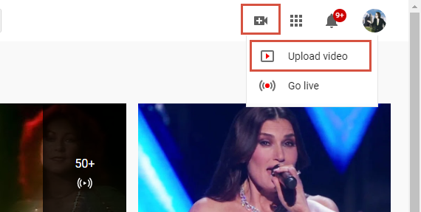

- Drag and drop your video file into the box provided to upload it. When the video is finished uploading, go through the video settings to finish the upload.

- Click on the video you uploaded. In the editor view, click “Subtitles.”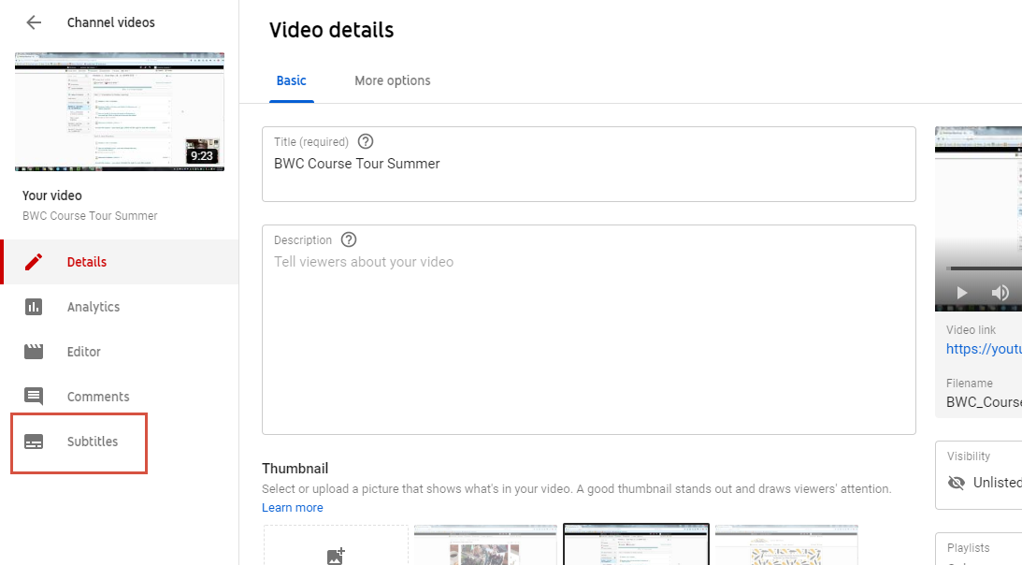

- If you already have a captions file showing on this page, skip this step. If you don’t, click “ADD” on the “English (video language)” line. Note: If your video is in a foreign language, you need to click “ADD LANGUAGE” and select your language.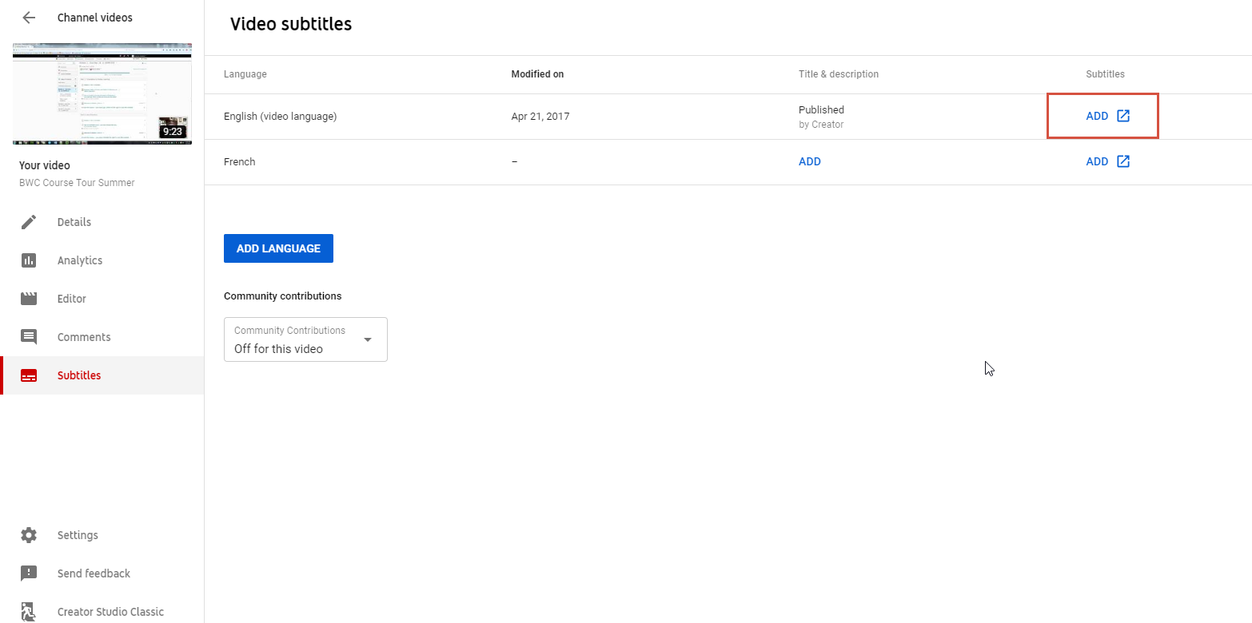

- Click “Create new subtitles or CC.”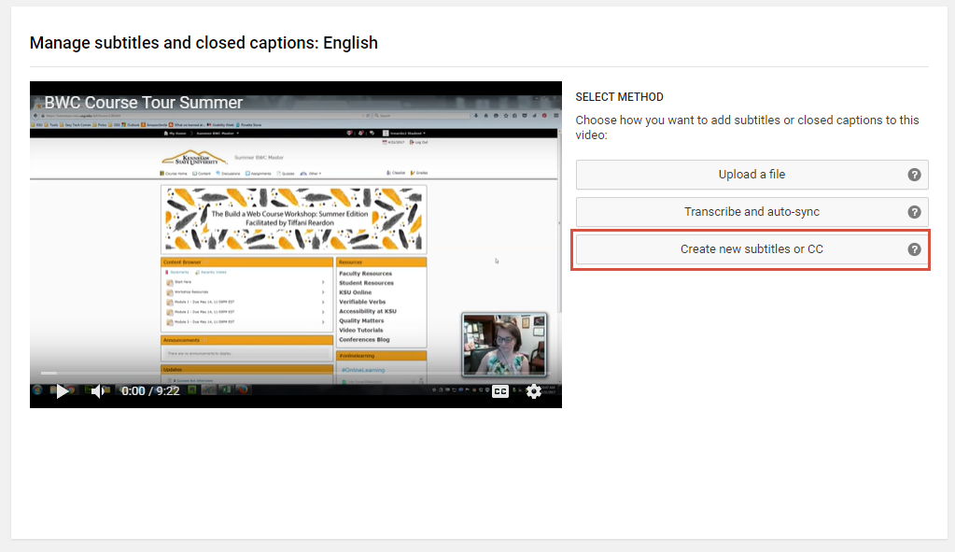

- The YouTube editor should give you auto-generated captions to start with. If you click the play button on the video, the video will start playing. You can edit your captions as you watch, and each time you start to type, the video will automatically pause until you are finished. Edit your captions as needed. When you are finished, click “Save changes.”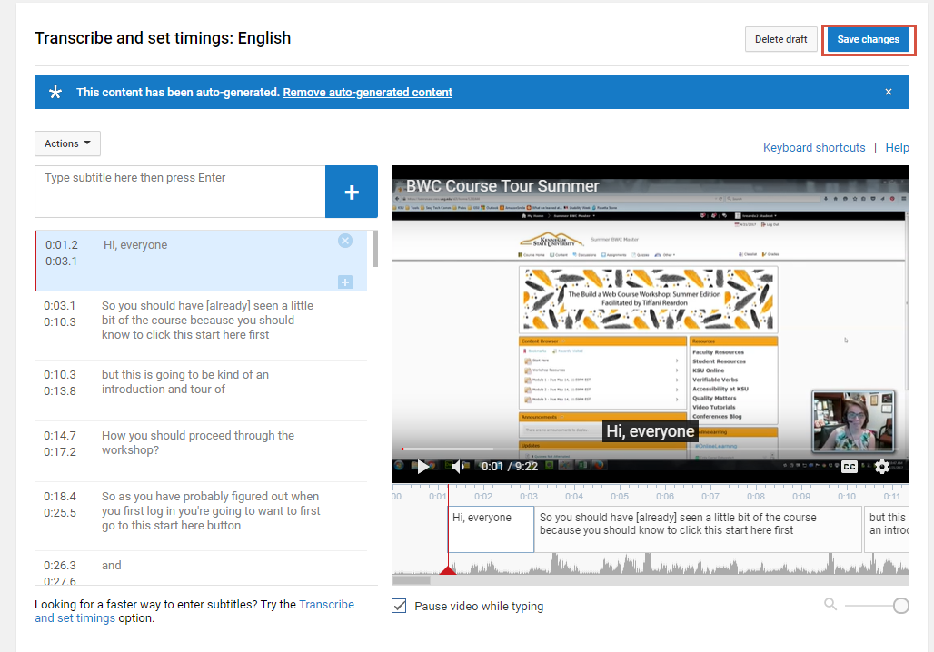

Transcribing Audio with Otter
Otter is an audio transcription tool with a free option that allows you to transcribe up to 600 minutes per month. The tool has an easy-to-use editor similar to YouTube and allows you to export your transcripts. It also has a mobile app for on-the-fly transcribing.
- Go to otter.ai and sign up for an account.

- Once you are all signed in, click “Import audio/video.”

- Drag and drop your audio file into the box provided to start the upload. Click “Done” when the upload is finished.

- Refresh the page every once in a while, as you wait for the audio file to finish processing. When it is ready, click on it.

- To edit your transcript, click “Edit” in the top right corner, then click play at the bottom. It will play your audio and highlight the words as it comes to them. You can edit as needed from this screen.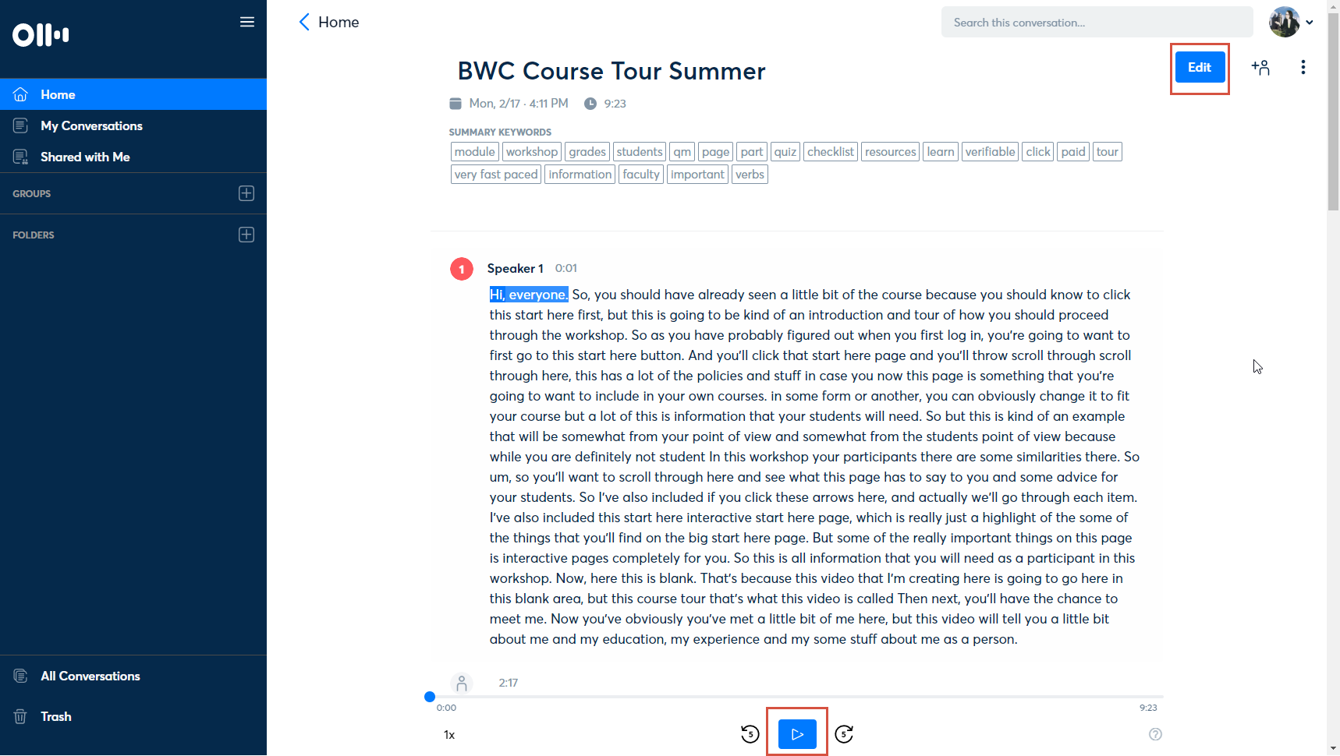

- When you’re finished editing, click “Done.”

- To export your transcripts, click the three dots in the top right corner, then click “Export Text.”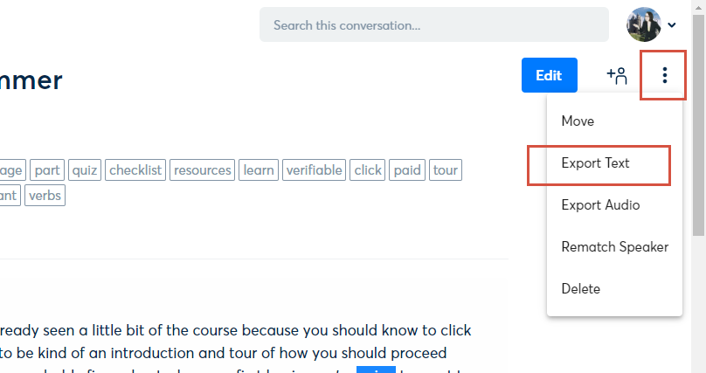

- Under export format, change it to “CLIPBOARD.” This will allow you to past the text into Word, since exporting directly to it is a premium feature.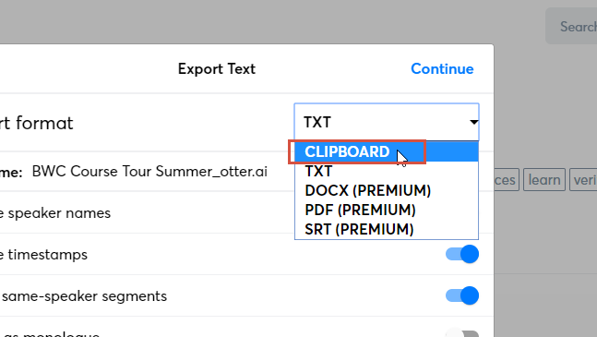

- Select your settings as desired, then click “Continue.”

- The text will be copied to your clipboard. You can now open up Microsoft Word and past the transcript into a document, then save it as desired.

