T. O.

401 Big StateLane #111  
Austin, Texas 78705

November 8, 2005  
  
St. Edward’s University   
Attn: David McMurrey  
3001 South Congress Avenue  
Austin, TX 78704

Dear Mr. McMurrey:

As previously agreed upon, I am submitting the attached handbook entitled *Handbook: Campus Resources and Basic Film Production Processes[.]*

This handbook will no doubt provide the reader with the necessary knowledge and guidance to effectively film and edit his or her video project. If there are any questions, comments or concerns please email me at [mdoak@acad.stedwards.edu](mailto:mdoak@acad.stedwards.edu) or call me at 281-687-4690 as soon as possible.

Sincerely yours,

T. O.

Encl: *Handbook: Campus Resources and Basic Film Production Processes*

**Handbook:  
Campus Resources and Basic Film Production Processes**



T. O.  
Groove Productions, Inc.  
Austin, Texas

December 5, 2005

This handbook discusses basic video production skills and the utilization of campus resources in order for students and faculty to produce quality video projects.

**Table of Contents**

**LIST OF CHARTS AND GRAPHICS**……………………………………………… iv

**I. INTRODUCTION** …………………………………………………………… 4

**II**. **ST. EDWARD’S RESOURCES** ……………………………………………. 5

**II. DEFINITIONS** ……………………………………………………………….. 7

Video Equipment …………………………………………………………… 7

Audio Equipment …………………………………………………………… 7

Basic Computer Terminology ………………………………………………. 8

Editing Terms ..………..…………………………………………………… 8

**III. SAFETY AND CARE** ……………………………………………………... 11

Mini-DVD Tapes …………………………………………………………… 9

Camera ……………………………………………………………………… 9

Editing ……………………….……………………………………………… 9

Computers ……………...……………………………………………….. 10

External hard drives ………..…………………………………………… 10

[sure would be nice to see properly aligned page #]

**IV. PRODUCTION AND TIPS** ……………………………………………….. 11

Pre-Production ………………………………………………………………. 11

Production …………………………………………………………………… 12

Post-Production …………………………………………………………….... 12

**V. EDITING** …………………………………………………………………….. 14

Introduction to Non-Linear Editing ………………………………………….. 14

Computer Requirements ……………………………………………………… 14

Final Cut Pro Discussion ……………………………………………………… 15

Logging and capturing ………………………………………………... 16

Editing to the timeline ………………………………………………… 17

Audio and video transitions …………………………………………… 19

Inserting color, text, pictures, etc ……………………………………… 20

Exporting ………………………………………………………………. 22

Back to mini-dv tape ………………………………………… 22

Creating a DVD ……………………………………………… 23

[list appendices at bottom of TOC]

**LIST OF CHARTS AND GRAPHICS**

**Figure** **Page**

1. Final Cut Pro Upon Launch ……………………………………….. 15

2. Log and Capture Window ………………………………………….. 16

3. Viewer Window Highlight …………………………………………. 17

4. Enlarged Viewer Window With Labels ……………………………. 18

5. Dragging Effects to the Timeline …………………………………... 19

6. Command Tab and Changing Color ………………………………... 20

7. Adding Text ………………………………………………………… 21

8. Exporting Back to Mini-DV Tape ………………………………….. 22

9. Exporting to Quicktime …………………………………………….. 23

10. Using iDVD ……………………………………………………….... 24

HANDBOOK: CAMPUS RESOURCES AND FILM PRODUCTION PROCESSES

I. INTRODUCTION

This Handbook is written primarily for students and faculty of St. Edward’s University who desire to attain [not quite the right word] the required knowledge to produce quality video projects using campus equipment. St. Edward’s does offer brief assistance by appointment. However, due to the fact that video production can be a time consuming task, this handbook provides a readily available instructional resource so that a quality final result can be achieved in less time.

Since the university does not have a film school and professors from many areas of study assign video projects, this handbook will help to remove any confusion concerning the production process.

This handbook provides an overview of the following aspects of video production:

* Section 2 provides students and faculty information regarding resources at St. Edward’s, including media labs and equipment check out[]
* Section 3 gives a list of definitions that will help readers understand the video, audio, computer and editing systems they will be using
* Section 4 examines safety and care precautions so there are no unfortunate issues regarding damaged equipment or lost footage
* Section 5 explains the production process and provides tips for a more smooth and efficient production
* Section 6 details the process of editing footage once it has been captured and how to export it to tape or DVD

Hopefully this handbook will assist readers in reducing the time it would take to finish their projects.

II. ST. EDWARD’S RESOURCES

The university has many resources available for students and faculty. Those at St. Edward’s can check out video equipment, capture and edit their footage and get assistance on campus.

Media Services

Media Services is located on the second floor of Moody Hall in room 207. They offer digital equipment checkout for faculty and students. This includes both digital still cameras and digital video cameras. Media Services also provides free tutorials on how to use the provided equipment. In addition, they provide portable technology for classroom usage with advance reservations. Most checkouts are for twenty-four hours. No reservations are necessary for student camera checkout, however late fees are imposed for equipment returned after the due date. [The preceding contains a comma splice: that’s where two complete sentences are joined by a comma but no coordinating conjunction. For more comma splices, see http://www.io.com/~hcexres/tcm1603/acchtml/gram1.html#commasplice]

Phone: 512.448.8663  
  
Hours of Operation:  
Monday through Thursday 8 am – 10 pm  
Friday 8 am – 5 pm  
Saturday 8 am – 1:30 pm  
Sunday closed

Digital Video Assistance

The university employs a digital video developer who is responsible for keeping the school up to date with video technology and assisting those who need help with digital video editing. The current Digital Video Developer is Adrian Tapia. He is located in Moody Hall, room 309A.

Phone: 512.448.1040

Email: [carlost@admin.stedwards.edu](mailto:carlost@admin.stedwards.edu)

Faculty Resource Center

The Faculty Resource Center provides faculty with all the resources necessary to integrate video and other technologies into the classroom. The center contains 8 top of the line computer stations complete with editing equipment and staff which will be happy to assist with all needs. The center is technically open twenty-four hours a day, however a faculty member needs to visit the center to attain a door code for after hours entry. The resource center is located in Premont Hall room 110.

Hours of Staffed Operation:

Monday through Friday 8 am – 6 pm

Student Editing Resources

Students may edit their captured footage on-campus using computers found in three places. Trustee Hall, room 108 and Arts Building, room 121 are both lab-classrooms which contain top of the line Apple Powermac G5 computers loaded with the editing software Final Cut Pro. To use these computers, students must first find out the current class schedules for those rooms and come by when class is not in session. The computer lab in the arts building is usually open at night, however it is advisable that the student calls the university to verify hours since the schedule can be dynamic. The third resource is in Moody Hall room 309 in Adrian Tapias’s office and is available by appointment only.

III. DEFINITIONS

Those who are new to the world of video production may find some of the technical jargon confusing. Knowing or at least being able to recognize some of the terminology involved can make the experience much easier and possibly even enjoyable. The terms listed here are not the only ones pertaining to video, of course, but they are the only ones necessary to know for school purposes.

***Video Equipment***Digital Video (DV) – The capturing, manipulation and storage of video in digital formats.

CCD – Refers to a Charge Coupled Device. Cameras can be referred to as having “chips.” The more chips a camera has inside of it will dictate a better quality picture. The cameras available at media services are one-chip cameras. A one-chip camera is perfectly fine for classroom projects but it will not produce commercial quality material.

Mini-DV – A digital video tape format used by cameras owned by the university.

***Audio Equipment***Shotgun Mic – A type of mic which is designed to pick up sounds from a distance. Typically has a long barrel and has a narrow pick up range. Shotgun microphones are available for checkout from Media Services and may allow for better sound quality, depending on the project.

1/8” Mic Cable – A cable which has a connector identical to that of a set of consumer grade headphones. The microphone will plug straight in to the video camera using this connection.

***Basic Computer Terms***Firewire – Describes a computer connection or a type of cable. Cameras checked out from Media Services come with a firewire cable so it may be connected to a computer for video capture and editing. A single firewire port on a computer can connect up to 63 other firewire devices such as cameras, hard drives and more. Firewire devices are hot-swappable, meaning that they can be connected and detached while the devices are running.

DVD-R, +R, +/-R – There are two types of consumer grade blank DVDs. Most newer Powermac G5 computers, like the ones owned by the university, contain DVD writers that will write to both +R and –R discs. Other computers may not have the ability to write to all types.

***Editing Terms***Final Cut Pro – A software program by Apple Computer which enables a user to capture video from their camera (or other source) and edit it to their liking. Quite a few Hollywood films have been edited with this software.

NLE (non-linear editing). [like this] All computer run software editing packages, such as Final Cut Pro, are Non-Linear Editing [no reason for the caps]systems. This is opposed to Linear Editing, which is the older, tape-to-tape system.

Capture – The process of getting the footage off of a mini-dv tape and on to a computer so that it may be manipulated.

In/Out Points – The precise point at which a clip is to be started or stopped. In and Out Points can be specified at any time during editing.

Frame – A single image in a sequence of video images.

Fps – Frames per second.

Safety and Care

There are a few things that you can keep in mind that will help protect the equipment and your footage. It is quite tragic when hard work, time and money is lost due to avoidable mistakes. Following these tips will undoubtedly help to keep you on the safe path.

Mini-DV Tapes  
  
These tapes come in hard plastic cases and are made of hard plastic themselves. But protecting them from blunt trauma is not enough; they are also very temperamental with other things. Make sure not to leave a tape in the camera for a long time. Leaving it in for usage is fine but do not store a tape in the camera. If bringing a tape inside from a cold environment, be sure to wait for roughly two hours before using it. This helps prevent the formation of condensation which could hurt the camera and possibly the tape. Do not keep mini-dv tapes in hot or humid places like a car in the sweltering Texas heat. Also, make sure not to load and unload a tape in to a camera without running it. This puts strain on the tape.

Camera  
  
Be sure to always use a lens-cap [no reason for hyphen here; the two words are not acting as a unit to modify anything. For more on hyphens, see http://www.io.com/~hcexres/tcm1603/acchtml/gram1.html#hyph] when possible. Camera lenses can be quite expensive and will likely ruin your shots. As with the mini-dv tapes, make sure not to keep a camera in ~~real~~ humid places. Also, try to refrain from leaving the camera on while unattended or while not in use. When loading a tape make sure to follow directions on the camera.[Use a comma after any introductory element regardless of length (for details see the online textbook). For more on commas, see http://www.io.com/~hcexres/tcm1603/acchtml/gram1.html#comma] Most cameras have notices that will tell you where to push to close the apparatus. Applying pressure to the wrong parts may harm the camera. If the lens of your camera gets dirty, clean the lens with an antistatic cloth. You can purchase cleaning fluid from most camera stores as well but it is not required. Also, make sure to run the camera battery down all the way before you charge it. When you do charge it, make sure to charge it completely. This will help keep the battery healthy and maintain the ability to provide a full charge over time. Lastly, be sure and remove the battery when storing the camera.

Editing  
  
*Computers*[use the run-in style you use on the next page]  
It goes without saying that drinks should never be placed next to a computer. Some people still do and some things still happen. When launching and running Final Cut Pro, make sure that a video camera is connected to the computer via a firewire cable and is turned on to the VCR, VTR or playback setting. Make sure that your scratch disk is set to a location that will not get erased by nightly sweeps of student files on computers at St. Edward’s. This setting is found under Final Cut Pro -> System Settings from within the application. Save your project constantly. Do not rely on the “autosave” function.

*External Hard Drives*  
Many people like to use an external hard drive to store their footage and project files on. When using an external hard drive make sure to move it as little as possible. Do not throw it in a back pack whenever you are not using it. They are not entirely designed for portability and are very sensitive to shock and movement. Not taking special precautions with an external hard drive can result in data loss. Also, if your drive does not show up on the desktop after you plug it in, unplug the drive’s power and firewire connections. Wait a few seconds and connect the drive’s power cable (and turn on the drive if applicable). Wait ten seconds and connect the firewire cable.

III. PRODUCTION AND TIPS

You have a great idea, know what you want to shoot and how it is supposed to look. How are you going to put that idea on the screen? Some simple planning will help make your idea a reality.

Pre-Production

Just as it sounds, pre-production is everything that will go in to a project before it is actually shot. Planning out what the project will entail will make for a much easier and less stressful production. You will want to consider things such as the project’s target audience and your schedule.

Budget. Knowing how much money, if any, your project will cost is a very beneficial bit of information to have. Make sure to include in your budget the total cost of:

1. All mini-dv tapes, DVDs and video related supplies.
2. Food, drink and entertainment expenses.
3. Transportation costs including gas, rentals and lodging, if applicable. [use bulleted lists for items in no necessary order; numbered lists, for items in a required order (such as steps in instructions). For more on lists, see http://www.io.com/~hcexres/tcm1603/acchtml/lists.html]

Locations. Whether you are shooting in one location or multiple locations, you need to have an idea of where it will be. If not filmed on campus or at your own house, it is a good idea to obtain a location usage agreement. An example of a location agreement can be found in appendix a.

Scenes. What are you going to shoot? If you find that your project will have you stopping and starting the camera a lot, you may find that it is beneficial to create some simple scene breakdown sheets. These are very easy to do and can be done in Microsoft Excel. An example of a scene breakdown can be found in appendix a. In a scene breakdown, you may include such details as:

1. Wardrobe requirements and props for every scene
2. Time of day and climate (sunny, rainy, cloudy, elements that will effect lighting and shooting)
3. Who will be required in each scene (cast and crew)[ditto]

Production

The production process is where the act of actually filming your project occurs.[Avoid “is when,” “is where,” “is because” phrasing; try to get an active verb in the place of *is*. For more this sentence-syle problem, see http://www.io.com/~hcexres/tcm1603/acchtml/hirev2.html] Taking in to account the following aspects of the production process will make for a much easier shoot, especially if it is a one person operation.

Camera Work. Make sure and use a good approach to setting up your shots. Be sure and completely set up before any filming takes place. This includes making sure to:

1. Frame your shots well and use good lighting.
2. Use a tripod unless you want the handheld look
3. Run a test shot and replay it to make sure everything works.
4. Log your footage on paper by time code and description so it is easy to find at a later time.

Directing. Many of the projects done by St. Edward’s students involve interviewing another person. As a director, make sure you make it a priority to make the subject feel comfortable at all times. Also try and put extra consideration in to the types of questions you ask. Try to be sensitive, caring and understanding. Use non-verbal affirmations like “head nods” to show you are listing. In addition, try to have everything planned in pre-production so you don’t waste any of their time. Lastly, try to be as professional as possible at all times.

Quantity. Too much is definitely better than too little. Make sure and get multiple takes on every shot so you can pick the best one later. You can never have too much.

Post Production

The Post Production [no need for the caps] process is where everything happens once you are done shooting. This includes editing, of course, as well as everything else it takes to get your product shown. For example, this could include film festival applications, submissions, websites and distribution.

Organization. The best thing you can do for your project is to stay organized. Know in advance what is necessary in terms of your assignments, when your equipment is due for return, film festival submission requirements, deadlines, etc. [Avoid use of “etc.” in regular text: it looks lazy, unfinished to some readers. Instead rephrase with “such as … and” ⎯ means same thing but is more discreet]

[why all this blank space?]

III. EDITING USING FINAL CUT PRO

At this point you have one or more tapes on which your project is stored. Now is the time to manipulate the footage in to your final product. In this section you will learn how to complete the process of making your own movie.

Introduction to NLE

Non-Linear Editing is a digital process of editing on a computer, rather than using the older tape-to-tape analog method. For most student purposes it is an excellent way to achieve a desired look with a lot of flexibility. There are many NLE programs on the market including Final Cut Pro, Adobe Premiere and Avid. St. Edward’s University provides students with Final Cut Pro, which is widely used in the entertainment industry. In recent years NLE systems have become increasingly popular. This is partly due to its extremely low cost versus actual film editing. Provided you have a fairly newer computer, you can even use an NLE program in the convenience of your own home.

Computer Requirements

The requirements for running an NLE vary depending on which program. Since this handbook focuses on Final Cut Pro, it will focus on the computer requirements to run the latest version (5) on an Apple Powermac computer. You will need a Powermac G4 or G5 computer with:

1. At least an 867 mhz processor [use bulleted lists for items in no necessary order; numbered lists, for items in a required order (such as steps in instructions). For more on lists, see http://www.io.com/~hcexres/tcm1603/acchtml/lists.html (This comment applies throughout this document; I haven’t marked all occurrences.)]
2. Minimum 512 megabytes physical RAM
3. Macintosh Operating System OS X version 10.3.9 or later
4. Quicktime 7 or later installed
5. As much hard drive space required to accommodate approximately 1.5gb per minute of digital video

Final Cut Pro

Final Cut Pro can be a very intimidating program upon the first time running it. Do not be afraid. It will not hurt you. It can be complicated when doing advanced projects but for most student and faculty projects it is a fairly simple program to use. In this section you will learn the basics of editing with this powerful program shown below.

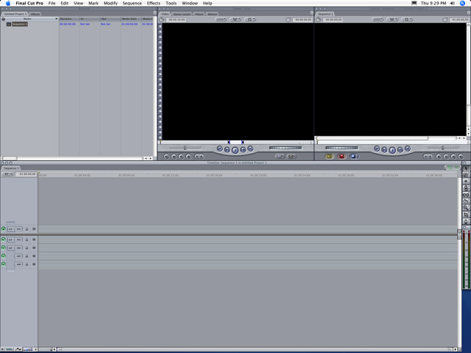

At the top left of the screen you will notice what is called the bin. This is the part of the program that holds all of your imported video, audio and picture files for you to select from. The two black squares are called viewers. The left viewer shows video from your originals and the right viewer shows what the final video product will look like. At the bottom of the screen is the timeline. This is where you place and then arrange your audio, video and other multimedia. Finally, there is a toolbar at the right side of the screen with various tools you can use to make editing easier. It is similar to the toolbar found in other applications such as Photoshop.

Logging and Capturing

The process of getting your footage into the computer so that you can manipulate it is called capturing. To start capturing video click on the file menu and then click log and capture. A new window will show up which contains all of the tools necessary to import your footage. The log and capture window is as shown.

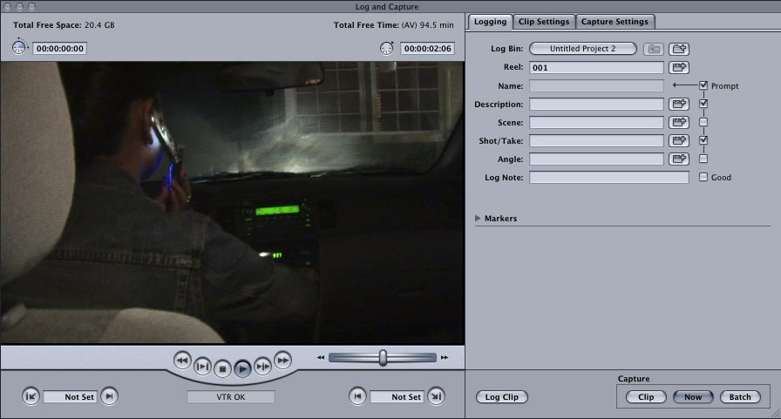

There are many options and methods for capturing digital video. The simplest way is to just play and capture. You can actually control the video camera from Final Cut Pro’s log and capture window using the buttons located under the preview pane.

[these are steps! numbered lists!]First start by typing a description in the description box. This can be anything. For example “Jason pulls in the driveway.” What you type here will be the name of the video file when it captures to the computer (it will show up in the bin automatically!)

Then, find the part of the tape where you would like to start importing. Rewind it to give about 5 seconds “cushioning” time and click the play button. After you click play, click the “now” button at the bottom right corner of the log and capture window.

Repeat the process, beginning with typing a description, for every clip you want to import. When you are finished, close the log and capture window.

Editing to the Timeline

At this point you should have one or more video files in your bin. In case you forgot, the bin is the top left window in Final Cut Pro. Try double clicking one of these files (click the icon, not the text). Your video clip should appear in the left viewer window.

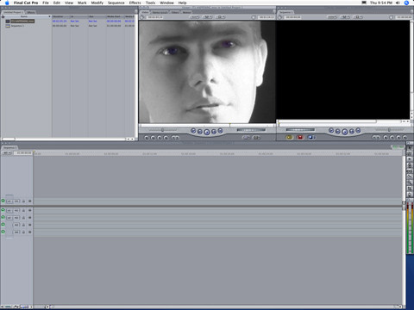

It is from this window where you will select what parts of certain clips you want to have in your timeline. To do this you will move the yellow marker to a certain point, where an “in point” is marked. This is the point from which it will start playing. To do this you click the in point button. Then move the yellow marker to the precise point where you want it to stop and then click the “out point” button. You will notice a blue bracket where the in point is marked and another blue bracket where the out point is marked. Keep in mind that you may, at any time, modify the in or out point by clicking and dragging the blue bracket or simply setting a new in or out point. The old one will disappear. Once the in and outpoints are set and you are happy with where the clip will start and end, you are ready to send it to the timeline. You do this by simply clicking on any point in the picture and dragging it down into the timeline in the v1 track (it says v1 on the left of the screen).

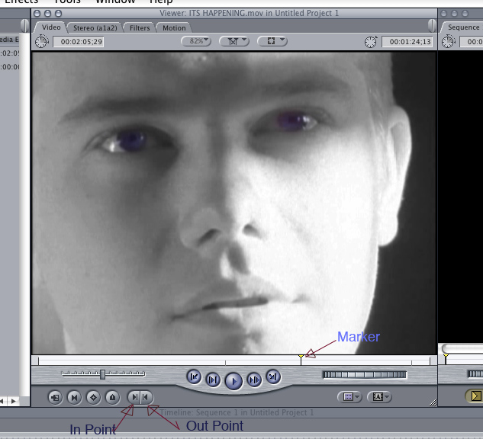

Once you have completed this step, move on to the next clip and repeat the process for each one you want to show in your movie. If you have a still photo or an mp3, wav or aif audio file you would like to use you may place them in the bin by right clicking in the bin, click import, files and then find the file you would like to use. Once you have enough clips in the timeline you can arrange them. Simply click and drag them to their new locations.

Audio and Video Transitions

Once you have your video clips in order you may want to add transitions.[another introductory-element comma] This is a quick and fairly painless process. At the top of the bin there is a tab called effects. Click this tab. A long list of effects will appear. For the purpose of this handbook, you will be taught to apply one, a cross dissolve. However, all of the transitions under the effects tab can be applied the same way. Simply play around and find the ones that work best for your project.

To apply a simple cross dissolve between two clips, make sure the two clips are back to back with one another in the timeline. Then simply click and drag the cross dissolve icon straight on top of the joint between the two clips.

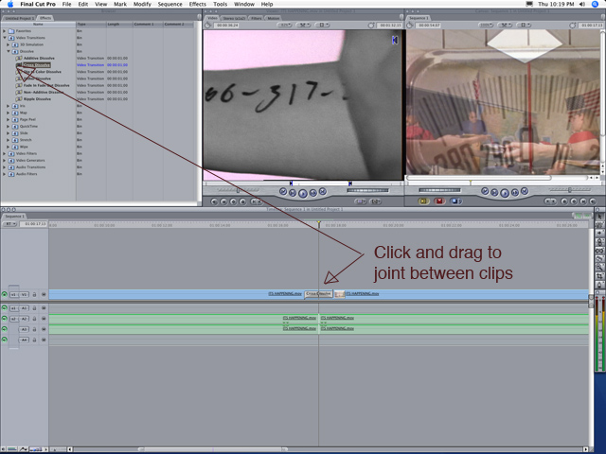

For every video or audio item in Final Cut Pro you can right click and modify properties for that item. For example, you can right click the transition you just dropped in and modify the duration of the transition so that it starts earlier.

You may also add audio dissolves the same way. Simply drag them on the joint between the audio tracks (green) instead of the video. Audio dissolves are located in the folder named audio transitions in the effects tab of your bin.

Adding Color and Text

You may find it necessary to add a background color or possibly even so overlying text to your video. This is quite easy to do as well. In the effects tab of the bin, under video generators is a folder called matte. In this folder you will find color. Click and drag the color icon on to the timeline wherever you want it. After it is in place you can double click it on the timeline and the left viewer will more than likely change to a shade of gray. At the top of the viewer window is a controls tab. Click this tab and then you may change the color of your new selection.

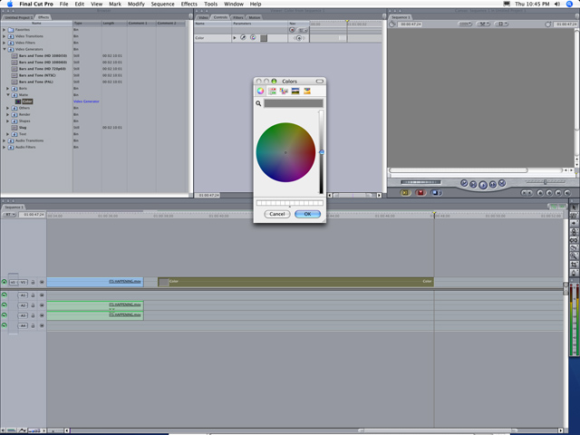

To add text, right click above V1 on the left side of the screen and click add video track. Then, in the effects tab of the bin, under the video generator folder, select the text folder. In this folder there are various text options. Start by playing with the regular text option appropriately labeled “text.” Just as you did before, click and drag the text icon but drag it into V2 right above your previously inserted color. Double click the new text selection and the viewer will change again. Under the controls tab will be a text box where you can type your text.

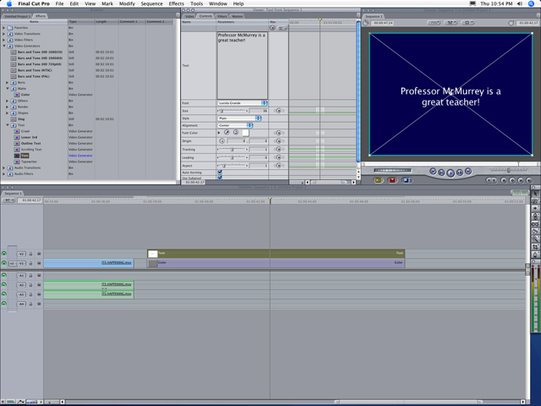

[yeah right]You can also manipulate other text features under the control tab. You can make it bold or italic, change the size and font along with others. Notice the big white X in the sample image above. This is called a wireframe. If you do not see this on your screen, click the view menu at the top of your screen and click image & wireframe. What this does is enable you to position the text (or selected image) wherever you want it by simply clicking and dragging the wireframe.

Remember that these techniques are building blocks. Final Cut Pro is a great program because practically the same techniques can be used for anything within the program. Try using the techniques outlined in this section to apply different transitions, change colors and manipulate your images in more ways than mentioned here.

Exporting your final product

When you are finished creating your masterpiece in Final Cut Pro you are ready to export it to a medium for viewing on a television, projector, etc. Doing this is very simple, it just depends on what format you want it exported to. Exporting back on to a mini-dv tape works when you want to show it on a camera or use the camera’s audio/video cable to play to a VCR or other video source with the appropriate inputs. Exporting a quicktime movie works well for ultimately creating a DVD or other uses such as internet streaming.

*Exporting back to Mini-DV*[use that run-in style!]

Make sure that your tape is cued appropriately as to not overwrite any footage. Use a new tape when possible. Ensure that the camera is still turned on and in VTR, VCR or playback mode. In Final Cut Pro, click the File menu and click Print to Video.

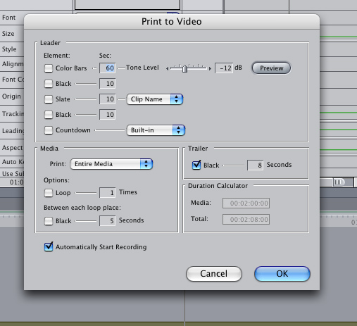

There are three items in this window that you need pay attention to. Ensure that “Print:” is selected to say “Entire Media.” Then make sure that “Automatically Start Recording” is checked. Finally, give your project a few seconds of black video before it starts by checking the box next to the word “Black.”

Once you are finished, click “ok.” The screen will change and then it will prompt you to click “ok” once more. The video will automatically start recording on your camera. When it is done you may save your project and quit Final Cut Pro.

Remember: Always watch your tape afterwards to make sure it transferred correctly!

*Creating a DVD*

If you want to create a DVD from your project, you will first have to export a quicktime file. To do this, click the File menu at the top of the screen, click Export and then click Quicktime Movie.

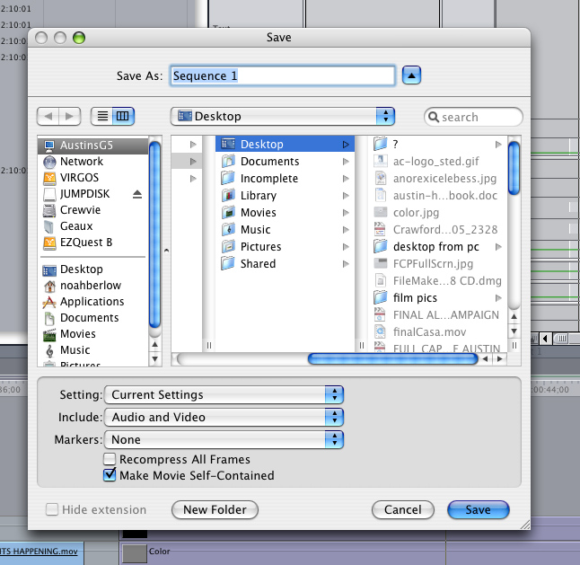

In this window, make sure that the settings match the example above. The “Include Audio and Video” box needs to be selected. You may name the file anything you want, just remember where you save it!

After the export process you may export the Quicktime file to your favorite DVD burning software. St. Edward’s has a program named DVD Studio Pro for burning DVD discs. However, this program can be quite difficult to use, even for intermediate users. A program named iDVD is recommended instead.

When you run the program a window will come up with an animated template. Simply find your saved quicktime movie and drag it into the main window. A St. Edward’s film was dropped in to the iDVD screen to create the example below.

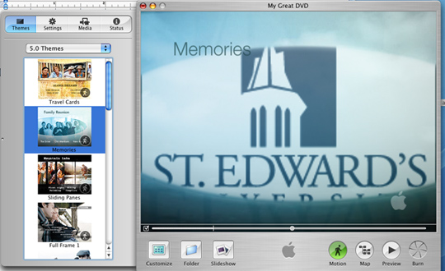

### At this point you may select a new template from the list on the left or proceed to burn your project by clicking “burn” and following the instructions.

[start new page and use same format as start of a new section in the body]

**APPENDIX A.**

**EXAMPLE: SCENE BREAKDOWN**

**SCENE #:** 6 **ACTION:** Projected Newsreel. German audience

**INT/EXT:** INT **DAY/NIGHT:**Day **SEASON:**

**# SET-UPS:**  **2**  **TIME:**

**LOCATION**: Cornell University Cinema

**LINKED TO:**

**EXAMPLE: LOCATION RELEASE FORM**

**PRODUCTION NOTES:** WE DON’T HAVE A LOCATION YET!!!! PLEASE HELP! We need to make Archival Newsreel.

# EXTRAS

* 15-20 German Audience members

# CAST

* Judd (in projection booth)

**ART DESIGN:**

# SPECIAL EQUIPMENT: Fog Machine, Edited Newsreel material

# WARDROBE

* 1930s Wardrobe

# PROPS

* Cigars
* Reel
* Light

## Location Usage Agreement

**_________________________ (hereinafter referred to as "Owner") hereby grant to _________________________ (hereinafter referred to as “Filmmaker”), his/her successors, assigns and licensees, the right to photograph, reproduce and use (either accurately or with such liberties as they may deem necessary) the exteriors and interiors of the premises (including and without limitation, all land, buildings, other structures, works of art, sculptures and landscaping, as well as all architectural and design features of the same) located at ________________________________, and to bring personnel and equipment onto the premises and remove the same.**

**By this agreement, we grant you possession of the premises on ______________, 20___, and may continue in possession thereof until the completion of your proposed scenes and work, requiring occupancy over a period of ____ days. The Filmmaker should be finished filming on said premises by _____________, 20___, and will leave the area in the condition in which it was originally found with exceptions as specified by this agreement.**

**However, in the event of the incapacitation of actors, director, or other essential artist or crew, adverse weather conditions, or any other occurrence beyond the control of the Filmmaker, that prevents starting or completing work on or by the previously designated dates, or in the event of damaged or imperfect film or equipment, Owner agrees to the best of our ability to accommodate the Filmmaker in granting the right to use the premises at a later date to be mutually agreed upon.**

**This grant of location rights is in connection with the motion picture photoplay tentatively entitled _______________________________, and includes the right to re-use the photography in connection with other motion picture photoplays as you, your successors, assigns and licensees shall elect, and, in connection with the exhibition, promotion, advertising and exploitation thereof, in any manner whatsoever and at any time and in any part of the world.**

**Similarly, Filmmaker agrees to hold Owner free from any claims for liability, damage or injury arising during occupancy of the premises and arising out of your negligence thereon on the aforementioned dates; Filmmaker further agrees to leave the premises in as good order and condition as when received, excepting reasonable wear, tear, *force majeure*, and use.**

**Owner acknowledges that, in photographing the premises, Filmmaker is not in any way depicting or portraying Owner in the motion picture photoplay, either directly or indirectly. Owner guarantees hereto that he will not assert or maintain against Filmmaker any claim of any kind or nature whatsoever, including, and without limitation, those based upon intellectual property rights, invasion of privacy or civil rights, defamation, slander or libel, in connection with the exercise of the permission herein granted.**

**Further, Owner represents that he/she/they is/are the actual and legal owner(s) and/or authorized representative(s) of the premises, and thereby has the authority to grant to Filmmaker by pen the permission and rights herein specified, and that the permission of no other party is required.**

**_________________________**

**Owner or Authorized Agent**

**_________________________**

**Date**

**_________________________**

**(Type in your name)**

**_________________________**

**Date**

**_________________________**

**Witness**

_________________________

**Date**

[interesting work.

C (those comma splices!)

Hope my comments make sense. To revise, just use a copy of the original; I’ve kept my commented version. Get in touch if you have any questions at all. ⎯ *David*]