Cardiac Cycle
To understand cardiac cycle, the set of actions that the heart performs repeatedly to keep us alive, consider first the structure the human heart.
Chambers of the Heart. The human heart is divided by a series of partitions, called septa, into four chambers, which segregate the blood at different stages in the pumping cycle. The lower two are ventricles, thick-walled pumping chambers that receive blood from the upper chambers and drive it into the arteries by a series of contractions known as heartbeats. The upper two, called atria (or, sometimes, auricles), are thin-walled reservoirs that readily distend to collect blood that pours in from the veins between beats.
The left and right sides of the heart, each consisting of an atrium and a ventricle, are isolated from each other. The right side receives oxygen-poor blood from the body tissues and distributes it to the body tissues. The left ventricle is, by far, the thickest and heaviest chamber of the heart, reflecting its great work in delivering blood to the systemic circulation; its usual thickness is under one-half inch.
Cardiac Cycle. The sequence of events producing heartbeat is known as the cardiac cycle. During the cycle, each of the four chambers goes through a contraction, called the systole, and a relaxation, called the diastole. In the first phase of the cycle both atria contract, the right first, followed almost instantly by the left. This contraction fills the relaxed ventricles with blood. Then the ventricles contract, repelling their blood in a powerful surge. As they do so, the atria relax and are filled once again by the veins. This cycle lasts, on the average, six-sevenths of a second.
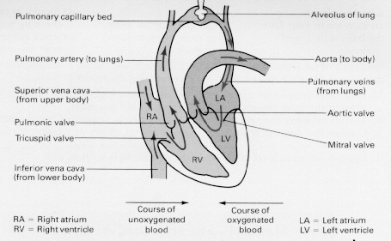
Figure 1. Chambers of the Heart and the Cardiac Cycle
The pressure created by the heart's contraction varies from point to point in the heart and great vessels. Blood returning from the right atrium through veins is under a relatively and low pressure of about 1 or 2 mm Hg. The right ventricle, which sends blood to the lungs, boosts the pressure to about 20 mm Hg during systole. Blood returning to the left atrium is once again at a low pressure, rising with contraction to 3 or 4 mm. The left ventricle delivers blood to the body with considerable force. It raises the pressure to about 120 mm Hg with contraction, the same as the pressure in the arteries of the body. Between beats, the flow of blood into the capillaries lowers the pressure in the arteries to about 80 mm Hg. It is these last two pressures, systolic and diastolic, taken together, that doctors generally call "blood pressure." Thus a typical "normal" pressure might be 120/80.

