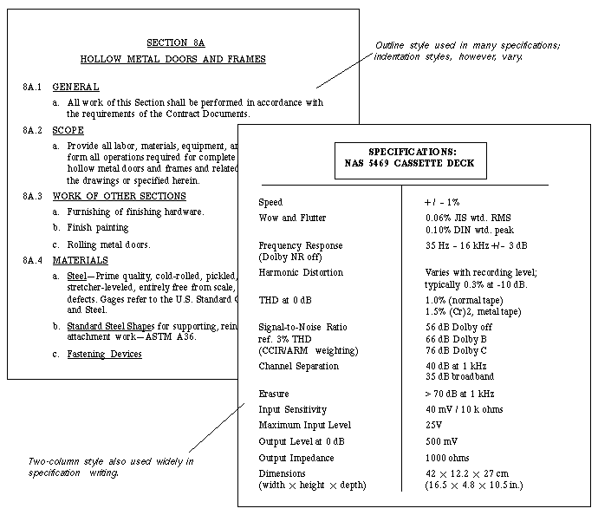
Technical specifications. (a) Metal Doors and Frames, (b) Cassette Deck

